Level 2 Adult ESL Curriculum: Semester Plan, Lessons 1–13, and Exams
Edition: Public edition, October 2026
Audience: Program coordinators and volunteer teachers
Companion files: printable PDF, audio/ (listening MP3s), images/ (181 vocabulary pictures + images/CREDITS.md)
Topics: practical daily life, work, family, health, shopping, and community services.

How this document is organized
Part | What's inside | Who uses it
A. Program Guide | What changed, the semester plan, the weekly routine, scope and sequence, exam and graduation weeks | Coordinators, all teachers
B. Teacher Guide | Lessons 1–13 + midterm (Week 8) and final (Week 15) exam nights: at a glance, clock-time plan, step-by-step boxes, listening scripts, answer keys | Volunteer teachers
C. Student Workbook | Lessons 1–13 (New Words, Listening, Grammar, Homework) + Midterm Review and Final Review pages. Print this part for learners | Learners
E. Assessment Packets | Midterm and final: listening tests, grammar tests, speaking cards, score sheets, can-do self-checks, answer keys. Print separately; don't put them in the workbook | Teachers
D. Reference | Audio, licensing, printing, website, sources | Coordinators

PART A
Program Guide

The semester, the weekly routine, and the course plan

0. About This Edition
This is the complete semester: 13 lessons, a midterm (Week 8), a final (Week 15), and graduation (Week 16).
• Part B has a teacher plan for every lesson and both exam nights. Teachers need no Spanish.
• Part C is the Student Workbook, with pictures, listening tasks, grammar boxes, short Spanish notes for learners, and homework.
• Part E has the midterm and final papers. Print them separately.
• Listening audio exists for Lessons 1–4. Scripts for Lessons 5–13 and the exams are in Part B; the audio is coming later. Until then, read the scripts aloud with a volunteer.
1. The Semester at a Glance
Week | Class | Content | Notes
1 | Lesson 1 (Week 1): Nice to Meet You | be vs. do questions | Includes orientation and baseline snapshot
2 | Lesson 2 (Week 2): A Day in My Life | Simple present (he/she + -s), frequency words
3 | Lesson 3 (Week 3): Free Time | like/love/hate + -ing; me too / me neither
4 | Lesson 4 (Week 4): Right Now | Present continuous; "now" vs. "every day"
5 | Lesson 5 (Week 5): Last Weekend | Past of be; simple past (regular -ed)
6 | Lesson 6 (Week 6): My Story | Irregular past; Did you…?; ago
7 | Lesson 7 (Week 7): Getting Around | Comparatives; How long does it take?
8 | Week 8: Midterm | Review stations + exam (Lessons 1–7) | No new content
9 | Lesson 8 (Week 9): The Best Place in Town | Superlatives; recommending places
10 | Lesson 9 (Week 10): Food and Shopping | Count/noncount; some/any; How much/many; I'd like
11 | Lesson 10 (Week 11): Health | I have a cold; My ___ hurts; should / shouldn't
12 | Lesson 11 (Week 12): Making Plans | be going to; invitations; present continuous for plans
13 | Lesson 12 (Week 13): Getting Things Done | have to / need to; Can/Could you…?; phone calls about services
14 | Lesson 13 (Week 14): Then, Now, and Next | Past/present/future together; prepare graduation talk
15 | Week 15: Final Exam | Review stations + exam (all lessons) | No new content
16 | Week 16: Graduation | Certificates, 1-minute talks, celebration | No new content

2. The Class Routine (Same Every Week)
2.1 Clock-time template
The core runs 6:00–6:45 and 7:00–7:15 (60 minutes). It has six steps, each with room to breathe. 7:15–7:30 is optional ("If time"). Week 1 uses a modified version (see Lesson 1).
Clock time | Step | Minutes | What happens | Status
6:00–6:10 | 1. Opening Talk + Homework Check | 10 | Same partner for both. First ~5 min: a question about last week's lesson (late arrivals join a pair). Next ~5 min: compare homework. The teacher corrects only 2 items on the board. | Core
6:10–6:18 | 2. New Words | 8 | Picture page: point, say, repeat; quick pair game | Core
6:18–6:30 | 3. Listening + "Say it" | 12 | Before you listen → Task A → Task B → Task C (grammar fill-in) → 1–2 min repeating 2 lines from the audio | Core
6:30–6:45 | 4. Grammar Q&A + quick pair check | 15 | Learners read the Q's; class answers; examples, common mistakes, check questions; then 3–5 min of pair practice | Core
6:45–7:00 | BREAK | 15
7:00–7:10 | 5. Talk Time | 10 | The main speaking activity of the night | Core
7:10–7:15 | 6. Exit Ticket + Homework | 5 | One sentence on a slip; explain the homework and do item 1 together | Never skip
7:15–7:30 | If time (pick in order) | 0–15 | ① Pronunciation activity (5) ② Pair practice game, long version (5–10) ③ Extension / second Talk Time round (10) | Optional

If you're running behind, skip in this order: (1) everything in "If time"; (2) the third play of the audio, so do Task C together with the teacher reading the lines; (3) the pair check at the end of Grammar, which becomes part of the homework; (4) teach only the ★ words (the others stay on the page for home study); (5) the second half of Talk Time, so do one round only. Never skip: the Listening tasks, the Grammar Q&A mistakes table, and the Exit Ticket + Homework.

If you're ahead of time: go to the "If time" menu at 7:15, or let Talk Time run 5 minutes longer and switch partners once more.

Late-arrival rules: Step 1 is designed for people walking in late. A late learner joins any pair (making a group of 3) and starts talking right away. Keep 3 extra copies of every handout by the door.

2.2 Adapting to attendance (15 → 7–8 learners)
Situation | 15 learners | 7–8 learners | 5 or fewer
Pairs | 7 pairs + 1 group of 3 | 3–4 pairs | Pairs; the teacher joins only if one person is left
Small groups | 3–4 groups of 4–5 | 2 groups of 3–4 | One group
Circles (inside–outside) | Two circles of 7–8, or one big circle | One circle | Use "rotate seats" instead
Mingles | Each learner talks to 5–6 people | Each learner talks to everyone | Turn the mingle into a table interview
Printing | Print for the number expected, plus 3 spares

Why attendance drops, and what helps: adults miss class because of work and family. The homework check and opening question give returning learners a quick way back in. Each lesson's handout stands alone, so a learner who missed a week can still follow.

2.3 Assessment and progress (semester version)
Tool | When | What | Who / how long
Baseline snapshot | Weeks 1–3 | Same 6 speaking prompts every time (name, from, live, work, routine, free time) | Teacher or a second volunteer, 2 minutes per learner, about 5 learners per week during Talk Time
Can-do self-check | Week 1, Week 8, Week 15 | "I can…" list with 😀 🙂 😐 | Learner, 5 minutes
Exit ticket | Every lesson | One sentence or question with today's grammar | Learner; teacher reads it after class
Homework | Every lesson | Short written or speaking task | Pairs check in the 6:00–6:10 opening block
Midterm | Week 8 | Listening (audio), grammar (15 items), speaking (pair task + rubric) on Lessons 1–7 | See Section 4.1 and Part E
Final | Week 15 | Same format, all lessons, focus on 8–13; speaking uses the baseline prompts to show growth | See Section 4.1 and Part E
Speaking rubric | Midterm, final, and some Talk Times | Communication / target grammar / pronunciation and fluency, each scored 1–3 | Teacher

Speaking rubric:
Score | Communication | Target grammar | Pronunciation and fluency
3 | Completes the task; asks and answers follow-up questions | Uses the target form correctly most of the time | Easy to understand; few long pauses
2 | Completes most of the task with some help | Uses the form, with errors that don't block meaning | Mostly understandable; some pauses
1 | Needs a lot of help; very short answers | Rarely uses the form, or errors block meaning | Hard to understand without effort

Proposed graduation standard (confirm): attend at least 9 of the 13 lessons (plus the exams) and complete the final. "Ready for Level 3" = 2 or higher in all rubric areas on the final, plus 🙂 or 😀 on at least 80% of the can-do list. Learners who are not ready still graduate from the course and are encouraged to repeat Level 2.
3. Scope and Sequence: 13 Lessons
3.1 Lesson list
Lesson (Week) | Title | Grammar | Real-life function | Listening (audio) | Pronunciation
Lesson 1 (Week 1) | Nice to Meet You | be vs. do/does questions; short answers | Meet a new classmate or neighbor | Two neighbors meet at a community center | Rising ↗ / falling ↘ question intonation
Lesson 2 (Week 2) | A Day in My Life | Simple present; he/she + -s; doesn't; frequency words | Describe routines; compare weeks | Coworkers talk about a long day | -s endings /s/ /z/ /ɪz/
Lesson 3 (Week 3) | Free Time | love/like/don't mind/hate + noun or -ing; me too / me neither | Break-room small talk | Coworkers talk about weekends | /ŋ/ in -ing; stress for feeling
Lesson 4 (Week 4) | Right Now | Present continuous (am/is/are + -ing); now vs. every day | Phone call: "What are you doing?"; telling time (review) | A phone call while waiting for the bus | Contractions I'm, she's, they're
Lesson 5 (Week 5) | Last Weekend | was/were; simple past regular verbs | Talk about the weekend; ask How was…? | Friends talk about their weekend | -ed endings /t/ /d/ /ɪd/
Lesson 6 (Week 6) | My Story | Common irregular past verbs; Did you…?; negatives; ago | Tell a short life story (moving, first job, first days here) | A learner tells how she started a new life in a new city | Did you → "didja" (recognize)
Lesson 7 (Week 7) | Getting Around | Comparatives (-er / more / better); How long does it take?; by bus / on foot | Compare commutes and ways to travel | Two people compare bus vs. car | -er /ər/; word stress
Week 8: Midterm | Midterm | Review of Lessons 1–7 | Review stations, speaking interview, listening + grammar tests | Midterm listening clip
Lesson 8 (Week 9) | The Best Place in Town | Superlatives (the -est / the most / the best); there is / there are (review) | Recommend a store, park, or clinic | Neighbors recommend places | th /ð/ in the, there
Lesson 9 (Week 10) | Food and Shopping | Count/noncount; some/any; How much/How many; I'd like / Can I have…? | Order food; make a shopping list | Ordering at a restaurant | /ɪ/ vs. /i/ (chip/cheap)
Lesson 10 (Week 11) | Health | I have a…; My ___ hurts; should / shouldn't | Describe symptoms; make an appointment by phone | Calling a clinic | /ʃ/ vs. /tʃ/ (shoe/chew); silent l in should
Lesson 11 (Week 12) | Making Plans | be going to; present continuous for arrangements; invitations | Invite, accept, decline politely | Friends make weekend plans | going to → "gonna" (recognize)
Lesson 12 (Week 13) | Getting Things Done | have to / need to; Can/Could you…? | Call about a bill; mail a package; leave a voicemail | A customer service call | have to → "hafta"; polite intonation
Lesson 13 (Week 14) | Then, Now, and Next | Past + present + future in one story | Prepare and practice a 1-minute graduation talk | A former learner's short talk | Sentence stress and linking
Week 15: Final Exam | Final Exam | Review of all lessons | Review stations, speaking interview, listening + grammar tests | Final listening clip
Week 16: Graduation | Graduation | — | 1-minute talks, certificates | —

3.2 What we dropped or moved (to fit 13 lessons)
Topic | Decision | Why
Describing people (What's he like? / What does he look like?) | Optional bonus worksheet; may belong in Level 1 or 3 | Lower priority than survival functions; confirm with Level 1 content
Directions and prepositions of movement | Optional "If time" activity in Lesson 7 | Lesson 7 already contains comparatives and travel time
a few / a little | Light mention in Lesson 9 only | Keeps Lesson 9 manageable
can / can't for ability | Dropped (probably Level 1) | Confirm with Level 1
will for offers; object pronouns | Moved to Level 3 | Not essential for this level's goals
Feelings about moving | Folded into Lesson 6 (I felt nervous / happy) | Fits the life-story topic
Holidays and celebrations | Optional in Lesson 6 (learners choose what to share) | Optional
Telling time as a full lesson | Reviewed inside Lesson 4 | Most learners know numbers; practice the language in context instead

3.3 Grammar in teaching order
1. be vs. do questions (Lesson 1) → 2. simple present + -s (Lesson 2) → 3. frequency adverbs (Lesson 2) → 4. like + -ing, me too/neither (Lesson 3) → 5. present continuous (Lesson 4) → 6. simple present vs. continuous (Lesson 4) → 7. was/were (Lesson 5) → 8. regular past (Lesson 5) → 9. irregular past + did (Lesson 6) → 10. comparatives (Lesson 7) → midterm → 11. superlatives (Lesson 8) → 12. count/noncount, some/any, how much/many (Lesson 9) → 13. I'd like / Can I have (Lesson 9) → 14. should (Lesson 10) → 15. be going to (Lesson 11) → 16. present continuous for plans (Lesson 11) → 17. have to / need to, Can/Could you (Lesson 12) → 18. tense review (Lesson 13) → final.
Spiral recycling: every Opening Talk reuses last week's grammar. The homework always mixes in one older point. The midterm and final review stations revisit everything.
4. Exam and Graduation Weeks
4.1 Midterm (Week 8) and Final (Week 15)
Clock time | What | Notes
6:00–6:10 | Opening Talk + Homework Check | Same routine as every week
6:10–6:30 | Review stations (two 10-minute rounds): ① Grammar Auction, ② Listening Replay, ③ Question / Role-Play Cards, ④ Pronunciation Bingo (midterm) or Talk Rehearsal (final). 15 learners: 4 stations; 7–8 learners: stations ② and ③ | Speaking interviews start: the teacher (or a second volunteer) calls pairs to a quiet corner for a 3-minute task scored with the rubric. 15 learners ≈ 8 pairs ≈ 24 minutes; 7–8 learners ≈ 12 minutes
6:30–6:45 | Listening test (8 items: circle + true/false; the audio plays 2–3 times) | Same task types as class. No surprises
6:45–7:00 | Break
7:00–7:15 | Grammar test (15 items: circle the correct answer) | Speaking interviews continue with pairs who finish early. Slow readers may continue to 7:20
7:15–7:30 | If time: finish interviews; can-do self-check + one goal; go over the listening answers | The self-check can go home if time is short

Exam-week timing: the listening test now comes before the break, while learners are fresh, and the grammar test gets its own 15 minutes after the break. Stations are shorter (20 minutes) so the tests fit in the core time. The full plans are in Part B (Week 8 and Week 15); the papers are in Part E.

Confirm whether the program needs grades. We recommend a simple scale: "Meets / Almost / Not yet."
4.2 Graduation (Week 16)
• No new content. Each learner gives their 1-minute talk prepared in Lesson 13 (or reads 2–3 sentences).
• Certificates of completion. Optional potluck: ask about allergies, and don't require anyone to bring food.
• Hand out a "Keep practicing" sheet with the website and QR codes for all audio.

PART B
Teacher Guide

Lessons 1–13 · Week 8 Midterm · Week 15 Final Exam · Week 16 Graduation
At a glance · Clock-time plan · Step by step · Script and answer key

5. Teacher Guide: How to Use the Lesson Plans
How to read these plans: Each lesson has (A) a Teacher Plan with clock times, steps, the listening script, and answer keys, and (B) a Student Page to print. The student page has the listening tasks, grammar box, Spanish note (Nota para hispanohablantes, written for learners to read on their own; teachers don't need to read or explain it), tips for all learners, and the homework. Audio files are in audio/ (L1_listening.mp3 … L4_listening.mp3; L5–L13 and the exam files Midterm_listening.mp3 and Final_listening.mp3 will use the same names once produced). Each file plays the conversation once; play the audio again if needed. No speaker or device? Read the script aloud with a volunteer learner.

Grouping toolkit: Pairs: turn to a neighbor; with an odd number make one group of 3. New partners: matching cards, or line up by birthday month and "fold" the line. Inside–outside circles: inner circle faces out, outer circle faces in; the outer circle moves one person clockwise each round. Instruction rule: Model it (show with one learner), check it (ask "Do you write or speak?"), then go (start the timer).

You don't need to speak Spanish. Teach in English. The Spanish notes on the student pages are for learners to read on their own. They are not something you need to read, translate, or explain.

When a learner is stuck or asks something in Spanish: (1) show it: use the picture, a gesture, or the board; (2) give one more simple English example; (3) point to the Grammar Box or the Spanish note on their page; (4) ask a classmate to help for a few seconds, then continue in English. You don't need to understand what classmates say to each other.

Where are the student pages? In Part C: Student Workbook. Each lesson there has four pages: New Words, Listening, Grammar, Homework. The exam papers are in Part E: Assessment Packets.

Lesson 1 (Week 1): Nice to Meet You
At a glance
Objectives: learners can…
• ask and answer 8 or more personal-information questions
• choose between be and do questions
• introduce a partner using he/she

Materials
• name tags
• markers
• "How Our Class Works" sheet
• Student Page 1
• question-card envelopes (one per pair)
• "Find Someone Who" sheet
• baseline checklist
• phone + small speaker
• L1_listening.mp3
• Prep time: 30 min.

Key vocabulary (with pictures in the Student Workbook)
from, live, work, job, neighborhood, married / single, kids, brother / sister, hometown, near, nice to meet you, What about you?

Clock-time plan
Core = 6:00–6:45 and 7:00–7:15. Everything after 7:15 is optional ("If time").
Time | Step | Min | Grouping (15 / 7–8) | If running behind
6:00–6:10 | Welcome + Name Chain (the Week 1 opening) | 10 | Two circles / one circle | Go around once only
6:10–6:15 | Orientation: "How Our Class Works" | 5 | Whole class | Hand out the sheet; read the 3 key rules only
6:15–6:23 | New Words (picture page) | 8 | Pairs | Teach the ★ words only
6:23–6:33 | Listening (audio) + "Say it" | 10 | Individuals, then pairs check | Skip the third play; do Task C as a whole class
6:33–6:45 | Grammar Q&A: be or do? + quick pair check | 12 | Whole class, then pairs | Skip the pair check; it becomes homework item 1
6:45–7:00 | BREAK | 15
7:00–7:10 | Talk Time: Find Someone Who + baseline snapshot | 10 | Talk to 6+ people / everyone | Learners talk to 4 people
7:10–7:15 | Exit Ticket + Homework | 5 |  | Never skip
7:15–7:30 | If time (in this order): ① Pronunciation ↗/↘ (5) ② Question Scramble (5) ③ Interview and Introduce (10) | 0–15 |  | Optional

How to use this plan: the core is 6:00–6:45 and 7:00–7:15. If you fall behind, use the right-hand column. Everything after 7:15 is optional.

Step by step
Step 1 · 6:00–6:10 · Welcome + Name Chain · 10 min
• Grouping: two circles (15 learners) / one circle (7–8 learners).
• Model: "I'm Ana. I like coffee."
• Do: each next person repeats the previous person, then adds their own: "She's Ana. She likes coffee. I'm Carlos. I like soccer."
• Late arrivals: join the circle.
• If behind: go around once only.

Step 2 · 6:10–6:15 · Orientation: "How Our Class Works" · 5 min
• Grouping: whole class.
• Cover: class times and the break; homework every week (short!), checked at the start of class.
• Language rule: "English in class. If you're stuck, a classmate can help you for a few seconds. Then back to English." You don't need to understand what classmates say to each other. Just smile and say "Now in English, please."
• Also say: phones are OK for audio and dictionary. "You can tell the truth or make it up."
• If behind: hand out the sheet and read the 3 key rules only.

Step 3 · 6:15–6:23 · New Words · 8 min
• Grouping: pairs.
• Do: open the Student Workbook to the New Words page. Point to each picture, say the word; learners repeat twice.
• Pairs: A points to a picture, B says the word. Then switch.
• Extra example: show the ID card for a fictional person.
• If behind: teach only the ★ words.

Step 4 · 6:23–6:33 · Listening + "Say it" · 10 min
• Grouping: individuals, then pairs check.
• Before you listen (1 min): "Rosa and Sam meet. What questions do they ask?" Write 2–3 guesses.
• Listen 1 → Task A (true/false). Listen 2 → Task B (circle). Listen 3 → Task C (write are / do).
• Pairs compare after each task.
• "Say it" (1–2 min): pause after "Where are you from?" and "Where do you live?" The class repeats each line twice.
• Bridge to grammar: "When do we use are? When do we use do?"
• If behind: skip the third play; do Task C together (teacher reads the 4 lines).

Step 5 · 6:33–6:45 · Grammar: be or do? · 12 min
• Grouping: whole class, then pairs.
• Show: the Grammar Box (question side / answer side).
• Say: "English questions need a helper word at the front. With am/is/are, move it to the front. With no be, borrow do or does."
• Q&A: a learner reads a Q; the class guesses; read the A; write one example on the board.
• Check questions: "___ you like rice?" (do) • "___ you tired?" (are) • "Where ___ she work?" (does)
• Pair check (last 3–4 min): A builds a question from the box; B answers from the answer side.
• If behind: skip the pair check.

Break · 6:45–7:00 · 15 min
• Set up the "Find Someone Who" sheets during the break.

Step 6 · 7:00–7:10 · Talk Time: Find Someone Who · 10 min
• Grouping: mingle (talk to 6+ people / everyone).
• Do: learners turn each prompt into a correct question (Do you live near here? / Are you a morning person?).
• When someone says yes: write their name and ask one follow-up question. One name per row.
• Baseline snapshot: the teacher (or a second volunteer) uses the checklist: Can they ask a do question? Answer in a full sentence? Give 1 extra detail?
• Later: formal 2-minute baseline interviews in Weeks 2–3 (about 5 learners per week).
• If behind: learners talk to 4 people.

Step 7 · 7:10–7:15 · Exit Ticket + Homework · 5 min · NEVER SKIP
• Exit ticket: write one be question and one do question.
• Homework: explain it from the workbook and do item 1 together.

If time · 7:15–7:30 · pick in this order
• ① Pronunciation (5 min): Yes/No questions go up ↗; Wh- questions go down ↘. Hum the melody, then say the words. Pairs: A says a question, B draws the arrow in the air.
• ② Question Scramble (5 min): each pair builds 4 questions from an envelope of word cards.
• ③ Interview and Introduce (10 min): partners interview each other, then introduce the partner to a group: "This is Marta. She's from Guatemala." (Previews Lesson 2's -s. Don't teach it yet.)

Listening script: L1_listening.mp3 (about 1:10; the conversation plays once, so play the audio again if needed)
Audio: play from a phone + small speaker. No speaker? Read the script with a volunteer learner.

Narrator: Lesson one. Listening. Rosa and Sam meet at the community center. Listen.
Rosa: Hi! Are you new here?
Sam: Yes, I am. I'm Sam. Nice to meet you.
Rosa: Nice to meet you too. I'm Rosa. Where are you from, Sam?
Sam: I'm from Honduras. And you?
Rosa: I'm from Colombia. Where do you live?
Sam: I live on Pine Street, near the park.
Rosa: Oh, me too! Do you work near here?
Sam: Yes, I do. I work at a hotel. I'm a cook. What do you do?
Rosa: I work at a bakery. I start very early, at five in the morning!
Sam: Wow. Do you have kids?
Rosa: Yes, I do. I have two daughters. Are you married?
Sam: No, I'm not. But my brother lives here with me.
Rosa: That's nice. Well, see you in class!
Sam: See you!

Answer key
• Task A: 1 T, 2 F (Honduras), 3 T, 4 F (a hotel), 5 T.
• Task B: 1 a cook, 2 5:00, 3 brother.
• Task C: 1 are, 2 do, 3 Do, 4 Are.
Teacher notes
• Privacy: never ask about immigration status, money, or exact addresses. Married/single is optional; Do you have family here? is an alternative.
• Mixed levels: stronger learners add a follow-up question to every answer; newer learners use the question cards as a script.
• Typical mistakes from Spanish speakers: I have 35 years (Spanish uses "have" for age) and Where you live? (Spanish questions need no helper word). These are the two most common errors this week. Write the correct form on the board, and point learners to the Spanish note on their Grammar page. They can read it themselves; you don't need to explain it.
Lesson 2 (Week 2): A Day in My Life
At a glance
Objectives: learners can…
• describe a daily routine with 10 or more routine verbs
• use he/she + -s, doesn't, Does…?
• use always … never in the correct position

Materials
• Student Page 2
• routine picture cards (1 set per group)
• info-gap sheets A/B
• frequency signs (ALWAYS … NEVER)
• slips of paper
• L2_listening.mp3
• Prep time: 25 min.

Key vocabulary (with pictures in the Student Workbook)
get up, take a shower, get dressed, have breakfast, take the bus, drive, start work, take a break, pick up the kids, cook dinner, do the dishes, go to bed; every day, on weekends, in the morning, at night.

Clock-time plan
Core = 6:00–6:45 and 7:00–7:15. Everything after 7:15 is optional ("If time").
Time | Step | Min | Grouping (15 / 7–8) | If running behind
6:00–6:10 | Opening Talk + Homework Check (same partner): ask 3 questions (Where do you live? Do you work? Are you from a big city?), then ask each other your 5 homework questions | 10 | Pairs | Teacher collects the homework instead of reviewing it on the board
6:10–6:18 | New Words: picture page + Picture Sequence | 8 | Groups of 4–5 / 2 groups | Teach the ★ words; skip mime-and-guess
6:18–6:30 | Listening + "Say it" | 12 | Individuals → pairs | Skip the third play; do Task C together
6:30–6:45 | Grammar Q&A: simple present + frequency, then a short Information Gap | 15 | Whole class, then pairs | Do the Q&A + mistakes table only; the Information Gap moves to "If time"
6:45–7:00 | BREAK | 15
7:00–7:10 | Talk Time: Frequency Line → "Our Week" | 10 | Line, then pairs | Do "Our Week" only
7:10–7:15 | Exit Ticket + Homework | 5 |  | Never skip
7:15–7:30 | If time (in this order): ① Pronunciation: 3 sounds of -s (5) ② Information Gap, full version (5) ③ "Guess Who?" (10) | 0–15 |  | Optional

How to use this plan: the core is 6:00–6:45 and 7:00–7:15. If you fall behind, use the right-hand column. Everything after 7:15 is optional.

Step by step
Step 1 · 6:00–6:10 · Opening Talk + Homework Check · 10 min
• Grouping: pairs (same partner for both parts).
• Minutes 0–5: ask 3 questions: Where do you live? Do you work? Are you from a big city? Late arrivals join a pair.
• Minutes 5–10: partners ask each other their 5 homework questions.
• Teacher: walk around; write only 2 corrected questions on the board.
• If behind: collect the homework; return it next week with one correction each.

Step 2 · 6:10–6:18 · New Words · 8 min
• Grouping: groups of 4–5 (15) / 2 groups (7–8).
• Do: New Words page: point, say, repeat twice.
• Picture Sequence: groups put 12 routine cards in order for a typical day and say each one aloud.
• If time: pairs play mime-and-guess.
• If behind: teach the ★ words only.

Step 3 · 6:18–6:30 · Listening + "Say it" · 12 min
• Grouping: individuals → pairs.
• Before you listen: "Marco looks tired. Why?"
• Listen 1 → Task A (circle the times). Listen 2 → Task B (Marco or his wife?). Listen 3 → Task C (fill in).
• Ask: "Why drives with an -s?" (his wife = she)
• "Say it" (1–2 min): the class repeats "My wife drives. She works at a restaurant." Make the -s loud.
• If behind: skip the third play.

Step 4 · 6:30–6:45 · Grammar: simple present + frequency · 15 min
• Grouping: whole class, then pairs.
• Say: "We use the simple present for routines and facts. With he, she, it, the verb gets an -s. With does / doesn't, the -s moves to does, so the main verb has no -s."
• Grammar Box: read across one row of the question side, then the answer side. Learners choose a word from each column.
• Q&A: learner reads Q → class guesses → read A → board example.
• Check questions: "Marco takes the bus. One day or every day?" • "She ___ (not drive)." • "I take usually or I usually take?"
• Short Information Gap (last 5 min): A has Rosa's week, B has Ali's. Ask 3 questions each (What time does Rosa start work?). Don't show papers.
• If behind: skip the Information Gap.

Break · 6:45–7:00 · 15 min
• Put the ALWAYS … NEVER signs on the wall during the break.

Step 5 · 7:00–7:10 · Talk Time: Frequency Line → Our Week · 10 min
• Frequency Line (4 min): signs from ALWAYS to NEVER along a wall. Call "How often do you cook?" Learners stand at a sign and tell a neighbor.
• Our Week (6 min): pairs find 2 things in common and 2 differences, then report: "We both take the bus. Maria usually cooks, but I never cook!"
• If behind: do "Our Week" only.

Step 6 · 7:10–7:15 · Exit Ticket + Homework · 5 min · NEVER SKIP
• Exit ticket: one sentence about a family member with -s.
• Homework: explain it and do item 1 together.

If time · 7:15–7:30 · pick in this order
• ① Pronunciation (5 min): /s/ works, takes; /z/ plays, drives; /ɪz/ watches, fixes. Hold up 1, 2, or 3 fingers. Most important: say the -s at all.
• ② Information Gap, full version (5 min): finish all the blank cells.
• ③ Guess Who? (10 min): each learner writes 3 routine sentences anonymously. Groups read a slip aloud as he/she ("This person always gets up at 4…") and guess who wrote it.

Listening script: L2_listening.mp3 (about 0:58; the conversation plays once, so play the audio again if needed)
Audio: play from a phone + small speaker. No speaker? Read the script with a volunteer learner.

Narrator: Lesson two. Listening. Ana and Marco talk at work. Listen.
Ana: Marco, you look tired!
Marco: I am! I get up at five thirty every day.
Ana: Five thirty? Why?
Marco: I work at the hospital. I start work at seven. I usually take the bus.
Ana: Do you drive?
Marco: No, I don't. My wife drives. She has the car.
Ana: Does she work at the hospital too?
Marco: No, she doesn't. She works at a restaurant. She works at night.
Ana: So who picks up the kids?
Marco: I do. I always pick them up at three thirty. Then I cook dinner.
Ana: Do you ever rest?
Marco: Sometimes! On Sundays, I never get up early. I sleep until nine!

Answer key
• Task A: 5:30; 7:00; 3:30; 9:00.
• Task B: works at the hospital = Marco; drives = wife; works at night = wife; picks up the kids = Marco; cooks dinner = Marco.
• Task C: drives; works; always; never.
Teacher notes
• Some learners work night shifts. Accept any routine: "morning" means whenever they wake up.
• Repeat the "one -s rule" every time the error appears this week.
• Info-gap sheets: make two copies of a weekly table and blank out 6 different cells on each.
Lesson 3 (Week 3): Free Time
At a glance
Objectives: learners can…
• say likes and dislikes with love / like / don't mind / don't like / hate + noun or -ing
• agree and disagree (Me too / Me neither / Really? I don't / Oh, I do!)
• keep a short conversation going with What kind of…?

Materials
• Student Page 3
• four corner signs (LOVE / LIKE / DON'T MIND / HATE)
• free-time picture cards
• a soft ball
• "Find Your Twin" survey
• L3_listening.mp3
• Prep time: 15 min.

Key vocabulary (with pictures in the Student Workbook)
soccer, cooking, dancing, shopping, cleaning, gardening, fixing things, watching TV/movies, walking, reading, video calls, music (salsa, cumbia, pop, rock), What kind of…?.

Clock-time plan
Core = 6:00–6:45 and 7:00–7:15. Everything after 7:15 is optional ("If time").
Time | Step | Min | Grouping (15 / 7–8) | If running behind
6:00–6:10 | Opening Talk + Homework Check (same partner): "What time do you usually get up? Does your family get up early?" Then read your 6 homework sentences; the partner raises a hand at each -s | 10 | Pairs | Teacher collects the homework
6:10–6:18 | New Words: picture page + feelings scale with gestures | 8 | Pairs | Teach the ★ words; skip the picture sort
6:18–6:30 | Listening + "Say it" | 12 | Individuals → pairs | Skip the third play; do Task C together
6:30–6:45 | Grammar Q&A: like + -ing; Me too / Me neither, then a short Ball Toss | 15 | Whole class, then circle(s) | Do the Q&A + mistakes table only; Ball Toss moves to "If time"
6:45–7:00 | BREAK | 15
7:00–7:10 | Talk Time: Four Corners → Break-Room Small Talk | 10 | Corners, then pairs (7–8: 2 corners) | Do Break-Room Small Talk only
7:10–7:15 | Exit Ticket + Homework | 5 |  | Never skip
7:15–7:30 | If time (in this order): ① Pronunciation: /ŋ/ + stress for feeling (5) ② Ball Toss round 2 (5) ③ Find Your Twin survey (10) | 0–15 |  | Optional

How to use this plan: the core is 6:00–6:45 and 7:00–7:15. If you fall behind, use the right-hand column. Everything after 7:15 is optional.

Step by step
Step 1 · 6:00–6:10 · Opening Talk + Homework Check · 10 min
• Grouping: pairs (same partner for both parts).
• Minutes 0–5: "What time do you usually get up? Does your family get up early?"
• Minutes 5–10: each partner reads their 6 homework sentences; the listener raises a hand at every -s.
• Teacher: note 2 common errors for the board.
• If behind: collect the homework.

Step 2 · 6:10–6:18 · New Words · 8 min
• Grouping: pairs.
• Do: New Words page: point, say, repeat.
• Feelings scale: teach with gestures (❤❤ love → ✘ hate).
• Picture sort: pairs sort the free-time cards into "I like" and "I don't like."
• If behind: teach the ★ words; skip the sort.

Step 3 · 6:18–6:30 · Listening + "Say it" · 12 min
• Grouping: individuals → pairs.
• Before you listen: "What do you think Kim likes?"
• Listen 1 → Task A (✓/✗ chart). Listen 2 → Task B (circle the reply). Listen 3 → Task C (fill in).
• "Say it" (1–2 min): repeat "I love dancing." and "Me neither!" with strong feeling.
• If behind: skip the third play.

Step 4 · 6:30–6:45 · Grammar: like + -ing; Me too / Me neither · 15 min
• Grouping: whole class, then circle(s).
• Say: "After like, love, hate, don't mind, use a thing or an activity. To make an action an activity, add -ing."
• Say: "Me too answers a positive sentence. Me neither answers a negative sentence."
• Grammar Box + Q&A: learner reads Q → class guesses → read A → board example.
• Check: "I don't like snow." → (Me neither / Really? I do!)
• Short Ball Toss (last 5 min): the thrower says a true sentence; the catcher agrees or disagrees correctly, then makes a new sentence. (Two circles for 15; one for 7–8.)
• If behind: skip the Ball Toss.

Break · 6:45–7:00 · 15 min
• Put the four corner signs up (LOVE / LIKE / DON'T MIND / HATE).

Step 5 · 7:00–7:10 · Talk Time: Four Corners → Break-Room Small Talk · 10 min
• Four Corners (5 min): call out an activity; learners walk to a corner and tell the others why ("…because it's boring"). 7–8 learners: use 2 corners only (LIKE / DON'T LIKE).
• Break-Room Small Talk (5 min): "You're on a break with a new coworker. Find one thing you both like." Switch partners once.
• If behind: Small Talk only.

Step 6 · 7:10–7:15 · Exit Ticket + Homework · 5 min · NEVER SKIP
• Exit ticket: one love / hate + -ing sentence.
• Homework: explain it and do item 1 together.

If time · 7:15–7:30 · pick in this order
• ① Pronunciation (5 min): the /ŋ/ sound at the end of -ing (back of the tongue up, no hard "g"). Stress the feeling word: "I LOVE dancing."
• ② Ball Toss round 2 (5 min): the catcher also asks a follow-up question (What kind of music do you like?).
• ③ Find Your Twin (10 min): learners use the 8-item survey, mingle, ask Do you like…?, and find the classmate who matches on the most items.

Listening script: L3_listening.mp3 (about 1:05; the conversation plays once, so play the audio again if needed)
Audio: play from a phone + small speaker. No speaker? Read the script with a volunteer learner.

Narrator: Lesson three. Listening. Kim and Carlos talk on a break at work. Listen.
Kim: Carlos, what do you do on weekends?
Carlos: I love playing soccer. I play every Saturday. Do you like soccer?
Kim: Not really. I like watching it on TV, but I don't like playing.
Carlos: What do you like doing?
Kim: I love cooking. And I like dancing. I go dancing with my sister on Fridays.
Carlos: Me too! I love dancing. What kind of music do you like?
Kim: Salsa and cumbia. I don't like rock music.
Carlos: Me neither. It's too loud! Do you like shopping?
Kim: I don't mind it. But I hate cleaning the house!
Carlos: Oh, I don't mind cleaning. I listen to music when I clean.
Kim: Good idea!

Answer key
• Task A: playing soccer: Carlos ✓, Kim ✗ • watching soccer on TV: Kim ✓ • cooking: Kim ✓ • dancing: Kim ✓, Carlos ✓ • rock music: Kim ✗, Carlos ✗ • cleaning: Kim ✗ (hates), Carlos ✓ (doesn't mind).
• Task B: 1 Me too!, 2 Me neither.
• Task C: Fridays; Saturday; mind.
Teacher notes
• Use music genres and artists from learners' own cultures (keep the examples general).
• I like to cook is also correct. At this level we practice the -ing form so learners learn one pattern well.
• because comes up naturally in Four Corners. Model it but don't teach it formally.
Lesson 4 (Week 4): Right Now
At a glance
Objectives: learners can…
• say what people are doing now (am/is/are + -ing)
• ask What are you doing?
• tell the difference between "now" (present continuous) and "every day" (simple present)
• review telling time

Materials
• Student Page 4
• 10 action pictures (or a busy street picture)
• "Now or Every Day?" sentence cards
• a toy or real phone for role plays
• clock face
• L4_listening.mp3
• Prep time: 20 min.

Key vocabulary (with pictures in the Student Workbook)
waiting (for the bus), cooking, working late, doing homework, watching TV, looking at, calling, coming, right now, today; What time is it? It's five forty-five.

Clock-time plan
Core = 6:00–6:45 and 7:00–7:15. Everything after 7:15 is optional ("If time").
Time | Step | Min | Grouping (15 / 7–8) | If running behind
6:00–6:10 | Opening Talk + Homework Check (same group): "What do you love doing on weekends? What do you hate doing?" (answer Me too / Me neither / Really?). Then share 2 homework sentences; vote for the funniest | 10 | Groups of 3–4 / whole group | Skip the vote; teacher collects homework
6:10–6:18 | New Words: picture page + Charades ("You're cooking!") | 8 | 2 teams / 1 team | Teach the ★ words; 3 charades only
6:18–6:30 | Listening + "Say it" | 12 | Individuals → pairs | Skip the third play; do Task C together
6:30–6:45 | Grammar Q&A: present continuous; now vs. every day, then a short Picture Talk | 15 | Whole class, then pairs | Do the Q&A + mistakes table only; Picture Talk moves to "If time"
6:45–7:00 | BREAK | 15
7:00–7:10 | Talk Time: Phone Call Role Play ("What are you doing?") | 10 | Pairs back to back | One call each (no partner switch)
7:10–7:15 | Exit Ticket + Homework | 5 |  | Never skip
7:15–7:30 | If time (in this order): ① Pronunciation: contractions + fifteen / fifty (5) ② Picture Talk (5) ③ "Now or Every Day?" card sort race (10) | 0–15 |  | Optional

How to use this plan: the core is 6:00–6:45 and 7:00–7:15. If you fall behind, use the right-hand column. Everything after 7:15 is optional.

Step by step
Step 1 · 6:00–6:10 · Opening Talk + Homework Check · 10 min
• Grouping: groups of 3–4 (15) / whole group (7–8). Same group for both parts.
• Minutes 0–5: "What do you love doing on weekends? What do you hate doing?" Answer with Me too / Me neither / Really?
• Minutes 5–10: each person shares 2 homework sentences about other people; the group votes for the funniest.
• Teacher: correct 2 sentences on the board.
• If behind: skip the vote.

Step 2 · 6:10–6:18 · New Words · 8 min
• Grouping: 2 teams (15) / 1 team (7–8).
• Do: New Words page: point, say, repeat.
• Charades: a learner mimes an action; the class says "You're cooking!"
• If behind: teach the ★ words and do 3 charades.

Step 3 · 6:18–6:30 · Listening + "Say it" · 12 min
• Grouping: individuals → pairs.
• Before you listen: show a picture of a woman at a bus stop on the phone: "Who is she calling? Why?"
• Listen 1 → Task A (circle). Listen 2 → Task B (true/false). Listen 3 → Task C (fill in).
• Ask: "Is Rosa waiting for the bus every day or right now?" (right now)
• "Say it" (1–2 min): repeat "I'm cooking dinner. What are you doing?"
• If behind: skip the third play.

Step 4 · 6:30–6:45 · Grammar: present continuous; now vs. every day · 15 min
• Grouping: whole class, then pairs.
• Say: "For something happening right now, use am / is / are + verb-ing. For every day / usually, use the simple present."
• Board: a timeline with a dot labeled NOW (continuous) and X X X marks (every day).
• Grammar Box + Q&A: learner reads Q → class guesses → read A → board example.
• Check: "I'm cooking: now or every day?" • "She works at night: now or every day?" • "Is I cooking OK?" (No: I'm cooking.)
• Short Picture Talk (last 5 min): pairs describe a busy picture ("The man is waiting."); B points to the person.
• If behind: skip Picture Talk.

Break · 6:45–7:00 · 15 min
• Set chairs back to back for the phone calls during the break.

Step 5 · 7:00–7:10 · Talk Time: Phone Call Role Play · 10 min
• Set-up: pairs sit back to back (like a real phone call: no lip reading!).
• Card A: "You're at the bus stop. The bus is late." Card B: "You're at home cooking. Your kids are doing homework."
• Frame: Hi, it's ___. What are you doing? / I'm ___. Where are you? / I'm ___.
• Then: switch cards, then switch partners. (15: 7 pairs + a 3-person "conference call." 7–8: everyone does 3 calls.)
• If behind: one call each.

Step 6 · 7:10–7:15 · Exit Ticket + Homework · 5 min · NEVER SKIP
• Exit ticket: "What is your family doing right now?" (one sentence)
• Homework: explain it and do the first "photo in words" together.

If time · 7:15–7:30 · pick in this order
• ① Pronunciation (5 min): contractions I'm, she's, they're (short and fast). fifteen (fif-TEEN) vs. fifty (FIF-ty). Pairs: A says a time, B points to it on the clock.
• ② Picture Talk (5 min) if it was skipped.
• ③ "Now or Every Day?" card sort (10 min): teams sort cards into NOW (He's sleeping right now) and EVERY DAY (He sleeps at 10), then fix 3 wrong cards (She cooking now → She's cooking now).

Listening script: L4_listening.mp3 (about 1:06; the conversation plays once, so play the audio again if needed)
Audio: play from a phone + small speaker. No speaker? Read the script with a volunteer learner.

Narrator: Lesson four. Listening. Rosa calls Sam on the phone. Listen.
Sam: Hello?
Rosa: Hi, Sam! It's Rosa. Are you busy?
Sam: A little. I'm cooking dinner. What are you doing?
Rosa: I'm waiting for the bus. It's late again!
Sam: Oh no. What time is it?
Rosa: It's five forty-five. Class starts at six.
Sam: Where are your daughters?
Rosa: They're at home. They're doing their homework. My husband is working late today.
Sam: Are you coming to class tonight?
Rosa: Yes, I am! That's why I'm calling. Do you have the homework page?
Sam: Yes. I'm looking at it right now.
Rosa: Great! Can you bring it, please?
Sam: Sure, no problem.
Rosa: Oh! The bus is coming now. See you at six!
Sam: See you!

Answer key
• Task A: 1 cooking, 2 at the bus stop, 3 5:45.
• Task B: 1 T, 2 F (he's working late), 3 T, 4 F (he has it / he's looking at it).
• Task C: cooking; are; doing; is.
Teacher notes
• Rosa and Sam are the same characters as in Lesson 1. Point this out; learners enjoy following them.
• Typical mistake from Spanish speakers: dropping am/is/are (I cooking), because Spanish often uses one verb word for "now." Point to the 'm every time, and point learners to the Spanish note on their Grammar page.
• "Stative" verbs (like, know, want) usually don't take -ing. Don't teach this rule now. If someone says I'm liking it, just recast it: "Oh, you like it!"
Lesson 5 (Week 5): Last Weekend
At a glance
Objectives: learners can…
• ask and answer How was…? / Was it…? / Were you…?
• use was / were / wasn't / weren't correctly
• tell about last weekend with 8 or more regular past verbs (-ed)
• pronounce the three -ed endings /t/ /d/ /ɪd/

Materials
• Student Workbook, Lesson 5
• weekend activity picture cards (1 set per group)
• "Weekend Mingle" sheet (6 boxes)
• 3 slips of paper per learner (If time)
• L5_listening.mp3 (script below; audio to be produced)
• Prep time: 20 min.

Key vocabulary (with pictures in the Student Workbook)
last weekend, yesterday, stayed home, cleaned the house, visited family, watched a movie, cooked, walked (in the park), called (my mom), listened to music, worked, relaxed, fun, boring, tired, busy.

Clock-time plan
Core = 6:00–6:45 and 7:00–7:15. Everything after 7:15 is optional ("If time").
Time | Step | Min | Grouping (15 / 7–8) | If running behind
6:00–6:10 | Opening Talk + Homework Check: "It's 8 PM. What are you doing? What is your family doing?" Then read your 3 "photos in words" to your partner | 10 | Pairs (same partner for both parts) | collect the homework; return it next week with one correction each.
6:10–6:18 | New Words: picture page + "Yesterday or every day?" | 8 | Pairs | teach the ★ words only.
6:18–6:30 | Listening + "Say it" | 12 | Individuals → pairs | skip the third play; do Task C together (teacher reads the 4 lines).
6:30–6:45 | Grammar: was / were + regular past: Grammar Boxes + Q&A, then a short "Weekend Chain" | 15 | Whole class, then pairs | skip the Weekend Chain.
6:45–7:00 | BREAK | 15
7:00–7:10 | Talk Time: Weekend Mingle | 10 | Mingle: talk to 5 people / everyone | learners talk to 3 people; skip the report.
7:10–7:15 | Exit Ticket + Homework | 5 |  | Never skip
7:15–7:30 | If time (in this order): ① Pronunciation: three -ed sounds (5) ② Two Truths and a Lie (5) ③ Weekend Chain Story (10) | 0–15 |  | Optional

How to use this plan: the core is 6:00–6:45 and 7:00–7:15. If you fall behind, use the right-hand column. Everything after 7:15 is optional.

Step by step
Step 1 · 6:00–6:10 · Opening Talk + Homework Check · 10 min
• Grouping: Pairs (same partner for both parts).
• Minutes 0–5 (review Lesson 4): partners ask What are you doing right now? What is your family doing at 8 PM? Late arrivals join a pair.
• Minutes 5–10: partners read their 3 homework "photos in words." The listener checks for am / is / are + -ing.
• Teacher: walk around; write only 2 corrected sentences on the board.
• If behind: collect the homework; return it next week with one correction each.

Step 2 · 6:10–6:18 · New Words · 8 min
• Grouping: Pairs.
• Do: New Words page: point, say, repeat twice. Stress that the words are past: Yesterday I cleaned.
• Yesterday or every day? Say a sentence (I cleaned the house. / I clean the house.). Learners point behind them (past) or down (every day).
• If behind: teach the ★ words only.

Step 3 · 6:18–6:30 · Listening + "Say it" · 12 min
• Grouping: Individuals → pairs.
• Before you listen: "It's Monday. Kim and Marco talk about the weekend. Who had a good weekend?" Take 2 guesses.
• Listen 1 → Task A (who did it?). Listen 2 → Task B (circle). Listen 3 → Task C (fill in).
• Ask: "Kim says I cleaned the house. Is that today or before?" (before = past)
• "Say it" (1–2 min): the class repeats "How was your weekend?" and "It was great!"
• If behind: skip the third play; do Task C together (teacher reads the 4 lines).

Step 4 · 6:30–6:45 · Grammar: was / were + regular past · 15 min
• Grouping: Whole class, then pairs.
• Say: "For the past, am and is become was. Are becomes were. Most other verbs add -ed, the same for everyone."
• Grammar Boxes: read across one row of the question side, then the answer side. Learners choose a word from each column.
• Q&A: learner reads Q → class guesses → read A → board example.
• Check questions: "She ___ tired. was or were?" (was) • "They ___ at home." (were) • "Yesterday I ___ (watch) TV." (watched)
• Short Weekend Chain (last 5 min): pairs take turns: On Saturday, I cleaned the house. / On Saturday, you cleaned the house, and I visited my sister…
• If behind: skip the Weekend Chain.

Break · 6:45–7:00 · 15 min
• Set out the picture cards for the If-time activities during the break.

Step 5 · 7:00–7:10 · Talk Time: Weekend Mingle · 10 min
• Grouping: Mingle: talk to 5 people / everyone.
• Model: "How was your weekend?" "It was fun. I visited my family. How about you?"
• Do: learners ask How was your weekend? What did you do? and write each person's name and one activity in a box.
• Report (last 3 min): "Ana visited her family. Marco worked. Two people cleaned the house."
• Privacy: learners can tell the truth or make it up.
• If behind: learners talk to 3 people; skip the report.

Step 6 · 7:10–7:15 · Exit Ticket + Homework · 5 min · NEVER SKIP
• Exit ticket: one sentence with was or were and one sentence with an -ed verb about yesterday.
• Homework: explain it and do item 1 together.

If time · 7:15–7:30 · pick in this order
• ① Pronunciation: three -ed sounds (5 min): /t/ worked, walked, cooked; /d/ played, called, stayed; /ɪd/ visited, waited, needed. The extra syllable comes only after t or d. Hold up 1 finger for /t/, 2 for /d/, 3 for /ɪd/.
• ② Two Truths and a Lie (5 min): each learner writes 3 weekend sentences; one is false. The group asks Was it fun? Were you tired? and guesses the lie.
• ③ Weekend Chain Story (10 min): groups of 4–5 (15 learners) or one group (7–8) build one long story about "our crazy weekend." Each person adds one sentence with was/were or -ed.

Listening script: L5_listening.mp3 (about 1:30; the conversation plays once, so play the audio again if needed)
Audio: play from a phone + small speaker. No speaker? Read the script with a volunteer learner.

Narrator: Lesson five. Listening. It is Monday morning. Kim and Marco talk at work. Listen.
Kim: Good morning, Marco! How was your weekend?
Marco: It was great, thanks. On Saturday, I visited my sister. We cooked a big lunch together.
Kim: That sounds nice. Was the food good?
Marco: Yes, it was. It was delicious! And on Sunday, I played soccer in the park. How about you? How was your weekend?
Kim: It was boring. I was very busy. On Saturday, I worked all day.
Marco: Oh no. And on Sunday?
Kim: On Sunday, I cleaned the house, and I washed the clothes. In the evening, I watched a movie.
Marco: Was it good?
Kim: No, it wasn't. It was terrible! I stopped it after twenty minutes.
Marco: Ha! Were you tired this morning?
Kim: Yes, I was. I was very tired. But I'm happy it's Monday. Work is easier!

Answer key
• Task A: visited his sister = Marco; worked all day = Kim; played soccer = Marco; cleaned the house = Kim; watched a movie = Kim; cooked a big lunch = Marco.
• Task B: 1 great; 2 boring; 3 terrible; 4 20 minutes.
• Task C: was; cooked; Were; cleaned.
Teacher notes
• Some learners work on weekends. Accept any two days: "my days off."
• What did you do? appears as a fixed question today. Lesson 6 explains did fully. Don't teach it yet.
• Typical mistakes from Spanish speakers: I was clean the house (using was as a past marker) and The movie was bored (boring = the thing; bored = the person feels it). Write the correct form on the board and point learners to the Spanish note on their Grammar page.
• Mixed levels: stronger learners add because: "It was boring because I worked all day."
Lesson 6 (Week 6): My Story
At a glance
Objectives: learners can…
• use 12–15 common irregular past verbs (went, got, had, met, felt…)
• ask and answer Did you…? and Wh- questions in the past
• say didn't + verb
• use ago (five years ago)
• tell a short life story with 6 or more past sentences

Materials
• Student Workbook, Lesson 6
• irregular verb cards (base form / past form) for a memory game
• blank timeline strips (1 per learner)
• "Find Someone Who" sheet for If time
• L6_listening.mp3 (script below; audio to be produced)
• Prep time: 25 min.

Key vocabulary (with pictures in the Student Workbook)
grew up, went to school, got a job, first job, moved (to a new city), found an apartment, met (a friend), got married, had a baby, bought (a car), learned (English), felt nervous, felt happy, ago (5 years ago).

Clock-time plan
Core = 6:00–6:45 and 7:00–7:15. Everything after 7:15 is optional ("If time").
Time | Step | Min | Grouping (15 / 7–8) | If running behind
6:00–6:10 | Opening Talk + Homework Check: "How was your weekend? What did you do?" Then read your 6 weekend sentences | 10 | Pairs (same partner for both parts) | collect the homework.
6:10–6:18 | New Words: picture page + "Life in Order" | 8 | Pairs | teach the ★ words only.
6:18–6:30 | Listening + "Say it" | 12 | Individuals → pairs | skip the third play; do Task C together.
6:30–6:45 | Grammar: irregular past, did, ago: Grammar Boxes + Q&A, then a short Memory Game | 15 | Whole class, then pairs | skip the Memory Game.
6:45–7:00 | BREAK | 15
7:00–7:10 | Talk Time: Timeline Interview | 10 | Pairs, then groups of 4 (15) / one group (7–8) | pairs only; skip the report.
7:10–7:15 | Exit Ticket + Homework | 5 |  | Never skip
7:15–7:30 | If time (in this order): ① Pronunciation: "Did you" → "didja" (5) ② Find Someone Who (past) (5) ③ Lie Detector (10) | 0–15 |  | Optional

How to use this plan: the core is 6:00–6:45 and 7:00–7:15. If you fall behind, use the right-hand column. Everything after 7:15 is optional.

Step by step
Step 1 · 6:00–6:10 · Opening Talk + Homework Check · 10 min
• Grouping: Pairs (same partner for both parts).
• Minutes 0–5 (review Lesson 5): partners ask How was your weekend? Was it fun? What did you do?
• Minutes 5–10: partners read their 6 homework sentences. The listener raises a hand at every was / were and every -ed.
• Teacher: note 2 common errors for the board.
• If behind: collect the homework.

Step 2 · 6:10–6:18 · New Words · 8 min
• Grouping: Pairs.
• Do: New Words page: point, say, repeat twice.
• Life in Order: pairs put the life-event words in a typical order (grew up → went to school → got a job…). Many orders are OK.
• If behind: teach the ★ words only.

Step 3 · 6:18–6:30 · Listening + "Say it" · 12 min
• Grouping: Individuals → pairs.
• Before you listen: "Sam talks to Ana about her life. What questions does he ask?" Write 2 guesses.
• Listen 1 → Task A (put the events in order). Listen 2 → Task B (true/false). Listen 3 → Task C (fill in).
• Ask: "Ana says I grew up. What is the present?" (grow up)
• "Say it" (1–2 min): the class repeats "When did you move here?" and "I moved here eight years ago."
• If behind: skip the third play; do Task C together.

Step 4 · 6:30–6:45 · Grammar: irregular past, did, ago · 15 min
• Grouping: Whole class, then pairs.
• Say: "Some verbs don't use -ed. We learn them one by one: go → went, get → got. For questions and no, use did / didn't + the base verb."
• The "one past" rule: like the "one -s" rule. With did / didn't, the main verb is not past: Did you go? not Did you went?
• Grammar Boxes + Q&A: learner reads Q → class guesses → read A → board example.
• Check: "Did you ___ (go) to school here?" (go) • "I ___ (meet) my wife in 2015." (met) • "Five years ago or ago five years?"
• Short Memory Game (last 5 min): pairs turn over verb cards and match go – went, get – got…
• If behind: skip the Memory Game.

Break · 6:45–7:00 · 15 min
• Shuffle the verb cards and hand out timeline strips during the break.

Step 5 · 7:00–7:10 · Talk Time: Timeline Interview · 10 min
• Grouping: Pairs, then groups of 4 (15) / one group (7–8).
• Do (3 min): each learner draws a timeline with 4 events (true or invented): grew up, moved, first job, met…
• Interview (5 min): the partner asks When did you…? Did you…? How did you feel? Then switch.
• Report (2 min): one fact about the partner: "Rosa moved here six years ago. She felt nervous."
• Privacy: learners choose what to share and can make it up.
• If behind: pairs only; skip the report.

Step 6 · 7:10–7:15 · Exit Ticket + Homework · 5 min · NEVER SKIP
• Exit ticket: one sentence with an irregular verb and ago.
• Homework: explain it and do the first timeline point together.

If time · 7:15–7:30 · pick in this order
• ① Pronunciation: "Did you" → "didja" (5 min): say Did you slowly, then fast: "Didja go?" Learners only need to recognize the fast form. Pairs: A says a fast question; B answers.
• ② Find Someone Who (past) (5 min): Find someone who… moved here more than 5 years ago / had a first job before age 18 / learned to drive. Learners ask Did you…?
• ③ Lie Detector (10 min): each learner says 3 past sentences about their life; one is false. The group asks Did you…? When did you…? and guesses the false one.

Listening script: L6_listening.mp3 (about 1:30; the conversation plays once, so play the audio again if needed)
Audio: play from a phone + small speaker. No speaker? Read the script with a volunteer learner.

Narrator: Lesson six. Listening. Sam talks to Ana for the class newsletter. Listen.
Sam: Ana, thank you for talking to me. Where did you grow up?
Ana: I grew up in a small town by the sea. I went to school there.
Sam: When did you move to this city?
Ana: I moved here eight years ago. I came with my sister.
Sam: Did you speak English then?
Ana: No, I didn't. I only knew three words: hello, thank you, and pizza!
Sam: Ha! Did you find a job quickly?
Ana: Yes, I did. I got my first job after two weeks. I made sandwiches in a coffee shop.
Sam: How did you feel?
Ana: I felt nervous every day. But I met a lot of nice people.
Sam: And you met your husband there, right?
Ana: That's right! We got married five years ago. Now we have a little boy.
Sam: What a story! Thank you, Ana.

Answer key
• Task A: 1 grew up in a small town; 2 moved to this city; 3 got her first job; 4 met her husband; 5 got married.
• Task B: 1 F (a small town); 2 T; 3 F (she knew three words); 4 T; 5 F (a little boy).
• Task C: grew; moved; didn't; felt.
Teacher notes
• Privacy: never ask about immigration status, documents, or why someone left a country. Life-story activities always allow invented answers.
• Holidays and celebrations are optional topics; let learners choose what to share.
• Teach about 15 irregular verbs only (the list on the Grammar page). More come in later lessons.
• Typical mistakes from Spanish speakers: Did you went? (two past forms) and Ago five years (Spanish puts hace first). Write the correct form on the board and point learners to the Spanish note on their Grammar page.
Lesson 7 (Week 7): Getting Around
At a glance
Objectives: learners can…
• ask and answer How do you get to…? How long does it take?
• say by bus / by car / on foot
• compare two things with -er / more … than, better, worse
• compare their commute with a classmate's

Materials
• Student Workbook, Lesson 7
• transport picture cards (pairs)
• large paper for a class line-up (optional)
• simple map of the neighborhood (If time)
• L7_listening.mp3 (script below; audio to be produced)
• Prep time: 20 min.

Key vocabulary (with pictures in the Student Workbook)
by bus, by car, by bike, on foot (walk), by train, by taxi, traffic, fast, slow, cheap, expensive, far, crowded, comfortable, How long does it take?.

Clock-time plan
Core = 6:00–6:45 and 7:00–7:15. Everything after 7:15 is optional ("If time").
Time | Step | Min | Grouping (15 / 7–8) | If running behind
6:00–6:10 | Opening Talk + Homework Check: "Tell me 3 things from your story." Partner asks one Did you…? question | 10 | Pairs (same partner for both parts) | collect the homework.
6:10–6:18 | New Words: picture page + "Faster or slower?" | 8 | Pairs | teach the ★ words only.
6:18–6:30 | Listening + "Say it" | 12 | Individuals → pairs | skip the third play; do Task C together.
6:30–6:45 | Grammar: comparatives + How long does it take?: Grammar Boxes + Q&A, then a short "Which is better?" | 15 | Whole class, then pairs | skip "Which is better?".
6:45–7:00 | BREAK | 15
7:00–7:10 | Talk Time: Commute Survey + Line-Up | 10 | Pairs, then whole class | do the survey only.
7:10–7:15 | Exit Ticket + Homework | 5 |  | Never skip
7:15–7:30 | If time (in this order): ① Pronunciation: weak -er and than (5) ② Directions mini-lesson (5) ③ Which is better? Debate (10) | 0–15 |  | Optional

How to use this plan: the core is 6:00–6:45 and 7:00–7:15. If you fall behind, use the right-hand column. Everything after 7:15 is optional.

Step by step
Step 1 · 6:00–6:10 · Opening Talk + Homework Check · 10 min
• Grouping: Pairs (same partner for both parts).
• Minutes 0–5 (review Lesson 6): partners tell 3 sentences from their homework story. The listener asks one Did you…? or When did you…? question.
• Minutes 5–10: partners swap stories and underline the irregular verbs.
• Teacher: write 2 corrected sentences on the board (often did + past).
• If behind: collect the homework.

Step 2 · 6:10–6:18 · New Words · 8 min
• Grouping: Pairs.
• Do: New Words page: point, say, repeat twice. Note: by bus, by car, but on foot.
• Faster or slower? Hold up two cards (bike / car). Learners call out "The car is faster!" Model only; grammar comes later.
• If behind: teach the ★ words only.

Step 3 · 6:18–6:30 · Listening + "Say it" · 12 min
• Grouping: Individuals → pairs.
• Before you listen: "Rosa takes the bus. Carlos drives. Which is better?" Take 2 opinions.
• Listen 1 → Task A (circle). Listen 2 → Task B (car or bus?). Listen 3 → Task C (fill in).
• Ask: "Rosa says slower. What is the short word?" (slow)
• "Say it" (1–2 min): the class repeats "How long does it take?" and "The car is faster than the bus."
• If behind: skip the third play; do Task C together.

Step 4 · 6:30–6:45 · Grammar: comparatives + How long does it take? · 15 min
• Grouping: Whole class, then pairs.
• Say: "To compare two things: short words add -er; long words use more. Then say than."
• Board: fast → faster than; expensive → more expensive than; good → better; bad → worse.
• Grammar Boxes + Q&A: learner reads Q → class guesses → read A → board example.
• Check: "The bus is ___ (cheap) than the car." (cheaper) • "more fast or faster?" • "bigger that or bigger than?"
• Short "Which is better?" (last 5 min): pairs compare two cards: A bike is cheaper than a car. A car is more comfortable.
• If behind: skip "Which is better?".

Break · 6:45–7:00 · 15 min
• Clear a space along one wall for the line-up during the break.

Step 5 · 7:00–7:10 · Talk Time: Commute Survey + Line-Up · 10 min
• Grouping: Pairs, then whole class.
• Survey (5 min): pairs ask How do you get to class? How long does it take? Is it expensive? Then compare: "My trip is longer than Ana's trip."
• Line-Up (5 min): everyone stands in a line from the shortest trip to the longest, asking How long does it take? to find their place. (15 learners: two lines. 7–8: one line.)
• Close: two learners compare out loud: "Carlos's trip is shorter than my trip."
• If behind: do the survey only.

Step 6 · 7:10–7:15 · Exit Ticket + Homework · 5 min · NEVER SKIP
• Exit ticket: one comparative sentence about two ways to travel.
• Homework: explain it. Remind learners: next week is the midterm (review, not a surprise).

If time · 7:15–7:30 · pick in this order
• ① Pronunciation: weak -er and than (5 min): faster = "FAS-ter" (weak /ər/), than = weak /ðən/. Word stress: ex-PEN-sive, COM-for-ta-ble. Pairs say 3 comparisons.
• ② Directions mini-lesson (5 min): with a simple map: How do I get to the library? Go straight. Turn left on Pine Street. It's next to the bank. Pairs ask for 2 places.
• ③ Which is better? Debate (10 min): groups choose a pair (city / small town, bus / car, morning / night class) and give 3 reasons with comparatives. (15: 3 groups; 7–8: 2 groups.)

Listening script: L7_listening.mp3 (about 1:30; the conversation plays once, so play the audio again if needed)
Audio: play from a phone + small speaker. No speaker? Read the script with a volunteer learner.

Narrator: Lesson seven. Listening. Rosa and Carlos talk about getting to work. Listen.
Carlos: Rosa, how do you get to work?
Rosa: I usually take the bus. How about you?
Carlos: I drive. The car is faster than the bus.
Rosa: That's true. How long does it take?
Carlos: It takes twenty minutes by car. And by bus?
Rosa: It takes forty-five minutes. The bus is slower, but it's cheaper. Gas is very expensive!
Carlos: You're right. And parking is expensive too. Ten dollars a day!
Rosa: Wow. Also, on the bus, I can read. It's more relaxing than driving.
Carlos: Is the bus crowded?
Rosa: In the morning, yes. It's more crowded in the morning than at night.
Carlos: Maybe I can try my bike. A bike is cheaper than a car, and it's better for my health.
Rosa: Yes, but it's worse in the rain!

Answer key
• Task A: 1 by car; 2 20 minutes; 3 45 minutes; 4 $10.
• Task B: faster = car; cheaper = bus; more relaxing = bus; slower = bus.
• Task C: faster; more; takes; better.
Teacher notes
• Some learners walk or get rides; accept every way of getting around. Don't ask about owning a car or a driver's license.
• How long does it take? asks about time. How much does it cost? asks about money. Write both on the board.
• Directions are an optional "If time" activity in this lesson.
• Typical mistakes from Spanish speakers: more cheap / more fast (Spanish uses más for all adjectives) and bigger that (Spanish que). Write the correct form on the board and point learners to the Spanish note on their Grammar page.
• Midterm next week: remind learners to bring their workbook and to review Lessons 1–7.
Week 8: Midterm (Review Stations + Exam)
At a glance
Objectives: learners show they can…
• understand a short conversation that uses grammar from Lessons 1–7 (8 listening items)
• choose the correct grammar form in 15 sentences
• ask and answer questions with a partner in a 3-minute speaking interview (scored with the 1–3 rubric)
• reflect on their progress with the can-do self-check and set one goal

Materials
• Part E: Assessment Packets: Midterm Listening Test, Grammar Test, Speaking Task Cards, Speaking Score Sheet, Can-Do Self-Check (1 per learner + 3 spares)
• Teacher copies: Speaking Interview Card, Answer Key
• Midterm_listening.mp3 (script below; audio to be produced) + phone and small speaker
• station materials (see the box below); a timer
• pencils; a quiet corner with 2 chairs + 1 for the interviewer
• Prep time: 40 min (set up stations before class).

No surprises
Every test item uses a task type learners know from class: circle, true/false, choose the correct word, and pair questions. Learners prepare with the Midterm Review pages in their workbook.

Clock-time plan
Exam nights use this plan, not the lesson template. Core = 6:00–6:45 and 7:00–7:15.
Time | Step | Min | Grouping (15 / 7–8) | If running behind
6:00–6:10 | Opening Talk + Homework Check: "What was your favorite lesson? What is still difficult?" + last week's homework | 10 | Pairs | Skip the homework check
6:10–6:30 | Review Stations (two 10-minute rounds) + speaking interviews begin | 20 | 4 stations / 2 stations | One round of 20 minutes; keep interviewing
6:30–6:45 | Listening Test (8 items; play the audio 2–3 times) | 15 | Individuals | Never skip
6:45–7:00 | BREAK | 15
7:00–7:15 | Grammar Test (15 items) + speaking interviews continue in a corner | 15 | Individuals | Never skip; slow readers may continue to 7:20
7:15–7:30 | If time (in this order): ① finish interviews (0–10) ② Can-Do Self-Check + one goal (5) ③ go over the listening answers (5) | 0–15 |  | Self-check can go home

How to use this plan: the tests are the core. Stations are flexible. Interview learners whenever you can: during stations, during the grammar test (fast finishers first), and after 7:15.

Step by step
Step 1 · 6:00–6:10 · Opening Talk + Homework Check · 10 min
• Grouping: pairs (same partner for both parts).
• Minutes 0–5: partners ask What was your favorite lesson? What is still difficult for you?
• Minutes 5–10: partners check last week's homework.
• Teacher: explain tonight in one sentence: "Stations, then a listening test, then a break, then a grammar test. Speaking interviews happen during the stations."
• If behind: skip the homework check.

Step 2 · 6:10–6:30 · Review Stations + Speaking Interviews · 20 min
• Grouping: 15 learners: 4 groups at 4 stations (each group visits 2 stations). 7–8 learners: 2 groups at stations ② and ③, then switch.
• Rounds: two rounds of 10 minutes. Call "Change!" at 6:20.
• Interviews: call one pair at a time to the quiet corner (3 minutes per pair; see "Speaking interview" below). 15 learners ≈ 8 pairs ≈ 24 minutes, so about 6 pairs now and the rest after the break. 7–8 learners ≈ 4 pairs ≈ 12 minutes.
• Second volunteer? One person runs the stations; the other interviews.
• If behind: one 20-minute round only; keep interviewing.

Step 3 · 6:30–6:45 · Listening Test · 15 min · NEVER SKIP
• Grouping: individuals. Hand out the Midterm Listening Test.
• Before you play (2 min): read the questions aloud together. Check understanding: "Circle one answer."
• Play 1 → Part A. Play 2 → Part B. Play 3 → check all answers. Pause 30 seconds between plays.
• Collect the papers.

Break · 6:45–7:00 · 15 min
• Put a Grammar Test face down at each seat during the break.

Step 4 · 7:00–7:15 · Grammar Test · 15 min · NEVER SKIP
• Grouping: individuals.
• Say: "Circle the correct answer. 15 sentences. Take your time."
• Interviews continue: call the remaining pairs when both partners finish the test.
• Slow readers may continue to 7:20.

If time · 7:15–7:30 · pick in this order
• ① Finish interviews (0–10 min): any pair not yet interviewed.
• ② Can-Do Self-Check (5 min): learners complete the Midterm Can-Do Self-Check and write one goal. Short on time? It goes home and comes back next week.
• ③ Go over the listening (5 min): play the audio once more and say the answers.

Review stations: setup
Station | What learners do | 7–8 learners
① Grammar Auction | Groups get 10 sentences from Lessons 1–7 (some correct, some wrong) and "bid" play money on the correct ones. Then they fix the wrong ones. | 2 groups of 3–4 play against each other at one table
② Listening Replay | A phone + speaker with the Lesson 5–7 audio. Learners redo Task C from their workbook, then read the script lines aloud. | Same; one group
③ Question Cards | A stack of questions from every lesson (What time do you get up? What did you do last weekend? How do you get to class?). Learners take turns asking and answering with one follow-up. | Same; this is one of the 2 stations
④ Pronunciation Bingo | Bingo cards with works / worked / walks / walked / visits / visited… One learner calls; others mark the word they hear. | Skip (combine with Station ②)

Speaking interview (3 minutes per pair)
Procedure
• Part 1 (1 minute, individual): ask each learner 2 questions from the Speaking Interview Card. A different 2 for each partner.
• Part 2 (2 minutes, pair): give the pair a task card. Ask your partner about last weekend: How was your weekend? What did you do? Then compare how you get to class: How do you get to class? How long does it take? Say one sentence: My trip is …er than your trip.
• Follow-up: ask one follow-up question (Did you…? / Was it…? / Which is faster?).
• Score right away on the Speaking Score Sheet: three areas, 1–3 each (total 3–9). Write one strength in "Notes."
• Be kind: smile, repeat a question once if needed, and never correct during the interview.

Speaking rubric (from Section 2.3):
Score | Communication | Target grammar | Pronunciation and fluency
3 | Completes the task; asks and answers follow-up questions | Uses the target form correctly most of the time | Easy to understand; few long pauses
2 | Completes most of the task with some help | Uses the form, with errors that don't block meaning | Mostly understandable; some pauses
1 | Needs a lot of help; very short answers | Rarely uses the form, or errors block meaning | Hard to understand without effort

Listening script: Midterm_listening.mp3 (about 1:15; play it 2–3 times)
Audio: play from a phone + small speaker. No speaker? Read the script with a volunteer (not a learner).

Narrator: Midterm listening. Sam meets Kim on the street. Listen.
Sam: Kim! Hi! How are you?
Kim: Hi, Sam! I'm great, thanks. I moved last week. I live on Maple Street now.
Sam: Really? Do you like it?
Kim: Yes, I love it. There's a big park near my apartment. On Sunday, I walked in the park. It was beautiful.
Sam: Nice! Do you still work at the bank?
Kim: Yes, I do. I work at a bank downtown. I start at eight thirty.
Sam: How do you get to work?
Kim: I take the train now. It's faster than the bus. It takes twenty-five minutes.
Sam: That's good. What are you doing right now?
Kim: I'm waiting for a delivery. My new sofa is coming today!
Sam: Oh, nice. Do you cook in your new kitchen?
Kim: Of course! I love cooking. Come for dinner sometime!
Sam: Thanks, Kim! See you soon.

Answer key
• Listening Part A: 1 last week; 2 Maple; 3 8:30; 4 25.
• Listening Part B: 1 T; 2 F (a bank); 3 F (the train is faster); 4 T.
• Grammar: 1 Are; 2 does; 3 works; 4 have; 5 b; 6 dancing; 7 neither; 8 are playing; 9 are; 10 was; 11 were; 12 visited; 13 Did; 14 ago; 15 cheaper.
Teacher notes
• Scoring: listening 8 points + grammar 15 points = 23. Suggested scale: Meets 18–23, Almost 12–17, Not yet 0–11. Speaking: Meets = 2 or higher in all three areas.
• Absent learners: give the tests at 7:15 next week or let them take the listening and grammar papers home (the speaking interview needs a teacher).
• Accommodations: read the grammar items aloud for learners who read slowly; extra time is fine. Low-literacy learners can answer the listening orally.
• Return score sheets next week with one strength and one goal for each learner.
Lesson 8 (Week 9): The Best Place in Town
At a glance
Objectives: learners can…
• name 10 or more places in town
• ask Where's the best…? Is there a… near here?
• use superlatives: the cheapest, the biggest, the most expensive, the best
• recommend places in their neighborhood

Materials
• Student Workbook, Lesson 8
• place picture cards
• poster paper + markers (1 per group) for the Neighborhood Guide
• sticky notes (If time)
• L8_listening.mp3 (script below; audio to be produced)
• Prep time: 20 min.

Key vocabulary (with pictures in the Student Workbook)
park, library, supermarket, restaurant, clinic, pharmacy, laundromat, bank, post office, gas station, bakery, the best, the cheapest, the closest.

Clock-time plan
Core = 6:00–6:45 and 7:00–7:15. Everything after 7:15 is optional ("If time").
Time | Step | Min | Grouping (15 / 7–8) | If running behind
6:00–6:10 | Opening Talk + Homework Check: "How was the midterm? What was easy? What was difficult?" Then share a goal from the can-do self-check | 10 | Pairs (same partner for both parts) | return score sheets at the break instead.
6:10–6:18 | New Words: picture page + "What can you do there?" | 8 | Pairs | teach the ★ words only.
6:18–6:30 | Listening + "Say it" | 12 | Individuals → pairs | skip the third play; do Task C together.
6:30–6:45 | Grammar: superlatives + Is there…?: Grammar Boxes + Q&A, then a short "Class Records" | 15 | Whole class, then pairs | skip "Class Records".
6:45–7:00 | BREAK | 15
7:00–7:10 | Talk Time: Neighborhood Guide | 10 | Groups of 3–4 (15) / two groups (7–8) | one place per group; skip sharing.
7:10–7:15 | Exit Ticket + Homework | 5 |  | Never skip
7:15–7:30 | If time (in this order): ① Pronunciation: th /ð/ in the, there (5) ② Gallery Walk (5) ③ Agree or Disagree (10) | 0–15 |  | Optional

How to use this plan: the core is 6:00–6:45 and 7:00–7:15. If you fall behind, use the right-hand column. Everything after 7:15 is optional.

Step by step
Step 1 · 6:00–6:10 · Opening Talk + Homework Check · 10 min
• Grouping: Pairs (same partner for both parts).
• Minutes 0–5 (review Week 8): partners ask How was the midterm? Was it easy or difficult? How do you get to class? (Lesson 7 review)
• Minutes 5–10: partners share one goal from their midterm can-do self-check. Return the midterm score sheets.
• Teacher: praise one strength from the speaking interviews for the whole class.
• If behind: return score sheets at the break instead.

Step 2 · 6:10–6:18 · New Words · 8 min
• Grouping: Pairs.
• Do: New Words page: point, say, repeat twice.
• What can you do there? Say an action (buy medicine, send a letter, wash clothes). Pairs point to the place.
• If behind: teach the ★ words only.

Step 3 · 6:18–6:30 · Listening + "Say it" · 12 min
• Grouping: Individuals → pairs.
• Before you listen: "Kim is new in the neighborhood. She asks Rosa for help. What places does she need?" Take 2 guesses.
• Listen 1 → Task A (check the places). Listen 2 → Task B (match). Listen 3 → Task C (fill in).
• "Say it" (1–2 min): the class repeats "Where's the best supermarket?" and "It's the cheapest in town."
• If behind: skip the third play; do Task C together.

Step 4 · 6:30–6:45 · Grammar: superlatives + Is there…? · 15 min
• Grouping: Whole class, then pairs.
• Say: "Two things: cheaper than. Three or more: the cheapest. Short words add -est; long words use the most."
• Board: cheap → cheaper → the cheapest; expensive → more expensive → the most expensive; good → better → the best.
• Grammar Boxes + Q&A: learner reads Q → class guesses → read A → board example.
• Check: "It's ___ (big) store in town." (the biggest) • "the most cheap or the cheapest?" • "Have a bank near here?" (Is there a bank near here?)
• Short "Class Records" (last 5 min): pairs ask 2 questions and find a "record": Who has the longest trip? Who has the biggest family?
• If behind: skip "Class Records".

Break · 6:45–7:00 · 15 min
• Put the poster paper and markers on the tables during the break.

Step 5 · 7:00–7:10 · Talk Time: Neighborhood Guide · 10 min
• Grouping: Groups of 3–4 (15) / two groups (7–8).
• Do (7 min): groups make a poster: "The best ___ in our neighborhood." Each learner adds 1–2 places: name, street, why it's the best (It's the cheapest. It's the closest.).
• Share (3 min): groups present one place: "The best park is Lake Park. It's on Lake Street. It's the biggest."
• Tip: learners use real places or invent them.
• If behind: one place per group; skip sharing.

Step 6 · 7:10–7:15 · Exit Ticket + Homework · 5 min · NEVER SKIP
• Exit ticket: one sentence: The best ___ in my neighborhood is ___. It's ___ (superlative).
• Homework: explain it.

If time · 7:15–7:30 · pick in this order
• ① Pronunciation: th /ð/ in the, there (5 min): tongue between the teeth: the, there, this, that. Not "de" or "dere." Then link Is there a → "Iz-there-a." Pairs ask 3 Is there a…? questions and answer with the …-est.
• ② Gallery Walk (5 min): groups walk around and read other posters. Each learner puts a sticky note on one place they want to try.
• ③ Agree or Disagree (10 min): the teacher says a superlative opinion (The best food is pizza. Winter is the worst season.). Learners move to "agree" or "disagree" sides and give a reason.

Listening script: L8_listening.mp3 (about 1:35; the conversation plays once, so play the audio again if needed)
Audio: play from a phone + small speaker. No speaker? Read the script with a volunteer learner.

Voices: Kim, Rosa, Narrator (reused).

Narrator: Lesson eight. Listening. Kim is new in the neighborhood. She asks Rosa for help. Listen.
Kim: Rosa, I need some help. Where's the best supermarket around here?
Rosa: Fresh Market is the biggest, and the fruit is the freshest. But it's expensive.
Kim: Hmm. Is there a cheaper supermarket?
Rosa: Yes. Value Foods is the cheapest. It's on Lake Street.
Kim: Great. Are there any pharmacies near here?
Rosa: Yes, there are two. The closest one is on Pine Street, next to the bank.
Kim: Perfect. And what's the best restaurant in town?
Rosa: I think The Sunny Kitchen is the best. The food is delicious, and it's not expensive.
Kim: And is there a park for my kids?
Rosa: Yes! Lake Park is the most beautiful park in town. It's the best place on a sunny day.
Kim: Thank you, Rosa. You're the best neighbor!

Answer key
• Task A: ✓ supermarket, pharmacy, restaurant, park, bank (bank = next to the pharmacy). ✗ library, post office.
• Task B: Fresh Market = the biggest; Value Foods = the cheapest; The Sunny Kitchen = the best restaurant; Lake Park = the most beautiful.
• Task C: cheapest; closest; best; most.
Teacher notes
• The listening places are invented. Learners can recommend real local places in Talk Time.
• This lesson connects with Lesson 7: cheaper than (two) → the cheapest (three or more).
• Typical mistakes from Spanish speakers: the more cheap (Spanish el más barato) and Have a pharmacy near here? (Spanish ¿Hay…?). Write the correct form on the board and point learners to the Spanish note on their Grammar page.
• Mixed levels: stronger learners add in town / in the city / in my neighborhood and a reason with because.
Lesson 9 (Week 10): Food and Shopping
At a glance
Objectives: learners can…
• name 15 or more food and drink items
• use some / any and How much / How many
• order in a restaurant with I'd like… / Can I have…?
• ask and say prices

Materials
• Student Workbook, Lesson 9
• food picture cards
• simple menu cards (1 per group; teacher-made, with prices)
• play money or price cards (If time)
• L9_listening.mp3 (script below; audio to be produced)
• Prep time: 25 min.

Key vocabulary (with pictures in the Student Workbook)
apples, bananas, tomatoes, onions, eggs, rice, bread, milk, cheese, chicken, coffee, water, soup, sandwich, shopping list, the check (the bill).

Clock-time plan
Core = 6:00–6:45 and 7:00–7:15. Everything after 7:15 is optional ("If time").
Time | Step | Min | Grouping (15 / 7–8) | If running behind
6:00–6:10 | Opening Talk + Homework Check: "What's the best place in your neighborhood? Why?" Then read your 5 sentences | 10 | Pairs (same partner for both parts) | collect the homework.
6:10–6:18 | New Words: picture page + "Can you count it?" | 8 | Pairs | teach the ★ words only.
6:18–6:30 | Listening + "Say it" | 12 | Individuals → pairs | skip the third play; do Task C together.
6:30–6:45 | Grammar: some/any, How much/many, I'd like: Grammar Boxes + Q&A, then a short "Shopping List" | 15 | Whole class, then pairs | skip "Shopping List".
6:45–7:00 | BREAK | 15
7:00–7:10 | Talk Time: Restaurant Role Play | 10 | Groups of 3: 1 server + 2 customers (15: 5 groups; 7–8: 2 groups + teacher) | one round only.
7:10–7:15 | Exit Ticket + Homework | 5 |  | Never skip
7:15–7:30 | If time (in this order): ① Pronunciation: /ɪ/ vs. /i/ (5) ② At the Store (5) ③ Party Planning (10) | 0–15 |  | Optional

How to use this plan: the core is 6:00–6:45 and 7:00–7:15. If you fall behind, use the right-hand column. Everything after 7:15 is optional.

Step by step
Step 1 · 6:00–6:10 · Opening Talk + Homework Check · 10 min
• Grouping: Pairs (same partner for both parts).
• Minutes 0–5 (review Lesson 8): partners ask What's the best restaurant / park in your neighborhood? Is there a pharmacy near your home?
• Minutes 5–10: partners read their 5 homework sentences. The listener checks for the + -est.
• Teacher: write 2 corrected sentences on the board.
• If behind: collect the homework.

Step 2 · 6:10–6:18 · New Words · 8 min
• Grouping: Pairs.
• Do: New Words page: point, say, repeat twice.
• Can you count it? Say a food. Learners hold up fingers if you can count it (apples, eggs) or make a "pile" with both hands if you can't (rice, milk, water).
• If behind: teach the ★ words only.

Step 3 · 6:18–6:30 · Listening + "Say it" · 12 min
• Grouping: Individuals → pairs.
• Before you listen: "Sam and Ana are in a restaurant. What do they order?" Take 2 guesses.
• Listen 1 → Task A (check the food). Listen 2 → Task B (circle). Listen 3 → Task C (fill in).
• "Say it" (1–2 min): the class repeats "I'd like the chicken soup, please." and "Can I have the check?"
• If behind: skip the third play; do Task C together.

Step 4 · 6:30–6:45 · Grammar: some/any, How much/many, I'd like · 15 min
• Grouping: Whole class, then pairs.
• Say: "Some foods we can count: one egg, two eggs. Some we can't: rice, milk. Count → How many. Can't count → How much. Money → How much."
• Board: some in positive sentences, any in questions and negatives. I'd like = I want (polite).
• Grammar Boxes + Q&A: learner reads Q → class guesses → read A → board example.
• Check: "How ___ eggs?" (many) • "How ___ milk?" (much) • "Do you have ___ bread?" (any) • "I want a coffee or I'd like a coffee?" (I'd like = more polite)
• Short "Shopping List" (last 5 min): A dictates a list; B writes it and asks How many? How much?
• If behind: skip "Shopping List".

Break · 6:45–7:00 · 15 min
• Put one menu card on each table during the break.

Step 5 · 7:00–7:10 · Talk Time: Restaurant Role Play · 10 min
• Grouping: Groups of 3: 1 server + 2 customers (15: 5 groups; 7–8: 2 groups + teacher).
• Model with a volunteer (1 min): "Are you ready to order?" "Yes. I'd like the soup, please." "Anything to drink?"
• Do: each group uses a menu card. The server takes the order and says the total. Switch roles every 3 minutes.
• Challenge: the server says "Sorry, we don't have any ___ today." The customer chooses again.
• If behind: one round only.

Step 6 · 7:10–7:15 · Exit Ticket + Homework · 5 min · NEVER SKIP
• Exit ticket: write one restaurant order (I'd like… / Can I have…?) and one How much / How many question.
• Homework: explain it.

If time · 7:15–7:30 · pick in this order
• ① Pronunciation: /ɪ/ vs. /i/ (5 min): short /ɪ/ chicken, fish, milk, chip; long /i/ cheese, eat, beans, cheap. Say chip / cheap, fill / feel: learners hold up 1 finger (/ɪ/) or 2 (/i/). Then prices: fifteen vs. fifty (fif-TEEN, FIF-ty).
• ② At the Store (5 min): pairs: customer and clerk. Excuse me, do you have any rice? How much is it? It's $3.49. Use price cards.
• ③ Party Planning (10 min): groups plan food for a class party for 15 people: We need some rice. How many eggs? We don't need any coffee. Report the shopping list.

Listening script: L9_listening.mp3 (about 1:35; the conversation plays once, so play the audio again if needed)
Audio: play from a phone + small speaker. No speaker? Read the script with a volunteer learner.

Voices: Sam, Ana, Narrator (reused); Server (new role, any adult voice).

Narrator: Lesson nine. Listening. Sam and Ana are at a restaurant. Listen.
Server: Hi! Are you ready to order?
Ana: Yes, please. I'd like the chicken soup.
Server: Sure. The soup comes with some bread. And for you?
Sam: Do you have any fish today?
Server: Sorry, we don't have any fish today.
Sam: Okay. Can I have a chicken sandwich and a salad, please?
Server: Of course. Anything to drink?
Ana: Can I have some water, please? No ice.
Sam: I'd like a coffee with milk, please.
Server: How much sugar?
Sam: Two sugars, please.
Narrator: Later.
Ana: Excuse me. Can we have the check, please?
Server: Here you go. That's twenty-four fifty.
Sam: Thank you. Everything was delicious!

Answer key
• Task A: ✓ soup, bread, sandwich, salad, water, coffee, milk. ✗ fish, eggs, cheese.
• Task B: 1 chicken soup; 2 fish; 3 no ice; 4 two; 5 $24.50.
• Task C: I'd like; any; Can I; check.
Teacher notes
• Menus and prices are invented. Learners can talk about any food from their culture.
• Diet and allergies: let learners say I don't eat ___ without explaining why.
• a coffee / a water are common in restaurants (= a cup / a glass). Accept them in role plays.
• Typical mistakes from Spanish speakers: How many money? and breads / rices (Spanish counts some foods English doesn't), and I want a coffee sounding too direct. Write the correct form on the board and point learners to the Spanish note on their Grammar page.
Lesson 10 (Week 11): Health
At a glance
Objectives: learners can…
• name common health problems: a headache, a cold, a fever…
• say I have a… / My … hurts
• give and ask for advice with should / shouldn't
• make a simple appointment on the phone

Materials
• Student Workbook, Lesson 10
• health picture cards
• patient role cards (invented problems; 1 per learner)
• appointment calendar slips (If time)
• L10_listening.mp3 (script below; audio to be produced)
• Prep time: 20 min.

Key vocabulary (with pictures in the Student Workbook)
a headache, a stomachache, a fever, a cold, a cough, a sore throat, a toothache, hurts (My arm hurts.), doctor, dentist, medicine, appointment, rest, drink water.

Clock-time plan
Core = 6:00–6:45 and 7:00–7:15. Everything after 7:15 is optional ("If time").
Time | Step | Min | Grouping (15 / 7–8) | If running behind
6:00–6:10 | Opening Talk + Homework Check: "What's on your shopping list? How many / how much?" Then read your restaurant conversation | 10 | Pairs (same partner for both parts) | collect the homework.
6:10–6:18 | New Words: picture page + "Act it out" | 8 | Pairs | teach the ★ words only.
6:18–6:30 | Listening + "Say it" | 12 | Individuals → pairs | skip the third play; do Task C together.
6:30–6:45 | Grammar: have / hurt / should: Grammar Boxes + Q&A, then a short "Advice Circle" | 15 | Whole class, then pairs | skip the "Advice Circle".
6:45–7:00 | BREAK | 15
7:00–7:10 | Talk Time: At the Clinic | 10 | Pairs (15) / pairs + teacher (7–8) | one role play only.
7:10–7:15 | Exit Ticket + Homework | 5 |  | Never skip
7:15–7:30 | If time (in this order): ① Pronunciation: /ʃ/ vs. /tʃ/ and silent l (5) ② Pharmacy Role Play (5) ③ Advice Column (10) | 0–15 |  | Optional

How to use this plan: the core is 6:00–6:45 and 7:00–7:15. If you fall behind, use the right-hand column. Everything after 7:15 is optional.

Step by step
Step 1 · 6:00–6:10 · Opening Talk + Homework Check · 10 min
• Grouping: Pairs (same partner for both parts).
• Minutes 0–5 (review Lesson 9): partners ask What do you need from the store this week? How many eggs? How much rice?
• Minutes 5–10: partners read their homework restaurant conversation as a role play.
• Teacher: write 2 corrected sentences on the board.
• If behind: collect the homework.

Step 2 · 6:10–6:18 · New Words · 8 min
• Grouping: Pairs.
• Do: New Words page: point, say, repeat twice. Note: a headache, a cold (with a).
• Act it out: one learner acts (cough, hand on head); the partner says "You have a cough!"
• If behind: teach the ★ words only.

Step 3 · 6:18–6:30 · Listening + "Say it" · 12 min
• Grouping: Individuals → pairs.
• Before you listen: "Marco is sick. He calls the clinic. What does he say?" Take 2 guesses.
• Listen 1 → Task A (check the problems). Listen 2 → Task B (true/false). Listen 3 → Task C (fill in).
• "Say it" (1–2 min): the class repeats "What's the matter?" and "You should rest."
• If behind: skip the third play; do Task C together.

Step 4 · 6:30–6:45 · Grammar: have / hurt / should · 15 min
• Grouping: Whole class, then pairs.
• Say: "Problems: I have a headache. Body parts: My arm hurts. Advice: You should rest. Should + base verb, the same for everyone."
• Grammar Boxes + Q&A: learner reads Q → class guesses → read A → board example.
• Check: "She should ___ (rest / rests / to rest)." (rest) • "I have headache or I have a headache?" • "My legs ___ (hurt / hurts)." (hurt)
• Short "Advice Circle" (last 5 min): A says a problem; B gives advice; C gives a different idea.
• If behind: skip the "Advice Circle".

Break · 6:45–7:00 · 15 min
• Hand out patient role cards face down during the break.

Step 5 · 7:00–7:10 · Talk Time: At the Clinic · 10 min
• Grouping: Pairs (15) / pairs + teacher (7–8).
• Do: A takes a patient role card (an invented problem). B is the receptionist: What's the matter? When did it start? Then B offers a time, and A accepts or asks for another time.
• Switch after 4 minutes. Then new partners: friend and friend: What's the matter? You should…
• Rule: use the role card; nobody talks about their real health unless they want to.
• If behind: one role play only.

Step 6 · 7:10–7:15 · Exit Ticket + Homework · 5 min · NEVER SKIP
• Exit ticket: one problem (I have… / My … hurts) and one piece of advice with should or shouldn't.
• Homework: explain it.

If time · 7:15–7:30 · pick in this order
• ① Pronunciation: /ʃ/ vs. /tʃ/ and silent l (5 min): /ʃ/ shoe, should, sure vs. /tʃ/ chew, chicken, check: learners show a flat hand for /ʃ/ (long sound) and a fist for /tʃ/ (short stop). Then should = "shud" (no l), could, would too. Pairs say 3 pieces of advice.
• ② Pharmacy Role Play (5 min): pairs: Excuse me, I have a cough. What should I take? The pharmacist recommends something. Use invented product names.
• ③ Advice Column (10 min): groups read a short "problem" (I'm always tired. I can't sleep.) and write 4 pieces of advice with should / shouldn't. Share the best one.

Listening script: L10_listening.mp3 (about 1:30; the conversation plays once, so play the audio again if needed)
Audio: play from a phone + small speaker. No speaker? Read the script with a volunteer learner.

Voices: Marco, Narrator (reused); Receptionist (new role, any adult voice). Clinic name: Riverside Clinic (invented).

Narrator: Lesson ten. Listening. Marco is sick. He calls Riverside Clinic. Listen.
Receptionist: Good morning, Riverside Clinic. How can I help you?
Marco: Hi. I'd like to make an appointment, please. I'm sick.
Receptionist: I'm sorry. What's the matter?
Marco: I have a bad cough and a sore throat. And I have a fever.
Receptionist: When did it start?
Marco: Three days ago.
Receptionist: Okay. The doctor can see you today at ten fifteen.
Marco: Sorry, I can't come at ten fifteen. Is there a later time?
Receptionist: Yes. How about three thirty?
Marco: Three thirty is fine. Thank you.
Receptionist: What's your name, please?
Marco: Marco Silva.
Receptionist: Okay, Mr. Silva. For now, you should rest and drink a lot of water. And you shouldn't go to work today.
Marco: Okay. Thank you very much.

Answer key
• Task A: ✓ a cough, a sore throat, a fever. ✗ a headache, a stomachache, a toothache.
• Task B: 1 T; 2 F (three days ago); 3 F (he can't come at 10:15); 4 T (3:30); 5 F (he shouldn't go to work).
• Task C: matter; ago; should; shouldn't.
Teacher notes
• Language practice only, not medical advice. Use invented role cards. Never ask learners about their real health or medicines.
• Learners may want local information (clinics, low-cost care). Share a printed list from your program if it has one; don't give medical opinions.
• "Marco Silva" is invented. Check that the TTS voice says Silva clearly; if not, use Marco Green.
• Typical mistakes from Spanish speakers: I have headache (no a), My head is hurting me / Me duele → My head hurts, and You should to rest. Write the correct form on the board and point learners to the Spanish note on their Grammar page.
Lesson 11 (Week 12): Making Plans
At a glance
Objectives: learners can…
• talk about future plans with be going to
• use the present continuous for fixed plans (I'm working on Saturday)
• invite with Would you like to…? / Do you want to…?
• accept or decline politely with a reason

Materials
• Student Workbook, Lesson 11
• activity picture cards
• "My Weekend Planner" sheet (Fri / Sat / Sun, morning / afternoon / evening)
• invitation cards (If time)
• L11_listening.mp3 (script below; audio to be produced)
• Prep time: 20 min.

Key vocabulary (with pictures in the Student Workbook)
tonight, tomorrow, this weekend, next week, go to the movies, have a party, have a picnic, go to the beach, watch a game, visit friends, invite, free (not busy), I'd love to!, Sorry, I can't..

Clock-time plan
Core = 6:00–6:45 and 7:00–7:15. Everything after 7:15 is optional ("If time").
Time | Step | Min | Grouping (15 / 7–8) | If running behind
6:00–6:10 | Opening Talk + Homework Check: "What's the matter?" role play: partner gives advice. Then read your 4 problems + advice | 10 | Pairs (same partner for both parts) | collect the homework.
6:10–6:18 | New Words: picture page + "When?" timeline | 8 | Pairs | teach the ★ words only.
6:18–6:30 | Listening + "Say it" | 12 | Individuals → pairs | skip the third play; do Task C together.
6:30–6:45 | Grammar: going to + invitations: Grammar Boxes + Q&A, then a short "Yes / No / Reason" | 15 | Whole class, then pairs | skip "Yes / No / Reason".
6:45–7:00 | BREAK | 15
7:00–7:10 | Talk Time: Weekend Planner Mingle | 10 | Mingle: everyone | skip the report.
7:10–7:15 | Exit Ticket + Homework | 5 |  | Never skip
7:15–7:30 | If time (in this order): ① Pronunciation: "going to" → "gonna" (5) ② Party Planning (5) ③ Excuses Game (10) | 0–15 |  | Optional

How to use this plan: the core is 6:00–6:45 and 7:00–7:15. If you fall behind, use the right-hand column. Everything after 7:15 is optional.

Step by step
Step 1 · 6:00–6:10 · Opening Talk + Homework Check · 10 min
• Grouping: Pairs (same partner for both parts).
• Minutes 0–5 (review Lesson 10): A acts a health problem; B asks What's the matter? and gives advice with should. Switch.
• Minutes 5–10: partners read their homework appointment call as a role play.
• Teacher: write 2 corrected sentences on the board (often should to).
• If behind: collect the homework.

Step 2 · 6:10–6:18 · New Words · 8 min
• Grouping: Pairs.
• Do: New Words page: point, say, repeat twice.
• "When?": draw a line on the board: now → tonight → tomorrow → this weekend → next week. Learners say an activity for each time.
• If behind: teach the ★ words only.

Step 3 · 6:18–6:30 · Listening + "Say it" · 12 min
• Grouping: Individuals → pairs.
• Before you listen: "Kim calls Carlos. She invites him. Does he say yes?" Take 2 guesses.
• Listen 1 → Task A (circle). Listen 2 → Task B (true/false). Listen 3 → Task C (fill in).
• "Say it" (1–2 min): the class repeats "Would you like to come?" and "I'd love to!" / "Sorry, I can't."
• If behind: skip the third play; do Task C together.

Step 4 · 6:30–6:45 · Grammar: going to + invitations · 15 min
• Grouping: Whole class, then pairs.
• Say: "For plans: am / is / are + going to + verb. I'm going to visit my mother. For fixed plans with a time, we also say I'm working on Saturday."
• Invitations: Would you like to…? (polite) / Do you want to…? (friendly). Accept: I'd love to! / Sure! Decline: Sorry, I can't. + a reason.
• Grammar Boxes + Q&A: learner reads Q → class guesses → read A → board example.
• Check: "She ___ going to cook." (is) • "I going to work or I'm going to work?" • "Would you like ___ (come)?" (to come)
• Short "Yes / No / Reason" (last 5 min): A invites; B accepts or declines with a reason.
• If behind: skip "Yes / No / Reason".

Break · 6:45–7:00 · 15 min
• Hand out the planner sheets during the break.

Step 5 · 7:00–7:10 · Talk Time: Weekend Planner Mingle · 10 min
• Grouping: Mingle: everyone.
• Do (2 min): learners write 2 plans in their planner and leave the other times free.
• Mingle (6 min): invite classmates to fill free times: Are you free on Saturday afternoon? Would you like to have a picnic? Accept or decline with a reason. Write the plan + name.
• Report (2 min): "On Sunday I'm going to watch a game with Marco."
• If behind: skip the report.

Step 6 · 7:10–7:15 · Exit Ticket + Homework · 5 min · NEVER SKIP
• Exit ticket: one going to sentence about this weekend and one invitation.
• Homework: explain it.

If time · 7:15–7:30 · pick in this order
• ① Pronunciation: "going to" → "gonna" (5 min): in fast speech, going to sounds like "gonna." Learners recognize it; they don't need to say it. Play 3 sentences fast; learners write the full form.
• ② Party Planning (5 min): groups plan a class party: Who is going to bring the food? We're going to play music. Each person says one job.
• ③ Excuses Game (10 min): A invites with a silly idea (Would you like to go swimming at 5 AM?). B must decline politely with a creative reason. The group votes for the best excuse.

Listening script: L11_listening.mp3 (about 1:30; the conversation plays once, so play the audio again if needed)
Audio: play from a phone + small speaker. No speaker? Read the script with a volunteer learner.

Voices: Kim, Carlos, Narrator (reused).

Narrator: Lesson eleven. Listening. Kim calls Carlos. Listen.
Carlos: Hello?
Kim: Hi, Carlos! It's Kim. Are you free this weekend?
Carlos: Hi, Kim! I'm not sure. Why?
Kim: We're going to have a picnic at Lake Park on Saturday. Would you like to come?
Carlos: I'd love to! What time?
Kim: At two o'clock.
Carlos: Great. I'm working in the morning, but I'm free in the afternoon. Is Rosa going to come?
Kim: No, she isn't. She's going to visit her mother.
Carlos: Okay. I'm going to bring a ball. We can play soccer!
Kim: Good idea. And do you want to go to the movies on Sunday?
Carlos: Sorry, I can't. I'm helping my brother on Sunday. He's moving to a new apartment.
Kim: No problem. See you on Saturday!
Carlos: See you then. Thanks for inviting me!

Answer key
• Task A: 1 a picnic; 2 Saturday; 3 2:00; 4 a ball.
• Task B: 1 T; 2 F (he's working in the morning); 3 F (she's going to visit her mother); 4 T; 5 F (he's helping his brother).
• Task C: going; love; can't; helping.
Teacher notes
• will is not taught here. If learners use it for offers (I'll bring a salad), accept it. Lesson 13 shows it in the tense helper.
• Learners can decline any real invitation in class. Practice invitations are always "pretend."
• Typical mistakes from Spanish speakers: I going to work (missing am), I go to visit (Spanish voy a visitar → I'm going to visit), and Would you like come? (missing to). Write the correct form on the board and point learners to the Spanish note on their Grammar page.
• Mixed levels: stronger learners suggest another day: Sorry, I can't on Sunday. How about next week?
Lesson 12 (Week 13): Getting Things Done
At a glance
Objectives: learners can…
• say what is necessary with have to / need to / don't have to
• make polite requests with Can you…? / Could you…?
• ask for repetition and spelling on the phone
• leave a simple phone message

Materials
• Student Workbook, Lesson 12
• errand picture cards
• phone role cards (customer / agent; fictional companies and 555-01xx numbers)
• a sample bill with a fictional company name (If time)
• L12_listening.mp3 (script below; audio to be produced)
• Prep time: 25 min.

Key vocabulary (with pictures in the Student Workbook)
pay a bill, mail a package, fill out a form, make a phone call, leave a message, ID card, receipt, account number, customer service, fix (the sink), wait in line, Could you repeat that?, Can you spell that?, due date.

Clock-time plan
Core = 6:00–6:45 and 7:00–7:15. Everything after 7:15 is optional ("If time").
Time | Step | Min | Grouping (15 / 7–8) | If running behind
6:00–6:10 | Opening Talk + Homework Check: "What are you going to do this weekend?" Partner invites. Then read your invitation texts | 10 | Pairs (same partner for both parts) | collect the homework.
6:10–6:18 | New Words: picture page + "Spell it!" | 8 | Pairs | teach the ★ words only; skip "Spell it!".
6:18–6:30 | Listening + "Say it" | 12 | Individuals → pairs | skip the third play; do Task C together.
6:30–6:45 | Grammar: have to / need to + Can / Could you: Grammar Boxes + Q&A, then a short "Errand List" | 15 | Whole class, then pairs | skip the "Errand List".
6:45–7:00 | BREAK | 15
7:00–7:10 | Talk Time: Phone Service Role Plays | 10 | Pairs, back to back (15) / pairs + teacher (7–8) | one role play only.
7:10–7:15 | Exit Ticket + Homework | 5 |  | Never skip
7:15–7:30 | If time (in this order): ① Pronunciation: "have to" → "hafta" (5) ② Voicemail (5) ③ Reading a bill (10) | 0–15 |  | Optional

How to use this plan: the core is 6:00–6:45 and 7:00–7:15. If you fall behind, use the right-hand column. Everything after 7:15 is optional.

Step by step
Step 1 · 6:00–6:10 · Opening Talk + Homework Check · 10 min
• Grouping: Pairs (same partner for both parts).
• Minutes 0–5 (review Lesson 11): partners ask What are you going to do this weekend? Then A invites B; B accepts or declines with a reason.
• Minutes 5–10: partners read their homework invitation and answers.
• Teacher: write 2 corrected sentences on the board.
• If behind: collect the homework.

Step 2 · 6:10–6:18 · New Words · 8 min
• Grouping: Pairs.
• Do: New Words page: point, say, repeat twice.
• Spell it!: quick alphabet review: A spells their first name; B writes it. Review hard letters: A / E / I, G / J, B / V.
• If behind: teach the ★ words only; skip "Spell it!".

Step 3 · 6:18–6:30 · Listening + "Say it" · 12 min
• Grouping: Individuals → pairs.
• Before you listen: "Sam calls the phone company. His bill is too high. What do they ask him?" Take 2 guesses.
• Listen 1 → Task A (circle). Listen 2 → Task B (write the numbers and letters). Listen 3 → Task C (fill in).
• "Say it" (1–2 min): the class repeats "Could you repeat that, please?" and "Do I have to pay today?"
• If behind: skip the third play; do Task C together.

Step 4 · 6:30–6:45 · Grammar: have to / need to + Can / Could you · 15 min
• Grouping: Whole class, then pairs.
• Say: "have to / need to = it is necessary. don't have to = not necessary (you can choose). For requests: Can you…? is friendly; Could you…? is more polite."
• Board: I have to pay. She has to pay. Do I have to pay? You don't have to pay today.
• Grammar Boxes + Q&A: learner reads Q → class guesses → read A → board example.
• Check: "He ___ to work tomorrow." (has) • "Do I have to pay today? — It's due on the 15th." (No, you don't have to) • "Could you to help me?" (Could you help me?)
• Short "Errand List" (last 5 min): pairs tell 3 things they have to do this week and 1 thing they don't have to do.
• If behind: skip the "Errand List".

Break · 6:45–7:00 · 15 min
• Arrange chairs back to back for the phone role plays during the break.

Step 5 · 7:00–7:10 · Talk Time: Phone Service Role Plays · 10 min
• Grouping: Pairs, back to back (15) / pairs + teacher (7–8).
• Set up: partners sit back to back (like a phone call, no faces).
• Do: customer card (problem + invented name + account number) and agent card. The agent asks Can you spell that? Could you repeat your account number? The customer writes what they have to do.
• Switch after 4 minutes with a new card.
• If behind: one role play only.

Step 6 · 7:10–7:15 · Exit Ticket + Homework · 5 min · NEVER SKIP
• Exit ticket: one sentence with have to or need to and one request with Could you…?
• Homework: explain it.

If time · 7:15–7:30 · pick in this order
• ① Pronunciation: "have to" → "hafta" (5 min): have to sounds like "HAF-tuh," has to → "HAS-tuh," Could you → "COOD-juh." Recognize first. Then polite intonation: requests start higher and sound friendly (Could you HELP me, please?); flat requests can sound rude. Pairs repeat 3 requests.
• ② Voicemail (5 min): learners practice leaving a message: Hi, this is ___. My number is 555-01__. Could you call me back, please? Thank you. Partner writes the name and number.
• ③ Reading a bill (10 min): pairs read a sample bill (fictional company): What is the account number? How much do you have to pay? When is the due date?

Listening script: L12_listening.mp3 (about 1:40; the conversation plays once, so play the audio again if needed)
Audio: play from a phone + small speaker. No speaker? Read the script with a volunteer learner.

Voices: Sam, Narrator (reused); Agent (new role, no name, any adult voice). City Phone is an invented company. TTS check: Sam spells L-O-P-E-Z letter by letter; listen to confirm each letter is clear. The account number is read digit by digit.

Narrator: Lesson twelve. Listening. Sam calls City Phone. His phone bill is too high. Listen.
Agent: Thank you for calling City Phone customer service. How can I help you?
Sam: Hi. I have a question about my bill. It's too high.
Agent: I can help with that. Could you give me your account number, please?
Sam: Yes. It's four, seven, two, nine, one, six.
Agent: Sorry, could you repeat that, please?
Sam: Sure. Four, seven, two, nine, one, six.
Agent: Thank you. And what's your last name?
Sam: Lopez.
Agent: Can you spell that, please?
Sam: L. O. P. E. Z.
Agent: Thank you, Mr. Lopez. Let me check. Yes, I see the problem. We charged you two times this month. I'm sorry.
Sam: Okay. Do I have to pay the full bill?
Agent: No, you don't have to. You only need to pay forty-five dollars.
Sam: When do I have to pay?
Agent: You have to pay by the fifteenth.
Sam: Great. Could you send me a new bill, please?
Agent: Of course. Is there anything else?
Sam: No, that's all. Thank you very much.

Answer key
• Task A: 1 too high; 2 two times; 3 $45; 4 the 15th.
• Task B: account number 472916; last name L-O-P-E-Z.
• Task C: repeat; spell; have; send.
Teacher notes
• Companies, names, and numbers are invented. Use only 555-0100 to 555-0199 phone numbers in materials (reserved for fiction).
• Privacy: never ask learners for real account numbers, bills, or ID numbers. Role cards give invented ones.
• Many learners find phone calls the hardest real-life task. Teach the "rescue" phrases: Could you repeat that? Could you speak more slowly? Can you spell that?
• Typical mistakes from Spanish speakers: I have to paying / I must to pay, and You don't have to understood as "you must not" (Spanish no tienes que can mean either). Write the correct form on the board and point learners to the Spanish note on their Grammar page.
Lesson 13 (Week 14): Then, Now, and Next
At a glance
Objectives: learners can…
• talk about the past, present, and future in one conversation
• choose the correct tense with a time word (ago / now / next year)
• talk about feelings then and now (I was nervous. Now I feel proud.)
• prepare and practice a short graduation talk (4–6 sentences)

Materials
• Student Workbook, Lesson 13
• tense helper poster (copy the table from the Grammar page)
• "Then / Now / Next" cards
• a timer or phone for practice talks
• L13_listening.mp3 (script below; audio to be produced)
• Prep time: 20 min.

Key vocabulary (with pictures in the Student Workbook)
in the past, now, in the future, dream, goal, learn, improve, practice, proud, give a talk, graduate, next step.

Clock-time plan
Core = 6:00–6:45 and 7:00–7:15. Everything after 7:15 is optional ("If time").
Time | Step | Min | Grouping (15 / 7–8) | If running behind
6:00–6:10 | Opening Talk + Homework Check: "What do you have to do this week?" Partner asks Could you…? Then play your voicemail | 10 | Pairs (same partner for both parts) | collect the homework.
6:10–6:18 | New Words: picture page + "Then, now, or next?" | 8 | Pairs | teach the ★ words only.
6:18–6:30 | Listening + "Say it" | 12 | Individuals → pairs | skip the third play; do Task C together.
6:30–6:45 | Grammar: Review of all tenses: Tense helper + Q&A, then a short "Time Word Dice" | 15 | Whole class, then pairs | skip the "Time Word Dice".
6:45–7:00 | BREAK | 15
7:00–7:10 | Talk Time: Practice Graduation Talks | 10 | Groups of 3 (15: 5 groups) / two groups of 3–4 (7–8) | learners write the frame only; practice at home.
7:10–7:15 | Exit Ticket + Homework | 5 |  | Never skip
7:15–7:30 | If time (in this order): ① Pronunciation: sentence stress for talks (5) ② Then and Now Interview (5) ③ Dream Board (10) | 0–15 |  | Optional

How to use this plan: the core is 6:00–6:45 and 7:00–7:15. If you fall behind, use the right-hand column. Everything after 7:15 is optional.

Step by step
Step 1 · 6:00–6:10 · Opening Talk + Homework Check · 10 min
• Grouping: Pairs (same partner for both parts).
• Minutes 0–5 (review Lesson 12): partners ask What do you have to do this week? Do you have to work on Saturday?
• Minutes 5–10: partners "play" their voicemail (read it). The listener writes the name and number and asks Could you repeat that?
• Teacher: write 2 corrected sentences on the board.
• If behind: collect the homework.

Step 2 · 6:10–6:18 · New Words · 8 min
• Grouping: Pairs.
• Do: New Words page: point, say, repeat twice.
• Then, now, or next? Say a sentence (I was nervous. / I'm going to graduate.). Learners point behind (past), down (now), or forward (future).
• If behind: teach the ★ words only.

Step 3 · 6:18–6:30 · Listening + "Say it" · 12 min
• Grouping: Individuals → pairs.
• Before you listen: "Ana gives a talk at graduation. What does she talk about?" Take 2 guesses.
• Listen 1 → Task A (then / now / next). Listen 2 → Task B (true/false). Listen 3 → Task C (fill in).
• "Say it" (1–2 min): the class repeats "One year ago, I was nervous." and "Now I feel proud."
• If behind: skip the third play; do Task C together.

Step 4 · 6:30–6:45 · Grammar: Review of all tenses · 15 min
• Grouping: Whole class, then pairs.
• Say: "The time word tells you the tense. ago / last / yesterday → past. now / right now → present continuous. every day / usually → present. tomorrow / next year → going to."
• Tense helper table: read each row together. Learners make one sentence per row about themselves.
• Grammar Boxes + Q&A: learner reads Q → class guesses → read A → board example.
• Check: "Last year I ___ (work) at a hotel." (worked) • "Next year I ___ (take) a class." (am going to take) • "I am agree or I agree?"
• Short "Time Word Dice" (last 5 min): pairs take a card with a time word and a verb (last year + live) and make a sentence.
• If behind: skip the "Time Word Dice".

Break · 6:45–7:00 · 15 min
• Put up the tense helper poster during the break.

Step 5 · 7:00–7:10 · Talk Time: Practice Graduation Talks · 10 min
• Grouping: Groups of 3 (15: 5 groups) / two groups of 3–4 (7–8).
• Do (3 min): each learner fills in the talk frame on the Homework page: Then / Now / Next / Thank you.
• Practice (7 min): each learner gives the talk to the group (about 1 minute). Listeners give one compliment and one question (How did you feel? What are you going to study?).
• Reassure: at graduation, learners can read from their paper, give the talk with a partner, or just say 2 sentences.
• If behind: learners write the frame only; practice at home.

Step 6 · 7:10–7:15 · Exit Ticket + Homework · 5 min · NEVER SKIP
• Exit ticket: three sentences: one past, one present, one future.
• Homework: explain it. Remind learners: final next week (Week 15), graduation in Week 16.

If time · 7:15–7:30 · pick in this order
• ① Pronunciation: sentence stress for talks (5 min): stress the important words: "One year AGO, I was NERVOUS. NOW, I feel PROUD." Pause at each period. Pairs practice their first 2 sentences.
• ② Then and Now Interview (5 min): pairs ask Where did you live five years ago? Where do you live now? Where are you going to live in five years?
• ③ Dream Board (10 min): learners draw 3 pictures (then / now / next) and explain them to a small group. Hang them up for graduation.

Listening script: L13_listening.mp3 (about 1:30; the conversation plays once, so play the audio again if needed)
Audio: play from a phone + small speaker. No speaker? Read the script with a volunteer learner.

Voices: Ana, Narrator (reused).

Narrator: Lesson thirteen. Listening. Ana gives a short talk at graduation. Listen.
Ana: Good evening, everyone. My name is Ana.
Ana: One year ago, I was very nervous. I didn't understand people at the store. I was afraid to talk on the phone.
Ana: Then I started this class. I came to class every week. I practiced a lot with my classmates.
Ana: Now, I work at a bakery. I talk to customers every day. I make my own appointments at the clinic. I feel proud.
Ana: Next year, I am going to take a computer class. My goal is to get an office job. My dream is to help other people learn English.
Ana: Thank you to my teachers and to my classmates. You helped me a lot. Thank you!

Answer key
• Task A: nervous = then; works at a bakery = now; makes appointments = now; computer class = next; office job = next (goal).
• Task B: 1 F (she was nervous); 2 T; 3 F (a bakery); 4 T; 5 F (help other people learn English).
• Task C: was; practiced; work; going.
Teacher notes
• This lesson reviews all the grammar from Lessons 1–12. No new grammar except will (shown only in the tense helper, for recognition).
• Graduation talks are optional. Offer three choices: alone, with a partner, or 2 sentences only. Never force a learner to speak in front of guests.
• Typical mistakes from Spanish speakers: I am agree (Spanish estoy de acuerdo), I have 30 years (age), and In the next year (→ next year). Write the correct form on the board and point learners to the Spanish note on their Grammar page.
Week 15: Final Exam (Review Stations + Exam)
At a glance
Objectives: learners show they can…
• understand a short conversation that uses grammar from all lessons (focus on Lessons 8–13) (8 listening items)
• choose the correct grammar form in 15 sentences
• ask and answer questions with a partner in a 3-minute speaking interview (scored with the 1–3 rubric)
• reflect on their progress with the can-do self-check and set one goal

Materials
• Part E: Assessment Packets: Final Listening Test, Grammar Test, Speaking Task Cards, Speaking Score Sheet, Can-Do Self-Check (1 per learner + 3 spares)
• Teacher copies: Speaking Interview Card, Answer Key
• Final_listening.mp3 (script below; audio to be produced) + phone and small speaker
• station materials (see the box below); a timer
• pencils; a quiet corner with 2 chairs + 1 for the interviewer
• Prep time: 40 min (set up stations before class).

No surprises
Every test item uses a task type learners know from class: circle, true/false, choose the correct word, and pair questions. Learners prepare with the Final Review pages in their workbook.

Clock-time plan
Exam nights use this plan, not the lesson template. Core = 6:00–6:45 and 7:00–7:15.
Time | Step | Min | Grouping (15 / 7–8) | If running behind
6:00–6:10 | Opening Talk + Homework Check: "What was your favorite lesson? What is still difficult?" + last week's homework | 10 | Pairs | Skip the homework check
6:10–6:30 | Review Stations (two 10-minute rounds) + speaking interviews begin | 20 | 4 stations / 2 stations | One round of 20 minutes; keep interviewing
6:30–6:45 | Listening Test (8 items; play the audio 2–3 times) | 15 | Individuals | Never skip
6:45–7:00 | BREAK | 15
7:00–7:15 | Grammar Test (15 items) + speaking interviews continue in a corner | 15 | Individuals | Never skip; slow readers may continue to 7:20
7:15–7:30 | If time (in this order): ① finish interviews (0–10) ② Can-Do Self-Check + one goal (5) ③ go over the listening answers (5) | 0–15 |  | Self-check can go home

How to use this plan: the tests are the core. Stations are flexible. Interview learners whenever you can: during stations, during the grammar test (fast finishers first), and after 7:15.

Step by step
Step 1 · 6:00–6:10 · Opening Talk + Homework Check · 10 min
• Grouping: pairs (same partner for both parts).
• Minutes 0–5: partners ask What was your favorite lesson? What is still difficult for you?
• Minutes 5–10: partners check last week's homework.
• Teacher: explain tonight in one sentence: "Stations, then a listening test, then a break, then a grammar test. Speaking interviews happen during the stations."
• If behind: skip the homework check.

Step 2 · 6:10–6:30 · Review Stations + Speaking Interviews · 20 min
• Grouping: 15 learners: 4 groups at 4 stations (each group visits 2 stations). 7–8 learners: 2 groups at stations ② and ③, then switch.
• Rounds: two rounds of 10 minutes. Call "Change!" at 6:20.
• Interviews: call one pair at a time to the quiet corner (3 minutes per pair; see "Speaking interview" below). 15 learners ≈ 8 pairs ≈ 24 minutes, so about 6 pairs now and the rest after the break. 7–8 learners ≈ 4 pairs ≈ 12 minutes.
• Second volunteer? One person runs the stations; the other interviews.
• If behind: one 20-minute round only; keep interviewing.

Step 3 · 6:30–6:45 · Listening Test · 15 min · NEVER SKIP
• Grouping: individuals. Hand out the Final Listening Test.
• Before you play (2 min): read the questions aloud together. Check understanding: "Circle one answer."
• Play 1 → Part A. Play 2 → Part B. Play 3 → check all answers. Pause 30 seconds between plays.
• Collect the papers.

Break · 6:45–7:00 · 15 min
• Put a Grammar Test face down at each seat during the break.

Step 4 · 7:00–7:15 · Grammar Test · 15 min · NEVER SKIP
• Grouping: individuals.
• Say: "Circle the correct answer. 15 sentences. Take your time."
• Interviews continue: call the remaining pairs when both partners finish the test.
• Slow readers may continue to 7:20.

If time · 7:15–7:30 · pick in this order
• ① Finish interviews (0–10 min): any pair not yet interviewed.
• ② Can-Do Self-Check (5 min): learners complete the Final Can-Do Self-Check and write one goal. Short on time? It goes home and comes back next week.
• ③ Go over the listening (5 min): play the audio once more and say the answers.

Review stations: setup
Station | What learners do | 7–8 learners
① Grammar Auction | 10 sentences from Lessons 8–13 (some wrong). Groups bid on the correct ones and fix the wrong ones. | 2 groups play against each other at one table
② Listening Replay | Lesson 10–12 audio on a phone + speaker. Learners redo Task B or C from their workbook. | Same; one group
③ Role-Play Cards | Restaurant, clinic, phone call, and invitation cards. Learners act out 2 cards and switch roles. | Same; this is one of the 2 stations
④ Talk Rehearsal | Learners practice their graduation talk (Lesson 13) in 1 minute; listeners give one compliment and one question. | Skip (learners practice at home)

Speaking interview (3 minutes per pair)
Procedure
• Part 1 (1 minute, individual): ask each learner 2 questions from the Speaking Interview Card. A different 2 for each partner.
• Part 2 (2 minutes, pair): give the pair a task card. A: invite your partner to do something this weekend. B: accept or say no politely with a reason. B: tell A about a problem (I have a cold. / I need cheap food. / My bill is too high.). A: give advice (You should…) or recommend a place (The best… is…). Then switch.
• Follow-up: ask one follow-up question (What are you going to do? Where's the best…? Did you…?).
• Score right away on the Speaking Score Sheet: three areas, 1–3 each (total 3–9). Write one strength in "Notes."
• Be kind: smile, repeat a question once if needed, and never correct during the interview.

Speaking rubric (from Section 2.3):
Score | Communication | Target grammar | Pronunciation and fluency
3 | Completes the task; asks and answers follow-up questions | Uses the target form correctly most of the time | Easy to understand; few long pauses
2 | Completes most of the task with some help | Uses the form, with errors that don't block meaning | Mostly understandable; some pauses
1 | Needs a lot of help; very short answers | Rarely uses the form, or errors block meaning | Hard to understand without effort

Listening script: Final_listening.mp3 (about 1:20; play it 2–3 times)
Audio: play from a phone + small speaker. No speaker? Read the script with a volunteer (not a learner).

Narrator: Final listening. Rosa meets Marco at the supermarket. Listen.
Marco: Hi, Rosa! How are you?
Rosa: Not great. I have a headache, and I'm very tired.
Marco: Oh no. You should drink water and rest. Do you need any medicine?
Rosa: Yes. Is there a pharmacy near here?
Marco: Yes. The closest pharmacy is next to the bank. It's also the cheapest.
Rosa: Thanks. What are you buying?
Marco: Some rice, six eggs, and a chicken. I'm going to cook for a party.
Rosa: A party? When?
Marco: On Saturday at four o'clock. It's my son's birthday. Would you like to come?
Rosa: I'd love to! Can I bring something?
Marco: Sure. Could you bring a salad?
Rosa: Of course. How many people are going to come?
Marco: About twenty. It's going to be the biggest party of the year!

Answer key
• Listening Part A: 1 a headache; 2 bank; 3 six; 4 4:00.
• Listening Part B: 1 T; 2 F (it's the cheapest); 3 F (his son); 4 T.
• Grammar: 1 the biggest; 2 the best; 3 Is; 4 many; 5 any; 6 Can; 7 a; 8 should; 9 hurt; 10 going to; 11 b; 12 has; 13 Could; 14 lived; 15 slower.
Teacher notes
• Scoring: listening 8 points + grammar 15 points = 23. Suggested scale: Meets 18–23, Almost 12–17, Not yet 0–11. Speaking: Meets = 2 or higher in all three areas.
• Absent learners: give the tests at 7:15 next week or let them take the listening and grammar papers home (the speaking interview needs a teacher).
• Accommodations: read the grammar items aloud for learners who read slowly; extra time is fine. Low-literacy learners can answer the listening orally.
• Return score sheets next week with one strength and one goal for each learner.
• Growth: Part 1 of the final interview uses the same 6 baseline prompts from Weeks 1–3. Compare the scores and notes with the baseline checklist and tell each learner one way they improved.
• Ready for Level 3 (proposed, Section 2.3): 2 or higher in all rubric areas + 🙂 or 😀 on at least 80% of the can-do list. Everyone who completes the final graduates.
Week 16: Graduation
• No new content. Each learner gives their 1-minute talk prepared in Lesson 13 (or reads 2–3 sentences).
• Hand out certificates of completion. See Section 4.2 for the full plan.

PART C
Student Workbook

Lessons 1–13 · Week 8 Midterm Review · Week 15 Final Exam Review
New Words · Listening · Grammar · Homework

How to Use This Workbook
• Each lesson has 4 pages: New Words, Listening, Grammar, and Homework.
• New Words: look at the pictures. Say the words. ★ = most important.
• Listening: listen to the audio 2 or 3 times. Check, circle, or write.
• Grammar: read across the box. Choose one word from each column.
• Homework: do it at home. Bring it to the next class!
Nota para hispanohablantes: Cada lección tiene notas en español para ayudarte. ¡Pero habla inglés en clase!

Lesson 1 (Week 1): Nice to Meet You
Student Page 1 · Week 1
Name: ______________________________ Date: ________________
New Words
Look. Listen. Repeat. ★ = most important words.
  ★ from | 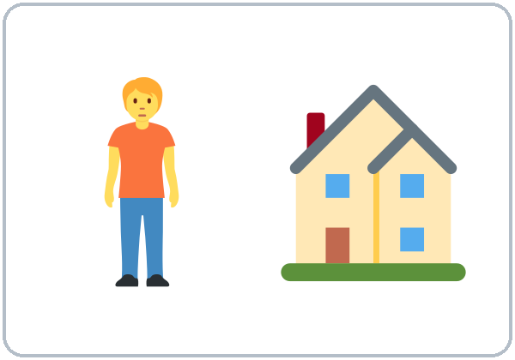  ★ live (I live on…) | 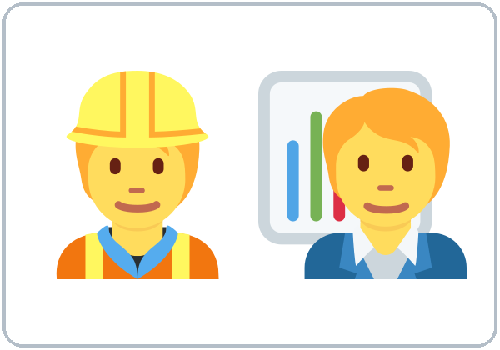  ★ work
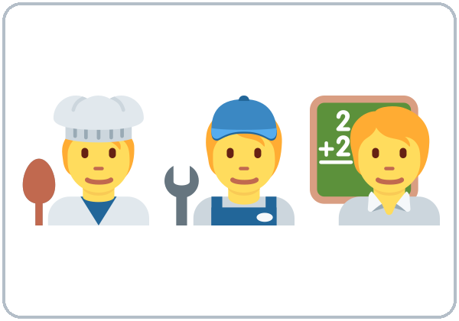  ★ job | 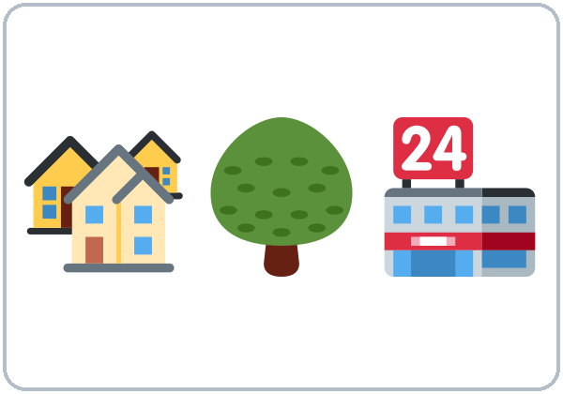  neighborhood | 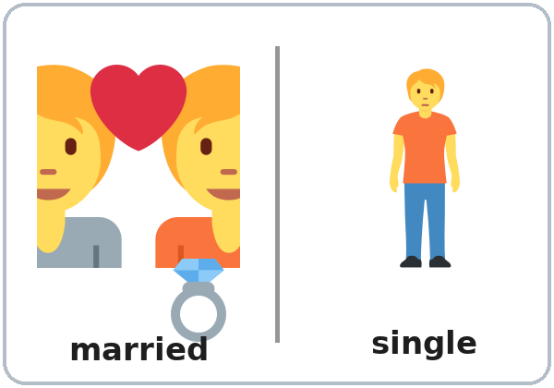  ★ married / single
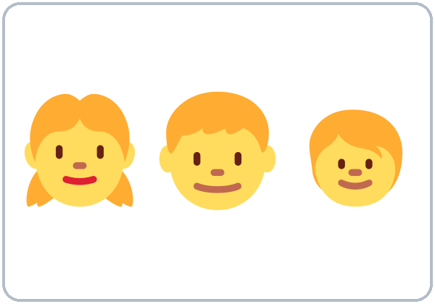  ★ kids (children) | 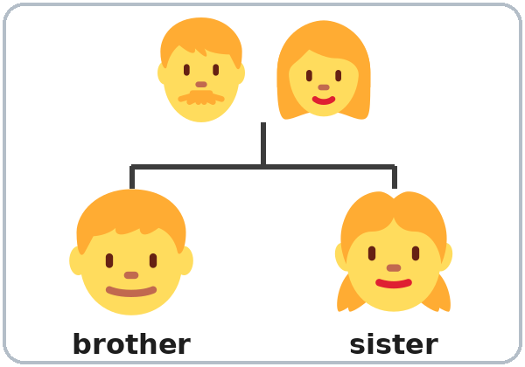  brother / sister | 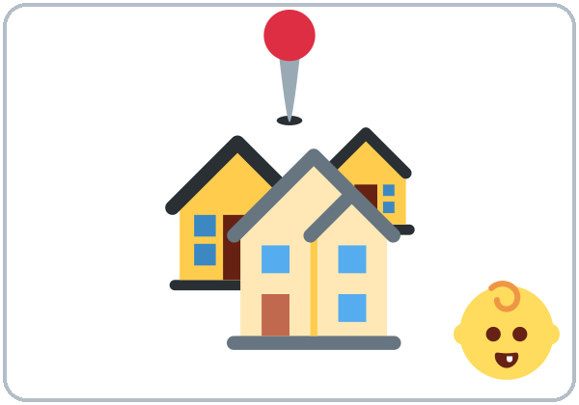  hometown
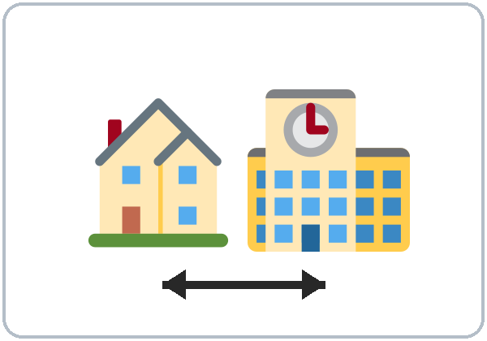  near | 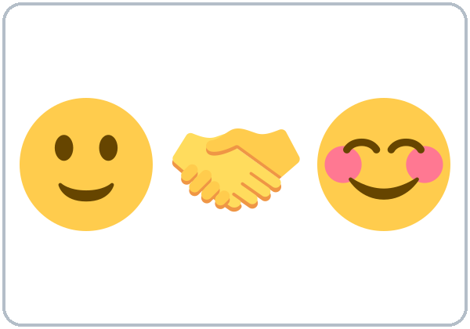  ★ Nice to meet you |   ★ What about you?

Lesson 1 (Week 1) · Listening
Listen to Rosa and Sam.
A. Listen. Check ✓ True or False.
 | True | False
1. Sam is new. | ☐ | ☐
2. Sam is from Colombia. | ☐ | ☐
3. Rosa lives on Pine Street. | ☐ | ☐
4. Sam works at a bakery. | ☐ | ☐
5. Rosa has two daughters. | ☐ | ☐

B. Listen again. Circle the answer.
1. Sam is a cook / driver / teacher.
2. Rosa starts work at 5:00 / 7:00 / 9:00.
3. Sam lives with his wife / brother / sister.
C. Listen again. Write are or do.
1. Where ______ you from?
2. Where ______ you live?
3. ______ you work near here?
4. ______ you married?
Lesson 1 (Week 1) · Grammar
Grammar Box 1: Questions with be (am / is / are)
Choose one word from each column. Read across.
QUESTION |  |  |  | ANSWER
Are | you | from Mexico?  married?  new here? |  | Yes, | I | am.
Are | you | from Mexico?  married?  new here? |  | No, | I'm | not.
Is | he  she | a cook?  from Peru?  married? |  | Yes, | he  she | is.
Is | he  she | a cook?  from Peru?  married? |  | No, | he  she | isn't.

Grammar Box 2: Questions with do / does
QUESTION |  |  |  | ANSWER
Do | you | live here?  work near here?  have kids? |  | Yes, | I | do.
Do | you | live here?  work near here?  have kids? |  | No, | I | don't.
Does | he  she | live here?  work at night?  have kids? |  | Yes, | he  she | does.
Does | he  she | live here?  work at night?  have kids? |  | No, | he  she | doesn't.

Grammar Box 3: Wh- questions
QUESTION |  |  |  |  | ANSWER
Where | are | you | from? |  | I'm | from | Honduras.  Colombia.  Mexico.
Where | do | you | live? |  | I | live | on Pine Street.  near the park.
Where | do | you | work? |  | I | work | at a hotel.  at a bakery.
What | do | you | do? |  | I'm | a | cook.  driver.  teacher.

Questions and answers
Q: How do I make a question in English?
A: Put a helper word at the front: am / is / are or do / does.
Q: When do I use am / is / are?
A: With where you're from, age, job title, feelings, married/single, and places. Look at Box 1.
Q: When do I use do / does?
A: With action verbs like live, work, have, like, speak. Look at Box 2.
Q: What order do the words go in?
A: Question word → helper → person → the rest. Look at Box 3.
Q: How do I give a short answer?
A: Use the same helper as the question. Are you…? → Yes, I am. Do you…? → Yes, I do.
Q: Can I use do and are together?
A: No, never. ✗ Do you are married? ✓ Are you married?
Q: How do I say my age?
A: With be: I'm 35. (not I have 35 years)
Common mistakes
✗ Don't say | ✓ Say
Where you are from? | Where are you from?
Where you live? | Where do you live?
Do you are married? | Are you married?
I have 35 years. | I'm 35.
Is from Peru. | She's from Peru.
Yes, I live. | Yes, I do.

Nota para hispanohablantes: En español decimos «¿Dónde vives?» sin palabra extra. En inglés la pregunta necesita do/does o am/is/are al principio: Where do you live? La edad usa be: I'm 35 (no «I have 35 years»). Y siempre usa la persona: She's from Peru (no «Is from Peru»).

Tip for speakers of other languages: If your language makes questions with only your voice, or puts the question word at the end, remember: English needs a helper word (do / are) at the beginning.

Lesson 1 (Week 1) · Homework
Homework (10 minutes). Bring it next week!
1. Write 5 questions for a friend, family member, or coworker: 3 with do/does and 2 with am/is/are.
2. Write their answers (in English!).
3. Bonus: Ask one person your questions in English.
My homework
______________________________________________________________
______________________________________________________________
______________________________________________________________
______________________________________________________________
______________________________________________________________
______________________________________________________________
______________________________________________________________
______________________________________________________________
Lesson 2 (Week 2): A Day in My Life
Student Page 2 · Week 2
Name: ______________________________ Date: ________________
New Words
Look. Listen. Repeat. ★ = most important words.
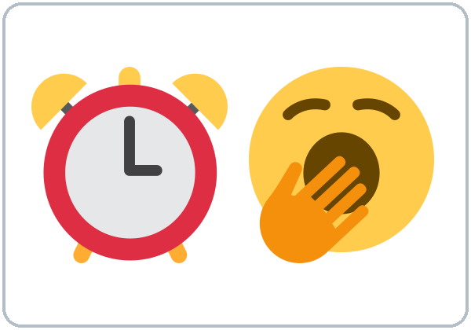  ★ get up | 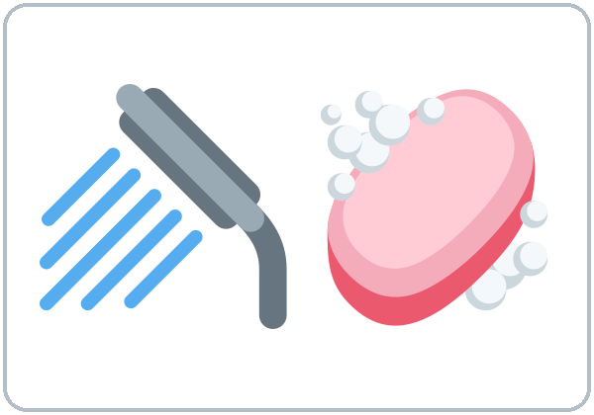  ★ take a shower | 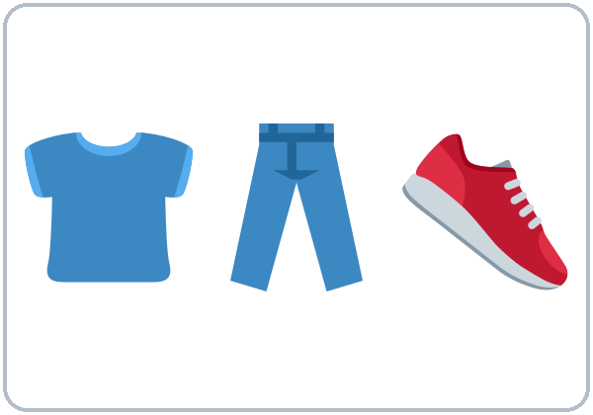  get dressed | 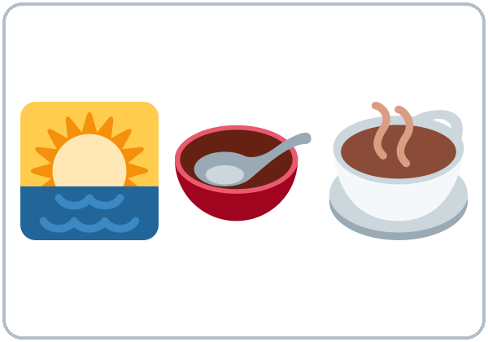  ★ have breakfast
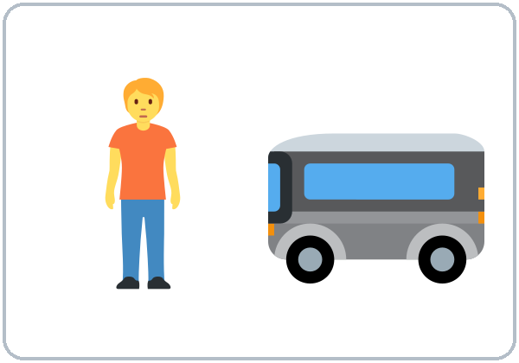  ★ take the bus | 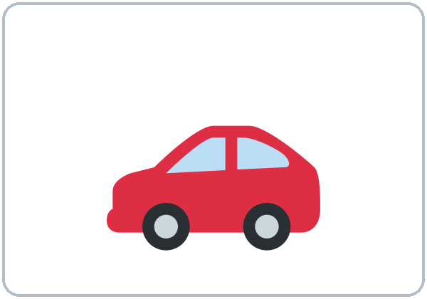  drive | 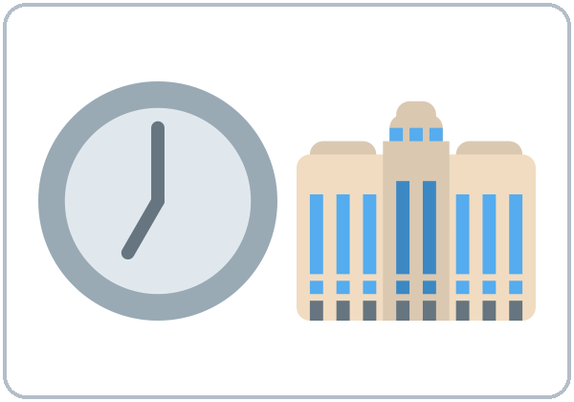  ★ start work | 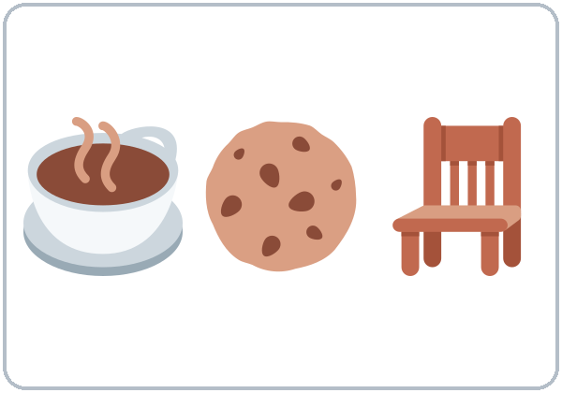  take a break
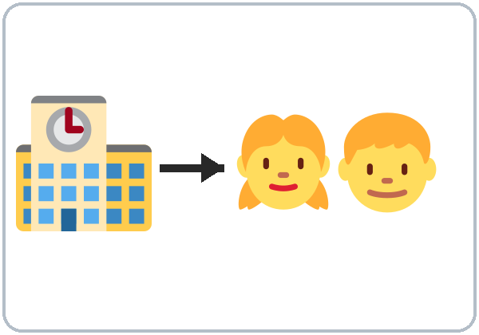  pick up the kids | 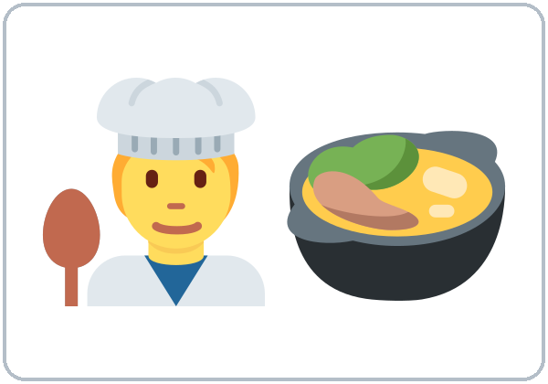  ★ cook dinner | 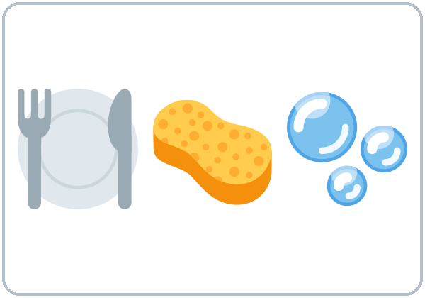  do the dishes | 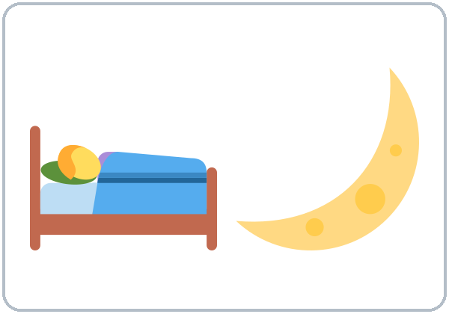  ★ go to bed
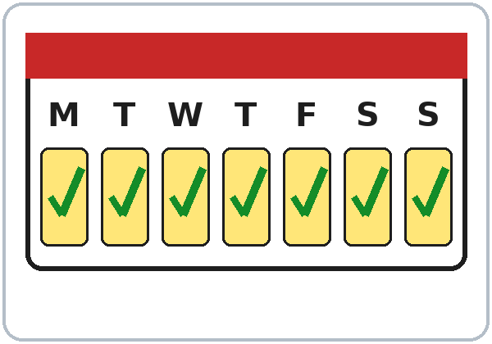  ★ every day | 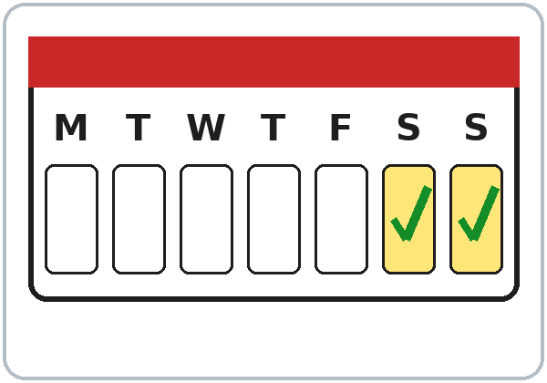  on weekends |   in the morning | 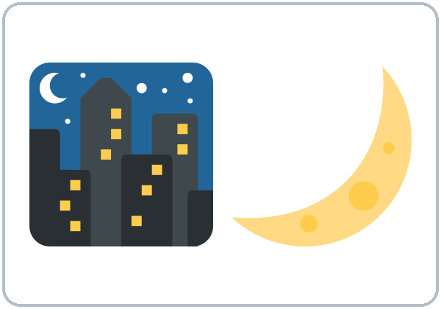  at night

Lesson 2 (Week 2) · Listening
Listen to Ana and Marco.
A. Listen. Circle the time.
1. Marco gets up at 5:30 / 6:30 / 7:00.
2. He starts work at 6:00 / 7:00 / 8:00.
3. He picks up the kids at 3:00 / 3:30 / 4:30.
4. On Sundays he sleeps until 8:00 / 9:00 / 10:00.
B. Listen again. Who does it? Check ✓.
 | Marco | His wife
works at the hospital | ☐ | ☐
drives | ☐ | ☐
works at night | ☐ | ☐
picks up the kids | ☐ | ☐
cooks dinner | ☐ | ☐

C. Listen again. Write the missing word.
1. My wife ________. She has the car.
2. She ________ at a restaurant.
3. I ________ pick them up at three thirty.
4. On Sundays, I ________ get up early.
Lesson 2 (Week 2) · Grammar
Grammar Box 1: Yes/No questions
Choose one word from each column. Read across.
QUESTION |  |  |  | ANSWER
Do | you  they | work?  drive?  cook? |  | Yes, | I  we  they | do.
Do | you  they | work?  drive?  cook? |  | No, | I  we  they | don't.
Does | he  she  it | work?  drive?  cook? |  | Yes, | he  she  it | does.
Does | he  she  it | work?  drive?  cook? |  | No, | he  she  it | doesn't.

Answer about yourself: Do you work? → Yes, I do.
Grammar Box 2: What time…? and How often…?
QUESTION |  |  |  |  | ANSWER
What time | do | you | get up?  start work? |  | I | get up  start work | at 6:00.  at 7:30.
What time | does | he  she | get up?  start work? |  | He  She | gets up  starts work | at 6:00.  at 7:30.
How often | do | you | cook?  drive? |  | I | always  sometimes  never | cook.  drive.
How often | does | he  she | cook?  drive? |  | He  She | always  sometimes  never | cooks.  drives.

Sentences: positive and negative
Person | ✔ Positive | ✘ Negative
I / You / We / They | I work. | I don't work.
He / She / It | She works. | She doesn't work.

Questions and answers
Q: When do I use the simple present?
A: For routines and facts: things that happen again and again. I work at a hospital. I get up at 6.
Q: When do I add -s to the verb?
A: Only with he, she, it (one other person or thing). She works. Marco takes the bus.
Q: How do I spell the -s?
Rule | Examples
Most verbs: +s | work → works, play → plays
-sh, -ch, -s, -x, -o: +es | watch → watches, go → goes, do → does
consonant + y: -ies | study → studies
Special | have → has

Q: After doesn't or does, does the verb keep the -s?
A: No. The "one -s" rule: the -s moves to does. She works. → She doesn't work. → Does she work?
Q: How do I say how often?
always 100% | usually | often | sometimes | rarely | never 0%
I always take the bus. |  |  | She sometimes cooks. |  | He never drives.

Q: Where do always, usually, never… go?
A: Before the main verb: I usually take the bus. But after be: He is always late. Longer phrases go at the end: I cook every day.
Common mistakes
✗ Don't say | ✓ Say
She work at a store. | She works at a store.
He doesn't works. | He doesn't work.
Does she works? | Does she work?
I go always to the park. | I always go to the park.
I am work at a restaurant. | I work at a restaurant.
He have two kids. | He has two kids.

Nota para hispanohablantes: En español el verbo cambia con cada persona (trabajo, trabajas, trabaja). En inglés solo cambia con he/she/it: agrega -s (she works). ¡No olvides la -s! Y no uses am con otro verbo: I work (no «I am work»).

Tip for speakers of other languages: If your language has no verb endings, make a habit: he / she / it = -s. Circle every -s in your homework.

Lesson 2 (Week 2) · Homework
Homework (10 minutes)
1. Write 6 sentences about the routine of someone you know (My sister gets up at 6. She always takes the bus…). Use at least 3 frequency words.
2. Listen to the audio again at home (scan the QR code or use the link) and repeat Marco's lines.
My homework
______________________________________________________________
______________________________________________________________
______________________________________________________________
______________________________________________________________
______________________________________________________________
______________________________________________________________
______________________________________________________________
______________________________________________________________
Lesson 3 (Week 3): Free Time
Student Page 3 · Week 3
Name: ______________________________ Date: ________________
New Words
Look. Listen. Repeat. ★ = most important words.
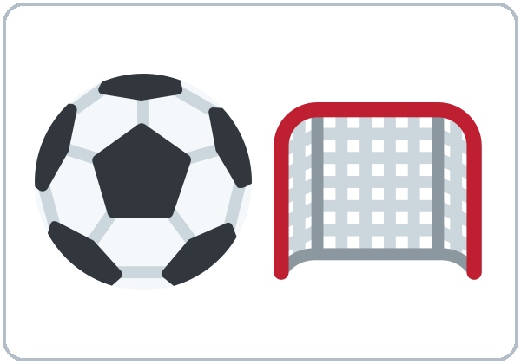  ★ soccer |   ★ cooking | 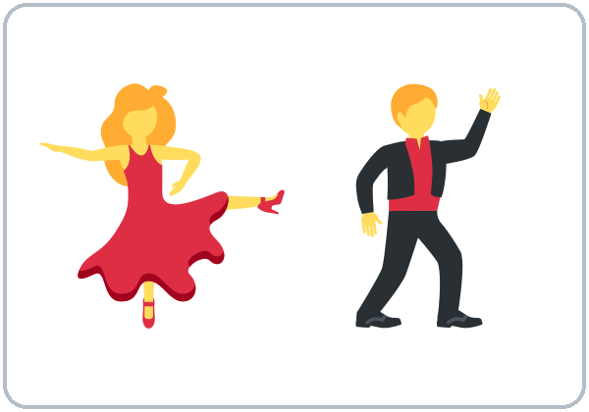  ★ dancing |   ★ shopping
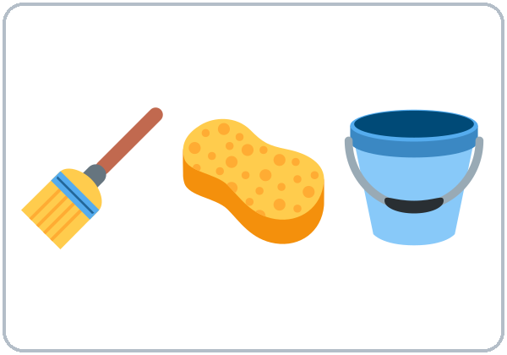  ★ cleaning | 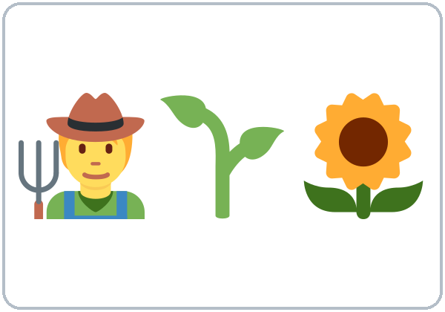  gardening | 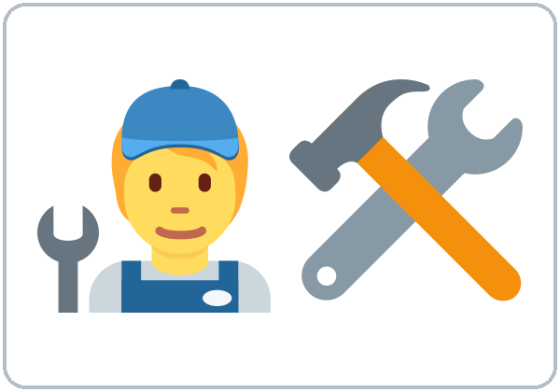  fixing things |   ★ watching TV / movies
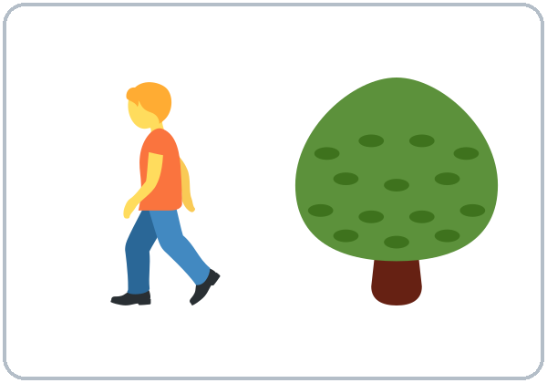  walking | 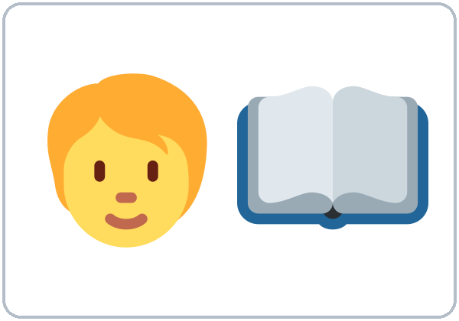  reading | 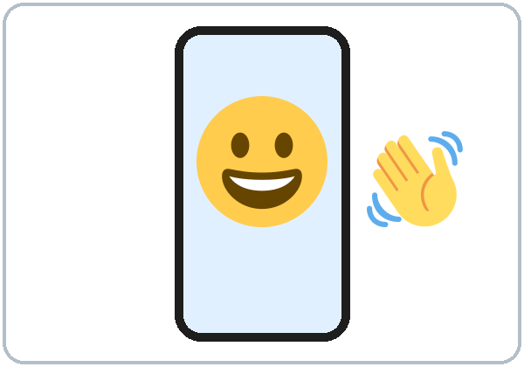  video calls | 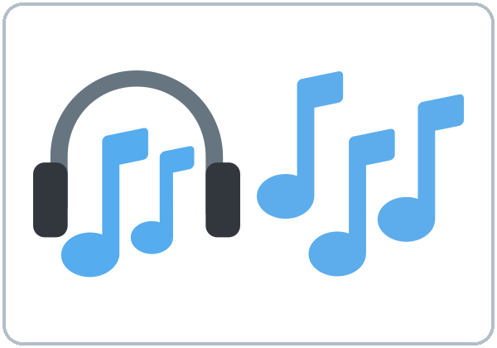  ★ music
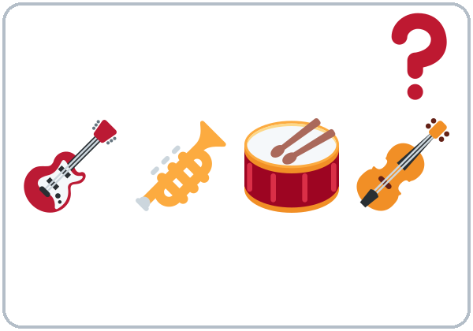
★ What kind of (music)?

Music examples: salsa, cumbia, pop, rock (no pictures; ask learners for their favorite kinds).
Lesson 3 (Week 3) · Listening
Listen to Kim and Carlos.
A. Listen. ✓ = likes / doesn't mind, ✗ = doesn't like / hates. Some boxes stay empty.
 | Kim | Carlos
playing soccer
watching soccer on TV
cooking
dancing
rock music
cleaning

B. Listen again. Circle the reply you hear.
1. Kim: "I like dancing." → Carlos: Me too! / Me neither!
2. Kim: "I don't like rock music." → Carlos: Me too. / Me neither.
C. Listen again. Write the missing word.
1. Kim goes dancing on ____________.
2. Carlos plays soccer every ____________.
3. Kim: "Shopping? I don't ________ it."
Lesson 3 (Week 3) · Grammar
Grammar Box 1: Do you like…?
Choose one word from each column. Read across.
QUESTION |  |  |  |  | ANSWER
Do | you | like | soccer?  cooking?  dancing? |  | Yes, I do. | I love it.  I like it.
 |  |  |  |  | It's OK. | I don't mind it.
 |  |  |  |  | No, I don't. | I don't like it.  I hate it.
Does | he  she | like | shopping?  cleaning? |  | Yes, he/she does. | He/She loves it.
 |  |  |  |  | No, he/she doesn't. | He/She hates it.

Grammar Box 2: What…? questions
QUESTION |  |  |  |  | ANSWER
What | do | you | like doing?  love doing?  hate doing? |  | I | like  love  hate  don't mind | cooking.  dancing.  cleaning.
What kind of | music  food  movies | do | you like? |  | I like | salsa.  cumbia.  pop.

Grammar Box 3: Agree or disagree
YOU SAY |  |  |  | YOUR PARTNER SAYS
I | like  love | coffee.  dancing.  soccer. |  | 👍 Me too! | 👎 Really? I don't.
I | don't like  hate | coffee.  dancing.  soccer. |  | 👍 Me neither! | 👎 Oh, I do!

Questions and answers
Q: How strong are these words?
❤❤ love | ❤ like | 😐 don't mind | 👎 don't like | ✘ hate

Q: What can I say after like, love, hate, don't mind?
A: A thing (pizza, soccer) or an activity (verb + -ing: cooking, dancing).
Q: Why do I add -ing?
A: -ing turns an action into an activity, like a "thing." (I like to cook is also correct, but in this class we practice -ing.)
Q: How do I spell the -ing?
Rule | Examples
Most verbs: +ing | cook → cooking, play → playing
Silent e: drop it | dance → dancing, make → making
Short verb (1 vowel + 1 consonant): double the last letter | swim → swimming, shop → shopping

Q: Me too or Me neither?
A: Look at your partner's sentence. Positive (I like…) → Me too. Negative (I don't like…) → Me neither. Look at Box 3.
Q: Where do a lot and very much go?
A: At the end: I like soccer a lot.
Common mistakes
✗ Don't say | ✓ Say
I like cook. | I like cooking.
I am like pizza. | I like pizza.
I don't like coffee. / Me too. | … / Me neither.
She like dancing. | She likes dancing.
I like very much soccer. | I like soccer a lot.
I don't like nothing. | I don't like anything.

Nota para hispanohablantes: «Me gusta la música» → en inglés la persona va primero: I like music. Para actividades usa -ing: I like cooking (no «I like cook»). Usa una sola negación: I don't like anything (no «I don't like nothing»). Me too = «yo también»; Me neither = «yo tampoco».

Tip for speakers of other languages: an -ing word can be a "thing": Cooking is fun. I love dancing.

Lesson 3 (Week 3) · Homework
Homework (10–15 minutes)
1. Ask 3 people (family, friends, coworkers): What do you like doing? What do you hate doing? If they don't speak English, ask in your language but write in English.
2. Write 6 sentences: My son loves playing video games. My wife hates cleaning…
My homework
______________________________________________________________
______________________________________________________________
______________________________________________________________
______________________________________________________________
______________________________________________________________
______________________________________________________________
______________________________________________________________
______________________________________________________________
Lesson 4 (Week 4): Right Now
Student Page 4 · Week 4
Name: ______________________________ Date: ________________
New Words
Look. Listen. Repeat. ★ = most important words.
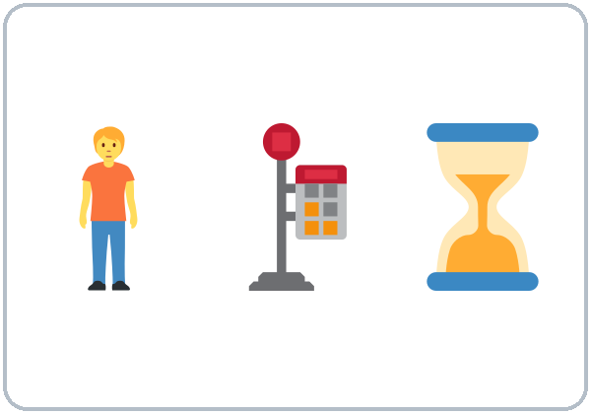  ★ waiting (for the bus) | ★ cooking (now) | 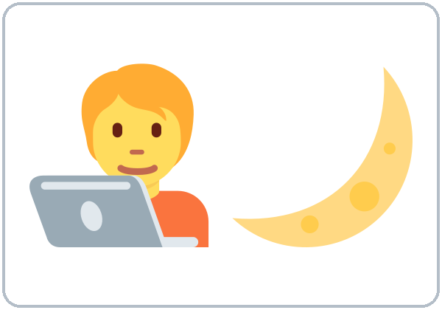  ★ working late
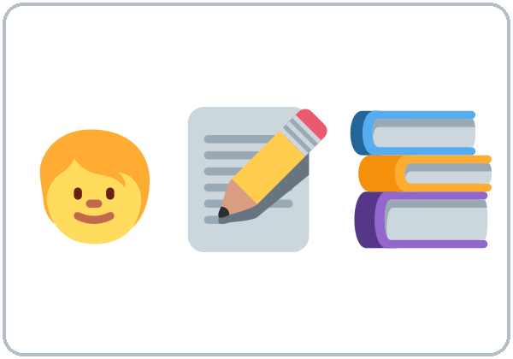  ★ doing homework | ★ watching TV |   looking at
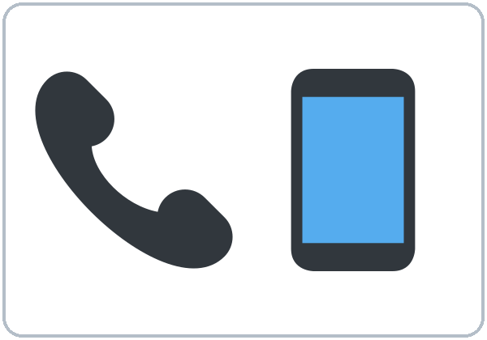  ★ calling (on the phone) | 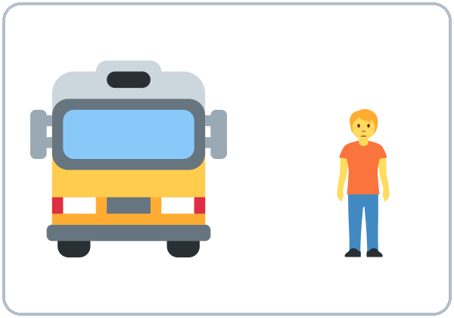  coming (The bus is coming.) | 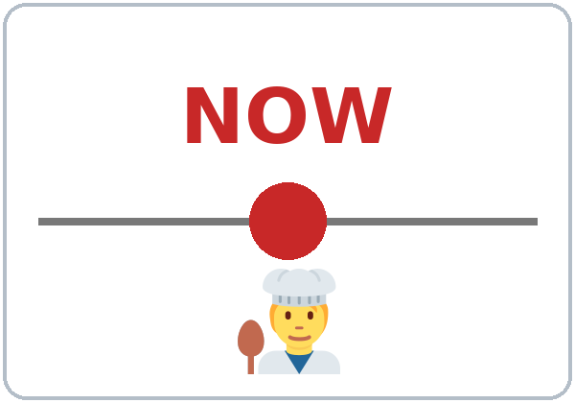  ★ right now
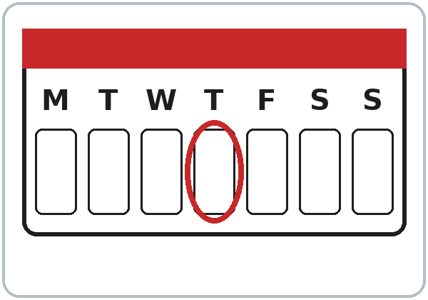  today | 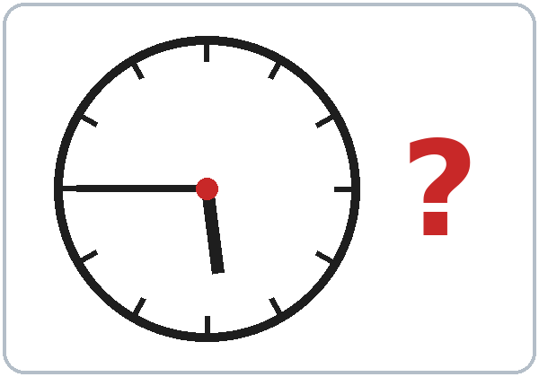  ★ What time is it? (It’s 5:45.)

Lesson 4 (Week 4) · Listening
Listen to Rosa and Sam on the phone.
A. Listen. Circle the answer.
1. Sam is cooking / sleeping / driving.
2. Rosa is at home / at the bus stop / at work.
3. It's 5:15 / 5:45 / 6:15.
B. Listen again. Check ✓ True or False.
 | True | False
1. Rosa's daughters are doing their homework. | ☐ | ☐
2. Rosa's husband is watching TV. | ☐ | ☐
3. Rosa is coming to class tonight. | ☐ | ☐
4. Sam doesn't have the homework page. | ☐ | ☐

C. Listen again. Write the missing word.
1. I'm ____________ dinner.
2. What ________ you doing?
3. They're ____________ their homework.
4. The bus ________ coming now.
Lesson 4 (Week 4) · Grammar
Grammar Box 1: What are you doing?
Choose one word from each column. Read across.
QUESTION |  |  |  |  | ANSWER
What | are | you | doing? |  | I'm | cooking.  waiting for the bus.  watching TV.
What | is | he  she | doing? |  | He's  She's | working late.  calling a friend.
What | are | they | doing? |  | They're | doing homework.  playing.

Grammar Box 2: Yes/No questions
QUESTION |  |  |  | ANSWER
Are | you | coming?  working today? |  | Yes, | I | am.
Are | you | coming?  working today? |  | No, | I'm | not.
Is | he  she | cooking?  working late? |  | Yes, | he  she | is.
Is | he  she | cooking?  working late? |  | No, | he  she | isn't.
Are | they | sleeping?  doing homework? |  | Yes, | they | are.
Are | they | sleeping?  doing homework? |  | No, | they | aren't.

Grammar Box 3: Telling time
QUESTION |  |  |  | ANSWER
What time | is | it? |  | It's | five forty-five.  six o'clock.  seven fifteen.

Sentences: positive and negative
Person | ✔ Positive | ✘ Negative
I | I'm cooking. | I'm not cooking.
He / She / It | She's waiting. | She isn't waiting.
You / We / They | They're playing. | They aren't playing.

Questions and answers
Q: How do I talk about something happening right now?
A: Use am / is / are + verb-ing. I'm cooking. She's waiting.
Q: Can I leave out am / is / are?
A: No. ✗ I cooking. ✓ I'm cooking.
Q: What's the difference between I cook and I'm cooking?
A: I cook = every day, a routine. I'm cooking = right now.
RIGHT NOW: am/is/are + -ing | EVERY DAY: simple present
I'm cooking right now. | I cook every day.
She's working late today. | She works at a hotel.
Words: now, right now, today, at the moment | Words: every day, usually, always, on Mondays

Q: Is What do you do? the same as What are you doing?
A: No! What do you do? = What's your job? What are you doing? = What are you doing right now?
Q: How do I spell the -ing?
A: The same rules as Lesson 3: cook → cooking, make → making, shop → shopping.
Common mistakes
✗ Don't say | ✓ Say
I cooking now. | I'm cooking now.
She is work today. | She is working today.
What you are doing? | What are you doing?
I'm cooking every day. | I cook every day.

Nota para hispanohablantes: En español usamos el presente para «ahora» («¿Qué haces?»). En inglés, para ahora mismo usamos am/is/are + -ing: What are you doing? — I'm cooking. ¡No olvides am/is/are! (no «I cooking»). Cuidado: What do you do? = «¿En qué trabajas?», y What are you doing? = «¿Qué estás haciendo?»

Tip for speakers of other languages: If your language has no special "now" form, remember the formula: am / is / are + verb-ing = happening now.

Lesson 4 (Week 4) · Homework
Homework (10 minutes)
At 3 different times this week, write what you and your family are doing:
It's 8:00 PM. I'm washing the dishes. My son is watching TV. My husband is working.
Bring your 3 "photos in words" next week. (Lesson 5's Opening Talk uses them!)
My homework
______________________________________________________________
______________________________________________________________
______________________________________________________________
______________________________________________________________
______________________________________________________________
______________________________________________________________
______________________________________________________________
______________________________________________________________
Lesson 5 (Week 5): Last Weekend
Student Page 5 · Week 5
Name: ______________________________ Date: ________________
New Words
Look. Listen. Repeat. ★ = most important words.
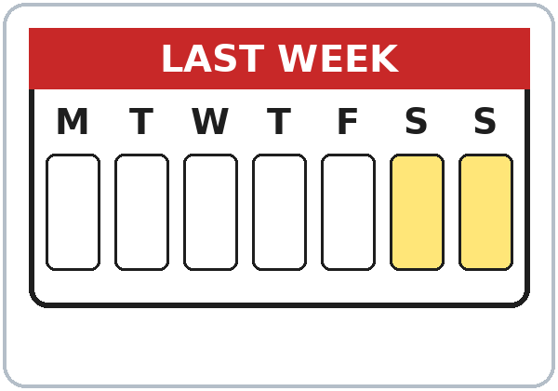  ★ last weekend | 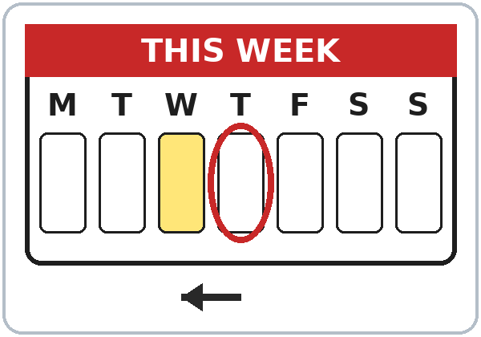  ★ yesterday | 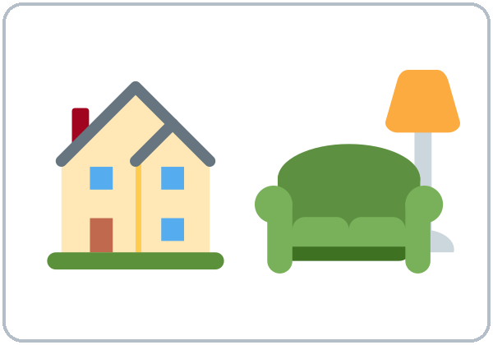  ★ stayed home | 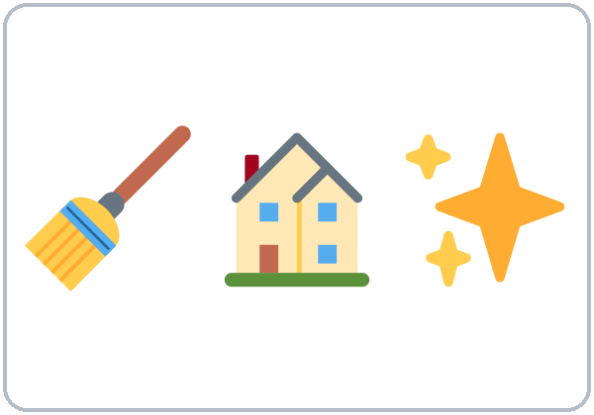  ★ cleaned the house
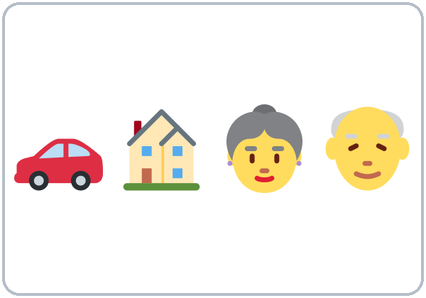  ★ visited family |   ★ watched a movie |   cooked | 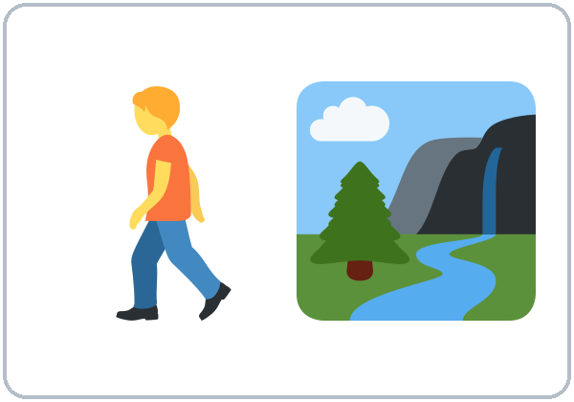  walked (in the park)
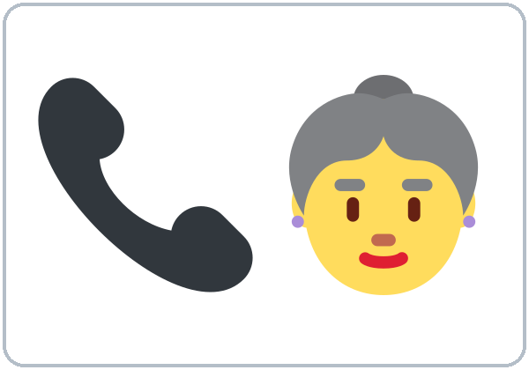  called (my mom) | 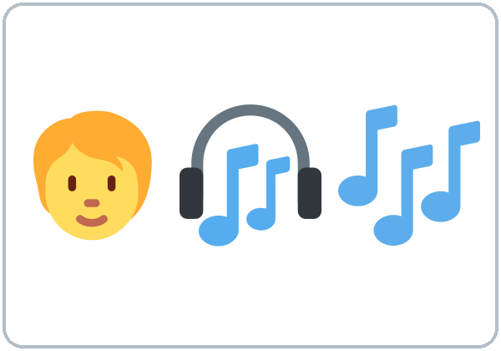  listened to music | 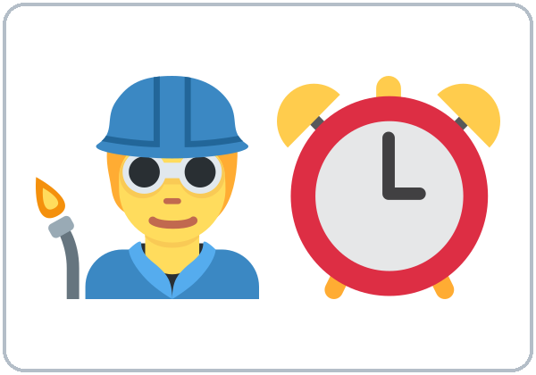  ★ worked |   relaxed
  fun |   boring | 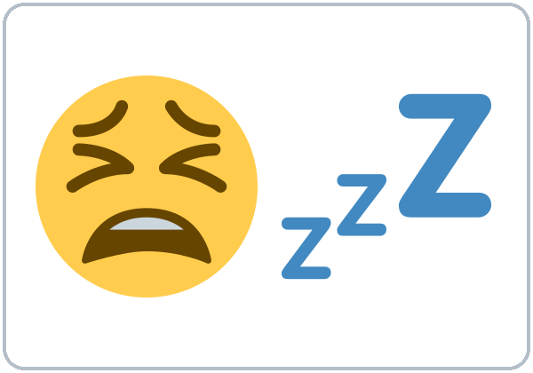  ★ tired | 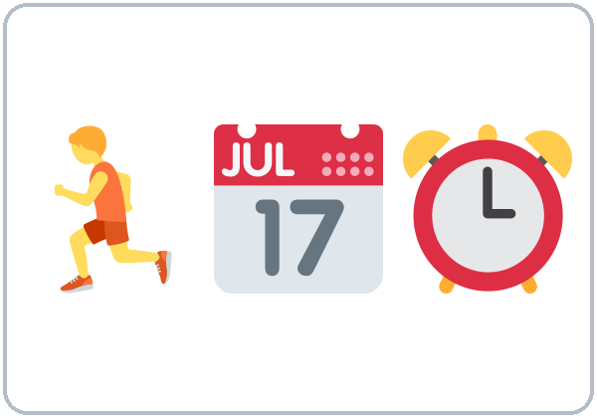  busy

Lesson 5 (Week 5) · Listening
Listen to Kim and Marco.
A. Listen. Who did it? Check ✓.
 | Marco | Kim
visited his sister | ☐ | ☐
worked all day | ☐ | ☐
played soccer | ☐ | ☐
cleaned the house | ☐ | ☐
watched a movie | ☐ | ☐
cooked a big lunch | ☐ | ☐

B. Listen again. Circle the answer.
1. Marco's weekend was great / boring / terrible.
2. Kim's weekend was fun / boring / great.
3. Kim's movie was good / funny / terrible.
4. Kim stopped the movie after 10 / 20 / 30 minutes.
C. Listen again. Write the missing word.
1. It ________ great, thanks.
2. We ________ a big lunch together.
3. ________ you tired this morning?
4. On Sunday, I ________ the house.
Lesson 5 (Week 5) · Grammar
Grammar Box 1: How was…? and Was it…?
Choose one word from each column. Read across.
QUESTION |  |  |  | ANSWER
How | was | your weekend?  the party?  the movie? |  | It | was | great.  fun.  boring.  terrible.
Was | it  the food | good?  fun?  expensive? |  | Yes, | it | was.
Was | it  the food | good?  fun?  expensive? |  | No, | it | wasn't.

Grammar Box 2: Were you…?
QUESTION |  |  |  | ANSWER
Were | you | busy?  tired?  at home? |  | Yes, | I | was.
Were | you | busy?  tired?  at home? |  | No, | I | wasn't.
Was | he  she | busy?  tired?  at work? |  | Yes, | he  she | was.
Was | he  she | busy?  tired?  at work? |  | No, | he  she | wasn't.
Were | they | busy?  at home? |  | Yes, | they | were.
Were | they | busy?  at home? |  | No, | they | weren't.

Grammar Box 3: What did you do?
QUESTION |  |  |  |  | ANSWER
What | did | you  he  she | do? |  | I  He  She | cleaned  watched  visited  played | the house.  a movie.  my family.  soccer.

Add a time: … last weekend? / … on Saturday? / … yesterday?
Sentences: was and were
Person | ✔ Positive | ✘ Negative
I / He / She / It | I was busy. | I wasn't busy.
You / We / They | They were busy. | They weren't busy.

Questions and answers
Q: When do I use was and were?
A: They are the past of be. am / is → was. are → were. I'm tired today. → I was tired yesterday.
Q: How do I make other verbs past?
A: Most verbs add -ed: work → worked, clean → cleaned, watch → watched.
Q: Do I add -s for he or she in the past?
A: No. The past is the same for everyone: I worked. She worked. They worked.
Q: How do I spell the -ed?
Rule | Examples
Most verbs: +ed | clean → cleaned, watch → watched
Ends in e: +d | dance → danced, live → lived
consonant + y: -ied | study → studied, try → tried
Short verb (1 vowel + 1 consonant): double | stop → stopped, plan → planned

Q: How do I say the -ed?
A: Three ways. /t/ worked, /d/ played, /ɪd/ visited. You hear an extra syllable only after t or d.
Q: What does What did you do? mean?
A: It asks about activities in the past. Answer with an -ed verb: I cleaned the house. (Lesson 6 explains did.)
Common mistakes
✗ Don't say | ✓ Say
I was clean the house. | I cleaned the house.
She were tired. | She was tired.
We was busy. | We were busy.
Yesterday I work. | Yesterday I worked.
I studyed. | I studied.
The movie was bored. | The movie was boring.

Nota para hispanohablantes: En español «estuve / estaba / fui» → en inglés was (I, he, she, it) o were (you, we, they). Para otros verbos, agrega -ed: I worked, she worked (igual para todos, ¡sin -s!). No uses was con otro verbo: I cleaned (no «I was clean»). Y cuidado: la película es boring (aburrida); la persona está bored (aburrida).

Tip for speakers of other languages: If your language doesn't change the verb for the past, use two signals: a time word and -ed: Yesterday I worked.

Lesson 5 (Week 5) · Homework
Homework (10 minutes)
1. Write 6 sentences about your last weekend: 3 with was / were and 3 with -ed verbs (On Saturday I was tired. I cleaned the house…).
2. Ask a family member or friend: How was your weekend? Write their answer in English.
3. Bonus: Circle every -ed in your sentences and say each one aloud.
My homework
______________________________________________________________
______________________________________________________________
______________________________________________________________
______________________________________________________________
______________________________________________________________
______________________________________________________________
______________________________________________________________
______________________________________________________________
Lesson 6 (Week 6): My Story
Student Page 6 · Week 6
Name: ______________________________ Date: ________________
New Words
Look. Listen. Repeat. ★ = most important words.
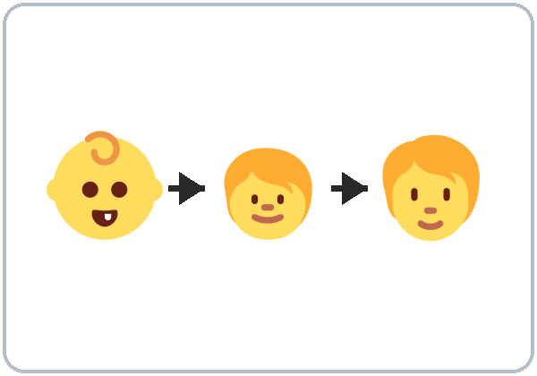  ★ grew up | 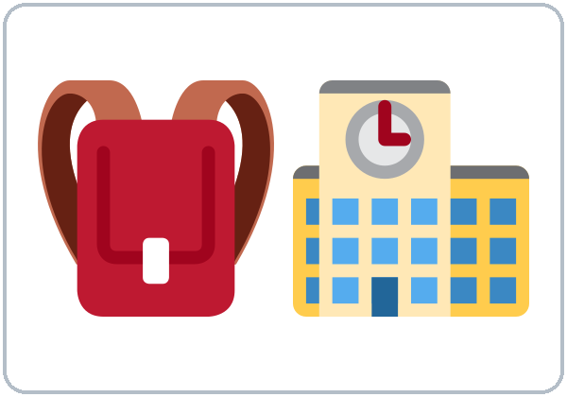  ★ went to school | 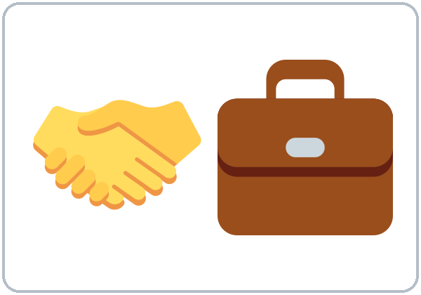  ★ got a job |   first job
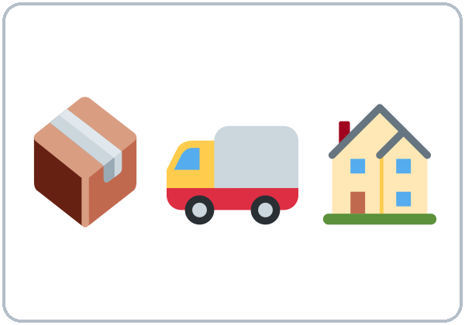  ★ moved (to a new city) | 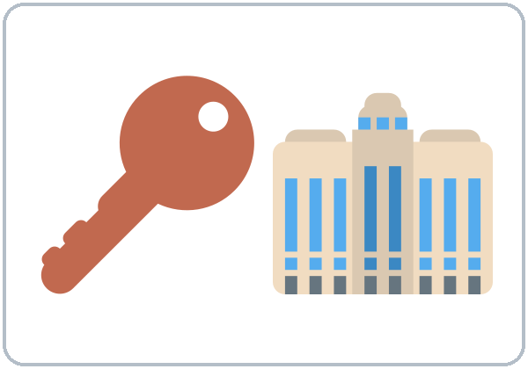  found an apartment | 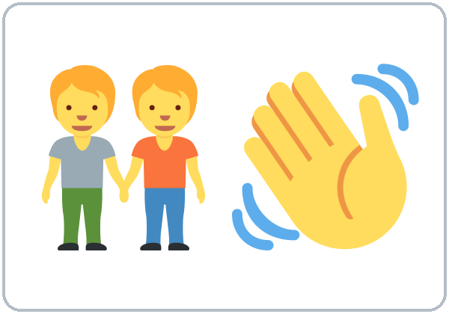  ★ met (a friend) | 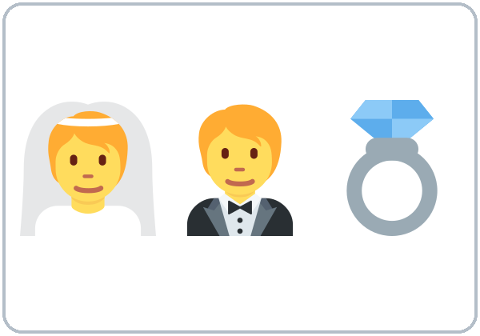  got married
  had a baby | 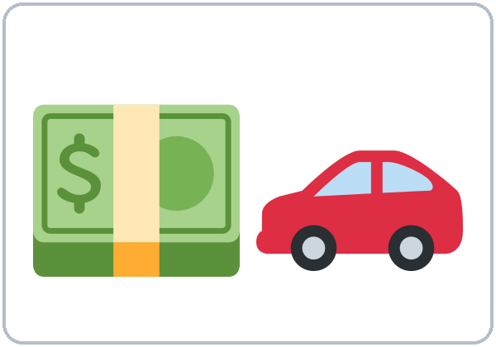  bought (a car) |   learned (English) |   ★ felt nervous
  ★ felt happy | 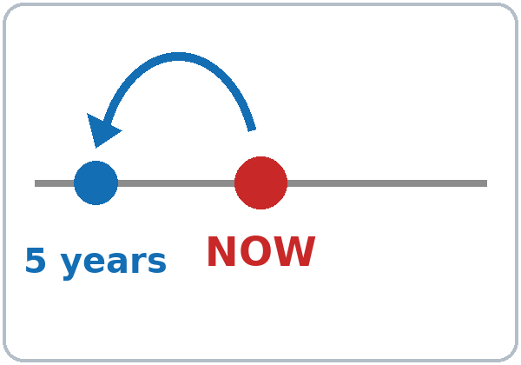  ★ ago (5 years ago)

Lesson 6 (Week 6) · Listening
Listen to Sam and Ana.
A. Listen. Put Ana's story in order. Write 1–5.
 | Order
She got married. | ____
She moved to this city. | ____
She grew up in a small town. | ____
She got her first job. | ____
She met her husband. | ____

B. Listen again. Check ✓ True or False.
 | True | False
1. Ana grew up in a big city. | ☐ | ☐
2. She moved here eight years ago. | ☐ | ☐
3. She spoke English very well. | ☐ | ☐
4. Her first job was in a coffee shop. | ☐ | ☐
5. Ana has a little girl. | ☐ | ☐

C. Listen again. Write the missing word.
1. I ________ up in a small town by the sea.
2. I ________ here eight years ago.
3. No, I ________. I only knew three words.
4. I ________ nervous every day.
Lesson 6 (Week 6) · Grammar
Grammar Box 1: Did you…?
Choose one word from each column. Read across.
QUESTION |  |  |  | ANSWER
Did | you  he  she  they | grow up in a city?  move here?  work there? |  | Yes, | I  he  she  they | did.
Did | you  he  she  they | grow up in a city?  move here?  work there? |  | No, | I  he  she  they | didn't.

Grammar Box 2: Where…? When…? How…?
QUESTION |  |  |  |  | ANSWER
Where | did | you | grow up?  go to school? |  | I | grew up  went to school | in a small town.  in a big city.
When | did | you | move here?  get your first job? |  | I | moved here  got my first job | five years ago.  in 2019.
How | did | you | feel? |  | I | felt | nervous.  happy.  tired.

Grammar Box 3: ago
QUESTION |  |  |  |  | ANSWER
How long ago | did | you | move here?  start your job? |  | two  five  ten | days  months  years | ago.

Common irregular verbs
Now | Past | Now | Past | Now | Past
go | went | have | had | get | got
come | came | make | made | take | took
meet | met | find | found | feel | felt
buy | bought | leave | left | know | knew
grow up | grew up | see | saw | eat | ate

Sentences: positive and negative
 | ✔ Positive | ✘ Negative
regular | I moved here. | I didn't move here.
irregular | She went to school. | She didn't go to school.

Questions and answers
Q: What is an irregular verb?
A: A verb that doesn't use -ed in the past: go → went, get → got. Learn them like vocabulary.
Q: How do I make a question in the past?
A: Use did at the front: Did you move here? Where did you grow up?
Q: After did or didn't, is the verb past?
A: No. The "one past" rule: did is already past, so the verb is the base form. Did you go? (not went). I didn't go.
Q: Where does ago go?
A: After the time: five years ago, two weeks ago.
Q: Can I use did with was / were?
A: No. Were you nervous? (not Did you were nervous?)
Common mistakes
✗ Don't say | ✓ Say
Did you went to school? | Did you go to school?
I didn't went. | I didn't go.
I goed to the store. | I went to the store.
Ago five years. | Five years ago.
She get married in 2020. | She got married in 2020.
Did you were nervous? | Were you nervous?

Nota para hispanohablantes: «Hace cinco años» → five years ago (ago va al final). Para preguntar en pasado usa did + verbo base: Did you go? (no «Did you went?»). Para negar: I didn't go. Muchos verbos comunes son irregulares: go → went, have → had, get → got. ¡Apréndelos como vocabulario!

Tip for speakers of other languages: Make flash cards: go on one side, went on the other. Practice 5 cards every day.

Lesson 6 (Week 6) · Homework
Homework (15 minutes)
1. Draw a timeline of your life with 5 points (true or invented).
2. Write your story in 6–8 sentences. Use at least 4 irregular verbs and ago (I grew up in… I moved here six years ago…).
3. Bonus: Ask a family member 3 questions with Did you…? or When did you…? Write the answers in English.
My homework
______________________________________________________________
______________________________________________________________
______________________________________________________________
______________________________________________________________
______________________________________________________________
______________________________________________________________
______________________________________________________________
______________________________________________________________
Lesson 7 (Week 7): Getting Around
Student Page 7 · Week 7
Name: ______________________________ Date: ________________
New Words
Look. Listen. Repeat. ★ = most important words.
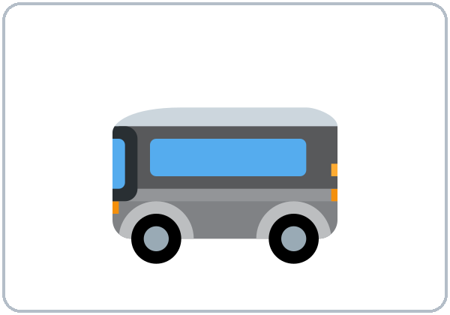  ★ by bus | ★ by car | 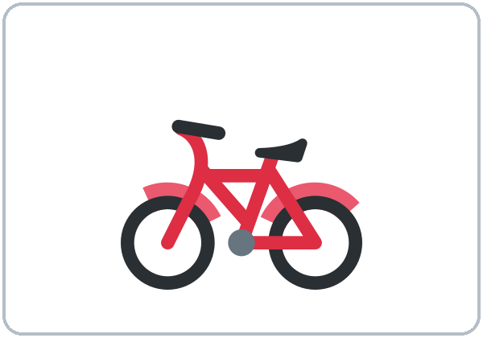  by bike | 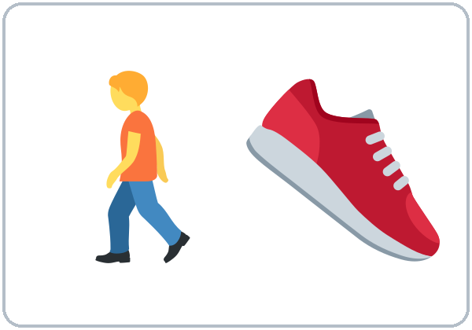  ★ on foot (walk)
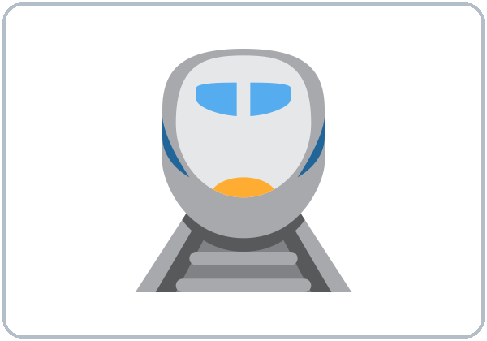  by train | 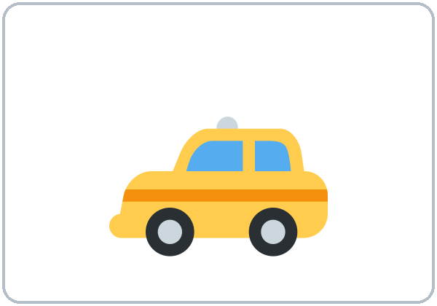  by taxi | 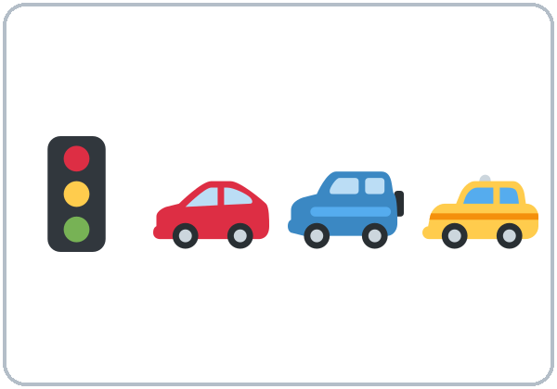  ★ traffic | 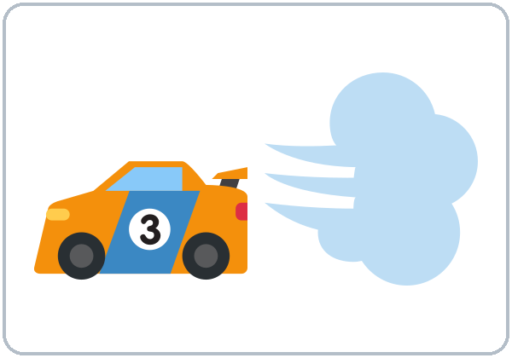  ★ fast
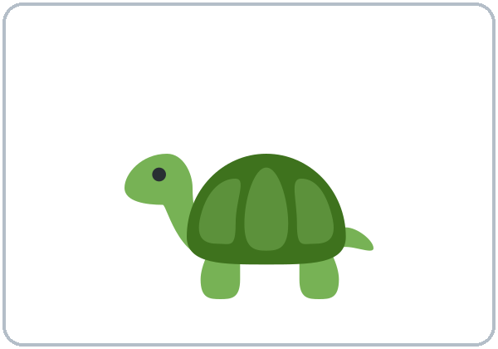  ★ slow |   ★ cheap | 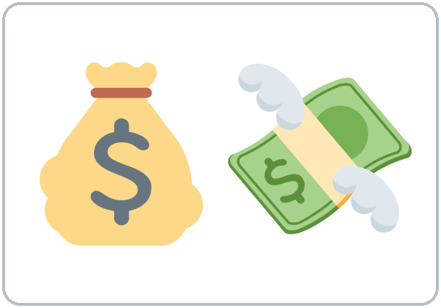  ★ expensive | 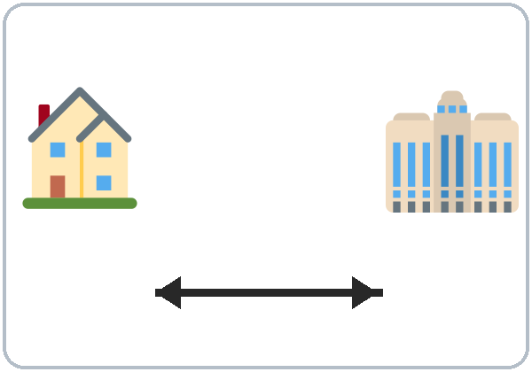  far
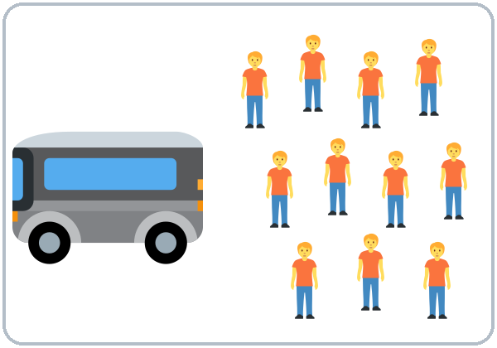  crowded | 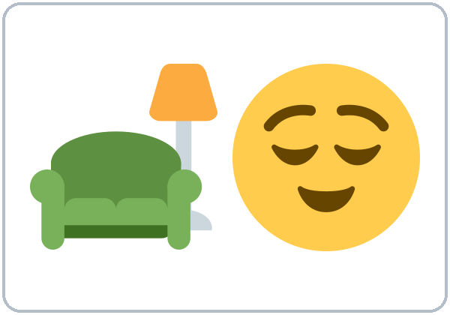  comfortable | 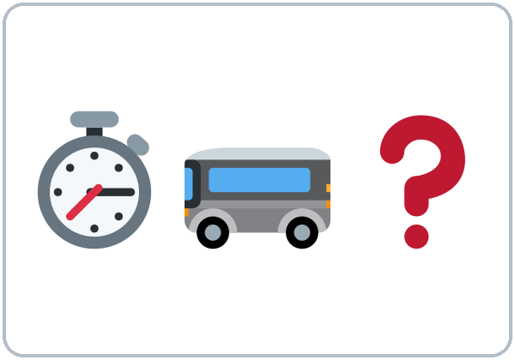  How long does it take?

Lesson 7 (Week 7) · Listening
Listen to Rosa and Carlos.
A. Listen. Circle the answer.
1. Carlos goes to work by car / by bus / by bike.
2. By car, it takes 10 / 20 / 45 minutes.
3. By bus, it takes 20 / 30 / 45 minutes.
4. Parking costs $5 / $10 / $20 a day.
B. Listen again. Which one? Check ✓.
 | Car | Bus
faster | ☐ | ☐
cheaper | ☐ | ☐
more relaxing | ☐ | ☐
slower | ☐ | ☐

C. Listen again. Write the missing word.
1. The car is ________ than the bus.
2. It's ________ relaxing than driving.
3. It ________ twenty minutes by car.
4. A bike is ________ for my health.
Lesson 7 (Week 7) · Grammar
Grammar Box 1: How do you get to…?
Choose one word from each column. Read across.
QUESTION |  |  |  |  | ANSWER
How | do | you | get to work?  get to class? |  | I | take the bus.  drive.  walk.  ride my bike.
How | does | he  she | get to work?  get to school? |  | He  She | takes the bus.  drives.  walks.

Grammar Box 2: How long does it take?
QUESTION |  |  |  |  | ANSWER
How long | does | it take | by car?  by bus?  on foot? |  | It | takes | ten minutes.  half an hour.  an hour.

Grammar Box 3: Which is…?
QUESTION |  |  | ANSWER
Which is | faster?  cheaper?  more comfortable?  better? |  | The car | is | faster  more comfortable  better
Which is | faster?  cheaper?  more comfortable?  better? |  | The bus | is | cheaper  slower  more crowded

Add than: The car is faster than the bus.
How to compare two things
Word | Rule | Example
short: fast, cheap, slow | +er | fast → faster than
ends in e: safe, nice | +r | safe → safer than
ends in y: easy, busy | -ier | easy → easier than
short, 1 vowel + 1 consonant: big, hot | double + er | big → bigger than
long: expensive, comfortable | more + word | more expensive than
irregular |  | good → better, bad → worse, far → farther

Questions and answers
Q: How do I compare two things?
A: Short words: add -er. Long words: use more. Then say than: The bus is cheaper than the car.
Q: Can I say more faster?
A: No. Use -er or more, never both: faster, more expensive.
Q: What are the special words?
A: good → better, bad → worse, far → farther.
Q: What does How long does it take? ask?
A: It asks how much time a trip needs. Answer: It takes twenty minutes.
Q: By or on?
A: by bus, by car, by train, by bike, but on foot (= walk).
Common mistakes
✗ Don't say | ✓ Say
The bus is more cheap. | The bus is cheaper.
The car is more faster. | The car is faster.
It's bigger that my house. | It's bigger than my house.
The bike is more good. | The bike is better.
How much time it takes? | How long does it take?
I go by foot. | I go on foot. / I walk.

Nota para hispanohablantes: «más rápido que» → faster than (palabra corta: -er; no «more fast»). «más cómodo que» → more comfortable than (palabra larga). «que» = than (no «that»). «¿Cuánto tiempo se tarda?» → How long does it take? «a pie» = on foot.

Tip for speakers of other languages: Comparing two things? Look for -er or more and then than.

Lesson 7 (Week 7) · Homework
Homework (10 minutes) + Midterm review
1. Write about your trip to work or class: How do you get there? How long does it take? (2 sentences)
2. Write 4 comparison sentences about two ways to travel (The bus is cheaper than the car…).
3. Midterm next week: look at the Midterm Review pages in this workbook and listen to the Lesson 1–7 audio again.
My homework
______________________________________________________________
______________________________________________________________
______________________________________________________________
______________________________________________________________
______________________________________________________________
______________________________________________________________
______________________________________________________________
______________________________________________________________
Week 8: Midterm Review · What to Expect
Midterm Review · Week 8
Name: ______________________________ Date: ________________
On midterm night
Time | What you do
6:00–6:10 | Talk with a partner + homework check
6:10–6:30 | Review stations (games). Your teacher calls you and a partner for a 3-minute speaking interview
6:30–6:45 | Listening test: 8 questions. You hear the audio 2–3 times
6:45–7:00 | Break
7:00–7:15 | Grammar test: 15 sentences. Circle the correct answer
7:15–7:30 | Can-do self-check: how do you feel about your English?

How to study
1. Read the Grammar pages for Lessons 1–7.
2. Listen to the lesson audio again.
3. Do the practice on the next pages.
4. Practice the speaking questions with a friend or family member.
Don't worry! The test uses the same activities as class: circle, true/false, and questions with a partner.

Week 8: Midterm Review · Grammar at a Glance
Lesson | Grammar | Question | Answer
1 | be or do questions | Where are you from? / Where do you live? | I'm from… / I live on…
2 | simple present + -s | What time does she start work? | She starts at 7:00.
3 | like + -ing; me too / neither | What do you like doing? | I love cooking. / Me neither.
4 | present continuous | What are you doing? | I'm waiting for the bus.
5 | was / were; -ed | How was your weekend? | It was fun. I cleaned the house.
6 | irregular past; did; ago | When did you come here? | I came here three years ago.
7 | comparatives; How long…? | How long does it take? | It takes 20 minutes. The car is faster than the bus.

Week 8: Midterm Review · Practice
A. Write the correct word.
1. She _____ (watch) TV every night.
2. _____ you busy yesterday?
3. I _____ (go) to the store last night.
4. Listen! The baby _____ (cry).
5. A: I love soccer. B: Me _____!
6. Did you _____ (eat) breakfast?
7. A car is _____ (expensive) than a bike.
8. He _____ (not / like) shopping.
9. How _____ does it take?
10. They _____ (stay) home last weekend.
B. Fix the mistake. Write the correct sentence.
1. Where you live?
______________________________________________
2. She go to work at 8.
______________________________________________
3. Did you went to the park?
______________________________________________
4. The bus is more cheap.
______________________________________________
5. I was clean the house.
______________________________________________
Week 8: Midterm Review · Speaking Practice
Ask and answer with a partner.
1. Where are you from? Where do you live?
2. What do you do every morning?
3. What do you like doing? What do you hate doing?
4. What are you doing right now?
5. How was your last weekend? What did you do?
6. Where did you grow up? When did you move here?
7. How do you get to class? How long does it take? Which is faster, the bus or a car?
Partner task (like the interview)
• Ask your partner about last weekend: How was your weekend? What did you do?
• Then compare how you get to class: How do you get to class? How long does it take? Say one sentence: My trip is …er than your trip.
Tip: answer with two sentences: the answer + one more detail. I take the bus. It takes 30 minutes.

Answers to the practice page
A: 1 watches; 2 Were; 3 went; 4 is crying; 5 too; 6 eat; 7 more expensive; 8 doesn't like; 9 long; 10 stayed.
B: 1. Where do you live? 2. She goes to work at 8. 3. Did you go to the park? 4. The bus is cheaper. 5. I cleaned the house.
Lesson 8 (Week 9): The Best Place in Town
Student Page 8 · Week 9
Name: ______________________________ Date: ________________
New Words
Look. Listen. Repeat. ★ = most important words.
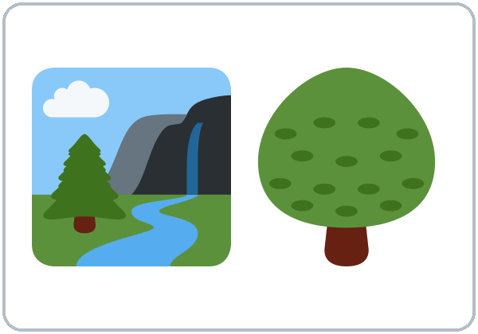  ★ park |   ★ library |   ★ supermarket | 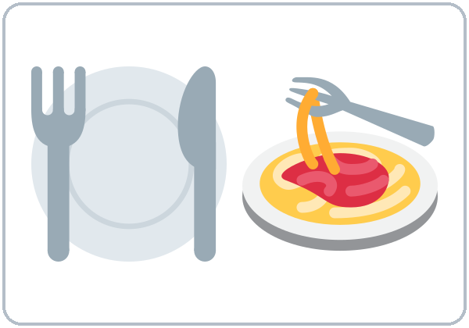  restaurant
  ★ clinic | 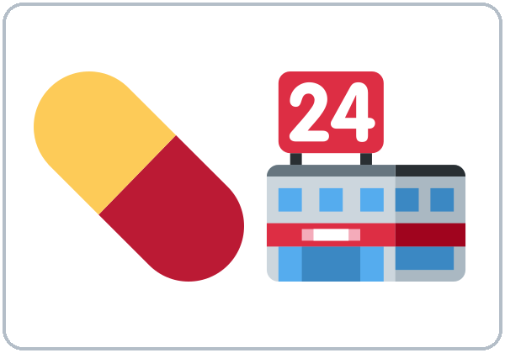  ★ pharmacy | 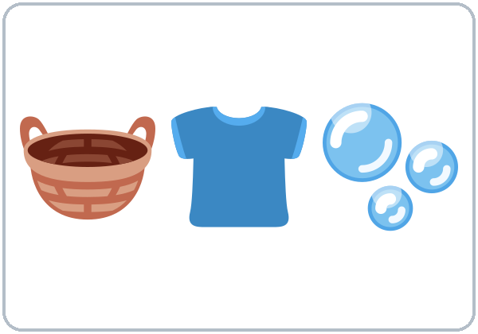  laundromat | 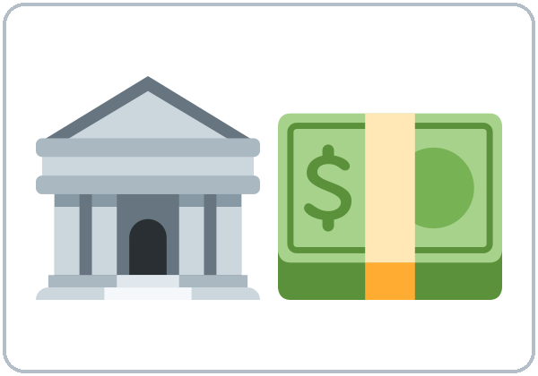  ★ bank
  post office | 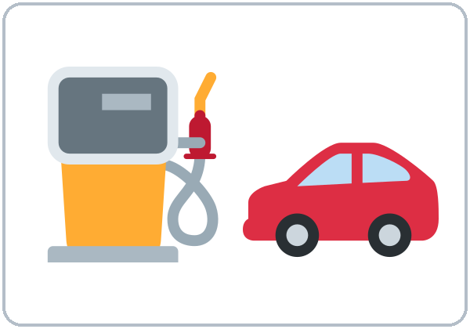  gas station | 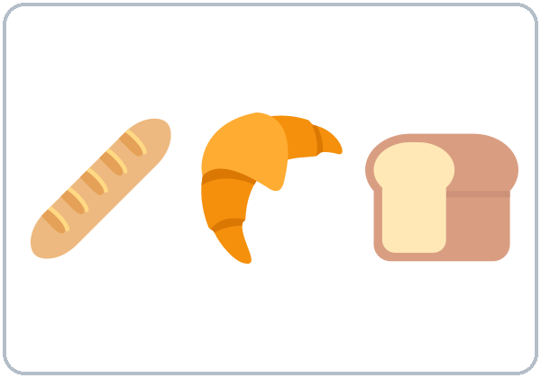  bakery |   ★ the best
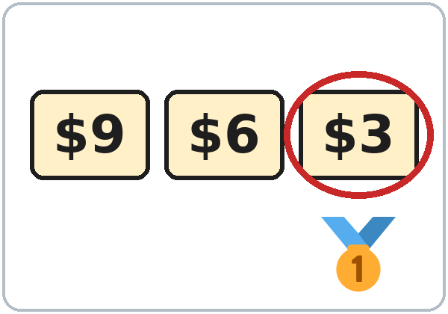  ★ the cheapest | 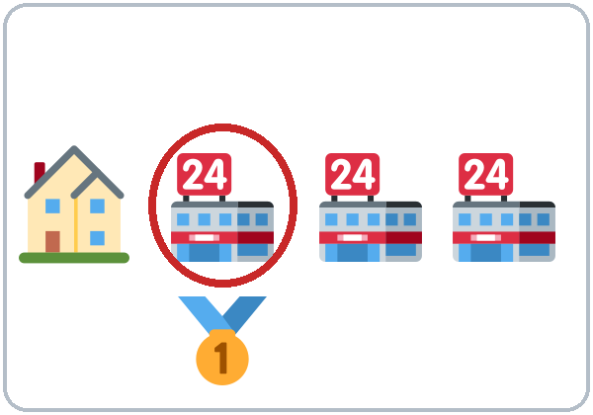  the closest

Lesson 8 (Week 9) · Listening
Listen to Kim and Rosa.
A. Listen. Which places do they talk about? Check ✓.
 | ✓ |  | ✓
supermarket | ☐ | library | ☐
pharmacy | ☐ | restaurant | ☐
post office | ☐ | park | ☐
bank | ☐

B. Listen again. Match.
Place |  | It's…
1. Fresh Market |  | a. the cheapest
2. Value Foods |  | b. the most beautiful park
3. The Sunny Kitchen |  | c. the biggest
4. Lake Park |  | d. the best restaurant

C. Listen again. Write the missing word.
1. Value Foods is the ________.
2. The ________ one is on Pine Street.
3. I think The Sunny Kitchen is the ________.
4. Lake Park is the ________ beautiful park in town.
Lesson 8 (Week 9) · Grammar
Grammar Box 1: Where's the best…?
Choose one word from each column. Read across.
QUESTION |  |  |  | ANSWER
Where's | the best  the cheapest  the closest | supermarket?  pharmacy?  restaurant? |  | It's | on | Lake Street.  Pine Street.  Main Street.
Where's | the best  the cheapest  the closest | supermarket?  pharmacy?  restaurant? |  | It's | next to | the bank.  the park.  the library.

Grammar Box 2: What's the … in town?
QUESTION |  |  |  |  | ANSWER
What's | the best  the cheapest | restaurant  park  store | in town? |  | I think | ___ | is the best.  is the cheapest.

Grammar Box 3: Is there…? Are there…?
QUESTION |  |  |  |  | ANSWER
Is there | a | bank  clinic  laundromat | near here? |  | Yes, | there | is.
 |  |  |  |  | No, | there | isn't.
Are there | any | parks  restaurants | near here? |  | Yes, | there | are.
 |  |  |  |  | No, | there | aren't.

Two or more than two?
Word | Two things | Three or more
cheap | cheaper than | the cheapest
big | bigger than | the biggest
easy | easier than | the easiest
expensive | more expensive than | the most expensive
good | better than | the best
bad | worse than | the worst
far | farther than | the farthest

Questions and answers
Q: When do I use the …-est?
A: To compare three or more things: Value Foods is the cheapest supermarket in town.
Q: Short or long word?
A: Short: the cheapest. Long: the most expensive. Never both: not the most cheapest.
Q: Do I always say the?
A: Yes. It's the best. (not It's best restaurant.)
Q: How do I ask if a place is near?
A: Is there a bank near here? (one) • Are there any parks near here? (two or more)
Q: What are the special words?
A: good → the best, bad → the worst, far → the farthest.
Common mistakes
✗ Don't say | ✓ Say
It's the more cheap. | It's the cheapest.
It's the most cheapest. | It's the cheapest.
It's best restaurant. | It's the best restaurant.
Have a pharmacy near here? | Is there a pharmacy near here?
There is two banks. | There are two banks.
The more good park. | The best park.

Nota para hispanohablantes: «el más barato» → the cheapest (palabra corta: the + -est; no «the more cheap»). «el más caro» → the most expensive. «el mejor» → the best; «el peor» → the worst. «¿Hay una farmacia cerca?» → Is there a pharmacy near here? (no «Have a pharmacy…?»).

Tip for speakers of other languages: Three or more things? Look for the + -est or the most.

Lesson 8 (Week 9) · Homework
Homework (10 minutes)
1. Write 5 sentences about the best places in your neighborhood (The best park is… It's the biggest…).
2. Write 2 questions with Is there…? or Are there…? and answer them.
3. Bonus: Ask a friend or neighbor: What's the best restaurant in town? Write the answer.
My homework
______________________________________________________________
______________________________________________________________
______________________________________________________________
______________________________________________________________
______________________________________________________________
______________________________________________________________
______________________________________________________________
______________________________________________________________
Lesson 9 (Week 10): Food and Shopping
Student Page 9 · Week 10
Name: ______________________________ Date: ________________
New Words
Look. Listen. Repeat. ★ = most important words.
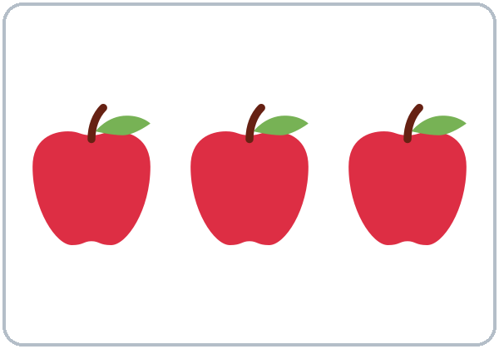  apples | 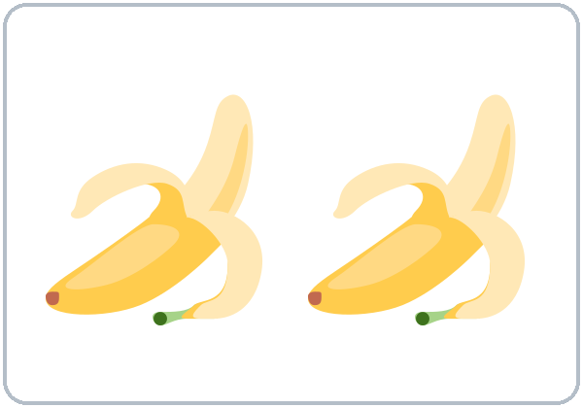  bananas | 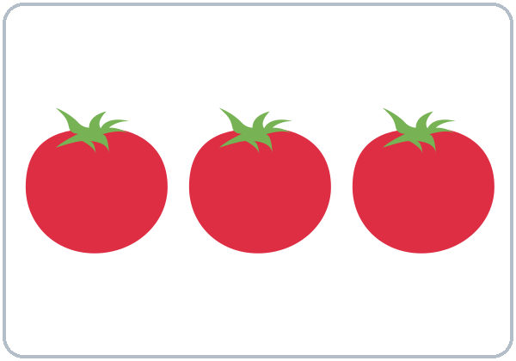  tomatoes | 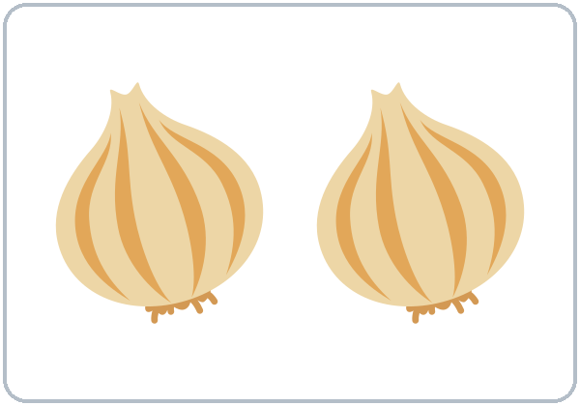  onions
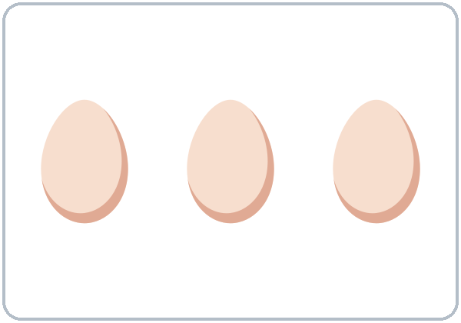  ★ eggs |   ★ rice | 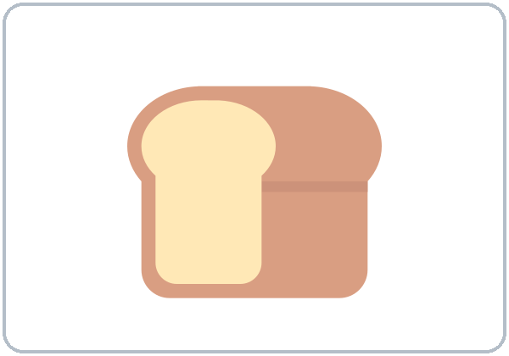  ★ bread |   ★ milk
  cheese | 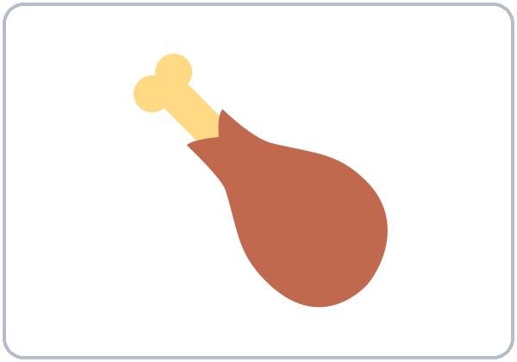  ★ chicken | 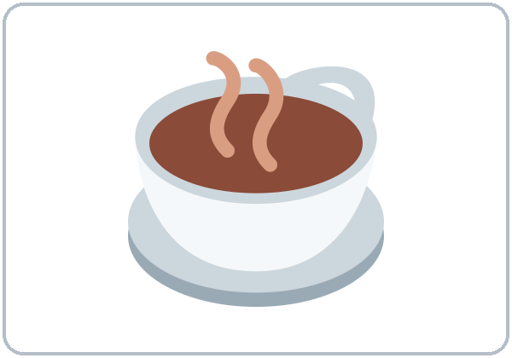  coffee | 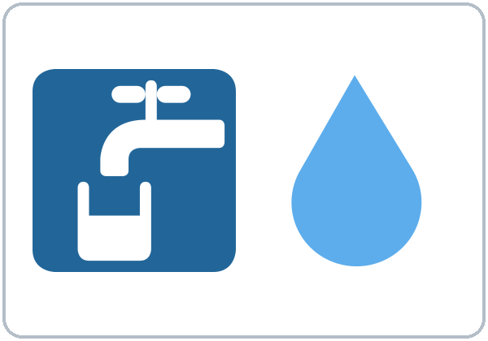  ★ water
  soup |   sandwich |   ★ shopping list | 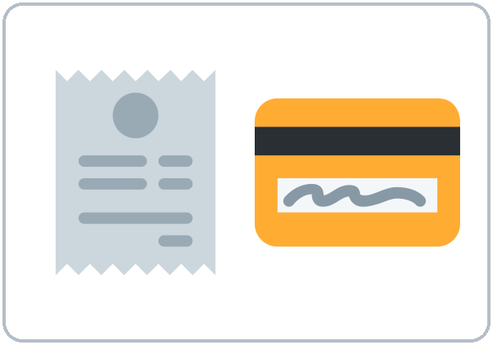  ★ the check (the bill)

Lesson 9 (Week 10) · Listening
Listen to Sam, Ana, and the server.
A. Listen. What do they order? Check ✓.
 | ✓ |  | ✓
soup | ☐ | water | ☐
fish | ☐ | coffee | ☐
sandwich | ☐ | eggs | ☐
salad | ☐ | cheese | ☐
bread | ☐ | milk | ☐

B. Listen again. Circle the answer.
1. Ana orders chicken soup / fish / a salad.
2. The restaurant doesn't have any chicken / fish / bread today.
3. Ana wants water with ice / no ice / lemon.
4. Sam wants one / two / three sugars.
5. The total is $14.50 / $24.15 / $24.50.
C. Listen again. Write the missing words.
1. ____________ the chicken soup.
2. Sorry, we don't have ________ fish today.
3. ________ ________ have a chicken sandwich?
4. Can we have the ________, please?
Lesson 9 (Week 10) · Grammar
Grammar Box 1: Ordering
Choose one word from each column. Read across.
YOU SAY |  |  | THE SERVER SAYS
I'd like | the soup, please.  a sandwich, please.  a coffee, please. |  | Sure.  Of course. | Anything to drink?  Anything else?
Can I have | some water, please?  some bread, please?  the check, please? |  | Sure.  Of course. | Anything to drink?  Anything else?

Grammar Box 2: Do you have any…?
QUESTION |  |  |  | ANSWER
Do you have | any | fish?  eggs?  bread?  milk? |  | Yes, | we have | some.
Do you have | any | fish?  eggs?  bread?  milk? |  | Sorry, | we don't have | any today.

Grammar Box 3: How many? How much?
QUESTION |  |  |  | ANSWER
How many | eggs  apples  tomatoes | do you need? |  | Six.  Two.  A lot. | I need six eggs.
How much | rice  milk  coffee | do you need? |  | A little.  A lot.  One bag. | I need a little rice.

Grammar Box 4: Prices
QUESTION |  |  |  | ANSWER
How much | is | the soup?  the bread?  it? |  | It's | $3.50.  $2.99.
How much | are | the apples?  the eggs? |  | They're | $4.00 a pound.  $3.49.

Count or no count?
Count (1, 2, 3…) | No count
an apple, two apples | rice
an egg, six eggs | milk, water, coffee
a tomato, three tomatoes | bread, cheese
a sandwich, two sandwiches | soup, chicken (food)
How many? | How much?

Questions and answers
Q: How much or How many?
A: How many + things you can count (eggs, apples). How much + things you can't count (rice, milk) and money.
Q: Some or any?
A: some in positive sentences: I need some eggs. any in questions and negatives: Do you have any milk? We don't have any fish.
Q: What does I'd like mean?
A: I'd like = I would like = a polite I want. I'd like the soup, please.
Q: Can I say breads or rices?
A: No. Say some bread, a loaf of bread, a bag of rice.
Q: How do I say prices?
A: $3.50 = "three fifty" or "three dollars and fifty cents." $24.50 = "twenty-four fifty."
Common mistakes
✗ Don't say | ✓ Say
How many milk? | How much milk?
How many money? | How much money? / How much is it?
I want a coffee. (too direct) | I'd like a coffee, please.
Do you have some fish? (OK, but…) | Do you have any fish?
I need two breads. | I need some bread / two loaves of bread.
We don't have some eggs. | We don't have any eggs.

Nota para hispanohablantes: «¿Cuánto(s)?» → How much (no se cuenta: rice, milk, dinero) / How many (se cuenta: eggs, apples). «Quiero un café» puede sonar brusco; mejor I'd like a coffee, please o Can I have…? En inglés bread, rice, cheese no llevan -s («some bread», no «breads»).

Tip for speakers of other languages: Count it on your fingers? → How many. Can't count it? → How much.

Lesson 9 (Week 10) · Homework
Homework (10 minutes)
1. Write your shopping list for this week with numbers and amounts (6 eggs, some rice, 2 pounds of apples…).
2. Write a restaurant conversation (4–6 lines): you and a server.
3. Bonus: At a store, read 3 prices in English. Write them in words ($2.99 = two ninety-nine).
My homework
______________________________________________________________
______________________________________________________________
______________________________________________________________
______________________________________________________________
______________________________________________________________
______________________________________________________________
______________________________________________________________
______________________________________________________________
Lesson 10 (Week 11): Health
Student Page 10 · Week 11
Name: ______________________________ Date: ________________
New Words
Look. Listen. Repeat. ★ = most important words.
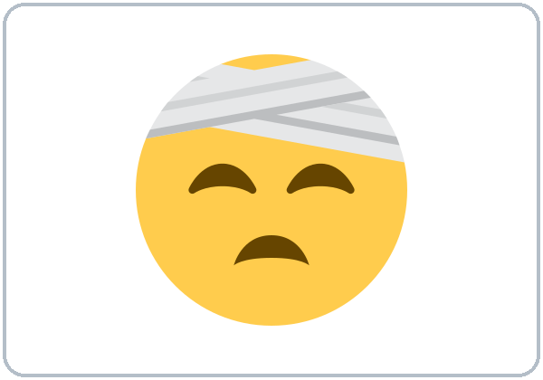  ★ a headache | 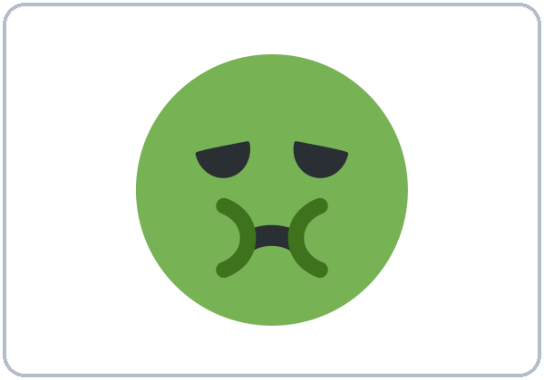  a stomachache | 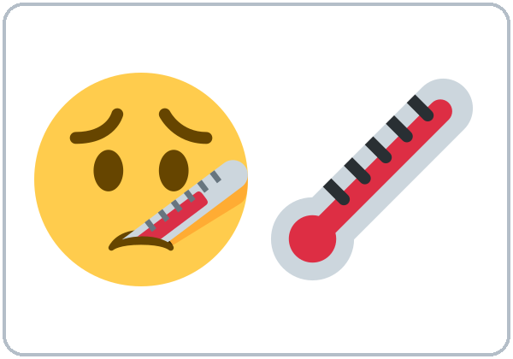  ★ a fever |   ★ a cold
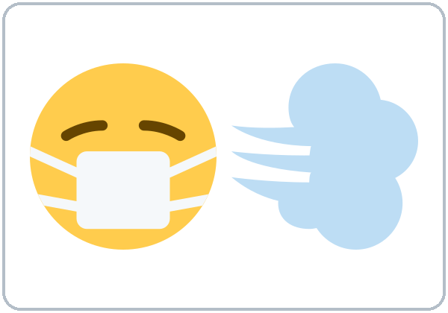  ★ a cough | 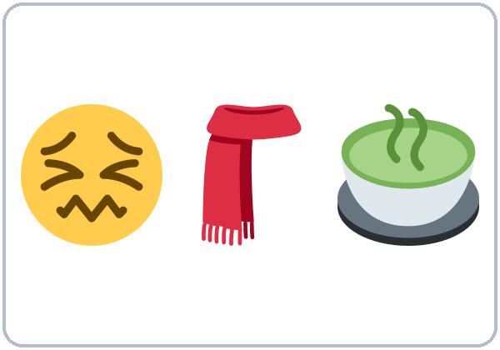  ★ a sore throat | 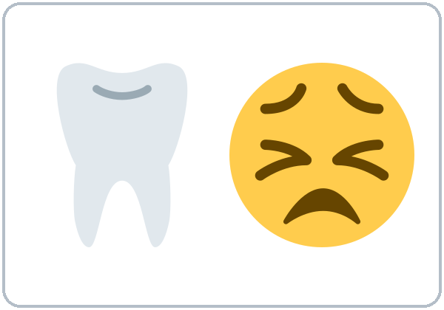  a toothache | 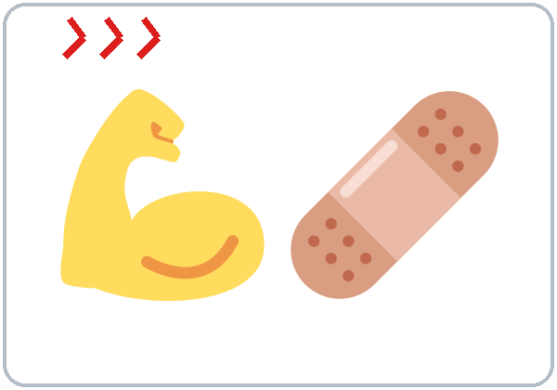  ★ hurts (My arm hurts.)
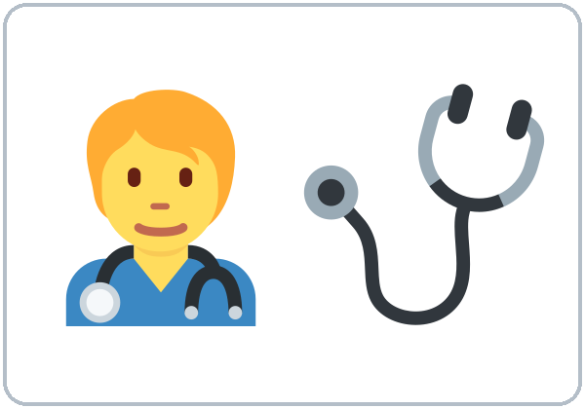  doctor | 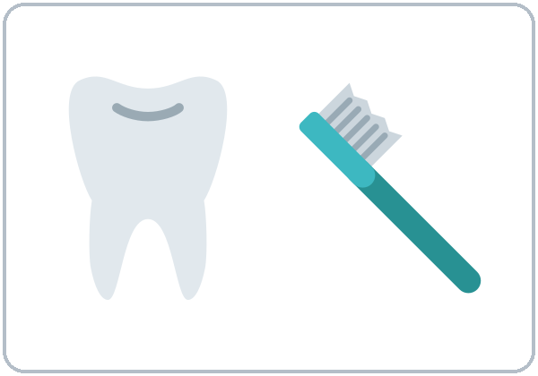  dentist | 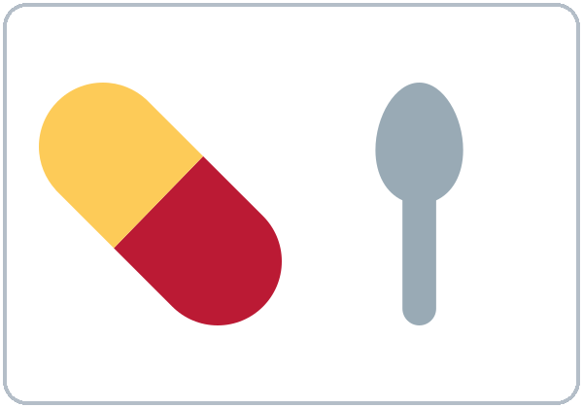  ★ medicine | 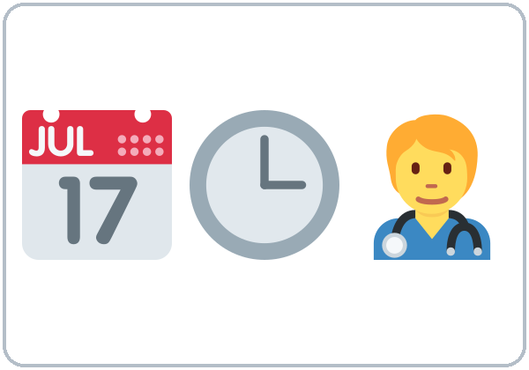  ★ appointment
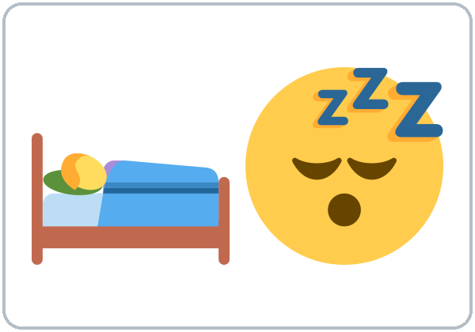  rest | 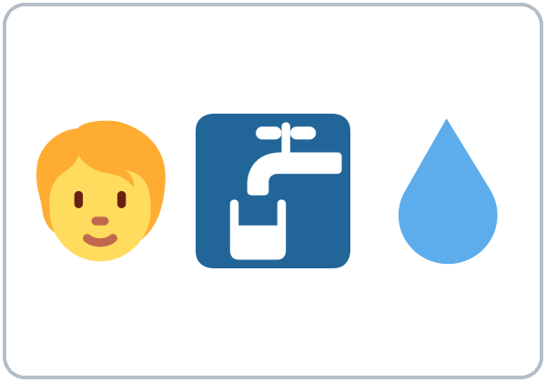  drink water

Lesson 10 (Week 11) · Listening
Listen to Marco and the receptionist.
A. Listen. What's the matter with Marco? Check ✓.
 | ✓ |  | ✓
a headache | ☐ | a sore throat | ☐
a cough | ☐ | a fever | ☐
a stomachache | ☐ | a toothache | ☐

B. Listen again. Check ✓ True or False.
 | True | False
1. Marco wants an appointment. | ☐ | ☐
2. He got sick yesterday. | ☐ | ☐
3. He can come at 10:15. | ☐ | ☐
4. His appointment is at 3:30. | ☐ | ☐
5. He should go to work today. | ☐ | ☐

C. Listen again. Write the missing word.
1. I'm sorry. What's the ________?
2. Three days ________.
3. You ________ rest and drink a lot of water.
4. You ________ go to work today.
Lesson 10 (Week 11) · Grammar
Grammar Box 1: What's the matter?
Choose one word from each column. Read across.
QUESTION |  | ANSWER
What's the matter?  What's wrong? |  | I | have | a headache.  a cold.  a fever.  a cough.
What's the matter?  What's wrong? |  | My | head  back  arm  tooth | hurts.
What's the matter?  What's wrong? |  | My | feet  eyes | hurt.

Grammar Box 2: Does your … hurt?
QUESTION |  |  |  |  | ANSWER
Does | your | head  back  arm | hurt? |  | Yes, it does.  No, it doesn't.
Do | your | feet  eyes | hurt? |  | Yes, they do.  No, they don't.

Grammar Box 3: What should I do?
QUESTION |  |  |  |  | ANSWER
What | should | I  he  she | do? |  | You  He  She | should | rest.  drink water.  see a doctor.  take medicine.
 |  |  |  |  | You  He  She | shouldn't | go to work.  eat a lot.  stay up late.
Should | I  he  she | see | a doctor?  a dentist? |  | Yes, | you  he  she | should.
 |  |  |  |  | No, | you  he  she | shouldn't.

Grammar Box 4: Making an appointment
YOU SAY |  |  | THE RECEPTIONIST SAYS
I'd like to make | an appointment, please. |  | What's the matter? | When did it start?
Is there | a later time?  an earlier time? |  | How about | 3:30?  tomorrow at 9?
___ is fine. | Thank you. |  | What's your name, | please?

Questions and answers
Q: have or hurt?
A: have + the problem: I have a headache. hurt + body part: My back hurts. (= it is painful)
Q: Do I need a?
A: Yes, for most problems: a cold, a fever, a headache, a sore throat.
Q: What does should mean?
A: It gives advice (a good idea): You should rest. shouldn't = not a good idea.
Q: should + what?
A: + the base verb, the same for everyone: She should rest. (not shoulds, not should to rest)
Q: hurts or hurt?
A: One part: My arm hurts. Two or more: My feet hurt.
Common mistakes
✗ Don't say | ✓ Say
I have headache. | I have a headache.
My head is hurting me. / Me hurts the head. | My head hurts.
You should to rest. | You should rest.
She shoulds go. | She should go.
I have pain in my throat. (OK, but…) | I have a sore throat.
My feet hurts. | My feet hurt.

Nota para hispanohablantes: «Me duele la cabeza» → My head hurts o I have a headache (no «Me hurts the head»). Usa a: I have a cold. «Deberías descansar» → You should rest (sin to, sin -s: She should rest). «No deberías» → shouldn't.

Tip for speakers of other languages: For advice, remember the pattern: should + verb (You should rest.). No to. No -s.

Lesson 10 (Week 11) · Homework
Homework (10 minutes)
1. Write 4 health problems and advice for each (I have a cold. You should rest and drink water.).
2. Write a phone call to make an appointment (4–6 lines). Use an invented problem.
3. Bonus: Learn the clinic and emergency numbers your program gives you. Practice saying your name and phone number clearly.
My homework
______________________________________________________________
______________________________________________________________
______________________________________________________________
______________________________________________________________
______________________________________________________________
______________________________________________________________
______________________________________________________________
______________________________________________________________
Lesson 11 (Week 12): Making Plans
Student Page 11 · Week 12
Name: ______________________________ Date: ________________
New Words
Look. Listen. Repeat. ★ = most important words.
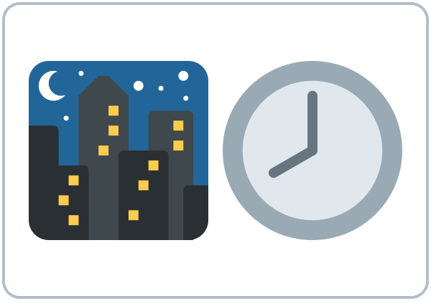  ★ tonight | 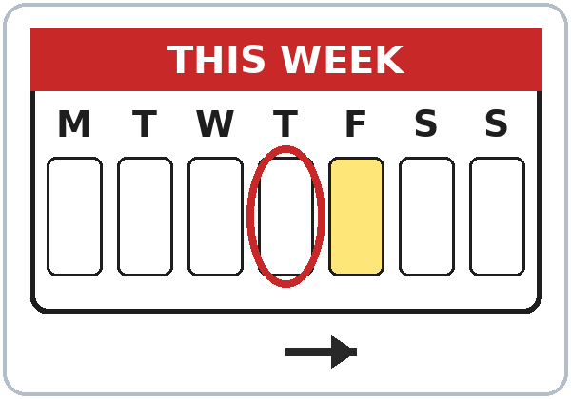  ★ tomorrow | 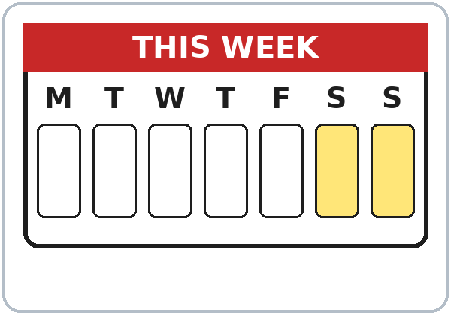  ★ this weekend | 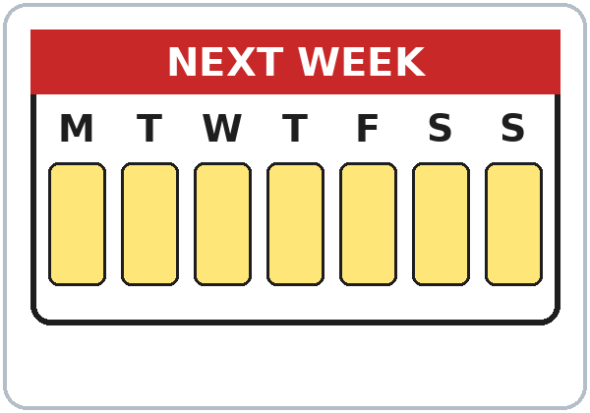  ★ next week
  go to the movies | 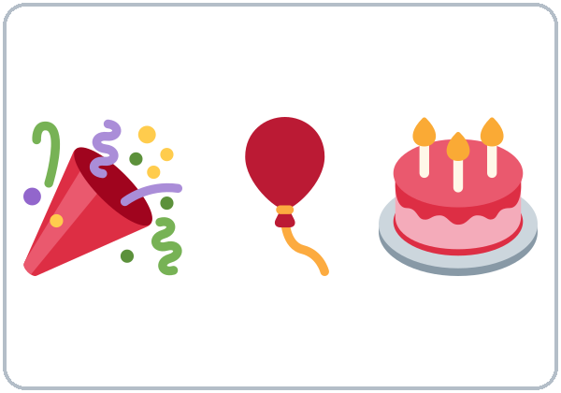  ★ have a party | 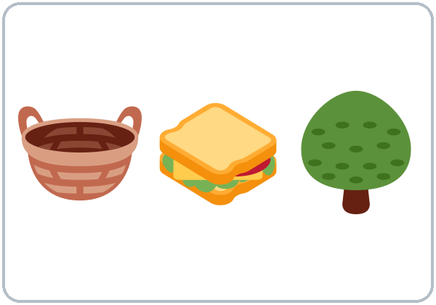  have a picnic |   go to the beach
  watch a game | 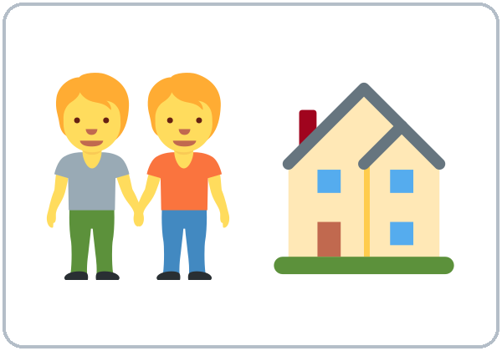  visit friends |   ★ invite | 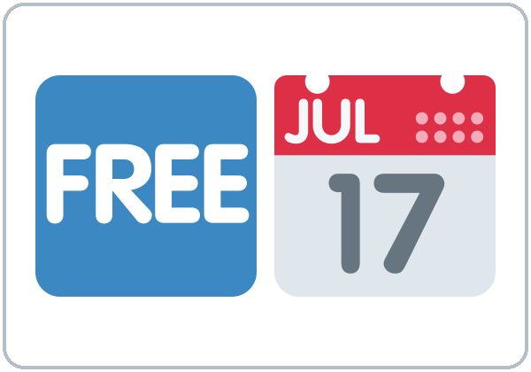  ★ free (not busy)
  I'd love to! | 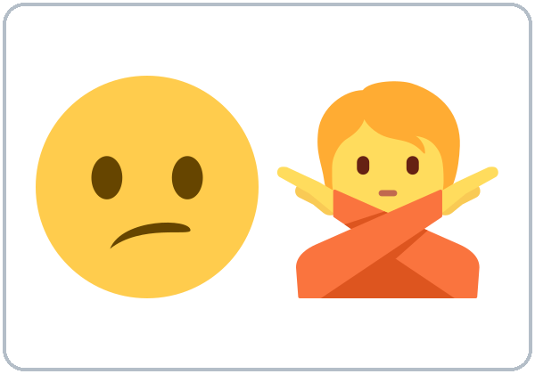  ★ Sorry, I can't.

Lesson 11 (Week 12) · Listening
Listen to Kim and Carlos.
A. Listen. Circle the answer.
1. Kim is going to have a party / a picnic / a dinner.
2. The picnic is on Friday / Saturday / Sunday.
3. It starts at 2:00 / 4:00 / 12:00.
4. Carlos is going to bring a salad / a cake / a ball.
B. Listen again. Check ✓ True or False.
 | True | False
1. The picnic is at Lake Park. | ☐ | ☐
2. Carlos is free on Saturday morning. | ☐ | ☐
3. Rosa is going to come to the picnic. | ☐ | ☐
4. Kim invites Carlos to the movies. | ☐ | ☐
5. Carlos is free on Sunday. | ☐ | ☐

C. Listen again. Write the missing word.
1. We're ________ to have a picnic.
2. I'd ________ to! What time?
3. Sorry, I ________.
4. I'm ________ my brother on Sunday.
Lesson 11 (Week 12) · Grammar
Grammar Box 1: What are you going to do?
Choose one word from each column. Read across.
QUESTION |  |  |  |  |  | ANSWER
What | are | you | going to do | tonight?  this weekend?  tomorrow? |  | I'm | going to | visit friends.  watch a game.  clean the house.
What | is | he  she | going to do | tonight?  this weekend?  tomorrow? |  | He's  She's | going to | go to the beach.  have a party.  rest.

Grammar Box 2: Are you going to…?
QUESTION |  |  |  | ANSWER
Are | you | going to work tomorrow?  going to cook tonight? |  | Yes, | I | am.
Are | you | going to work tomorrow?  going to cook tonight? |  | No, | I'm | not.
Is | he  she | going to come?  going to call? |  | Yes, | he  she | is.
Is | he  she | going to come?  going to call? |  | No, | he  she | isn't.

Grammar Box 3: Invitations
INVITE |  |  |  | ACCEPT / DECLINE
Would you like to | go to the movies  have a picnic  watch a game | on Saturday? |  | I'd love to!  Sure! | What time?
Do you want to | visit friends  have dinner | tonight? |  | Sorry, I can't. | I'm working.  I'm visiting my mother.

Grammar Box 4: Fixed plans (present continuous)
QUESTION |  |  |  | ANSWER
What | are you doing | on Saturday?  tomorrow?  next week? |  | I'm | working  helping my brother  visiting family | on Saturday.

Questions and answers
Q: How do I make going to?
A: am / is / are + going to + base verb: I'm going to visit my mother. She's going to rest.
Q: going to or -ing for the future?
A: Both are OK for plans. -ing is common for fixed plans with a time: I'm working on Saturday.
Q: What's the difference between Would you like to and Do you want to?
A: Same meaning. Would you like to is more polite. Do you want to is friendly.
Q: How do I say no politely?
A: Sorry, I can't. + a reason: I'm working. / I'm visiting my mother. Maybe add Thanks for asking!
Q: What's gonna?
A: Fast speech for going to. Understand it; in writing, use going to.
Common mistakes
✗ Don't say | ✓ Say
I going to work. | I'm going to work.
I go to visit my mother tomorrow. | I'm going to visit my mother tomorrow.
She is going to visits. | She is going to visit.
Would you like come? | Would you like to come?
No, I can't. (too short) | Sorry, I can't. I'm working.
Are you free in Saturday? | Are you free on Saturday?

Nota para hispanohablantes: «Voy a visitar» → I'm going to visit (no olvides am / is / are). «¿Quieres venir?» → Do you want to come? o, más cortés, Would you like to come? (con to). Para decir que no: Sorry, I can't + una razón. «el sábado» → on Saturday.

Tip for speakers of other languages: Plans need three parts: am / is / are + going to + verb.

Lesson 11 (Week 12) · Homework
Homework (10 minutes)
1. Write 5 plans for this weekend or next week with going to (On Saturday I'm going to…).
2. Write an invitation text message to a friend and two answers: one yes, one no with a reason.
3. Bonus: Ask a family member: What are you going to do this weekend? Write the answer.
My homework
______________________________________________________________
______________________________________________________________
______________________________________________________________
______________________________________________________________
______________________________________________________________
______________________________________________________________
______________________________________________________________
______________________________________________________________
Lesson 12 (Week 13): Getting Things Done
Student Page 12 · Week 13
Name: ______________________________ Date: ________________
New Words
Look. Listen. Repeat. ★ = most important words.
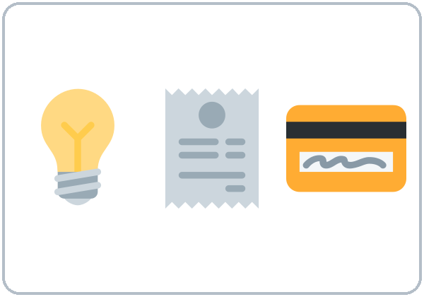  ★ pay a bill | 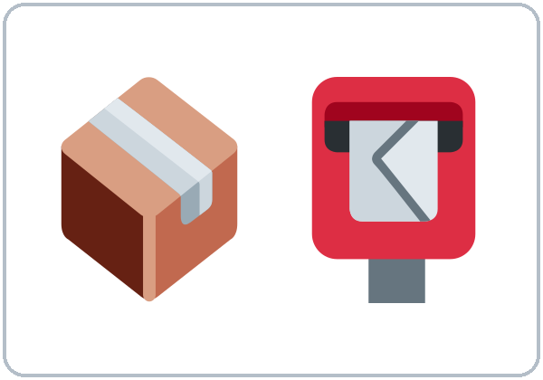  mail a package | 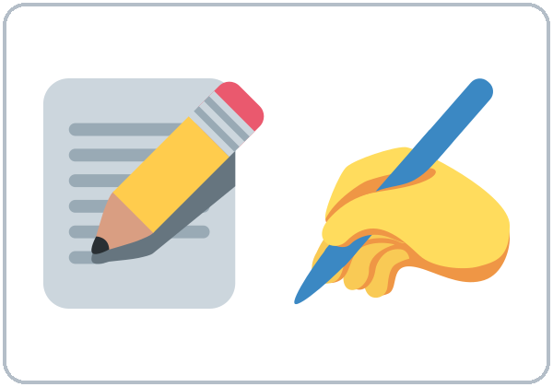  ★ fill out a form | 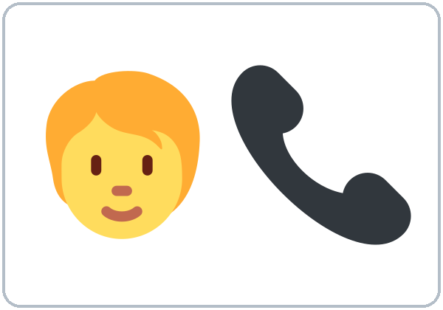  ★ make a phone call
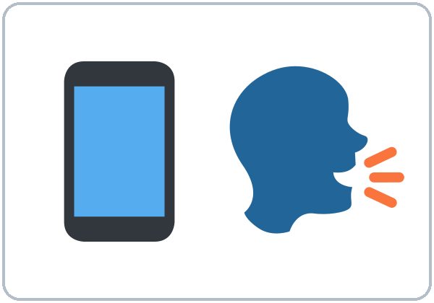  ★ leave a message | 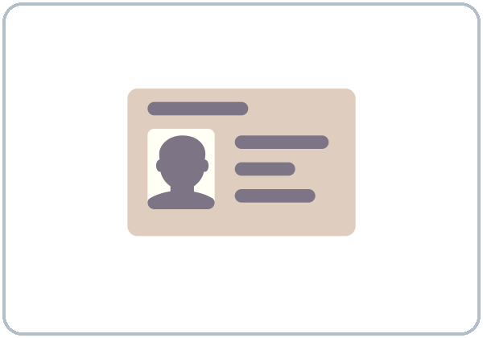  ID card |   receipt | 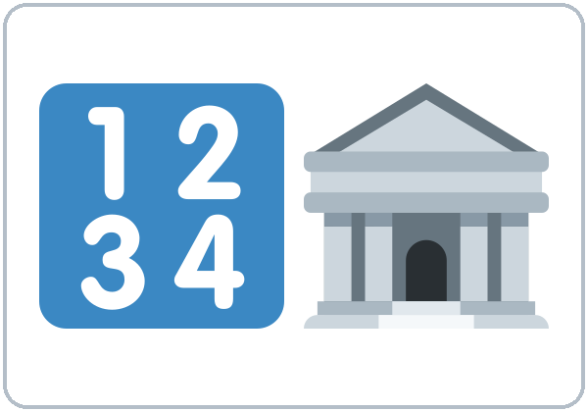  ★ account number
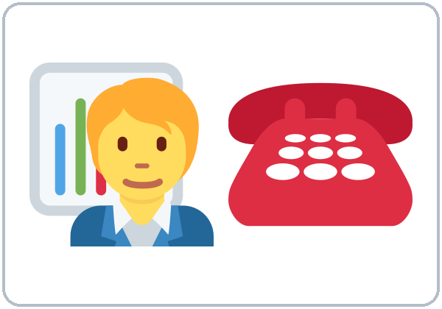  ★ customer service | 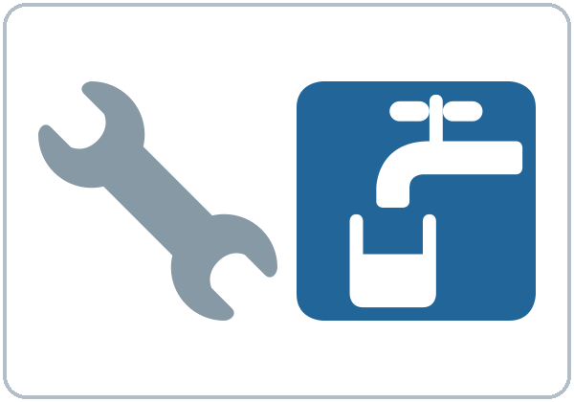  fix (the sink) | 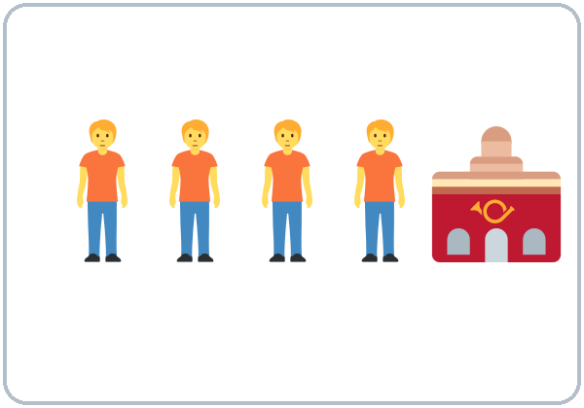  wait in line | 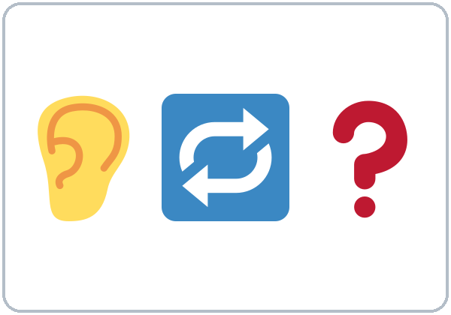  ★ Could you repeat that?
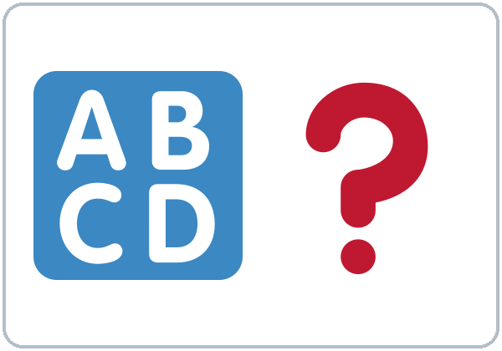  ★ Can you spell that? | 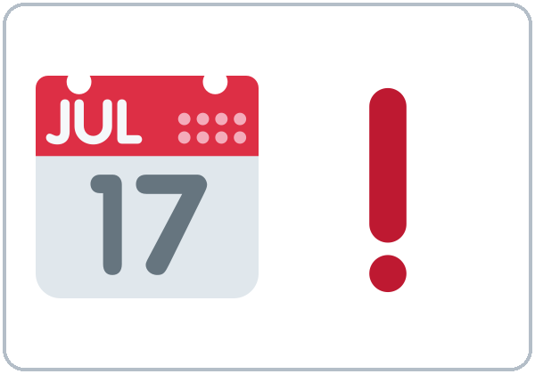  due date

Lesson 12 (Week 13) · Listening
Listen to Sam and the phone company agent.
A. Listen. Circle the answer.
1. Sam's bill is too high / too low / late.
2. The company charged him one time / two times / three times.
3. Sam has to pay $15 / $45 / $54.
4. He has to pay by the 5th / the 15th / the 50th.
B. Listen again. Write the information.
Account number: | ___ ___ ___ ___ ___ ___
Last name: | ___ ___ ___ ___ ___

C. Listen again. Write the missing word.
1. Sorry, could you ________ that, please?
2. Can you ________ that, please?
3. When do I ________ to pay?
4. Could you ________ me a new bill, please?
Lesson 12 (Week 13) · Grammar
Grammar Box 1: Do I have to…?
Choose one word from each column. Read across.
QUESTION |  |  |  |  | ANSWER
Do | I  you  we | have to  need to | pay today?  fill out a form?  bring an ID card? |  | Yes, | you  I  we | do.
 |  |  |  |  | No, | you  I  we | don't.
Does | he  she | have to  need to | work?  come in person? |  | Yes, | he  she | does.
 |  |  |  |  | No, | he  she | doesn't.

Grammar Box 2: Can you…? Could you…?
REQUEST |  |  |  | ANSWER
Can you  Could you | repeat that,  spell that,  speak more slowly, | please? |  | Sure.  Of course. | No problem.
Can you  Could you | help me,  send me a new bill,  call me back, | please? |  | Sorry, I can't. | I'm busy right now.

Grammar Box 3: Can I…?
QUESTION |  |  |  | ANSWER
Can I | pay  leave a message  talk to a manager | by phone?  now?  please? |  | Yes, you can.  Sure. | One moment, please.
Can I | pay  leave a message  talk to a manager | by phone?  now?  please? |  | Sorry, you can't. | You have to come in person.

have to / need to / don't have to
Meaning | Example
necessary | I have to pay the bill. She has to work.
necessary | We need to fill out a form. He needs to call.
not necessary (you can choose) | You don't have to pay today. She doesn't have to come.

Questions and answers
Q: What's the difference between have to and need to?
A: Almost the same: something is necessary. I have to pay the bill. I need to pay the bill.
Q: What does don't have to mean?
A: Not necessary. You can choose. You don't have to pay today = you can pay later. It does not mean "you can't."
Q: have to or has to?
A: he / she / it → has to: She has to work. Questions: Does she have to work?
Q: Can you or Could you?
A: Both are requests. Could you is more polite: good for phone calls, offices, and strangers.
Q: What do I say when I don't understand?
A: Could you repeat that, please? Could you speak more slowly? Can you spell that?
Common mistakes
✗ Don't say | ✓ Say
I have to paying. | I have to pay.
I must to pay. | I have to pay. / I must pay.
She have to work. | She has to work.
Could you to help me? | Could you help me?
Does she has to go? | Does she have to go?
You don't have to smoke here. (= not necessary) | You can't smoke here. (= not allowed)

Nota para hispanohablantes: «Tengo que pagar» → I have to pay / I need to pay (con to + verbo base). «No tienes que pagar hoy» → You don't have to pay today = no es necesario (¡no es una prohibición! Prohibido = can't). «¿Podría…?» → Could you…? (más cortés que Can you…?).

Tip for speakers of other languages: On the phone, always keep these phrases ready: Could you repeat that? Can you spell that? Could you speak more slowly?

Lesson 12 (Week 13) · Homework
Homework (10 minutes)
1. Write 4 things you have to do this week and 2 things you don't have to do.
2. Write a voicemail message (3–4 sentences): your name, a fictional number (555-01__), the reason, and Could you call me back, please?
3. Bonus: Practice spelling your name and street aloud 3 times.
My homework
______________________________________________________________
______________________________________________________________
______________________________________________________________
______________________________________________________________
______________________________________________________________
______________________________________________________________
______________________________________________________________
______________________________________________________________
Lesson 13 (Week 14): Then, Now, and Next
Student Page 13 · Week 14
Name: ______________________________ Date: ________________
New Words
Look. Listen. Repeat. ★ = most important words.
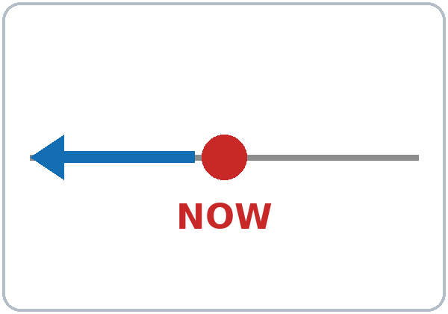  ★ in the past | 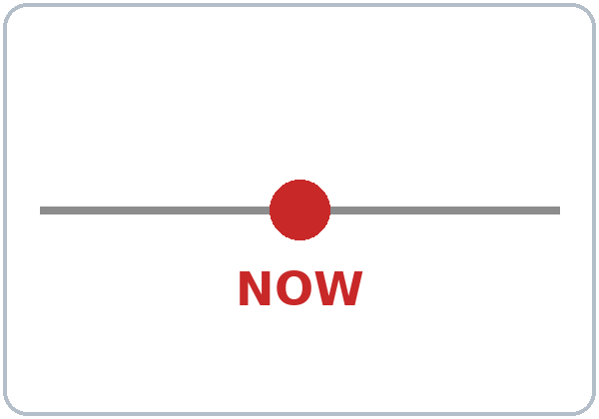  ★ now | 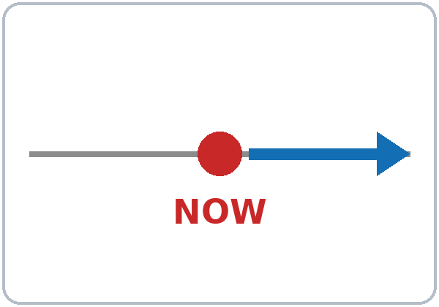  ★ in the future
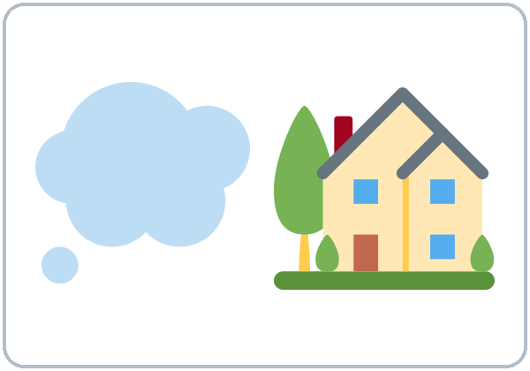  ★ dream |   ★ goal |   learn
  ★ improve | 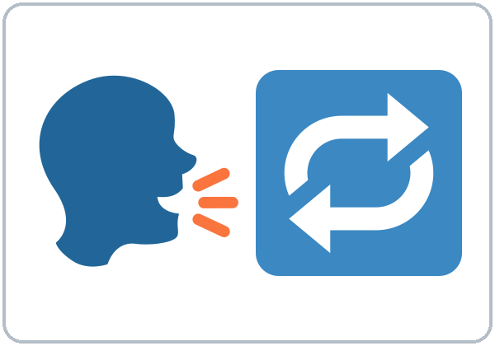  practice |   ★ proud
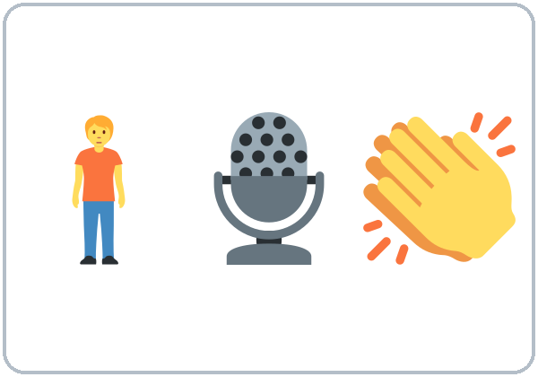  ★ give a talk |   graduate | 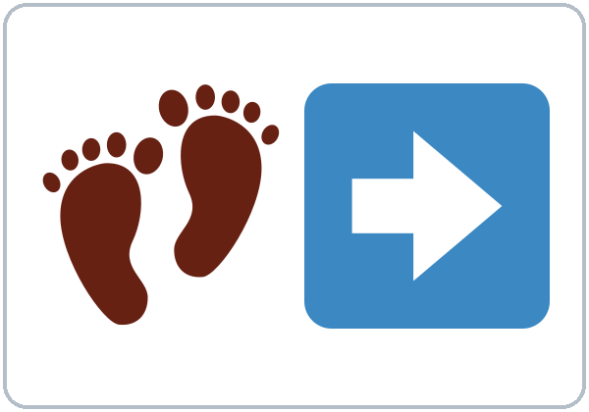  next step

Lesson 13 (Week 14) · Listening
Listen to Ana's graduation talk.
A. Listen. Then, now, or next? Check ✓.
 | Then (past) | Now | Next (future)
She was nervous. | ☐ | ☐ | ☐
She works at a bakery. | ☐ | ☐ | ☐
She makes her own appointments. | ☐ | ☐ | ☐
She is going to take a computer class. | ☐ | ☐ | ☐
She is going to get an office job. | ☐ | ☐ | ☐

B. Listen again. Check ✓ True or False.
 | True | False
1. One year ago, Ana felt relaxed. | ☐ | ☐
2. She practiced with her classmates. | ☐ | ☐
3. Now she works at a restaurant. | ☐ | ☐
4. She feels proud now. | ☐ | ☐
5. Her dream is to open a bakery. | ☐ | ☐

C. Listen again. Write the missing word.
1. One year ago, I ________ very nervous.
2. I ________ a lot with my classmates.
3. Now, I ________ at a bakery.
4. Next year, I am ________ to take a computer class.
Lesson 13 (Week 14) · Grammar
Grammar Box 1: Then / Now / Next
Choose one word from each column. Read across.
QUESTION |  |  |  |  | ANSWER
Where | did you | live  work | five years ago? |  | I | lived  worked | in ___.
Where | do you | live  work | now? |  | I | live  work | in ___.
What | are you | going to do | next year? |  | I'm | going to | take a class.  find a new job.

Grammar Box 2: Feelings then and now
QUESTION |  |  |  | ANSWER
How | did you | feel in the first class? |  | I | felt  was | nervous.  shy.  excited.
How | do you | feel now? |  | I | feel  am | proud.  happy.  more confident.

Grammar Box 3: Goals and dreams
QUESTION |  |  | ANSWER
What's your | goal?  dream? |  | My goal  My dream | is to | get a better job.  improve my English.  help my kids.

Tense helper
Time words | Tense | Example
ago, last year, yesterday | Past | I moved here two years ago. I was nervous.
every day, usually, always | Present | I work at a bakery. I take the bus.
now, right now, today | Present continuous | I'm studying English now.
tomorrow, next year, this weekend | going to (plans) | I'm going to take a computer class.
(offers, promises) | will (recognize) | I'll help you.

Questions and answers
Q: How do I choose the tense?
A: Look at the time word. ago → past. every day → present. now → -ing. next year → going to.
Q: was or did?
A: was / were with adjectives and places: I was nervous. did with other verbs in questions and negatives: Did you study?
Q: How do I talk about a goal?
A: My goal is to + verb: My goal is to get an office job.
Q: Can I mix tenses in one talk?
A: Yes! A good talk goes then → now → next: I was… Now I… Next year I'm going to…
Q: How do I end a talk?
A: Thank you to my teachers and classmates. Thank you for listening.
Common mistakes
✗ Don't say | ✓ Say
I am agree. | I agree.
One year ago I am nervous. | One year ago I was nervous.
Next year I take a class. | Next year I'm going to take a class.
In the next year… | Next year…
My goal is get a job. | My goal is to get a job.
I have 30 years. | I'm 30 (years old).

Nota para hispanohablantes: «Estoy de acuerdo» → I agree (sin am). «El próximo año» → next year (sin in the). «Hace un año estaba nerviosa» → One year ago I was nervous. «Mi meta es conseguir…» → My goal is to get… (con to). «Tengo 30 años» → I'm 30.

Tip for speakers of other languages: Before you speak, find the time word. It tells you which tense to use.

Lesson 13 (Week 14) · Homework
Homework: My Graduation Talk (15 minutes)
1. Complete your talk below (4–6 sentences). Practice it aloud 3 times.
Part | Your sentence
Then (past) | One year ago / Before this class, I ________________________
Now (present) | Now I ________________________
Next (future) | Next year I'm going to ________________________
Goal or dream | My goal is to ________________________
Thank you | Thank you to ________________________

2. Final next week: look at the Final Review pages in this workbook.
3. Bonus: Record your talk on your phone and listen.
My homework
______________________________________________________________
______________________________________________________________
______________________________________________________________
______________________________________________________________
______________________________________________________________
______________________________________________________________
______________________________________________________________
______________________________________________________________
Week 15: Final Exam Review · What to Expect
Final Review · Week 15
Name: ______________________________ Date: ________________
On final night
Time | What you do
6:00–6:10 | Talk with a partner + homework check
6:10–6:30 | Review stations (games). Your teacher calls you and a partner for a 3-minute speaking interview
6:30–6:45 | Listening test: 8 questions. You hear the audio 2–3 times
6:45–7:00 | Break
7:00–7:15 | Grammar test: 15 sentences. Circle the correct answer
7:15–7:30 | Can-do self-check: how do you feel about your English?

How to study
1. Read the Grammar pages for all lessons (focus on Lessons 8–13).
2. Listen to the lesson audio again.
3. Do the practice on the next pages.
4. Practice the speaking questions with a friend or family member.
Don't worry! The test uses the same activities as class: circle, true/false, and questions with a partner.

Week 15: Final Exam Review · Grammar at a Glance
Lesson | Grammar | Question | Answer
8 | superlatives; Is there…? | Where's the best park? Is there a bank near here? | Lake Park is the biggest. Yes, there is.
9 | some / any; How much / many; I'd like | How many eggs? Do you have any rice? | I'd like the soup, please.
10 | have a…; hurts; should | What's the matter? What should I do? | I have a cold. You should rest.
11 | going to; invitations | What are you going to do? Would you like to come? | I'm going to visit friends. Sorry, I can't.
12 | have to / need to; Could you…? | Do I have to pay today? Could you repeat that? | No, you don't have to. Sure.
13 | all tenses | Where did you live? What are you going to do? | I lived in… Now I live… Next year I'm going to…
1–7 | review | Do you…? Are you…? Did you…? Which is faster? | See the Midterm Review pages.

Week 15: Final Exam Review · Practice
A. Write the correct word.
1. Value Foods is _____ (cheap) supermarket in town.
2. How _____ milk do you need?
3. _____ there any parks near here?
4. I'd like _____ water, please.
5. He has a fever. He _____ go to work.
6. We're _____ to have a picnic on Sunday.
7. Do you _____ to work tomorrow?
8. _____ you spell that, please?
9. Last year I _____ (work) at a hotel.
10. Lake Park is _____ (beautiful) park in town.
B. Fix the mistake. Write the correct sentence.
1. It's the more cheap store.
______________________________________________
2. How many money?
______________________________________________
3. You should to rest.
______________________________________________
4. I going to visit my mom.
______________________________________________
5. She have to work.
______________________________________________
Week 15: Final Exam Review · Speaking Practice
Ask and answer with a partner.
1. What's the best restaurant in your neighborhood? Why?
2. What do you usually buy at the supermarket? How many…? How much…?
3. What should I do? I have a cold.
4. What are you going to do this weekend? Would you like to…?
5. What do you have to do this week?
6. Tell me your graduation talk: then, now, next.
7. Where are you from? What do you do every day? What do you like doing? (baseline questions)
Partner task (like the interview)
• A: invite your partner to do something this weekend. B: accept or say no politely with a reason.
• B: tell A about a problem (I have a cold. / I need cheap food. / My bill is too high.). A: give advice (You should…) or recommend a place (The best… is…). Then switch.
Tip: answer with two sentences: the answer + one more detail. I take the bus. It takes 30 minutes.

Answers to the practice page
A: 1 the cheapest; 2 much; 3 Are; 4 some; 5 shouldn't; 6 going; 7 have; 8 Can / Could; 9 worked; 10 the most beautiful.
B: 1. It's the cheapest store. 2. How much money? 3. You should rest. 4. I'm going to visit my mom. 5. She has to work.
Picture Credits
Vocabulary pictures use Twemoji graphics by Twitter, Inc. and other contributors (https://github.com/jdecked/twemoji), licensed under CC BY 4.0 (https://creativecommons.org/licenses/by/4.0/). The graphics were resized and combined, and arrows, calendars, clocks, and labels were added.

PART E
Assessment Packets

Midterm (Week 8) and Final (Week 15)
Listening and grammar tests · Speaking cards · Score sheets · Can-do self-checks · Answer keys

How to Use the Assessment Packets
Print these pages separately. Don't put them in the Student Workbook. Learners prepare with the Review pages in Part C.

Page | Copies | Who
Listening Test | 1 per learner + 3 | Learners
Grammar Test | 1 per learner + 3 | Learners
Speaking Interview Card | 1 per interviewer | Teacher
Speaking Task Cards | 1 set per 4 pairs (cut apart) | Learner pairs
Speaking Score Sheet | 1–2 per class | Teacher
Can-Do Self-Check | 1 per learner + 3 | Learners
Answer Key | 1 per teacher | Teacher

The full exam-night plans and listening scripts are in Part B (Week 8 and Week 15). The speaking rubric is in Section 2.3.
Week 8: Midterm · Listening Test
Name: ______________________________ Date: ________________
Listen to Sam and Kim.
A. Listen. Circle the answer. (4 points)
1. Kim moved last week / last month / last year.
2. Kim lives on Pine / Maple / Lake Street now.
3. Kim starts work at 8:00 / 8:30 / 9:30.
4. The train takes 15 / 25 / 45 minutes.
B. Listen again. Check ✓ True or False. (4 points)
 | True | False
1. Kim walked in the park on Sunday. | ☐ | ☐
2. Kim works at a hospital. | ☐ | ☐
3. The bus is faster than the train. | ☐ | ☐
4. Kim is waiting for a delivery right now. | ☐ | ☐

Score: ______ / 8
Week 8: Midterm · Grammar Test
Name: ______________________________ Date: ________________
Circle the correct answer. For number 5, circle a, b, or c. (15 points)
1. _____ you from Mexico? ( Are / Do )
2. Where _____ your sister work? ( do / does )
3. My brother _____ at a hotel. ( work / works )
4. Do you _____ kids? ( have / has )
5. Choose the correct sentence: a) I go always to work by bus. b) I always go to work by bus. c) Always I go to work by bus.
6. I love _____ on weekends. ( dance / dancing )
7. A: I don't like rock music. B: Me _____. ( too / neither )
8. Look! The kids _____ soccer in the park right now. ( play / are playing )
9. What _____ you doing now? ( are / do )
10. Last weekend _____ fun. ( was / were )
11. We _____ tired yesterday. ( was / were )
12. On Saturday, I _____ my family. ( visit / visited )
13. _____ you go to school here? Yes, I did. ( Do / Did )
14. I moved here five years _____. ( ago / before )
15. The bus is _____ than the taxi. ( cheaper / more cheap )
Score: ______ / 15
Week 8: Midterm · Speaking Interview Card (Teacher)
Part 1 · Individual (1 minute)
Ask each learner 2 questions. Use different questions for each partner.
1. Where do you live? Do you like your neighborhood?
2. What time do you get up? What do you do in the morning?
3. What do you like doing on weekends?
4. What is your family doing right now, do you think?
5. What did you do last weekend? How was it?
6. Where did you grow up? When did you move here?
7. How do you get to class? How long does it take?
Part 2 · Pair task (2 minutes)
• Ask your partner about last weekend: How was your weekend? What did you do?
• Then compare how you get to class: How do you get to class? How long does it take? Say one sentence: My trip is …er than your trip.
Follow-up (ask one)
Did you…? / Was it…? / Which is faster?
Rubric
Score | Communication | Target grammar | Pronunciation and fluency
3 | Completes the task; asks and answers follow-up questions | Uses the target form correctly most of the time | Easy to understand; few long pauses
2 | Completes most of the task with some help | Uses the form, with errors that don't block meaning | Mostly understandable; some pauses
1 | Needs a lot of help; very short answers | Rarely uses the form, or errors block meaning | Hard to understand without effort

Week 8: Midterm · Speaking Task Cards (cut apart)
Learner A | Learner B
Ask B: How was your weekend? What did you do? | Answer. Then ask A: How was your weekend?
Answer B's questions about your trip to class. | Ask A: How do you get to class? How long does it take?
Say one sentence: My trip is …er than your trip. | Say one sentence: The bus / car is …er than…

Week 8: Midterm · Speaking Score Sheet (Teacher)
Teacher: ______________________ Date: ______________
Learner | Comm. (1–3) | Grammar (1–3) | Pron. (1–3) | Total (/9) | Notes

Comm. = Communication · Grammar = Target grammar · Pron. = Pronunciation and fluency (rubric in Section 2.3 and on the Interview Card).
Meets = 2 or higher in all three areas. Use a second sheet for more learners.
Week 8: Midterm · Can-Do Self-Check
Name: ______________________________ Date: ________________
How do you feel? Check ✓ one box for each line. 😀 = I can do it well. 🙂 = I can do it with a little help. 😐 = Not yet.
I can… | 😀 | 🙂 | 😐
I can ask and answer questions about me: name, home, work, family. (Lesson 1) | ☐ | ☐ | ☐
I can talk about my daily routine and a family member's routine. (Lesson 2) | ☐ | ☐ | ☐
I can say what I like and don't like doing, and agree (Me too / Me neither). (Lesson 3) | ☐ | ☐ | ☐
I can say what people are doing right now. (Lesson 4) | ☐ | ☐ | ☐
I can talk about last weekend with was / were and -ed verbs. (Lesson 5) | ☐ | ☐ | ☐
I can tell a short story about my life with ago. (Lesson 6) | ☐ | ☐ | ☐
I can compare two ways to travel and say how long a trip takes. (Lesson 7) | ☐ | ☐ | ☐
I can understand a short conversation about daily life. | ☐ | ☐ | ☐

My goal for the next 7 weeks
______________________________________________________________
______________________________________________________________
Week 8: Midterm · Answer Key (Teacher)
Listening
Part A | Answer | Part B | Answer
1 | last week | 1 | T
2 | Maple | 2 | F (a bank)
3 | 8:30 | 3 | F (the train is faster)
4 | 25 | 4 | T

Grammar
# | Answer | # | Answer | # | Answer
1 | Are | 6 | dancing | 11 | were
2 | does | 7 | neither | 12 | visited
3 | works | 8 | are playing | 13 | Did
4 | have | 9 | are | 14 | ago
5 | b | 10 | was | 15 | cheaper

Total: listening /8 + grammar /15 = /23. Meets 18–23 · Almost 12–17 · Not yet 0–11. The listening script is in the Teacher Guide (Week 8).
Week 15: Final Exam · Listening Test
Name: ______________________________ Date: ________________
Listen to Rosa and Marco.
A. Listen. Circle the answer. (4 points)
1. Rosa has a headache / a cough / a fever.
2. The pharmacy is next to the bank / park / library.
3. Marco is buying two / six / ten eggs.
4. The party starts at 2:00 / 4:00 / 6:00.
B. Listen again. Check ✓ True or False. (4 points)
 | True | False
1. Marco says Rosa should rest. | ☐ | ☐
2. The closest pharmacy is the most expensive. | ☐ | ☐
3. The party is for Marco's daughter. | ☐ | ☐
4. Rosa is going to bring a salad. | ☐ | ☐

Score: ______ / 8
Week 15: Final Exam · Grammar Test
Name: ______________________________ Date: ________________
Circle the correct answer. For number 11, circle a, b, or c. (15 points)
1. This is _____ store in town. ( the biggest / the bigger )
2. The Sunny Kitchen is _____ restaurant on Main Street. ( the best / the most good )
3. _____ there a bank near here? ( Is / Are )
4. How _____ eggs do you need? ( much / many )
5. Sorry, we don't have _____ fish today. ( some / any )
6. _____ I have a coffee, please? ( Can / Do )
7. I have _____ headache. ( a / the )
8. You _____ rest and drink water. ( should / should to )
9. My feet _____. ( hurt / hurts )
10. Tomorrow I'm _____ visit my mother. ( going to / go )
11. A: Would you like to come to my party? B: _____ a) No. b) Sorry, I can't. I'm working. c) I no can come.
12. She _____ to work on Saturday. ( have / has )
13. _____ you repeat that, please? ( Could / Do )
14. Five years ago, I _____ in a small town. ( live / lived )
15. The bus is _____ than the train. ( slower / more slow )
Score: ______ / 15
Week 15: Final Exam · Speaking Interview Card (Teacher)
Part 1 · Individual (1 minute)
Ask each learner 2 questions. Use different questions for each partner.
1. What's your name? Can you spell it?
2. Where are you from?
3. Where do you live?
4. Do you work? What do you do?
5. Tell me about your day. What do you do every day?
6. What do you like doing in your free time?
These are the 6 baseline prompts from Weeks 1–3. Ask 2 or more and compare with the baseline notes.
Part 2 · Pair task (2 minutes)
• A: invite your partner to do something this weekend. B: accept or say no politely with a reason.
• B: tell A about a problem (I have a cold. / I need cheap food. / My bill is too high.). A: give advice (You should…) or recommend a place (The best… is…). Then switch.
Follow-up (ask one)
What are you going to do? Where's the best…? Did you…?
Rubric
Score | Communication | Target grammar | Pronunciation and fluency
3 | Completes the task; asks and answers follow-up questions | Uses the target form correctly most of the time | Easy to understand; few long pauses
2 | Completes most of the task with some help | Uses the form, with errors that don't block meaning | Mostly understandable; some pauses
1 | Needs a lot of help; very short answers | Rarely uses the form, or errors block meaning | Hard to understand without effort

Week 15: Final Exam · Speaking Task Cards (cut apart)
Learner A | Learner B
Invite B: Would you like to … on Saturday? | Say yes (I'd love to!) or no with a reason (Sorry, I can't. I'm…).
Listen to B's problem. Give advice (You should…) or recommend a place (The best … is …). | Tell A a problem: I have a cold. / I need cheap food. / My phone bill is too high.
Ask one more question: Where…? When…? | Say Thank you! and ask A one question about next weekend.

Week 15: Final Exam · Speaking Score Sheet (Teacher)
Teacher: ______________________ Date: ______________
Learner | Comm. (1–3) | Grammar (1–3) | Pron. (1–3) | Total (/9) | Notes

Comm. = Communication · Grammar = Target grammar · Pron. = Pronunciation and fluency (rubric in Section 2.3 and on the Interview Card).
Meets = 2 or higher in all three areas. Use a second sheet for more learners.
Compare with the baseline (Weeks 1–3). Ready for Level 3 (proposed): 2+ in all areas and 🙂 / 😀 on at least 80% of the can-do list.
Week 15: Final Exam · Can-Do Self-Check
Name: ______________________________ Date: ________________
How do you feel? Check ✓ one box for each line. 😀 = I can do it well. 🙂 = I can do it with a little help. 😐 = Not yet.
I can… | 😀 | 🙂 | 😐
I can ask about and recommend the best places in my neighborhood. (Lesson 8) | ☐ | ☐ | ☐
I can order food in a restaurant and ask about prices. (Lesson 9) | ☐ | ☐ | ☐
I can make a shopping list and use How much / How many. (Lesson 9) | ☐ | ☐ | ☐
I can describe a health problem and give advice with should. (Lesson 10) | ☐ | ☐ | ☐
I can make an appointment on the phone. (Lesson 10) | ☐ | ☐ | ☐
I can talk about my plans, invite a friend, and say no politely. (Lesson 11) | ☐ | ☐ | ☐
I can say what I have to do and ask for help: Could you repeat that? (Lesson 12) | ☐ | ☐ | ☐
I can talk about my past, my life now, and my plans in a short talk. (Lesson 13) | ☐ | ☐ | ☐

My goal after this class
______________________________________________________________
______________________________________________________________
Week 15: Final Exam · Answer Key (Teacher)
Listening
Part A | Answer | Part B | Answer
1 | a headache | 1 | T
2 | bank | 2 | F (it's the cheapest)
3 | six | 3 | F (his son)
4 | 4:00 | 4 | T

Grammar
# | Answer | # | Answer | # | Answer
1 | the biggest | 6 | Can | 11 | b
2 | the best | 7 | a | 12 | has
3 | Is | 8 | should | 13 | Could
4 | many | 9 | hurt | 14 | lived
5 | any | 10 | going to | 15 | slower

Total: listening /8 + grammar /15 = /23. Meets 18–23 · Almost 12–17 · Not yet 0–11. The listening script is in the Teacher Guide (Week 15).

PART D
Reference

Audio · Licensing · Printing · Website · Sources

6. Listening Audio: Free AI Voices
6.1 What we needed
The voices had to be completely free (no paid tier required), with a license that clearly allows classroom use, nonprofit or commercial use, and redistribution (posting MP3s on a website and sharing them with learners).
6.2 Comparison
Option | Cost | License / terms for our use | Quality and ease | Verdict
Chatterbox TTS by Resemble AI (open model, runs on a computer) | Free | MIT License for both the code (github.com/resemble-ai/chatterbox) and the model weights (huggingface.co/ResembleAI/chatterbox). Every file it makes carries an inaudible Perth watermark that marks the audio as AI-generated. | Very natural, expressive voices; runs on an ordinary computer without a GPU (about 5–8 minutes per lesson, including automatic checks). | ✅ Recommended (used for the final audio)
Kokoro-82M (open model, runs on a computer) | Free | Apache 2.0 weights. The model card says it "can be deployed anywhere," it is used in commercial products, and it was trained only on permissive or non-copyrighted audio. The runner we used (kokoro-onnx) is MIT-licensed. | Natural voices; about 20 US English voices; runs on an ordinary laptop or server without a GPU. Each 1.5-minute clip took a few seconds. | ✅ Good free backup (used for the first drafts; listeners found it a little rushed and flat)
Piper TTS (open, runs on a computer) | Free | The code is open source, but each voice has its own license, listed in its MODEL_CARD. The lessac voices come from the Blizzard 2013 dataset, which excludes commercial use; the maintainer says users would need a separate agreement for redistribution rights. Some voices (for example libritts_r) use CC BY datasets that allow commercial use with attribution. | Good and very fast, but you must check every voice's license | ⚠️ Usable only with carefully chosen voices
Microsoft Edge "Read Aloud" / edge-tts | Free | edge-tts is an unofficial client for Edge's Read Aloud service. Microsoft has not published permission to redistribute the audio, and Microsoft Q&A answers point to the paid Azure Speech service for publishing. | Excellent voices | ❌ Not recommended (rights unclear)
Google Cloud Text-to-Speech | Has a monthly free allowance (e.g., 4M characters for Standard/WaveNet, 1M for Neural2/Chirp 3 HD), but billing must be enabled with automatic charges past the free tier | Commercial output is allowed under Google Cloud terms | Excellent | ❌ Fails the "no paid tier needed" rule (needs a credit card / billing account)
TTSMaker (website) | Free up to 20,000 characters per week | The site says audio can be used "for any lawful purpose, including commercial use," with no attribution required, but it "reserv[es] the right to make adjustments" to the free policy | Easy (no install); quality varies by voice | ⚠️ Acceptable backup. Save a screenshot of the terms on the day you make the audio

Recommendation: Chatterbox TTS (Resemble AI), run on an ordinary computer. It is truly free, its MIT license clearly permits redistribution, and no account is needed. Credit line: "Audio voices: Chatterbox TTS by Resemble AI (MIT License). These are synthetic voices, not real people; the files carry an inaudible Perth watermark that marks them as AI-generated." The output of a program takes the copyright status of its input (our scripts), not of the program (GNU FAQ).

6.3 What was produced
File | Length | Speakers
audio/L1_listening.mp3 | about 1:10 | Narrator, Rosa, Sam
audio/L2_listening.mp3 | about 0:58 | Narrator, Ana, Marco
audio/L3_listening.mp3 | about 1:05 | Narrator, Kim, Carlos
audio/L4_listening.mp3 | about 1:06 | Narrator, Rosa, Sam

• Each file has a narrator intro, the conversation once, and an end cue. Play the audio again if needed (for example, once for each task). Lines are made one at a time, with clear pauses at commas, at the ends of sentences, and between speakers. Files are mono MP3 at 96 kbps, with even loudness.
• Voices: Chatterbox copies a voice from a short sample clip; the sample clips were made with Kokoro-82M (Apache 2.0). Each character keeps the same voice in every lesson.
• Quality check: we transcribed every file with an automatic speech recognizer and checked each line for missing or extra words and odd sounds; bad takes were remade. The transcripts match the scripts, except the recognizer spells "Ana" as "Anna" and "cumbia" as "kumbia."
• To regenerate or make Lessons 5–13: the scripts and the generator are in audio/scripts.py and audio/processor.py (see audio/README.txt).
• Lessons 5–13 and exam audio are not produced yet. Their scripts are in Part B (each lesson's "Listening script" and the Week 8 / Week 15 plans). They are written for Chatterbox TTS: short sentences, clear punctuation, numbers spelled the way they should be spoken ("ten fifteen," "twenty-four fifty"), and the same characters (Rosa, Sam, Ana, Carlos, Marco, Kim, Narrator). New roles: Server (Lesson 9), Receptionist (Lesson 10), Agent (Lesson 12). Check after generating: Sam spelling L-O-P-E-Z letter by letter and the account number read digit by digit (Lesson 12), and the surname Silva (Lesson 10).
Planned file | Length (estimate) | Speakers
audio/L5_listening.mp3 | about 1:30 | Narrator, Kim, Marco
audio/L6_listening.mp3 | about 1:30 | Narrator, Sam, Ana
audio/L7_listening.mp3 | about 1:30 | Narrator, Carlos, Rosa
audio/L8_listening.mp3 | about 1:35 | Narrator, Kim, Rosa
audio/L9_listening.mp3 | about 1:35 | Narrator, Server, Ana, Sam
audio/L10_listening.mp3 | about 1:30 | Narrator, Receptionist, Marco
audio/L11_listening.mp3 | about 1:30 | Narrator, Carlos, Kim
audio/L12_listening.mp3 | about 1:40 | Narrator, Agent, Sam
audio/L13_listening.mp3 | about 1:30 | Narrator, Ana
audio/Midterm_listening.mp3 | about 1:15 | Narrator, Sam, Kim
audio/Final_listening.mp3 | about 1:20 | Narrator, Marco, Rosa

7. Copyright, License, and Credits
Not legal advice. This section summarizes public information so the program can make informed decisions. For a definite answer, consult a qualified attorney.

7.1 Basic points
1. Ideas and methods are free; expression is protected. Copyright does not extend to "any idea, procedure, process, system, method of operation, concept, principle, or discovery" (17 U.S.C. § 102(b)). Common teaching approaches and standard grammar topics are free to use.
2. Titles, names, and short phrases are not protected by copyright, but they may be trademarks. Search the USPTO trademark database before choosing a program or curriculum name.
3. AI-assisted materials: the U.S. Copyright Office's January 2025 report says purely AI-generated material is not copyrightable. Human-authored expression, and creative human selection, arrangement, or modification of AI output, can be. Volunteers should edit and adapt these drafts.
7.2 Licensing our own materials
License | What others may do | Good for | Watch out
CC BY-NC-SA 4.0 (the authors' chosen license) | Share and adapt, with credit, noncommercially, and adaptations must use the same license | Free sharing with other volunteer programs | "NonCommercial" depends on the use, not on whether the user is a nonprofit
CC BY-SA 4.0 | The same, but commercial use is also allowed | Maximum reuse | Others could sell printed copies
All rights reserved | Nothing without permission | Full control | Makes sharing harder

• Notice used on the website and materials: "© 2026 the authors. The authors license these materials under CC BY-NC-SA 4.0 (https://creativecommons.org/licenses/by-nc-sa/4.0/). Provided as-is for educational use, without warranty."
• Third-party parts keep their own licenses:
• Vocabulary pictures: Twemoji graphics by Twitter, Inc. and other contributors, licensed under CC BY 4.0 (https://creativecommons.org/licenses/by/4.0/), modified (see Picture Credits). CC BY material may be used inside a work shared under CC BY-NC-SA as long as the attribution line is kept.
• Listening audio: synthetic voices made with Chatterbox TTS by Resemble AI (MIT License). Each file carries an inaudible Perth watermark that marks it as AI-generated. Voice reference clips were made with Kokoro-82M (Apache 2.0).
• Slide font: Lexend Deca by The Lexend Project Authors, SIL Open Font License 1.1. Picture labels: DejaVu Sans (free font license).
• Program names and logos are not covered by the CC license.
• Ownership: decide who holds the copyright, the program or each volunteer author. A simple contributor agreement ("I license my contributions under CC BY-NC-SA 4.0") avoids problems later.
• Disclaimer: these materials are provided as-is for educational use, without warranty of any kind.
8. Student Workbook: Printing and Distribution
Assumed workbook size: about 4 pages per lesson × 13 + midterm, final, and extras ≈ 64 black-and-white pages (8.5×11). All prices were found online in October 2026 and change often; verify locally.
Option | Cost per learner (64 pp.) | Upfront | Pros | Cons
Weekly handouts, self-service copier (~$0.10–0.15/side, reported by a third-party site; not verified) | ~$6.40–9.60 if everyone gets every page; less in practice because you print only for who comes | $0 | Easy to edit weekly; print only what's needed | Someone must copy every week
Weekly handouts, full-service copy shop (Staples lists black-and-white copies from about $0.32–0.34/side) | ~$20–22 | $0 | No volunteer copying time | Expensive
+ Binder (1-inch economy binders, 12-packs: about $2.42 each at Walmart to $3.67–4.17 at Staples) | +$2.42–4.17 |  | Pages stay organized; reusable | Bulky; adds cost
Amazon KDP author copies (8.5×11 = "large trim"; 24–110 black-ink pages = $2.84 per copy, plus shipping and tax) | ≈ $2.84 + shipping | $0 (free account) | Cheapest bound book; perfect binding | Needs a finished, stable file. Author copies are sold at print cost; check whether the title must be published (public) on Amazon (not verified). Slower to update
Lulu "print copies for your own use" (private project) (a 100-page 8.5×11 black-and-white paperback was $5.48; the cheapest shipping cited was $5.69 per order) | ≈ $4–6 + shipping (64 pages probably less; check Lulu's calculator) | $0 | Can stay private (not in any store) | Higher print price than KDP
Free digital (PDF, Google Doc, website pages on phones) | $0 | $0 | Audio and links in one place; nothing to lose | Some learners lack data or printers; writing on paper still matters
Donated printing (host site, adult-education partner, public library, an employer partner) | $0–low | Ask | Saves money | Depends on goodwill; ask early
Grants: Dollar General Literacy Foundation adult literacy grants (nonprofits, libraries, schools within 15 miles of a Dollar General store; 2026 deadline was Feb 5, 2026; next cycle reported to open January 2027) | — | Application | Can fund workbooks and supplies (one recipient used its grant for ESL workbooks and handouts) | Competitive; annual timing

Recommendation:
This semester (pilot): print weekly lesson packets (3-hole punched) on a self-service or donated copier, only for the expected attendance + 3 spares. Give each learner a pocket folder or a cheap binder, and post every page and MP3 on the website (with QR codes on each page). Expected cost: roughly $9–14 per learner in the worst case, and less as attendance drops. This lets you fix the materials each week while you pilot them, and you won't print 15 full books when 7–8 learners finish.
Next semesters (stable version): order a bound workbook through a Lulu private project or KDP author copies (≈ $3–6 each + shipping). That's cheaper than full-service copies + binder (≈ $23–26) and about the same as self-service copies + binder. Apply for a literacy grant in January to cover it.

9. Website: Hosting the Curriculum and Audio
What the site needs: lesson pages (teacher + student), printable PDFs, 13+ MP3s (≈ 15–25 MB total), QR codes for each lesson, mobile-friendly, free, and editable later.
Host | Free plan facts (from the provider's docs) | Fit
GitHub Pages | Free; published site up to 1 GB; soft bandwidth limit of 100 GB/month; not for e-commerce or SaaS (an educational site is fine) | ✅ Recommended. Our whole site is tiny. Content is versioned (every change is saved and can be undone)
Cloudflare Pages | Free; up to 20,000 files, 25 MiB max per file, 500 builds/month; unlimited bandwidth advertised | ✅ Excellent alternative; supports drag-and-drop uploads without Git
Netlify (Free) | 300 credits/month hard limit (about 15 GB bandwidth); projects pause until next month if exceeded | ⚠️ Works, but the site could go offline mid-month
Google Sites | Free with a Google account; no coding; audio is embedded from Google Drive (some users report mobile playback quirks) | ⚠️ Best if non-technical volunteers must edit pages themselves; less control over layout and printing

10. Sources
Vocabulary pictures
• Twemoji, maintained fork (graphics CC BY 4.0): https://github.com/jdecked/twemoji ; graphics license: https://github.com/jdecked/twemoji/blob/main/LICENSE-GRAPHICS ; attribution guidance in the README: https://github.com/jdecked/twemoji#attribution-requirements
• CC BY 4.0 deed: https://creativecommons.org/licenses/by/4.0/
• File-by-file credits with source SVG URLs: images/CREDITS.md
• Attribution line for the workbook and website: "Vocabulary pictures use Twemoji graphics by Twitter, Inc. and other contributors (https://github.com/jdecked/twemoji), licensed under CC BY 4.0 (https://creativecommons.org/licenses/by/4.0/). The graphics were resized and combined, and arrows, calendars, clocks, and labels were added."
Fonts
• Lexend Deca (SIL Open Font License 1.1): https://github.com/googlefonts/lexend/blob/main/OFL.txt
Text-to-speech
• Chatterbox TTS (MIT), code: https://github.com/resemble-ai/chatterbox ; model card: https://huggingface.co/ResembleAI/chatterbox
• Resemble Perth watermarker: https://github.com/resemble-ai/Perth
• Kokoro-82M model card (Apache 2.0, training data): https://huggingface.co/hexgrad/Kokoro-82M
• kokoro-onnx (MIT): https://github.com/thewh1teagle/kokoro-onnx
• Piper voice licensing discussion: https://huggingface.co/rhasspy/piper-voices/discussions/105 ; https://github.com/rhasspy/piper/discussions/271
• Lessac (Blizzard 2013) noncommercial license: https://www.cstr.ed.ac.uk/projects/blizzard/2013/lessac_blizzard2013_software/license.html
• edge-tts: https://github.com/rany2/edge-tts ; Microsoft Q&A on commercial use: https://learn.microsoft.com/en-in/answers/questions/6007729/commercial-use-of-microsoft-edge-text-to-speech-vi
• Google Cloud TTS pricing: https://cloud.google.com/text-to-speech/pricing
• TTSMaker terms (FAQ on homepage): https://ttsmaker.com/
• GNU GPL FAQ (program output): https://www.gnu.org/licenses/gpl-faq.html#GPLOutput
Copyright and licensing
• 17 U.S.C. § 102: https://www.law.cornell.edu/uscode/text/17/102
• U.S. Copyright Office, AI Report Part 2 (Copyrightability): https://copyright.gov/ai/Copyright-and-Artificial-Intelligence-Part-2-Copyrightability-Report.pdf
• Creative Commons BY-NC-SA 4.0 deed: https://creativecommons.org/licenses/by-nc-sa/4.0/ ; CC FAQ: https://creativecommons.org/faq/
Workbook printing
• KDP paperback printing cost: https://kdp.amazon.com/en_US/help/topic/G201834340 ; author copy cost: https://kdp.amazon.com/en_US/help/topic/G2MYNEKHT443C2H2
• Lulu cost comparison (blog): https://blog.lulu.com/print-on-demand-costs-for-authors/ ; Lulu private print projects: https://help.lulu.com/en/support/solutions/articles/64000255486-how-to-create-a-print-book
• Staples copies: https://www.staples.com/services/printing/offers/color-copies-and-printing/
• Binders: https://www.staples.com/bulk-binders/cat_CL167205/7y92m ; https://www.walmart.com/ip/Comix-Economy-1-inch-3-Ring-Binder-1-O-ring-250-Sheet-Capacity-School-Supplies-12-Pack-Black/5356564688
• Dollar General Literacy Foundation grants: https://www.dgliteracy.org/grant-programs/ ; Nebraska Library Commission notice: http://nlcblogs.nebraska.gov/nlcblog/2026/01/22/dollar-general-literacy-foundation-2026-grants-application-cycle-is-open/
Website hosting
• GitHub Pages limits: https://docs.github.com/en/pages/getting-started-with-github-pages/github-pages-limits
• Cloudflare Pages limits: https://developers.cloudflare.com/pages/platform/limits/
• Netlify credit-based plans: https://docs.netlify.com/manage/accounts-and-billing/billing/billing-for-credit-based-plans/credit-based-pricing-plans/
• Google Sites (add Drive files): https://support.google.com/sites/answer/90569?hl=en

