Level 3 Adult ESL Curriculum · Lesson 4 (Week 4): It Happened So Fast
Status: Complete lesson (all 13 Level 3 lessons are published).
Date: October 2026
Audience: Program coordinators and volunteer teachers
Companion files: audio/L3_L4_listening.mp3, images/ (12 vocabulary pictures, 3 activity pictures + images/CREDITS.md)
Topic: a small car accident (no one is hurt): what people were doing, what happened, and how to report it, with the past continuous (I was driving) and when / while + the simple past.

How this lesson is organized
Part | What's inside | Who uses it
Teacher Plan | At a glance, clock-time plan, step-by-step boxes, listening script, answer key, teacher notes | Volunteer teachers
Student Pages | Opening Talk, New Words, My Words, Listening, Grammar, Talk Time, Homework, Read & Write, Progress Check. Print this part for learners | Learners
Picture Credits | Picture, audio, and license credits | Coordinators

What Lesson 4 builds on and what it adds
Before (review only) | Where | New in Level 3 Lesson 4
Present continuous: I'm working now. | Level 2 Lesson 4 | Past continuous: At 8:00 I was driving to work.
was / were: I was tired. | Level 2 Lesson 5 | was / were + -ing: They were crossing the street.
Simple past: A car hit my car. | Level 2 Lessons 5–6 | Long action + short action: I was waiting when a car hit my car.
should / shouldn't | Level 2 Lesson 10 | Advice after an accident: You should call your insurance company. (review only)
used to | Level 3 Lesson 3 | Opening Talk and Homework review

TEACHER PLAN
Lesson 4 (Week 4)

It Happened So Fast
At a glance · Clock-time plan · Step by step · Script and answer key

How to Use This Plan
You don't need to speak Spanish or any other language. Teach in English. Show, point, and gesture. Each Grammar page has one short Spanish note and one tip for speakers of other languages. Learners read them on their own. You never need to read, translate, or explain them.

Instructions: use the same short task words every week: Listen. Circle. Check. Write. Work with a partner. Work in a group. Ask a follow-up question. Learners have the Task Words page from Lesson 1.

Instruction rule: Model it (do it with one learner while everyone watches), check it (ask: "Do you write or speak? How many people do you talk to?"), then go. Say less, show more.

Grouping toolkit: Pairs: turn to a neighbor; with an odd number, make one group of 3. Groups: 3–4 learners. Inside–outside circles: the inner circle faces out, the outer circle faces in; the outer circle moves one person to the right each round. Mingle: everyone stands and talks to many classmates. The teacher joins a pair only if one learner is left over.

When a learner is stuck or speaks another language to you: (1) show it: the picture, a gesture, or the board; (2) give one more short English example; (3) point to the grammar box on their page; (4) a classmate can help for a few seconds, then back to English. You don't need to understand what classmates say to each other.

Lesson 4 (Week 4): It Happened So Fast
At a glance
Objectives: learners can…
• say what they were doing at a time in the past (At 8:00 I was driving to work.)
• ask and answer Were you…? → Yes, I was. / No, I wasn't. and Was anyone hurt?
• tell what happened with when and while (I was waiting at the light when a car hit my car.)
• answer an insurance agent's questions about a small car accident
• describe what people were doing in a picture (a witness)
• read a short accident story and fill out a simple accident report

Materials
• Student Pages for Lesson 4 (print for the number expected + 3 spares)
• Talk Time: the two pictures and the Witness Form (on the Talk Time pages)
• phone + small speaker, L3_L4_listening.mp3
• a phone with a timer (30 seconds for Talk Time)
• optional: two toy cars to show hit and dent (or two books)
• Prep time: 15 min.

Key vocabulary (with pictures on the New Words page)
★ accident • ★ intersection • ★ traffic light • ★ stop sign • ★ hit (a car) • ★ dent • ★ driver • ★ police officer • ★ witness • ★ insurance card • ★ report • wet floor

Clock-time plan
Times are loose. If a step runs long, take time from Read & Write first, then from Talk Time.
Time | Step | Min | Grouping (15 / 7–8) | If running behind
6:00–6:10 | Opening Talk + Homework Check | 10 | Pairs (7 pairs + 1 trio / 3–4 pairs) | One card only
6:10–6:18 | New Words (picture page) + pair game | 8 | Whole class, then pairs | Teach the ★ words only
6:18–6:30 | Listening: play 1 (Task A), play 2 (Tasks B and C) + "Say it" | 12 | Individuals, then pairs check | Do Task C together on the board
6:30–6:45 | Grammar Q&A: was / were + -ing; when / while; should review + pair drill | 15 | Whole class, then pairs | Skip the pair drill; Talk Time practices it
6:45–7:00 | BREAK | 15
7:00–7:12 | Talk Time: Witness (two pictures, a witness form) | 12 | Pairs | One picture only
7:12–7:17 | Exit Ticket + Homework | 5 | Individuals | Never skip
7:17–7:25 | Read & Write: an accident story + an accident report | 8 | Individuals, then pairs | Reading questions only; the report becomes homework
7:25–7:30 | Progress Check | 5 | Individuals | Do it in Week 5 at 6:00, while people arrive

Skip order if you're running behind: (1) the Read & Write report (it becomes homework); (2) the pair drill at the end of Grammar; (3) half of Talk Time (one picture only). Never skip: the listening tasks, the grammar boxes and the mistakes table, and the exit ticket.

Attendance (15 → 7–8): every step lists both sizes. With 5 or fewer, sit at one table: Talk Time stays in pairs (or one group of 3, with two learners asking questions). Late arrivals join a pair as a second questioner.

Step by step
Step 1 · 6:00–6:10 · Opening Talk + Homework Check · 10 min
• Grouping: pairs, the same partner for both parts. 15 learners: 7 pairs + 1 group of 3. 7–8 learners: 3–4 pairs.
• Before class: write on the board: Did you use to…? What did you use to do?
• Opening Talk (6 min): learners open the Opening Talk page. A asks a card question; B answers with 2–3 sentences; A asks one follow-up. Switch after each card.
• Model with one learner: "Did you use to walk to school?" → (answer) → "Really? How far was it?"
• Homework Check (4 min): partners read their Lesson 3 Homework item 1 (3 sentences about their childhood or a place they used to live) to each other. Walk around. Write 2 common errors on the board (often I use to live… or Did you used to…?) and correct them together.
• Late arrivals: join any pair as a group of 3.
• If behind: one card only, then the homework check.

Step 2 · 6:10–6:18 · New Words · 8 min
• Grouping: whole class, then pairs. Show the New Words page.
• Do: point to each picture and say the word. Learners repeat once. Show hit and dent with two toy cars or two books: move one into the other ("hit"), then point to a small spot ("a dent, a small problem").
• Keep it light: say "a small accident. No one is hurt. Only a dent." Use only the pictures; don't ask about learners' own accidents.
• Check meaning (1 min): "Who saw the accident?" (a witness) • "Who writes the report?" (a police officer) • "Red light: stop or go?" (stop) • "Where do two streets meet?" (an intersection)
• Pairs (2 min): A says a word; B points to the picture and makes a sentence (The driver stopped at the stop sign.). Switch.
• If behind: teach the ★ words only. wet floor is for the workplace option (teacher notes).

Step 3 · 6:18–6:30 · Listening + "Say it" · 12 min
• Grouping: individuals, then pairs check.
• Before you listen (1 min): point to the accident picture on the New Words page. Say: "This is Elena's car. She had a small accident. No one was hurt. Now she's calling her insurance company. Where did it happen? Listen."
• Play 1 → Task A (where? was anyone hurt?). Pairs compare. Check together.
• Read Tasks B and C together (1 min) so learners know what to listen for.
• Play 2 → Tasks B and C. Pairs compare. Then show the answers (answer key).
• "Say it" (2 min): say: "In a sentence, was and were are short and quiet: I was driving (wuz). In a short answer, they're strong: Yes, I WAS." Read the lines in the "Say it" box. The class repeats each line twice.
• The audio plays the conversation once (about 1:18). Press play again for play 2. A third play is fine if the class needs it.
• If behind: do Task C together on the board, reading the lines yourself.

Step 4 · 6:30–6:45 · Grammar Q&A · 15 min
• Grouping: whole class, then pairs. Show the Grammar page. The left side is the question. The right side is the answer.
• Draw a timeline on the board: a long wavy line labeled I was driving (8:00–8:30) and a short arrow in the middle labeled a car hit my car (8:15). Say: "The long action is was + -ing. The short action is the simple past."
• Box 1 (3 min): ask: "What were you doing at 8:00 this morning?" Learners answer: I was working. I was sleeping. Then read Box 1 across; the class answers from the right side.
• Box 2 (2 min): questions and short answers: Were you driving? → Yes, I was. / No, I wasn't. Was anyone hurt? → No, everyone was OK.
• Boxes 3 and 4 (4 min): when + the short action; while + the long action. Point to the timeline each time. Box 5 is a quick should review (You should take a picture.).
• Check questions: "At 7:00 I ___ eating." (was) • "They ___ crossing the street." (were) • "I was cooking when the phone ___." (rang, a short action) • "___ I was walking home, it started to rain." (While)
• Practice A and B (3 min): learners write, then pairs check. Go over the answers.
• Pair drill (last 2 min): A says a time (Yesterday at 6:00?); B answers I was…ing. Switch.
• If behind: skip the pair drill. Talk Time practices it.

Break · 6:45–7:00 · 15 min
• Write on the board: What was he / she doing? He / She was…ing. Was anyone…? Yes, … was… / No, no one was…

Step 5 · 7:00–7:12 · Talk Time: Witness · 12 min
• Grouping: pairs, A and B. 15 learners: 7 pairs + 1 group of 3 (two Bs ask questions). 7–8 learners: 3–4 pairs. 5 or fewer: pairs, or one group of 3.
• Round 1 (5 min): A opens Picture 1 (Main Street). B does not look. Start the timer: A looks at the picture for 30 seconds and then turns the page over. B opens the Witness Form and asks the Round 1 questions (What was the man with the dog doing?). A answers from memory (He was walking.). B writes short answers.
• Model with one learner (1 min): show Picture 1 to one learner for 30 seconds. Then ask: "Was anyone crossing the street?" → "Yes, a woman was crossing." Write it on the board.
• Check (1 min): A and B look at the picture together. B checks ✓ the right answers.
• Round 2 (5 min): switch. B looks at Picture 2 (the parking lot) for 30 seconds; A asks the Round 2 questions.
• Fast pairs: add one question of their own (What was the man wearing?).
• If behind: one picture only.

Step 6 · 7:12–7:17 · Exit Ticket + Homework · 5 min · NEVER SKIP
• Exit ticket: each learner writes two sentences on a slip: one with was / were + -ing (At 7:00 last night I was cooking dinner.), and one with when or while and because or so (I was walking home when it started to rain, so I ran.). Collect at the door.
• Homework: open the Homework page. Do item 1 together (one sentence on the board: Yesterday at 7:00 a.m., I was…). Say: "About 15 minutes. Bring it next week."

Read & Write · 7:17–7:25 · An Accident Story and Report · 8 min
• Grouping: individuals, then pairs check.
• Read (3 min): learners look at the 4-picture story and read Lee's story. Then they answer questions 1–5. Say: "Read fast first. Then find the answers."
• Pairs check (1 min): compare answers; check together.
• Write (4 min): learners fill out the Accident Report for Lee, with information from the story. Show where each answer is in the story (date, time, place).
• If behind: questions 1–5 only; the report becomes homework.

Progress Check · 7:25–7:30 · 5 min
• Grouping: individuals. Open the Progress Check page.
• Part A: read the 4 sentences in the answer key, slowly, 2 times each. Learners circle a or b.
• Parts B and C: learners do them alone. Walk around and help with the instructions only.
• Part D: read each "I can…" line aloud and point to the 3 faces: 😀 "I can do it." 🙂 "With a little help." 😐 "Not yet."
• Collect the pages (or check them at the start of Week 5).
• If behind: do the Progress Check in Week 5 at 6:00, while learners arrive.

Listening script: L3_L4_listening.mp3 (about 1:18; the conversation plays once, so press play again for the second listen)
Audio: play from a phone + small speaker. No speaker? Read the script with a volunteer, at a normal, friendly speed.

Narrator: Lesson four. Listening. Elena had a small car accident. Now she's calling her insurance company. Listen.
Mark: Safe Road Insurance, this is Mark. How can I help you?
Elena: Hi, this is Elena Ramos. I had a small car accident this morning.
Mark: I'm sorry to hear that. Was anyone hurt?
Elena: No, everyone was OK. But my car has a dent.
Mark: Where did it happen?
Elena: At the intersection of Oak Street and Second Avenue.
Mark: What were you doing when it happened?
Elena: I was driving to work. The light was red, so I stopped.
Mark: And what was the other driver doing?
Elena: He was talking on his phone. He wasn't looking, and he hit my car.
Mark: Did anyone see the accident?
Elena: Yes. Two people were crossing the street. One woman gave me her phone number.
Mark: Good. Did the police come?
Elena: Yes. A police officer came and wrote a report.
Mark: OK. Please send me the report number today.
Elena: I will. Thank you for your help.
Narrator: That's the end of the listening.

Answer key
• Listening Task A: 1 b (at the intersection of Oak Street and Second Avenue) • 2 No (everyone was OK).
• Listening Task B (order): 1 Elena was driving to work. • 2 She stopped at the red light. • 3 The other car hit her car. • 4 A police officer wrote a report. • 5 Elena called her insurance company.
• Listening Task C: 1 Was, 2 were, 3 was, 4 was, 5 wasn't, 6 were.
• Grammar Practice A: 1 was eating, 2 were waiting, 3 Were … working, 4 wasn't looking, 5 were watching, 6 was … doing.
• Grammar Practice B: 1 hit, 2 was cooking, 3 rang, 4 when, 5 While, 6 should.
• Talk Time, Picture 1 (Main Street): 1 Yes. A woman was crossing the street. • 2 He was walking (with his dog). • 3 She was waiting for the bus. • 4 He was talking on the phone. • 5 She was eating ice cream. • 6 He was riding a bike.
• Talk Time, Picture 2 (the parking lot): 1 She was shopping / pushing a shopping cart. • 2 He was carrying a box. • 3 Yes. A woman was running. • 4 He / She was drinking coffee. • 5 The blue car (at the top). • 6 answers will vary.
• Homework 1, 3 and 4: answers will vary. Homework 2: 1 I was cooking when the phone rang. 2 We were watching TV when the lights went out. 3 She was walking to work when it started to rain. 4 They were eating dinner when their friend called.
• Read & Write B: 1 He was driving to work. • 2 at the stop sign at Pine Street and River Road • 3 He was looking at his map (he wasn't looking at the road). • 4 No. No one was hurt. • 5 a man (who was) walking his dog
• Read & Write C (sample report): Name: Lee Walker • Date: Tuesday, May 12 • Time: 8:10 a.m. • Place: Pine Street and River Road (at the stop sign) • What were you doing? I was waiting at the stop sign. / I was driving to work. • What happened? A truck hit my car from behind. • Was anyone hurt? No. • Damage: a dent • Witness: a man with a dog • Police report? Yes. Wording will vary.
• Progress Check Part A (the teacher says, 2 times each): 1 "At eight o'clock this morning, I was driving to work." → a • 2 "She was waiting for the bus when it started to rain." → b • 3 "Was anyone hurt? No, everyone was OK." → b • 4 "The other driver was talking on the phone." → a
• Progress Check Part B: 1 was, 2 were, 3 Were, 4 wasn't.
• Progress Check Part C: answers will vary; for example 1 I was cooking dinner when my friend called. 2 While I was walking to work, I saw an accident.
• Progress Check scoring: A /4 + B /4 + C /2 = /10. This is not a test grade. It shows who needs more help hearing the past continuous (A) and with was / were (B) and when / while (C).
Teacher notes
• Keep it simple and non-graphic (important): this lesson is about dents, not injuries. Never ask about real accidents, injuries, or experiences with the police. Use the pictures and the invented stories. If a learner starts a personal story, thank them and go back to the picture. Say once, clearly: "In a real emergency, call 911."
• Workplace option: if your class prefers, use a small workplace incident instead of the street pictures: I was carrying a box when I slipped on the wet floor. While I was mopping, a customer walked in. Use the wet floor card. The grammar is the same.
• What the past continuous means: an action in progress at a time in the past (At 8:00 I was driving). It is often the "background" of a story; the short action that interrupts it is the simple past (when a car hit my car).
• when or while: while goes with the long action (While I was waiting…); when usually goes with the short action (…when a car hit my car). Don't spend a long time on exceptions.
• Mixed levels: stronger learners tell the whole picture story with when and while. Newer learners use Box 1 and Box 2 as a script in Talk Time.
• Typical mistakes this week: I was drive, They was crossing, a car was hitting my car (for the short action), Were you work?, You should to call. Say the right form clearly; the learner repeats. Learners can read the Spanish note and the tip on their Grammar page themselves; you don't need to explain them.

STUDENT WORKBOOK
Lesson 4 (Week 4)

It Happened So Fast
Opening Talk · New Words · Listening · Grammar · Talk Time · Homework · Read & Write · Progress Check

Lesson 4 (Week 4) · Opening Talk
Name: ______________________________ Date: ________________
Work with a partner. A asks a question. B answers with 2–3 sentences. A asks one follow-up question. Then switch.
Did you use to walk to school? How far was it? | What did you use to do on weekends as a child?
What did you use to eat for breakfast? What about now? | What do you do now that you didn't use to do?

Follow-ups: Really? Why? Where? Do you miss it? What about now?
Homework check: read your Lesson 3 homework (item 1) to your partner. Your partner asks one question about it.
My partner used to… | My question about it

Lesson 4 (Week 4): It Happened So Fast
Student Page 1 · Week 4
Name: ______________________________ Date: ________________
New Words
Look. Listen. Repeat. ★ = most important words.
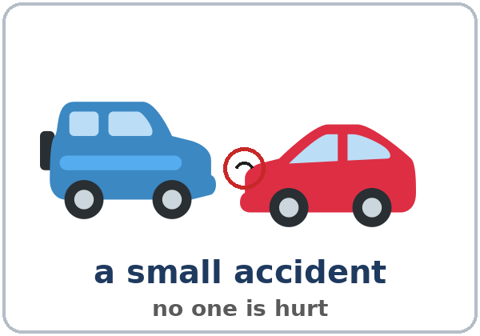  ★ accident | 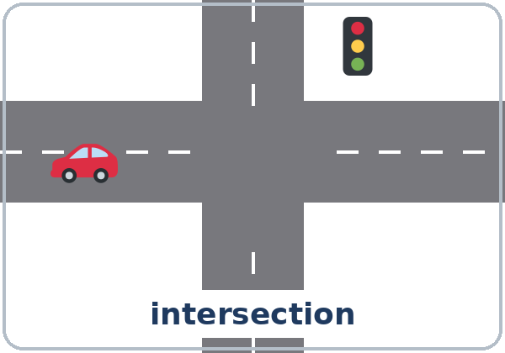  ★ intersection | 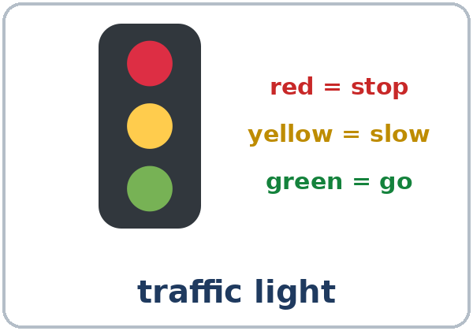  ★ traffic light | 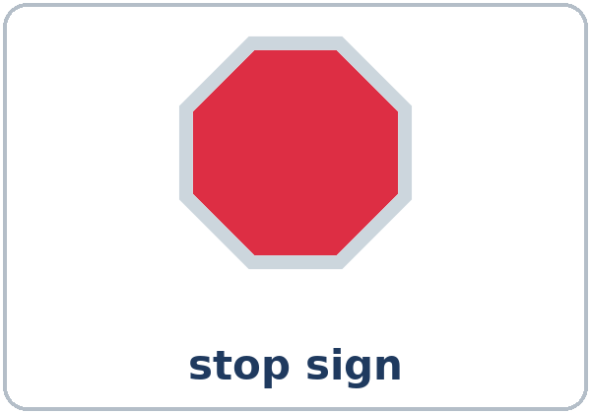  ★ stop sign
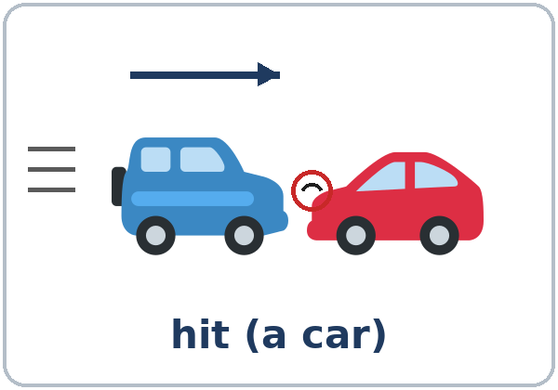  ★ hit (a car) | 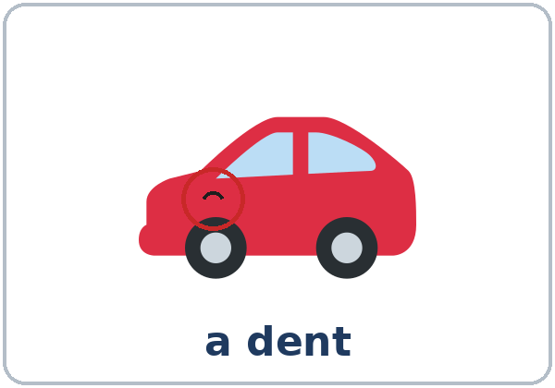  ★ dent | 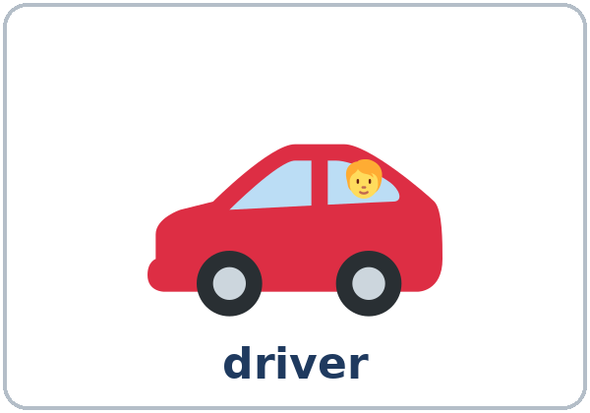  ★ driver | 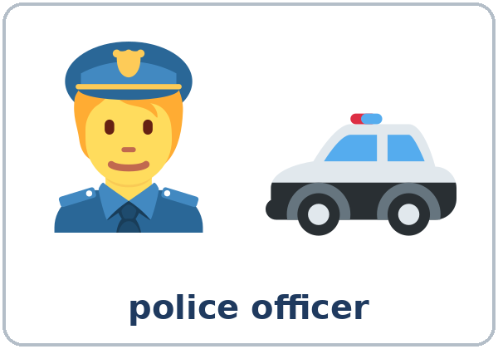  ★ police officer
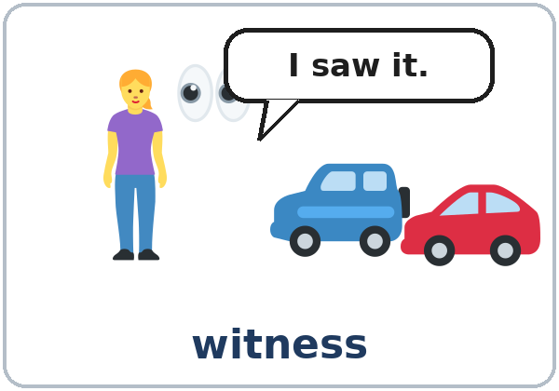  ★ witness | 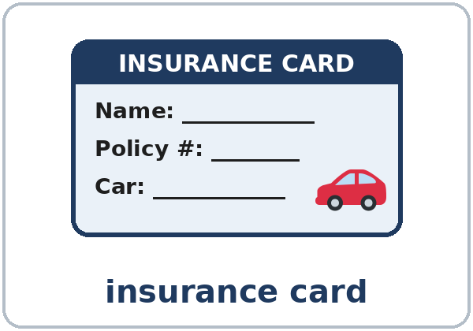  ★ insurance card | 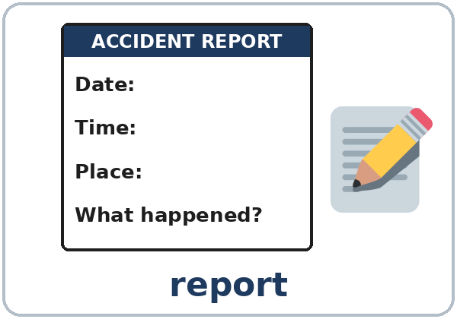  ★ report | 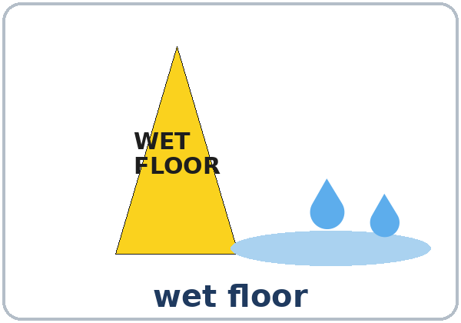  wet floor

Partner game: A says a word. B points and makes a sentence.
Example: A: witness. B: (points) The witness saw the accident.
Lesson 4 (Week 4) · My Words
Write each word in your language, if you want. Then write your own example.
Word | My language | My example
accident
intersection
traffic light
stop sign
hit (a car)
dent
driver
police officer
witness
insurance card
report
wet floor

Lesson 4 (Week 4) · Listening
Listen to Elena. She had a small car accident. Now she's calling Mark at her insurance company.
A. Listen. Circle the answer.
1. Where did it happen? a. in a parking lot b. at the intersection of Oak Street and Second Avenue c. on the highway
2. Was anyone hurt? Yes / No
B. Listen again. Put the events in order. Write 1–5.
Order | What happened?
____ | A police officer wrote a report.
____ | Elena was driving to work.
____ | The other car hit her car.
____ | Elena stopped at the red light.
____ | Elena called her insurance company.

C. Listen again. Write was, were, or wasn't.
1. ____________ anyone hurt?
2. What ____________ you doing when it happened?
3. I ____________ driving to work.
4. He ____________ talking on his phone.
5. He ____________ looking, and he hit my car.
6. Two people ____________ crossing the street.
Say it: I was driving. (wuz, short) • They were crossing. (wer, short) • Yes, I WAS. (strong)
Lesson 4 (Week 4) · Grammar
Read across. A reads from the left side. B answers from the right side. Choose one part from each column.
Grammar Box 1: What were you doing?
QUESTION |  |  |  |  | ANSWER
What were | you | doing | at 8:00?  last night? |  | I was | driving  walking | to work.  home.
What were | they | doing | at the corner? |  | They were | waiting | for the bus.  at the light.
What was | he  she | doing | in the parking lot? |  | He was  She was | carrying | a box.  some bags.

Grammar Box 2: Were you…? Was anyone…? Short answers
QUESTION |  |  |  | ANSWER
Were | you | driving?  working? |  | Yes, | I | was.
Were | you | driving?  working? |  | No, | I | wasn't.
Was | he  she | talking on the phone? |  | Yes, | he  she | was.
Was | he  she | talking on the phone? |  | No, | he  she | wasn't.
Was | anyone | hurt? |  | No, | everyone | was OK.

Grammar Box 3: a long action + when + a short action
LONG ACTION (was / were + -ing) |  | when | ‖ | SHORT ACTION (simple past)
I was waiting at the light |  | when | ‖ | a car hit my car.
We were eating dinner |  | when | ‖ | the phone rang.
They were crossing the street |  | when | ‖ | the light changed.

Grammar Box 4: while + a long action
While + LONG ACTION |  | WHAT HAPPENED
While I was turning left, |  | the other driver was talking on the phone.
While she was walking to work, |  | it started to rain.
While we were waiting for the bus, |  | we saw an accident.

Grammar Box 5: Review: should
QUESTION |  |  | ANSWER
What should I do? | (after a small accident) |  | You should | call your insurance company.  take a picture.  tell your supervisor.
What should I do? | (after a small accident) |  | You shouldn't | leave.  get angry.

Questions and answers
Q: What does was / were + -ing mean?
A: An action was in progress at a time in the past. At 8:00 I was driving. (I started before 8:00 and stopped after 8:00.)
Q: was or were?
A: I / he / she / it was. you / we / they were. Negative: wasn't, weren't.
Q: Which action gets -ing?
A: The long action: I was waiting. The short action that happens in the middle is the simple past: a car hit my car (not was hitting).
Q: when or while?
A: while + the long action: While I was waiting… when + the short action: …when the phone rang.
Q: How do I say it?
A: In a sentence, was and were are short and quiet (wuz, wer). In short answers, they are strong: Yes, I was.
Practice A: Write was or were + the verb with -ing.
1. At 7:00 I ____________________ (eat) breakfast.
2. They ____________________ (wait) for the bus.
3. ________ you ____________ (work) at 9:00 last night?
4. She ____________________ (not / look) at the road.
5. We ____________________ (watch) TV when the lights went out.
6. What ________ he ____________ (do)?
Practice B: Circle the right words.
1. I was driving when a car (hit / was hitting) my car.
2. While I (cooked / was cooking), the phone rang.
3. The phone (rang / was ringing) when I was taking a shower.
4. I was sleeping (when / while) the alarm rang.
5. (When / While) I was turning left, the other driver was talking on the phone.
6. You (should / should to) call your insurance company.
Common mistakes
✗ Don't say | ✓ Say
I was drive to work. | I was driving to work.
They was crossing the street. | They were crossing the street.
I was waiting when a car was hitting my car. | I was waiting when a car hit my car.
Were you work at 9:00? | Were you working at 9:00?
While I cooking, the phone rang. | While I was cooking, the phone rang.
You should to call the police. | You should call the police.

Nota para hispanohablantes: I was driving = Estaba manejando. Usa was / were + -ing para la acción larga. La acción corta usa el pasado simple: when the phone rang = cuando sonó el teléfono (no was ringing). No olvides was / were: I was driving (no I driving).

Tip for speakers of other languages: long action = was / were + -ing. A short action that interrupts it = the simple past (hit, rang, saw).

Lesson 4 (Week 4) · Talk Time: Witness
Work with a partner. Round 1: A looks at Picture 1 for 30 seconds. B doesn't look. Then A turns the page over. B asks the Round 1 questions on the Witness Form. A answers.
B: Was anyone crossing the street? A: Yes. A woman was crossing.
B: What was the man with the dog doing? A: I think he was walking.
Useful: I think… I'm not sure. I didn't see. Yes, … was… / No, no one was…

Picture 1: Main Street
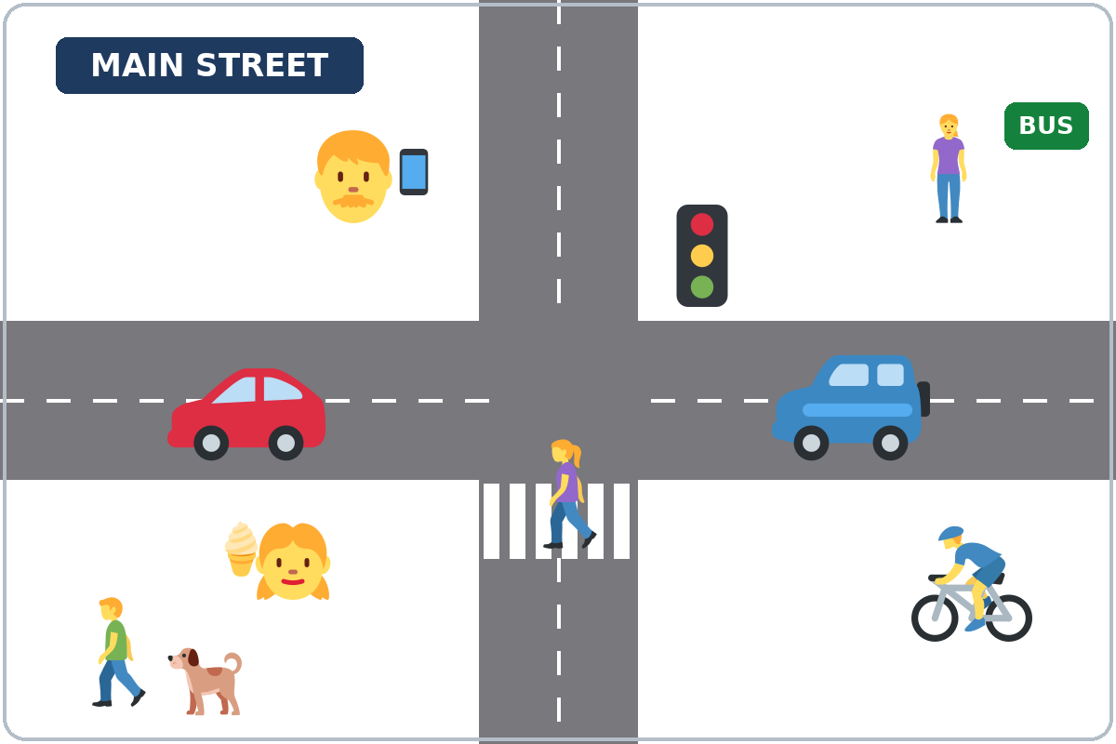

Lesson 4 (Week 4) · Talk Time: Witness (Round 2)
Round 2: Switch. B looks at Picture 2 for 30 seconds. A doesn't look. Then A asks the Round 2 questions.
Picture 2: A parking lot
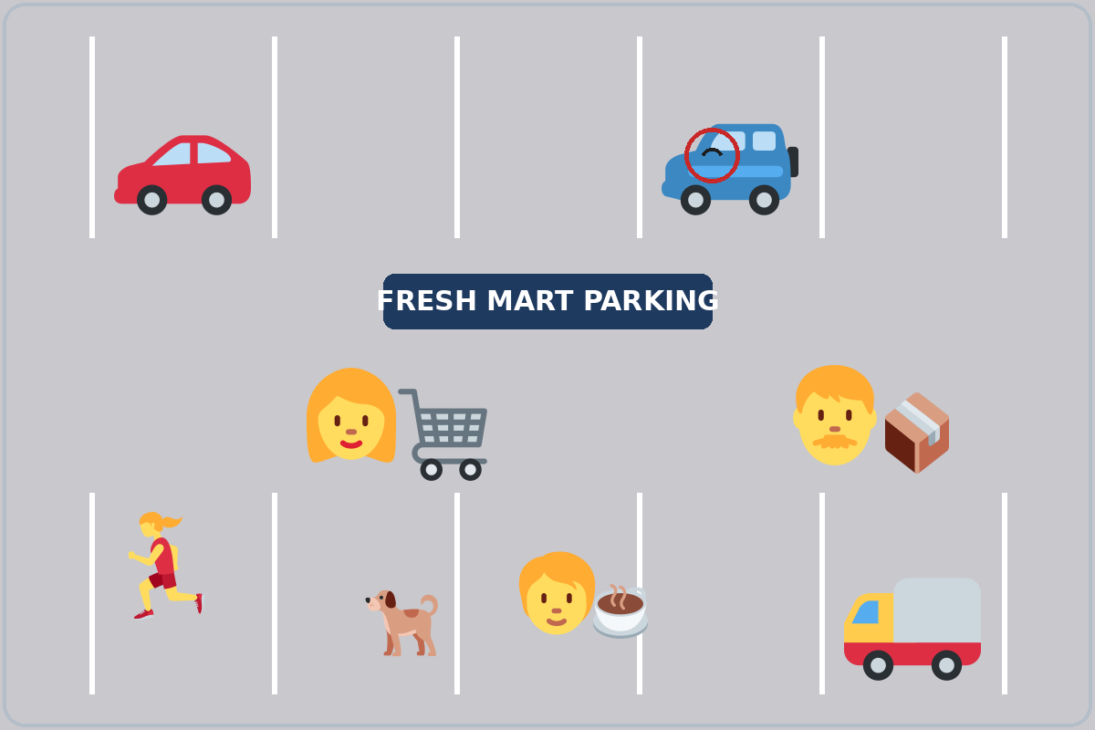

Lesson 4 (Week 4) · Talk Time: Witness Form
Ask the questions. Write short answers. Then look at the picture together and check ✓ the right answers.
Round 1 (Picture 1: Main Street) | Answer | ✓
1. Was anyone crossing the street? |  | ☐
2. What was the man with the dog doing? |  | ☐
3. What was the woman at the bus stop doing? |  | ☐
4. What was the man with the phone doing? |  | ☐
5. What was the girl doing? |  | ☐
6. What was the man on the bike doing? |  | ☐

Round 2 (Picture 2: a parking lot) | Answer | ✓
1. What was the woman with the cart doing? |  | ☐
2. What was the man carrying? |  | ☐
3. Was anyone running? |  | ☐
4. What was the person with the cup doing? |  | ☐
5. Which car had a dent? |  | ☐
6. My question: ______________________________ |  | ☐

My score: Round 1 ______ / 6 Round 2 ______ / 6
Lesson 4 (Week 4) · Homework
Homework (about 15 minutes). Bring it next week!
1. What were you doing yesterday at these times? Write sentences with I was…ing.
Example: At 7:00 a.m., I was making breakfast.
1. At 7:00 a.m., ______________________________________________________
2. At 12:00 p.m., ______________________________________________________
3. At 6:00 p.m., ______________________________________________________
4. At 9:00 p.m., ______________________________________________________
2. Make one sentence with when.
Example: I was walking. It started to rain. → I was walking when it started to rain.
1. I was cooking. The phone rang. → ______________________________________________
2. We were watching TV. The lights went out. → ______________________________________________
3. She was walking to work. It started to rain. → ______________________________________________
4. They were eating dinner. Their friend called. → ______________________________________________
3. Ask a family member, a neighbor, or a friend: What were you doing at 8:00 last night? Write the answers.
Name | What was he / she doing?

4. Review (Lesson 3): Write 2 sentences with used to or didn't use to.
______________________________________________________________
______________________________________________________________
Lesson 4 (Week 4) · Read & Write
A. Look at the pictures. Then read Lee's story.
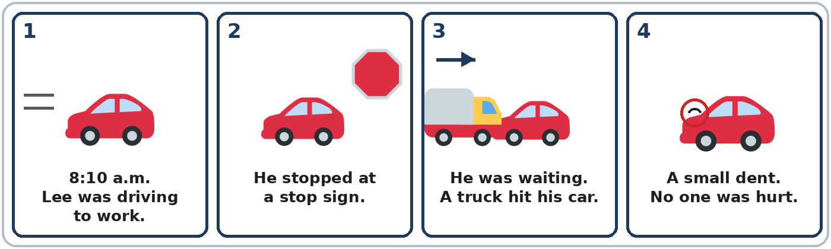

My Accident, by Lee Walker
Last Tuesday, May 12, at 8:10 in the morning, I was driving to work. It was raining a little. I stopped at the stop sign at Pine Street and River Road. While I was waiting, a big truck hit my car from behind. It happened so fast! The truck driver was looking at his map. He wasn't looking at the road. No one was hurt, but my car has a dent. A man was walking his dog on the corner, and he saw everything. He was a witness. A police officer came and wrote a report. Then I called my supervisor, because I was late for work.

B. Answer the questions.
1. What was Lee doing at 8:10? ______________________________________________
2. Where did he stop? ______________________________________________
3. What was the truck driver doing? ______________________________________________
4. Was anyone hurt? ______________________________________________
5. Who was the witness? ______________________________________________
C. You are Lee. Fill out the accident report. Use the story.
ACCIDENT REPORT
Name
Date
Time
Place
What were you doing?
What happened?
Was anyone hurt?
Damage to your car
Witness
Did the police write a report? | ☐ Yes ☐ No

D. Check your report with a partner.
 | Yes | Not yet
"What were you doing?" has was + -ing. | ☐ | ☐
"What happened?" has a simple past verb (hit). | ☐ | ☐
The date, time, and place are the same as in the story. | ☐ | ☐
Each sentence starts with a capital letter and ends with a period. | ☐ | ☐

Lesson 4 (Week 4) · Progress Check
Name: ______________________________ Date: ________________
A. Listen to the teacher. Circle a or b.
1. a. driving to work b. waiting at the light
2. a. driving to work b. waiting for the bus
3. a. Someone was hurt. b. No one was hurt.
4. a. talking on the phone b. crossing the street
B. Circle the right words.
1. I (was / were) driving to work.
2. Two people (was / were) crossing the street.
3. (Was / Were) you working at 9:00?
4. He (wasn't / weren't) looking at the road.
C. Finish the sentences.
1. I was cooking dinner when ______________________________________________
2. While I was walking to work, ______________________________________________
Score: A ______ / 4 B ______ / 4 C ______ / 2
D. How do you feel? Check ✓ one face for each line.
I can… | 😀 I can do it. | 🙂 With a little help. | 😐 Not yet.
I can say what I was doing at a time in the past. | ☐ | ☐ | ☐
I can tell what happened with when and while. | ☐ | ☐ | ☐
I can answer questions about a small car accident. | ☐ | ☐ | ☐
I can fill out a simple accident report. | ☐ | ☐ | ☐

Picture Credits
Pictures use Twemoji graphics by Twitter, Inc. and other contributors (https://github.com/jdecked/twemoji), licensed under CC BY 4.0 (https://creativecommons.org/licenses/by/4.0/). The graphics were resized and combined, and drawings (roads, signs, a dent mark, forms, a parking lot) and labels were added. The file-by-file list is in images/CREDITS.md.
Listening audio: synthetic voices made with Chatterbox TTS (Resemble AI, MIT License), cloned from synthetic reference clips made with Kokoro-82M (Apache License 2.0). No recordings of real people were used. Each file carries an inaudible Perth watermark marking it as AI-generated. The names and the story are invented.
Course materials: © 2026 the authors, licensed under CC BY-NC-SA 4.0 (https://creativecommons.org/licenses/by-nc-sa/4.0/).

