Level 3 Adult ESL Curriculum · Lesson 9 (Week 10): My Strengths
Status: Complete lesson (all 13 Level 3 lessons are published).
Date: October 2026
Audience: Program coordinators and volunteer teachers
Companion files: audio/L3_L9_listening.mp3, images/ (12 vocabulary pictures, 1 activity picture + images/CREDITS.md)
Topic: skills, strengths, and interests for work: answering job-interview questions with good at, interested in, enjoy, and don't mind + -ing, and reading a job ad.

How this lesson is organized
Part | What's inside | Who uses it
Teacher Plan | At a glance, clock-time plan, step-by-step boxes, listening script, answer key, teacher notes | Volunteer teachers
Student Pages | Opening Talk, New Words, My Words, Listening, Grammar, Talk Time, Homework, Read & Write, Progress Check. Print this part for learners | Learners
Picture Credits | Picture, audio, and license credits | Coordinators

What Lesson 9 builds on and what it adds
Before (review only) | Where | New in Level 3 Lesson 9
I can… | Level 1 | I'm good at + -ing: I'm good at fixing things.
like / love / hate + -ing | Level 2 | enjoy / don't mind + -ing: I don't mind working weekends.
Jobs and workplaces | Levels 1–2 | Strengths, experience, and shifts in a job interview
Reasons with because | Level 3 Lesson 1 | An example after each strength: I'm reliable. I was never late.
mine, yours, hers… | Level 3 Lesson 8 | Opening Talk and Homework review

TEACHER PLAN
Lesson 9 (Week 10)

My Strengths
At a glance · Clock-time plan · Step by step · Script and answer key

How to Use This Plan
You don't need to speak Spanish or any other language. Teach in English. Show, point, and gesture. Each Grammar page has one short Spanish note and one tip for speakers of other languages. Learners read them on their own. You never need to read, translate, or explain them.

Instructions: use the same short task words every week: Listen. Circle. Check. Write. Work with a partner. Work in a group. Ask a follow-up question. Learners have the Task Words page from Lesson 1.

Instruction rule: Model it (do it with one learner while everyone watches), check it (ask: "Do you write or speak? How many people do you talk to?"), then go. Say less, show more.

Grouping toolkit: Pairs: turn to a neighbor; with an odd number, make one group of 3. Groups: 3–4 learners. Inside–outside circles: the inner circle faces out, the outer circle faces in; the outer circle moves one person to the right each round. Mingle: everyone stands and talks to many classmates. The teacher joins a pair only if one learner is left over.

When a learner is stuck or speaks another language to you: (1) show it: the picture, a gesture, or the board; (2) give one more short English example; (3) point to the grammar box on their page; (4) a classmate can help for a few seconds, then back to English. You don't need to understand what classmates say to each other.

Lesson 9 (Week 10): My Strengths
At a glance
Objectives: learners can…
• say what they are good at: I'm good at fixing things. / I'm good with people.
• say what they are interested in: I'm interested in learning new skills.
• say what they enjoy and don't mind: I enjoy helping people. I don't mind working weekends.
• give an example after a strength: I'm reliable. I was never late at my last job.
• answer Tell me about yourself in 3–4 sentences
• read two short job ads and write a 3-sentence skills summary

Materials
• Student Pages for Lesson 9 (print for the number expected + 3 spares)
• Talk Time: the four job cards and the Manager Questions (on the Talk Time pages)
• phone + small speaker, L3_L9_listening.mp3
• Prep time: 10 min (decide where the two circles will stand).

Key vocabulary (with pictures on the New Words page)
★ strength • ★ good at • ★ interested in • ★ experience • ★ reliable • ★ teamwork • ★ organize • ★ solve problems • ★ résumé • ★ apply • ★ training • shift

Clock-time plan
Times are loose. If a step runs long, take time from Read & Write first, then from Talk Time.
Time | Step | Min | Grouping (15 / 7–8) | If running behind
6:00–6:10 | Opening Talk + Homework Check | 10 | Pairs (7 pairs + 1 trio / 3–4 pairs) | One card only
6:10–6:18 | New Words (picture page) + pair game | 8 | Whole class, then pairs | Teach the ★ words only
6:18–6:30 | Listening: play 1 (Task A), play 2 (Tasks B and C) + "Say it" | 12 | Individuals, then pairs check | Do Task C together on the board
6:30–6:45 | Grammar Q&A: good at / interested in / enjoy / don't mind + -ing + pair drill | 15 | Whole class, then pairs | Skip the pair drill; Talk Time practices it
6:45–7:00 | BREAK | 15
7:00–7:12 | Talk Time: Interview Rotation | 12 | Inside–outside circles (pairs with 5 or fewer) | 2 rotations, no role switch
7:12–7:17 | Exit Ticket + Homework | 5 | Individuals | Never skip
7:17–7:25 | Read & Write: two job ads; write a skills summary | 8 | Individuals, then pairs | Reading questions only; the summary becomes homework
7:25–7:30 | Progress Check | 5 | Individuals | Do it in Week 11 at 6:00, while people arrive

Skip order if you're running behind: (1) the Read & Write skills summary (it becomes homework); (2) the pair drill at the end of Grammar; (3) half of Talk Time (2 rotations, no role switch). Never skip: the listening tasks, the grammar boxes and the mistakes table, and the exit ticket.

Attendance (15 → 7–8): every step lists both sizes. With 5 or fewer, sit at one table: one manager interviews one applicant while the others listen and note one strength; then change roles.

Step by step
Step 1 · 6:00–6:10 · Opening Talk + Homework Check · 10 min
• Grouping: pairs, the same partner for both parts. 15 learners: 7 pairs + 1 group of 3. 7–8 learners: 3–4 pairs.
• Before class: write on the board: Whose… is this? It's mine. / It's hers.
• Opening Talk (6 min): learners open the Opening Talk page. A asks a card question; B answers with 2–3 sentences; A asks one follow-up. Switch after each card.
• Model with one learner: "Did you ever lose something important?" → (answer) → "Really? Where did you find it?"
• Homework Check (4 min): partners read their Lesson 8 Homework item 3 (The blue cup is mine…) to each other. Walk around. Write 2 common errors on the board (often It's the mine or his for a woman) and correct them together.
• Late arrivals: join any pair as a group of 3.
• If behind: one card only, then the homework check.

Step 2 · 6:10–6:18 · New Words · 8 min
• Grouping: whole class, then pairs. Show the New Words page.
• Do: point to each picture and say the word. Learners repeat once. Show strength: make a strong arm. Show reliable: point to the clock, "always on time."
• Show good at: "I'm good at cooking. I'm not good at singing!" Mime both.
• Check meaning (1 min): "A paper with your jobs and skills is a…?" (résumé) • "Morning, evening, or night work time is a…?" (shift) • "A class at work for new workers is…?" (training)
• Pairs (2 min): A says a word; B points to the picture and makes a sentence (I'm good at solving problems.). Switch.
• If behind: teach the ★ words only.

Step 3 · 6:18–6:30 · Listening + "Say it" · 12 min
• Grouping: individuals, then pairs check.
• Before you listen (1 min): say: "Lucia has a job interview at a hotel. She wants a maintenance job. Does she get a second interview? Listen."
• Play 1 → Task A (a second interview?). Pairs compare. Check together.
• Read Tasks B and C together (1 min) so learners know what to listen for.
• Play 2 → Tasks B and C. Pairs compare. Then show the answers (answer key).
• "Say it" (2 min): say: "The end of -ing is in the nose: fix-ing, help-ing, work-ing." Don't add a g or k sound at the end. Then stress: INterested, exPERience. The class repeats each word twice.
• The audio plays the conversation once (about 1:20). Press play again for play 2. A third play is fine if the class needs it.
• If behind: do Task C together on the board, reading the lines yourself.

Step 4 · 6:30–6:45 · Grammar Q&A · 15 min
• Grouping: whole class, then pairs. Show the Grammar page. The left side is the question. The right side is the answer.
• Show it (2 min): write on the board: good at + fixing. Say: "After at, in, about, the verb gets -ing." Write I'm good at fix. and cross it out.
• Boxes 1, 2, and 3 (5 min): read a question from the left; the class answers from the right. Then ask 3 learners: "What are you good at?" Help them finish with an -ing word.
• Box 4 (2 min): read the spelling rows: fix → fixing, organize → organizing (no e), shop → shopping (double letter).
• Check questions: "I'm interested ___ learning." (in) • "I enjoy ___ (help) people." (helping) • "I'm good ___ cooking." (at) • "I don't mind ___ (work) at night." (working)
• Practice A and B (3 min): learners write, then pairs check. Go over the answers.
• Pair drill (last 2 min): A asks "What are you good at?" B answers and gives one example (I'm good at cooking. I cook for my family every day.). Switch.
• If behind: skip the pair drill. Talk Time practices it.

Break · 6:45–7:00 · 15 min
• Write on the board: What are you good at? / Are you interested in…? / Do you enjoy…? / I don't mind… and at / in + -ing. Set up the two circles of chairs if you have the space.

Step 5 · 7:00–7:12 · Talk Time: Interview Rotation · 12 min
• Grouping: inside–outside circles. The inner circle are managers; the outer circle are applicants. 15 learners: 7 managers + 8 applicants (one applicant waits and listens each round). 7–8 learners: 4 and 4 (or 3 and 4). 5 or fewer: one manager, the others take turns as applicants.
• Before (2 min): each manager chooses a job card (1–4) and the Manager Questions. Each applicant fills in the "My answers" box on their page (strengths, experience, shifts). Invented details are fine.
• Model with one learner (1 min): you are the manager at the hotel (card 2). "Tell me about yourself." → (answer) → "What are you good at?" → (answer) → follow-up: "Can you give me an example?"
• Rotation (6 min): each interview is about 2 minutes: the manager asks 3 questions from the card and one follow-up, then writes one strength in the notes table. Then say "Move!" The outer circle moves one person to the right. 3 rotations.
• Switch (3 min): managers and applicants change places for one or two more rotations.
• Finish: ask 2 managers: "Who gets a second interview? Why?" (Ana, because she's good at organizing.)
• If behind: 2 rotations, no role switch.

Step 6 · 7:12–7:17 · Exit Ticket + Homework · 5 min · NEVER SKIP
• Exit ticket: each learner writes two sentences on a slip: one with good at or interested in + -ing (I'm good at organizing things.), and one with an example and because or so (I'm reliable, so I'm never late.). Collect at the door.
• Homework: open the Homework page. Do item 1 together (one sentence on the board). Say: "About 15 minutes. Bring it next week."

Read & Write · 7:17–7:25 · Two Job Ads and a Skills Summary · 8 min
• Grouping: individuals, then pairs check.
• Read (3 min): learners read the two job ads and answer questions 1–5. Say: "Read fast first. Then find the answers."
• Pairs check (1 min): compare answers; check together.
• Write (4 min): learners write a 3-sentence skills summary for themselves or an invented person: a strength with an example, experience, and an interest. Say: "You can invent the job history."
• If behind: questions 1–5 only; the summary becomes homework.

Progress Check · 7:25–7:30 · 5 min
• Grouping: individuals. Open the Progress Check page.
• Part A: read the 4 sentences in the answer key, slowly, 2 times each. Learners circle a or b.
• Parts B and C: learners do them alone. Walk around and help with the instructions only.
• Part D: read each "I can…" line aloud and point to the 3 faces: 😀 "I can do it." 🙂 "With a little help." 😐 "Not yet."
• Collect the pages (or check them at the start of Week 11).
• If behind: do the Progress Check in Week 11 at 6:00, while learners arrive.

Listening script: L3_L9_listening.mp3 (about 1:20; the conversation plays once, so press play again for the second listen)
Audio: play from a phone + small speaker. No speaker? Read the script with a volunteer, at a normal, friendly speed.

Narrator: Lesson nine. Listening. Lucia has a job interview at a hotel. Mr. Hall is the manager. Listen.
Mr. Hall: Hi, Lucia. Thank you for coming in. Please sit down. So, tell me about yourself.
Lucia: Well, I have three years of experience in maintenance. I worked at a big apartment building.
Mr. Hall: That's great. What are you good at?
Lucia: I'm good at fixing things, and I'm good at solving problems.
Mr. Hall: Are you reliable?
Lucia: Yes. I was never late at my last job, and I always finish my work.
Mr. Hall: Good. Do you enjoy working on a team?
Lucia: Yes, I enjoy helping people. I like teamwork.
Mr. Hall: Are you interested in training? We have a class for new workers.
Lucia: Yes! I'm very interested in learning about the machines here.
Mr. Hall: Which shift can you work?
Lucia: I can work the day shift. And I don't mind working weekends.
Mr. Hall: Great. I'd like you to meet our team. Can you come back on Thursday for a second interview?
Lucia: Yes, of course. Thank you!
Narrator: That's the end of the listening.

Answer key
• Listening Task A: Yes (on Thursday).
• Listening Task B: 1 three years • 2 ✓ fixing things, ✓ solving problems, ✓ helping people, ✗ cooking, ✗ driving • 3 the day shift • 4 Yes, she doesn't mind working weekends. • 5 Thursday.
• Listening Task C: 1 fixing, 2 solving, 3 working, 4 helping, 5 learning, 6 working.
• Grammar Practice A: 1 cooking, 2 learning, 3 working, 4 organizing, 5 shopping, 6 fixing.
• Grammar Practice B: 1 at, 2 in, 3 helping, 4 working, 5 good with.
• Talk Time: answers will vary.
• Homework 1: 1 I'm good at cooking. 2 She's interested in learning English. 3 He enjoys working with his hands. 4 I don't mind working at night. Homework 2, 3, and 4: answers will vary.
• Read & Write B: 1 Lakeview Inn and Little Stars Center • 2 Little Stars Center • 3 the night shift (11 p.m.–7 a.m.) • 4 a résumé • 5 on Saturday mornings • Writing (C): answers will vary.
• Progress Check Part A (the teacher says, 2 times each): 1 "He's good at fixing cars." → a • 2 "She's interested in working with children." → b • 3 "He doesn't mind working at night." → a • 4 "He enjoys cooking for his family." → b
• Progress Check Part B: 1 at, 2 in, 3 working, 4 helping.
• Progress Check Part C: answers will vary; for example 1 I'm good at organizing. I organize the shelves at my job. 2 I'm interested in learning about computers.
• Progress Check scoring: A /4 + B /4 + C /2 = /10. This is not a test grade. It shows who needs more help hearing the phrases (A) and with at / in + -ing (B, C).
Teacher notes
• Invented job histories are fine (important): invite, don't require, real job details. Learners can talk about home, family, or volunteer work, or invent a job history. Never ask about immigration or work status, papers, or pay.
• The one rule: after at, in, about (and after enjoy and don't mind), use -ing: good at fixing, interested in learning, enjoy helping, don't mind working.
• good at or good with? good at + an activity (good at cooking). good with + people or things (good with people, good with numbers, good with my hands).
• Give an example: in a real interview, a strength is stronger with an example: I'm reliable. I was never late at my last job. Praise every example.
• Spelling: most verbs add -ing. Drop a final e (organize → organizing). Short words like shop, run double the last letter (shopping, running). Don't teach more rules than this.
• Typical mistakes this week: I'm good at cook, interested on, I enjoy to work, I'm boring of… (save bored / boring for Lesson 11), I don't mind work. Say the right form clearly; the learner repeats. Learners can read the Spanish note and the tip on their Grammar page themselves; you don't need to explain them.
• Mixed levels: stronger learners add a second example and a follow-up question. Newer learners use Boxes 1–3 as a script.

STUDENT WORKBOOK
Lesson 9 (Week 10)

My Strengths
Opening Talk · New Words · Listening · Grammar · Talk Time · Homework · Read & Write · Progress Check

Lesson 9 (Week 10) · Opening Talk
Name: ______________________________ Date: ________________
Work with a partner. A asks a question. B answers with 2–3 sentences. A asks one follow-up question. Then switch.
Did you ever lose something important? What was it? | Look at your bag. What is in it? Is it all yours?
Your friend finds a phone in class. What does she say? | Describe your favorite jacket or bag.

Follow-ups: Really? Where did you find it? Whose is it? What color is it?
Homework check: read your Lesson 8 homework (item 3) to your partner. Your partner asks one question about it.
Something at my partner's home, and whose it is | My question about it

Lesson 9 (Week 10): My Strengths
Student Page 1 · Week 10
Name: ______________________________ Date: ________________
New Words
Look. Listen. Repeat. ★ = most important words.
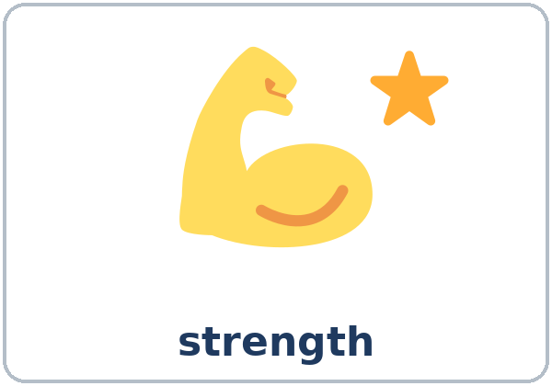  ★ strength | 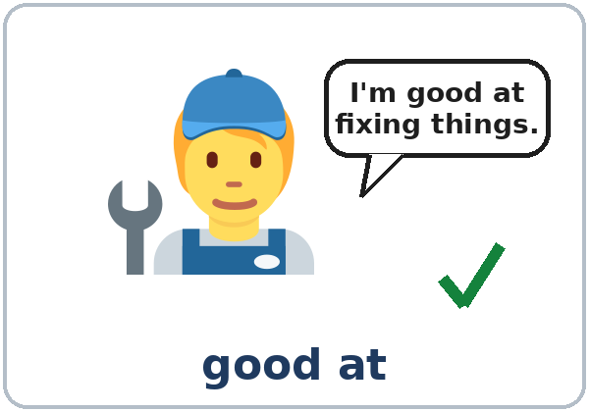  ★ good at | 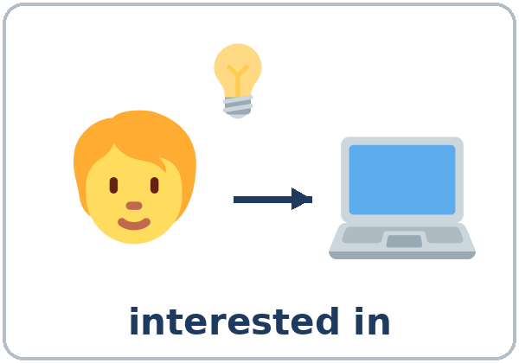  ★ interested in |   ★ experience
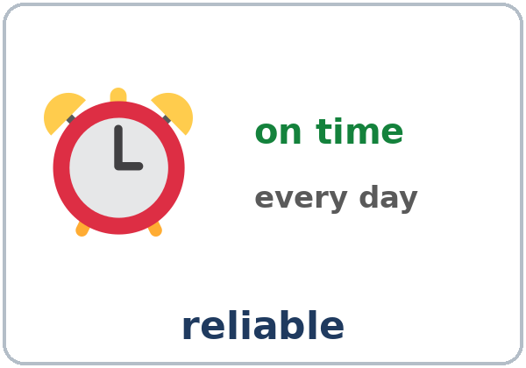  ★ reliable | 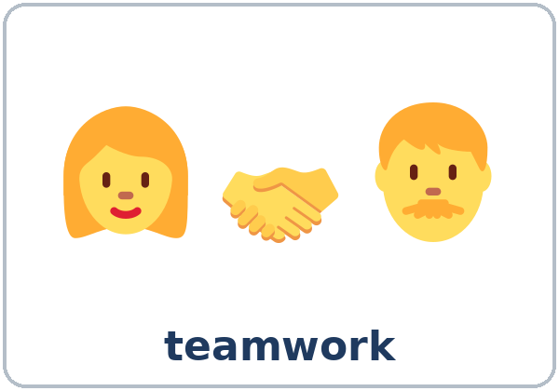  ★ teamwork | 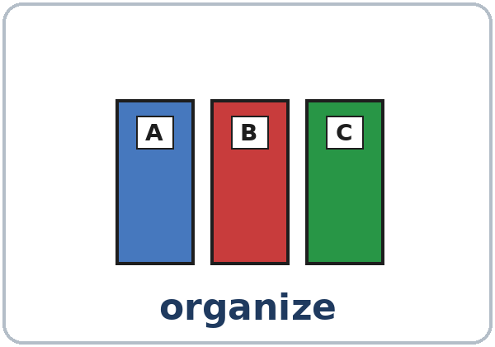  ★ organize | 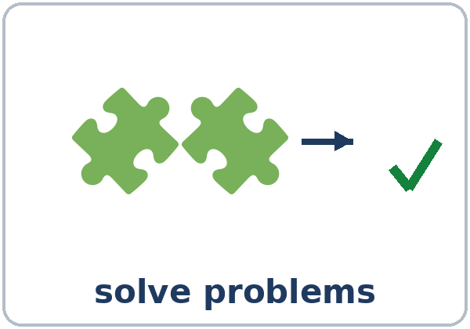  ★ solve problems
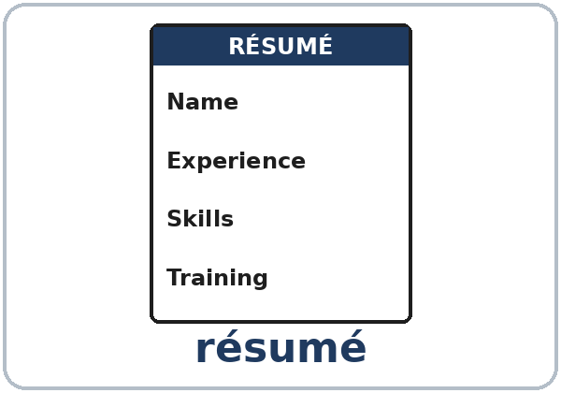  ★ résumé | 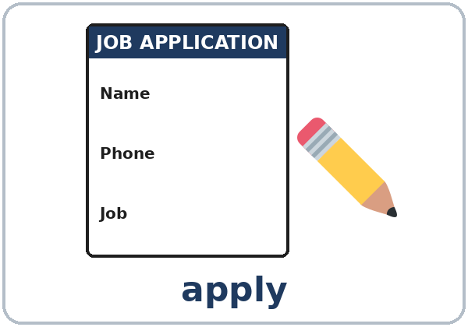  ★ apply | 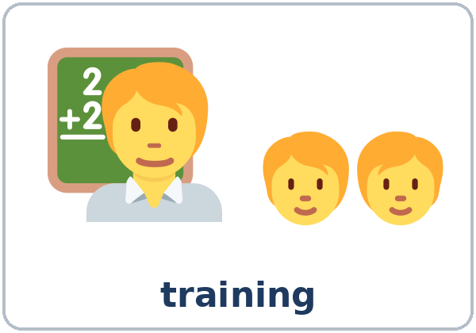  ★ training | 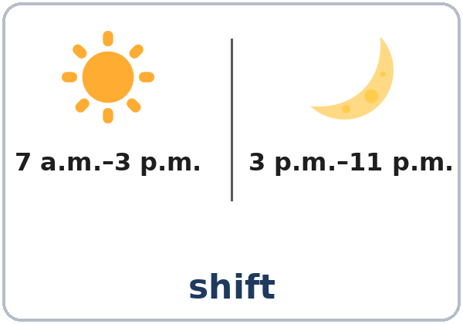  shift

Partner game: A says a word. B points and makes a sentence.
Example: A: reliable. B: (points) I'm reliable. I'm always on time.
Lesson 9 (Week 10) · My Words
Write each word in your language, if you want. Then write your own example.
Word | My language | My example
strength
good at
interested in
experience
reliable
teamwork
organize
solve problems
résumé
apply
training
shift

Lesson 9 (Week 10) · Listening
Listen to Lucia. She has a job interview at a hotel. Mr. Hall is the manager.
A. Listen. Does Lucia get a second interview? Circle.
Yes No
B. Listen again. Circle or check ✓.
1. Experience: three years / five years
2. She's good at… / She enjoys… ☐ fixing things ☐ solving problems ☐ helping people ☐ cooking ☐ driving
3. Shift: the day shift / the night shift
4. Can she work weekends? Yes / No
5. The second interview is on: Tuesday / Thursday
C. Listen again. Write the -ing word.
1. I'm good at ____________ things.
2. I'm good at ____________ problems.
3. Do you enjoy ____________ on a team?
4. Yes, I enjoy ____________ people.
5. I'm very interested in ____________ about the machines here.
6. I don't mind ____________ weekends.
Say it: fixing • helping • working (end in the nose, no k) • INterested • exPERience
Lesson 9 (Week 10) · Grammar
Read across. A reads from the left side. B answers from the right side. Choose one part from each column.
Grammar Box 1: good at
QUESTION |  |  | ANSWER
What are you | good at? |  | I'm good at | fixing things.  cooking.
Are you | good at organizing? |  | Yes, I am. I'm good at | organizing shelves.
Are you | good with people? |  | Yes, I'm good with | people.  numbers.  my hands.

Grammar Box 2: interested in
QUESTION |  |  | ANSWER
What are you | interested in? |  | I'm interested in | learning new skills.
Are you | interested in training? |  | Yes, I'm very interested in | working with computers.

Grammar Box 3: enjoy / don't mind
QUESTION |  |  | ANSWER
Do you | enjoy working on a team? |  | Yes, I enjoy | helping people.
Can you | work weekends? |  | Yes, I don't mind | working weekends.  working at night.

Grammar Box 4: -ing spelling
MOST VERBS: + -ing | END IN e: no e + -ing | SHORT WORDS: double + -ing
fix → fixing | organize → organizing | shop → shopping
help → helping | solve → solving | run → running
work → working | drive → driving | plan → planning

Questions and answers
Q: good at fix or good at fixing?
A: good at fixing. After at, in, about, use -ing. (not good at fix)
Q: interested in or interested on?
A: interested in: I'm interested in learning English.
Q: I enjoy to work or I enjoy working?
A: I enjoy working. After enjoy and don't mind, use -ing.
Q: good at or good with?
A: good at + an activity: good at cooking. good with + people or things: good with people, good with numbers.
Q: What does I don't mind mean?
A: It's OK for me. It's not a problem: I don't mind working weekends.
Practice A: Write the -ing word.
1. I'm good at ____________ (cook).
2. She's interested in ____________ (learn) English.
3. Do you enjoy ____________ (work) outside?
4. He's good at ____________ (organize) things.
5. They don't mind ____________ (shop) for the office.
6. I'm good at ____________ (fix) bikes.
Practice B: Circle the right words.
1. I'm good (at / in) solving problems.
2. Are you interested (on / in) training?
3. I enjoy (help / helping) customers.
4. I don't mind (work / working) at night.
5. She's (good at / good with) people.
Common mistakes
✗ Don't say | ✓ Say
I'm good at cook. | I'm good at cooking.
I'm interested on computers. | I'm interested in computers.
I enjoy to work on a team. | I enjoy working on a team.
I don't mind work weekends. | I don't mind working weekends.

Nota para hispanohablantes: después de at / in / about, el inglés usa -ing: good at cooking (en español: bueno para cocinar, con el infinitivo). Se dice interested in (no interested on).

Tip for speakers of other languages: in an interview, give an example after each strength: I'm reliable. I was never late at my last job.

Lesson 9 (Week 10) · Talk Time: Interview Rotation
Work in two circles. The inner circle are managers. The outer circle are applicants. Managers choose a job card and ask 3 questions + 1 follow-up. Applicants answer with good at / interested in / enjoy. Then move!
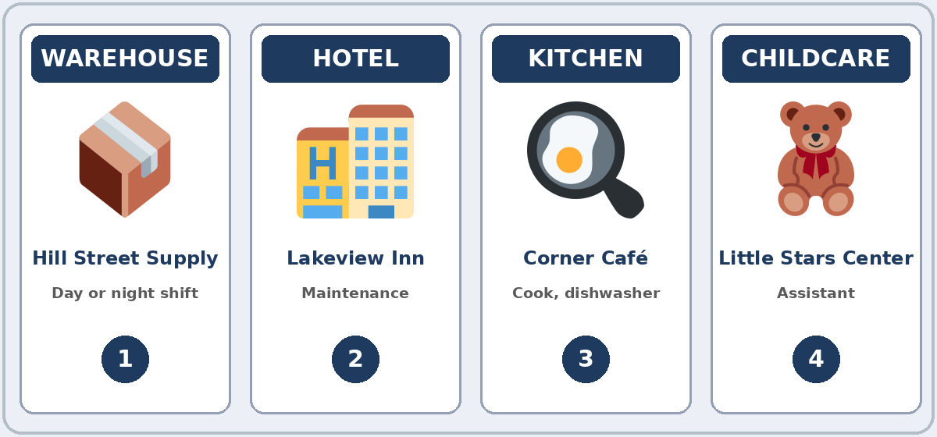

Manager Questions
1. Tell me about yourself. | 2. What are you good at?
3. Are you interested in training? | 4. Do you enjoy working on a team?
5. Which shift can you work? | 6. Do you mind working weekends?

Follow-ups: Can you give me an example? Why? Where did you learn that?
Applicant: I'm good at organizing. At my last job, I organized the shelves every day.

Lesson 9 (Week 10) · Talk Time: My Notes
Applicants: fill in your answers before you start. You can invent them.
My answers
I'm good at…
An example
I'm interested in…
My experience
Shifts I can work

Managers: after each interview, write one strength. Do they get a second interview? Why?
Applicant's name | One strength | Second interview? Why?

Finish: tell the class one person who gets a second interview, and why. Ana, because she's good at organizing.
Lesson 9 (Week 10) · Homework
Homework (about 15 minutes). Bring it next week!
1. Write the sentence. Use the -ing word.
Example: I / good at / drive → I'm good at driving.
1. I / good at / cook → ______________________________________________
2. She / interested in / learn English → ______________________________________________
3. He / enjoy / work with his hands → ______________________________________________
4. I / don't mind / work at night → ______________________________________________
2. A manager says: Tell me about yourself. Write 3–4 sentences. You can invent the details.
Example: I have two years of experience in a kitchen. I'm good at cooking, and I'm reliable. I'm interested in learning new recipes.
______________________________________________________________
______________________________________________________________
______________________________________________________________
3. Ask a family member or a coworker: What are you good at? Write the answer and one example.
Example: My sister is good at fixing things. She fixed our door last week.
______________________________________________________________
______________________________________________________________
4. Review (Lesson 8): Write 2 sentences with mine, yours, his, hers, ours, or theirs.
______________________________________________________________
______________________________________________________________
Lesson 9 (Week 10) · Read & Write
A. Read the two job ads.
JOB AD 1 · Lakeview Inn · Night Desk Clerk
We're looking for a reliable night desk clerk. Shift: 11 p.m.–7 a.m., four nights a week. You are good with people and good at solving problems. Experience is not necessary; we have paid training. Please apply in person with your résumé. Lakeview Inn, 90 Lake Road.

JOB AD 2 · Little Stars Center · Childcare Assistant
We need a childcare assistant on Saturday mornings, 8 a.m.–12 p.m. Are you interested in working with children? Do you enjoy reading, singing, and playing games? You must be patient and good at teamwork. One year of experience with children is necessary. Call Ms. Park at 555-0174.

B. Answer the questions.
1. Which two places are hiring? ______________________________________________
2. Which job needs experience? ______________________________________________
3. Which shift is the Lakeview Inn job? ______________________________________________
4. What do you bring to Lakeview Inn? ______________________________________________
5. When is the childcare job? ______________________________________________
C. Write a 3-sentence skills summary for you or an invented person. Write: a strength + an example, your experience, and one interest.
Example: I'm good at organizing; I organized the storeroom at my last job. I have two years of experience in a warehouse. I'm interested in learning to drive a forklift.
My skills summary

D. Check your summary with a partner.
 | Yes | Not yet
It has a strength and an example. | ☐ | ☐
It has experience (I have… years of experience…). | ☐ | ☐
It has interested in + -ing. | ☐ | ☐
It uses -ing after at / in. | ☐ | ☐

Lesson 9 (Week 10) · Progress Check
Name: ______________________________ Date: ________________
A. Listen to the teacher. Circle a or b.
1. a. He can fix cars. b. He wants to learn about cars.
2. a. She works with children now. b. She wants to work with children.
3. a. Night work is OK for him. b. Night work is a problem for him.
4. a. He doesn't like cooking. b. He likes cooking for his family.
B. Circle the right words.
1. I'm good (at / on) solving problems.
2. She's interested (in / at) training.
3. I don't mind (work / working) weekends.
4. He enjoys (helping / to help) people.
C. Write.
1. What are you good at? Give an example. ______________________________________________
2. What are you interested in? ______________________________________________
Score: A ______ / 4 B ______ / 4 C ______ / 2
D. How do you feel? Check ✓ one face for each line.
I can… | 😀 I can do it. | 🙂 With a little help. | 😐 Not yet.
I can say what I'm good at. | ☐ | ☐ | ☐
I can say what I'm interested in. | ☐ | ☐ | ☐
I can talk about my experience. | ☐ | ☐ | ☐
I can answer Tell me about yourself. | ☐ | ☐ | ☐

Picture Credits
Pictures use Twemoji graphics by Twitter, Inc. and other contributors (https://github.com/jdecked/twemoji), licensed under CC BY 4.0 (https://creativecommons.org/licenses/by/4.0/). The graphics were resized and combined, one was mirrored (a puzzle piece), and drawings (forms, binders, cards, signs, bubbles, arrows) and labels were added. The file-by-file list is in images/CREDITS.md.
Listening audio: synthetic voices made with Chatterbox TTS (Resemble AI, MIT License), cloned from synthetic reference clips made with Kokoro-82M (Apache License 2.0). No recordings of real people were used. Each file carries an inaudible Perth watermark marking it as AI-generated. The names and the story are invented.
Course materials: © 2026 the authors, licensed under CC BY-NC-SA 4.0 (https://creativecommons.org/licenses/by-nc-sa/4.0/).

