Level 5 Adult ESL Curriculum · Lesson 10 (Week 11): Can We Meet in the Middle?
Status: Published. Listening audio, lesson pages, and teacher slides are ready.
Date: October 2026
Audience: Volunteer teachers and adult learners
Companion files: images/ (12 vocabulary pictures + images/CREDITS_L5_L10.md). Listening audio: L5_L10_listening.mp3 (2:11).
Topic: Two coworkers share a Saturday job. They disagree, then meet in the middle. The conflict is a schedule between coworkers, not a complaint against a boss and not a pay dispute.

How this lesson is organized
Part | What's inside | Who uses it
Teacher Plan | At a glance, clock, steps, listening script, answer key, notes | Volunteer teachers
Student Pages | Opening Talk, New Words, Listening, Grammar, Talk Time, Homework, Read & Write, Exit Ticket | Learners

TEACHER PLAN
Lesson 10 (Week 11)

Can We Meet in the Middle?
At a glance · Clock · Steps · Script and answer key

Lesson 10 (Week 11): Can We Meet in the Middle?
At a glance
Objectives: learners can…
• say what they need and ask what the other person needs
• offer a middle idea
• explain a result with so… that or such… that
• use work out, call off, or give in in a real sentence

Today you will: Say what you need. • Offer a middle idea. • Explain a result with so… that.
By the end of class, you can do these four things. Every goal is a good goal.
• I can say what I need and ask what the other person needs.
• I can offer a middle idea.
• I can explain a result with so… that or such… that.
• I can use work out, call off, or give in in a real sentence.
Materials
• Student pages for Lesson 10 (print for the number expected + 3 spares)
• Board and markers
• Constraint cards: morning class, a family visit, a second job (one card per person in a pair)
• A 4-minute timer for the timekeeper
• Listening: phone + small speaker, L5_L10_listening.mp3 (2:11). No speaker? Read the script aloud with a volunteer.
• Prep time: 15 minutes

Key vocabulary (with pictures on the New Words page)
★ compromise • ★ offer • ★ counteroffer • ★ priority • ★ shared task • ★ solution • ★ fairness • ★ sticky note • ★ break time • ★ swap • whiteboard • middle

Clock-time plan
Times are loose. If the listening or Talk Time runs long, take the time from Read & Write.
Time | Step | Min | Grouping (15 / 7–8) | If running behind
6:00–6:06 | Opening Talk + Homework Check | 6 | Pairs (one group of 3 if odd) | One card only
6:06–6:12 | New Words + pair game | 6 | Whole class, then pairs | Teach the ★ words only
6:12–6:32 | Listening (play 1 Task A, play 2 Tasks B and C) + Hear it, say it | 20 | Individuals, then pairs | Do Task C together on the board
6:32–6:45 | Grammar Q&A + pair check | 13 | Whole class, then pairs | Skip the pair check
6:45–7:00 | BREAK | 15
7:00–7:18 | Talk Time: Saturday Split + Learner Timekeeper | 18 | Pairs, then groups of 3 | Round 1 only
7:18–7:25 | Read & Write | 7 | Pairs read, then individual writing | Questions only; writing is homework
7:25–7:30 | Exit Ticket + Homework | 5 | Individuals | Never skip

Skip order: (1) the Read & Write writing task; (2) the pair check; (3) the second round of Talk Time. Never skip the listening tasks, the grammar boxes and the mistakes table, and the exit ticket.

Attendance: 15 learners: pairs, then groups of 3. 7–8: pairs, then one group of 3 and pairs. 5 or fewer: one group; rotate the timekeeper.

Step by step
Step 1 · 6:00–6:06 · Opening Talk + Homework Check · 6 min
• Grouping: pairs, the same partner for both parts. 15 learners: pairs, one group of 3 if odd. 7–8: pairs. 5 or fewer: pairs, or one group with you.
• Opening Talk: A asks a card question. B answers in about four sentences. A asks one follow-up. Then switch.
• Model: "What must a fair plan do?" Help the learner give a short summary: the answer, a reason, and one detail.
• Homework Check: pairs compare one homework item from Lesson 9 (a sentence with must, might, or can't). Write 2 corrections on the board. No names.
• If behind: one card only.

Step 2 · 6:06–6:12 · New Words · 6 min
• Grouping: whole class, then pairs.
• Do: point to each picture and say the word. Learners repeat once. ★ = the most important words.
• Show the hard words: an offer is your idea; a counteroffer is the other person's answer to it. A priority is what you need most. Fairness means both people keep something. Swap means you trade times. The middle is the idea between the two needs.
• Check the meaning: "Is a compromise one person winning?" (No. A middle idea.) • "Does give in take an object here?" (No.) • "Which is right: so busy that, or so busy so?" (so busy that)
• Partner game: A points to a picture. B says the word in a sentence. Switch. 15 learners: then 3 teams. 7–8: 2 teams. 5 or fewer: one team against the clock.
• If behind: teach the ★ words only.

Step 3 · 6:12–6:32 · Listening + Hear it, say it · 20 min
• Grouping: individuals, then pairs. With 5 or fewer, the whole group checks together.
• Before you listen: Camila and Jon both need Saturday. Ms. Nguyen asks them to work it out before she calls the shift off.
• Voices: Camila, Jon, and Ms. Nguyen. A narrator opens and closes the listening.
• Play 1 → Task A (the problem). Pairs compare. Then read Tasks B and C.
• Play 2 → Tasks B and C. Pairs compare. Check together.
• Hear it, say it: gonna and wanna are short forms. This listening uses the full forms. You can say going to and want to. Say each line two times. Stress the offer: What if WE split the day? Falling tone on Let's meet in the middle.
• If behind: do Task C together on the board.

Step 4 · 6:32–6:45 · Grammar Q&A + pair check · 13 min
• Show it: two sticky notes on the board, "morning" and "afternoon." Say the other person's idea, then move the notes to a middle plan.
• Box 1: offers. What if we split the day? Let's meet in the middle. I can take the morning if you take the afternoon.
• Box 2: so + adjective + that; such + a / an + adjective + noun + that.
• Box 3: review only: work it out, call it off, give in. Noun after the verb, or it in the middle. Give in has no object here.
• Box 4: too is different. The week is too full for one person.
• Rule of thumb: Say the other person's idea in one sentence before you offer yours. So and such both mean the result was big enough to cause the next clause.
• Pair check: A says a need. B says that idea back, then offers a middle idea. Then switch.
• Break · 6:45–7:00. On the board: Say their idea. → Offer a middle. → so / such … that.
• If behind: skip the pair check. Talk Time practices it.

Step 5 · 7:00–7:18 · Talk Time · 18 min
• Round 1, Saturday Split (pairs): each person gets a constraint card (morning class, a family visit, or a second job). They must leave with a written compromise. Say the other person's idea in one sentence before you offer yours.
• Round 2, Learner Timekeeper (groups of 3): one learner keeps a 4-minute timer, makes sure both people speak, and reads the compromise aloud. Then rotate the leader.
• 15: pairs, then groups of 3. 7–8: pairs, then one group of 3 and pairs. 5 or fewer: one group; rotate the timekeeper.
• Do not role-play yelling. Praise the sentence that repeats the other person's need. Ms. Nguyen only asks them to decide.
• If behind: round 1 only.

Step 6 · 7:18–7:25 · Read & Write · 7 min
• Read: the team note about shared weekend duties. Pairs answer the five questions.
• Write: a 6–8 sentence message to a coworker proposing a compromise, with one so… that or such… that. Start in class. Finish at home.
• If behind: questions only. The writing becomes homework.

Step 7 · 7:25–7:30 · Exit Ticket + Homework · 5 min · NEVER SKIP
• Exit ticket: Describe a small compromise. Four sentences: what each person needed, the middle idea, a so / such result, and why it was fair. Give it to the teacher at the door.
• Collect. Sort into yes / almost / not yet. Next class: 2 corrections, no names.
• Homework (about 20–25 minutes): do item 1 together. The week / be / so busy / that / we split Saturday. → The week was so busy that we split Saturday. Bring it next week.

Listening script
2:11. The conversation plays once, so press play again for the second listen. Spoken lines use going to and want to.
Narrator: Lesson ten. Camila and Jon share a Saturday job. They both want the day off. Ms. Nguyen asks them to work it out before she calls the shift off.
Ms. Nguyen: I don't want to call the shift off. The week was so busy that we need Saturday. Please meet in the middle.
Camila: I want to take the morning off. I have a class, and that class is my priority.
Jon: I hear you. I have a family visit in the afternoon. I was going to ask for the whole day too.
Ms. Nguyen: Say the other person's idea before you offer yours.
Camila: Jon, you need the afternoon for a family visit. I need the morning for my class.
Jon: Yes. What if we split the day? I can take the morning if you take the afternoon.
Camila: That is a fair offer. My class ends at noon. What if we swap at twelve? That is my counteroffer.
Jon: Your counteroffer works. The week was so busy that we split Saturday.
Camila: And it was such a long shift that we shared it. The week is too full for one person.
Jon: The visit is so important that I need the afternoon. This solution is about fairness.
Camila: My class is so important that I need the morning. We didn't give in. We found the middle.
Jon: I'll write the shared task on a sticky note and put it on the whiteboard.
Camila: We each get a break time. I'm going to come in at noon.
Ms. Nguyen: Read the compromise, please. I want to hear it.
Jon: I'm going to work the morning. Camila is going to work the afternoon. We swap at twelve.
Camila: Noon is such a clear time that nobody has to guess.
Ms. Nguyen: You worked it out. I'm not going to call it off. Thank you for the compromise.
Narrator: That's the end of the listening.

Answer key
• Listening Task A: b (Both need Saturday off.)
• Listening Task B: 1 a morning class, 2 an afternoon visit, 3 twelve, 4 such a long shift, 5 a sticky note, 6 not call it off.
• Listening Task C: 1 so, 2 such, 3 so, 4 such, 5 so, 6 so.
• Grammar Practice A: 1 so, 2 such, 3 too, 4 so, 5 such, 6 it out.
• Grammar Practice B: 1 so, 2 such, 3 it out, 4 it off, 5 give in, 6 too.
• Talk Time: answers will vary. A good compromise names both needs and one middle time.
• Homework 1: The week was so busy that we split Saturday. Homework 2–4: answers will vary.
• Read & Write: 1 The Saturday shift. 2 A morning class. 3 At noon. 4 On the whiteboard. 5 No. She will not call it off.
• Exit ticket: answers will vary. A good answer has four sentences: each person's need, the middle idea, a so / such result, and why it was fair.
Teacher notes
• The conflict is a schedule between coworkers, not a complaint against a boss and not a pay dispute. Ms. Nguyen only asks them to decide. Do not role-play yelling.
• Praise the sentence that repeats the other person's need.
• Give in the argument is the wrong pattern. Give in has no object here.
• Work it out and call it off: it only in the middle. You can also put the noun after: call the shift off.
• Invented limits are fine. Do not ask about real pay, a real boss, or a real family problem.
• gonna and wanna are short forms. This listening uses the full forms.

STUDENT WORKBOOK
Lesson 10 (Week 11)

Can We Meet in the Middle?
Opening Talk · New Words · Listening · Grammar · Talk Time · Homework · Read & Write · Exit Ticket

Lesson 10 (Week 11) · Opening Talk
Name: ______________________________ Date: ________________
Work with a partner. A asks a card question. B answers in about four sentences. A asks one follow-up. Then switch.
1. What must a fair plan do? | 2. A page might be an ad. Name one clue.
3. What can't a fair plan ignore? | 4. Name one Saturday priority.
5. Homework check: one sentence with must, might, or can't.

Follow-ups: What do you need? • Why? • What is a middle idea?
My partner's name | One need my partner named

Lesson 10 (Week 11) · Words
New Words
Look. Listen. Repeat. ★ = most important words.
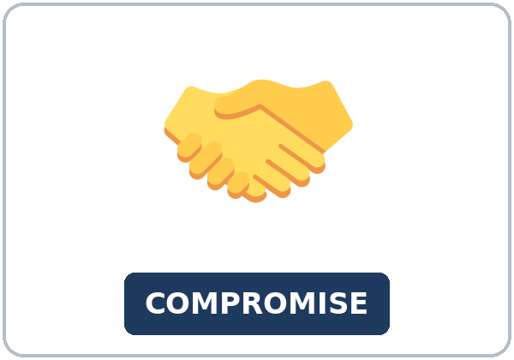  ★ compromise |   ★ offer |   ★ counteroffer |   ★ priority
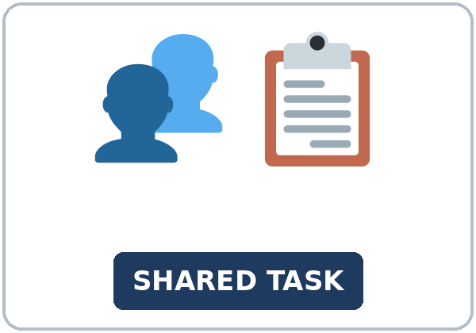  ★ shared task |   ★ solution | 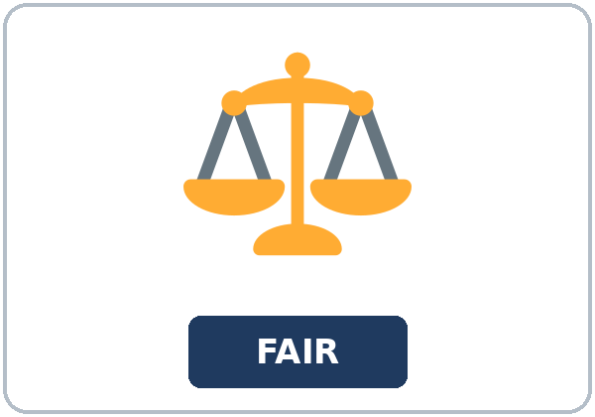  ★ fairness | 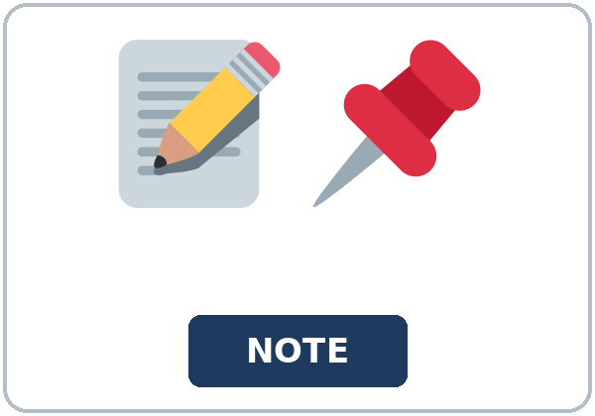  ★ sticky note
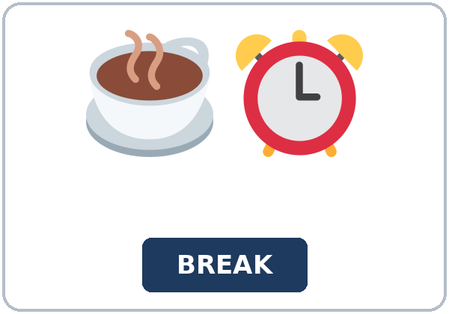  ★ break time | 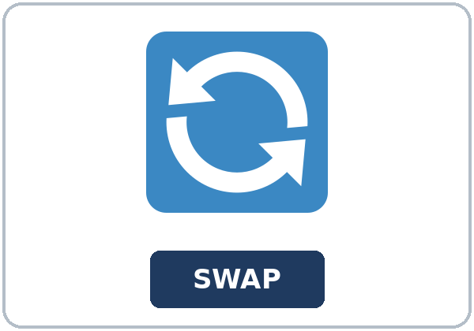  ★ swap |   whiteboard |   middle

Partner game: Say it in a sentence
Example: A points to priority. B says: "My class is my priority." Switch.
Lesson 10 (Week 11) · Listening
Camila and Jon both need Saturday. Ms. Nguyen asks them to work it out before she calls the shift off.
Voices: Camila, Jon, and Ms. Nguyen. A narrator opens and closes the listening.
A. Listen. What is the problem? Circle.
a. Camila wants a new job. b. Both need Saturday off. c. The store is closed.
B. Listen again. Circle the answers.
1. Camila's priority: (a morning class / an afternoon visit / a second job)
2. Jon's limit: (a morning class / an afternoon visit / the whiteboard)
3. They swap at: (ten / twelve / four)
4. The shift was: (so short / such a long shift / too easy)
5. They write the plan on: (a sticky note / a napkin / a menu)
6. Ms. Nguyen is going to: (call it off / not call it off / give in)
C. Listen again. Write so or such.
1. The week was ____________ busy that we split Saturday.
2. It was ____________ a long shift that we shared it.
3. The visit is ____________ important that I need the afternoon.
4. Noon is ____________ a clear time that nobody has to guess.
5. The week was ____________ busy that we need Saturday.
6. My class is ____________ important that I need the morning.
Hear it, say it
gonna and wanna are short forms. This listening uses the full forms. gonna = going to. wanna = want to. You can say going to and want to.
Say each line two times:
• I want to take the morning off.
• I was going to ask for the whole day too.
• I'm going to work the morning.
• What if WE split the day?
Let's meet in the middle. Use a falling tone. It is a suggestion, not an order.
Lesson 10 (Week 11) · Grammar
Read across. The left side is the pattern. The right side is the example.
Grammar Box 1: a middle idea
YOU CAN SAY | A MIDDLE IDEA
What if we split the day? | I can take the morning if you take the afternoon.
Let's meet in the middle. | We can swap at twelve.
Say the other idea first. | You need the afternoon. I need the morning.

Grammar Box 2: so… that / such… that
PATTERN | EXAMPLE
so + adjective + that | The week was so busy that we split Saturday.
such + a + adjective + noun + that | It was such a long shift that we shared it.
so + adjective + that | The visit is so important that Jon needs the afternoon.
such + a + adjective + noun + that | Noon is such a clear time that nobody has to guess.

Grammar Box 3: work out, call off, give in (review)
REVIEW | A REAL SENTENCE
work it out | We can work it out.
call it off | She is not going to call it off.
call the shift off | Noun after, or it in the middle: call it off.
give in | We didn't give in. No object.

Grammar Box 4: don't mix them
DON'T MIX THEM | SAY
so + adjective + that | The week was so busy that we split Saturday.
such a + adjective + noun | It was such a long shift that we shared it.
too + adjective + for | The week is too full for one person.

Rule of thumb: Say the other person's idea in one sentence before you offer yours. So and such both mean the result was big enough to cause the next clause.
Questions and answers
Q: Can I say so busy so we split it?
A: No. Say so busy that we split it.
Q: So or such before a long shift?
A: Such. It was such a long shift.
Q: Can I say give in the argument?
A: No. Give in has no object here.
Practice A: Write so, such, too, or it out.
1. The week was ____________ busy that we split Saturday.
2. It was ____________ a long shift that we shared it.
3. The week is ____________ full for one person.
4. The class is ____________ important that she needs the morning.
5. It was ____________ a fair plan that they both said yes.
6. We can work ____________.
Practice B: Circle the correct words.
1. The week was (so / such) busy that we split it.
2. It was (so / such) a long shift.
3. Work (it out / out it).
4. Call (it off / off it).
5. We didn't (give in / give in the argument).
6. The week is (too / such) full for one person.
Common mistakes
Don't say | Say
The week was so busy so we split it. | The week was so busy that we split it.
It was so long shift. | It was such a long shift.
Give in the argument. | Give in. No object here.
Work out it. | Work it out.

Pair check
A says a need: "I need the morning for a class." B says it back, then offers: "You need the morning. What if I take the afternoon?" Then switch.
Lesson 10 (Week 11) · Talk Time: Saturday Split
Round 1. Pairs. Leave with a written compromise.
Cards: morning class, a family visit, or a second job. Read your card. Say what you need. Say your partner's idea first. Then offer a middle idea. Write the compromise.
My need | My partner's need | Our middle idea

Useful: What if we split the day? • Let's meet in the middle. • I can take the morning if you take the afternoon.
Lesson 10 (Week 11) · Talk Time: Learner Timekeeper
Round 2. Groups of 3. One learner keeps the time. 7:00–7:18 for both rounds.
Start a 4-minute timer. Make sure both people speak. Read the compromise aloud. Then rotate the leader.
The compromise, in one or two sentences

15: pairs, then groups of 3. 7–8: pairs, then one group of 3 and pairs. 5 or fewer: one group; rotate the timekeeper.
Lesson 10 (Week 11) · Homework
Homework (about 20–25 minutes). Bring it next week!
1. Write one so… that sentence.
The week / be / so busy / that / we split Saturday. → ______________________________________________
2. Finish your message (Read & Write).
☐ I finished it. ☐ It has one so… that or such… that.
3. Tell a friend a small compromise. Write one sentence they said.
What they needed | The middle idea

4. Review: work it out, call it off, give in. Write one real sentence with each.
1. ______________________________________________
2. ______________________________________________
3. ______________________________________________
Lesson 10 (Week 11) · Read & Write
A. Read the team note.
North Side Market · Team note · Shared Saturday
Our Saturday shift is a shared task. One person cannot cover the whole day. Last month the week was so busy that two people split Saturday. That compromise worked, and the lead did not call the shift off.
This month Camila and Jon wrote a new plan. Camila has a morning class. That class is her priority. Jon has a family visit in the afternoon. They did not give in. They met in the middle. Each person said the other person's idea first, and then made an offer.
Here is the offer on the sticky note. Jon works from eight to twelve. Camila works from twelve to four. They swap at noon. Each person gets one break time. Jon's break is at ten. Camila's break is at two.
They copied the same plan onto the whiteboard in the break room. The note says the solution in one line: morning, Jon; afternoon, Camila. Ms. Nguyen read it. She is not going to call the shift off. She said the plan was fair. She did not pick a winner.
Fairness means both people keep what they need most. It was such a long shift that they shared it. The week is too full for one person. If you have a different limit, write a counteroffer on a new sticky note. Say the other person's idea first. Then offer yours. A second job, a class, or a family visit can all be a real priority. Do not call the shift off by yourself. Bring the note to the lead before Friday. A good message uses so or such: The morning was so full that we swapped at noon. Or: It was such a long shift that we shared it.
B. Answer the questions.
1. What is the shared task? ______________________________________________
2. What is Camila's priority? ______________________________________________
3. When do they swap? ______________________________________________
4. Where did they copy the plan? ______________________________________________
5. Is Ms. Nguyen going to call the shift off? ______________________________________________
C. Write a 6–8 sentence message to a coworker. Propose a compromise. Use one so… that or such… that.
My message

Lesson 10 (Week 11) · Exit Ticket
Name: ______________________________ Date: ________________
Describe a small compromise. Four sentences.
1. What each person needed.
2. The middle idea.
3. A so / such result.
4. Why it was fair.
Give it to me at the door.
My answer
1.
2.
3.
4.

For the teacher | yes | almost | not yet
Four sentences, a middle idea, so or such | ☐ | ☐ | ☐

Picture Credits
Pictures use Twemoji graphics by Twitter, Inc. and other contributors (https://github.com/jdecked/twemoji), licensed under CC BY 4.0 (https://creativecommons.org/licenses/by/4.0/). The graphics were resized and combined, and signs and labels were added. The file-by-file list is in images/CREDITS_L5_L10.md.
Listening audio: L5_L10_listening.mp3 (2:11). The voices are computer-generated. No recordings of real people. The names and the story are invented.
Course materials: © 2026 the authors, licensed under CC BY-NC-SA 4.0 (https://creativecommons.org/licenses/by-nc-sa/4.0/).

