Level 5 Adult ESL Curriculum · Lesson 11 (Week 12): I'd Like to File a Claim
Status: Published. Listening audio, lesson pages, and teacher slides are ready.
Date: October 2026
Audience: Volunteer teachers and adult learners
Companion files: images/ (12 vocabulary pictures + images/CREDITS_L5_L11.md). Listening audio: L5_L11_listening.mp3 (2:02).
Topic: Ask about a small claim for a cracked phone screen, or a water stain that is already dry, and write a two-paragraph letter. This letter is practice. It is not insurance advice.

How this lesson is organized
Part | What's inside | Who uses it
Teacher Plan | At a glance, clock, steps, listening script, answer key, notes | Volunteer teachers
Student Pages | Opening Talk, New Words, Listening, Grammar, Talk Time, Homework, Read & Write, Exit Ticket | Learners

TEACHER PLAN
Lesson 11 (Week 12)

I'd Like to File a Claim
At a glance · Clock · Steps · Script and answer key

Lesson 11 (Week 12): I'd Like to File a Claim
At a glance
Objectives: learners can…
• start a sentence with a gerund (Waiting on hold is tiring)
• soften a request with I was wondering if…
• say what was sent or attached, in the passive
• write a 1–2 paragraph letter

Today you will: Start with a gerund. • Soften a request. • Write a short letter.
By the end of class, you can do these four things. Every goal is a good goal.
• I can start a sentence with a gerund (Waiting on hold is tiring).
• I can soften a request with I was wondering if….
• I can say what was sent or attached, in the passive.
• I can write a 1–2 paragraph letter.
Materials
• Student pages for Lesson 11
• Claim cards: cracked screen; a dry water stain on a page
• Status cards: received, missing the photo, in review
• Listening: L5_L11_listening.mp3 (2:02). No speaker? Read the script aloud with a volunteer.
• Prep time: 15 minutes

Key vocabulary
★ claim form • ★ policy number • ★ photo • ★ estimate • ★ complaint • ★ attachment • ★ reference number • ★ customer service • ★ on hold • ★ resolution • cracked screen • water stain

Clock-time plan
Time | Step | Min | Grouping (15 / 7–8) | If running behind
6:00–6:06 | Opening Talk + Homework Check | 6 | Pairs | One card only
6:06–6:12 | New Words + pair game | 6 | Whole class, then pairs | ★ words only
6:12–6:32 | Listening + Hear it, say it | 20 | Individuals, then pairs | Task C on the board
6:32–6:45 | Grammar Q&A + pair check | 13 | Whole class, then pairs | Skip the pair check
6:45–7:00 | BREAK | 15
7:00–7:18 | Talk Time: The Call + Letter Outline | 18 | Pairs | Round 1 only
7:18–7:25 | Read & Write | 7 | Pairs read, then writing | Questions only
7:25–7:30 | Exit Ticket + Homework | 5 | Individuals | Never skip

15: pairs, then switch roles with a new card. 7–8: pairs. 5 or fewer: one call the group coaches, then individual outlines.

Step by step
Step 1 · 6:00–6:06 · Opening Talk + Homework Check · 6 min
• Opening Talk: A asks a card question. B answers in about four sentences. A asks one follow-up. Then switch.
• Homework Check: pairs read one so… that or such… that sentence from Lesson 10. Write 2 corrections on the board. No names.
• If behind: one card only.

Step 2 · 6:06–6:12 · New Words · 6 min
• Point, say, repeat. ★ = most important.
• Show: a claim form is the paper. A policy number and a reference number are two different numbers. An attachment is a file you send with a letter. On hold means you are waiting on the phone. A resolution is the answer at the end. The cracked screen is the phone. The water stain is already dry.
• Check the meaning: "Is Waiting one activity or many?" (One.) • "Does the verb after Waiting take is or are?" (is) • "Was the photo attached, or did Hector forget it?" (It was attached.)
• Partner game: A points. B makes a sentence. 15: 3 teams. 7–8: 2 teams. 5 or fewer: one team against the clock.

Step 3 · 6:12–6:32 · Listening + Hear it, say it · 20 min
• Before you listen: Hector calls about a cracked-screen claim. Ms. Lane says the form was received and asks him to send the estimate.
• Voices: Narrator, Hector, and Ms. Lane.
• Play 1 → Task A. Play 2 → Tasks B and C.
• Hear it, say it: gonna and wanna are short forms. This listening uses the full forms. You can say going to and want to. Say I was wondering if as one soft chunk. Keep the -ing in filing, waiting, and sending.
• This letter is practice. It is not insurance advice.

Step 4 · 6:32–6:45 · Grammar Q&A + pair check · 13 min
• Box 1: the -ing word is the subject. Waiting on hold is tiring. Filing a claim takes time. Sending a photo helps.
• Box 2: I was wondering if you could check the claim. Statement order after if. Would you mind looking up the reference number?
• Box 3: The photo was attached. The form was received.
• Box 4: You have to include the policy number. You don't have to stay on hold.
• Rule of thumb: A gerund subject is one activity, treated as it. The verb after it is singular: Waiting is, not Waiting are.
• Pair check: A reads a gerund subject. B finishes with a singular verb. Then switch.
• Break: On the board: Waiting is… / I was wondering if you could… / was attached.

Step 5 · 7:00–7:18 · Talk Time · 18 min
• Round 1, The Call: A is the customer with a claim card (cracked screen, or a dry water stain). B is customer service with a status card (received, missing the photo, or in review). A must use I was wondering if and one gerund subject. Then switch.
• Round 2, Letter Outline: pairs list the two paragraphs (what happened; what you are asking) before anyone writes full sentences.
• 15: pairs, then switch with a new card. 7–8: pairs. 5 or fewer: one call the group coaches, then individual outlines.
• Do not ask if learners have filed a claim. Invented facts only.

Step 6 · 7:18–7:25 · Read & Write · 7 min
• Read the claim-status letter. Pairs answer the five questions.
• Write a two-paragraph reply, about 8–12 sentences. Paragraph 1: what happened and what was sent. Paragraph 2: what you are asking, with I was wondering if and a thank-you. Start in class. Finish at home. Bring it next week.
• This letter is practice. It is not insurance advice.

Step 7 · 7:25–7:30 · Exit Ticket + Homework · 5 min · NEVER SKIP
• Exit ticket: Start a claim letter. Four sentences: a gerund subject, one passive, the request, and a polite close.
• Homework: do item 1 together. Waiting on hold ____ tiring. → is. About 20–25 minutes. Bring the finished letter next week.

Listening script
2:02. The phone call is the whole story. Spoken lines use going to and want to.
Narrator: Lesson eleven. Hector calls customer service about a cracked phone screen. Ms. Lane answers. The phone call is the whole story.
Ms. Lane: Thank you for calling customer service. This is Ms. Lane. How can I help you?
Hector: Hello. I want to file a claim for a cracked screen. Waiting on hold was tiring, but I'm glad you answered.
Ms. Lane: I can help. What is your policy number?
Hector: It is four two eight. I was wondering if you could look up my claim.
Ms. Lane: The form was received. The claim is about a cracked screen. Is that right?
Hector: Yes. Filing a claim takes time, so I sent a photo last week.
Ms. Lane: The photo was attached. Sending a photo helps, but we still need the estimate.
Hector: I was wondering if you could tell me the reference number. I want to send the estimate today.
Ms. Lane: The reference number is seven one. Please send the estimate as an attachment.
Hector: Would you mind saying that number again? I want to write it on the claim form.
Ms. Lane: Of course. Seven one. You have to include the policy number on the estimate.
Hector: Sending the estimate is my next step. I don't want to stay on hold again.
Ms. Lane: You don't have to wait on hold. You can send the attachment with the reference number.
Hector: This is not a water stain. A water stain can be a claim too, but that stain is already dry. Nobody was hurt.
Ms. Lane: This file is only the cracked screen. The home is safe. When the estimate arrives, we can look for a resolution.
Hector: I'm going to send it today. Thank you for your help.
Ms. Lane: Thank you, Hector. A clear photo and a clear estimate are enough for this practice file.
Narrator: That's the end of the listening.

Answer key
• Listening Task A: b (A cracked phone screen.)
• Listening Task B: 1 was received, 2 was attached, 3 the estimate, 4 seven one, 5 four two eight, 6 send it today.
• Listening Task C: 1 Waiting, 2 was received, 3 was attached, 4 Filing, 5 Sending, 6 Sending.
• Grammar Practice A: 1 is, 2 attached, 3 takes, 4 could, 5 received, 6 helps.
• Grammar Practice B: 1 is, 2 you could, 3 attached, 4 Filing, 5 have to, 6 helps.
• Homework 1: is.
• Read & Write: 1 A cracked phone screen. 2 The photo. 3 The estimate. 4 Seven one. 5 Four two eight.
• Exit ticket: four sentences: a gerund subject, one passive, the request, and a polite close.
Teacher notes
• This letter is practice. It is not insurance advice. For a real claim, use the phone number on your own policy.
• The damage is a phone screen or a dry stain. Nobody is hurt, and the home is safe. Do not invent a fire, a flood, or an injury.
• Do not ask if learners have filed a claim.
• I was wondering if could you is the wrong order. Say if you could.
• gonna and wanna are short forms. This listening uses the full forms.

STUDENT WORKBOOK
Lesson 11 (Week 12)

I'd Like to File a Claim
Opening Talk · New Words · Listening · Grammar · Talk Time · Homework · Read & Write · Exit Ticket

Lesson 11 (Week 12) · Opening Talk
Name: ______________________________ Date: ________________
Work with a partner. A asks a card question. B answers in about four sentences. A asks one follow-up. Then switch.
1. Say one so… that sentence from last week. | 2. What does give in mean in that lesson?
3. What is a compromise? | 4. Name one thing a fair plan needs.
5. Homework check: read your Lesson 10 message, or one sentence from it.

Follow-ups: Why? • What happened next? • What did the other person need?
Lesson 11 (Week 12) · Words
New Words
Look. Listen. Repeat. ★ = most important words.
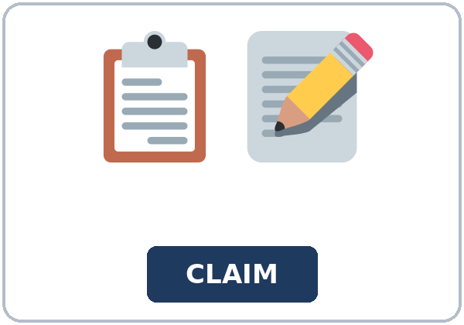  ★ claim form |   ★ policy number |   ★ photo | 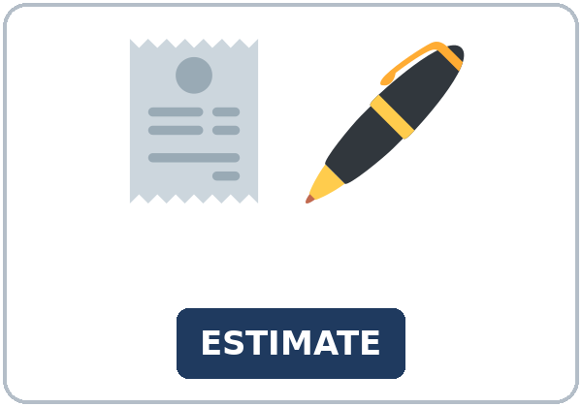  ★ estimate
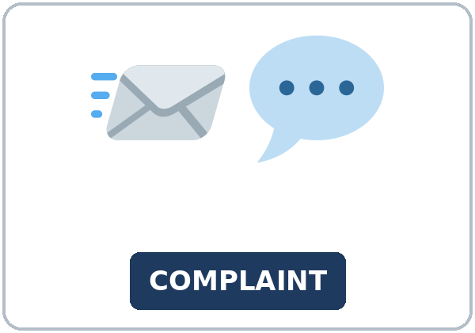  ★ complaint |   ★ attachment | 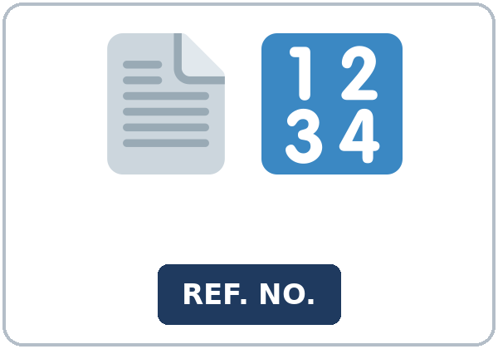  ★ reference number |   ★ customer service
  ★ on hold | 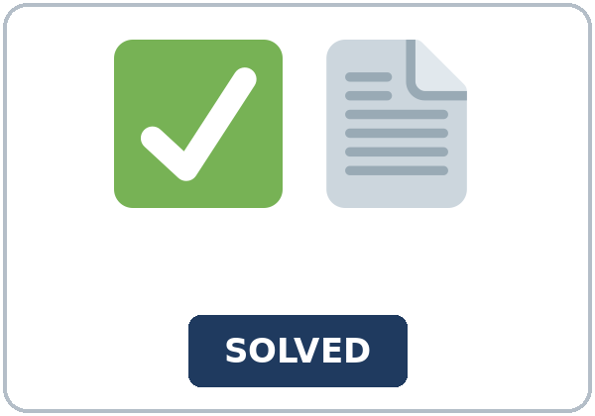  ★ resolution | 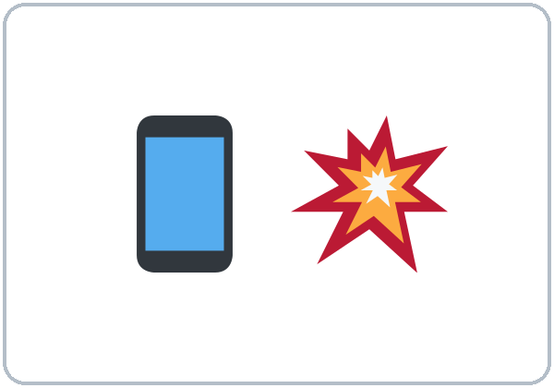  cracked screen | 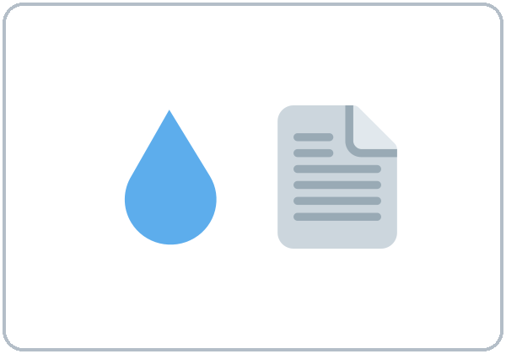  water stain

Partner game: Say it in a sentence
Example: A points to on hold. B says: "Waiting on hold is tiring." Switch.
Lesson 11 (Week 12) · Listening
Hector calls about a cracked-screen claim. Ms. Lane says the form was received and asks him to send the estimate.
Voices: Narrator, Hector, and Ms. Lane.
A. Listen. What is the claim about? Circle.
a. A new phone he wants to buy. b. A cracked phone screen. c. A water stain that is still wet.
B. Listen again. Circle the answers.
1. The form: (was received / was lost / was not sent)
2. The photo: (was attached / is missing / is a water stain)
3. He still must send: (the estimate / the phone / a new complaint)
4. Reference number: (seven one / four two eight / nine nine)
5. Policy number: (four two eight / seven one / three three)
6. He is going to: (send it today / stay on hold / buy a new phone)
C. Listen again. Write the gerund or the passive.
1. ____________ on hold was tiring.
2. The form ____________.
3. The photo ____________.
4. ____________ a claim takes time.
5. ____________ a photo helps.
6. ____________ the estimate is my next step.
Hear it, say it
gonna and wanna are short forms. This listening uses the full forms. gonna = going to. wanna = want to. You can say going to and want to.
Say each line two times. Say I was wondering if as one soft chunk.
• I want to file a claim.
• I was wondering if you could look up my claim.
• I'm going to send it today.
• Waiting on hold was tiring.
Lesson 11 (Week 12) · Grammar
Grammar Box 1: a gerund is the subject
THE ACTIVITY | THE VERB IS SINGULAR
Waiting on hold | is tiring.
Filing a claim | takes time.
Sending a photo | helps.
Sending the estimate | is my next step.

Grammar Box 2: a soft request
YOU CAN SAY | STATEMENT ORDER
I was wondering if | you could check the claim.
I was wondering if | you could look up the reference number.
Would you mind | looking up the reference number?

Grammar Box 3: what was sent
THE THING | PASSIVE
The photo | was attached.
The form | was received.
The estimate | was not attached yet.

Grammar Box 4: have to
YOU HAVE TO | YOU DON'T HAVE TO
include the policy number | stay on hold
send the estimate | call again if the letter is complete
write the reference number | add a different problem

Rule of thumb: A gerund subject is one activity, treated as it. The verb after it is singular: Waiting is, not Waiting are.
Questions and answers
Q: Can I say Waiting on hold are tiring?
A: No. Waiting is tiring.
Q: Can I say I was wondering if could you check?
A: No. Say if you could check. That is statement order.
Q: Was attach or was attached?
A: Was attached.
Practice A: Write the missing word.
1. Waiting on hold ____________ tiring.
2. The photo was ____________.
3. Filing a claim ____________ time.
4. I was wondering if you ____________ check it.
5. The form was ____________.
6. Sending a photo ____________.
Practice B: Circle the correct words.
1. Waiting on hold (is / are) tiring.
2. I was wondering if (could you / you could) check.
3. The photo was (attach / attached).
4. (Filing / File) a claim takes time.
5. You (have to / has to) include the policy number.
6. Sending a photo (help / helps).
Common mistakes
Don't say | Say
Waiting on hold are tiring. | Waiting on hold is tiring.
I was wondering if could you check. | I was wondering if you could check.
The photo was attach. | The photo was attached.
Waiting are hard. | Waiting is hard.

Pair check
A says: "Waiting on hold." B says: "Waiting on hold is tiring." Then switch. Use filing and sending too.
Lesson 11 (Week 12) · Talk Time: The Call
Round 1. Pairs. A is the customer. B is customer service. Then switch.
A has a claim card: cracked screen, or a dry water stain. B has a status card: received, missing the photo, or in review. A must use I was wondering if and one gerund subject.
My claim | The status | One sentence I said

Lesson 11 (Week 12) · Talk Time: Letter Outline
Round 2. List the two paragraphs before anyone writes full sentences. 7:00–7:18 for both rounds.
Paragraph 1: what happened and what was sent | Paragraph 2: what you are asking

Use I was wondering if in paragraph 2. Do not write the full letter yet.
15: pairs, then switch with a new card. 7–8: pairs. 5 or fewer: one call the group coaches, then individual outlines.
Lesson 11 (Week 12) · Homework
Homework (about 20–25 minutes). Bring the finished letter next week.
1. Write the verb.
Waiting on hold ____________ tiring.
2. Finish your letter (Read & Write). About 8–12 sentences.
☐ Paragraph 1: what happened and what was sent. ☐ Paragraph 2: I was wondering if and a thank-you.
3. Say I was wondering if to a friend. Write the sentence.
My sentence

4. Review: write one passive. The photo was attached. Then write one of your own.
Lesson 11 (Week 12) · Read & Write
This letter is practice. It is not insurance advice.
A. Read the letter from Northline Cover.
Dear Hector,
We received your claim form. This letter is about a cracked phone screen. Nobody was hurt. The form was received on Monday. The photo was attached. Thank you for sending it. Please keep a copy of the form at home. You do not need to send the same photo again.
Your policy number is four two eight. Your reference number is seven one. Please keep both numbers on every page you send. Waiting on hold is tiring, so you do not have to call if the estimate is complete. You can write to customer service instead. A short letter is enough.
We still need the estimate. Sending a photo helps. The estimate shows the cost to fix the screen. Please send the estimate as an attachment. Put the policy number on the first line. You have to include it. If the number is missing, we cannot match the file to your claim. Write the reference number on the same line so the two numbers stay together.
The claim is in review. A resolution is not ready yet. Filing a claim takes time. A file like this often takes about two weeks after the estimate arrives. That time is only for this practice letter. It is not a promise. Please do not call every day while you wait.
If you want a person to look, write: I was wondering if you could check the claim. You can also write: Would you mind looking up the reference number? Please use statement order after if: if you could, not if could you. A polite sentence is easier to answer than a complaint with no facts.
A dry water stain is a different kind of claim. This file is only the cracked screen. Do not add a stain to this letter. The home in this practice is safe. The water-stain card in class is already dry. Leave it out of this file. Do not describe a bigger problem than the screen.
Customer service is open from nine to five on weekdays. If you call, have the reference number ready. You can also reply by letter. Paragraph 1 should say what happened and what was sent. Paragraph 2 should say what you are asking, with I was wondering if, and a thank-you close. Sign your name under the thank-you.
Sincerely,
Ms. Lane
Customer service
Northline Cover
B. Answer the questions.
1. What is the claim about? ______________________________________________
2. What was attached? ______________________________________________
3. What is still missing? ______________________________________________
4. What is the reference number? ______________________________________________
5. What is the policy number? ______________________________________________
C. Write a two-paragraph reply (about 8–12 sentences).
Paragraph 1: what happened and what was sent. Paragraph 2: what you are asking, with I was wondering if and a thank-you.
My letter

Lesson 11 (Week 12) · Exit Ticket
Name: ______________________________ Date: ________________
Start a claim letter. Four sentences.
1. A gerund subject.
2. One passive.
3. The request (I was wondering if…).
4. A polite close.
Give it to me at the door.
My answer
1.
2.
3.
4.

Picture Credits
Pictures use Twemoji graphics by Twitter, Inc. and other contributors (https://github.com/jdecked/twemoji), licensed under CC BY 4.0 (https://creativecommons.org/licenses/by/4.0/). The graphics were resized and combined, and signs and labels were added. The file-by-file list is in images/CREDITS_L5_L11.md.
Listening audio: L5_L11_listening.mp3 (2:02). The voices are computer-generated. No recordings of real people. The names and the story are invented.
Course materials: © 2026 the authors, licensed under CC BY-NC-SA 4.0 (https://creativecommons.org/licenses/by-nc-sa/4.0/).

