Level 5 Adult ESL Curriculum · Lesson 13 (Week 14): A Short Talk
Status: Published. Listening audio, lesson pages, and teacher slides are ready.
Date: October 2026
Audience: Volunteer teachers and adult learners
Companion files: images/ (12 vocabulary pictures + images/CREDITS_L5_L13.md). Listening audio: L5_L13_listening.mp3 (1:47).
Topic: Plan and rehearse a 2–3 minute talk: an introduction, two examples, and a conclusion. The topic is an accomplishment, a skill, or someone who helped. "My class," "my job," or "a person who helped me practice" is always enough.

How this lesson is organized
Part | What's inside | Who uses it
Teacher Plan | At a glance, clock, steps, listening script, answer key, notes | Volunteer teachers
Student Pages | Opening Talk, New Words, Listening, Grammar, Talk Time, Homework, Read & Write, Exit Ticket | Learners

TEACHER PLAN
Lesson 13 (Week 14)

A Short Talk
At a glance · Clock · Steps · Script and answer key

Lesson 13 (Week 14): A Short Talk
At a glance
Objectives: learners can…
• open a talk with one clear sentence
• give two examples
• close with a next step
• speak for about two minutes from notes

Today you will: Open with one clear sentence. • Give two examples. • Close with a next step.
By the end of class, you can do these four things. Every goal is a good goal.
• I can open a talk with one clear sentence.
• I can give two examples.
• I can close with a next step.
• I can speak for about two minutes from notes.
Materials
• Student pages for Lesson 13
• Notecards and a stopwatch or phone timer
• Listening: L5_L13_listening.mp3 (1:47). No speaker? Read the script aloud with a volunteer.
• Prep time: 15 minutes. Model a one-minute version of your own first: introduction, one example, conclusion.

Key vocabulary
★ outline • ★ notecard • ★ pause • ★ eye contact • ★ introduction • ★ example • ★ conclusion • ★ mentor • ★ applause • ★ community center • achievement • stopwatch

Clock-time plan
Time | Step | Min | Grouping (15 / 7–8) | If running behind
6:00–6:06 | Opening Talk + Homework Check | 6 | Pairs | One card only
6:06–6:12 | New Words + pair game | 6 | Whole class, then pairs | ★ words only
6:12–6:32 | Listening + Hear it, say it | 20 | Individuals, then pairs | Task C on the board
6:32–6:45 | Grammar Q&A + pair check | 13 | Whole class, then pairs | Skip the pair check
6:45–7:00 | BREAK | 15
7:00–7:18 | Talk Time: Outline Aloud + Timed Rehearsal | 18 | Pairs, then groups of 3 | Round 1 only
7:18–7:25 | Read & Write | 7 | Pairs read, then the outline | The full talk is homework
7:25–7:30 | Exit Ticket + Homework | 5 | Individuals | Never skip

15: pairs, then 5 groups of 3. 7–8: pairs, then 2–3 groups. 5 or fewer: everyone rehearses for the whole group.

Step by step
Step 1 · 6:00–6:06 · Opening Talk + Homework Check · 6 min
• A asks a card question. B answers in about four sentences. Then switch.
• Homework check: one which or where sentence from Lesson 12. Write 2 corrections. No names.
• Topics tonight are class, job, or a person who helped. Do not ask anyone to tell a harder story.

Step 2 · 6:06–6:12 · New Words · 6 min
• Point, say, repeat.
• Show: an outline is the four parts. A notecard holds a few words, not the whole talk. A pause is a short stop between parts. Eye contact means looking up from the card. Applause is for finishing. The community center is the room for the practice night. A stopwatch keeps the time.
• Check the meaning: "Does the introduction name the point?" (Yes.) • "Does each example need a detail?" (Yes.) • "Is a conclusion a new story?" (No.)

Step 3 · 6:12–6:32 · Listening + Hear it, say it · 20 min
• Before you listen: Imani, a former learner, gives a short talk at a practice night: what she has been learning, one hard moment, one person who helped, and her next step. Mr. Gordon asks one question.
• Voices: Narrator, Imani, and Mr. Gordon.
• Play 1 → Task A. Play 2 → Tasks B and C.
• Hear it, say it: gonna and wanna are short forms. This listening uses the full forms. Pause between the four parts. Slow down on the introduction and the conclusion.

Step 4 · 6:32–6:45 · Grammar Q&A + pair check · 13 min
• This is a talk frame, not a new tense. Introduction → Example 1 → Example 2 → Conclusion.
• Useful review sentences, one each: I've been learning… / By the time I finished…, I had… / I wish I had…, so next time I will… / I'm going to…
• Rule of thumb: The introduction names the point. Each example has a detail. The conclusion repeats the point in new words and adds a next step.
• Pair check: A says "introduction," "example," or "conclusion." B says what that part must do.

Step 5 · 7:00–7:18 · Talk Time · 18 min
• Round 1, Outline Aloud: partners read their four-part outline. The listener asks one question about an example.
• Round 2, Timed Rehearsal: groups of 3. A learner is the timekeeper with a stopwatch (about 2 minutes, up to 3). Listeners write one strength and one tip. Everyone rehearses.
• Topics: my class, my job, or a person who helped me practice. You choose how personal to be.
• Reading from cards is fine. Applause is for finishing, not for the most dramatic story.

Step 6 · 7:18–7:25 · Read & Write · 7 min
• Read Imani's talk. The four parts are marked. Pairs answer the five questions.
• Write your own outline, then the talk in 12–16 sentences. Start the outline in class. Finish at home.

Step 7 · 7:25–7:30 · Exit Ticket + Homework · 5 min · NEVER SKIP
• Exit ticket: Write your introduction and your conclusion only. Four sentences. You will say the examples in the rehearsal.
• Homework: do item 1 together. Label the three parts. About 20–25 minutes. Bring the outline and the talk next time you speak.

Listening script
1:47. Spoken lines use going to and want to.
Narrator: Lesson thirteen. Imani, a former learner, gives a short talk at a practice night at the community center. Then Mr. Gordon asks one question.
Imani: Good evening. My point is simple. I've been learning to speak up at work, and a mentor helped me.
Imani: That is my introduction. I want to give two examples.
Imani: Example one. By the time I finished my first month, I had learned to pause.
Imani: The hard moment was a team meeting. I wish I had looked up sooner, so next time I will make eye contact.
Imani: Example two. My mentor at the community center listened and asked one question.
Imani: That question helped me find my point. The achievement was small, and it was mine.
Imani: I'm going to practice with a stopwatch for two minutes. The outline is on my note card.
Imani: This is my conclusion. I can speak from notes. My next step is one short talk a week at work.
Mr. Gordon: Thank you. Which example do you want to keep?
Imani: I want to keep the mentor example. I'm going to say it again, more slowly.
Mr. Gordon: Good. A pause between the parts helps. Applause is for finishing, not for the longest story.
Imani: I am not going to memorize the talk. Eye contact means I look up from the card.
Mr. Gordon: What is your next step, in one sentence?
Imani: I'm going to practice one talk a week. I want to keep the introduction short.
Mr. Gordon: The conclusion should repeat the point, not start a new story.
Imani: An achievement can be small. My class, my job, or a person who helped me is enough.
Narrator: That's the end of the listening.

Answer key
• Listening Task A: b (speaking up at work.)
• Listening Task B: 1 introduction, 2 example, 3 example, 4 conclusion, 5 a stopwatch, 6 finishing.
• Listening Task C: 1 Introduction, 2 Example 1, 3 Example 2, 4 Conclusion.
• Grammar Practice A: 1 Introduction, 2 Example, 3 Example, 4 Conclusion, 5 Conclusion, 6 Example.
• Grammar Practice B: 1 names the point, 2 has a detail, 3 repeats the point, 4 I'm going to, 5 had learned, 6 learning.
• Homework 1: 1 Introduction, 2 Example, 3 Conclusion.
• Read & Write: 1 She has been learning to speak up at work. 2 She did not look up. 3 Her mentor. 4 One short talk a week. 5 It repeats the point and adds a next step.
• Exit ticket: introduction and conclusion only, four sentences.
Teacher notes
• "My class," "my job," or "a person who helped me practice" is always enough. Never ask about a journey to this country, family separation, or a hard personal event.
• Reading from cards is fine. Model a one-minute version of your own first. Applause is for finishing, not for the most dramatic story.
• The frame is not a new tense. The review sentences are ones learners already know.
• A talk that starts with the example never says the point. A conclusion that is a new story does not close the talk.
• gonna and wanna are short forms. This listening uses the full forms.

STUDENT WORKBOOK
Lesson 13 (Week 14)

A Short Talk
Opening Talk · New Words · Listening · Grammar · Talk Time · Homework · Read & Write · Exit Ticket

Lesson 13 (Week 14) · Opening Talk
Name: ______________________________ Date: ________________
Work with a partner. A asks a card question. B answers in about four sentences. A asks one follow-up. Then switch.
1. Say one sentence with which. | 2. Say one sentence with where.
3. Which idea did your group support? | 4. Where did the library group meet?
5. Homework check: your comment for the chair, or one sentence from it.

Follow-ups: Why? • Can you add a detail? • What was the decision?
Topics for later tonight: my class, my job, or a person who helped me practice.
Lesson 13 (Week 14) · Words
New Words
Look. Listen. Repeat. ★ = most important words.
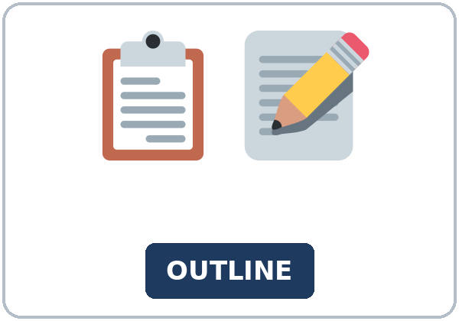  ★ outline | 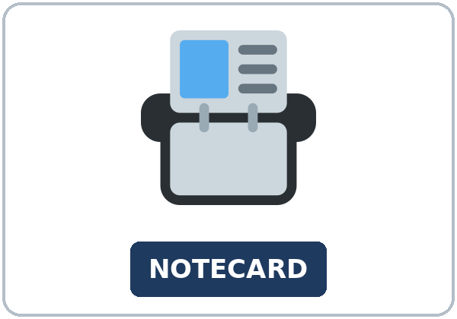  ★ notecard | 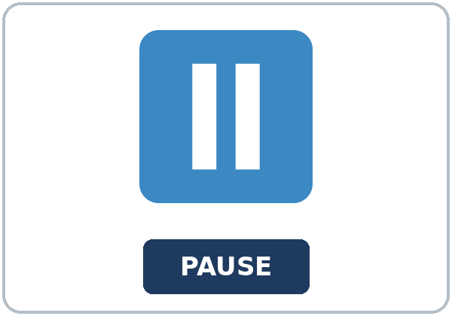  ★ pause |   ★ eye contact
  ★ introduction | 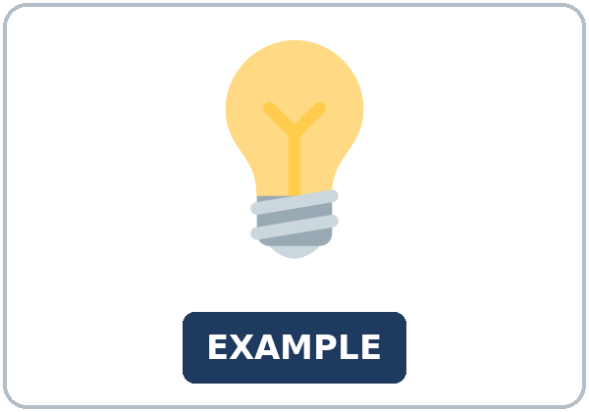  ★ example |   ★ conclusion | 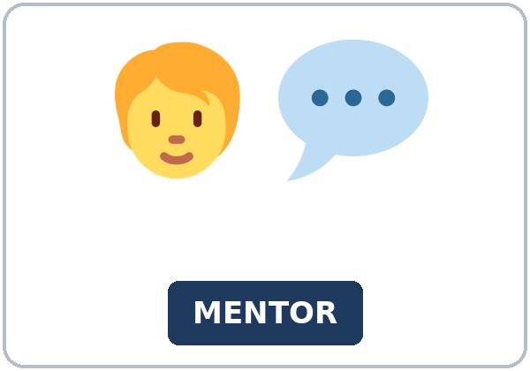  ★ mentor
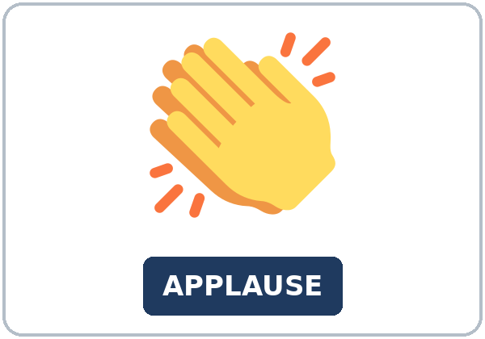  ★ applause |   ★ community center |   achievement | 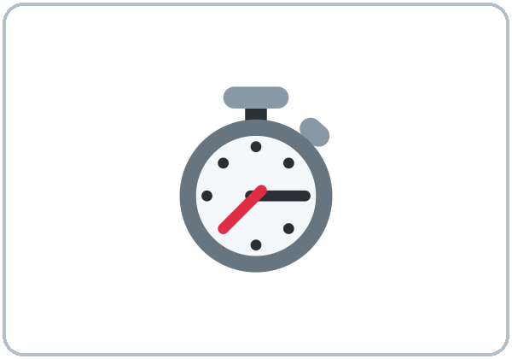  stopwatch

Partner game: Say it in a sentence
Example: A points to pause. B says: "A pause comes between the parts." Switch.
Lesson 13 (Week 14) · Listening
Imani, a former learner, gives a short talk at a practice night: what she has been learning, one hard moment, one person who helped, and her next step. Mr. Gordon asks one question.
Voices: Narrator, Imani, and Mr. Gordon.
A. Listen. What is her main point? Circle.
a. the loudest applause b. speaking up at work c. a forgotten notecard
B. Listen again. Circle the answers.
1. "My point is simple" is the: (introduction / example / conclusion)
2. The hard moment is an: (introduction / example / conclusion)
3. The mentor's question is an: (introduction / example / conclusion)
4. The next step is the: (introduction / example / conclusion)
5. She is going to practice with: (a stopwatch / a microphone / a whiteboard)
6. Applause is for: (finishing / the longest story / a perfect memory)
C. Listen again. Write the four parts in order.
1. First: ____________
2. Second: ____________
3. Third: ____________
4. Fourth: ____________
Words: Introduction, Example 1, Example 2, Conclusion.
Hear it, say it
gonna and wanna are short forms. This listening uses the full forms. gonna = going to. wanna = want to. You can say going to and want to.
Say each line two times. Pause between the parts.
• I've been learning to speak up at work.
• I want to give two examples.
• I'm going to practice with a stopwatch.
• I am not going to memorize the talk.
Lesson 13 (Week 14) · Grammar
This is a talk frame, not a new tense.
Grammar Box 1: introduction
THE INTRODUCTION | IT NAMES THE POINT
I've been learning to speak up at work. | That is my point.
A mentor helped me. | That is part of the point.
I want to give two examples. | Then the examples start.

Grammar Box 2: two examples
THE EXAMPLE | A DETAIL
Example 1 | By the time I finished my first month, I had learned to pause.
The hard moment | I wish I had looked up sooner, so next time I will make eye contact.
Example 2 | My mentor asked one question.

Grammar Box 3: conclusion
THE CONCLUSION | NOT A NEW STORY
Repeat the point in new words. | I can speak from notes.
Add a next step. | I'm going to practice one talk a week.
Stop. | Applause is for finishing.

Grammar Box 4: review sentences, not a new tense
REVIEW | ONE SENTENCE
I've been learning… | I've been learning to speak up at work.
By the time I finished…, I had… | By the time I finished my first month, I had learned to pause.
I wish I had…, so next time I will… | I wish I had looked up sooner, so next time I will make eye contact.
I'm going to… | I'm going to practice with a stopwatch.

Rule of thumb: The introduction names the point. Each example has a detail. The conclusion repeats the point in new words and adds a next step.
Questions and answers
Q: Can the talk start with the example?
A: No. The introduction names the point first.
Q: Can the conclusion be a new story?
A: No. It repeats the point and adds a next step.
Q: Can I say I gonna practice?
A: No. Say I'm going to practice.
Practice A: Write Introduction, Example, or Conclusion.
1. My point is simple. I've been learning to speak up. ____________
2. By the time I finished my first month, I had learned to pause. ____________
3. My mentor asked one question. ____________
4. I can speak from notes, and my next step is one talk a week. ____________
5. I'm going to practice with a stopwatch. ____________
6. I wish I had looked up sooner, so next time I will make eye contact. ____________
Practice B: Circle the correct words.
1. The introduction (names the point / tells a new story).
2. Each example (has a detail / has no detail).
3. The conclusion (is a new story / repeats the point).
4. Next step: (I'm going to / I gonna) practice.
5. By the time I finished, I (had learned / have learn) to pause.
6. I've been (learning / learn) to speak up.
Common mistakes
Don't say | Say
Start with the example and never say the point. | Start with the introduction. It names the point.
A conclusion that is a new story. | The conclusion repeats the point and adds a next step.
I gonna practice. | I'm going to practice.

Pair check
A says "introduction," "example," or "conclusion." B says what that part must do. Then switch.
Lesson 13 (Week 14) · Talk Time: Outline Aloud
Round 1. Partners. Read your four-part outline. The listener asks one question about an example.
Topics: my class, my job, or a person who helped me practice. You choose how personal to be.
Introduction (the point) | Example 1 | Example 2 | Conclusion (next step)

Lesson 13 (Week 14) · Talk Time: Timed Rehearsal
Round 2. Groups of 3. 7:00–7:18 for both rounds.
A learner is the timekeeper with a stopwatch (about 2 minutes, up to 3). Listeners write one strength and one tip. Everyone rehearses. Reading from cards is fine. Applause is for finishing.
One strength | One tip

15: pairs, then 5 groups of 3. 7–8: pairs, then 2–3 groups. 5 or fewer: everyone rehearses for the whole group.
Lesson 13 (Week 14) · Homework
Homework (about 20–25 minutes).
1. Label the part: Introduction, Example, or Conclusion.
1. My point is that I can speak from notes. ____________
2. One day my mentor asked me a question. ____________
3. Next, I'm going to practice one talk a week. ____________
2. Finish your outline, then the talk in 12–16 sentences.
3. Say your introduction aloud to a friend. One time is enough.
4. Review: write I'm going to and your next step.
Lesson 13 (Week 14) · Read & Write
A. Read the talk. The four parts are marked.
Imani's practice talk · Community center
Introduction. My point is simple. I've been learning to speak up at work, and a mentor helped me. I want to tell you two examples, and then a next step. You can follow the outline on my notecard. I am not going to memorize the words.
Example 1. By the time I finished my first month, I had learned to pause and look up from my notecard. The hard moment was a team meeting. I read every word, and I never looked up. I wish I had looked up sooner, so next time I will make eye contact. A pause is not a mistake. It gives people time to hear the point. Eye contact means looking up from the card, not memorizing the talk.
Example 2. My mentor at the community center listened and asked one question: What is the one thing you want us to remember? That question helped me. The achievement was small. I answered in two sentences, and then I stopped. I'm going to keep that question on my notecard. A person who helped me practice is enough for this example. I do not need a longer story.
Conclusion. I can speak from notes. That is the same point, in new words. My next step is one short talk a week at work. I'm going to practice with a stopwatch for two minutes. Applause is for finishing, not for a dramatic story. Thank you.
Mr. Gordon asked, "Which example do you want to keep?" Imani said, "I want to keep the mentor example." She is going to say it again, more slowly.
The introduction names the point. Each example has a detail. The conclusion repeats the point in new words and adds a next step. A talk that starts with the example never says the point. A conclusion that is a new story does not close the talk. Topics that are always enough: my class, my job, or a person who helped me practice.
B. Answer the questions.
1. What is her main point? ______________________________________________
2. What happened in example 1? ______________________________________________
3. Who helped her? ______________________________________________
4. What is her next step? ______________________________________________
5. What does the conclusion do? ______________________________________________
C. Write your outline, then the talk in 12–16 sentences. Finish at home.
Introduction | Examples | Conclusion

Lesson 13 (Week 14) · Exit Ticket
Name: ______________________________ Date: ________________
Write your introduction and your conclusion only. Four sentences.
You will say the examples in the rehearsal.
Give it to me at the door.
My answer
1. Introduction:
2. Introduction:
3. Conclusion:
4. Conclusion:

Picture Credits
Pictures use Twemoji graphics by Twitter, Inc. and other contributors (https://github.com/jdecked/twemoji), licensed under CC BY 4.0 (https://creativecommons.org/licenses/by/4.0/). The graphics were resized and combined, and signs and labels were added. The file-by-file list is in images/CREDITS_L5_L13.md.
Listening audio: L5_L13_listening.mp3 (1:47). The voices are computer-generated. No recordings of real people. The names and the story are invented.
Course materials: © 2026 the authors, licensed under CC BY-NC-SA 4.0 (https://creativecommons.org/licenses/by-nc-sa/4.0/).

