Level 5 Adult ESL Curriculum · Lesson 2 (Week 2): By the Time We Opened
Status: Published. Listening audio, lesson pages, and teacher slides are ready.
Date: October 2026
Audience: Program coordinators and volunteer teachers
Companion files: images/ (12 vocabulary pictures + images/CREDITS_L5_L2.md). Listening audio: L5_L2_listening.mp3 (1:39).
Topic: A neighborhood bakery getting ready to open. Learners say what had already happened before the next thing, put events in order, and write a short project note.

How this lesson is organized
Part | What's inside | Who uses it
Teacher Plan | At a glance, the clock, step-by-step boxes, the listening script, the answer key, teacher notes | Volunteer teachers
Student Pages | Opening Talk, New Words, Listening, Grammar, Talk Time, Homework, Read & Write, Exit Ticket | Learners
Picture Credits | Picture and license lines | Coordinators

What Lesson 2 builds on and what it adds
Before (review only) | Where | New in Level 5 Lesson 2
already / yet / just | Level 4 Lesson 3 | already now sits before had: we had already painted
before / after / when | Level 4 Lesson 13 | by the time marks the later past
Past continuous as background | earlier lessons | The painter was still working when the inspector knocked.
I've been working | Lesson 1 | Opening Talk only. The new point is had + past participle for the earlier past.

TEACHER PLAN
Lesson 2 (Week 2)

By the Time We Opened
At a glance · Clock · Steps · Script and answer key

How to Use This Plan
Teach in English. You do not need to speak the learners' languages. Draw two X's on a line. There is no contrast-tip box. The common mix-up is a row in the mistakes table.

Instructions: Listen. Circle. Number. Write. Work with a partner. Give a reason.

Instruction rule: Model it, check it ("Which time is earlier?"), then go.

When a learner is stuck: show the two X's, give one more English example, point to the grammar box, let a classmate help for a few seconds, then stay in English.

About four sentences: the exit ticket is four sentences: an earlier event, a later event, one more event, and why the order mattered.

Lesson 2 (Week 2): By the Time We Opened
At a glance
Objectives: learners can…
• say what had already happened
• use by the time and when with two past times
• put four events in order
• write a short project note

Materials
• Student Pages for Lesson 2 (print the number you expect + 3 spares)
• Board and markers. Two X's: left = earlier: had painted; right = later: the inspector arrived
• Four picture cards from the bakery set, one pack per pair (bakery, oven, paint roller, inspector). Shuffle them.
• Listening: L5_L2_listening.mp3 (1:39). Play it two times. No speaker? Read the script aloud with a volunteer.
• Prep time: 15 minutes. Draw the line. Shuffle the card packs.

Key vocabulary (with pictures on the New Words page)
★ bakery • ★ oven • ★ permit • ★ inspector • ★ paint roller • ★ store sign • ★ ribbon • ★ opening day • ★ counter • ★ display case • awning • poster

Clock-time plan
Times are loose. If listening or Talk Time runs long, take the time from Read & Write.
Time | Step | Min | Grouping (15 / 7–8) | If running behind
6:00–6:06 | Opening Talk + Homework Check | 6 | Pairs (one group of 3 if odd) / pairs | One card only
6:06–6:12 | New Words + a one-minute meaning check | 6 | Whole class, then pairs | Teach the ★ words only
6:12–6:32 | Listening (play 1 = Task A; play 2 = Tasks B and C) + "Hear it, say it" | 20 | Individuals, then pairs check | Do Task C together on the board
6:32–6:45 | Grammar Q&A + a short pair check | 13 | Whole class, then pairs | Skip the pair check
6:45–7:00 | BREAK | 15
7:00–7:18 | Talk Time: Two Timelines + Tell the Other Group | 18 | Pairs, then a second pair / pairs, then one switch | Round 1 only
7:18–7:25 | Read & Write: the project update + start the note | 7 | Pairs read; then individual writing | Questions only; the note is homework
7:25–7:30 | Exit Ticket + Homework | 5 | Individuals | Never skip

Skip order: (1) the writing task; (2) the grammar pair check; (3) Talk Time round 2. Never skip listening, the grammar boxes, the mistakes table, or the exit ticket.

5 or fewer: one group builds one timeline on the table.

Step by step
Step 1 · 6:00–6:06 · Opening Talk + Homework Check · 6 min
• Grouping: pairs. 15 learners: 7 pairs + 1 group of 3. 7–8: 3–4 pairs. 5 or fewer: pairs, or one group with you.
• Opening: one question from last week. A asks. B answers in a short summary. A asks one follow-up. Then switch.
• Model: "How long have you been studying English?" If the learner says I am studying since September, point to the Lesson 1 fix: I've been studying since September or I've studied since September.
• Homework check (last 2 min): pairs read one sentence from Lesson 1 Homework item 1. You write two corrections on the board. No names.
• If behind: one card only.

Step 2 · 6:06–6:12 · New Words · 6 min
• Do: point, say, repeat. ★ = most important.
• Show the hard words: the oven bakes. It is not a person. The inspector visits before opening day. A permit is the paper that says the work is allowed. A paint roller spreads paint on a wall. The awning is a cover over the door, not a cake. The store sign and the poster are two different things. In our story, the sign went up first.
• Check the meaning: "Is the oven a person?" (no, it bakes) • "Who comes before opening day?" (the inspector) • "Is an awning a cover or a cake?" (a cover)
• Partner game: A points to two pictures and asks, "Which one comes first in a bakery opening?" B answers with before. Switch.
• If behind: the ★ words only.

Step 3 · 6:12–6:32 · Listening + "Hear it, say it" · 20 min
• Before you listen: "Priya and Ben work at a new bakery. Ms. Cole, the inspector, visits before opening day. Listen: is the bakery open yet?"
• Voices: Priya, Ben, and Ms. Cole. A narrator opens and closes. Audio is recorded (about 1:39). Read the script two times.
• Play 1 → Task A. Answer: b. No. It opens tomorrow.
• Play 2 → Tasks B and C. B is the order of five events. C is had or the simple past.
• "Hear it, say it": gonna and wanna are short forms. This listening uses the full forms. Say the full had so the two times stay clear. We'd already is easy to miss. In this lesson, say had.
• If behind: Task C on the board.

Step 4 · 6:32–6:45 · Grammar Q&A · 13 min
• Draw two X's. Label the left one "earlier: had painted" and the right one "later: the inspector arrived."
• Rule of thumb: the earlier past uses had + past participle. The later past uses the simple past. By the time marks the later time.
• Read the boxes across. Box 1 is by the time and when. Box 2 is earlier and later. Box 3 is the past continuous at the later moment. Box 4 is the rule in three lines.
• Questions and answers: Had you finished the sign before the poster went up? → Yes, we had. / No, we hadn't.
• Practice, mistakes, then the pair check: A says a later time (the inspector arrived). B says what had already happened. Switch.
• If behind: skip the pair check.

Break · 6:45–7:00 · 15 min
• Leave the two X's on the board.

Step 5 · 7:00–7:18 · Talk Time · 18 min
• Round 1, Two Timelines: each learner gets four picture cards from a bakery opening. They are shuffled. The partner asks, "What had they already done by the time…?" Together they rebuild the order.
• Round 2, Tell the Other Group: a new partner retells the story in four sentences. Use by the time or had already.
• 15 learners: pairs, then a second pair.
• 7–8 learners: pairs, then one switch. Listen to the learners who did not do the baseline last week.
• 5 or fewer: one group builds one timeline on the table.
• Projects can be invented. Do not ask learners to describe a move between countries.
• If behind: round 1 only.

Step 6 · 7:18–7:25 · Read & Write · 7 min
• Read Priya's project update. Pairs answer the five questions.
• Write a 6–8 sentence note about a project you finished (a class, a move inside the city, a team at work). Use by the time once and had already once. Invented details are fine. This is writing check 1. Start in class. Finish at home. You will write one strength and one fix. Learners keep the note in a folder.
• If behind: questions only.

Step 7 · 7:25–7:30 · Exit Ticket + Homework · 5 min · NEVER SKIP
• Exit ticket: Tell one change, in order. Four sentences with by the time or had already, plus a reason the order mattered.
• Collect and sort into yes / almost / not yet. Next week, two corrections, no names.
• Homework: about 20–25 minutes. Do item 1 together: By the time the inspector arrived, we had already painted the walls.

Listening script
Audio is recorded (about 1:39). Read it with volunteers at a natural, friendly speed. The spoken lines use going to and want to. gonna and wanna are short forms. This listening uses the full forms.
Narrator: Lesson two. Priya and Ben work at a new bakery. Opening day is tomorrow. Ms. Cole, the inspector, is here today.
Ms. Cole: Good morning. I'm Ms. Cole. Is the bakery open yet?
Priya: Not yet. We want to open tomorrow. We are going to cut the ribbon in the morning.
Ms. Cole: What had you already finished before I arrived?
Ben: By the time you arrived, we had already painted the walls.
Priya: When the oven was delivered, Ben had already cleaned the kitchen.
Ms. Cole: Had you finished the store sign before the poster went up?
Ben: Yes, we had. The sign was first. Then the poster went up.
Priya: We had already picked up the permit before we painted.
Ben: First I cleaned the kitchen. Second, the oven arrived. Third, we painted. Fourth, the poster went up. You arrived last.
Ms. Cole: Was the painter still working when I knocked?
Priya: Yes. The painter was still working. The walls are dry now.
Ms. Cole: The display case and the awning look ready. You can open tomorrow.
Ben: The counter was ready yesterday. Thank you.
Ms. Cole: Bring the permit to the door in the morning.
Ben: We will. It is already in the folder.
Priya: We want to tell the staff tonight. We are going to hang the ribbon in the morning.
Narrator: That's the end of the listening.

Answer key
• Check the meaning: 1 no, it bakes. 2 the inspector. 3 a cover.
• Listening Task A: b. No. It opens tomorrow.
• Listening Task B: 1 cleaned the kitchen. 2 the oven arrived. 3 we painted. 4 the poster went up. 5 the inspector.
• Listening Task C: 1 had. 2 arrived. 3 had. 4 went. 5 had. 6 was.
• Grammar Practice A: 1 had. 2 had. 3 arrived. 4 went. 5 had. 6 was.
• Grammar Practice B: 1 arrived. 2 had already painted. 3 opened. 4 was delivered. 5 Yes, we had. 6 was working.
• Talk Time: answers will vary. Four events, in order, with had already or by the time.
• Homework 1: 1 By the time the inspector arrived, we had already painted the walls. 2 When the oven was delivered, Ben had already cleaned the kitchen. 3 Yes, we had. 4 The painter was still working when the inspector knocked. Homework 2 and 3: answers will vary. Homework 4: 1 I've been working. 2 worked. 3 I've worked. 4 She's been taking.
• Read & Write: 1 No. It opens tomorrow. 2 He had cleaned the kitchen. 3 They had painted the walls. 4 The store sign was first. 5 The permit and dry paint.
• Exit ticket: answers will vary. A good answer: "By the time the inspector arrived, we had already painted the walls. When the oven was delivered, Ben had already cleaned the kitchen. The poster went up after the sign. The order mattered because the inspector needed the permit and dry paint."
Teacher notes
• Draw two X's and leave them up all night. Left: "earlier: had painted." Right: "later: the inspector arrived."
• Say the full had. We'd already is easy to miss, and have is a different time. This lesson keeps had strong.
• The by the time half is the later event. By the time we had opened, the inspector arrived swaps the times. The fix is By the time we opened, the inspector had arrived.
• Projects can be invented. Do not ask learners to describe a move between countries. A class, a team at work, or a move inside the city is enough.
• Writing check 1: the 6–8 sentence note. Write one strength and one fix. Learners keep it.
• Reductions: the script says going to and want to. People often say gonna and wanna. Learners only need to recognize the short forms.

STUDENT WORKBOOK
Lesson 2 (Week 2)

By the Time We Opened
Opening Talk · New Words · Listening · Grammar · Talk Time · Homework · Read & Write · Exit Ticket

Lesson 2 (Week 2) · Opening Talk
Name: ______________________________ Date: ________________
Work with a partner. A asks. B answers in a short summary. A asks one follow-up. Then switch.
A: How long have you been working, or studying English? | A: What have you been practicing?
A: Have you finished any training? | A: Give one example from last week.

Follow-ups: How long? • For or since? • Can you give an example?
Homework check
Read one sentence from Lesson 1, Homework item 1, to your partner.
My partner's name | One been or worked sentence

Lesson 2 (Week 2): By the Time We Opened
Name: ______________________________ Date: ________________
New Words
Look. Listen. Repeat. ★ = most important words.
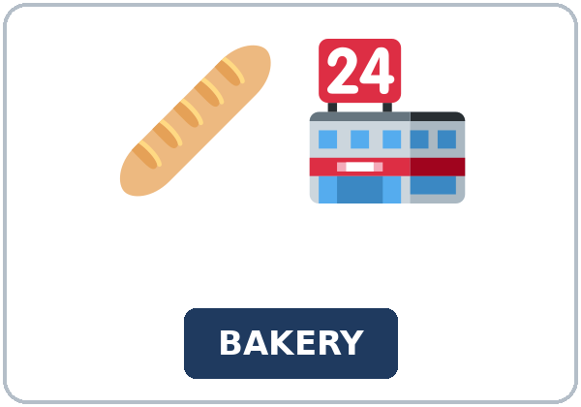  ★ bakery | 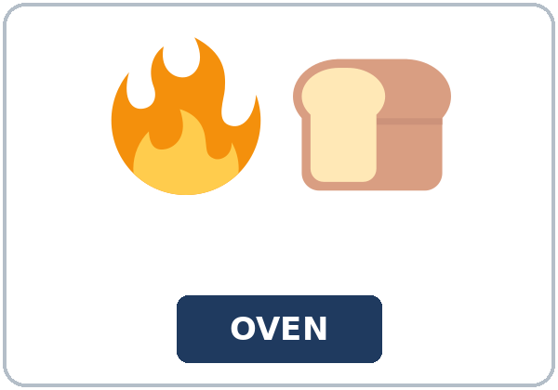  ★ oven | 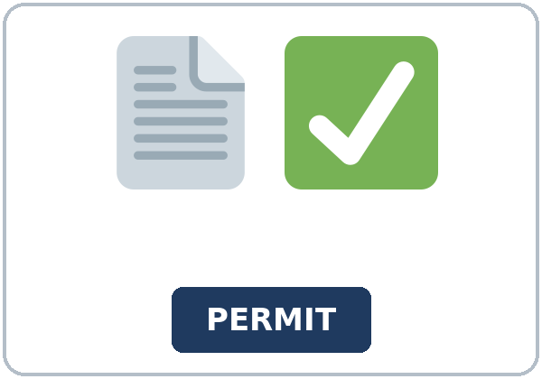  ★ permit | 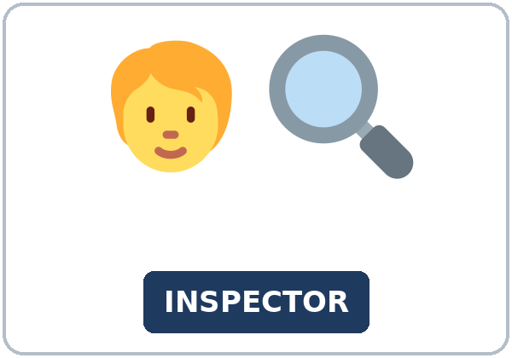  ★ inspector
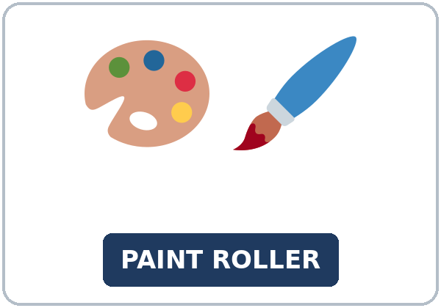  ★ paint roller | 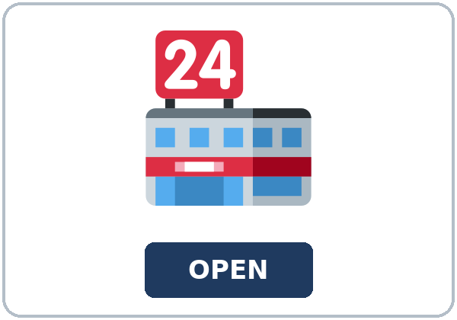  ★ store sign |   ★ ribbon | 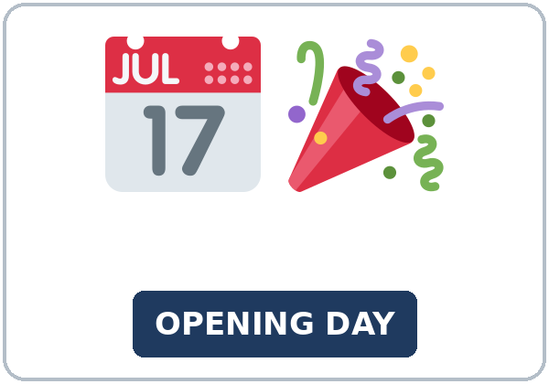  ★ opening day
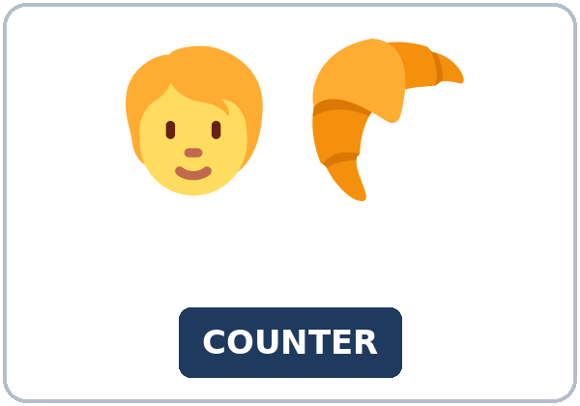  ★ counter | 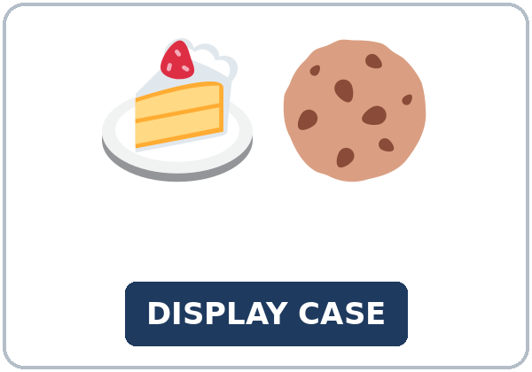  ★ display case | 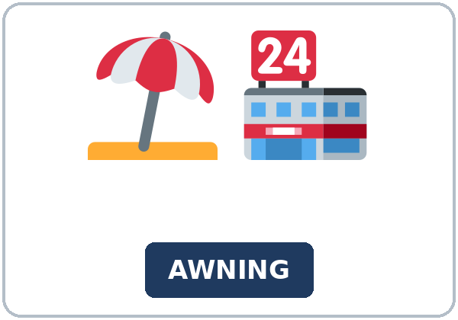  awning | 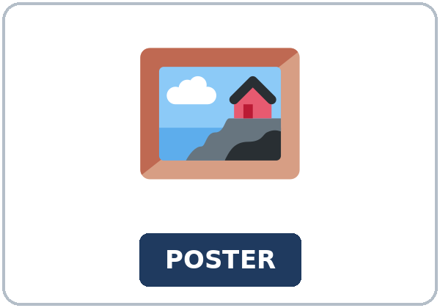  poster

Partner game: Which one comes first?
Example: A points to the store sign and the poster. "Which one came first?" B says, "The store sign was first." Switch.
Lesson 2 (Week 2) · Listening
Priya and Ben work at a new bakery. Ms. Cole, the inspector, visits before opening day.
A. Listen. Is the bakery open yet? Circle.
a. Yes. It is open now. b. No. It opens tomorrow. c. No. It failed the visit.
B. Listen again. What happened first, second, third, fourth, and last? Circle.
1. First: (cleaned the kitchen / the poster / the inspector)
2. Second: (the oven arrived / opening day / the ribbon)
3. Third: (we painted / we opened / we failed)
4. Fourth: (the poster went up / the oven / the permit)
5. Last: (the inspector / the oven / the sign)
C. Listen again. Write had or the simple past.
1. We ____________ already painted the walls.
2. You ____________ last.
3. Ben ____________ already cleaned the kitchen.
4. The poster ____________ up.
5. We ____________ already picked up the permit.
6. The oven ____________ delivered.
Hear it, say it
gonna and wanna are short forms. This listening uses the full forms. You can say going to and want to.
Say the full word had. had and have are different. Say each line two times.
1. We want to open tomorrow.
2. We are going to cut the ribbon.
3. We had already painted the walls.
4. By the time the inspector arrived, we had painted.
Lesson 2 (Week 2) · Grammar
Read across. A reads the question. B says the answer.
Grammar Box 1: by the time and when
QUESTION | ANSWER
What had you done by the time the inspector arrived? | We had already painted the walls.
What had Ben done when the oven was delivered? | Ben had already cleaned the kitchen.
Had you finished the sign before the poster went up? | Yes, we had. / No, we hadn't.

Grammar Box 2: earlier and later
EARLIER: had + past participle | LATER: simple past
we had already painted the walls | the inspector arrived
Ben had already cleaned the kitchen | the oven was delivered
we had finished the sign | the poster went up

Grammar Box 3: the later moment's background
QUESTION | ANSWER
What was the painter doing when the inspector knocked? | The painter was still working.

Grammar Box 4: Which time?
FORM | EXAMPLE
earlier past | had + past participle: we had already painted
later past | simple past: the inspector arrived
by the time | marks the later time: By the time the inspector arrived, …

Rule of thumb: the earlier past uses had + past participle. The later past uses the simple past. By the time marks the later time.
Questions and answers
Q: Where does already go?
A: Before had's participle: we had already painted. Not we already painted for the earlier time.
Q: Which half of by the time is later?
A: The by the time half. By the time the inspector arrived is later. we had painted is earlier.
Q: Yes, we did or Yes, we had?
A: After Had you…?, say Yes, we had.
Practice A: Write had or the simple past.
1. By the time the inspector arrived, we ____________ already painted the walls.
2. When the oven was delivered, Ben ____________ already cleaned the kitchen.
3. The inspector ____________ after the painting.
4. The poster ____________ up after the sign.
5. Had you finished the sign? Yes, we ____________.
6. The painter ____________ still working when the inspector knocked.
Practice B: Circle the correct words.
1. By the time the inspector (arrived / had arrived), we had already painted.
2. We (already painted / had already painted) the walls.
3. By the time we (had opened / opened), the inspector had arrived.
4. When the oven (was delivered / had delivered), Ben had cleaned the kitchen.
5. Had you finished the sign? (Yes, we had. / Yes, we did.)
6. The painter (was working / had worked) when the inspector knocked.
Common mistakes
✗ Don't say | ✓ Say
When the inspector arrived, we already painted. | When the inspector arrived, we had already painted.
By the time we had opened, the inspector arrived. | By the time we opened, the inspector had arrived.

Pair check
A says a later time: the inspector arrived. B says what had already happened: We had already painted the walls. Then switch.
Lesson 2 (Week 2) · Talk Time: Two Timelines
Round 1. Four picture cards, shuffled. Ask: What had they already done by the time…? Rebuild the order.
Order | What had already happened | By the time…
1
2
3
4

Round 2. Tell the other group. A new partner retells the story in four sentences. Use by the time or had already.
Four sentences
1.
2.
3.
4.

Lesson 2 (Week 2) · Homework
Homework (about 20–25 minutes). Bring it next week!
1. Write the sentence.
Example: the inspector / arrive · we / already / paint the walls → By the time the inspector arrived, we had already painted the walls.
1. the inspector / arrive · we / already / paint the walls → ______________________________________________
2. the oven / be delivered · Ben / already / clean the kitchen → ______________________________________________
3. Had you finished the sign before the poster went up? → ______________________________________________
4. the painter / still work · the inspector / knock → ______________________________________________
2. Finish your project note from Read & Write. This is writing check 1. Use by the time once and had already once.
☐ 6–8 sentences. ☐ by the time once. ☐ had already once. ☐ A reason the order mattered.
3. Tell the four-sentence story to a friend or a family member. Ask them which event was earlier.
4. Review (Lesson 1). Write I've been working, I've worked, worked, or She's been taking.
1. I ____________ at the hotel for two years. (still true; stress the activity)
2. I ____________ at a bakery in 2022. (finished)
3. I ____________ here since 2024. (still true; the other correct form)
4. ____________ this class since September. (She / the class)
Lesson 2 (Week 2) · Read & Write
A. Read Priya's note to the staff.
Project update · Opening day is tomorrow
Opening day is tomorrow. The bakery is not open yet. This note is the order of the work, so the next shift can see what was already done.
By the time Ms. Cole arrived, we had already painted the walls. When the oven was delivered, Ben had already cleaned the kitchen. We had already picked up the permit before we painted. Had we finished the store sign before the poster went up? Yes, we had. The sign went up first. The poster went up after the sign, and it was already up when the inspector arrived.
The painter was still working when Ms. Cole knocked. He stopped. The walls are dry now. She looked at the permit, the oven, and the clean kitchen. She said we can open tomorrow. She needed the permit and dry paint before she could say yes.
Here is the same order in one list. First, Ben cleaned the kitchen. Second, the oven arrived. Third, we painted the walls. Fourth, the poster went up. Last, the inspector arrived. The ribbon is still on the counter. We are going to hang it in the morning. We want every guest to see it on the door. The display case was ready before her visit, and the awning was already up. The paint roller is in the back room. Please do not leave it on the counter.
If you write about your own project, use by the time once and had already once. A class, a team at work, or a move inside the city is enough. You may invent the details. Please do not describe a move between countries. This note is practice. It is not a real city permit.

B. Answer the questions.
1. Is the bakery open yet? ______________________________________________
2. What had Ben done when the oven was delivered? ______________________________________________
3. What had they done by the time Ms. Cole arrived? ______________________________________________
4. Which went up first? ______________________________________________
5. What did she need before she said yes? ______________________________________________
C. Write a 6–8 sentence note about a project you finished. Use by the time once and had already once. Invented details are fine. (Writing check 1.)
Example: By the time the class show started, we had already set the chairs. When the teacher arrived, I had already printed the sign. The order mattered because guests needed a place to sit. We had already checked the list before the door opened.
My note

Lesson 2 (Week 2) · Exit Ticket
Name: ______________________________ Date: ________________
Tell one change, in order. Four sentences. Then give this page to your teacher.
1. One earlier event (had already). 2. The later event (by the time or when). 3. One more event in order. 4. Why the order mattered.
My answer
1.
2.
3.
4.

For the teacher | yes | almost | not yet
Four sentences, had or by the time, a reason | ☐ | ☐ | ☐

Picture Credits
Pictures use Twemoji graphics by Twitter, Inc. and other contributors (https://github.com/jdecked/twemoji), licensed under CC BY 4.0 (https://creativecommons.org/licenses/by/4.0/). The graphics were resized and combined, and signs and labels were added. The file-by-file list is in images/CREDITS_L5_L2.md.
Listening audio: L5_L2_listening.mp3 (1:39). The voices are computer-generated. No recordings of real people. The names and the story are invented.
Course materials: © 2026 the authors, licensed under CC BY-NC-SA 4.0 (https://creativecommons.org/licenses/by-nc-sa/4.0/).

