Level 5 Adult ESL Curriculum · Lesson 8 (Week 9): Do You Know If It's Tonight?
Status: Published. Listening audio, lesson pages, and teacher slides are ready.
Date: October 2026
Audience: Program coordinators and volunteer teachers
Companion files: images/ (12 vocabulary pictures + images/CREDITS_L5_L8.md). Listening audio is recorded (about 1:43).
Topic: Call a school office or a community program office. Ask Do you know if…? and Do you know whether…? Report what the office said. Some cards are a parent. Some are a volunteer. Pick either one.

How this lesson is organized
Part | What's inside | Who uses it
Teacher Plan | At a glance, clock-time plan, step-by-step boxes, listening script, answer key, teacher notes | Volunteer teachers
Student Pages | Opening Talk, New Words, Listening, Grammar, Talk Time, Homework, Read & Write, Exit Ticket. Print this part for learners | Learners
Picture Credits | Picture, audio, and license credits | Coordinators

What Lesson 8 builds on and what it adds
Before (review only) | Where | New in Level 5 Lesson 8
Do you know where / when…? with statement order | Level 4 | Do you know if / whether…? with the same statement order
Tag questions | Lesson 7 | Report the office answer with said or told
asked if | Lesson 6 | A real question you ask the office, not a report of an old one

TEACHER PLAN
Lesson 8 (Week 9)

Do You Know If It's Tonight?
At a glance · Clock-time plan · Step by step · Script and answer key

How to Use This Plan
Teach in English. Show, point, and gesture. The common mix-up is a row in the mistakes table.

Instructions: use the same short task words every week: Listen. Circle. Check. Write. Work with a partner. Work in a group. Ask a follow-up question. Give a reason.

Instruction rule: Model it, check it (ask: "Is the word order a statement?"), then go.

Grouping toolkit: Pairs: turn to a neighbor; with an odd number, make one group of 3. The teacher joins a pair only if one learner is left over.

When a learner is stuck: (1) show the picture or the board; (2) give one more English example; (3) point to the grammar box; (4) a classmate can help for a few seconds, then back to English.

Four sentences on the exit ticket: two with Do you know if / whether, one reported answer, and a reason.

Lesson 8 (Week 9): Do You Know If It's Tonight?
At a glance
By the end of class, you can do these four things.
Today you will: Ask Do you know if / whether…? Keep statement order after if. Report the answer with said or told.
Now you can: Ask Do you know if / whether…? Keep statement order after if. Report the answer with said or told.
Objectives: learners can…
• I can ask Do you know if / whether…?
• I can keep statement order after if.
• I can ask Do you know when / where…? the Level 4 way.
• I can report the answer with said or told.

Materials
• Student Pages for Lesson 8 (print for the number expected + 3 spares)
• Board and markers
• Goal cards: one volunteer card and one parent card. Information cards for the office.
• Listening: phone + small speaker. The audio is recorded (about 1:43). No speaker? Read the script aloud with a volunteer.
• Prep time: 15 minutes (read the plan; cut the two goal cards; practice Do you know if as one chunk).

Key vocabulary (with pictures on the New Words page)
★ school office • ★ counselor • ★ conference • ★ permission slip • ★ dismissal • ★ pickup • ★ newsletter • ★ backpack • ★ sign-up • ★ office window • bell • hallway
Also: volunteer, early, ten minutes early, library, Northside School.

Clock-time plan
Times are loose. If the listening or Talk Time runs long, take the time from Read & Write.
Time | Step | Min | Grouping (15 / 7–8) | If running behind
6:00–6:06 | Opening Talk + Homework Check | 6 | Pairs (7 pairs + 1 trio / 3–4 pairs) | One card only
6:06–6:12 | New Words (picture page) + pair game | 6 | Whole class, then pairs | Teach the ★ words only
6:12–6:32 | Listening: play 1 (Task A), play 2 (Tasks B and C) + "Hear it, say it" | 20 | Individuals, then pairs check | Do Task C together on the board
6:32–6:45 | Grammar Q&A: Do you know if / whether + pair check | 13 | Whole class, then pairs | Skip the pair check; Talk Time practices it
6:45–7:00 | BREAK | 15
7:00–7:18 | Talk Time: Office Call + Pass It On | 18 | Pairs, then a new partner / pairs | Round 1 only
7:18–7:25 | Read & Write: a school newsletter and an email | 7 | Pairs read, then individual writing | Reading questions only; the writing becomes homework
7:25–7:30 | Exit Ticket + Homework | 5 | Individuals | Never skip

Skip order if you're running behind: (1) the Read & Write writing task (it becomes homework); (2) the pair check at the end of Grammar; (3) the second round of Talk Time. Never skip: the listening tasks, the grammar box and the mistakes table, and the exit ticket.

Attendance (15 → 7–8 → 5 or fewer): with 5 or fewer, one call the whole group can hear, then each person asks one more question.

Step by step
Step 1 · 6:00–6:06 · Opening Talk + Homework Check · 6 min
• Grouping: pairs, the same partner for both parts. 15 learners: 7 pairs + 1 group of 3. 7–8 learners: 3–4 pairs. 5 or fewer: pairs, or one group with you.
• Before class: write on the board: …, didn't you? / …, isn't it? / Actually, …
• Opening Talk: A asks a Lesson 7 tag. B answers with a short yes, a short no, or Actually.
• Model: "The class is on Tuesday, isn't it?" "Yes, it is." Then: "The room is A, isn't it?" "Actually, it's room C."
• Homework Check: pairs read one sentence from the Lesson 7 confirmation email. Write 2 corrections on the board (often Yes, I didn't and a positive sentence with did you). No names.
• If behind: one card only.

Step 2 · 6:06–6:12 · New Words · 6 min
• Grouping: whole class, then pairs.
• Do: point to each picture and say the word. Learners repeat once. ★ = the most important words.
• Show the hard words: school office (the desk, not a classroom) • conference (the meeting) • permission slip (the paper a parent brings) • dismissal (the end of the school day) vs. pickup (someone comes to get a child early) • sign-up (the sheet you put your name on) • office window (the window at the desk).
• Check the Meaning: 1. What do you carry books in? (a backpack) • 2. What rings in the hallway? (a bell) • 3. What paper does a parent bring for early pickup? (a permission slip).
• Partner game: Point and ask! A points. B asks Do you know where the ______ is? Switch. 15: then 3 teams. 7–8: 2 teams. 5 or fewer: one team against the clock.
• If behind: teach the ★ words only.

Step 3 · 6:12–6:32 · Listening + "Hear it, say it" · 20 min
• Grouping: individuals, then pairs check. With 5 or fewer, the whole group checks together.
• Before you listen: "Maya calls the office at Northside School. Mr. Reed answers. Listen: why is she calling?"
• Voices: Narrator, Maya, Mr. Reed.
• Play 1 → Task A. Pairs compare. Check together.
• Read Tasks B and C together.
• Play 2 → Tasks B and C. Then show the answers.
• "Hear it, say it": gonna and wanna are short forms. This listening uses the full forms. You can say going to and want to. Say each line two times. Do you know if is one friendly chunk. The voice rises a little because it is a real question. Statement order stays even when the voice rises.
• The audio is recorded (about 1:43). When it is ready, it plays the conversation once. Press play again for play 2. A third play is fine if the class needs it. Until then, read the script with a volunteer at a normal, friendly speed, two times.
• If behind: do Task C together on the board.

Step 4 · 6:32–6:45 · Grammar Q&A + pair check · 13 min
• Grouping: whole class, then pairs. The left side is the question. The right side is the answer.
• Show it: write the wrong order and cross it out: "Do you know if is the conference tonight?" Then write, "Do you know if the conference is tonight?"
• The boxes: Box 1 if / whether. Box 2 when / where. Box 3 report with said or told. Box 4 statement order.
• Rule of thumb: After Do you know if / whether / when / where, use statement order. Not Do you know if is the conference tonight?
• Questions and answers: read each Q. The class reads the A.
• Practice A and B. Then read the mistakes table.
• Pair check: A asks, "Do you know if the conference is tonight?" B answers, "Yes. It starts at 6:30." Then switch. 5 or fewer: you join one pair.
• If behind: skip the pair check.

Break · 6:45–7:00 · 15 min
• Write on the board: Do you know if + statement. He said… / He told me to…

Step 5 · 7:00–7:18 · Talk Time: Office Call + Pass It On · 18 min
• Say at the start: "Some cards are a parent. Some are a volunteer. Pick either one." Do not ask who has children.
• Model one question: "Do you know if the conference is tonight?" Answer from the information card.
• Round 1, Office Call (back to back): A is the caller with a goal card. B is the office, with an information card. A must use Do you know if at least twice. 15: pairs, then a new partner for round 2. 7–8: pairs. 5 or fewer: one call the whole group can hear, then each person asks one more question.
• Round 2, Pass It On: A tells a new partner what the office said. Use said or told. The partner reads it back.
• If behind: round 1 only.

Step 6 · 7:18–7:25 · Read & Write · 7 min
• Grouping: pairs read; individual writing. With 5 or fewer, read the newsletter aloud together.
• Read: the Northside School newsletter page about conference week. Say: "Read fast first. Then find the time, the place, and what to bring."
• Check: questions 1–5.
• Write: a 6–8 sentence email to the office that asks two indirect questions and confirms one detail. Start in class. Finish at home.
• If behind: questions 1–5 only; the writing becomes homework.

Step 7 · 7:25–7:30 · Exit Ticket + Homework · 5 min · NEVER SKIP
• Exit ticket: Write the question you would ask the office, and the answer you hope for. Four sentences: two with Do you know if / whether, one reported answer, and a reason.
• Collect the pages. Sort them into yes / almost / not yet. No names next week.
• Homework: about 20–25 minutes. Do item 1 together: Do you know if the office is open?

Listening script
1:43. The conversation plays once, so press play again for the second listen.
Audio: Play L5_L8_listening.mp3 (1:43) from a phone and a small speaker. No speaker? Read the script with a volunteer, at a normal, friendly speed. The script says going to and want to. People often say gonna and wanna; learners only need to recognize those words.

Narrator: Lesson eight. Maya is calling the office at Northside School. She volunteers for the after-school reading hour. Mr. Reed answers the phone.
Mr. Reed: Northside School office. This is Mr. Reed.
Maya: Hello. This is Maya. I want to ask about the conference.
Mr. Reed: Of course. How can I help you?
Maya: Do you know if the conference is tonight?
Mr. Reed: Yes. It starts at six thirty, in the library.
Maya: Thank you. Do you know whether I should bring the signup sheet?
Mr. Reed: Yes. Please bring the signup sheet. I'm going to set it by the office window.
Maya: Do you know where the office window is?
Mr. Reed: It's down the hallway, past the bell.
Maya: Can you tell me if I need a permission slip? I'm a volunteer, not a parent.
Mr. Reed: A volunteer does not need a slip. A parent brings a permission slip for early pickup.
Maya: Do you know when I should arrive?
Mr. Reed: Please arrive ten minutes early.
Maya: I will. I'm going to put the sheet in my backpack.
Maya: Do you know where I should leave my backpack?
Mr. Reed: Leave it by the office window.
Mr. Reed: The newsletter also says the conference is tonight.
Maya: Do you know if dismissal is at the usual time?
Mr. Reed: Yes. Dismissal is at three. The conference is in the evening.
Maya: Thank you. I don't want to miss the start.
Mr. Reed: You're welcome. We'll see you ten minutes early.
Narrator: That's the end of the listening.

Answer key
• Check the Meaning: 1 a backpack, 2 a bell, 3 a permission slip.
• Listening Task A: b (to ask about the conference).
• Listening Task B: 1 tonight, 2 6:30, 3 the signup sheet, 4 ten minutes early, 5 down the hallway, 6 no. Six thirty in the script is 6:30.
• Listening Task C: 1 if, 2 whether, 3 where, 4 if, 5 if, 6 where.
• Grammar Practice A: 1 where, 2 when, 3 whether, 4 if, 5 where, 6 when.
• Grammar Practice B: 1 the conference is, 2 the office is, 3 it starts, 4 said, 5 me, 6 the office is.
• Talk Time: answers will vary. A good report: He said the conference was tonight. He told me to bring the signup sheet.
• Homework 1: 1 Do you know if the office is open? 2 Do you know where the conference is? 3 Do you know when it starts? Homework 4: The class is on Tuesday, isn't it? Homework 2 and 3: answers will vary.
• Read & Write B: 1 Tonight at 6:30. 2 In the library. 3 The signup sheet. 4 A permission slip. 5 Ten minutes early. Writing (C): answers will vary. A good email has two Do you know if / whether questions and confirms one detail.
• Exit ticket: answers will vary. A good answer: "Do you know if the conference is tonight? Do you know whether I should bring the sheet? He said it starts at 6:30. I want to arrive on time."
Teacher notes
• Say at the start: "Some cards are a parent. Some are a volunteer. Pick either one." Do not ask who has children.
• The school is invented. No grades, no discipline stories, and no immigration paperwork.
• Statement order stays even when the voice rises. Do you know if is one friendly chunk.
• Reductions: the listening says going to and want to. People often say gonna and wanna. Learners only need to recognize the short forms.
• All names and the school are invented.

STUDENT WORKBOOK
Lesson 8 (Week 9)

Do You Know If It's Tonight?
Opening Talk · New Words · Listening · Grammar · Talk Time · Homework · Read & Write · Exit Ticket

Lesson 8 (Week 9) · Opening Talk
Student Page · Week 9
Name: ______________________________ Date: ________________
Work with a partner. A asks a tag from last week. B answers with a short yes, a short no, or Actually. Then compare one homework sentence.
1. Add a tag: The class is on Tuesday, ______.
2. Answer a tag: Yes, it is. / No, it isn't.
3. Correct one detail: Actually, ...
4. Homework check: read one sentence from your confirmation email.
Model: The class is on Tuesday, isn't it? Yes, it is. The room is A, isn't it? Actually, it's room C.
Lesson 8 (Week 9): Do You Know If It's Tonight?
Student Page · Week 9
New Words
Look. Listen. Repeat. ★ = most important words.
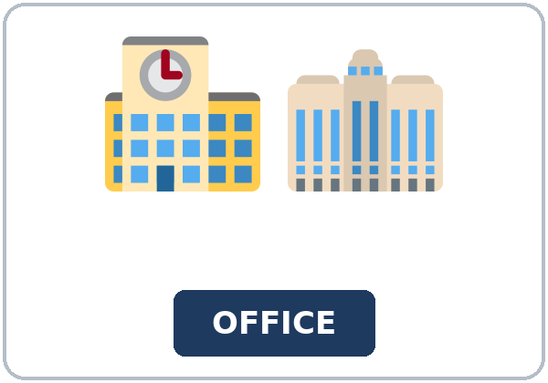  ★ school office | 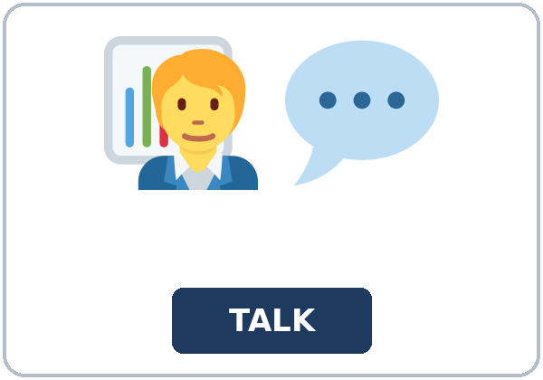  ★ counselor | 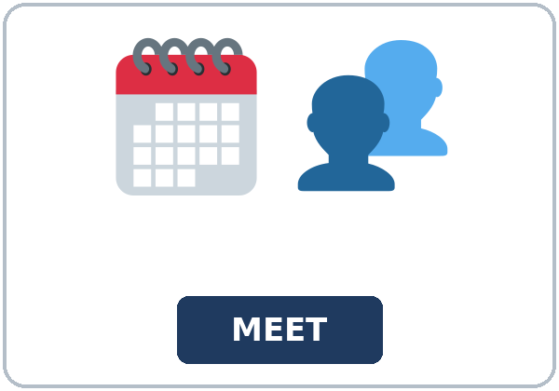  ★ conference | 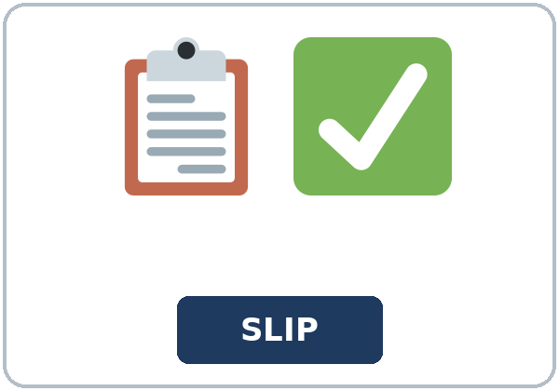  ★ permission slip
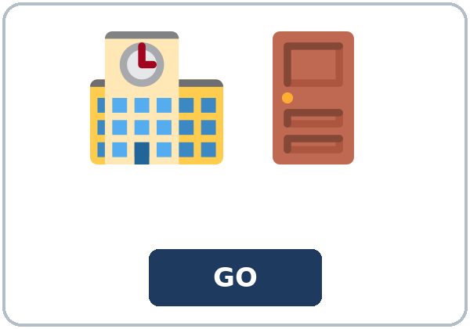  ★ dismissal | 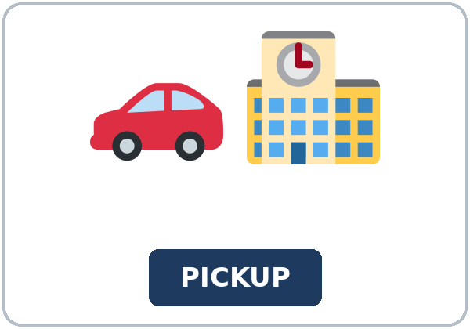  ★ pickup |   ★ newsletter |   ★ backpack
  ★ sign-up | 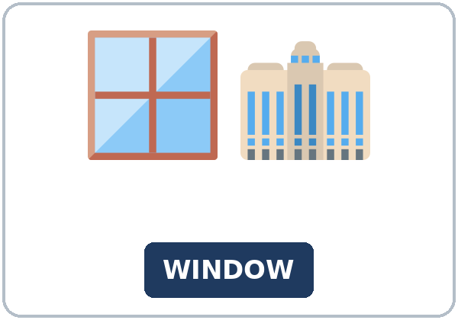  ★ office window | 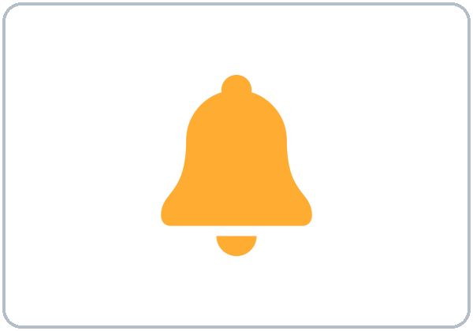  bell | 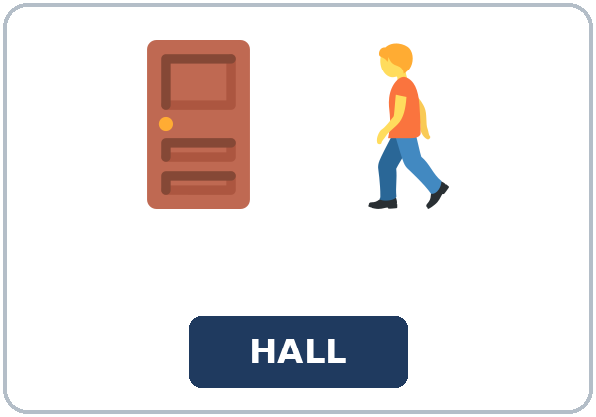  hallway

Partner game: Point and ask!
Example: A points to a picture. B asks, "Do you know where the office window is?" Switch.
Check the Meaning
Look at the picture. Answer the question.
1. What do you carry books in? ______________
2. What rings in the hallway? ______________
3. What paper does a parent bring for early pickup? ______________
Lesson 8 (Week 9) · Listening
Maya calls the office at Northside School. Mr. Reed answers.
A. Listen. Why is she calling? Circle.
a. to ask about the bus b. to ask about the conference c. to join the office staff
B. Listen again. Circle the note.
1. Day: (tonight / tomorrow / Monday)
2. Starts: (6:00 / 6:30 / 7:00)
3. Bring: (the slip / the signup sheet / the newsletter)
4. Arrive: (on time / ten minutes early / after three)
5. The window is: (in the library / down the hallway / in the parking lot)
6. A slip for Maya: (yes / no)
C. Listen again. Write if, whether, or where.
1. Do you know ______ the conference is tonight?
2. Do you know ______ I should bring the signup sheet?
3. Do you know ______ the office window is?
4. Can you tell me ______ I need a permission slip?
5. Do you know ______ dismissal is at the usual time?
6. Do you know ______ I should leave my backpack?
Hear it, say it
gonna and wanna are short forms. This listening uses the full forms. You can say going to and want to. Say each line two times.
1. I want to ask about the conference.
2. I'm going to put the sheet in my backpack.
3. Do you know if the conference is tonight?
4. Do you know where the office window is?
Do you know if is one friendly chunk. The voice rises a little because it is a real question. Statement order stays even when the voice rises.
Lesson 8 (Week 9) · Grammar
Read across. The left side is the question. The right side is the answer.
Grammar Box 1: if or whether
QUESTION | ANSWER
Do you know if the conference is tonight? | Yes. It starts at 6:30. / I'm not sure.
Do you know whether I need a permission slip? | Yes. Please bring the slip.
Can you tell me if the office is still open? | Yes. It closes at seven.

Grammar Box 2: when or where
QUESTION | ANSWER
Do you know where the office is? | It's down the hallway, by the office window.
Do you know when it starts? | It starts at 6:30.
Do you know where I sign up? | At the office window.

Grammar Box 3: said or told
QUESTION | ANSWER
What did he say about the night? | He said the conference was tonight.
What did he tell you to bring? | He told me to bring the slip.
What did he say about the time? | He said it starts at 6:30.

Grammar Box 4: statement order
NOT THIS | SAY THIS
Do you know if is the conference tonight? | Do you know if the conference is tonight?
Do you know where is the office? | Do you know where the office is?
Do you know when does it start? | Do you know when it starts?

Rule of thumb: After Do you know if / whether / when / where, use statement order. Not Do you know if is the conference tonight?
Questions and answers
Q: Can I say Do you know if is the office open?
A: No. Statement order: Do you know if the office is open?
Q: Can I say Do you know where is the conference?
A: No. Do you know where the conference is?
Q: How do I report the answer?
A: He said the conference was tonight. He told me to bring the slip.
Practice A: Write if, whether, when, or where.
1. Do you know ______ the office is?
2. Do you know ______ it starts?
3. Do you know ______ I need a permission slip?
4. Can you tell me ______ the office is still open?
5. Do you know ______ the signup sheet is?
6. Do you know ______ the bell rings?
Practice B: Circle the correct words.
1. Do you know if (the conference is / is the conference) tonight?
2. Do you know where (the office is / is the office)?
3. Do you know when (it starts / does it start)?
4. He (said / said me) the conference was tonight.
5. He told (me / to me) to bring the slip.
6. Can you tell me if (the office is / is the office) open?
Common mistakes
✗ Don't say | ✓ Say
Do you know if is the office open? | Do you know if the office is open?
Do you know where is the conference? | Do you know where the conference is?
He told to me to bring the slip. | He told me to bring the slip.
He said me the conference was tonight. | He said the conference was tonight.
Do you know when does it start? | Do you know when it starts?

Lesson 8 (Week 9) · Talk Time: Office Call
Round 1. Sit back to back. Pick a parent card or a volunteer card. A uses Do you know if at least twice. B answers from the information card.
Some cards are a parent. Some are a volunteer. Pick either one.
Volunteer card | Parent card
Ask if the conference is tonight. Ask if you should bring the signup sheet. | Ask if you can pick up early. Ask whether you need a permission slip.

Information card (the office)
Conference: tonight at 6:30, in the library.
Signup sheet: bring it. Leave the backpack by the office window.
Volunteer: no permission slip.
Parent, early pickup: bring a permission slip. Tell the office before dismissal.
Office window: down the hallway, past the bell.
Arrive: ten minutes early.

Lesson 8 (Week 9) · Talk Time: Pass It On
Round 2. Find a new partner. Tell what the office said. Use said or told. The partner reads it back.
Model: He said the conference was tonight. He told me to bring the signup sheet.
What the office said

15: pairs, then a new partner for round 2. 7–8: pairs. 5 or fewer: one call the whole group can hear, then each person asks one more question.
Lesson 8 (Week 9) · Homework
Homework (about 20–25 minutes). Bring it next week!
1. Finish the question. Use statement order.
Example: Do you know if the office ______? → Do you know if the office is open?
1. Do you know if the office ______? → ______________________________________________
2. Do you know where the conference ______? → ______________________________________________
3. Do you know when it ______? → ______________________________________________
2. Finish your email to the office (Read & Write C).
☐ Two questions with Do you know if or whether. ☐ One detail confirmed. ☐ 6–8 sentences.
3. Ask one person Do you know if…? Report the answer with said or told.
______________________________________________________________________________
4. Review (a tag). Write the tag.
The class is on Tuesday, ______?
Lesson 8 (Week 9) · Read & Write
A. Read the newsletter. Read fast first. Then read again and answer the questions.
NORTHSIDE SCHOOL · Conference week
Please read this page before you call the office. You may be a parent, or you may be a volunteer. The same questions work for both. You do not need to say which one you are.
The conference is tonight. It starts at 6:30 in the library. The counselor will be in the library from 6:30 until 7:30. Come if you want to ask about the after-school reading hour. This night is about the time, the place, and the sign-up.
Please arrive ten minutes early. The office window is down the hallway, past the bell. Mr. Reed is going to set the signup sheets by that window. A volunteer should bring the signup sheet. Put your backpack by the office window, and then walk to the library. A volunteer does not need a permission slip. If you are not sure, ask, "Do you know whether I need a permission slip?"
A parent who needs early pickup should bring a permission slip. Tell the office before dismissal. Dismissal is at three. Early pickup is before three. The conference is in the evening, so a parent can come back. Ask, "Do you know if I can pick up early?" The office says yes when the slip is signed. Do not write any ID number on the slip. A name and a signature are enough.
This newsletter is a second source. If a friend says the conference is tomorrow, check this page. The page says tonight. You can also call and ask, "Do you know whether the conference is tonight?" Or ask, "Do you know where the office window is?" Use statement order after if, whether, when, and where. Not "Do you know if is the conference tonight?"
Mr. Reed said the conference was tonight. He told volunteers to bring the signup sheet. He told parents to bring a permission slip for early pickup. He also said to arrive ten minutes early. If you cannot come, send an email with two Do you know if or Do you know whether questions, and confirm one detail. The office is open until seven. I want to keep the call short, so write your question before you dial.

B. Answer the questions.
1. When is the conference? ______________________________________________
2. Where is the conference? ______________________________________________
3. What does a volunteer bring? ______________________________________________
4. What does a parent bring for early pickup? ______________________________________________
5. How early should people arrive? ______________________________________________
C. Write an email to the office (6–8 sentences). Ask two indirect questions. Confirm one detail.
Start: Dear Mr. Reed, Do you know if the conference is tonight?
My email

D. Check your writing with a partner.
 | Yes | Not yet
It has 6–8 sentences. | ☐ | ☐
It has two questions with if or whether. | ☐ | ☐
The word order after if is a statement. | ☐ | ☐
It confirms one detail. | ☐ | ☐

Lesson 8 (Week 9) · Exit Ticket
Name: ______________________________ Date: ________________
Write the question you would ask the office, and the answer you hope for. Four sentences.
Two with Do you know if / whether. One reported answer. And a reason.
Example: Do you know if the conference is tonight? Do you know whether I should bring the sheet? He said it starts at 6:30. I want to arrive on time.
My answer
1.
2.
3.
4.

For the teacher | yes | almost | not yet
Four sentences, two indirect questions, one report, a reason | ☐ | ☐ | ☐

Picture Credits
Pictures use Twemoji graphics by Twitter, Inc. and other contributors (https://github.com/jdecked/twemoji), licensed under CC BY 4.0 (https://creativecommons.org/licenses/by/4.0/). The graphics were resized and combined, and signs and labels were added. The file-by-file list is in images/CREDITS_L5_L8.md.
Listening audio (L5_L8_listening.mp3, 1:43): synthetic voices made with Chatterbox TTS (MIT License), cloned from synthetic reference clips made with Kokoro-82M (Apache License 2.0). No recordings of real people. The names and the story are invented.
Course materials: © 2026 the authors, licensed under CC BY-NC-SA 4.0 (https://creativecommons.org/licenses/by-nc-sa/4.0/).

