Level 5 Adult ESL Curriculum · Lesson 9 (Week 10): It Must Be an Ad
Status: Published. Listening audio, lesson pages, and teacher slides are ready.
Date: October 2026
Audience: Program coordinators and volunteer teachers
Companion files: images/ (12 vocabulary pictures + images/CREDITS_L5_L9.md). Listening audio is recorded (about 1:50).
Topic: Decide whether a short web page is reliable: who wrote it, how old it is, and whether it is an advertisement. Say must be, might be, and can't be with a reason. Use only the invented pages in this lesson.

How this lesson is organized
Part | What's inside | Who uses it
Teacher Plan | At a glance, clock-time plan, step-by-step boxes, listening script, answer key, teacher notes | Volunteer teachers
Student Pages | Opening Talk, New Words, Listening, Grammar, Talk Time, Homework, Read & Write, Exit Ticket. Print this part for learners | Learners
Picture Credits | Picture, audio, and license credits | Coordinators

What Lesson 9 builds on and what it adds
Before (review only) | Where | New in Level 5 Lesson 9
might for a guess you are less sure about | Level 4 | must when you are almost sure, and can't when it is not possible
Do you know if…? | Lesson 8 | A reason after the modal: author, date, ad, or a mismatch
said / told | Lesson 6 | Tell a classmate what you would do before you shared a page

TEACHER PLAN
Lesson 9 (Week 10)

It Must Be an Ad
At a glance · Clock-time plan · Step by step · Script and answer key

How to Use This Plan
Teach in English. Show, point, and gesture. The common mix-up is a row in the mistakes table.

Instructions: use the same short task words every week: Listen. Circle. Check. Write. Work with a partner. Work in a group. Ask a follow-up question. Give a reason.

Instruction rule: Model it, check it (ask: "Almost sure, less sure, or not possible?"), then go.

Grouping toolkit: Groups: 3 learners. With an odd number, one group may have 4. The teacher joins a pair only if one learner is left over.

When a learner is stuck: (1) point to the author, the date, or the button on the class page; (2) give one more English example; (3) point to the grammar box; (4) a classmate can help for a few seconds, then back to English.

Four sentences on the exit ticket: use must, might, or can't, and give one reason.

Lesson 9 (Week 10): It Must Be an Ad
At a glance
By the end of class, you can do these four things.
Today you will: Say how sure you are with must, might, and can't. Name two clues. Tell a classmate, with a reason.
Now you can: Say how sure you are with must, might, and can't. Name two clues. Tell a classmate, with a reason.
Objectives: learners can…
• I can say how sure I am with must, might, and can't.
• I can name two clues (author, date, ad, a mismatch).
• I can say what I would do before I believed the page.
• I can tell a classmate, with a reason.

Materials
• Student Pages for Lesson 9 (print for the number expected + 3 spares)
• The three class pages on the Talk Time page (city bus notice, amazing-deal page, neighborhood post)
• Listening: phone + small speaker. The audio is recorded (about 1:50). No speaker? Read the script aloud with a volunteer.
• Prep time: 15 minutes (read the plan; practice stress on MUST and CAN'T).

Key vocabulary (with pictures on the New Words page)
★ website • ★ source • ★ author • ★ advertisement • ★ screenshot • ★ fact • ★ rumor • ★ date stamp • ★ logo • ★ comment • reliable • share button
Also: clue, mismatch, Buy now, second source, forward.

Clock-time plan
Times are loose. If the listening or Talk Time runs long, take the time from Read & Write.
Time | Step | Min | Grouping (15 / 7–8) | If running behind
6:00–6:06 | Opening Talk + Homework Check | 6 | Pairs (7 pairs + 1 trio / 3–4 pairs) | One card only
6:06–6:12 | New Words (picture page) + pair game | 6 | Whole class, then pairs | Teach the ★ words only
6:12–6:32 | Listening: play 1 (Task A), play 2 (Tasks B and C) + "Hear it, say it" | 20 | Individuals, then pairs check | Do Task C together on the board
6:32–6:45 | Grammar Q&A: must / might / can't + pair check | 13 | Whole class, then pairs | Skip the pair check; Talk Time practices it
6:45–7:00 | BREAK | 15
7:00–7:18 | Talk Time: Three Pages + Before You Share | 18 | 5 groups of 3 / 2 groups | Round 1 only
7:18–7:25 | Read & Write: two pages about one library event | 7 | Pairs read, then individual writing | Reading questions only; the writing becomes homework
7:25–7:30 | Exit Ticket + Homework | 5 | Individuals | Never skip

Skip order if you're running behind: (1) the Read & Write writing task (it becomes homework); (2) the pair check at the end of Grammar; (3) the second round of Talk Time. Never skip: the listening tasks, the grammar box and the mistakes table, and the exit ticket.

Attendance (15 → 7–8 → 5 or fewer): 15 learners: 5 groups of 3. 7–8: 2 groups. 5 or fewer: one group, all three pages.

Step by step
Step 1 · 6:00–6:06 · Opening Talk + Homework Check · 6 min
• Grouping: pairs, the same partner for both parts. 15 learners: 7 pairs + 1 group of 3. 7–8 learners: 3–4 pairs. 5 or fewer: pairs, or one group with you.
• Before class: write on the board: Do you know if the office is open? and the wrong order if is the office open?
• Opening Talk: A asks Do you know if…? B keeps statement order and reports one answer with said or told.
• Model: "Do you know if the office is open?" "He said the office was open. He told me to come at 6:30."
• Homework Check: pairs read one indirect question from the Lesson 8 email. Write 2 corrections (often Do you know if is… and told to me). No names.
• If behind: one card only.

Step 2 · 6:06–6:12 · New Words · 6 min
• Grouping: whole class, then pairs.
• Do: point to each picture and say the word. Learners repeat once. ★ = the most important words.
• Show the hard words: author (the person or office that wrote it) • date stamp (how old the page is) • advertisement (a page that wants you to buy) • rumor (a story with no good source) • reliable (you can name the author and the date, and it matches a second source) • share button (the button that sends the page to someone else).
• Check the Meaning: 1. A page with Buy now is what? (an ad) • 2. Who writes a page? (the author) • 3. What shows how old a page is? (the date stamp).
• Partner game: Must, might, or can't? A points to a picture. B says one sentence with must be, might be, or can't be. Switch. 15: then 3 teams. 7–8: 2 teams. 5 or fewer: one team against the clock.
• If behind: teach the ★ words only.

Step 3 · 6:12–6:32 · Listening + "Hear it, say it" · 20 min
• Grouping: individuals, then pairs check. With 5 or fewer, the whole group checks together.
• Before you listen: "Noah shows Aisha a post. The post says their grocery store is closing. Listen: is the store closing?"
• Voices: Narrator, Noah, Aisha.
• Play 1 → Task A. Pairs compare. Check together.
• Read Tasks B and C together.
• Play 2 → Tasks B and C. Then show the answers.
• "Hear it, say it": gonna and wanna are short forms. This listening uses the full forms. You can say going to and want to. Say each line two times. Stress the modal: It MUST be a rumor. It CAN'T be a fact. Might stays softer.
• The audio is recorded (about 1:50). When it is ready, it plays the conversation once. Press play again for play 2. A third play is fine if the class needs it. Until then, read the script with a volunteer at a normal, friendly speed, two times.
• If behind: do Task C together on the board.

Step 4 · 6:32–6:45 · Grammar Q&A + pair check · 13 min
• Grouping: whole class, then pairs. The left side is the clue or the question. The right side is the answer.
• Show it: point to a "Buy now" line and say, "It must be an ad." Point to "2019" and say, "It might be old." Point to a different logo and say, "It can't be the city's page."
• The boxes: Box 1 must be. Box 2 might be. Box 3 can't be. Box 4 how sure.
• Rule of thumb: must / might / can't + be or another base verb. Can't here means "that is not possible," not "is not able."
• Questions and answers. Then Practice A and B and the mistakes table.
• Pair check: A says, "It has a Buy now button." B says, "It must be an ad." Then switch. 5 or fewer: you join one pair.
• If behind: skip the pair check.

Break · 6:45–7:00 · 15 min
• Write on the board: almost sure → must be. Less sure → might be. Not possible → can't be.

Step 5 · 7:00–7:18 · Talk Time: Three Pages + Before You Share · 18 min
• Say at the start: "We use only the class pages." If a learner brings up a real post, say: "Let's stay with our class pages."
• Round 1, Three Pages: groups label each page must be, might be, or can't be and give a reason. 15: 5 groups of 3. 7–8: 2 groups. 5 or fewer: one group, all three pages.
• Round 2, Before You Share: each person says what they would check before they forwarded the page. The group agrees on one check.
• No elections, no health cures, no crime stories.
• If behind: round 1 only.

Step 6 · 7:18–7:25 · Read & Write · 7 min
• Grouping: pairs read; individual writing. With 5 or fewer, read both pages aloud.
• Read: two short pages about the same library event. One is the library's page. One is a repost with a wrong time.
• Check: questions 1–5.
• Write: a 6–8 sentence message to a friend: which page you trust, two clues, and what the person should do. Start in class. Finish at home.
• If behind: questions 1–5 only; the writing becomes homework.

Step 7 · 7:25–7:30 · Exit Ticket + Homework · 5 min · NEVER SKIP
• Exit ticket: How can you tell that a page might be wrong? Four sentences with must, might, or can't, and one reason.
• Collect the pages. Sort them into yes / almost / not yet. No names next week.
• Homework: about 20–25 minutes. Do item 1 together: It must be an ad.

Listening script
1:50. The conversation plays once, so press play again for the second listen.
Audio: Play L5_L9_listening.mp3 (1:50) from a phone and a small speaker. No speaker? Read the script with a volunteer, at a normal, friendly speed. The script says going to and want to. People often say gonna and wanna; learners only need to recognize those words.

Narrator: Lesson nine. Noah shows Aisha a post. The post says their grocery store is closing. They want to check the source.
Noah: Aisha, please look at this post. It says our grocery store is closing on Friday.
Aisha: Do you know who wrote it? I don't see an author.
Noah: There is no author. And I don't see a date stamp.
Aisha: Then it might be old. It might be a rumor. I'm going to look for the store's own page.
Noah: Here it is. The logo matches our store.
Aisha: What does that page say?
Noah: It says the store is open. The hours are the same.
Aisha: Then the closing post can't be true. It must be a rumor.
Noah: The post has a share button. I was going to share it.
Aisha: Don't share it yet. We want to check a second source first.
Noah: The store page names the author. The author is the store. The date is this week.
Aisha: That page must be the one we trust. The first post has no author and no date.
Noah: So the store isn't closing. I'm not going to share the post.
Aisha: Good. It can't be a fact when the store's own page says the opposite.
Noah: There is a comment under the post, but the comment has no source.
Aisha: A comment is not a fact. It might be someone's guess.
Noah: I see. A reliable page names the author and the date.
Aisha: Yes. And it matches a second source. This one does.
Narrator: That's the end of the listening.

Answer key
• Check the Meaning: 1 an ad, 2 the author, 3 the date stamp.
• Listening Task A: b (No. The store's page says it is open.)
• Listening Task B: 1 no, 2 no, 3 matches, 4 open, 5 he does not share it, 6 it is not a fact.
• Listening Task C: 1 might, 2 might, 3 can't, 4 must, 5 must, 6 can't.
• Grammar Practice A: 1 must, 2 might, 3 can't, 4 might, 5 can't, 6 must.
• Grammar Practice B: 1 must be, 2 can't be, 3 might be, 4 must be, 5 be, 6 not possible.
• Talk Time: Page 1 must be a real notice. Page 2 must be an ad. Page 3 might be old, and it can't be the library's page. Reasons will vary if they name a real clue on the card.
• Homework 1: 1 must, 2 might, 3 can't. Homework 4: Do you know if the library is open tonight? Homework 2 and 3: answers will vary.
• Read & Write B: 1 The library's page. 2 Thursday at 6:30. 3 Thursday at 8:00. 4 The library's page. 5 The author and the date. Writing (C): answers will vary. A good message names the library's page, two clues, and one next step.
• Exit ticket: answers will vary. A good answer: "A page with no author might be wrong. A page with no date might be old. It can't be a fact if a second source does not match. I must check the author and the date before I share it."
Teacher notes
• Use only the invented pages in the lesson. If a learner brings up a real post, say: "Let's stay with our class pages."
• No elections, no health cures, no crime stories.
• Reliable means you can name the author and the date, and the page matches a second source. It does not mean "I like it."
• Stress MUST and CAN'T. Might stays softer.
• Reductions: the listening says going to and want to. People often say gonna and wanna. Learners only need to recognize the short forms.
• Noah, Aisha, the store, and the library pages are invented.

STUDENT WORKBOOK
Lesson 9 (Week 10)

It Must Be an Ad
Opening Talk · New Words · Listening · Grammar · Talk Time · Homework · Read & Write · Exit Ticket

Lesson 9 (Week 10) · Opening Talk
Student Page · Week 10
Name: ______________________________ Date: ________________
Work with a partner. A asks Do you know if…? B keeps statement order and reports one answer. Then compare one homework sentence.
1. Ask: Do you know if the office is open?
2. Keep statement order. Not: if is the office open.
3. Report the answer: He said… / He told me…
4. Homework check: read one indirect question from your email.
Model: Do you know if the office is open? He said the office was open. He told me to come at 6:30.
Lesson 9 (Week 10): It Must Be an Ad
Student Page · Week 10
New Words
Look. Listen. Repeat. ★ = most important words.
  ★ website |   ★ source | 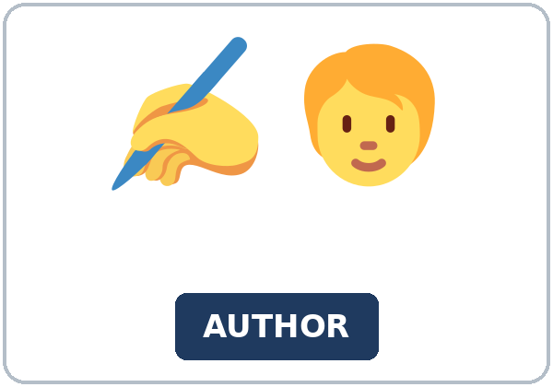  ★ author |   ★ advertisement
  ★ screenshot | 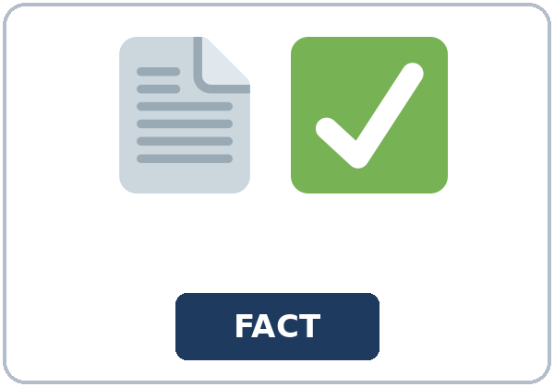  ★ fact | 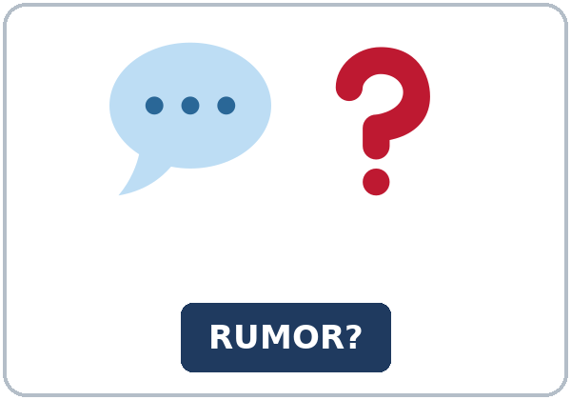  ★ rumor | 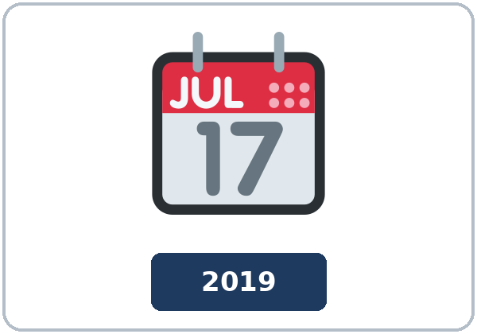  ★ date stamp
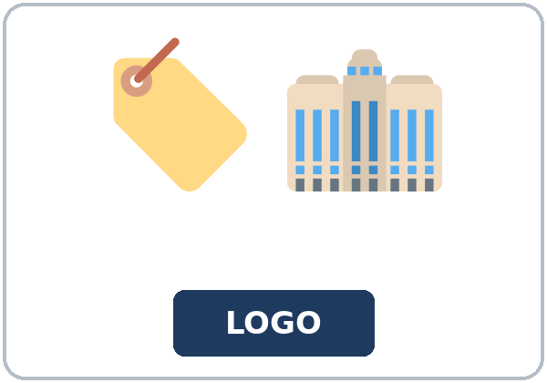  ★ logo | 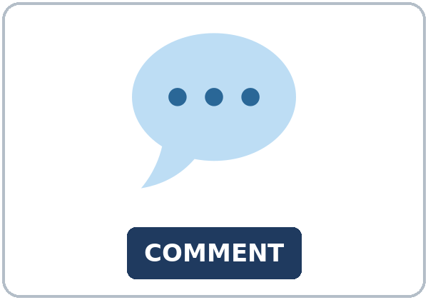  ★ comment | 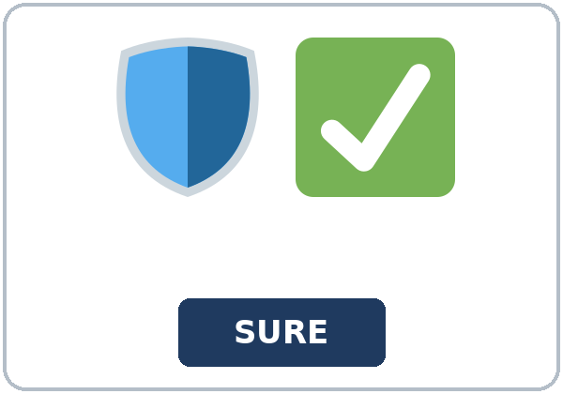  reliable |   share button

Partner game: Must, might, or can't?
Example: A points to a picture. B says, "A page with no author might be a rumor." Switch.
Check the Meaning
Look at the picture. Answer the question.
1. A page with Buy now is what? ______________
2. Who writes a page? ______________
3. What shows how old a page is? ______________
Lesson 9 (Week 10) · Listening
Noah shows Aisha a post. The post says their grocery store is closing.
A. Listen. Is the store closing? Circle.
a. Yes. It closes on Friday. b. No. The store's page says it is open. c. No one can tell.
B. Listen again. Circle the clue.
1. Author on the post: (yes / no)
2. Date stamp on the post: (yes / no)
3. Store logo: (matches / is different)
4. Store's own page: (open / closing)
5. The share button: (he shares it / he does not share it)
6. The comment: (it is a fact / it is not a fact)
C. Listen again. Write must, might, or can't.
1. Then it ______ be old.
2. (First guess) It ______ be a rumor.
3. The closing post ______ be true.
4. (After the store page) It ______ be a rumor.
5. That page ______ be the one we trust.
6. It ______ be a fact.
Hear it, say it
gonna and wanna are short forms. This listening uses the full forms. You can say going to and want to. Say each line two times.
1. We want to check a second source first.
2. I'm going to look for the store's own page.
3. It must be a rumor.
4. It can't be a fact.
Stress the modal: It MUST be a rumor. It CAN'T be a fact. Might stays softer.
Lesson 9 (Week 10) · Grammar
Read across. The left side is the clue. The right side is what you say.
Grammar Box 1: must be
CLUE | ANSWER
The page has a Buy now button. What is it? | It must be an ad.
The store's page says the store is open. What is the closing post? | It must be a rumor.
The logo, the author, and the date all match. What is the page? | It must be the store's page.

Must means you are almost sure.
Grammar Box 2: might be
CLUE | ANSWER
The date says 2019. What do you think? | It might be old.
There is no author. What do you think? | It might be a rumor.
The comment has no source. What do you think? | It might be a guess.

Might is a guess you are less sure about.
Grammar Box 3: can't be
CLUE | ANSWER
The logo is different. Is it the city's page? | It can't be the city's page.
The store's page says open. Is the store closing? | It can't be closing.
The first post has no author and no date. Is it a fact? | It can't be a fact.

Grammar Box 4: how sure?
HOW SURE? | SAY
You are almost sure. | must be
You are less sure. | might be
It is not possible. | can't be

Rule of thumb: must / might / can't + be or another base verb. Can't here means "that is not possible," not "is not able."
Questions and answers
Q: Can I say It must an ad?
A: No. It must be an ad.
Q: The logo is different. Can I say It can be not the city page?
A: No. It can't be the city page.
Q: Does can't here mean "is not able"?
A: No. It means that is not possible.
Practice A: Write must, might, or can't.
1. The page has a Buy now button. It ______ be an ad.
2. The date says 2019. It ______ be old.
3. The logo is different. It ______ be the city's page.
4. There is no author. It ______ be a rumor.
5. The store's own page says the store is open. The post ______ be true.
6. Aisha is almost sure. She says it ______ be a rumor.
Practice B: Circle the correct words.
1. It (must / must be) an ad.
2. It (can be not / can't be) the city page.
3. The date says 2019. It (must be / might be) old.
4. It (must to be / must be) an ad.
5. It can't (be / to be) official.
6. Can't here means (not able / not possible).
Common mistakes
✗ Don't say | ✓ Say
It must an ad. | It must be an ad.
It can be not the city page. | It can't be the city page.
It must to be an ad. | It must be an ad.
It can't means she is not able. | It can't be means it is not possible.
It must be not official. | It can't be official.

Lesson 9 (Week 10) · Talk Time: Three Pages
Round 1. Read the three class pages. Label each one must be, might be, or can't be. Give one reason.
Use only these pages.
Page 1 · City bus notice | Page 2 · Amazing deal | Page 3 · Neighborhood post
Author: the city bus office. Date: this week. Logo: the city bus logo. The evening bus still stops at the library at 6:15. | No author. No date. A Buy now button. The page says, "Amazing deal. Buy now." | No date. The logo is not the library logo. The post says the library event is canceled.
It must be a real notice. | It must be an ad. | It might be old. It can't be the library's page.

15: 5 groups of 3. 7–8: 2 groups. 5 or fewer: one group, all three pages.
Lesson 9 (Week 10) · Talk Time: Before You Share
Round 2. Before you share, name one check. Say what you would do. The group agrees on one check.
Checks: the author • the date stamp • the logo • a second source • not the share button yet
Our one check | Why

Model: I would check the author and the date before I pressed the share button. A page with no date might be old.
Lesson 9 (Week 10) · Homework
Homework (about 20–25 minutes). Bring it next week!
1. Write must, might, or can't.
1. The page has a Buy now button. It ______ be an ad.
2. The date says 2019. It ______ be old.
3. The logo is different. It ______ be the city's page.
2. Finish your message to a friend (Read & Write C).
☐ I named the page I trust. ☐ I named two clues. ☐ I said what to do. ☐ 6–8 sentences.
3. Tell a friend one clue you would check before you shared a class page. Write the sentence.
______________________________________________________________________________
4. Review (Do you know if). Finish the question in statement order.
Do you know if the library ______?
Lesson 9 (Week 10) · Read & Write
A. Read the two pages. They are about the same library event. One time is wrong. Read fast first. Then read again and answer the questions.
Page 1 · The city library
Author: the city library. Date stamp: this month. Logo: the library logo.
The evening reading hour is on Thursday at 6:30. The room is the meeting room on the first floor. Please come ten minutes early so you can find a seat. The page on the library website matches the paper newsletter at the front desk. Both say Thursday at 6:30. Both name the city library as the author.
You can trust this page. It names the author and the date, and it matches a second source. The logo is the same logo on the door. There is no Buy now button. This page is not an advertisement. If a friend asks, "Do you know if the reading hour is at 6:30?" you can say yes.
The hour ends at 7:30. The evening bus still stops outside at 6:15, so 6:30 is an easy time to arrive. We are not going to move the time. If the time changes, the library will change this page and the newsletter on the same day.

Page 2 · A repost
Author: none. Date stamp: none. Logo: a star, not the library logo. Share button: yes.
This repost says the reading hour is on Thursday at 8:00. It does not say who wrote it. It does not give a date. The logo does not match the library. A comment under the post says, "I heard it moved." The comment has no name and no source. That comment might be a guess. It can't be a fact by itself.
The time does not match. The library says 6:30. This page says 8:00. That mismatch is the clue. The repost might be old, or it might be a rumor. It can't be the library's page, because the logo is different and there is no author. Do not press the share button yet. Check the library's page first. If you already shared the repost, send a correction: the reading hour is Thursday at 6:30.
A reliable page names the author and the date, and it matches a second source. This repost does not. Liking a page is not the same as trusting it. Before you believe a time, look for the author, the date stamp, and one more source.

B. Answer the questions.
1. Which page names an author? ______________________________________________
2. What time is on the library's page? ______________________________________________
3. What time is on the repost? ______________________________________________
4. Which page do you trust? ______________________________________________
5. What is one clue? ______________________________________________
C. Write a message to a friend (6–8 sentences). Which page do you trust? Give two clues. Say what the person should do.
Start: I trust the library's page. It must be the right time.
My message

D. Check your writing with a partner.
 | Yes | Not yet
It has 6–8 sentences. | ☐ | ☐
It names the page you trust. | ☐ | ☐
It gives two clues. | ☐ | ☐
It has must, might, or can't, and a next step. | ☐ | ☐

Lesson 9 (Week 10) · Exit Ticket
Name: ______________________________ Date: ________________
How can you tell that a page might be wrong? Four sentences. Give one reason.
Use must, might, or can't.
Example: A page with no author might be wrong. A page with no date might be old. It can't be a fact if a second source does not match. I must check the author and the date before I share it.
My answer
1.
2.
3.
4.

For the teacher | yes | almost | not yet
Four sentences, must / might / can't, and a reason | ☐ | ☐ | ☐

Picture Credits
Pictures use Twemoji graphics by Twitter, Inc. and other contributors (https://github.com/jdecked/twemoji), licensed under CC BY 4.0 (https://creativecommons.org/licenses/by/4.0/). The graphics were resized and combined, and signs and labels were added. The file-by-file list is in images/CREDITS_L5_L9.md.
Listening audio (L5_L9_listening.mp3, 1:50): synthetic voices made with Chatterbox TTS (MIT License), cloned from synthetic reference clips made with Kokoro-82M (Apache License 2.0). No recordings of real people. The names and the story are invented.
Course materials: © 2026 the authors, licensed under CC BY-NC-SA 4.0 (https://creativecommons.org/licenses/by-nc-sa/4.0/).

