Level 5 Adult ESL Curriculum · Lesson 1 (Week 1): How Long Have You Been Working Here?
Status: Published. Listening audio, lesson pages, and teacher slides are ready.
Date: October 2026
Audience: Program coordinators and volunteer teachers
Companion files: images/ (12 vocabulary pictures + images/CREDITS_L5_L1.md). Listening audio: L5_L1_listening.mp3 (1:37).
Topic: A practice job interview at a community center. Learners say how long they have been doing something, give one accomplishment with an example, and ask a follow-up question. Week 1 also has a short welcome, the first can-do check, and a baseline snapshot for about five learners.

How this lesson is organized
Part | What's inside | Who uses it
Teacher Plan | At a glance, the clock, step-by-step boxes, the listening script, the answer key, teacher notes | Volunteer teachers
Student Pages | Opening Talk, New Words, Listening, Grammar, Talk Time, Homework, Read & Write, Can-do Check, Exit Ticket | Learners
Picture Credits | Picture and license lines | Coordinators

What Lesson 1 builds on and what it adds
Before (review only) | Where | New in Level 5 Lesson 1
Present perfect for experiences and for / since | Level 4 Lessons 1–2 | been + -ing for an activity that is still going on: I've been working there for two years.
How long have you lived / worked…? | Level 4 Lesson 2 | I've worked there for two years is also correct for How long. Both answers are accepted.
Simple past for a finished time | earlier lessons | A finished year still needs the simple past: I worked at a bakery in 2022.

TEACHER PLAN
Lesson 1 (Week 1)

How Long Have You Been Working Here?
At a glance · Clock · Steps · Script and answer key

How to Use This Plan
Teach in English. You do not need to speak the learners' languages. Show the picture, draw the line, and point to the grammar box. There is no contrast-tip box. The common mix-up is a row in the mistakes table.

Instructions: use the same short task words: Listen. Circle. Check. Write. Work with a partner. Ask a follow-up question. Give a reason.

Instruction rule: Model it (do it with one learner while everyone watches), check it (ask: "Is the job still true, or is the year finished?"), then go.

When a learner is stuck: (1) show it (picture, gesture, or the timeline); (2) give one more English example; (3) point to the grammar box; (4) a classmate can help for a few seconds, then back to English.

About four sentences: the Talk Time answer and the exit ticket are about four connected sentences: how long, what you have been doing, one example, and why it matters.

Lesson 1 (Week 1): How Long Have You Been Working Here?
At a glance
Objectives: learners can…
• answer How long have you been…?
• also answer with I've worked… for / since
• give one example of an accomplishment
• ask a follow-up question

Materials
• Student Pages for Lesson 1 (print the number you expect + 3 spares)
• Board and markers. Draw a line: 2022 (finished) ————→ now (still true)
• Six interview question cards (they are on the Talk Time page; cut them if you can)
• Listening: L5_L1_listening.mp3 (1:37). Play it two times. No speaker? Read the script aloud with a volunteer.
• Prep time: 15 minutes. Read the plan, draw the line, and practice the script once.

Key vocabulary (with pictures on the New Words page)
★ résumé • ★ interview • ★ accomplishment • ★ example • ★ skill • ★ job offer • ★ training • ★ portfolio • ★ handshake • ★ follow-up • qualification • name tag

Clock-time plan
Times are loose. If listening or Talk Time runs long, take the time from Read & Write.
Time | Step | Min | Grouping (15 / 7–8) | If running behind
6:00–6:06 | Opening Talk (Week 1: no homework yet) | 6 | Pairs (one group of 3 if odd) / pairs | One card only
6:06–6:12 | New Words + a one-minute meaning check | 6 | Whole class, then pairs | Teach the ★ words only
6:12–6:32 | Listening (play 1 = Task A; play 2 = Tasks B and C) + "Hear it, say it" | 20 | Individuals, then pairs check | Do Task C together on the board
6:32–6:45 | Grammar Q&A + a short pair check | 13 | Whole class, then pairs | Skip the pair check
6:45–7:00 | BREAK | 15
7:00–7:18 | Talk Time: Practice Interview + Kind Feedback | 18 | Pairs, then one rotation / pairs (you listen for the baseline) | Round 1 only
7:18–7:25 | Read & Write: a job posting + start the email | 7 | Pairs read; then individual writing | Questions only; the email is homework
7:25–7:30 | Can-do check + Exit Ticket + Homework | 5 | Individuals | Never skip the exit ticket

Skip order if you are behind: (1) the Read & Write writing (it becomes homework); (2) the pair check at the end of Grammar; (3) Talk Time round 2. Never skip the listening tasks, the grammar boxes and the mistakes table, and the exit ticket.

5 or fewer: one table. For Talk Time, each person interviews the person on their left.

Step by step
Step 1 · 6:00–6:06 · Opening Talk · 6 min
• Grouping: pairs. 15 learners: 7 pairs + 1 group of 3. 7–8 learners: 3–4 pairs. 5 or fewer: pairs, or one group with you.
• Week 1: there is no homework to check. Say: "Welcome. Tonight is practice, not a real interview. You may invent the hotel and the dates."
• Before class: write on the board: How long have you…? and I've been…
• Opening Talk: learners open the Opening Talk page. A asks a card question. B answers in a short summary (the answer, one detail). A asks one follow-up. Then switch.
• Model with one learner: "How long have you lived in this city?" Help the learner answer in two or three sentences. Then ask, "How long? Can you give an example?"
• Late arrivals: join any pair.
• If behind: one card only.

Step 2 · 6:06–6:12 · New Words · 6 min
• Grouping: whole class, then pairs.
• Do: point to each picture and say the word. Learners repeat once. ★ = most important.
• Show the hard words: a résumé is a paper about your work. An accomplishment is one thing you did well. An example makes it easy to see. A follow-up comes after the interview (a note or a call). A qualification is a fact that shows you can do the job. A name tag shows your name. It is not a skill.
• Check the meaning: "Is a résumé a paper about your work?" (yes, a work paper) • "Is a handshake a follow-up?" (no) • "Does a name tag show a skill?" (no, it shows a name)
• Partner game (about 2 min): A points to a picture and asks one question. B answers. Switch. 15 learners: finish with 3 teams if you have a minute. 7–8: 2 teams. 5 or fewer: one team against the clock.
• If behind: teach the ★ words only.

Step 3 · 6:12–6:32 · Listening + "Hear it, say it" · 20 min
• Grouping: individuals, then pairs. With 5 or fewer, check together.
• Before you listen: "Nora is practicing for a hotel front-desk job. Samir is her coach. Ms. Hale asks the questions. Listen: what job is the practice for?"
• Voices: Nora, Samir, and Ms. Hale. A narrator opens and closes. The audio is recorded (about 1:37). Read the script with volunteers, two times. Press nothing. A third read is fine if the class needs it.
• Play 1 → Task A (the main idea). Pairs compare. Check together: b. a hotel front-desk job.
• Read Tasks B and C so learners know what to listen for.
• Play 2 → Tasks B and C. Pairs compare. Then show the answers.
• "Hear it, say it": gonna and wanna are short forms. This listening uses the full forms. You can say going to and want to. Then the weak been in I've been working. Stress the job word, not been. Say each line two times.
• If behind: do Task C together on the board.

Step 4 · 6:32–6:45 · Grammar Q&A · 13 min
• Grouping: whole class, then pairs. The left side is the question. The right side is the answer.
• Draw the timeline (1 min): two marks. Left: 2022, finished: I worked at a bakery. Right: now, still true: I've been working / I've worked. Say: "been + -ing stresses the activity, still going on. have + past participle is also correct for How long. Both answers are accepted. A finished time (in 2022) still needs the simple past."
• Boxes: read across. Box 1 is been + -ing. Box 2 is have + past participle, also correct. Box 3 is the simple past for a finished job. Box 4 is which form.
• Rule of thumb: been + -ing stresses the activity, still going on. have + past participle is also correct for How long, and it is the form from Level 4. Both answers are accepted. A finished time (in 2022) still needs the simple past.
• Questions and answers: read each question. The class says the right sentence.
• Practice A and B: learners write, then pairs check.
• Common mistakes: read "Don't say" and ask for the fix before you show "Say."
• Pair check (last 2 min): A says "still true" or "finished in 2022." B makes one sentence. Switch.
• If behind: skip the pair check. Talk Time practices it.

Break · 6:45–7:00 · 15 min
• Leave the timeline on the board: still true → I've been working / I've worked. A finished year → I worked.

Step 5 · 7:00–7:18 · Talk Time: Practice Interview + Kind Feedback · 18 min
• Model a 30-second answer first: "I've been working with customers for three years. One accomplishment is that I trained two new cashiers. For example, I stayed with one cashier for a week. It matters because new workers need a calm start."
• Round 1, Practice Interview: A is the interviewer and uses the six question cards. B answers in about four sentences (how long, one accomplishment, one example, one reason). Then switch.
• Round 2, Kind Feedback: the partner names one clear sentence and asks one follow-up.
• 15 learners: pairs, then one rotation.
• 7–8 learners: pairs. You listen to each pair for the baseline. Prompts, if you need them: How long have you been coming to this class? Tell me about a project you finished. What do you wish you had asked someone? Do you know if the library is open tonight? Tell me one thing a person said to you this week. About five learners tonight. The same prompts come back at the final. Do not ask why someone left a job, what they earn, or how they came to this country.
• 5 or fewer: one table. Each person interviews the person on their left.
• If behind: round 1 only.

Step 6 · 7:18–7:25 · Read & Write · 7 min
• Grouping: pairs read; then each person starts the email. With 5 or fewer, read the posting aloud together.
• Read: the Harbor Hotel posting and the "How we interview" note. Say: "Read once for the job. Then find the answers."
• Questions: pairs answer. Then show the key.
• Write: a 6–8 sentence email to the coach. Name the job you want to practice, how long you have been doing related work, and one accomplishment with an example. Invented details are fine. Start in class. Finish at home.
• If behind: the questions only. The email is homework.

Step 7 · 7:25–7:30 · Can-do check + Exit Ticket + Homework · 5 min · NEVER SKIP
• Can-do check (about 1 min): read the four "I can" lines. Learners mark one face for each line: 😀 🙂 😐. Every goal is a good goal. This is the Week 1 check, not a test.
• Exit ticket: How long have you been studying English (or doing your job)? About four sentences: how long, what you have been doing, one example, and why it matters. With 5 or fewer, a learner can say it and then write it.
• Collect the pages. Sort them later into yes / almost / not yet. Next class, put two corrections on the board. No names.
• Homework: about 20–25 minutes. Do item 1 together: I / work / at the hotel / for two years (still true) → I've been working at the hotel for two years. (I've worked at the hotel for two years is also correct.)

Listening script
Audio is recorded (about 1:37). Read it with volunteers at a natural, friendly speed. The spoken lines use going to and want to. gonna and wanna are short forms. This listening uses the full forms.
Narrator: Lesson one. The community center is holding a practice interview night. Nora wants a hotel front-desk job.
Samir: Hi, Nora. I'm Samir, your coach. Are you ready to practice?
Nora: Yes. I want to practice for a front-desk job at the Harbor Hotel.
Samir: Good. Ms. Hale is going to ask the questions. I am going to take notes.
Ms. Hale: Welcome, Nora. How long have you been working with customers?
Nora: I've been working with customers for three years. I work at a store now.
Ms. Hale: Tell me one accomplishment.
Nora: I trained two new cashiers last spring.
Ms. Hale: Can you give an example?
Nora: Yes. One new cashier was nervous. I stayed with her for a week.
Ms. Hale: Have you finished any hotel training?
Nora: Not yet. I want to start the front-desk training next month.
Samir: That example was clear. You said, "I've been working."
Ms. Hale: What did you do in 2022?
Nora: I worked at a bakery in 2022. That job is finished.
Ms. Hale: Do you have a follow-up question?
Nora: Yes. What do you send after the interview?
Ms. Hale: A short note. A handshake and a thank-you are a good start.
Samir: Next, you are going to put one accomplishment in your portfolio.
Narrator: That's the end of the listening.

Answer key
• Check the meaning: 1 yes, a work paper. 2 no. 3 no, it shows a name.
• Listening Task A: b. a hotel front-desk job.
• Listening Task B: 1 three years. 2 trained two new cashiers. 3 stayed for a week. 4 a bakery.
• Listening Task C: 1 been working. 2 worked. 3 been working. 4 worked.
• Grammar Practice A: 1 working. 2 since. 3 for. 4 worked. 5 finished. 6 taking.
• Grammar Practice B: 1 've been working. 2 worked. 3 have you been working. 4 been working. 5 for. 6 since.
• Talk Time: answers will vary. A good answer has how long, one accomplishment, one example, and one reason.
• Homework 1: 1 She's been taking this class since September. 2 I worked at a bakery in 2022. 3 They've been working here since 2024. (They've worked here since 2024 is also correct.) 4 He helped customers at a store. Homework 2 and 3: answers will vary. Homework 4: 1 for. 2 since. 3 for. 4 since.
• Read & Write: 1 Front desk at Harbor Hotel. 2 For one year or more. 3 Stayed for a week. 4 The simple past. 5 A short follow-up note.
• Exit ticket: answers will vary. A good answer: "I've been studying English for two years. I've been taking this class since September. One example is my interview practice tonight. It matters because I want to give a clear answer."
Teacher notes
• This is practice. Do not ask why someone left a job, what they earn, or how they came to this country. Learners may invent the hotel and the dates. Model a 30-second answer first.
• Both forms are accepted when the work is still true: I've been working here since 2024 and I've worked here since 2024. Do not mark the Level 4 form wrong.
• A finished year (in 2022) needs the simple past. I've been working here in 2022 is the mix-up to fix.
• Baseline: during Talk Time, listen to about five learners. Use the prompts in Step 5. Write a few words for your folder. It is not a grade you announce.
• Reductions: the script says going to and want to. People often say gonna and wanna. Learners only need to recognize the short forms. They can always say the full forms.
• Weak been: in I've been working, been sounds like "bin." Stress the job word (working, customers), not been.

STUDENT WORKBOOK
Lesson 1 (Week 1)

How Long Have You Been Working Here?
Opening Talk · New Words · Listening · Grammar · Talk Time · Homework · Read & Write · Exit Ticket

Lesson 1 (Week 1) · Opening Talk
Name: ______________________________ Date: ________________
Work with a partner. A asks a question. B answers in a short summary. A asks one follow-up. Then switch.
A: How long have you lived in this city? | A: How long have you studied English?
A: Have you finished a class or a training? | A: What have you been doing this week?

Follow-ups: How long? • Can you give an example? • Why?
Week 1: there is no homework to check.
My partner's name | One thing my partner has been doing

Lesson 1 (Week 1): How Long Have You Been Working Here?
Name: ______________________________ Date: ________________
New Words
Look. Listen. Repeat. ★ = most important words.
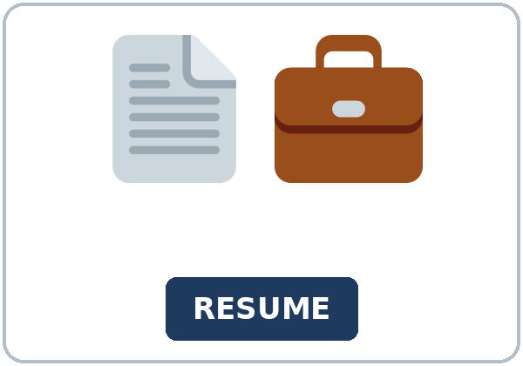  ★ résumé | 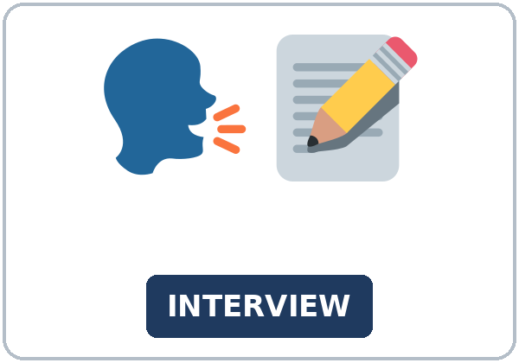  ★ interview | 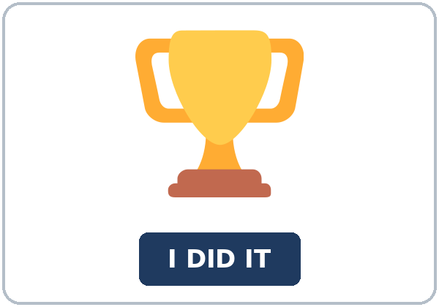  ★ accomplishment | 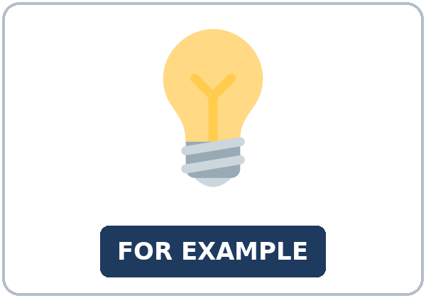  ★ example
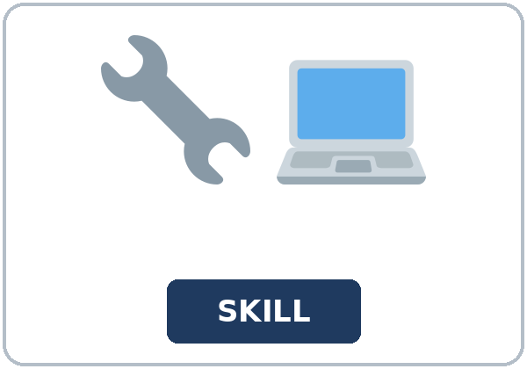  ★ skill |   ★ job offer | 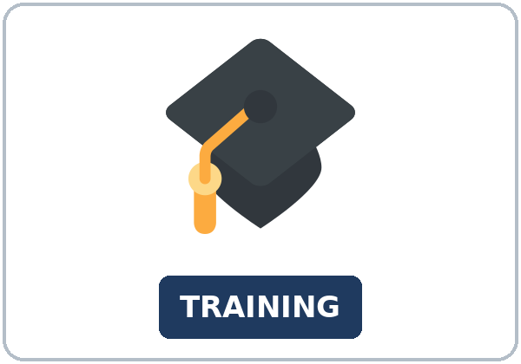  ★ training |   ★ portfolio
  ★ handshake |   ★ follow-up | 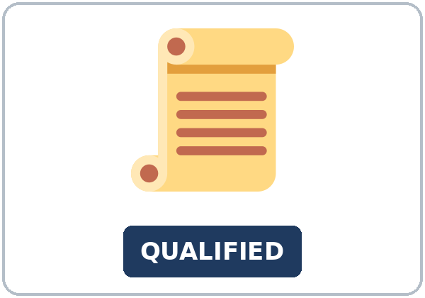  qualification | 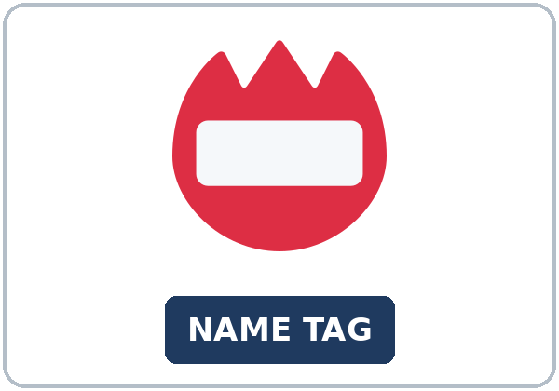  name tag

Partner game: Ask one question!
Example: A points and asks, "interview: What question can you ask?" B says, "How long have you been working here?" Switch.
Lesson 1 (Week 1) · Listening
Nora is practicing for a hotel front-desk job. Samir is her coach. Ms. Hale asks the questions.
A. Listen. What job is the practice for? Circle.
a. a bakery job b. a hotel front-desk job c. a coach's job
B. Listen again. Circle the answers.
1. How long with customers? (three years / two years / since September)
2. Accomplishment? (trained two new cashiers / finished the training / sent a follow-up)
3. Example? (stayed for a week / worked in 2022 / a handshake)
4. The job in 2022? (the hotel / a bakery / this class)
C. Listen again. Write been working or worked.
1. I've ____________ with customers for three years.
2. I ____________ at a bakery in 2022.
3. You said, "I've ____________."
4. I ____________ at a bakery in 2022. That job is finished.
Hear it, say it
gonna and wanna are short forms. This listening uses the full forms. You can say going to and want to.
Say the full words: going to and want to. Weak been in I've been working. Stress the job word, not been. Say each line two times.
1. I want to practice for a front-desk job.
2. Ms. Hale is going to ask the questions.
3. I've been working with customers.
4. How long have you been working here?
Lesson 1 (Week 1) · Grammar
Read across. A reads the question. B says the answer.
Grammar Box 1: been + -ing (the activity, still going on)
QUESTION | ANSWER
How long have you been working here? | I've been working here for two years.
How long have you been working at the hotel? | I've been working there for two years.
How long has she been taking this class? | She's been taking this class since September.

Grammar Box 2: have + past participle is also correct for How long
QUESTION | ANSWER
How long have you worked here? | I've worked here since 2024.
How long have you worked there? | I've worked there for two years.
Have you finished the training? | Yes, I have.

Grammar Box 3: a finished time needs the simple past
QUESTION | ANSWER
What did you do in your last job? | I helped customers at a store.
Where did you work in 2022? | I worked at a bakery in 2022.

Grammar Box 4: Which form?
FORM | EXAMPLE
been + -ing | the activity, still going on: I've been working here for two years.
have + past participle | also correct for How long: I've worked here since 2024.
simple past | a finished time (in 2022): I worked at a bakery in 2022.

Rule of thumb: been + -ing stresses the activity, still going on. have + past participle is also correct for How long, and it is the form from Level 4. Both answers are accepted. A finished time (in 2022) still needs the simple past.
Questions and answers
Q: Can I say I am working here since 2024?
A: No. Say I've been working here since 2024. I've worked here since 2024 is also correct.
Q: Can I say I've been working here in 2022?
A: No. That year is finished. Say I worked here in 2022.
Q: Is I've worked there for two years wrong?
A: No. For How long, both been working and worked are accepted when you still have the job.
Practice A: Write the missing word.
1. I've been ____________ here for two years.
2. I've worked here ____________ 2024.
3. I've worked here ____________ two years.
4. I ____________ at a bakery in 2022.
5. Have you ____________ the training?
6. She's been ____________ this class since September.
Practice B: Circle the correct words.
1. I (am working / 've been working) here since 2024.
2. I ('ve been working / worked) here in 2022.
3. How long (have you been working / you have been working) at the hotel?
4. I've (been working / working) there for two years.
5. I've worked there (for / since) two years.
6. She's been taking this class (since / for) September.
Common mistakes
✗ Don't say | ✓ Say
I am working here since 2024. | I've been working here since 2024. or I've worked here since 2024.
I've been working here in 2022. | I worked here in 2022.

Pair check
A says still true or finished in 2022. B makes one sentence (I've been working… or I worked…). Then switch.
Lesson 1 (Week 1) · Talk Time: Practice Interview
Round 1. A is the interviewer. Ask from the six cards. B answers in about four sentences: how long, one accomplishment, one example, one reason. Then switch.
1. How long have you been working at your job? (Invent a job if you want.)
2. How long have you been studying English?
3. What is one accomplishment?
4. Can you give an example?
5. Why does that example matter?
6. Do you have a question for me?
Useful: Can you say that again? • How long? • Can you give an example?
Round 2. Kind Feedback. Name one clear sentence. Ask one follow-up. With a large class, change partners once.
One clear sentence | My follow-up question

Lesson 1 (Week 1) · Homework
Homework (about 20–25 minutes). Bring it next week!
1. Write the sentence. If the work is still true, been working or worked is fine. A finished year needs worked.
Example: I / work / at the hotel / for two years (still true) → I've been working at the hotel for two years.
1. she / take / this class / since September → ______________________________________________
2. I / work / at a bakery / in 2022 (finished) → ______________________________________________
3. they / work / here / since 2024 (still true) → ______________________________________________
4. he / help / customers / at a store (last job) → ______________________________________________
2. Finish your email from Read & Write. Read it one more time.
☐ The job I want to practice. ☐ How long I have been doing related work. ☐ One accomplishment with an example.
3. Ask one person: How long have you been…? Write the answer in one sentence.
Question | Answer

4. Review (for or since).
1. I've lived here ____________ two years.
2. I've lived here ____________ 2024.
3. I've worked there ____________ three years.
4. She's been taking this class ____________ September.
Lesson 1 (Week 1) · Read & Write
A. Read. Read once for the job. Then find the answers.
Harbor Hotel · Front Desk Clerk · How we interview
The Harbor Hotel is hiring a front-desk clerk. This page is practice for class. It is not a real job offer. Bring a résumé if you have one. A name tag helps, but you can also say your name. You do not need every qualification tonight.
We want someone who has been working with customers for one year or more. You may also say, "I have worked with customers for one year." Both answers are fine when the work is still true. A finished job needs the simple past and the year. One example in the posting is, "I worked at a bakery in 2022."
Please bring one accomplishment and one example. An accomplishment is one thing you did well. In the posting, the accomplishment is "I trained two new cashiers." The example is "I stayed with one new cashier for a week." A skill is smaller. Greeting a guest is a skill. You can name one skill in a single line.
How we interview: First we ask, "How long have you been working with customers?" Next we ask for the accomplishment and the example. Then you ask one follow-up question. A handshake at the start is welcome. After the practice, the coach sends a short follow-up note. You can keep that note in your portfolio.
Front-desk training starts next month. You do not have to finish the training before this practice. Tell us one skill you use now. We do not ask why you left a job, what you earn, or how you came to this city. You may invent the hotel and the dates. Four clear sentences are enough.

B. Answer the questions.
1. What job is the posting for? ______________________________________________
2. How long with customers? ______________________________________________
3. What example do they give? ______________________________________________
4. A finished job in 2022 uses… ______________________________________________
5. What does the coach send after? ______________________________________________
C. Write a 6–8 sentence email to the coach. Name the job you want to practice, how long you have been doing related work, and one accomplishment with an example. Invented details are fine.
Example: I want to practice for a front-desk job. I've been working with customers for three years. I've worked at a store since 2023. One accomplishment is that I trained two new cashiers. For example, I stayed with one cashier for a week. I worked at a bakery in 2022. That job is finished. I want to ask one follow-up question at the end.
My email

Lesson 1 (Week 1) · Can-do Check
Read each line. Mark one face. 😀 = I can do this. 🙂 = I can do some of it. 😐 = Not yet. Every goal is a good goal.
I can… | 😀 | 🙂 | 😐
I can answer How long have you been…? | ☐ | ☐ | ☐
I can also answer with I've worked… for / since. | ☐ | ☐ | ☐
I can give one example of an accomplishment. | ☐ | ☐ | ☐
I can ask a follow-up question. | ☐ | ☐ | ☐

Lesson 1 (Week 1) · Exit Ticket
Name: ______________________________ Date: ________________
How long have you been studying English (or doing your job)? About four sentences. Then give this page to your teacher.
1. How long. 2. What you have been doing. 3. One example. 4. Why it matters.
My answer
1.
2.
3.
4.

For the teacher | yes | almost | not yet
About four sentences, today's grammar, a reason | ☐ | ☐ | ☐

Picture Credits
Pictures use Twemoji graphics by Twitter, Inc. and other contributors (https://github.com/jdecked/twemoji), licensed under CC BY 4.0 (https://creativecommons.org/licenses/by/4.0/). The graphics were resized and combined, and signs and labels were added. The file-by-file list is in images/CREDITS_L5_L1.md.
Listening audio: L5_L1_listening.mp3 (1:37). The voices are computer-generated. No recordings of real people. The names and the story are invented.
Course materials: © 2026 the authors, licensed under CC BY-NC-SA 4.0 (https://creativecommons.org/licenses/by-nc-sa/4.0/).

