Level 2 Adult ESL Curriculum: Semester Plan and Lessons 1–4 (Version 4.1)
Working title: Talk Together: Level 2 (placeholder; run a trademark search before adopting any name, see Section 7)
Version: 4.1, public edition (revised October 15, 2026: teacher instructions need no Spanish)
Audience: Program coordinators and volunteer teachers
Companion files: Level2_Curriculum_v4_1_public.md (same content), Level2_Curriculum_v4_1_public.pdf (print version), audio/ (listening MP3s for Lessons 1–4), images/ (52 vocabulary pictures + images/CREDITS.md)
Content policy: This curriculum is fully secular. It contains no religious, apologetics, or faith-based content, and none should be added. Topics are practical daily life, work, family, health, shopping, and community services.

Independence notice: Independent project, not affiliated with or endorsed by Intercambio Uniting Communities.

How this document is organized
Part | What's inside | Who uses it
A. Program Guide | What changed, the semester plan, the weekly routine, scope and sequence, exam and graduation weeks | Coordinators, all teachers
B. Teacher Guide | Lessons 1–4: at a glance, clock-time plan, step-by-step boxes, listening scripts, answer keys | Volunteer teachers
C. Student Workbook | Lessons 1–4: New Words, Listening, Grammar, Homework. Print this part for learners | Learners
D. Reference | Audio, copyright and licensing, printing, website, open questions, sources | Coordinators

PART A
Program Guide

The semester, the weekly routine, and the course plan

0. What Changed in Version 4.1
Teachers do not need to speak Spanish. All teachers are assumed to be fluent English speakers who may speak no Spanish. Teacher instructions now only ask teachers to work in English. The Spanish notes stay on the student pages for learners to read on their own.
Where | Version 4 | Version 4.1
Lesson 1, Step 2 (Orientation) | Language rule: "English first. Spanish for 10 seconds to help, then back to English." | Rule in English only: "English in class. If you're stuck, a classmate can help you for a few seconds. Then back to English." The teacher does not need to understand or use the other language
Teacher Guide intro | Mentioned the Spanish note only | New box: "You don't need to speak Spanish", with what to do when a learner is stuck or asks something in Spanish
Lesson 1 and Lesson 4 teacher notes | "Spanish speakers: watch for…" | The typical mistake is explained in English, and the teacher points learners to the Spanish note on the Grammar page
Section 3.3 grammar order | "(L1)", "(L2)"… | "(Lesson 1)", "(Lesson 2)"… so "L1" is not confused with "first language"
Section 0.3 (Version 2 changes) | "Spanish support" row | Clarified that learners read the Spanish notes themselves

0.1 What Changed in Version 4
Topic | Version 3 | Version 4
Organization | Teacher plan and student pages mixed together inside each lesson | Four parts: A. Program Guide, B. Teacher Guide, C. Student Workbook, D. Reference. The Student Workbook can be printed on its own
Layout | Dense pages, small type | More white space, larger type on student pages (13 pt), clear headers, page breaks between lessons and between sections
Teacher steps | Long paragraphs | One activity per box: grouping, what to do, what to say, and "If behind" as short lines
Student pages | Everything on 2 pages | One topic per page: New Words · Listening · Grammar · Homework (with writing lines)
Grammar | Q&A with tables | Two-sided grammar boxes (QUESTION on the left, ANSWER on the right) with substitution columns, then the short Q&A, common mistakes, and the Spanish note
Clock tables | Time column wrapped ("6:00–" / "6:10") | Wider fixed time column
Pictures and audio | — | Unchanged from Version 3

0.2 What Changed in Version 3
Topic | Version 2 | Version 3 (this document)
Vocabulary | Word lists only | A picture for every key word in Lessons 1–4 (52 pictures) on a "New Words" page at the top of each Student Page. ★ marks the 8 most important words. Pictures are Twemoji (CC BY 4.0, with attribution) plus original drawings. See images/CREDITS.md and Section 12
Grammar | Rule boxes and tables | Grammar Q&A: every grammar section is a set of questions learners actually ask (Q: When do I add -s? A: …), with the same tables, examples, common-mistake tables, Spanish notes, and tips
Core time | 6:00–6:45 + 7:00–7:20, steps of 5–7 min | 6:00–6:45 + 7:00–7:15, fewer and longer steps (8–15 min)
Opening + homework | Two separate 5-minute steps | One 10-minute block with the same partner; the teacher corrects only 2 items
Pronunciation | A 5-minute core step after the break | A 1–2 minute "Say it" repeat inside Listening; the full pronunciation activity moves to "If time"
Pair practice | A separate 6-minute step | A short pair check inside the Grammar block (last 3–5 min); the long version moves to "If time"
7:15–7:30 | Exit ticket + 10-min extension | "If time" menu in priority order: ① pronunciation ② pair game ③ extension
Running behind | "Short-night rules" only | "If running behind" column in every lesson plan, plus a priority list (Section 2.1)

0.3 What Changed in Version 2
Topic | Version 1 | Version 2
Course length | 32 lessons, 8 units | 16-week semester, 1 class per week, 13 new-content lessons + midterm (Week 8) + final (Week 15) + graduation (Week 16)
Class time | 90 minutes | 6:00–6:45 PM, 15-minute break, 7:00–7:20 PM core, optional extension until 7:30
Group size | 6–15 | About 15 at the start, dropping to 7–8. Every activity has a "15 learners / 7–8 learners" version
Spanish support | Teacher notes only | Short Spanish notes in the student pages (learners read them on their own; teachers need no Spanish) + rules for all learners + tips for speakers of other languages
Listening | Teacher read-aloud dialogue | A listening section in every lesson: an audio clip + check/circle/fill-in tasks. MP3s made for Lessons 1–4 with a free, Apache-licensed AI voice
Homework | None | Short homework every lesson, checked at 6:05 the next week
Opening | Warm-up game | 5-minute partner question based on the previous lesson (works for late arrivals)
Review lessons | Every 4th lesson | Removed; review happens in homework checks, warm-ups, Week 8, and Week 15
New sections | — | Copyright and licensing (Sec. 7), TTS audio (Sec. 6), workbook printing (Sec. 8), website hosting (Sec. 9)

1. The Semester at a Glance
Week | Class | Content | Notes
1 | Lesson 1: Nice to Meet You | be vs. do questions | Includes orientation and baseline snapshot
2 | Lesson 2: A Day in My Life | Simple present (he/she + -s), frequency words
3 | Lesson 3: Free Time | like/love/hate + -ing; me too / me neither
4 | Lesson 4: Right Now | Present continuous; "now" vs. "every day"
5 | Lesson 5: Last Weekend | Past of be; simple past (regular -ed)
6 | Lesson 6: My Story | Irregular past; Did you…?; ago
7 | Lesson 7: Getting Around | Comparatives; How long does it take?
8 | MIDTERM | Review stations + exam (Lessons 1–7) | No new content
9 | Lesson 8: The Best Place in Town | Superlatives; recommending places
10 | Lesson 9: Food and Shopping | Count/noncount; some/any; How much/many; I'd like
11 | Lesson 10: Health | I have a cold; My ___ hurts; should / shouldn't
12 | Lesson 11: Making Plans | be going to; invitations; present continuous for plans
13 | Lesson 12: Getting Things Done | have to / need to; Can/Could you…?; phone calls about services
14 | Lesson 13: Then, Now, and Next | Past/present/future together; prepare graduation talk
15 | FINAL | Review stations + exam (all lessons) | No new content
16 | GRADUATION | Certificates, 1-minute talks, celebration | No new content

2. The Class Routine (Same Every Week)
2.1 Clock-time template
The core runs 6:00–6:45 and 7:00–7:15 (60 minutes). It has six steps, each with room to breathe. 7:15–7:30 is optional ("If time"). Week 1 uses a modified version (see Lesson 1).
Clock time | Step | Minutes | What happens | Status
6:00–6:10 | 1. Opening Talk + Homework Check | 10 | Same partner for both. First ~5 min: a question about last week's lesson (late arrivals join a pair). Next ~5 min: compare homework. The teacher corrects only 2 items on the board. | Core
6:10–6:18 | 2. New Words | 8 | Picture page: point, say, repeat; quick pair game | Core
6:18–6:30 | 3. Listening + "Say it" | 12 | Before you listen → Task A → Task B → Task C (grammar fill-in) → 1–2 min repeating 2 lines from the audio | Core
6:30–6:45 | 4. Grammar Q&A + quick pair check | 15 | Learners read the Q's; class answers; examples, common mistakes, check questions; then 3–5 min of pair practice | Core
6:45–7:00 | BREAK | 15
7:00–7:10 | 5. Talk Time | 10 | The main speaking activity of the night | Core
7:10–7:15 | 6. Exit Ticket + Homework | 5 | One sentence on a slip; explain the homework and do item 1 together | Never skip
7:15–7:30 | If time (pick in order) | 0–15 | ① Pronunciation activity (5) ② Pair practice game, long version (5–10) ③ Extension / second Talk Time round (10) | Optional

If you're running behind, skip in this order: (1) everything in "If time"; (2) the third play of the audio, so do Task C together with the teacher reading the lines; (3) the pair check at the end of Grammar, which becomes part of the homework; (4) teach only the ★ words (the others stay on the page for home study); (5) the second half of Talk Time, so do one round only. Never skip: the Listening tasks, the Grammar Q&A mistakes table, and the Exit Ticket + Homework.

If you're ahead of time: go to the "If time" menu at 7:15, or let Talk Time run 5 minutes longer and switch partners once more.

Late-arrival rules: Step 1 is designed for people walking in late. A late learner joins any pair (making a group of 3) and starts talking right away. Keep 3 extra copies of every handout by the door.

Why the change from Version 2: Version 2 had 9 steps of 5–7 minutes each, so every transition (moving chairs, handing out paper, late arrivals) cost time the plan didn't have. Version 3 has 6 core steps with built-in slack, and everything else is clearly optional.

2.2 Adapting to attendance (15 → 7–8 learners)
Situation | 15 learners | 7–8 learners | 5 or fewer
Pairs | 7 pairs + 1 group of 3 | 3–4 pairs | Pairs; the teacher joins only if one person is left
Small groups | 3–4 groups of 4–5 | 2 groups of 3–4 | One group
Circles (inside–outside) | Two circles of 7–8, or one big circle | One circle | Use "rotate seats" instead
Mingles | Each learner talks to 5–6 people | Each learner talks to everyone | Turn the mingle into a table interview
Printing | Print for the number expected, plus 3 spares

Why attendance drops, and what helps: adults miss class because of work and family. The homework check and opening question give returning learners a quick way back in. Each lesson's handout stands alone, so a learner who missed a week can still follow.

2.3 Assessment and progress (semester version)
Tool | When | What | Who / how long
Baseline snapshot | Weeks 1–3 | Same 6 speaking prompts every time (name, from, live, work, routine, free time) | Teacher or a second volunteer, 2 minutes per learner, about 5 learners per week during Talk Time
Can-do self-check | Week 1, Week 8, Week 15 | "I can…" list with 😀 🙂 😐 | Learner, 5 minutes
Exit ticket | Every lesson | One sentence or question with today's grammar | Learner; teacher reads it after class
Homework | Every lesson | Short written or speaking task | Pairs check in the 6:00–6:10 opening block
Midterm | Week 8 | Listening (audio), grammar (15 items), speaking (pair task + rubric) on Lessons 1–7 | See Section 4.1
Final | Week 15 | Same format, all lessons, focus on 8–13; speaking uses the baseline prompts to show growth | See Section 4.1
Speaking rubric | Midterm, final, and some Talk Times | Communication / target grammar / pronunciation and fluency, each scored 1–3 | Teacher

Speaking rubric (same as v1):
Score | Communication | Target grammar | Pronunciation and fluency
3 | Completes the task; asks and answers follow-up questions | Uses the target form correctly most of the time | Easy to understand; few long pauses
2 | Completes most of the task with some help | Uses the form, with errors that don't block meaning | Mostly understandable; some pauses
1 | Needs a lot of help; very short answers | Rarely uses the form, or errors block meaning | Hard to understand without effort

Proposed graduation standard (confirm): attend at least 9 of the 13 lessons (plus the exams) and complete the final. "Ready for Level 3" = 2 or higher in all rubric areas on the final, plus 🙂 or 😀 on at least 80% of the can-do list. Learners who are not ready still graduate from the course and are encouraged to repeat Level 2.
3. Scope and Sequence: 13 Lessons
3.1 Lesson list
# (Week) | Title | Grammar | Real-life function | Listening (audio) | Pronunciation
1 (W1) | Nice to Meet You | be vs. do/does questions; short answers | Meet a new classmate or neighbor | Two neighbors meet at a community center | Rising ↗ / falling ↘ question intonation
2 (W2) | A Day in My Life | Simple present; he/she + -s; doesn't; frequency words | Describe routines; compare weeks | Coworkers talk about a long day | -s endings /s/ /z/ /ɪz/
3 (W3) | Free Time | love/like/don't mind/hate + noun or -ing; me too / me neither | Break-room small talk | Coworkers talk about weekends | /ŋ/ in -ing; stress for feeling
4 (W4) | Right Now | Present continuous (am/is/are + -ing); now vs. every day | Phone call: "What are you doing?"; telling time (review) | A phone call while waiting for the bus | Contractions I'm, she's, they're
5 (W5) | Last Weekend | was/were; simple past regular verbs | Talk about the weekend; ask How was…? | Friends talk about their weekend | -ed endings /t/ /d/ /ɪd/
6 (W6) | My Story | Common irregular past verbs; Did you…?; negatives; ago | Tell a short life story (moving, first job, first days here) | A learner tells how she started a new life in a new city | Did you → "didja" (recognize)
7 (W7) | Getting Around | Comparatives (-er / more / better); How long does it take?; by bus / on foot | Compare commutes and ways to travel | Two people compare bus vs. car | -er /ər/; word stress
— (W8) | Midterm | Review of Lessons 1–7 |  | Midterm listening clip
8 (W9) | The Best Place in Town | Superlatives (the -est / the most / the best); there is / there are (review) | Recommend a store, park, or clinic | Neighbors recommend places | th /ð/ in the, there
9 (W10) | Food and Shopping | Count/noncount; some/any; How much/How many; I'd like / Can I have…? | Order food; make a shopping list | Ordering at a restaurant | /ɪ/ vs. /i/ (chip/cheap)
10 (W11) | Health | I have a…; My ___ hurts; should / shouldn't | Describe symptoms; make an appointment by phone | Calling a clinic | /ʃ/ vs. /tʃ/ (shoe/chew); silent l in should
11 (W12) | Making Plans | be going to; present continuous for arrangements; invitations | Invite, accept, decline politely | Friends make weekend plans | going to → "gonna" (recognize)
12 (W13) | Getting Things Done | have to / need to; Can/Could you…? | Call about a bill; mail a package; leave a voicemail | A customer service call | have to → "hafta"; polite intonation
13 (W14) | Then, Now, and Next | Past + present + future in one story | Prepare and practice a 1-minute graduation talk | A former learner's short talk | Sentence stress and linking

3.2 What we dropped or moved (to fit 13 lessons)
Topic (v1) | Decision | Why
Describing people (What's he like? / What does he look like?) | Optional bonus worksheet; may belong in Level 1 or 3 | Lower priority than survival functions; confirm with Level 1 content
Directions and prepositions of movement | Optional "If time" activity in Lesson 7 | Lesson 7 already contains comparatives and travel time
a few / a little | Light mention in Lesson 9 only | Keeps Lesson 9 manageable
can / can't for ability | Dropped (probably Level 1) | Confirm with Level 1
will for offers; object pronouns | Moved to Level 3 | Not essential for this level's goals
Feelings about moving | Folded into Lesson 6 (I felt nervous / happy) | Fits the life-story topic
Holidays and celebrations | Optional in Lesson 6 (learners choose what to share) | Kept secular and optional
Telling time as a full lesson | Reviewed inside Lesson 4 | Most learners know numbers; practice the language in context instead

3.3 Grammar in teaching order
1. be vs. do questions (Lesson 1) → 2. simple present + -s (Lesson 2) → 3. frequency adverbs (Lesson 2) → 4. like + -ing, me too/neither (Lesson 3) → 5. present continuous (Lesson 4) → 6. simple present vs. continuous (Lesson 4) → 7. was/were (Lesson 5) → 8. regular past (Lesson 5) → 9. irregular past + did (Lesson 6) → 10. comparatives (Lesson 7) → midterm → 11. superlatives (Lesson 8) → 12. count/noncount, some/any, how much/many (Lesson 9) → 13. I'd like / Can I have (Lesson 9) → 14. should (Lesson 10) → 15. be going to (Lesson 11) → 16. present continuous for plans (Lesson 11) → 17. have to / need to, Can/Could you (Lesson 12) → 18. tense review (Lesson 13) → final.
Spiral recycling: every Opening Talk reuses last week's grammar. The homework always mixes in one older point. The midterm and final review stations revisit everything.
4. Exam and Graduation Weeks
4.1 Midterm (Week 8) and Final (Week 15)
Clock time | What | Notes
6:00–6:05 | Opening Talk (review question)
6:05–6:45 | Review stations (4 tables, 10 minutes each): ① Grammar Auction, ② Listening replay (previous lesson audio on a phone or speaker), ③ Question cards (speaking), ④ Pronunciation bingo | Speaking test during the stations: the teacher (or a second volunteer) calls pairs to a quiet corner for a 3-minute task scored with the rubric. With 15 learners, about 8 pairs × 3 minutes = 24 minutes; with 7–8 learners, about 12 minutes.
6:45–7:00 | Break
7:00–7:20 | Written test: listening (played twice, check/circle/fill-in, 8 items) + grammar (15 items) | Use the same task types learners know from class. No surprises.
7:20–7:30 | Can-do self-check; learners set one goal

Exam-week timing (unchanged from Version 2): exam nights use their own plan above, not the lesson template. The written test may run to 7:20 so slower readers are not rushed; the 7:20–7:30 self-check can go home as a take-home sheet if time is short.

Confirm whether the program needs grades. We recommend a simple scale: "Meets / Almost / Not yet."
4.2 Graduation (Week 16)
• No new content. Each learner gives their 1-minute talk prepared in Lesson 13 (or reads 2–3 sentences).
• Certificates of completion. Optional potluck: ask about allergies, and don't require anyone to bring food.
• Hand out a "Keep practicing" sheet with the website and QR codes for all audio.

PART B
Teacher Guide

Lessons 1–4
At a glance · Clock-time plan · Step by step · Script and answer key

5. Teacher Guide: How to Use the Lesson Plans
How to read these plans: Each lesson has (A) a Teacher Plan with clock times, steps, the listening script, and answer keys, and (B) a Student Page to print. The student page has the listening tasks, grammar box, Spanish note (Nota para hispanohablantes, written for learners to read on their own; teachers don't need to read or explain it), tips for all learners, and the homework. Audio files are in audio/ (L1_listening.mp3 … L4_listening.mp3). Each file plays the conversation twice. No speaker or device? Read the script aloud with a volunteer learner.

Grouping toolkit: Pairs: turn to a neighbor; with an odd number make one group of 3. New partners: matching cards, or line up by birthday month and "fold" the line. Inside–outside circles: inner circle faces out, outer circle faces in; the outer circle moves one person clockwise each round. Instruction rule: Model it (show with one learner), check it (ask "Do you write or speak?"), then go (start the timer).

You don't need to speak Spanish. Teach in English. The Spanish notes on the student pages are for learners to read on their own. They are not something you need to read, translate, or explain.

When a learner is stuck or asks something in Spanish: (1) show it: use the picture, a gesture, or the board; (2) give one more simple English example; (3) point to the Grammar Box or the Spanish note on their page; (4) ask a classmate to help for a few seconds, then continue in English. You don't need to understand what classmates say to each other.

Where are the student pages? In Part C: Student Workbook. Each lesson there has four pages: New Words, Listening, Grammar, Homework.

Lesson 1 · Nice to Meet You (Week 1)
At a glance
Objectives: learners can…
• ask and answer 8 or more personal-information questions
• choose between be and do questions
• introduce a partner using he/she

Materials
• name tags
• markers
• "How Our Class Works" sheet
• Student Page 1
• question-card envelopes (one per pair)
• "Find Someone Who" sheet
• baseline checklist
• phone + small speaker
• L1_listening.mp3
• Prep time: 30 min.

Key vocabulary (with pictures in the Student Workbook)
from, live, work, job, neighborhood, married / single, kids, brother / sister, hometown, near, nice to meet you, What about you?

Clock-time plan
Core = 6:00–6:45 and 7:00–7:15. Everything after 7:15 is optional ("If time").
Time | Step | Min | Grouping (15 / 7–8) | If running behind
6:00–6:10 | Welcome + Name Chain (the Week 1 opening) | 10 | Two circles / one circle | Go around once only
6:10–6:15 | Orientation: "How Our Class Works" | 5 | Whole class | Hand out the sheet; read the 3 key rules only
6:15–6:23 | New Words (picture page) | 8 | Pairs | Teach the ★ words only
6:23–6:33 | Listening (audio) + "Say it" | 10 | Individuals, then pairs check | Skip the third play; do Task C as a whole class
6:33–6:45 | Grammar Q&A: be or do? + quick pair check | 12 | Whole class, then pairs | Skip the pair check; it becomes homework item 1
6:45–7:00 | BREAK | 15
7:00–7:10 | Talk Time: Find Someone Who + baseline snapshot | 10 | Talk to 6+ people / everyone | Learners talk to 4 people
7:10–7:15 | Exit Ticket + Homework | 5 |  | Never skip
7:15–7:30 | If time (in this order): ① Pronunciation ↗/↘ (5) ② Question Scramble (5) ③ Interview and Introduce (10) | 0–15 |  | Optional

How to use this plan: the core is 6:00–6:45 and 7:00–7:15. If you fall behind, use the right-hand column. Everything after 7:15 is optional.

Step by step
Step 1 · 6:00–6:10 · Welcome + Name Chain · 10 min
• Grouping: two circles (15 learners) / one circle (7–8 learners).
• Model: "I'm Ana. I like coffee."
• Do: each next person repeats the previous person, then adds their own: "She's Ana. She likes coffee. I'm Carlos. I like soccer."
• Late arrivals: join the circle.
• If behind: go around once only.

Step 2 · 6:10–6:15 · Orientation: "How Our Class Works" · 5 min
• Grouping: whole class.
• Cover: class times and the break; homework every week (short!), checked at the start of class.
• Language rule: "English in class. If you're stuck, a classmate can help you for a few seconds. Then back to English." You don't need to understand what classmates say to each other. Just smile and say "Now in English, please."
• Also say: phones are OK for audio and dictionary. "You can tell the truth or make it up."
• If behind: hand out the sheet and read the 3 key rules only.

Step 3 · 6:15–6:23 · New Words · 8 min
• Grouping: pairs.
• Do: open the Student Workbook to the New Words page. Point to each picture, say the word; learners repeat twice.
• Pairs: A points to a picture, B says the word. Then switch.
• Extra example: show the ID card for a fictional person.
• If behind: teach only the ★ words.

Step 4 · 6:23–6:33 · Listening + "Say it" · 10 min
• Grouping: individuals, then pairs check.
• Before you listen (1 min): "Rosa and Sam meet. What questions do they ask?" Write 2–3 guesses.
• Listen 1 → Task A (true/false). Listen 2 → Task B (circle). Listen 3 → Task C (write are / do).
• Pairs compare after each task.
• "Say it" (1–2 min): pause after "Where are you from?" and "Where do you live?" The class repeats each line twice.
• Bridge to grammar: "When do we use are? When do we use do?"
• If behind: skip the third play; do Task C together (teacher reads the 4 lines).

Step 5 · 6:33–6:45 · Grammar: be or do? · 12 min
• Grouping: whole class, then pairs.
• Show: the Grammar Box (question side / answer side).
• Say: "English questions need a helper word at the front. With am/is/are, move it to the front. With no be, borrow do or does."
• Q&A: a learner reads a Q; the class guesses; read the A; write one example on the board.
• Check questions: "___ you like rice?" (do) • "___ you tired?" (are) • "Where ___ she work?" (does)
• Pair check (last 3–4 min): A builds a question from the box; B answers from the answer side.
• If behind: skip the pair check.

Break · 6:45–7:00 · 15 min
• Set up the "Find Someone Who" sheets during the break.

Step 6 · 7:00–7:10 · Talk Time: Find Someone Who · 10 min
• Grouping: mingle (talk to 6+ people / everyone).
• Do: learners turn each prompt into a correct question (Do you live near here? / Are you a morning person?).
• When someone says yes: write their name and ask one follow-up question. One name per row.
• Baseline snapshot: the teacher (or a second volunteer) uses the checklist: Can they ask a do question? Answer in a full sentence? Give 1 extra detail?
• Later: formal 2-minute baseline interviews in Weeks 2–3 (about 5 learners per week).
• If behind: learners talk to 4 people.

Step 7 · 7:10–7:15 · Exit Ticket + Homework · 5 min · NEVER SKIP
• Exit ticket: write one be question and one do question.
• Homework: explain it from the workbook and do item 1 together.

If time · 7:15–7:30 · pick in this order
• ① Pronunciation (5 min): Yes/No questions go up ↗; Wh- questions go down ↘. Hum the melody, then say the words. Pairs: A says a question, B draws the arrow in the air.
• ② Question Scramble (5 min): each pair builds 4 questions from an envelope of word cards.
• ③ Interview and Introduce (10 min): partners interview each other, then introduce the partner to a group: "This is Marta. She's from Guatemala." (Previews Lesson 2's -s. Don't teach it yet.)

Listening script: L1_listening.mp3 (about 1:40, plays twice)
Audio: play from a phone + small speaker. No speaker? Read the script with a volunteer learner.

Narrator: Lesson one. Listening. Rosa and Sam meet at the community center. Listen.
Rosa: Hi! Are you new here?
Sam: Yes, I am. I'm Sam. Nice to meet you.
Rosa: Nice to meet you too. I'm Rosa. Where are you from, Sam?
Sam: I'm from Honduras. And you?
Rosa: I'm from Colombia. Where do you live?
Sam: I live on Pine Street, near the park.
Rosa: Oh, me too! Do you work near here?
Sam: Yes, I do. I work at a hotel. I'm a cook. What do you do?
Rosa: I work at a bakery. I start very early, at five in the morning!
Sam: Wow. Do you have kids?
Rosa: Yes, I do. I have two daughters. Are you married?
Sam: No, I'm not. But my brother lives here with me.
Rosa: That's nice. Well, see you in class!
Sam: See you!

Answer key
• Task A: 1 T, 2 F (Honduras), 3 T, 4 F (a hotel), 5 T.
• Task B: 1 a cook, 2 5:00, 3 brother.
• Task C: 1 are, 2 do, 3 Do, 4 Are.
Teacher notes
• Privacy: never ask about immigration status, money, or exact addresses. Married/single is optional; Do you have family here? is an alternative.
• Mixed levels: stronger learners add a follow-up question to every answer; newer learners use the question cards as a script.
• Typical mistakes from Spanish speakers: I have 35 years (Spanish uses "have" for age) and Where you live? (Spanish questions need no helper word). These are the two most common errors this week. Write the correct form on the board, and point learners to the Spanish note on their Grammar page. They can read it themselves; you don't need to explain it.
Lesson 2 · A Day in My Life (Week 2)
At a glance
Objectives: learners can…
• describe a daily routine with 10 or more routine verbs
• use he/she + -s, doesn't, Does…?
• use always … never in the correct position

Materials
• Student Page 2
• routine picture cards (1 set per group)
• info-gap sheets A/B
• frequency signs (ALWAYS … NEVER)
• slips of paper
• L2_listening.mp3
• Prep time: 25 min.

Key vocabulary (with pictures in the Student Workbook)
get up, take a shower, get dressed, have breakfast, take the bus, drive, start work, take a break, pick up the kids, cook dinner, do the dishes, go to bed; every day, on weekends, in the morning, at night.

Clock-time plan
Core = 6:00–6:45 and 7:00–7:15. Everything after 7:15 is optional ("If time").
Time | Step | Min | Grouping (15 / 7–8) | If running behind
6:00–6:10 | Opening Talk + Homework Check (same partner): ask 3 questions (Where do you live? Do you work? Are you from a big city?), then ask each other your 5 homework questions | 10 | Pairs | Teacher collects the homework instead of reviewing it on the board
6:10–6:18 | New Words: picture page + Picture Sequence | 8 | Groups of 4–5 / 2 groups | Teach the ★ words; skip mime-and-guess
6:18–6:30 | Listening + "Say it" | 12 | Individuals → pairs | Skip the third play; do Task C together
6:30–6:45 | Grammar Q&A: simple present + frequency, then a short Information Gap | 15 | Whole class, then pairs | Do the Q&A + mistakes table only; the Information Gap moves to "If time"
6:45–7:00 | BREAK | 15
7:00–7:10 | Talk Time: Frequency Line → "Our Week" | 10 | Line, then pairs | Do "Our Week" only
7:10–7:15 | Exit Ticket + Homework | 5 |  | Never skip
7:15–7:30 | If time (in this order): ① Pronunciation: 3 sounds of -s (5) ② Information Gap, full version (5) ③ "Guess Who?" (10) | 0–15 |  | Optional

How to use this plan: the core is 6:00–6:45 and 7:00–7:15. If you fall behind, use the right-hand column. Everything after 7:15 is optional.

Step by step
Step 1 · 6:00–6:10 · Opening Talk + Homework Check · 10 min
• Grouping: pairs (same partner for both parts).
• Minutes 0–5: ask 3 questions: Where do you live? Do you work? Are you from a big city? Late arrivals join a pair.
• Minutes 5–10: partners ask each other their 5 homework questions.
• Teacher: walk around; write only 2 corrected questions on the board.
• If behind: collect the homework; return it next week with one correction each.

Step 2 · 6:10–6:18 · New Words · 8 min
• Grouping: groups of 4–5 (15) / 2 groups (7–8).
• Do: New Words page: point, say, repeat twice.
• Picture Sequence: groups put 12 routine cards in order for a typical day and say each one aloud.
• If time: pairs play mime-and-guess.
• If behind: teach the ★ words only.

Step 3 · 6:18–6:30 · Listening + "Say it" · 12 min
• Grouping: individuals → pairs.
• Before you listen: "Marco looks tired. Why?"
• Listen 1 → Task A (circle the times). Listen 2 → Task B (Marco or his wife?). Listen 3 → Task C (fill in).
• Ask: "Why drives with an -s?" (his wife = she)
• "Say it" (1–2 min): the class repeats "My wife drives. She works at a restaurant." Make the -s loud.
• If behind: skip the third play.

Step 4 · 6:30–6:45 · Grammar: simple present + frequency · 15 min
• Grouping: whole class, then pairs.
• Say: "We use the simple present for routines and facts. With he, she, it, the verb gets an -s. With does / doesn't, the -s moves to does, so the main verb has no -s."
• Grammar Box: read across one row of the question side, then the answer side. Learners choose a word from each column.
• Q&A: learner reads Q → class guesses → read A → board example.
• Check questions: "Marco takes the bus. One day or every day?" • "She ___ (not drive)." • "I take usually or I usually take?"
• Short Information Gap (last 5 min): A has Rosa's week, B has Ali's. Ask 3 questions each (What time does Rosa start work?). Don't show papers.
• If behind: skip the Information Gap.

Break · 6:45–7:00 · 15 min
• Put the ALWAYS … NEVER signs on the wall during the break.

Step 5 · 7:00–7:10 · Talk Time: Frequency Line → Our Week · 10 min
• Frequency Line (4 min): signs from ALWAYS to NEVER along a wall. Call "How often do you cook?" Learners stand at a sign and tell a neighbor.
• Our Week (6 min): pairs find 2 things in common and 2 differences, then report: "We both take the bus. Maria usually cooks, but I never cook!"
• If behind: do "Our Week" only.

Step 6 · 7:10–7:15 · Exit Ticket + Homework · 5 min · NEVER SKIP
• Exit ticket: one sentence about a family member with -s.
• Homework: explain it and do item 1 together.

If time · 7:15–7:30 · pick in this order
• ① Pronunciation (5 min): /s/ works, takes; /z/ plays, drives; /ɪz/ watches, fixes. Hold up 1, 2, or 3 fingers. Most important: say the -s at all.
• ② Information Gap, full version (5 min): finish all the blank cells.
• ③ Guess Who? (10 min): each learner writes 3 routine sentences anonymously. Groups read a slip aloud as he/she ("This person always gets up at 4…") and guess who wrote it.

Listening script: L2_listening.mp3 (about 1:25, plays twice)
Audio: play from a phone + small speaker. No speaker? Read the script with a volunteer learner.

Narrator: Lesson two. Listening. Ana and Marco talk at work. Listen.
Ana: Marco, you look tired!
Marco: I am! I get up at five thirty every day.
Ana: Five thirty? Why?
Marco: I work at the hospital. I start work at seven. I usually take the bus.
Ana: Do you drive?
Marco: No, I don't. My wife drives. She has the car.
Ana: Does she work at the hospital too?
Marco: No, she doesn't. She works at a restaurant. She works at night.
Ana: So who picks up the kids?
Marco: I do. I always pick them up at three thirty. Then I cook dinner.
Ana: Do you ever rest?
Marco: Sometimes! On Sundays, I never get up early. I sleep until nine!

Answer key
• Task A: 5:30; 7:00; 3:30; 9:00.
• Task B: works at the hospital = Marco; drives = wife; works at night = wife; picks up the kids = Marco; cooks dinner = Marco.
• Task C: drives; works; always; never.
Teacher notes
• Some learners work night shifts. Accept any routine: "morning" means whenever they wake up.
• Repeat the "one -s rule" every time the error appears this week.
• Info-gap sheets: make two copies of a weekly table and blank out 6 different cells on each.
Lesson 3 · Free Time (Week 3)
At a glance
Objectives: learners can…
• say likes and dislikes with love / like / don't mind / don't like / hate + noun or -ing
• agree and disagree (Me too / Me neither / Really? I don't / Oh, I do!)
• keep a short conversation going with What kind of…?

Materials
• Student Page 3
• four corner signs (LOVE / LIKE / DON'T MIND / HATE)
• free-time picture cards
• a soft ball
• "Find Your Twin" survey
• L3_listening.mp3
• Prep time: 15 min.

Key vocabulary (with pictures in the Student Workbook)
soccer, cooking, dancing, shopping, cleaning, gardening, fixing things, watching TV/movies, walking, reading, video calls, music (salsa, cumbia, pop, rock), What kind of…?.

Clock-time plan
Core = 6:00–6:45 and 7:00–7:15. Everything after 7:15 is optional ("If time").
Time | Step | Min | Grouping (15 / 7–8) | If running behind
6:00–6:10 | Opening Talk + Homework Check (same partner): "What time do you usually get up? Does your family get up early?" Then read your 6 homework sentences; the partner raises a hand at each -s | 10 | Pairs | Teacher collects the homework
6:10–6:18 | New Words: picture page + feelings scale with gestures | 8 | Pairs | Teach the ★ words; skip the picture sort
6:18–6:30 | Listening + "Say it" | 12 | Individuals → pairs | Skip the third play; do Task C together
6:30–6:45 | Grammar Q&A: like + -ing; Me too / Me neither, then a short Ball Toss | 15 | Whole class, then circle(s) | Do the Q&A + mistakes table only; Ball Toss moves to "If time"
6:45–7:00 | BREAK | 15
7:00–7:10 | Talk Time: Four Corners → Break-Room Small Talk | 10 | Corners, then pairs (7–8: 2 corners) | Do Break-Room Small Talk only
7:10–7:15 | Exit Ticket + Homework | 5 |  | Never skip
7:15–7:30 | If time (in this order): ① Pronunciation: /ŋ/ + stress for feeling (5) ② Ball Toss round 2 (5) ③ Find Your Twin survey (10) | 0–15 |  | Optional

How to use this plan: the core is 6:00–6:45 and 7:00–7:15. If you fall behind, use the right-hand column. Everything after 7:15 is optional.

Step by step
Step 1 · 6:00–6:10 · Opening Talk + Homework Check · 10 min
• Grouping: pairs (same partner for both parts).
• Minutes 0–5: "What time do you usually get up? Does your family get up early?"
• Minutes 5–10: each partner reads their 6 homework sentences; the listener raises a hand at every -s.
• Teacher: note 2 common errors for the board.
• If behind: collect the homework.

Step 2 · 6:10–6:18 · New Words · 8 min
• Grouping: pairs.
• Do: New Words page: point, say, repeat.
• Feelings scale: teach with gestures (❤❤ love → ✘ hate).
• Picture sort: pairs sort the free-time cards into "I like" and "I don't like."
• If behind: teach the ★ words; skip the sort.

Step 3 · 6:18–6:30 · Listening + "Say it" · 12 min
• Grouping: individuals → pairs.
• Before you listen: "What do you think Kim likes?"
• Listen 1 → Task A (✓/✗ chart). Listen 2 → Task B (circle the reply). Listen 3 → Task C (fill in).
• "Say it" (1–2 min): repeat "I love dancing." and "Me neither!" with strong feeling.
• If behind: skip the third play.

Step 4 · 6:30–6:45 · Grammar: like + -ing; Me too / Me neither · 15 min
• Grouping: whole class, then circle(s).
• Say: "After like, love, hate, don't mind, use a thing or an activity. To make an action an activity, add -ing."
• Say: "Me too answers a positive sentence. Me neither answers a negative sentence."
• Grammar Box + Q&A: learner reads Q → class guesses → read A → board example.
• Check: "I don't like snow." → (Me neither / Really? I do!)
• Short Ball Toss (last 5 min): the thrower says a true sentence; the catcher agrees or disagrees correctly, then makes a new sentence. (Two circles for 15; one for 7–8.)
• If behind: skip the Ball Toss.

Break · 6:45–7:00 · 15 min
• Put the four corner signs up (LOVE / LIKE / DON'T MIND / HATE).

Step 5 · 7:00–7:10 · Talk Time: Four Corners → Break-Room Small Talk · 10 min
• Four Corners (5 min): call out an activity; learners walk to a corner and tell the others why ("…because it's boring"). 7–8 learners: use 2 corners only (LIKE / DON'T LIKE).
• Break-Room Small Talk (5 min): "You're on a break with a new coworker. Find one thing you both like." Switch partners once.
• If behind: Small Talk only.

Step 6 · 7:10–7:15 · Exit Ticket + Homework · 5 min · NEVER SKIP
• Exit ticket: one love / hate + -ing sentence.
• Homework: explain it and do item 1 together.

If time · 7:15–7:30 · pick in this order
• ① Pronunciation (5 min): the /ŋ/ sound at the end of -ing (back of the tongue up, no hard "g"). Stress the feeling word: "I LOVE dancing."
• ② Ball Toss round 2 (5 min): the catcher also asks a follow-up question (What kind of music do you like?).
• ③ Find Your Twin (10 min): learners use the 8-item survey, mingle, ask Do you like…?, and find the classmate who matches on the most items.

Listening script: L3_listening.mp3 (about 1:35, plays twice)
Audio: play from a phone + small speaker. No speaker? Read the script with a volunteer learner.

Narrator: Lesson three. Listening. Kim and Carlos talk on a break at work. Listen.
Kim: Carlos, what do you do on weekends?
Carlos: I love playing soccer. I play every Saturday. Do you like soccer?
Kim: Not really. I like watching it on TV, but I don't like playing.
Carlos: What do you like doing?
Kim: I love cooking. And I like dancing. I go dancing with my sister on Fridays.
Carlos: Me too! I love dancing. What kind of music do you like?
Kim: Salsa and cumbia. I don't like rock music.
Carlos: Me neither. It's too loud! Do you like shopping?
Kim: I don't mind it. But I hate cleaning the house!
Carlos: Oh, I don't mind cleaning. I listen to music when I clean.
Kim: Good idea!

Answer key
• Task A: playing soccer: Carlos ✓, Kim ✗ • watching soccer on TV: Kim ✓ • cooking: Kim ✓ • dancing: Kim ✓, Carlos ✓ • rock music: Kim ✗, Carlos ✗ • cleaning: Kim ✗ (hates), Carlos ✓ (doesn't mind).
• Task B: 1 Me too!, 2 Me neither.
• Task C: Fridays; Saturday; mind.
Teacher notes
• Use music genres and artists from learners' own cultures (keep the examples general).
• I like to cook is also correct. At this level we practice the -ing form so learners learn one pattern well.
• because comes up naturally in Four Corners. Model it but don't teach it formally.
Lesson 4 · Right Now (Week 4)
At a glance
Objectives: learners can…
• say what people are doing now (am/is/are + -ing)
• ask What are you doing?
• tell the difference between "now" (present continuous) and "every day" (simple present)
• review telling time

Materials
• Student Page 4
• 10 action pictures (or a busy street picture)
• "Now or Every Day?" sentence cards
• a toy or real phone for role plays
• clock face
• L4_listening.mp3
• Prep time: 20 min.

Key vocabulary (with pictures in the Student Workbook)
waiting (for the bus), cooking, working late, doing homework, watching TV, looking at, calling, coming, right now, today; What time is it? It's five forty-five.

Clock-time plan
Core = 6:00–6:45 and 7:00–7:15. Everything after 7:15 is optional ("If time").
Time | Step | Min | Grouping (15 / 7–8) | If running behind
6:00–6:10 | Opening Talk + Homework Check (same group): "What do you love doing on weekends? What do you hate doing?" (answer Me too / Me neither / Really?). Then share 2 homework sentences; vote for the funniest | 10 | Groups of 3–4 / whole group | Skip the vote; teacher collects homework
6:10–6:18 | New Words: picture page + Charades ("You're cooking!") | 8 | 2 teams / 1 team | Teach the ★ words; 3 charades only
6:18–6:30 | Listening + "Say it" | 12 | Individuals → pairs | Skip the third play; do Task C together
6:30–6:45 | Grammar Q&A: present continuous; now vs. every day, then a short Picture Talk | 15 | Whole class, then pairs | Do the Q&A + mistakes table only; Picture Talk moves to "If time"
6:45–7:00 | BREAK | 15
7:00–7:10 | Talk Time: Phone Call Role Play ("What are you doing?") | 10 | Pairs back to back | One call each (no partner switch)
7:10–7:15 | Exit Ticket + Homework | 5 |  | Never skip
7:15–7:30 | If time (in this order): ① Pronunciation: contractions + fifteen / fifty (5) ② Picture Talk (5) ③ "Now or Every Day?" card sort race (10) | 0–15 |  | Optional

How to use this plan: the core is 6:00–6:45 and 7:00–7:15. If you fall behind, use the right-hand column. Everything after 7:15 is optional.

Step by step
Step 1 · 6:00–6:10 · Opening Talk + Homework Check · 10 min
• Grouping: groups of 3–4 (15) / whole group (7–8). Same group for both parts.
• Minutes 0–5: "What do you love doing on weekends? What do you hate doing?" Answer with Me too / Me neither / Really?
• Minutes 5–10: each person shares 2 homework sentences about other people; the group votes for the funniest.
• Teacher: correct 2 sentences on the board.
• If behind: skip the vote.

Step 2 · 6:10–6:18 · New Words · 8 min
• Grouping: 2 teams (15) / 1 team (7–8).
• Do: New Words page: point, say, repeat.
• Charades: a learner mimes an action; the class says "You're cooking!"
• If behind: teach the ★ words and do 3 charades.

Step 3 · 6:18–6:30 · Listening + "Say it" · 12 min
• Grouping: individuals → pairs.
• Before you listen: show a picture of a woman at a bus stop on the phone: "Who is she calling? Why?"
• Listen 1 → Task A (circle). Listen 2 → Task B (true/false). Listen 3 → Task C (fill in).
• Ask: "Is Rosa waiting for the bus every day or right now?" (right now)
• "Say it" (1–2 min): repeat "I'm cooking dinner. What are you doing?"
• If behind: skip the third play.

Step 4 · 6:30–6:45 · Grammar: present continuous; now vs. every day · 15 min
• Grouping: whole class, then pairs.
• Say: "For something happening right now, use am / is / are + verb-ing. For every day / usually, use the simple present."
• Board: a timeline with a dot labeled NOW (continuous) and X X X marks (every day).
• Grammar Box + Q&A: learner reads Q → class guesses → read A → board example.
• Check: "I'm cooking: now or every day?" • "She works at night: now or every day?" • "Is I cooking OK?" (No: I'm cooking.)
• Short Picture Talk (last 5 min): pairs describe a busy picture ("The man is waiting."); B points to the person.
• If behind: skip Picture Talk.

Break · 6:45–7:00 · 15 min
• Set chairs back to back for the phone calls during the break.

Step 5 · 7:00–7:10 · Talk Time: Phone Call Role Play · 10 min
• Set-up: pairs sit back to back (like a real phone call: no lip reading!).
• Card A: "You're at the bus stop. The bus is late." Card B: "You're at home cooking. Your kids are doing homework."
• Frame: Hi, it's ___. What are you doing? / I'm ___. Where are you? / I'm ___.
• Then: switch cards, then switch partners. (15: 7 pairs + a 3-person "conference call." 7–8: everyone does 3 calls.)
• If behind: one call each.

Step 6 · 7:10–7:15 · Exit Ticket + Homework · 5 min · NEVER SKIP
• Exit ticket: "What is your family doing right now?" (one sentence)
• Homework: explain it and do the first "photo in words" together.

If time · 7:15–7:30 · pick in this order
• ① Pronunciation (5 min): contractions I'm, she's, they're (short and fast). fifteen (fif-TEEN) vs. fifty (FIF-ty). Pairs: A says a time, B points to it on the clock.
• ② Picture Talk (5 min) if it was skipped.
• ③ "Now or Every Day?" card sort (10 min): teams sort cards into NOW (He's sleeping right now) and EVERY DAY (He sleeps at 10), then fix 3 wrong cards (She cooking now → She's cooking now).

Listening script: L4_listening.mp3 (about 1:40, plays twice)
Audio: play from a phone + small speaker. No speaker? Read the script with a volunteer learner.

Narrator: Lesson four. Listening. Rosa calls Sam on the phone. Listen.
Sam: Hello?
Rosa: Hi, Sam! It's Rosa. Are you busy?
Sam: A little. I'm cooking dinner. What are you doing?
Rosa: I'm waiting for the bus. It's late again!
Sam: Oh no. What time is it?
Rosa: It's five forty-five. Class starts at six.
Sam: Where are your daughters?
Rosa: They're at home. They're doing their homework. My husband is working late today.
Sam: Are you coming to class tonight?
Rosa: Yes, I am! That's why I'm calling. Do you have the homework page?
Sam: Yes. I'm looking at it right now.
Rosa: Great! Can you bring it, please?
Sam: Sure, no problem.
Rosa: Oh! The bus is coming now. See you at six!
Sam: See you!

Answer key
• Task A: 1 cooking, 2 at the bus stop, 3 5:45.
• Task B: 1 T, 2 F (he's working late), 3 T, 4 F (he has it / he's looking at it).
• Task C: cooking; are; doing; is.
Teacher notes
• Rosa and Sam are the same characters as in Lesson 1. Point this out; learners enjoy following them.
• Typical mistake from Spanish speakers: dropping am/is/are (I cooking), because Spanish often uses one verb word for "now." Point to the 'm every time, and point learners to the Spanish note on their Grammar page.
• "Stative" verbs (like, know, want) usually don't take -ing. Don't teach this rule now. If someone says I'm liking it, just recast it: "Oh, you like it!"

PART C
Student Workbook

Lessons 1–4
New Words · Listening · Grammar · Homework

How to Use This Workbook
• Each lesson has 4 pages: New Words, Listening, Grammar, and Homework.
• New Words: look at the pictures. Say the words. ★ = most important.
• Listening: listen to the audio 2 or 3 times. Check, circle, or write.
• Grammar: read across the box. Choose one word from each column.
• Homework: do it at home. Bring it to the next class!
Nota para hispanohablantes: Cada lección tiene notas en español para ayudarte. ¡Pero habla inglés en clase!

Lesson 1 · Nice to Meet You
Student Page 1 · Week 1
Name: ______________________________ Date: ________________
New Words
Look. Listen. Repeat. ★ = most important words.
  ★ from | 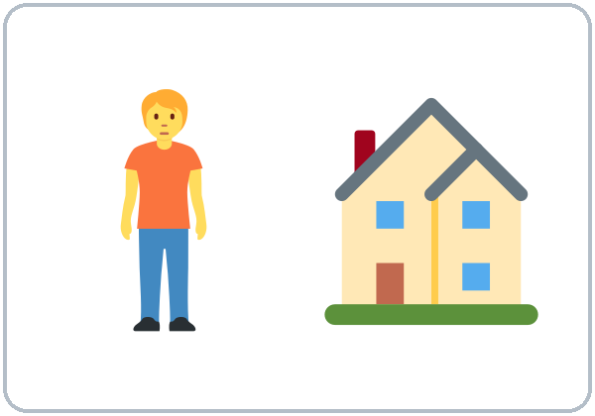  ★ live (I live on…) | 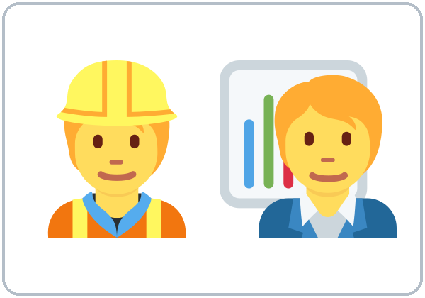  ★ work
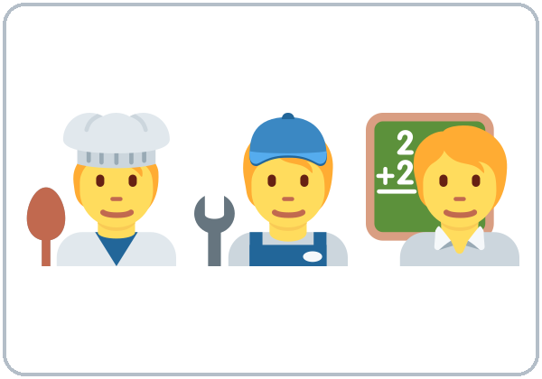  ★ job | 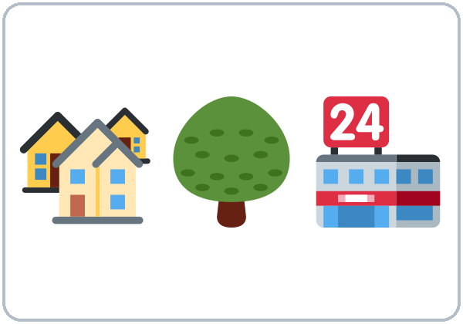  neighborhood | 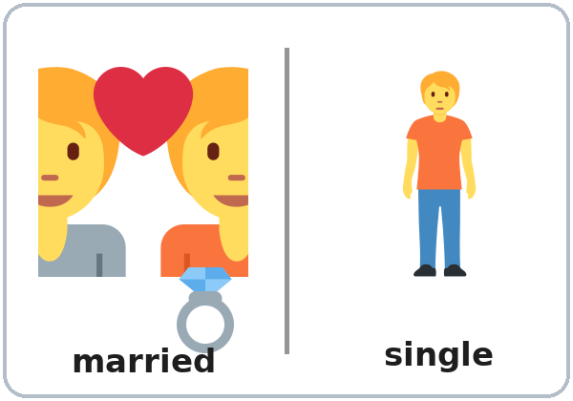  ★ married / single
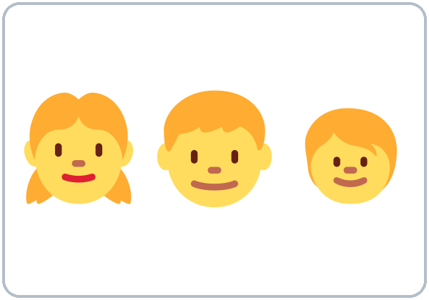  ★ kids (children) | 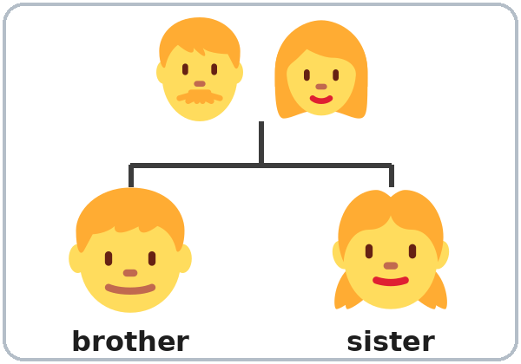  brother / sister | 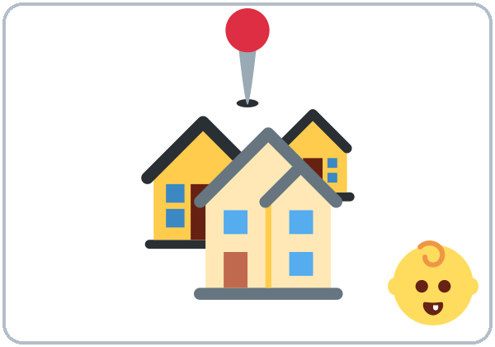  hometown
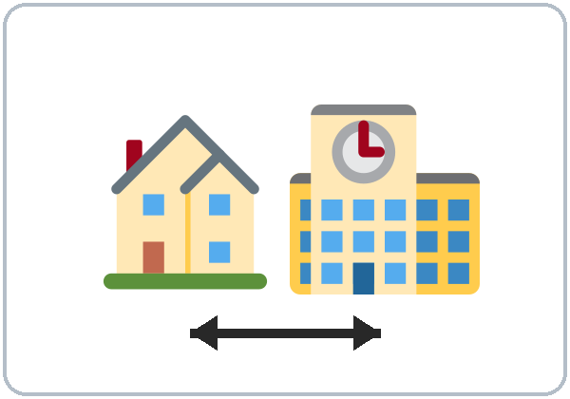  near | 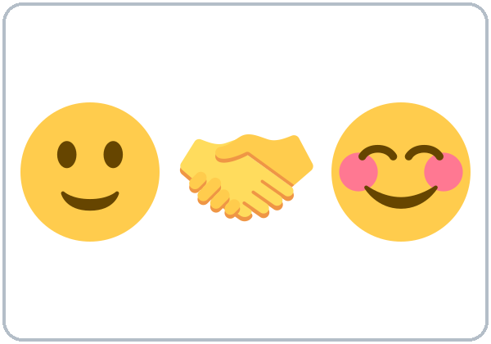  ★ Nice to meet you |   ★ What about you?

Lesson 1 · Listening
Listen to Rosa and Sam.
A. Listen. Check ✓ True or False.
 | True | False
1. Sam is new. | ☐ | ☐
2. Sam is from Colombia. | ☐ | ☐
3. Rosa lives on Pine Street. | ☐ | ☐
4. Sam works at a bakery. | ☐ | ☐
5. Rosa has two daughters. | ☐ | ☐

B. Listen again. Circle the answer.
1. Sam is a cook / driver / teacher.
2. Rosa starts work at 5:00 / 7:00 / 9:00.
3. Sam lives with his wife / brother / sister.
C. Listen again. Write are or do.
1. Where ______ you from?
2. Where ______ you live?
3. ______ you work near here?
4. ______ you married?
Lesson 1 · Grammar
Grammar Box 1: Questions with be (am / is / are)
Choose one word from each column. Read across.
QUESTION |  |  |  | ANSWER
Are | you | from Mexico?  married?  new here? |  | Yes, | I | am.
Are | you | from Mexico?  married?  new here? |  | No, | I'm | not.
Is | he  she | a cook?  from Peru?  married? |  | Yes, | he  she | is.
Is | he  she | a cook?  from Peru?  married? |  | No, | he  she | isn't.

Grammar Box 2: Questions with do / does
QUESTION |  |  |  | ANSWER
Do | you | live here?  work near here?  have kids? |  | Yes, | I | do.
Do | you | live here?  work near here?  have kids? |  | No, | I | don't.
Does | he  she | live here?  work at night?  have kids? |  | Yes, | he  she | does.
Does | he  she | live here?  work at night?  have kids? |  | No, | he  she | doesn't.

Grammar Box 3: Wh- questions
QUESTION |  |  |  |  | ANSWER
Where | are | you | from? |  | I'm | from | Honduras.  Colombia.  Mexico.
Where | do | you | live? |  | I | live | on Pine Street.  near the park.
Where | do | you | work? |  | I | work | at a hotel.  at a bakery.
What | do | you | do? |  | I'm | a | cook.  driver.  teacher.

Questions and answers
Q: How do I make a question in English?
A: Put a helper word at the front: am / is / are or do / does.
Q: When do I use am / is / are?
A: With where you're from, age, job title, feelings, married/single, and places. Look at Box 1.
Q: When do I use do / does?
A: With action verbs like live, work, have, like, speak. Look at Box 2.
Q: What order do the words go in?
A: Question word → helper → person → the rest. Look at Box 3.
Q: How do I give a short answer?
A: Use the same helper as the question. Are you…? → Yes, I am. Do you…? → Yes, I do.
Q: Can I use do and are together?
A: No, never. ✗ Do you are married? ✓ Are you married?
Q: How do I say my age?
A: With be: I'm 35. (not I have 35 years)
Common mistakes
✗ Don't say | ✓ Say
Where you are from? | Where are you from?
Where you live? | Where do you live?
Do you are married? | Are you married?
I have 35 years. | I'm 35.
Is from Peru. | She's from Peru.
Yes, I live. | Yes, I do.

Nota para hispanohablantes: En español decimos «¿Dónde vives?» sin palabra extra. En inglés la pregunta necesita do/does o am/is/are al principio: Where do you live? La edad usa be: I'm 35 (no «I have 35 years»). Y siempre usa la persona: She's from Peru (no «Is from Peru»).

Tip for speakers of other languages: If your language makes questions with only your voice, or puts the question word at the end, remember: English needs a helper word (do / are) at the beginning.

Lesson 1 · Homework
Homework (10 minutes). Bring it next week!
1. Write 5 questions for a friend, family member, or coworker: 3 with do/does and 2 with am/is/are.
2. Write their answers (in English!).
3. Bonus: Ask one person your questions in English.
My homework
______________________________________________________________
______________________________________________________________
______________________________________________________________
______________________________________________________________
______________________________________________________________
______________________________________________________________
______________________________________________________________
______________________________________________________________
Lesson 2 · A Day in My Life
Student Page 2 · Week 2
Name: ______________________________ Date: ________________
New Words
Look. Listen. Repeat. ★ = most important words.
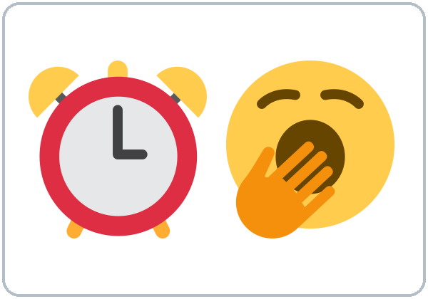  ★ get up | 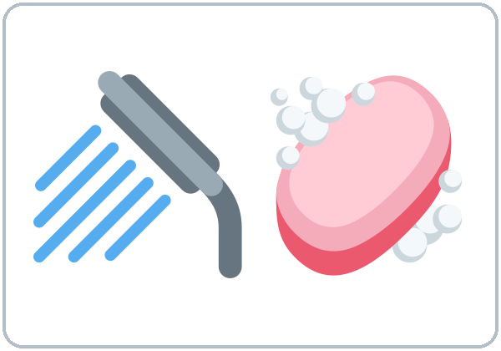  ★ take a shower | 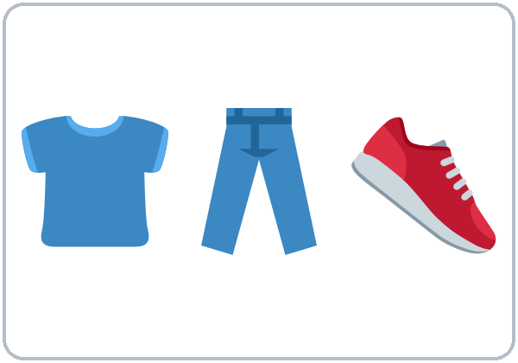  get dressed | 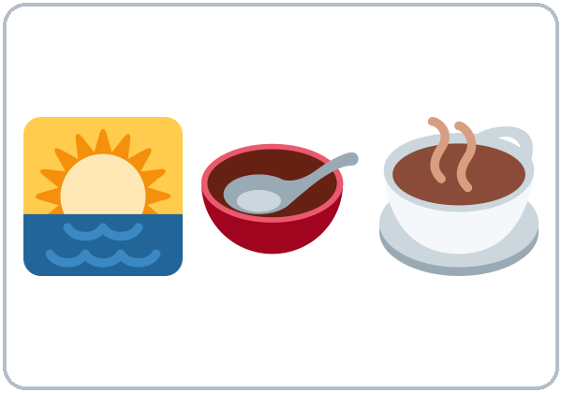  ★ have breakfast
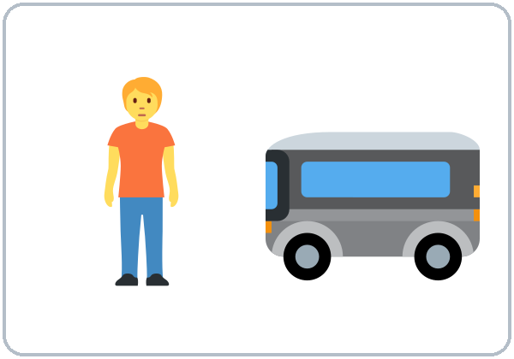  ★ take the bus | 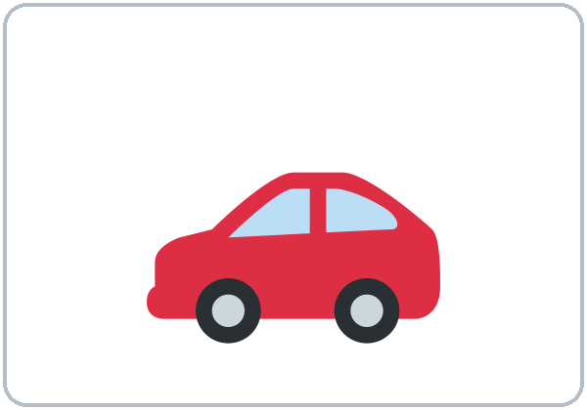  drive | 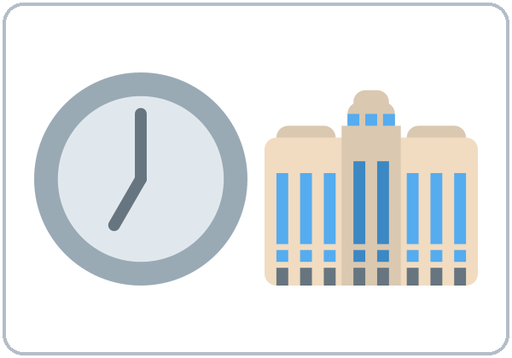  ★ start work | 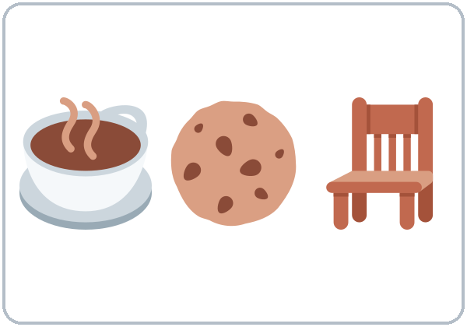  take a break
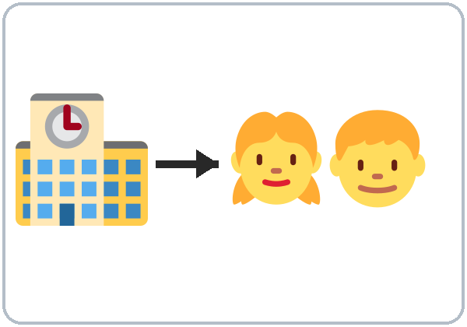  pick up the kids | 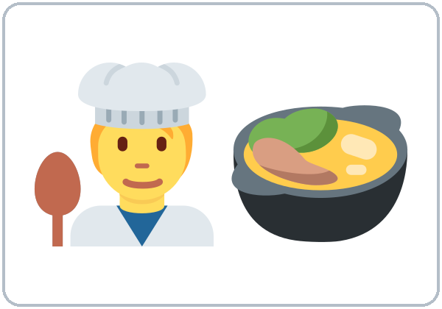  ★ cook dinner | 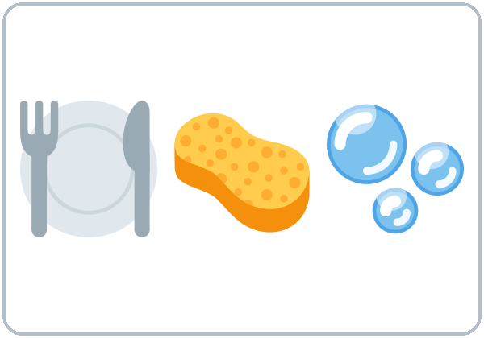  do the dishes | 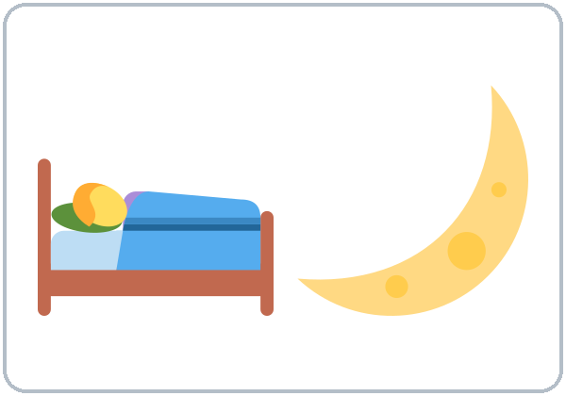  ★ go to bed
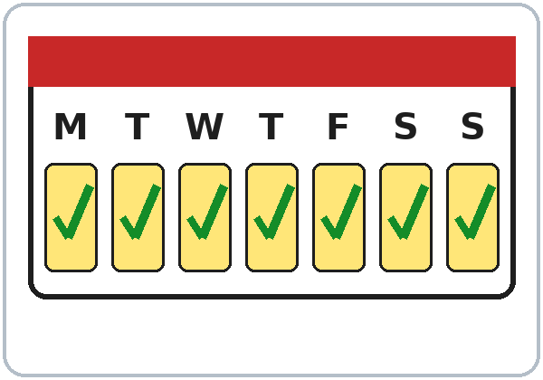  ★ every day | 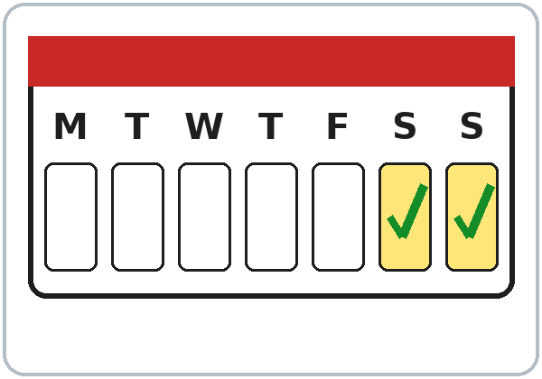  on weekends |   in the morning | 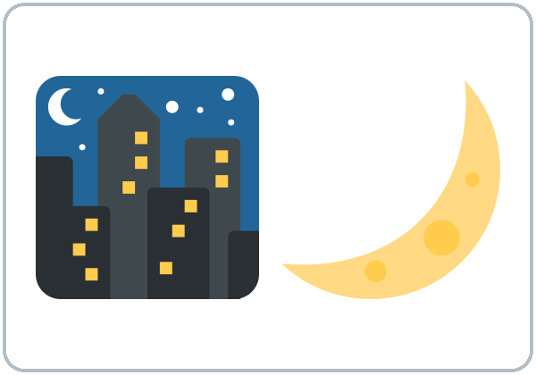  at night

Lesson 2 · Listening
Listen to Ana and Marco.
A. Listen. Circle the time.
1. Marco gets up at 5:30 / 6:30 / 7:00.
2. He starts work at 6:00 / 7:00 / 8:00.
3. He picks up the kids at 3:00 / 3:30 / 4:30.
4. On Sundays he sleeps until 8:00 / 9:00 / 10:00.
B. Listen again. Who does it? Check ✓.
 | Marco | His wife
works at the hospital | ☐ | ☐
drives | ☐ | ☐
works at night | ☐ | ☐
picks up the kids | ☐ | ☐
cooks dinner | ☐ | ☐

C. Listen again. Write the missing word.
1. My wife ________. She has the car.
2. She ________ at a restaurant.
3. I ________ pick them up at three thirty.
4. On Sundays, I ________ get up early.
Lesson 2 · Grammar
Grammar Box 1: Yes/No questions
Choose one word from each column. Read across.
QUESTION |  |  |  | ANSWER
Do | you  they | work?  drive?  cook? |  | Yes, | I  we  they | do.
Do | you  they | work?  drive?  cook? |  | No, | I  we  they | don't.
Does | he  she  it | work?  drive?  cook? |  | Yes, | he  she  it | does.
Does | he  she  it | work?  drive?  cook? |  | No, | he  she  it | doesn't.

Answer about yourself: Do you work? → Yes, I do.
Grammar Box 2: What time…? and How often…?
QUESTION |  |  |  |  | ANSWER
What time | do | you | get up?  start work? |  | I | get up  start work | at 6:00.  at 7:30.
What time | does | he  she | get up?  start work? |  | He  She | gets up  starts work | at 6:00.  at 7:30.
How often | do | you | cook?  drive? |  | I | always  sometimes  never | cook.  drive.
How often | does | he  she | cook?  drive? |  | He  She | always  sometimes  never | cooks.  drives.

Sentences: positive and negative
Person | ✔ Positive | ✘ Negative
I / You / We / They | I work. | I don't work.
He / She / It | She works. | She doesn't work.

Questions and answers
Q: When do I use the simple present?
A: For routines and facts: things that happen again and again. I work at a hospital. I get up at 6.
Q: When do I add -s to the verb?
A: Only with he, she, it (one other person or thing). She works. Marco takes the bus.
Q: How do I spell the -s?
Rule | Examples
Most verbs: +s | work → works, play → plays
-sh, -ch, -s, -x, -o: +es | watch → watches, go → goes, do → does
consonant + y: -ies | study → studies
Special | have → has

Q: After doesn't or does, does the verb keep the -s?
A: No. The "one -s" rule: the -s moves to does. She works. → She doesn't work. → Does she work?
Q: How do I say how often?
always 100% | usually | often | sometimes | rarely | never 0%
I always take the bus. |  |  | She sometimes cooks. |  | He never drives.

Q: Where do always, usually, never… go?
A: Before the main verb: I usually take the bus. But after be: He is always late. Longer phrases go at the end: I cook every day.
Common mistakes
✗ Don't say | ✓ Say
She work at a store. | She works at a store.
He doesn't works. | He doesn't work.
Does she works? | Does she work?
I go always to the park. | I always go to the park.
I am work at a restaurant. | I work at a restaurant.
He have two kids. | He has two kids.

Nota para hispanohablantes: En español el verbo cambia con cada persona (trabajo, trabajas, trabaja). En inglés solo cambia con he/she/it: agrega -s (she works). ¡No olvides la -s! Y no uses am con otro verbo: I work (no «I am work»).

Tip for speakers of other languages: If your language has no verb endings, make a habit: he / she / it = -s. Circle every -s in your homework.

Lesson 2 · Homework
Homework (10 minutes)
1. Write 6 sentences about the routine of someone you know (My sister gets up at 6. She always takes the bus…). Use at least 3 frequency words.
2. Listen to the audio again at home (scan the QR code or use the link) and repeat Marco's lines.
My homework
______________________________________________________________
______________________________________________________________
______________________________________________________________
______________________________________________________________
______________________________________________________________
______________________________________________________________
______________________________________________________________
______________________________________________________________
Lesson 3 · Free Time
Student Page 3 · Week 3
Name: ______________________________ Date: ________________
New Words
Look. Listen. Repeat. ★ = most important words.
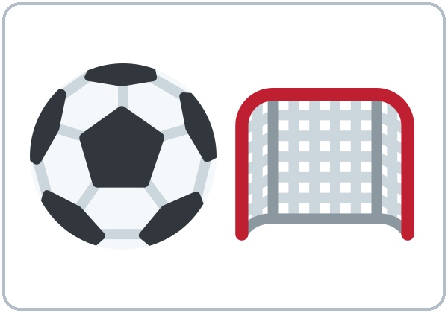  ★ soccer | 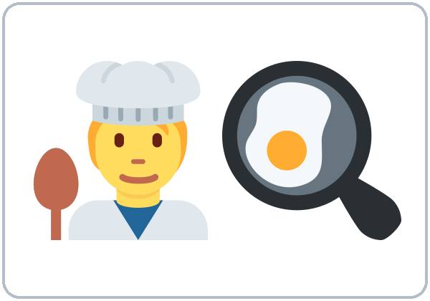  ★ cooking | 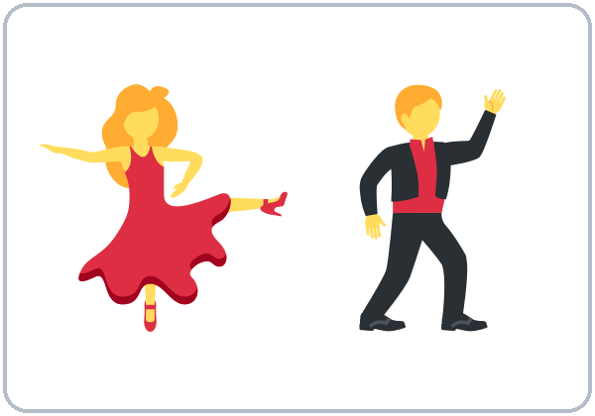  ★ dancing |   ★ shopping
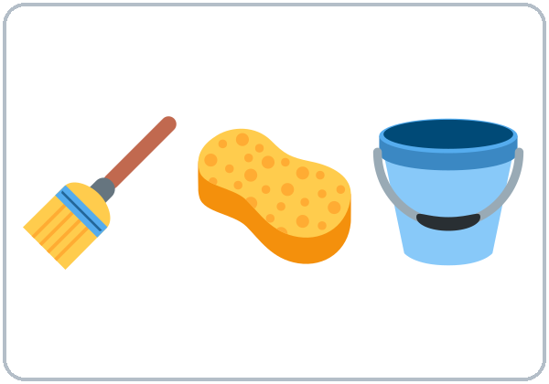  ★ cleaning | 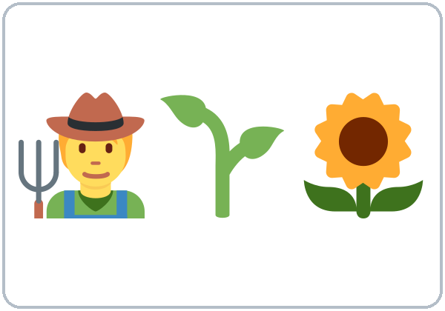  gardening |   fixing things |   ★ watching TV / movies
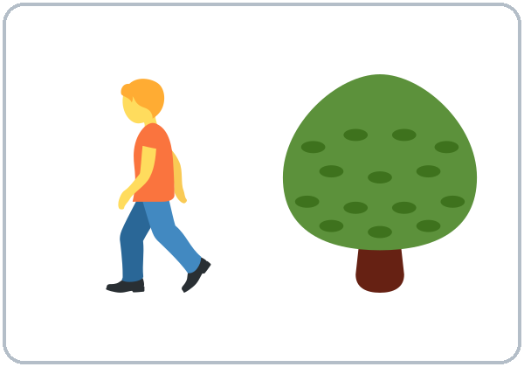  walking | 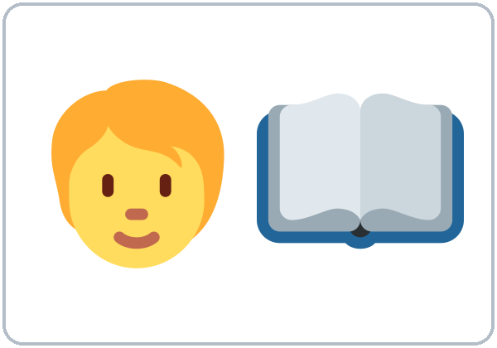  reading | 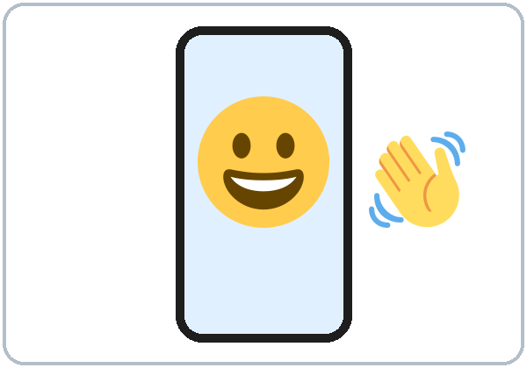  video calls | 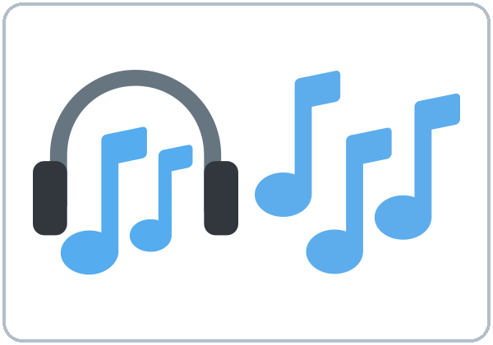  ★ music
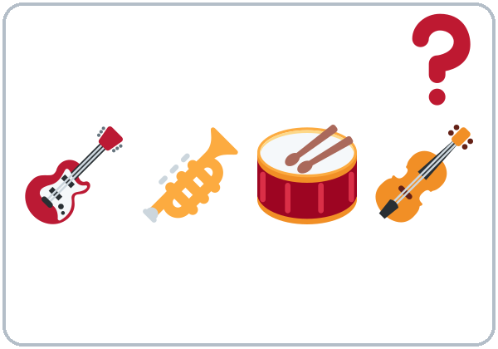
★ What kind of (music)?

Music examples: salsa, cumbia, pop, rock (no pictures; ask learners for their favorite kinds).
Lesson 3 · Listening
Listen to Kim and Carlos.
A. Listen. ✓ = likes / doesn't mind, ✗ = doesn't like / hates. Some boxes stay empty.
 | Kim | Carlos
playing soccer
watching soccer on TV
cooking
dancing
rock music
cleaning

B. Listen again. Circle the reply you hear.
1. Kim: "I like dancing." → Carlos: Me too! / Me neither!
2. Kim: "I don't like rock music." → Carlos: Me too. / Me neither.
C. Listen again. Write the missing word.
1. Kim goes dancing on ____________.
2. Carlos plays soccer every ____________.
3. Kim: "Shopping? I don't ________ it."
Lesson 3 · Grammar
Grammar Box 1: Do you like…?
Choose one word from each column. Read across.
QUESTION |  |  |  |  | ANSWER
Do | you | like | soccer?  cooking?  dancing? |  | Yes, I do. | I love it.  I like it.
 |  |  |  |  | It's OK. | I don't mind it.
 |  |  |  |  | No, I don't. | I don't like it.  I hate it.
Does | he  she | like | shopping?  cleaning? |  | Yes, he/she does. | He/She loves it.
 |  |  |  |  | No, he/she doesn't. | He/She hates it.

Grammar Box 2: What…? questions
QUESTION |  |  |  |  | ANSWER
What | do | you | like doing?  love doing?  hate doing? |  | I | like  love  hate  don't mind | cooking.  dancing.  cleaning.
What kind of | music  food  movies | do | you like? |  | I like | salsa.  cumbia.  pop.

Grammar Box 3: Agree or disagree
YOU SAY |  |  |  | YOUR PARTNER SAYS
I | like  love | coffee.  dancing.  soccer. |  | 👍 Me too! | 👎 Really? I don't.
I | don't like  hate | coffee.  dancing.  soccer. |  | 👍 Me neither! | 👎 Oh, I do!

Questions and answers
Q: How strong are these words?
❤❤ love | ❤ like | 😐 don't mind | 👎 don't like | ✘ hate

Q: What can I say after like, love, hate, don't mind?
A: A thing (pizza, soccer) or an activity (verb + -ing: cooking, dancing).
Q: Why do I add -ing?
A: -ing turns an action into an activity, like a "thing." (I like to cook is also correct, but in this class we practice -ing.)
Q: How do I spell the -ing?
Rule | Examples
Most verbs: +ing | cook → cooking, play → playing
Silent e: drop it | dance → dancing, make → making
Short verb (1 vowel + 1 consonant): double the last letter | swim → swimming, shop → shopping

Q: Me too or Me neither?
A: Look at your partner's sentence. Positive (I like…) → Me too. Negative (I don't like…) → Me neither. Look at Box 3.
Q: Where do a lot and very much go?
A: At the end: I like soccer a lot.
Common mistakes
✗ Don't say | ✓ Say
I like cook. | I like cooking.
I am like pizza. | I like pizza.
I don't like coffee. / Me too. | … / Me neither.
She like dancing. | She likes dancing.
I like very much soccer. | I like soccer a lot.
I don't like nothing. | I don't like anything.

Nota para hispanohablantes: «Me gusta la música» → en inglés la persona va primero: I like music. Para actividades usa -ing: I like cooking (no «I like cook»). Usa una sola negación: I don't like anything (no «I don't like nothing»). Me too = «yo también»; Me neither = «yo tampoco».

Tip for speakers of other languages: an -ing word can be a "thing": Cooking is fun. I love dancing.

Lesson 3 · Homework
Homework (10–15 minutes)
1. Ask 3 people (family, friends, coworkers): What do you like doing? What do you hate doing? If they don't speak English, ask in your language but write in English.
2. Write 6 sentences: My son loves playing video games. My wife hates cleaning…
My homework
______________________________________________________________
______________________________________________________________
______________________________________________________________
______________________________________________________________
______________________________________________________________
______________________________________________________________
______________________________________________________________
______________________________________________________________
Lesson 4 · Right Now
Student Page 4 · Week 4
Name: ______________________________ Date: ________________
New Words
Look. Listen. Repeat. ★ = most important words.
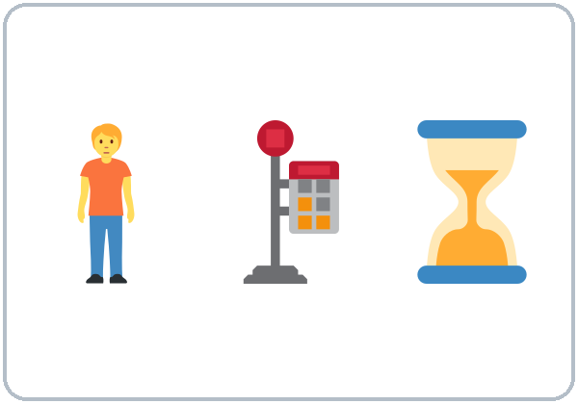  ★ waiting (for the bus) | ★ cooking (now) | 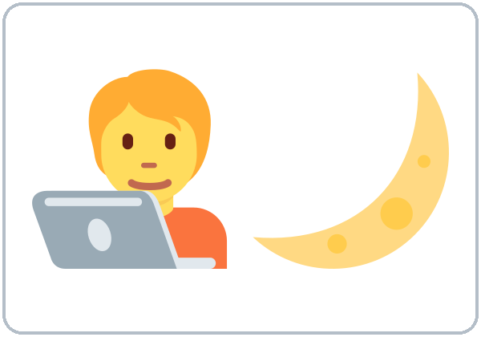  ★ working late
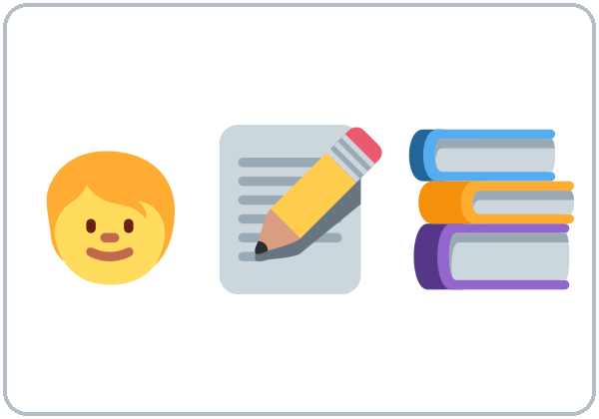  ★ doing homework | ★ watching TV |   looking at
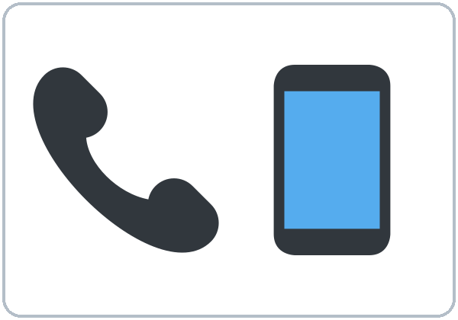  ★ calling (on the phone) | 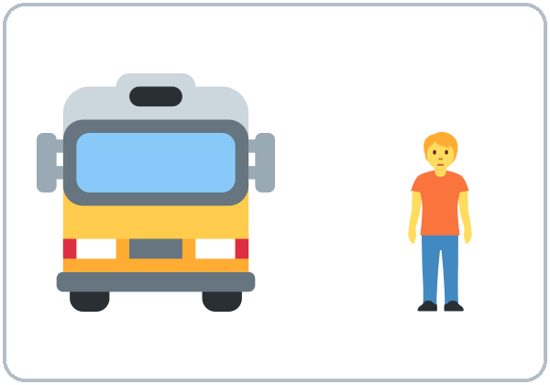  coming (The bus is coming.) | 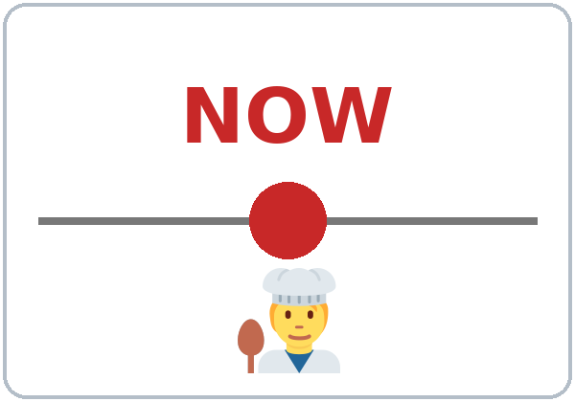  ★ right now
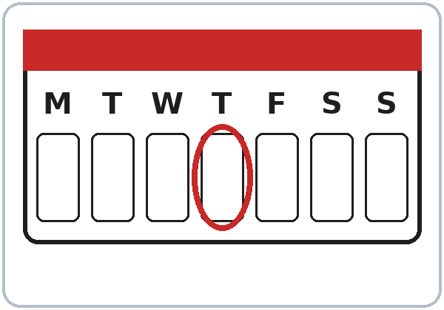  today | 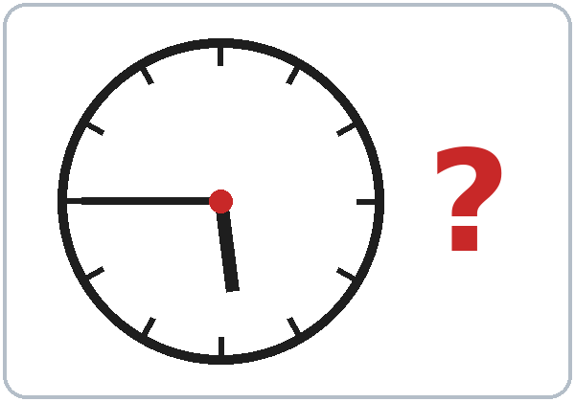  ★ What time is it? (It’s 5:45.)

Lesson 4 · Listening
Listen to Rosa and Sam on the phone.
A. Listen. Circle the answer.
1. Sam is cooking / sleeping / driving.
2. Rosa is at home / at the bus stop / at work.
3. It's 5:15 / 5:45 / 6:15.
B. Listen again. Check ✓ True or False.
 | True | False
1. Rosa's daughters are doing their homework. | ☐ | ☐
2. Rosa's husband is watching TV. | ☐ | ☐
3. Rosa is coming to class tonight. | ☐ | ☐
4. Sam doesn't have the homework page. | ☐ | ☐

C. Listen again. Write the missing word.
1. I'm ____________ dinner.
2. What ________ you doing?
3. They're ____________ their homework.
4. The bus ________ coming now.
Lesson 4 · Grammar
Grammar Box 1: What are you doing?
Choose one word from each column. Read across.
QUESTION |  |  |  |  | ANSWER
What | are | you | doing? |  | I'm | cooking.  waiting for the bus.  watching TV.
What | is | he  she | doing? |  | He's  She's | working late.  calling a friend.
What | are | they | doing? |  | They're | doing homework.  playing.

Grammar Box 2: Yes/No questions
QUESTION |  |  |  | ANSWER
Are | you | coming?  working today? |  | Yes, | I | am.
Are | you | coming?  working today? |  | No, | I'm | not.
Is | he  she | cooking?  working late? |  | Yes, | he  she | is.
Is | he  she | cooking?  working late? |  | No, | he  she | isn't.
Are | they | sleeping?  doing homework? |  | Yes, | they | are.
Are | they | sleeping?  doing homework? |  | No, | they | aren't.

Grammar Box 3: Telling time
QUESTION |  |  |  | ANSWER
What time | is | it? |  | It's | five forty-five.  six o'clock.  seven fifteen.

Sentences: positive and negative
Person | ✔ Positive | ✘ Negative
I | I'm cooking. | I'm not cooking.
He / She / It | She's waiting. | She isn't waiting.
You / We / They | They're playing. | They aren't playing.

Questions and answers
Q: How do I talk about something happening right now?
A: Use am / is / are + verb-ing. I'm cooking. She's waiting.
Q: Can I leave out am / is / are?
A: No. ✗ I cooking. ✓ I'm cooking.
Q: What's the difference between I cook and I'm cooking?
A: I cook = every day, a routine. I'm cooking = right now.
RIGHT NOW: am/is/are + -ing | EVERY DAY: simple present
I'm cooking right now. | I cook every day.
She's working late today. | She works at a hotel.
Words: now, right now, today, at the moment | Words: every day, usually, always, on Mondays

Q: Is What do you do? the same as What are you doing?
A: No! What do you do? = What's your job? What are you doing? = What are you doing right now?
Q: How do I spell the -ing?
A: The same rules as Lesson 3: cook → cooking, make → making, shop → shopping.
Common mistakes
✗ Don't say | ✓ Say
I cooking now. | I'm cooking now.
She is work today. | She is working today.
What you are doing? | What are you doing?
I'm cooking every day. | I cook every day.

Nota para hispanohablantes: En español usamos el presente para «ahora» («¿Qué haces?»). En inglés, para ahora mismo usamos am/is/are + -ing: What are you doing? — I'm cooking. ¡No olvides am/is/are! (no «I cooking»). Cuidado: What do you do? = «¿En qué trabajas?», y What are you doing? = «¿Qué estás haciendo?»

Tip for speakers of other languages: If your language has no special "now" form, remember the formula: am / is / are + verb-ing = happening now.

Lesson 4 · Homework
Homework (10 minutes)
At 3 different times this week, write what you and your family are doing:
It's 8:00 PM. I'm washing the dishes. My son is watching TV. My husband is working.
Bring your 3 "photos in words" next week. (Lesson 5's Opening Talk uses them!)
My homework
______________________________________________________________
______________________________________________________________
______________________________________________________________
______________________________________________________________
______________________________________________________________
______________________________________________________________
______________________________________________________________
______________________________________________________________
Picture Credits
Vocabulary pictures use Twemoji graphics by Twitter, Inc. and other contributors (https://github.com/jdecked/twemoji), licensed under CC BY 4.0 (https://creativecommons.org/licenses/by/4.0/). The graphics were resized and combined, and arrows, calendars, clocks, and labels were added.

PART D
Reference

Audio · Copyright and licensing · Printing · Website · Questions · Sources

6. Listening Audio: Free AI Voices
6.1 What we needed
The voices had to be completely free (no paid tier required), with a license that clearly allows classroom use, nonprofit or commercial use, and redistribution (posting MP3s on a website and sharing them with learners).
6.2 Comparison
Option | Cost | License / terms for our use | Quality and ease | Verdict
Kokoro-82M (open model, runs on a computer) | Free | Apache 2.0 weights. The model card says it "can be deployed anywhere," it is used in commercial products, and it was trained only on permissive or non-copyrighted audio. The runner we used (kokoro-onnx) is MIT-licensed. | Natural voices; about 20 US English voices; runs on an ordinary laptop or server without a GPU. Each 1.5-minute clip took a few seconds. | ✅ Recommended (used for our samples)
Piper TTS (open, runs on a computer) | Free | The code is open source, but each voice has its own license, listed in its MODEL_CARD. The lessac voices come from the Blizzard 2013 dataset, which excludes commercial use; the maintainer says users would need a separate agreement for redistribution rights. Some voices (for example libritts_r) use CC BY datasets that allow commercial use with attribution. | Good and very fast, but you must check every voice's license | ⚠️ Usable only with carefully chosen voices
Microsoft Edge "Read Aloud" / edge-tts | Free | edge-tts is an unofficial client for Edge's Read Aloud service. Microsoft has not published permission to redistribute the audio, and Microsoft Q&A answers point to the paid Azure Speech service for publishing. | Excellent voices | ❌ Not recommended (rights unclear)
Google Cloud Text-to-Speech | Has a monthly free allowance (e.g., 4M characters for Standard/WaveNet, 1M for Neural2/Chirp 3 HD), but billing must be enabled with automatic charges past the free tier | Commercial output is allowed under Google Cloud terms | Excellent | ❌ Fails the "no paid tier needed" rule (needs a credit card / billing account)
TTSMaker (website) | Free up to 20,000 characters per week | The site says audio can be used "for any lawful purpose, including commercial use," with no attribution required, but it "reserv[es] the right to make adjustments" to the free policy | Easy (no install); quality varies by voice | ⚠️ Acceptable backup. Save a screenshot of the terms on the day you make the audio

Recommendation: Kokoro-82M, run on this assistant's box (or any computer). It is truly free, its Apache-2.0 license clearly permits redistribution, and no account is needed. Credit line: "Audio voices: Kokoro-82M (Apache 2.0). These are synthetic voices, not real people." The GPL-licensed phonemizer it uses does not affect the audio: the GNU FAQ explains that a program's output takes the copyright status of its input (our scripts), not of the program.

6.3 What was produced (on this box)
File | Length | Speakers (Kokoro voices)
audio/L1_listening.mp3 | about 1:43 | Narrator (af_sarah), Rosa (af_heart), Sam (am_michael)
audio/L2_listening.mp3 | about 1:25 | Ana (af_bella), Marco (am_adam)
audio/L3_listening.mp3 | about 1:35 | Kim (af_nova), Carlos (am_eric)
audio/L4_listening.mp3 | about 1:41 | Rosa, Sam

• Each file has a narrator intro, the conversation, "Listen again," the conversation again, and an end cue. Speed is 0.9 (slightly slow), and files are mono MP3 at 96 kbps (about 1.1 MB each).
• Quality check: we transcribed every file with an automatic speech recognizer. The transcripts matched the scripts word for word, except that the narrator's "Ana" was heard as "On." (Kokoro reads Ana with a Spanish-style "Ah-na," which the recognizer mishears; listen and judge.) An early draft used the name Luis, which the voice read as "Lewis," so we renamed that character Carlos. Tip: test Spanish names; respell them in the audio script if needed.
• To regenerate or make Lessons 5–13: the scripts and the generator are in audio/scripts.py and audio/make_audio.py (see audio/README.txt).
7. Copyright, Trademark, and Licensing
Not legal advice. This section summarizes public information from the U.S. Copyright Office, U.S. trademark records, and Creative Commons so the program can make informed decisions. For a definite answer, consult a qualified attorney (many areas have pro bono intellectual-property clinics for nonprofits).

7.1 The basic rules (with sources)
1. Ideas and methods are free; expression is protected. U.S. law says copyright never extends to "any idea, procedure, process, system, method of operation, concept, principle, or discovery" (17 U.S.C. § 102(b)). The Copyright Office's example: a book's text and illustrations are protected, but not the system the book explains. For us: teaching approaches (pair work, a pronunciation point every lesson, ending with a conversation, listening tasks) and standard grammar topics are free to use.
2. Titles, names, and short phrases are not copyrightable (Circular 33), but they may be trademarks.
3. Layout and format are generally not protected, but a creative selection and arrangement of specific content can be (Circular 33). For us: don't copy Intercambio's specific lesson-by-lesson list and order, page design, or exercises.
4. Fair use is case by case and weighs four factors: purpose (nonprofit educational helps), nature of the work, amount used, and market effect. Copying a commercially sold textbook for students tends to hurt its market, which weighs against fair use (U.S. Copyright Office Fair Use Index).
5. Trademarks: Intercambio's curriculum series name and "THE INTERCAMBIO WAY" are registered U.S. trademarks of Intercambio de Comunidades. Naming another product only to identify it ("nominative use") is generally allowed when you use no more of the mark than needed and imply no sponsorship or endorsement (New Kids on the Block v. News America, 9th Cir. 1992).
6. AI-assisted materials: the Copyright Office's January 2025 report says purely AI-generated material is not copyrightable. Human-authored expression, and creative human selection, arrangement, or modification of AI output, can be. For us: volunteers should substantially edit and adapt these drafts. The program's copyright (and license) then covers the human contributions.
7.2 What you CAN and CAN'T do with the real Intercambio books
✅ You can | ❌ Avoid (without written permission from Intercambio)
Use your purchased books as intended in class | Photocopying or scanning pages for learners or posting them online
Read them to compare coverage: which grammar points and topics a level includes (facts and ideas) | Copying or closely paraphrasing their dialogues, explanations, exercises, instructions, or teacher tips
Use general teaching methods that many curricula share (pair work, pronunciation practice, a closing conversation, listening with check boxes) | Copying their images, page layouts, icons, or audio
Cover the same common ESL topics (food, health, transportation, bills), written in your own words and sequence | Reproducing their lesson titles and lesson order as your syllabus
Mention them factually: "independently developed; not affiliated with Intercambio" | Using Intercambio's series name, "The Intercambio Way," or "Intercambio" in your name, logo, or marketing, or saying "the improved Intercambio" or "Intercambio Level 2 version"
Tell teachers "if you also use Intercambio's books, Lesson 4 pairs well with their lessons on…" (factual cross-reference) | Feeding scanned pages into an AI tool and asking it to "rewrite" them: the result is likely a derivative of their text

Safe working process ("clean-room lite"): One person checks the real books and writes only a plain list of grammar points and topics (no sentences copied). The writers create materials from that list without the books open. Keep dated drafts as a record of independent creation.

7.4 Licensing our own materials
License | What others may do | Good for | Watch out
CC BY-NC-SA 4.0 (recommended) | Share and adapt, with credit, noncommercially, and adaptations must use the same license | Free sharing with other volunteer programs while keeping commercial sellers out | "NonCommercial" depends on the use, not on whether the user is a nonprofit; a program charging tuition might be unsure whether it may use the materials
CC BY-SA 4.0 | The same, but commercial use is also allowed | Maximum reuse (community colleges, fee-based programs) | Others could sell printed copies
All rights reserved | Nothing without permission | Full control | Makes sharing harder

• Mark it like this (footer of every page and on the website): "© 2026 [Program name]. Licensed under CC BY-NC-SA 4.0 (https://creativecommons.org/licenses/by-nc-sa/4.0/). Audio voices: Kokoro-82M (Apache 2.0). Vocabulary pictures: Twemoji (CC BY 4.0), modified."
• Pictures (new in Version 3): the Twemoji parts of the vocabulary pictures stay under CC BY 4.0. CC BY material may be used inside a work you share under CC BY-NC-SA, as long as you keep the Twemoji attribution line (see the CC FAQ on combining licenses: https://creativecommons.org/faq/). Print the attribution line from Section 12 on the workbook credits page and in the website footer.
• Your program name and logo are not covered by the CC license. Add a line saying so (Creative Commons recommends this).
• Ownership: decide who owns the materials, the program or each volunteer author. A simple contributor agreement ("I license my contributions to [Program] under CC BY-NC-SA 4.0") avoids problems later.
8. Student Workbook: Printing and Distribution
Assumed workbook size: about 4 pages per lesson × 13 + midterm, final, and extras ≈ 64 black-and-white pages (8.5×11). All prices were found online in October 2026 and change often; verify locally.
Option | Cost per learner (64 pp.) | Upfront | Pros | Cons
Weekly handouts, self-service copier (~$0.10–0.15/side, reported by a third-party site; not verified) | ~$6.40–9.60 if everyone gets every page; less in practice because you print only for who comes | $0 | Easy to edit weekly; print only what's needed | Someone must copy every week
Weekly handouts, full-service copy shop (Staples lists black-and-white copies from about $0.32–0.34/side) | ~$20–22 | $0 | No volunteer copying time | Expensive
+ Binder (1-inch economy binders, 12-packs: about $2.42 each at Walmart to $3.67–4.17 at Staples) | +$2.42–4.17 |  | Pages stay organized; reusable | Bulky; adds cost
Amazon KDP author copies (8.5×11 = "large trim"; 24–110 black-ink pages = $2.84 per copy, plus shipping and tax) | ≈ $2.84 + shipping | $0 (free account) | Cheapest bound book; perfect binding | Needs a finished, stable file. Author copies are sold at print cost; check whether the title must be published (public) on Amazon (not verified). Slower to update
Lulu "print copies for your own use" (private project) (a 100-page 8.5×11 black-and-white paperback was $5.48; the cheapest shipping cited was $5.69 per order) | ≈ $4–6 + shipping (64 pages probably less; check Lulu's calculator) | $0 | Can stay private (not in any store) | Higher print price than KDP
Free digital (PDF, Google Doc, website pages on phones) | $0 | $0 | Audio and links in one place; nothing to lose | Some learners lack data or printers; writing on paper still matters
Donated printing (host site, adult-education partner, public library, an employer partner) | $0–low | Ask | Saves money | Depends on goodwill; ask early
Grants: Dollar General Literacy Foundation adult literacy grants (nonprofits, libraries, schools within 15 miles of a Dollar General store; 2026 deadline was Feb 5, 2026; next cycle reported to open January 2027) | — | Application | Can fund workbooks and supplies (one recipient used its grant for ESL workbooks and handouts) | Competitive; annual timing

Recommendation:
This semester (pilot): print weekly lesson packets (3-hole punched) on a self-service or donated copier, only for the expected attendance + 3 spares. Give each learner a pocket folder or a cheap binder, and post every page and MP3 on the website (with QR codes on each page). Expected cost: roughly $9–14 per learner in the worst case, and less as attendance drops. This lets you fix the materials each week while you pilot them, and you won't print 15 full books when 7–8 learners finish.
Next semesters (stable version): order a bound workbook through a Lulu private project or KDP author copies (≈ $3–6 each + shipping). That's cheaper than full-service copies + binder (≈ $23–26) and about the same as self-service copies + binder. Apply for a literacy grant in January to cover it.

9. Website: Hosting the Curriculum and Audio
What the site needs: lesson pages (teacher + student), printable PDFs, 13+ MP3s (≈ 15–25 MB total), QR codes for each lesson, mobile-friendly, free, and editable later.
Host | Free plan facts (from the provider's docs) | Fit
GitHub Pages | Free; published site up to 1 GB; soft bandwidth limit of 100 GB/month; not for e-commerce or SaaS (an educational site is fine) | ✅ Recommended. Our whole site is tiny. Content is versioned (every change is saved and can be undone)
Cloudflare Pages | Free; up to 20,000 files, 25 MiB max per file, 500 builds/month; unlimited bandwidth advertised | ✅ Excellent alternative; supports drag-and-drop uploads without Git
Netlify (Free) | 300 credits/month hard limit (about 15 GB bandwidth); projects pause until next month if exceeded | ⚠️ Works, but the site could go offline mid-month
Google Sites | Free with a Google account; no coding; audio is embedded from Google Drive (some users report mobile playback quirks) | ⚠️ Best if non-technical volunteers must edit pages themselves; less control over layout and printing

9.1 Who should build it: this assistant or a separate coding tool (Grok Build)?
Recommendation: have this assistant build it. It should be a simple static website built on this box and deployed to GitHub Pages (or Cloudflare Pages).
• Why: the lesson content, MP3s, and conversion scripts already live on this box. A static site (plain HTML + MP3 + PDF) needs no database or logins. The assistant can generate the pages directly from the same source files that make the Word document, keeping the site and the workbook in sync, and it can run quality checks (broken links, mobile view, audio playback) before publishing.
• When Grok Build makes more sense: Grok Build is xAI's terminal-based coding agent for working in a code repository. Choose it if you later want a real web application (teacher logins, learner progress tracking, quizzes that save scores) or if a volunteer developer will maintain the code on their own computer. That isn't needed for this stage.
• What you would need to set up (about 15 minutes):
1. Create a free GitHub account (ideally an organization account in the program's name).
2. Connect GitHub to this assistant (there is a GitHub connection option) and approve access to one repository.
3. Choose a site address, for example yourprogram.github.io/level2. Optionally, use your own domain name (bought separately).
4. Confirm the license footer text and the program name.
5. Decide: public site (simplest; fits a CC license) or private teacher pages (would need a different setup).
• Alternative with zero accounts for the assistant: the assistant builds the site as a ZIP file and you drag and drop it into Cloudflare Pages yourself.
11. Remaining Questions
From the real Intercambio books (please send short lists, not copied pages):
1. For each 2L/2R lesson, what grammar point(s) appear in the "Language Tools" box? (A one-line list per lesson is enough.)
2. What grammar does Level 1 cover (especially can/can't, there is/are, simple past, describing people), so we don't re-teach or skip it?
3. What does Level 3 start with, so Level 2 hands off smoothly?
4. What format do the "Review and progress check" lessons use (for example, listening + speaking + checklist)? A description only.
5. Does the teacher book assume a class length?
About the program:
6. Is the midterm in Week 8 fixed, and do you need grades or just "Meets / Almost / Not yet"?
7. What are the graduation requirements (attendance %, final exam)? Are certificates provided?
8. Is there a second volunteer (helps with baseline and exam speaking tests)?
9. Classroom tech: is there a speaker or projector? Can learners use phones (WhatsApp group for audio links)?
10. Printing: what copier access do you have, and what's the budget per learner?
11. Ownership and license: who owns the materials (the program or the volunteer authors)? Is CC BY-NC-SA 4.0 OK, or do you prefer CC BY-SA 4.0?
12. Website: may we create a public GitHub Pages site? What program name and address should it use?
13. Name: do you have a program or curriculum name? (We'll check it on USPTO before using it.)
14. Voices: are the Kokoro sample voices acceptable? Would you like a slower version (speed 0.8) for each clip?
12. Sources
Intercambio research
• Issuu, Student Book 2L (cover and back-cover text): https://issuu.com/intercambio8/docs/2l_book_online_final
• Flatirons Library catalog, Level 2 Left Student Book (contents): https://broomfieldkids.flatironslibrary.org/GroupedWork/8e9b1684-554b-7dc3-f1f3-ee71db6f30d0
• Flatirons Library catalog, Level 2 Left Teacher Book: https://broomfieldkids.flatironslibrary.org/GroupedWork/a5ce394d-e16b-4431-d851-301e1af9161a
• Flatirons Library catalog, Level 2 Right Student Book: https://broomfieldkids.flatironslibrary.org/GroupedWork/5c23fb51-3b0a-a5fb-9bad-3b97bbd58531
• Los Angeles Public Library, curriculum page: https://www.lapl.org/literacy/curriculum
• Alaska Literacy Program, C&C resources: https://sites.google.com/alaskaliteracyprogram.org/alpteachers/curriculum/Intercambio
Vocabulary pictures (new in Version 3)
• Twemoji, maintained fork (graphics CC BY 4.0): https://github.com/jdecked/twemoji ; graphics license: https://github.com/jdecked/twemoji/blob/main/LICENSE-GRAPHICS ; attribution guidance in the README: https://github.com/jdecked/twemoji#attribution-requirements
• CC BY 4.0 deed: https://creativecommons.org/licenses/by/4.0/
• File-by-file credits with source SVG URLs: images/CREDITS.md
• Attribution line for the workbook and website: "Vocabulary pictures use Twemoji graphics by Twitter, Inc. and other contributors (https://github.com/jdecked/twemoji), licensed under CC BY 4.0 (https://creativecommons.org/licenses/by/4.0/). The graphics were resized and combined, and arrows, calendars, clocks, and labels were added."
Text-to-speech
• Kokoro-82M model card (Apache 2.0, training data): https://huggingface.co/hexgrad/Kokoro-82M
• kokoro-onnx (MIT): https://github.com/thewh1teagle/kokoro-onnx
• Piper voice licensing discussion: https://huggingface.co/rhasspy/piper-voices/discussions/105 ; https://github.com/rhasspy/piper/discussions/271
• Lessac (Blizzard 2013) noncommercial license: https://www.cstr.ed.ac.uk/projects/blizzard/2013/lessac_blizzard2013_software/license.html
• edge-tts: https://github.com/rany2/edge-tts ; Microsoft Q&A on commercial use: https://learn.microsoft.com/en-in/answers/questions/6007729/commercial-use-of-microsoft-edge-text-to-speech-vi
• Google Cloud TTS pricing: https://cloud.google.com/text-to-speech/pricing
• TTSMaker terms (FAQ on homepage): https://ttsmaker.com/
• GNU GPL FAQ (program output): https://www.gnu.org/licenses/gpl-faq.html#GPLOutput
Copyright and trademark
• 17 U.S.C. § 102: https://www.law.cornell.edu/uscode/text/17/102
• U.S. Copyright Office, Circular 33 (Works Not Protected by Copyright): https://www.copyright.gov/circs/circ33.pdf
• U.S. Copyright Office, Fair Use Index: https://www.copyright.gov/fair-use/
• U.S. Copyright Office, AI Report Part 2 (Copyrightability): https://copyright.gov/ai/Copyright-and-Artificial-Intelligence-Part-2-Copyrightability-Report.pdf
• Trademark record, THE INTERCAMBIO WAY: https://trademark.justia.com/884/34/the-intercambio-88434242.html
• New Kids on the Block v. News America Publishing, 971 F.2d 302 (9th Cir. 1992): https://law.resource.org/pub/us/case/reporter/F2/971/971.F2d.302.90-56258.90-56219.html
• Creative Commons BY-NC-SA 4.0 deed: https://creativecommons.org/licenses/by-nc-sa/4.0/ ; CC FAQ: https://creativecommons.org/faq/
• USPTO trademark search: https://tmsearch.uspto.gov
Workbook printing
• KDP paperback printing cost: https://kdp.amazon.com/en_US/help/topic/G201834340 ; author copy cost: https://kdp.amazon.com/en_US/help/topic/G2MYNEKHT443C2H2
• Lulu cost comparison (blog): https://blog.lulu.com/print-on-demand-costs-for-authors/ ; Lulu private print projects: https://help.lulu.com/en/support/solutions/articles/64000255486-how-to-create-a-print-book
• Staples copies: https://www.staples.com/services/printing/offers/color-copies-and-printing/
• Binders: https://www.staples.com/bulk-binders/cat_CL167205/7y92m ; https://www.walmart.com/ip/Comix-Economy-1-inch-3-Ring-Binder-1-O-ring-250-Sheet-Capacity-School-Supplies-12-Pack-Black/5356564688
• Dollar General Literacy Foundation grants: https://www.dgliteracy.org/grant-programs/ ; Nebraska Library Commission notice: http://nlcblogs.nebraska.gov/nlcblog/2026/01/22/dollar-general-literacy-foundation-2026-grants-application-cycle-is-open/
Website hosting
• GitHub Pages limits: https://docs.github.com/en/pages/getting-started-with-github-pages/github-pages-limits
• Cloudflare Pages limits: https://developers.cloudflare.com/pages/platform/limits/
• Netlify credit-based plans: https://docs.netlify.com/manage/accounts-and-billing/billing/billing-for-credit-based-plans/credit-based-pricing-plans/
• Google Sites (add Drive files): https://support.google.com/sites/answer/90569?hl=en
• Grok Build: https://github.com/xai-org/grok-build

