Level 4 Adult ESL Curriculum · Lesson 5 (Week 5): Would You Mind…?
Status: Draft for review; not published.
Date: October 2026
Audience: Program coordinators and volunteer teachers
Companion files: images/ (12 vocabulary pictures + images/CREDITS.md). Listening audio: not recorded yet (coming soon); until then, read the listening script in this plan aloud.
Topic: Asking a neighbor or coworker for a favor: getting the mail and watering the plants while you're away, a spare key, covering or switching a shift, and borrowing something. Learners ask with Would you mind…? and Do you mind if I…?, and say yes or no politely. All favors, keys, and addresses are invented.

How this lesson is organized
Part | What's inside | Who uses it
Teacher Plan | At a glance, clock-time plan, step-by-step boxes, listening script, answer key, teacher notes | Volunteer teachers
Student Pages | Opening Talk, New Words, My Words, Listening, Grammar, Talk Time, Homework, Read & Write, Exit Ticket, Task Words (optional). Print this part for learners | Learners
Picture Credits | Picture and license credits | Coordinators

What Lesson 5 builds on and what it adds
Before (review only) | Where | New in Level 4 Lesson 5
Can you…? / Could you…? for requests | Level 2 | Would you mind + -ing for bigger favors: Would you mind getting my mail?
I'd like to… | Level 3 Lesson 7 | I'd like to switch my Friday shift. and permission: Do you mind if I…?
will for offers; possessive pronouns | Level 3 | Sure, I'll do it. • Could I borrow yours?

TEACHER PLAN
Lesson 5 (Week 5)

Would You Mind…?
At a glance · Clock-time plan · Step by step · Script and answer key

How to Use This Plan
You don't need to speak Spanish or any other language. Teach in English. Show, point, and gesture. Some Grammar pages have one short contrast tip, only where a common mix-up exists. Learners read it on their own. You never need to read, translate, or explain it.

Instructions: use the same short task words every week: Listen. Circle. Check. Write. Work with a partner. Work in a group. Ask a follow-up question. Give a reason. An optional Task Words page is at the back of the workbook for learners who want it.

Instruction rule: Model it (do it with one learner while everyone watches), check it (ask: "Is it a problem for you? If not, what do you say?"), then go. Say less, show more.

Grouping toolkit: Pairs: turn to a neighbor; with an odd number, make one group of 3. Groups: 3–4 learners. Inside–outside circles: the inner circle faces out, the outer circle faces in; the outer circle moves one person to the right each round. Mingle: everyone stands and talks to many classmates. The teacher joins a pair only if one learner is left over.

When a learner is stuck or speaks another language to you: (1) show it: the picture, a gesture, or the board; (2) give one more short English example; (3) point to the grammar box on their page; (4) a classmate can help for a few seconds, then back to English. You don't need to understand what classmates say to each other.

Three sentences, not one: in Level 4, every Talk Time answer and every exit ticket has about three connected sentences: the answer, a reason, and a detail or example.

Lesson 5 (Week 5): Would You Mind…?
At a glance
Objectives: learners can…
• ask for a favor with Would you mind…?
• answer No, not at all (= "Yes, I'll help") or say no politely, with a reason and another idea
• ask permission with Do you mind if I…?
• ask a coworker to switch a shift and confirm it in a short text
• write a note to a neighbor (5–8 sentences) asking for a favor while they're away

Materials
• Student Pages for Lesson 5 (print for the number expected + 3 spares)
• Board and markers
• Favor cards and "my week" cards (in the workbook Talk Time page; copy them onto index cards, optional)
• A key and an envelope (optional, for the warm-up)
• Listening: no recording yet. Read the listening script aloud (with a volunteer if you can), at a natural speed, two times.
• Prep time: 15 minutes (read the plan; practice reading the listening script; practice the thumbs-up "No, not at all!").

Key vocabulary (with pictures on the New Words page)
★ favor • ★ borrow • ★ water the plants • ★ feed the cat • ★ get the mail • ★ spare key • ★ package • ★ switch shifts • ★ cover a shift • ★ be away • owe (someone) • thank-you note
Also: a neighbor, a coworker, lend, a ladder, a trip, a package room, a code, a text, ask the supervisor, I owe you one, go ahead.

Clock-time plan
Times are loose. If the listening or Talk Time runs long, take the time from Read & Write.
Time | Step | Min | Grouping (15 / 7–8) | If running behind
6:00–6:08 | Opening Talk + Homework Check | 8 | Pairs (7 pairs + 1 trio / 3–4 pairs) | One card only
6:08–6:15 | New Words (picture page) + pair game (+ My Words) | 7 | Whole class, then pairs | Teach the ★ words only
6:15–6:30 | Listening: play 1 (Task A), play 2 (Tasks B and C) + "Hear it, say it" | 15 | Individuals, then pairs check | Do Task C together on the board
6:30–6:45 | Grammar Q&A: Would you mind…? / Do you mind if I…? + pair check | 15 | Whole class, then pairs | Skip the pair check; Talk Time practices it
6:45–7:00 | BREAK | 15
7:00–7:15 | Talk Time: Favor Exchange + Shift Switch Text | 15 | Mingle, then pairs | Round 1 only
7:15–7:25 | Read & Write: A building notice + a neighbor's note; a note to a neighbor | 10 | Pairs read, then individual writing | Reading questions only; the writing becomes homework
7:25–7:30 | Exit Ticket + Homework | 5 | Individuals | Never skip

Skip order if you're running behind: (1) the Read & Write writing task (it becomes homework); (2) the pair check at the end of Grammar; (3) the second round of Talk Time. Never skip: the listening tasks, the grammar boxes and the mistakes table, and the exit ticket.

Attendance (15 → 7–8 → 5 or fewer): every step lists the sizes. With 5 or fewer, make a circle for Favor Exchange: each person asks the person on the left. Do the Shift Switch Text in pairs; you join if there is an odd number. Late arrivals join the mingle with a new favor card.

Step by step
Step 1 · 6:00–6:08 · Opening Talk · 8 min
• Grouping: pairs, the same partner for both parts. 15 learners: 7 pairs + 1 group of 3. 7–8 learners: 3–4 pairs. 5 or fewer: pairs, or one group with you.
• Before class: write on the board: suggestions: Why don't you…? / You could… / It's a good idea to…
• Opening Talk (5 min): learners open the Opening Talk page. A asks a card question; B answers in 3 sentences (the answer, a reason, a detail); A asks one follow-up. Switch after each card.
• Model with one learner: you say, "I sit all day at work. Any ideas?" The learner gives a suggestion. Then you ask, "Why is that a good idea?" Help them say 3 sentences.
• Homework Check (3 min): Pairs compare Homework item 1 (for / since and suggestions) and read their 3 good ideas (item 3) to each other. Then they fill in the box on the Opening Talk page. Walk around. Write 2 common errors on the board (often You could to try (→ You could try) and I have a cough since Sunday (→ I've had a cough since Sunday)) and correct them together. Also put up 2 corrections from last week's exit tickets.
• Late arrivals: join any pair as a group of 3.
• If behind: one card only.

Step 2 · 6:08–6:15 · New Words · 7 min
• Grouping: whole class, then pairs. Show the New Words page.
• Do: point to each picture and say the word. Learners repeat once.
• Show the hard words: favor (help you ask for); borrow (take and give back) vs. lend (give and get back); water the plants, feed the cat, get the mail (mime each); spare key (an extra key: show two keys); package; switch shifts (you take my Friday, I take your Sunday) vs. cover a shift (you work my shift); be away (not at home); owe (I owe you one = I'll help you next time); thank-you note.
• Check meaning (1 min): ask "If I borrow your pen, do I give it back?" (yes) • "If you cover my shift, who works?" (you do) • "Is a spare key the first key or an extra key?" (an extra key).
• Pairs (2 min): A says a word; B points to the picture and makes a sentence (Would you mind getting my mail? → No, not at all.). Switch. 15 learners: finish with a quick team round (3 teams; you say a clue, the first team with the word gets a point). 7–8: 2 teams. 5 or fewer: one team against the clock.
• My Words: "Write any word you want in your language on the My Words page. It's your personal list. It's optional." Learners do it at home.
• If behind: teach the ★ words only.

Step 3 · 6:15–6:30 · Listening + "Hear it, say it" · 15 min
• Grouping: individuals, then pairs check. With 5 or fewer, check together as a group.
• Before you listen (2 min): say: "Patricia is going away for a week. First, she talks to her neighbor, Mr. Wilson. Then, at work, her coworker Omar asks her for a favor. Listen: what favors do they ask for?"
• Play 1 → Task A (the main idea). Pairs compare. Check together.
• Read Tasks B and C together (1 min) so learners know what to listen for.
• Play 2 → Tasks B and C. Pairs compare. Then show the answers (answer key).
• "Hear it, say it" (3 min): Point to the script lines. gonna = going to: "I'm gonna be away next week." wanna = want to: "I wanna help, but I can't." Then practice Would you mind…? and Do you mind if I…? said smoothly, with a friendly rise. The class repeats the two lines twice.
• No recording yet: read the script aloud with a volunteer (about 1:47), at a natural speed, two times. Say gonna and wanna where the script has them. When the audio is ready, it plays the conversation once; press play again for play 2. A third play is fine if the class needs it.
• If behind: do Task C together on the board, reading the lines yourself.

Step 4 · 6:30–6:45 · Grammar Q&A · 15 min
• Grouping: whole class, then pairs. Show the Grammar page. The left side is the question. The right side is the answer.
• Show it (2 min): give a learner your key. Say, "I'm going to be away. Would you mind getting my mail?" Show a thumbs-up and help the learner say, "No, not at all." Write: Would you mind + -ing? → No = "No problem. I'll do it." Then ask, "Do you mind if I open the window?" Help them say, "No, go ahead."
• The boxes (5 min): Box 1: read across: Would you mind getting my mail? → No, not at all. I'll do it. / Sorry, I can't. Box 2: permission: Do you mind if I…? → No, go ahead. Box 3: saying yes and saying no politely. Box 4: how polite?
• Rule of thumb and Questions and answers (2 min): read the rule of thumb aloud. Read each Q and A; the class reads the right sentence after you.
• Check questions: "Would you mind helping me? You want to help. Do you say yes or no?" (No, not at all.) • "Would you mind to get or getting?" (getting) • "Do you mind if I leaving or if I leave?" (if I leave).
• Practice A and B (3 min): learners write, then pairs check. Go over the answers. Read the Common mistakes table together: "Don't say… Say…".
• Pair check (last 3 min): A asks a favor from the pictures with Would you mind…? B answers with a thumbs-up and No, not at all, or Sorry, I can't, because… Switch. 15 learners: swap partners once. 5 or fewer: you join one pair.
• If behind: skip the pair check. Talk Time practices it.

Break · 6:45–7:00 · 15 min
• Write on the board: Would you mind + -ing? → No, not at all. (= I'll help) / Sorry, I can't, because… • Do you mind if I…? → No, go ahead.

Step 5 · 7:00–7:15 · Talk Time: Favor Exchange + Shift Switch Text · 15 min
• Model it first (1 min): hold up a favor card and ask a learner, "Would you mind getting my mail next week?" Help them check their "my week" card and answer, "No, not at all," or "Sorry, I can't, because I'll be away. Why don't you ask Ana?" Say: "Answer, give a reason, and offer an idea."
• Round 1 (7 min): Favor Exchange (mingle). Each learner has a favor card and a "my week" card. Ask three people. Each person answers No, not at all or Sorry, I can't, because… and offers another idea. Write who said yes.
• Round 2 (6 min): Shift Switch Text (pairs). Pairs write a 3-sentence text that confirms a shift switch (the day, the time, thanks). Then they read it to another pair. Remind them: "Ask your supervisor first."
• 15 learners: a whole-room mingle for round 1; then pairs for round 2.
• 7–8 learners: two lines face each other; move one place each round. Then pairs.
• 5 or fewer: a circle for round 1: each person asks the person on the left. Then pairs (you join if there is an odd number).
• Every answer needs a reason; every partner asks a follow-up. Walk around and listen. Note 2 good sentences to praise and 1 common error for next week.
• If behind: round 1 only.

Step 6 · 7:15–7:25 · Read & Write: A building notice + a neighbor's note · 10 min
• Grouping: pairs read and answer; individual writing. With 5 or fewer, read the text aloud together.
• Read (4 min): Learners read the notice about packages and the note on the Read & Write page and answer the questions. Say: "Read fast first. Then find the answers." Pairs answer questions 1–5 together.
• Check (1 min): go over the answers (answer key).
• Write (5 min): Learners write a note to a neighbor (5–8 sentences) asking for a favor while they're away: the dates, what to do, where the key is, thanks, and an offer to help back. Show the example. Invented details are fine. Learners start in class and finish at home (Homework item 2).
• If behind: questions 1–5 only; the writing becomes homework.

Step 7 · 7:25–7:30 · Exit Ticket + Homework · 5 min · NEVER SKIP
• Exit ticket (3 min): learners open the Exit Ticket page and answer in 3 sentences with a reason: Ask a classmate for a favor with Would you mind…? Example on the board: Would you mind helping me with my homework? No, not at all. I'm asking because the last question is hard. With 5 or fewer, a learner can say it to you first and then write it.
• Collect the pages. After class, sort them into ✓ / almost / not yet. Start next week with 2 corrections on the board (no names).
• Homework (2 min): open the Homework page. Do item 1 together (item 1: you / mind / feed / my cat? → Would you mind feeding my cat?). Say: "About 15–20 minutes. Finish your Read & Write writing at home."

Listening script (not recorded yet; about 1:47 when recorded; the conversation plays once, so press play again for the second listen)
Audio: the recording is coming soon. Until then, read the script aloud two times, with a volunteer if you can, at a natural, friendly speed. Say gonna and wanna where the script has them.

Narrator: Lesson five. Patricia is going away for a week. First, she talks to her neighbor, Mr. Wilson.
Patricia: Hi, Mr. Wilson. Could I ask you a favor?
Mr. Wilson: Of course, Patricia. What is it?
Patricia: I'm gonna be away next week. I'm visiting my sister. Would you mind getting my mail?
Mr. Wilson: No, not at all. I'm home all week.
Patricia: Thank you! And would you mind watering my plants? Just two times, on Tuesday and Friday.
Mr. Wilson: No problem. Where will the key be?
Patricia: I'm gonna give you my spare key tonight. Oh, and would you mind feeding my cat, too?
Mr. Wilson: Sure, I'll do it. I love cats. Do you mind if I put your packages inside, too?
Patricia: No, go ahead. That's very kind.
Mr. Wilson: Have a good trip. Don't worry about anything.
Narrator: The next day, at work, Patricia talks to her coworker, Omar.
Omar: Hey, Patricia. Would you mind covering my Saturday shift? My son has a soccer game.
Patricia: Oh, I'm sorry, I can't. I'll be away on Saturday. I wanna help, but I can't.
Omar: Oh, right. You told me.
Patricia: Why don't you ask Lina? She wants more hours this month.
Omar: Good idea. Do you mind if I tell her you suggested it?
Patricia: No, not at all. But ask the supervisor first, OK?
Omar: Sure. Thanks, Patricia. I owe you one.
Patricia: You're welcome. Good luck with the game!
Narrator: That's the end of the listening.

Answer key
• Listening Task A: a (get the mail, water the plants, feed the cat, and cover a shift).
• Listening Task B: 1 yes, 2 Tuesday and Friday, 3 her spare key, 4 inside, 5 no, 6 will be away.
• Listening Task C: 1 getting, 2 watering, 3 feeding, 4 if, 5 covering, 6 if.
• Grammar Practice A: 1 watering, 2 open, 3 feeding, 4 switching, 5 borrow, 6 getting.
• Grammar Practice B: 1 covering, 2 No, not at all., 3 leave, 4 mine, 5 'll be, 6 to switch.
• Talk Time: answers will vary.
• Homework 1: 1 Would you mind feeding my cat? 2 Do you mind if I leave early? 3 Would you mind covering my shift on Sunday? 4 No, not at all. Homework 2 and 3: answers will vary. Homework 4: 1 Why, 2 try, 3 to, 4 since, 5 for.
• Read & Write B: 1 To the new package room next to the mailroom. • 2 Within 5 days. • 3 Your text with the code. • 4 From June 10 to June 17. • 5 In an envelope under Ms. Lee's door (on Sunday). • Writing (C): answers will vary.
• Exit ticket: answers will vary. A good answer: "Would you mind helping me with my homework? No, not at all. I'm asking because the last question is hard."
Teacher notes
• No = yes: practice the answer first, with a thumbs-up: No, not at all! Learners often say Yes and mean "I'll help." Smile and model it again.
• Invented details: all favor cards, keys, names, and addresses are invented. Learners never share real addresses or where they keep a key.
• Shift switches: every employer has its own rules. Add "Ask your supervisor first." It is printed on the Shift Switch Text page.
• mind + -ing: Would you mind getting…? But Do you mind if I + the base verb: Do you mind if I leave…?
• Saying no: model sorry + a reason + another idea. A polite no is a good answer.
• Spanish and other languages: the contrast tip on the Grammar page is optional. Learners read it on their own. You never need to read, translate, or explain it.
• Reductions: the listening has gonna and wanna. Learners need to understand them; they can always say going to and want to.

STUDENT WORKBOOK
Lesson 5 (Week 5)

Would You Mind…?
Opening Talk · New Words · Listening · Grammar · Talk Time · Homework · Read & Write · Exit Ticket

Lesson 5 (Week 5) · Opening Talk
Name: ______________________________ Date: ________________
Work with a partner. A asks a question. B answers in 3 sentences: the answer, a reason, and a detail. A asks one follow-up question. Then switch.
A: I sit all day at work. Any ideas? | A: I'm always tired in the afternoon. What can I do?
A: What's a good idea for a healthy lunch? | A: How often is it a good idea to get a checkup?

Follow-ups: Why? • Have you ever tried it? • How long have you…?
Write your partner's name and one good idea from Homework item 3.
My partner's name | A good idea (It's a good idea to…)

Lesson 5 (Week 5): Would You Mind…?
Student Page 1 · Week 5
Name: ______________________________ Date: ________________
New Words
Look. Listen. Repeat. ★ = most important words.
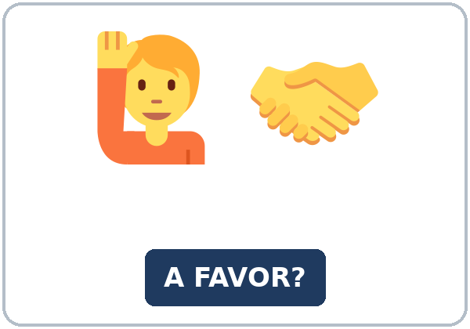  ★ favor | 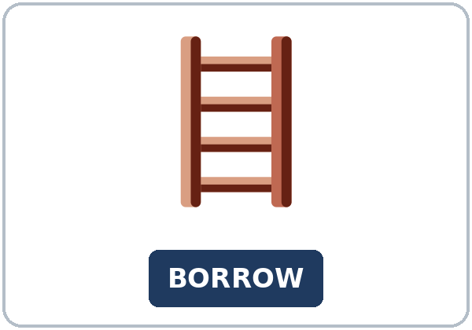  ★ borrow | 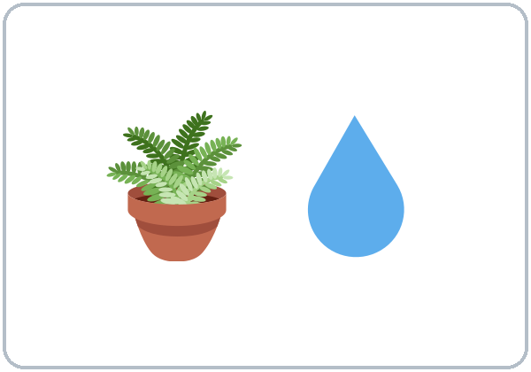  ★ water the plants | 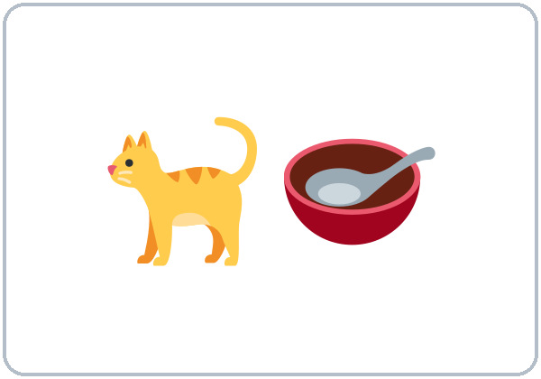  ★ feed the cat
  ★ get the mail | 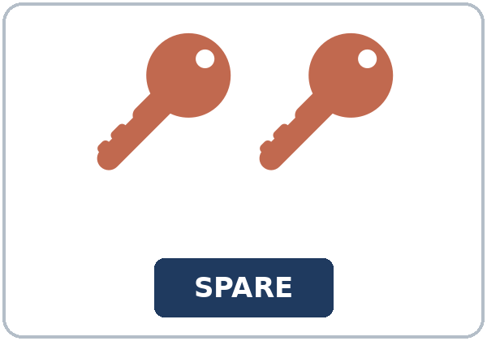  ★ spare key | 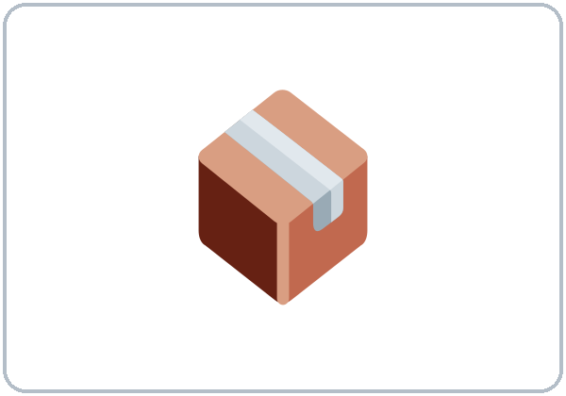  ★ package | 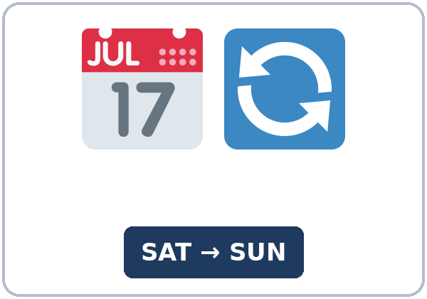  ★ switch shifts
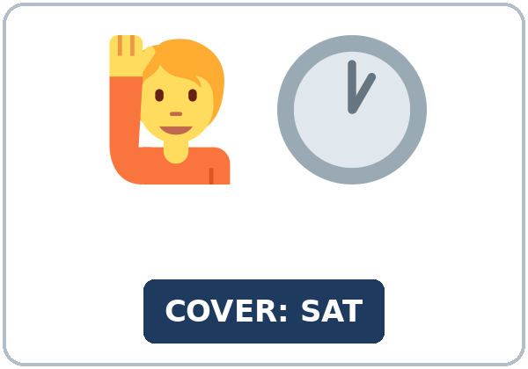  ★ cover a shift |   ★ be away |   owe (someone) | 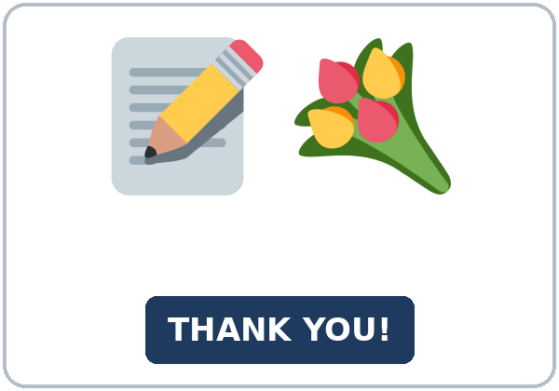  thank-you note

Partner game: Favor or no favor?
Example: A points to a picture and asks, "Would you mind getting the mail?" B gives a thumbs-up and says, "No, not at all," or says, "Sorry, I can't, because…" Switch.
Lesson 5 (Week 5) · My Words
My personal word list. Write each word in your language, if you want. Then write your own example.
Word | My language | My example
favor
borrow
water the plants
feed the cat
get the mail
spare key
package
switch shifts
cover a shift
be away
owe (someone)
thank-you note

Add 2 more words from tonight (from the listening, the reading, or your partner).
Lesson 5 (Week 5) · Listening
Patricia is going away for a week. First, she asks her older neighbor, Mr. Wilson, for some favors. The next day at work, her coworker Omar asks her for a favor.
A. Listen. What favors do they ask for? Circle.
a. get the mail, water the plants, feed the cat, and cover a shift b. borrow a ladder and switch shifts c. pick up a package and lend a car
B. Listen again. Yes or no, and why? Circle the answer.
1. The mail: Mr. Wilson says (yes / no).
2. The plants: water them on (Tuesday and Friday / Monday and Thursday).
3. The key: Patricia will give him (her spare key / her car key) tonight.
4. The packages: Mr. Wilson can put them (inside / at the office).
5. The Saturday shift: Patricia says (yes / no).
6. Why? She (will be away / has a soccer game).
C. Listen again. Write the missing word: an -ing word or if.
1. Would you mind ____________ my mail?
2. And would you mind ____________ my plants?
3. Oh, and would you mind ____________ my cat, too?
4. Do you mind ____________ I put your packages inside, too?
5. Would you mind ____________ my Saturday shift?
6. Do you mind ____________ I tell her you suggested it?
Hear it, say it
gonna = going to: "I'm gonna be away next week." • wanna = want to: "I wanna help, but I can't." You can say going to and want to. Say Would you mind…? and Do you mind if I…? smoothly, with a friendly rise at the end. Answer with a thumbs-up: No, not at all!
Lesson 5 (Week 5) · Grammar
Read across. A reads from the left side. B answers from the right side. Choose one part from each column.
Grammar Box 1: Would you mind + -ing?
QUESTION |  |  | ANSWER
Would you mind | getting my mail? |  | No, not at all. | I'll do it.
Would you mind | getting my mail? |  | Sorry, I can't. | I'll be away too.
Would you mind | covering my shift? |  | No, not at all. | I'm free on Saturday.
Would you mind | lending me a ladder? |  | No problem. | You can borrow mine.

Grammar Box 2: permission: Do you mind if I…?
QUESTION |  |  | ANSWER
Do you mind if I | open the window? |  | No, go ahead. | It's hot in here.
Do you mind if I | leave early today? |  | Sorry, | we need you until 5:00.
Do you mind if I | switch my Friday shift? |  | No, not at all. | Ask the supervisor first.

Rule of thumb: After Would you mind, use -ing (getting, covering). After Do you mind if I, use the base verb (open, leave). The answer No means "No problem. I'll help." / "Yes, you can."
Grammar Box 3: saying yes, saying no
YOU CAN HELP (say no!) | YOU CAN'T HELP (be polite)
No, not at all. • No problem. • Sure, I'll do it. | Sorry, I can't, because… + another idea: Why don't you ask Lina?

Grammar Box 4: how polite?
 | WHEN? | EXAMPLE
Can you…? | a small favor, a friend | Can you pass the salt?
Could you…? | more polite | Could you help me with this box?
Would you mind …ing? | the most polite; a bigger favor | Would you mind feeding my cat for a week?

Questions and answers
Q: Someone asks Would you mind helping me? I want to help. Do I say yes?
A: No! Say No, not at all. Mind asks "Is it a problem?" No = no problem.
Q: Would you mind to get or Would you mind getting?
A: After mind, use -ing: Would you mind getting my mail?
Q: How do I say no politely?
A: Say sorry, give a reason, and offer an idea: Sorry, I can't. I'll be away. Why don't you ask Lina?
Practice A: Write the correct form of the verb.
1. Would you mind ____________ my plants? (water)
2. Do you mind if I ____________ the window? (open)
3. Would you mind ____________ the cat on Sunday? (feed)
4. Would you mind ____________ shifts with me? (switch)
5. Do you mind if I ____________ your ladder? (borrow)
6. Would you mind ____________ my packages? (get)
Practice B: Circle the correct words.
1. Would you mind (covering / to cover) my shift?
2. A: Would you mind helping me? B: (No, not at all. / Yes, I do.) I'll help.
3. Do you mind if I (leave / leaving) early?
4. Could I borrow your pen? I forgot (mine / my).
5. Sorry, I can't. I ('ll be / be) away.
6. I'd like (to switch / switching) my Friday shift.
Common mistakes
✗ Don't say | ✓ Say
Would you mind to get my mail? | Would you mind getting my mail?
Yes, I mind. I'll help you. | No, not at all. I'll help you.
Do you mind if I using your phone? | Do you mind if I use your phone?
Can I borrow your? | Can I borrow yours?
I like to switch my shift. | I'd like to switch my shift.

Contrast tip (optional): In many languages, a yes answer means "I'll help." But Would you mind…? asks "Is it a problem for you?", so in English No means "No problem." Spanish ¿Te importaría…? No, para nada works the same way. What does your language do?

Lesson 5 (Week 5) · Talk Time: Favor Exchange
Round 1. Take a favor card and a "my week" card. Ask three people for your favor. Answer No, not at all or Sorry, I can't, because… and offer another idea. Write who said yes.
FAVOR CARDS (invented)
1. get my mail for a week | 2. switch my Saturday shift
3. lend me a ladder on Sunday | 4. water my plants on Friday
5. feed my cat this weekend | 6. cover my Monday shift
7. pick up my package today | 8. drive me to work on Tuesday

MY WEEK CARD | Mon | Tue | Wed | Thu | Fri | Sat | Sun
Card A | free | busy | free | free | busy | away | away
Card B | busy | free | free | busy | free | free | busy

Example: A: Would you mind getting my mail next week? B: No, not at all. I'm home all week. C: Sorry, I can't, because I'll be away. Why don't you ask Ana?
I asked… | Yes or no? | Their reason or idea
1.
2.
3.

Lesson 5 (Week 5) · Talk Time: Shift Switch Text
Round 2. Work with a partner. Write a 3-sentence text to a coworker. Confirm the shift switch: the day, the time, and thanks. Then read it to another pair.
Example: "Hi, Omar. Thanks for switching shifts with me! I'll work your Sunday shift (9:00–5:00), and you'll work my Friday shift (2:00–10:00). I've told Ms. Diaz, and she says it's OK."
Our text

CHECK: does your text have…? | ✓
the day and the time | ☐
who works which shift | ☐
thanks | ☐

Useful: Thanks for… • I'll work your… • You'll work my… • I've told the supervisor. • See you on…
Remember: every job has its own rules. Ask your supervisor first.
Lesson 5 (Week 5) · Homework
Homework (about 15–20 minutes). Bring it next week!
1. Write the question or answer. Use the words.
Example: you / mind / get / my mail? → Would you mind getting my mail?
1. you / mind / feed / my cat? → ______________________________________________
2. do you mind if I / leave / early? → ______________________________________________
3. you / mind / cover / my shift / on Sunday? → ______________________________________________
4. a "yes, I'll help" answer: no / not / all → ______________________________________________
2. Finish your writing from Read & Write C (your note). Read it one more time. Check ✓ the list in D.
☐ I finished it. ☐ I checked it with the list.
3. Write 3 favors you could ask a neighbor or a coworker. Then write a polite answer for each one.
My favor (Would you mind…?) | A polite answer
1.
2.
3.

4. Review (Lesson 4). Write one word.
1. ____________ don't you call the clinic?
2. You could ____________ a heating pad.
3. It's a good idea ____________ get a flu shot every year.
4. I've had a cough ____________ Sunday.
5. She's had a rash ____________ three days.
Lesson 5 (Week 5) · Read & Write
A. Read the notice. Read fast first. Then read again and answer the questions.
NOTICE · Maple Court Apartments + a note to a neighbor
NOTICE: Packages. Starting June 1, all packages will go to the new package room next to the mailroom. You will get a text with a code when a package arrives. Please pick up your packages within 5 days. If you are going to be away, you can ask a neighbor to pick them up for you. Your neighbor must show your text with the code. Questions? Call the office at (555) 210-4400.
A NOTE on the door of apartment 3B:
Hi, Ms. Lee! This is Tomás from 3A. I'm going to be away from June 10 to June 17. Would you mind picking up my packages from the package room? I'll text you the codes. Also, would you mind feeding my cat, Luna, in the evening? Her food is in the kitchen. My spare key will be in an envelope under your door on Sunday. Thank you so much! I owe you one. If you ever need help, just ask. Tomás

B. Answer the questions.
1. Where will all packages go? ______________________________________________
2. When must you pick up a package? ______________________________________________
3. What must a neighbor show? ______________________________________________
4. When will Tomás be away? ______________________________________________
5. Where will the spare key be? ______________________________________________
C. Write a note to a neighbor (5–8 sentences). Ask for a favor while you're away: the dates, what to do, where the key is, thanks, and an offer to help back.
Example: Hi, Mr. Ruiz! I'm going to be away from May 3 to May 8. Would you mind getting my mail? Also, would you mind watering my plants on Wednesday? My spare key will be under your door on Friday. Thank you so much! If you ever need help, just ask. Ana (2C)
My note

D. Check your writing with a partner.
 | Yes | Not yet
It has 5–8 sentences. | ☐ | ☐
It has the dates. | ☐ | ☐
It has Would you mind…? + -ing. | ☐ | ☐
It has thanks and an offer to help back. | ☐ | ☐

Lesson 5 (Week 5) · Exit Ticket
Name: ______________________________ Date: ________________
Answer in 3 sentences. Give a reason. Then give this page to your teacher.
Ask a classmate for a favor with Would you mind…?
Sentence 1: your question (Would you mind…?) • Sentence 2: their answer • Sentence 3: the reason, with because
My answer
1.
2.
3.

For the teacher | ✓ | almost | not yet
3 sentences, today's grammar, a reason | ☐ | ☐ | ☐

Lesson 5 (Week 5) · Task Words (optional)
This page is for you if you want it. You can skip it. Write each task word in your language, if you want.
Task word | What you do | My language
Listen. | Use your ears. Don't write yet.
Circle. | Draw a circle around the answer.
Check ✓. | Make a ✓ in the box.
Write. | Write words or sentences.
Number. | Write 1, 2, 3… to show the order.
Match. | Find the two parts that go together.
Work with a partner. | Work with one classmate.
Work in a group. | Work with 2 or 3 classmates.
Switch. | Change roles: A is B now.
Ask a follow-up question. | Ask one more question about the answer.
Give a reason. | Say why, with because or so.
Compare. | Look at your partner's answers. Are they the same?

Picture Credits
Pictures use Twemoji graphics by Twitter, Inc. and other contributors (https://github.com/jdecked/twemoji), licensed under CC BY 4.0 (https://creativecommons.org/licenses/by/4.0/). The graphics were resized and combined, and signs and labels were added. The file-by-file list is in images/CREDITS.md.
Listening audio: not recorded yet. When it is made, it will use synthetic voices made with Chatterbox TTS (Resemble AI, MIT License), cloned from synthetic reference clips made with Kokoro-82M (Apache License 2.0), with no recordings of real people. The names and the story are invented.
Course materials: © 2026 the authors, licensed under CC BY-NC-SA 4.0 (https://creativecommons.org/licenses/by-nc-sa/4.0/).

