A PROJECT REPORT ON
IMAGE COMPRESSION USING DISCRETE COSINE TRANSFORM & DISCRETE WAVELET TRANSFORM

SUBMITTED IN PARTIAL FULFILLMENT OF THE REQUIREMENTS FOR THE DEGREE OF

Bachelor in Technology

In
Electronics and Communication Engineering

Submitted by

K Satya Durga Reddy 16P35A0425
R Aishwarya
Mahesh
Mahitha
Under the Guidance of
Mr .Sarath Babu , M.Tech


Department of Electronics and Communication Engineering

ADITYA COLLEGE OF ENGINEERING AND TECHNOLOGY

SURAMPALEM E.G DIST

ACKNOWLEDGEMENT

Education along with the process of gaining knowledge and stronghold of subject is a continuous and ongoing process.It is an appropriate blend of mindset,learnt skills,experience and knowledge gained from various resources.

This project would not have been possible without the support of many people.First and foremost I would like to express my gratitude and indebtedness to Prof. R. Baliarsingh for his kind and valuable guidance that made the meaningful completion of project possible.New ideas and directions from him made it possible for me to sail through various areas of image compression techniques which were new to me.

I am also greatful to Prof. B. Majhi for assigning me this interesting project and for his valuable suggestions and encouragements during my project period.

Finally, I would like to thank Roop Sir who has patiently helped me throughout my project.

Bhawna Gautam

(10606053)
Department Of Computer Science And Engineering,2010
NIT Rourkela
ABSTRACT

It is used specially for the compression of images where tolerable degradation is required. With the wide use of computers and consequently need for large scale storage and transmission of data, efficient ways of storing of data have become necessary. With the growth of technology and entrance into the Digital Age ,the world has found itself amid a vast amount of information. Dealing with such enormous information can often present difficulties. Image compression is minimizing the size in bytes of a graphics file without degrading the quality of the image to an unacceptable level. The reduction in file size allows more images to be stored in a given amount of disk or memory space. It also reduces the time required for images to be sent over the Internet or downloaded from Web pages.JPEG and JPEG 2000 are two important techniques used for image compression.

JPEG image compression standard use DCT (DISCRETE COSINE TRANSFORM). The discrete cosine transform is a fast transform. It is a widely used and robust method for image compression. It has excellent compaction for highly correlated data.DCT has fixed basis images DCT gives good compromise between information packing ability and computational complexity.

JPEG 2000 image compression standard makes use of DWT (DISCRETE WAVELET TRANSFORM). DWT can be used to reduce the image size without losing much of the resolutions computed and values less than a pre-specified threshold are discarded. Thus it reduces the amount of memory required to represent given image.
Contents

Chapter 1 :Introduction

Chapter 2:Image Compression

2.1 Need for Image Compression

2.2 Principles behind Compression

2.3 Types of Compression

Chapter 3:Image Compression using DISCRETE COSINE TRANSFORM 3.1 JPEG Process

3.2 Quantization

3.3 Entropy Encoding

3.4 Results

Chapter 4: Image Compression using DISCRETE WAVELET TRANSFORM 4.1Subband coding

4.2 Compression steps

4.2 DWT Results

4.3 Comparison of DCT and DWT

4.4 Conclusions

REFRENCES

CHAPTER 1
INTRODUCTION

1.INTRODUCTION

Image compression is very important for efficient transmission and storage of images . Demand for communication of multimedia data through the telecommunications network and accessing the multimedia data through Internet is growing explosively[14].With the use of digital cameras, requirements for storage, manipulation, and transfer of digital images,has grown explosively . These image files can be very large and can occupy a lot of memory.A gray scale image that is 256 x 256 pixels has 65, 536 elements to store, and a a typical 640 x 480 color image has nearly a million.Downloading of these files from internet can be very time consuming task. Image data comprise of a significant portion of the multimedia data and they occupy the major portion of the communication bandwidth for multimedia communication.Therefore development of efficient techniques for image compression has become quite necessary[9]. A common characteristic of most images is that the neighbouring pixels are highly correlated and therefore contain highly redundant information. The basic objective of image compression is to find an image representation in which pixels are less correlated. The two fundamental principles used in image compression are redundancy and irrelevancy. Redundancy removes redundancy from the signal source and irrelevancy omits pixel values which are not noticeable by human eye. JPEG and JPEG 2000 are two important techniques used for image compression.

Work on international standards for image compression started in the late 1970s with the CCITT (currently ITU-T) need to standardize binary image compression algorithms for Group 3 facsimile communications. Since then, many other committees and standards have been formed to produce de jure standards (such as JPEG), while several commercially successful initiatives have effectively become de facto standards (such as GIF). Image compression standards bring about many benefits, such as: (1) easier exchange of image files between different devices and applications; (2) reuse of existing hardware and software for a wider array of products; (3) existence of benchmarks and reference data sets for new and alternative developments.

CHAPTER 2
REQUIREMENTS

REQUIREMENTS

- Windows Installed Computer or Laptop
- 4 GB RAM Atleast
- 20 GB of Hard Disk
- 1 GB GPU

SOFTWARE REQUIREMENTS

- Matlab
- Guide
- .Net Frameworks
- File Explorer
- Image Viewer

CHAPTER 3
IMAGE COMPRESSION

IMAGE COMPRESSION

2.1 Need for image compression:

The need for image compression becomes apparent when number of bits per image are computed resulting from typical sampling rates and quantization methods.For example, the amount of storage required for given images is (i) a low resolution, TV quality, color video image which has 512 x 512 pixels/color,8 bits/pixel, and 3 colors approximately consists of 6 x 10⁶ bits;(ii) a 24 x 36 mm negative photograph scanned at 12 x 10⁻⁶mm:3000 x 2000 pixels/color, 8 bits/pixel, and 3 colors nearly contains 144 x 10⁶ bits; (3) a 14 x 17 inch radiograph scanned at 70 x 10⁻⁶mm: 5000 x 6000 pixels, 12 bits/pixel nearly contains 360 x 10⁶ bits.Thus storage of even a few images could cause a problem. As another example of the need for image compression ,consider the transmission of low resolution 512 x 512 x 8 bits/pixel x 3-color video image over telephone lines. Using a 96000 bauds(bits/sec) modem, the transmission would take approximately 11 minutes for just a single image, which is unacceptable for most applications.

2.2 Principles behind compression:

Number of bits required to represent the information in an image can be minimized by removing the redundancy present in it.There are three types of redundancies: (i)spatial redundancy,which is due to the correlation or dependence between neighbouring pixel values; (ii) spectral redundancy, which is due to the correlation between different color planes or spectral bands; (iii) temporal redundancy,which is present because of correlation between different frames in images.Image compression research aims to reduce the number of bits required to represent an image by removing the spatial and spectral redundancies as much as possible.

Data redundancy is of central issue in digital image compression.If n1 and n2 denote the number of information carrying units in original and compressed image respectively ,then the compression ratio CR can be defined as

CR=n1/n2;

And relative data redundancy RD of the original image can be defined as

RD=1-1/CR;

Three possibilities arise here:

- If n1=n2,then CR=1 and hence RD=0 which implies that original image do not contain any redundancy between the pixels.

- If n1>>n1,then CR→∞ and hence RD>1 which implies considerable amount of redundancy in the original image.

- If n1<<n2,then CR>0 and hence RD→-∞ which indicates that the compressed image contains more data than original image.

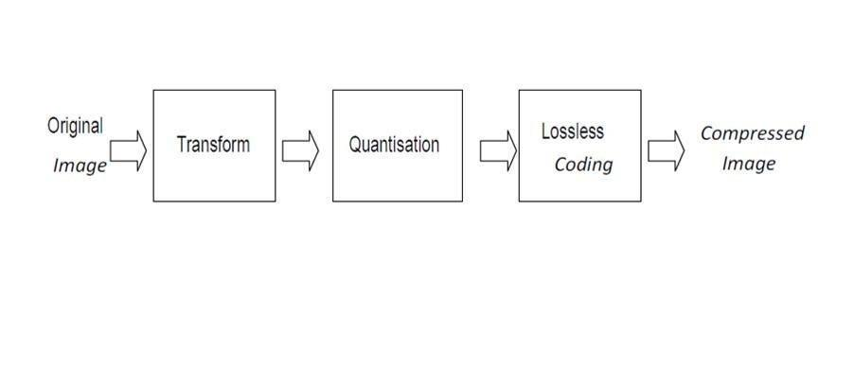

STEPS

Fig(2.1)

Image Compression model
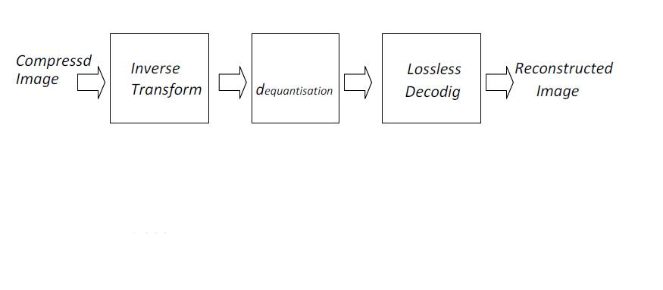

Fig(2.2)

Image Decompression model
Image compression model shown here consists of a Transformer, quantizer and encoder.

Transformer: It transforms the input data into a format to reduce interpixel redundancies in the input image. Transform coding techniques use a reversible, linear mathematical transform to map
the pixel values onto a set of coefficients, which are then quantized and encoded. The key factor behind the success of transform-based coding schemes is that many of the resulting coefficients for most natural images have small magnitudes and can be quantized without causing significant distortion in the decoded image. For compression purpose, the higher the capability. of compressing information in fewer coefficients, the better the transform; for that reason, the Discrete Cosine Transform (DCT) and Discrete Wavelet Transform(DWT) have become the most widely used transform coding techniques.

Transform coding algorithms usually start by partitioning the original image into subimages (blocks) of small size (usually 8 × 8). For each block the transform coefficients are calculated, effectively converting the original 8 × 8 array of pixel values into an array of coefficients within which the coefficients closer to the top-left corner usually contain most of the information needed to quantize and encode (and eventually perform the reverse process at the decoder’s side) the image with little perceptual distortion. The resulting coefficients are then quantized and the output of the quantizer is used by symbol encoding techniques to produce the output bitstream representing the encoded image. In image decompression model at the decoder’s side, the reverse process takes place, with the obvious difference that the dequantization stage will only generate an approximated version of the original coefficient values e.g., whatever loss was introduced by the quantizer in the encoder stage is not reversible.

Quantizer: It reduces the accuracy of the transformer’s output in accordance with some pre-established fidelity criterion. Reduces the psychovisual redundancies of the input image. This operation is not reversible and must be omitted if lossless compression is desired. The quantization stage is at the core of any lossy image encoding algorithm. Quantization at the encoder side, means partitioning of the input data range into a smaller set of values. There are two main types of quantizers: scalar quantizers and vector quantizers. A scalar quantizer partitions the domain of input values into a smaller number of intervals. If the output intervals are equally spaced, which is the simplest way to do it, the process is called uniform scalar quantization; otherwise, for reasons usually related to minimization of total distortion, it is called non uniform scalar quantization. One of the most popular non uniform quantizers is the Lloyd-

Max quantizer. Vector quantization (VQ) techniques extend the basic principles of scalar quantization to multiple dimensions.

Symbol (entropy) encoder: It creates a fixed or variable-length code to represent the quantizer’s output and maps the output in accordance with the code. In most cases, a variable-length code is used. An entropy encoder compresses the compressed values obtained by the quantizer to provide more efficient compression. Most important types of entropy encoders used in lossy image compression techniques are arithmetic encoder, huffman encoder and run-length encoder.

OTHER PROPERTIES

The best image quality at a given compression rate (or bit rate) is the main goal of image compression, however, there are other important properties of image compression schemes:

Scalability generally refers to a quality reduction achieved by manipulation of the bitstream or file (without decompression and re-compression). Other names for scalability are progressive coding or embedded bitstreams. Despite its contrary nature, scalability also may be found in lossless codecs, usually in form of coarse-to-fine pixel scans. Scalability is especially useful for previewing images while downloading them (e.g., in a web browser) or for providing variable quality access to e.g., databases. There are several types of scalability:

Quality progressive or layer progressive: The bitstream successively refines the reconstructed image.Resolution progressive: First encode a lower image resolution; then encode the difference to higher resolutions.

Component progressive: First encode grey-scale version; then adding full color.
Region of interest coding. Certain parts of the image are encoded with higher quality than others. This may be combined with scalability (encode these parts first, others later).

Meta information. Compressed data may contain information about the image which may be used to categorize, search, or browse images. Such information may include color and texture statistics, small preview images, and author or copyright information.

Processing power. Compression algorithms require different amounts of processing power to encode and decode. Some high compression algorithms require high processing power.

The quality of a compression method often is measured by the peak signal-to-noise ratio. It measures the amount of noise introduced through a lossy compression of the image, however, the subjective judgment of the viewer also is regarded as an important measure, perhaps, being the most important measure.

CHAPTER 3
TYPES OF IMAGE COMPRESSION

Types of compression:

Image Compression is of Two types they are
- Lossy Image Compression
- Loss Less Image Compression

Lossless versus Lossy compression: In lossless compression schemes, the reconstructed image, after compression, is numerically identical to the original image. However lossless compression can only a achieve a modest amount of compression. Lossless compression is preferred for archival purposes and often medical imaging, technical drawings, clip art or comics. This is because lossy compression methods, especially when used at low bit rates, introduce compression artifacts. An image reconstructed following lossy compression contains degradation relative to the original. Often this is because the compression scheme completely discards redundant information. However, lossy schemes are capable of achieving much higher compression. Lossy methods are especially suitable for natural images such as photos in applications where minor (sometimes imperceptible) loss of fidelity is acceptable to achieve a substantial reduction in bit rate. The lossy compression that produces imperceptible differences can be called visually lossless[8].

Predictive versus Transform coding: In predictive coding, information already sent or available is used to predict future values, and the difference is coded. Since this is done in the image or spatial domain, it is relatively simple to implement and is readily adapted to local image characteristics. Differential Pulse Code Modulation (DPCM) is one particular example of predictive coding. Transform coding, on the other hand, first transforms the image from its spatial domain representation to a different type of representation using some well-known transform and then codes the transformed values (coefficients). This method provides greater data compression compared to predictive methods, although at the expense of greater computational requirements.

CHAPTER 4
IMAGE COMPRESSION USING DISCRETE COSINE TRANSFORMATION

Image Compression using Discrete Cosine Transform

Discrete Cosine Transform

A discrete cosine transform (DCT) expresses a finite sequence of data points in terms of a sum of cosine functions oscillating at different frequencies. DCTs are important to numerous applications in science and engineering, from lossy compression of audio (e.g. MP3) and images (e.g. JPEG) (where small high-frequency components can be discarded), to spectral methods for the numerical solution of partial differential equations. The use of cosine rather than sine functions is critical for compression, since it turns out (as described below) that fewer cosine functions are needed to approximate a typical signal, whereas for differential equations the cosines express a particular choice of boundary conditions
In particular, a DCT is a Fourier-related transform similar to the discrete Fourier transform (DFT), but using only real numbers. The DCTs are generally related to Fourier Series coefficients of a periodically and symmetrically extended sequence whereas DFTs are related to Fourier Series coefficients of a periodically extended sequence. DCTs are equivalent to DFTs of roughly twice the length, operating on real data with even symmetry (since the Fourier transform of a real and even function is real and even), whereas in some variants the input and/or output data are shifted by half a sample. There are eight standard DCT variants, of which four are common.
The most common variant of discrete cosine transform is the type-II DCT, which is often called simply the DCT.Its inverse, the type-III DCT, is correspondingly often called simply "the inverse DCT" or "the IDCT". Two related transforms are the discrete sine transform (DST), which is equivalent to a DFT of real and odd functions, and the modified discrete cosine transform (MDCT), which is based on a DCT of overlapping data. Multidimensional DCTs (MD DCTs) are developed to extend the concept of DCT on MD Signals. There are several algorithms to compute MD DCT. A new variety of fast algorithms are also developed to reduce the computational complexity of implementing DCT.

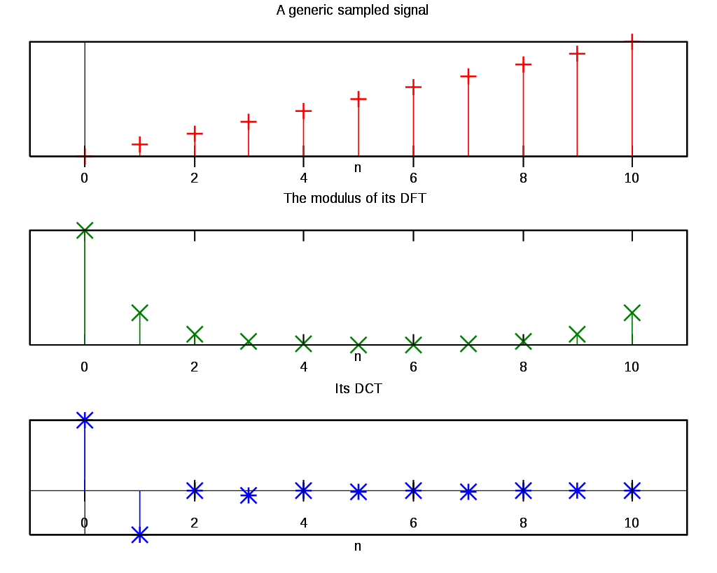
DCT COMPARED TO DFT OF A INPUT SIGNAL

APPLICATION OF DCT
The DCT, and in particular the DCT-II, is often used in signal and image processing, especially for lossy compression, because it has a strong "energy compaction" property:[1][2] in typical applications, most of the signal information tends to be concentrated in a few low-frequency components of the DCT. For strongly correlated Markov processes, the DCT can approach the compaction efficiency of the Karhunen-Loève transform (which is optimal in the decorrelation sense). As explained below, this stems from the boundary conditions implicit in the cosine functions.
A related transform, the modified discrete cosine transform, or MDCT (based on the DCT-IV), is used in AAC, Vorbis, WMA, and MP3 audio compression
DCTs are also widely employed in solving partial differential equations by spectral methods, where the different variants of the DCT correspond to slightly different even/odd boundary conditions at the two ends of the array.
DCTs are also closely related to Chebyshev polynomials, and fast DCT algorithms (below) are used in Chebyshev approximation of arbitrary functions by series of Chebyshev polynomials, for example in Clenshaw–Curtis quadrature.

JPEG
JPEG stands for the Joint Photographic Experts Group, a standards committee that had its origins within the International Standard Organization (ISO).JPEG provides a compression method that is capable of compressing continuous-tone image data with a pixel depth of 6 to 24 bits with reasonable speed and efficiency.JPEG may be adjusted to produce very small, compressed images that are of relatively poor quality in appearance but still suitable for many applications. Conversely, JPEG is capable of producing very high-quality compressed images that are still far smaller than the original uncompressed data.

JPEG is primarily a lossy method of compression.JPEG was designed specifically to discard information that the human eye cannot easily see. Slight changes in color are not perceived well by the human eye, while slight changes in intensity (light and dark) are. Therefore JPEG's lossy encoding tends to be more frugal with the gray-scale part of an image and to be more frivolous with the color[21].DCT separates images into parts of different frequencies where less important frequencies are discarded through quantization and important frequencies are used to retrieve the image during decompression. Compared to other input dependent transforms, DCT has many advantages: (1) It has been implemented in single integrated circuit; (2) It has the ability to pack most information in fewest coefficients; (3) It minimizes the block like appearance called blocking artifact that results when boundaries between sub-images become visible[11].

The forward 2D_DCT transformation is given by the following equation:
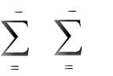

N 1 N 1
C(u,v)=D(u)D(v) f(x,y)cos[(2x+1)uπ/2N]cos[(2y+1)vπ/2N]

x 0 y 0

Where,u,v=0,1,2,3,……………,N-1

The inverse 2D-DCT transformation is given by the following equation:
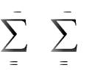

N 1 N 1
f(x,y)= D(u)D(v)D(u,v)cos[(2x+1)uπ/2N]xcos(2y+1)vπ/2N]

u 0 v 0

where

D(u)=(1/N) ^1/2

for u=0

D(u)=2(/N)^1/2

for u=1,2,3…….,(N-1)

3.1 JPEG Process:


Original image is divided into blocks of 8 x 8.


Pixel values of a black and white image range from 0-255 but DCT is designed to work on pixel values ranging from -128 to 127 .Therefore each block is modified to work in the range.

Equation(1) is used to calculate DCT matrix.

DCT is applied to each block by multiplying the modified block with DCT matrix on the left and transpose of DCT matrix on its right.

Each block is then compressed through quantization.

Quantized matrix is then entropy encoded.

Compressed image is reconstructed through reverse process.

Inverse DCT is used for decompression[11].

3.2 Quantization

Quantization is achieved by compressing a range of values to a single quantum value. When the number of discrete symbols in a given stream is reduced, the stream becomes more compressible.A quantization matrix is used in combination with a DCT coefficient matrix to carry out transformation. Quantization is the step where most of the compression takes place.DCT really does not compress the image because it is almost lossless. Quantization makes use of the fact that higher frequency components are less important than low frequency components. It allows varying levels of image compression and quality through selection of specific quantization matrices. Thus quality levels ranging from 1 to 100 can be selected, where 1 gives the poorest image quality and highest compression, while 100 gives the best quality and lowest compression. As a result quality to compression ratio can be selected to meet different needs.JPEG committee suggests matrix with quality level 50 as standard matrix. For obtaining quantization matrices with other quality levels, scalar multiplications of standard quantization matrix are used. Quantization is achieved by dividing transformed image matrix by the quantization matrix used. Values of the resultant matrix are then rounded off. In the resultant matrix coefficients situated near the upper left corner have lower frequencies .Human eye is more sensitive to lower frequencies .Higher frequencies are discarded. Lower frequencies are used to reconstruct the image[11].

3.3 Entropy Encoding

After quantization, most of the high frequency coefficients are zeros. To exploit the number of zeros, a zig-zag scan of the matrix is used yielding to long string of zeros. Once a block has been converted to a spectrum and quantized, the JPEG compression algorithm then takes the result and converts it into a one dimensional linear array, or vector of 64 values, performing a zig-zag scan by selecting the elements in the numerical order indicated by the numbers in the grid below:

0 1 2 3 4 5 6 7

___________________________________________________________________________

0: | 0 | 1 | 5 | 6 | 14 | 15 | 27 | 28
1: | 2 | 4 | 7 | 13 | 16 | 26 | 29 | 42
2: | 3 | 8 | 12 | 17 | 25 | 30 | 41 | 43
3: | 9 | 11 | 18 | 24 | 31 | 40 | 44 | 53
4: | 10 | 19 | 23 | 32 | 39 | 45 | 52 | 5
5: | 20 | 22 | 33 | 38 | 46 | 51 | 55 | 60

This places the elements of the coefficient block in a reasonable order of increasing frequency. Since the higher frequencies are more likely to be zero after quantization, this tends to group zero values in the high end of the vector[16].

Huffman coding:The basic idea in Huffman coding is to assign short codewords to those input blocks with high probabilities and long codewords to those with low probabilities.A Huffman code is designed by merging together the two least probable characters, and repeating this process until there is only one character remaining. A code tree is thus generated and the Huffman code is obtained from the labeling of the code tree.
3.4 Results and Discussions:

Results obtained after performing DCT of various orders on original images are shown.Fig(3.4.1) shows original images.Images obtained after applying 8 x 8 DCT are as shown

in Fig(3.4.2) whereas Fig(3.4.4) shows image obtained for same original image after applying 4 x 4 DCT.Similarly Fig(3.4.6) and Fig(3.4.8) are obtained after applying 8 x 8 DCT and 4 x 4 DCT of the image shown in Fig(3.4.5).Fig(3.4.9) shows the original Lena image.Fig(3.4.10) to Fig(3.4.14) show compressed images for the original Lena image after taking various number of coefficients for quantization.As the number of coefficients increases quality of the image decreases whereas compression ratio continues to increase.Fig(3.4.15) shows that SNR value increases with number of coefficients.
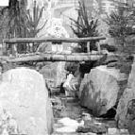
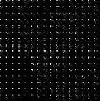
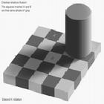
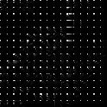
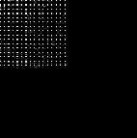
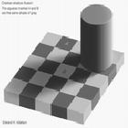
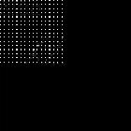

Fig(3.4.1)

Fig(3.4.2)

Fig(3.4.3)

Fig(3.4.4)

Original image

After 8 x8 DCT

Original image

After 4 x 4 DCT


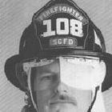

Fig(3.4.5)

Fig(3.4.6)
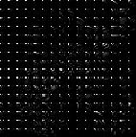
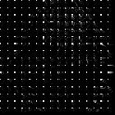

Fig(3.4.7)

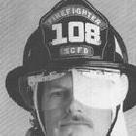

Fig(3.4.8)
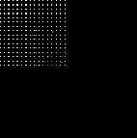
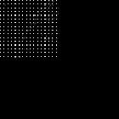

Original image
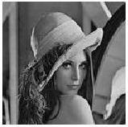

After 8 x 8 DCT
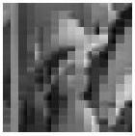

Original image

After 4 x 4 DCT
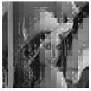

Fig (3.4.9) | Fig (3.4.10) | Fig (3.4.11)
Original Lena image | Compressed Lena image | Compressed image
 | with 4 coefficients | with 16 coefficients
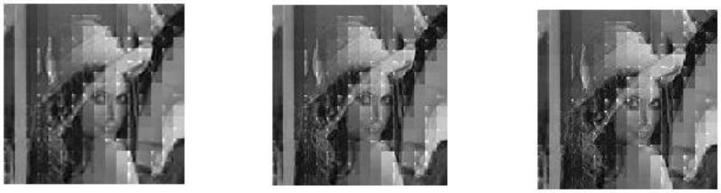

Fig (3.4.12) | Fig (3.4.13) | Fig (3.4.14)
Compressed image | Compressed image | Compressed image
with 25 coefficients | with 40 coefficients | with 50 coefficients

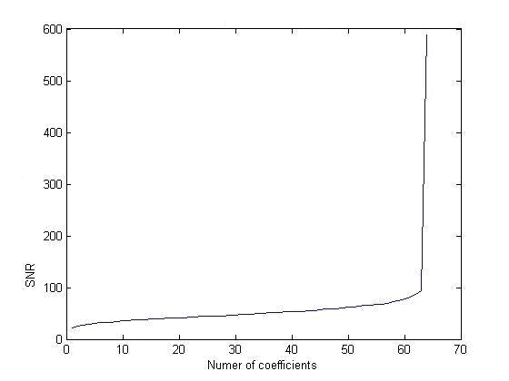

Fig(3.4.15)

SNR vs. No. of coefficients
Chapter 4

Image Compression using Descrete Wavelet Transform

Wavelet Transform has become an important method for image compression.Wavelet based coding provides substantial improvement in picture quality at high compression ratios mainly due to better energy compaction property of wavelet transforms.

Wavelet transform partitions a signal into a set of functions called wavelets.Wavelets are obtained from a single prototype wavelet called mother wavelet by dilations and shifting.The wavelet transform is computed separately for different segments of the time-domain signal at different frequencies.

4.1 Subband coding:

A signal is passed through a series of filters to calculate DWT.Procedure starts by passing this signal sequence through a half band digital low pass filter with impulse response h(n).Filtering of a signal is numerically equal to convolution of the tile signal with impulse response of the filter.
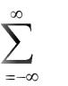

x[n]*h[n]= x[k].h[n-k]

k

A half band low pass filter removes all frequencies that are above half of the highest frequency in the tile signal.Then the signal is passed through high pass filter.The two filters are related to each other as

h[L-1-n]=(-1)ⁿg(n)

Filters satisfying this condition are known as quadrature mirror filters.After filtering half of the samples can be eliminated since the signal now has the highest frequency as half of the original frequency.The signal can therefore be subsampled by 2,simply by discarding every other sample.This consitutes 1 level of decomposition and can mathmatically be expressed as
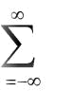
Y1[n]= x[k]h[2n-k]

k
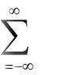

Y2[n]= x[k]g[2n+1-k]

k

where y1[n] and y2[n] are the outputs of low pass and high pass filters,respectively after subsampling by 2.

This decomposition halves the time resolution since only half the number of sample now characterizes the whole signal.Frequency resolution has doubled because each output has half the frequency band of the input.This process is called as sub band coding.It can be repeated further to increase the frequency resolution as shown by the filter bank.

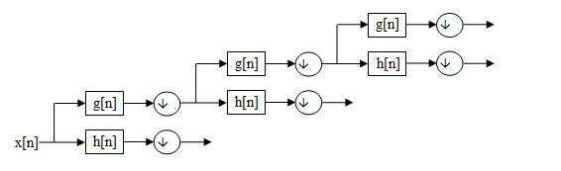

Filter Bank

4.2 Compression steps:

1.Digitize the source image into a signal s, which is a string of numbers.

2.Decompose the signal into a sequence of wavelet coefficients w.

3.Use threshold to modify the wavelet coefficients from w to w’.

4.Use quantization to convert w’ to a sequence q.

5.Entropy encoding is applied to convert q into a sequence e.

Digitation

The image is digitized first.The digitized image can be characterized by its intensity levels,or scales of gray which range from 0(black) to 255(white), and its resolution, or how many pixels per square inch[9].

Thresholding

In certain signals, many of the wavelet coefficients are close or equal to zero.Through threshold these coefficients are modified so that the sequence of wavelet coefficients contains long strings of zeros.

In hard threshold ,a threshold is selected.Any wavelet whose absolute value falls below the tolerance is set to zero with the goal to introduce many zeros without losing a great amount of detail.

Quantization

Quantization converts a sequence of floating numbers w’ to a sequence of integers q.The simplest form is to round to the nearest integer.Another method is to multiply each number in w’ by a constant k, and then round to the nearest integer.Quantization is called lossy because it introduces error into the process,since the conversion of w’ to q is not one to one function[9].

Entropy encoding

With this method,a integer sequence q is changed into a shorter sequence e,with the numbers in e being 8 bit integersThe conversion is made by an entropy encoding table.Strings of zeros are coded by numbers 1 through 100,105 and 106,while the non-zero integers in q are coded by 101 through 104 and 107 through 254.
4.3 DWT Results:

Results obtained with the matlab code[20]are shown below.Fig(4.3.1) shows original Lena image.Fig(4.3.2) to Fig(4.3.4) show compressed images for various threshold values.As threshold value increases blurring of image continues to increase.

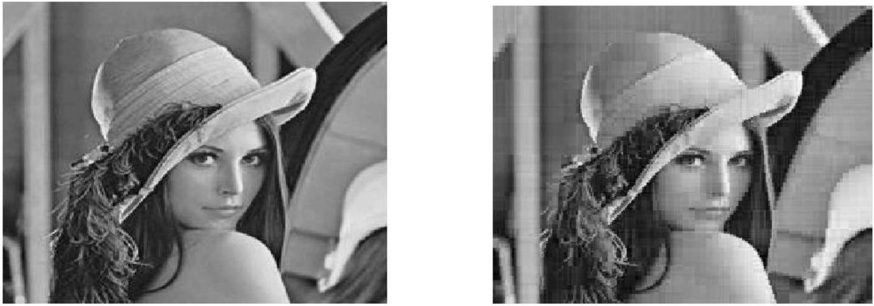

Fig (4.3.1) Fig (4.3.2)

Original Lena image Compressed Image for threshold value 1

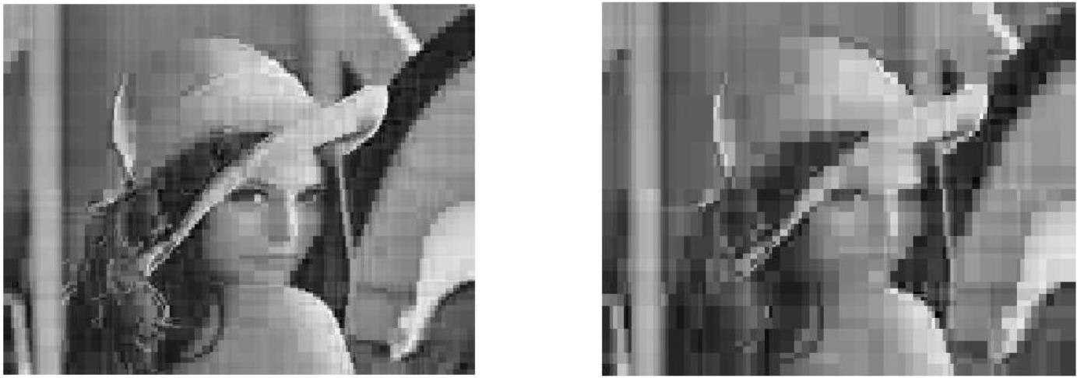

Fig 4.3.3) Fig (4.3.4)

Compressed Image for threshold value 2 Compressed Image for threshold value 5

4.4 Comparisons of results for DCT and DWT based on various performance parameters :

Mean Squared Error (MSE) is defined as the square of differences in the pixel values between the corresponding pixels of the two images. Graph of Fig(4.4.1) shows that for DCT based image compression ,as the window size increases MSE increases proportionately whereas for DWT based image compression Fig(4.4.2) shows that MSE first decreases with increase in window size and then starts to increase slowly with finally attaining a constant value.Fig(4.4.3) and Fig(4.4.4) plot show required for compressing image with change in window size for DCT and DWT respectively.Fig(4.4.5) and Fig(4.4.6) indicate compression ratio with change in window size for DCT and DWT based image compression techniques respectively.Compression increases with increase in window size for DCT and decreases with increase in window size for DWT.
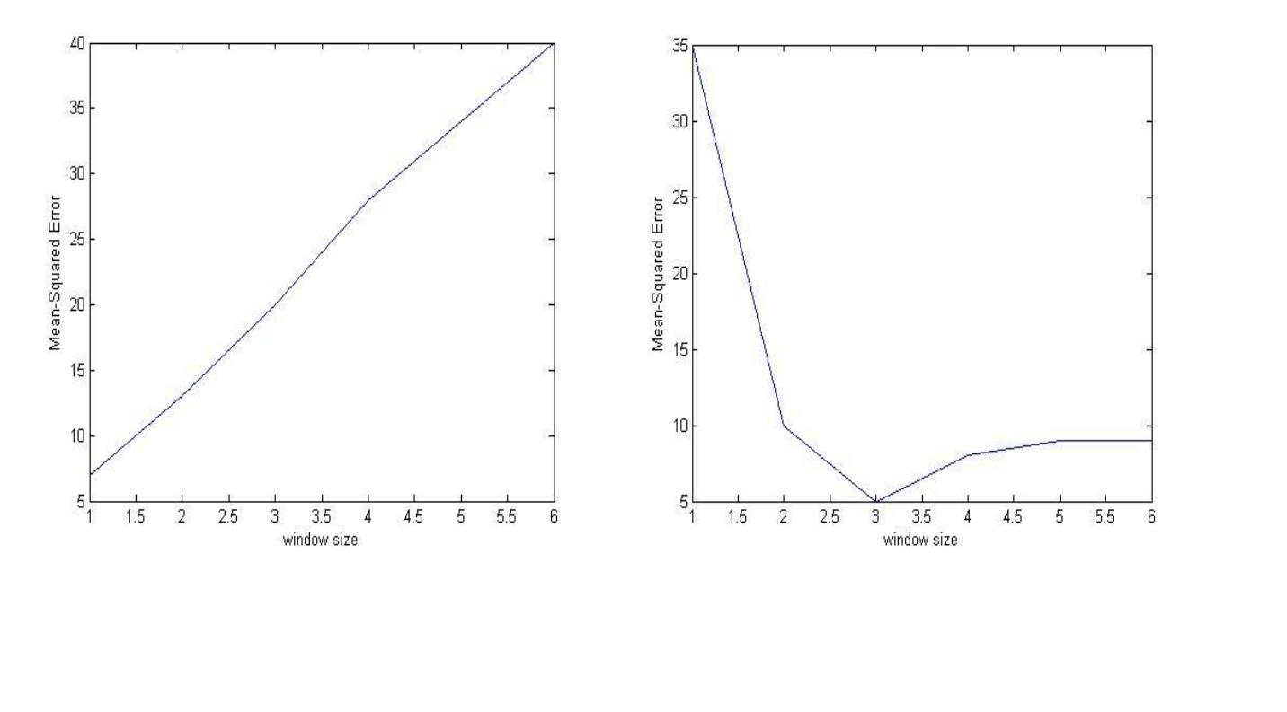

Fig(4.4.1) | Fig(4.4.2)
Mean Squared Error vs. window size for DCT | Mean Squared Error vs. window size for DWT

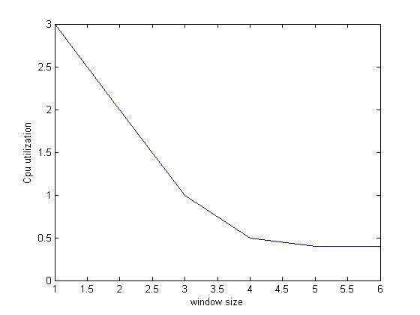
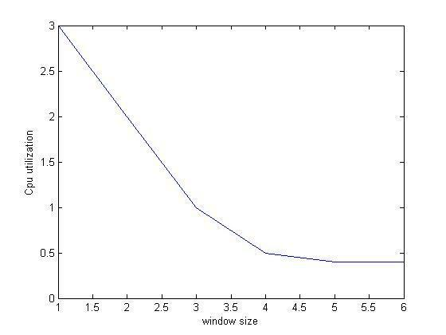

Fig(4.4.3)

Fig(4.4.4)

Cpu Utilization vs window size for DCT

Cpu Utilization vs window size for DWT

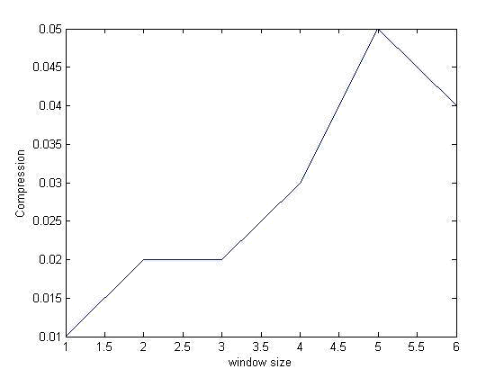
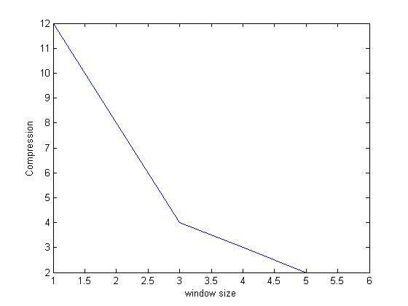

Fig(4.4.5)

Fig(4.4.6)

Compression vs. window size for DCT

Compression vs. window size for DWT

4.5 Conclusions:

In the thesis image compression techniques using DCT and DWT were implemented.

DCT is used for transformation in JPEG standard.DCT performs efficiently at medium bit rates.Disadvantage with DCT is that only spatial correlation of the pixels inside the single 2-D block is considered and the correlation from the pixels of the neighboring blocks is neglected.Blocks cannot be decorrelated at their boundaries using DCT.

DWT is used as basis for transformation in JPEG 2000 standard. DWT provides high quality compression at low bit rates. The use of larger DWT basis functions or wavelet filters produces blurring near edges in images.

DWT performs better than DCT in the context that it avoids blocking artifacts which degrade reconstructed images.However DWT provides lower quality than JPEG at low compression rates.DWT requires longer compression time.
References:

[1.] R. C. Gonzalez and R. E. Woods, “Digital Image Processing”,Second edition,pp. 411-514,

2004.

[2.] N. Ahmed, T. Natarajan, and K. R. Rao, "Discrete cosine transform," IEEE Trans. on Computers, vol. C-23, pp. 90-93,1974.

[3.] A. S. Lewis and G. Knowles, "Image Compression Using the 2-D Wavelet Transform" IEEE Trans. on Image Processing, Vol. I . NO. 2, PP. 244 - 250, APRIL 1992.

[4.] Amir Averbuch, Danny Lazar, and Moshe Israeli,"Image Compression Using Wavelet Transform and Multiresolution Decomposition"IEEE Trans. on Image Processing, Vol. 5, No. 1, JANUARY 1996.

[5.] M. Antonini , M. Barlaud and I. Daubechies, "Image Coding using Wavelet Transform”,IEEE Trans. On Image Processing Vol.1, No.2, pp. 205 – 220, APRIL 1992.

[6.] Robert M. Gray,IEEE, and David L. Neuhoff, IEEE"Quantization", IEEE Trans. on Information Theory, Vol. 44, NO. 6,pp. 2325-2383, OCTOBER 1998.(invited paper).

[7.] Ronald A. DeVore, Bjorn Jawerth, and Bradley J. Lucier, Member,"Image Compression Through Wavelet Transform Coding" IEEE Trans. on Information Theory, Vol. 38. NO. 2, pp. 719-746, MARCH 1992.

[8.] http://en.wikipedia.org/Image_compression.

[9.] Greg Ames,"Image Compression", Dec 07, 2002.

[10.] S. Mallat, "A Theory for Multiresolution Signal Decomposition: The Wavelet Representation," IEEE Trans. on Pattern Analysis and Machine Intelligence, Vol. 11, No.7, pp. 674-693, July 1989.

[11.] ken cabeen and Peter Gent,"Image Compression and the Descrete Cosine Transform"Math 45,College of the Redwoods.

[12.] J. Ziv and A. Lempel, ``A Universal Algorithm for Sequential Data Compression,'' IEEE Trans. on Information Theory, Vol. 23, pp. 337--342, 1977.

[13.] src-http://searchcio-midmarket.techtarget.com/sDefinition/0,,sid183_gci212327,00.html

[14.] http://www.3.interscience.wiley.com

[15.] http://en.wikipedia.org/wiki/Discrete_wavelet_transform.

[16.] http://www.vectorsite.net/ttdcmp 2.html.

[17.] src-http://searchcio midmarket.techtarget.com/sDefinition/0,,sid183_gci212327,00.html.

[18.] http://encyclopedia.jrank.org/articles/pages/6760/Image-Compression-and-Coding.html

[19.] . http://www.fileformat.info/mirror/egff/ch09_06.html

[20.] http://www.spelman.edu/%7Ecolm/wav.html

