Go2It 3.0

Build 43

Continuing Issues

1. Exit from project is not always possible. Haven’t figured out a pattern for this yet.
2. Labels return to 12 point Arial (regular – non bold/italic) whenever you make any change to the fonts.

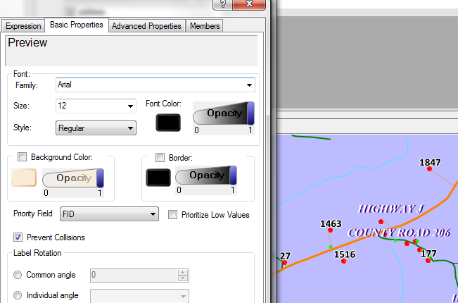

In this graphic (above), you can see that the labels for the address points are bold. But when I open the config up and open up the label manager for the address points, the font style has reverted back to “regular” and if I don’t reset it to “bold,” the font style will change when I close out. My experience is it always resets to Arial, 12 point, Regular. We need to make it “remember” the current settings and not change back to these defaults when the label manager is opened again.

1. Changing layer order is not always successful and results in some odd graphical display – layer names seem partially obliterated. In the example below, the horizontal lines appeared when I opened the legend then resized it. All the names that were exposed after I resized were distorted. This happens after changing layer order as well.

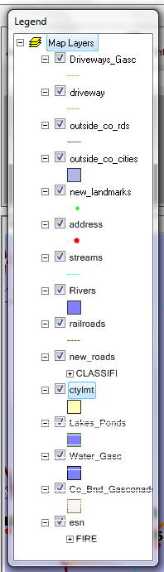

You can see that on the bottom of the graphic, the display is not clear. I would also like to see a scroll bar on this legend so that it doesn’t have to be resized to see all the layers.

1. Intersection search returns “close” results (road intersecting with a road that has a close but not exact name as the road chosen from the drop-down list). However, there is no way to know that the result is for a road other than the exact road chosen from the list.

When you select a road name from a drop-down list, do we want “close” matches in the results list? For example, “Circle Dr” returns the actual intersections for “Circle Dr” first but also returns intersections for “E W&W Circle Dr.” This is an odd case as the parser probably interprets W&W as directionals.

We think that the intersecting road should be shown in the results as well (i.e. “Circle Dr” or “E W&W Circle Dr.”

We may want to rethink the way the second drop-down works. It doesn’t make a lot of sense to have it unless using it moves the map directly to that intersection. It sometimes does, sometimes doesn’t, and I can’t see a pattern yet.

1. Setting extents for layers and fonts works only in that fonts and labels seem to go off at full extent but come on as soon as you do any zooms.

I zoom the map in to a specific area – perhaps a couple miles across in “real” space. Then I open up the configuration, right-click on the layer name, and choose “Set Dynamic Visibility Mode.” This appears:

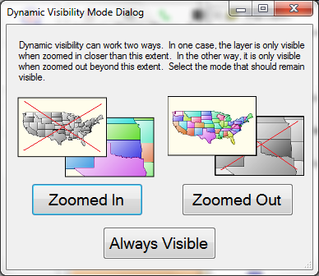

I choose “Zoomed In.”

In general, whether I do this for the features or for labels, the features/labels only turn off when zoomed to full extent. Even one “zoom” in will turn them back on again.

1. Graphic Marker for Attribute (Spatial) Location

We like the circle, like the zoom ration, but would like these colors and weights to be customizable by the user (we know you’re planning this) but we need to establish defaults. Yours are good.

However, we would like the “active” marker to be a different color – so that all previous markers still on map can be distinguished from the most recent search.

1. Auto-Map

We’d like to see a function where the map moves to the searched for location without the mouse click. In this scenario – the user keys in a location or chooses from the pick list. The results panel opens with the results, and the map moves automatically to the first result. This should be something the user can enable or disable (auto-map or no auto map).

The user will still have the option of clicking any of the results to move the map to that location.

1. On the legend, we’d like an “x” to close the legend as well as a scroll bar on it.
2. Measure – double click instead of right click to end measurement.