history

|  |  |  |  |
| --- | --- | --- | --- |
| Version | Datum | Änderung | Autor |
| 1.00 | 20.02.2013 | First release | Gunnebo Markersdorf GmbH - DH |
|  |  |  |  |
|  |  |  |  |
|  |  |  |  |
|  |  |  |  |
|  |  |  |  |
|  |  |  |  |
|  |  |  |  |
|  |  |  |  |

|  |  |
| --- | --- |
| **G:\Produktion\AV\SSA\Labels\Logos\neu\Gunnebo for a safer World\gunnebo_fsw_pms_trans.gif** | **Gunnebo Markersdorf GmbH** |
| **Phone** | +49 (0) 35829 638 - 30 |
| **E-mail** | ssa@gunnebo.com |
| **Anschrift** | Oldenburger Ring 11a  D-02829 Markersdorf, Deutschland |
| Member of the Gunnebo security group | |

Copyright

We reserve the right to make changes to the content of this document without notice.

Gunnebo takes no responsibility for technical or typographical errors and deficiencies in this document.

Gunnebo assumes no liability for damages that arise directly or indirectly from the delivery, content and use of this document.

This document contains copyright protected information. No part of this document may be reproduced in any form or converted, copied or distributed by use of electronic systems without prior written consent from Gunnebo.

© Gunnebo, 2013 – All Rights reserved.

Trademark

Every product name listed in this document is a trademark and/or registered trademark of the respective companies and is recognized as protected.

Generelle Bemerkung

Das Testtool “cb\_config” wurde entwickelt , um Mietfächer an ROSENGRENS SDL Controllern über das GUNNEBO communicationboard oder seriell testen zu können.

1. Erste Schritte / Vorbereitung

Die Fachverkablung sollte nach folgender Schaltung erfolgen:

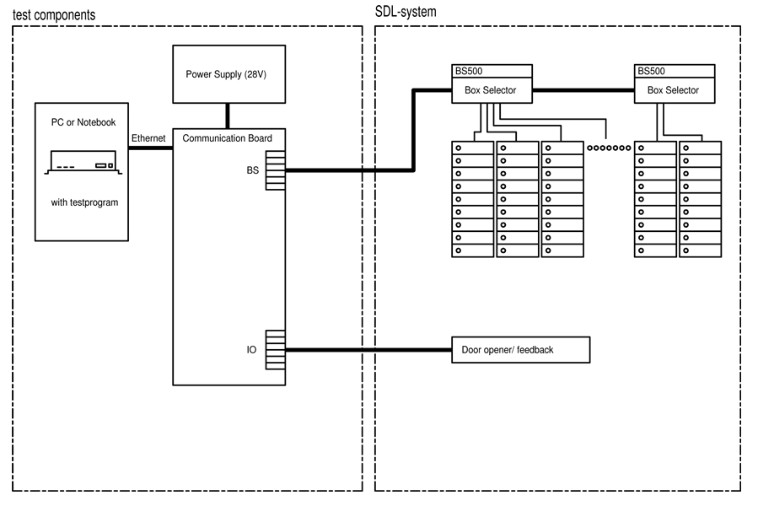

1. Anpassen der IP-Addresse

Das Communicationboard kommuniziert über TCP/IP. Deshalb wird eine Ethernetverbindung von dem PC , wo das CB\_Config läuft zum Communicationboard benötigt. Ohne Communicationboard ist eine Serielle Verbindung über RS485 mit den Controllern aufzubauen.

Das communicationbord ist stamdardmäßig auf die IP-adresse 192.168.1.126 gesetzt. Der IP Nummernkreis ist auf 192.168.1.x (e.g. 192.168.1.1). zu setzen.

1. connect cb\_config to communicationboard

Copy the program cb\_config.exe on a PC into a folder of your choice.  
Run cb\_config.exe and initialize the communicationboard:

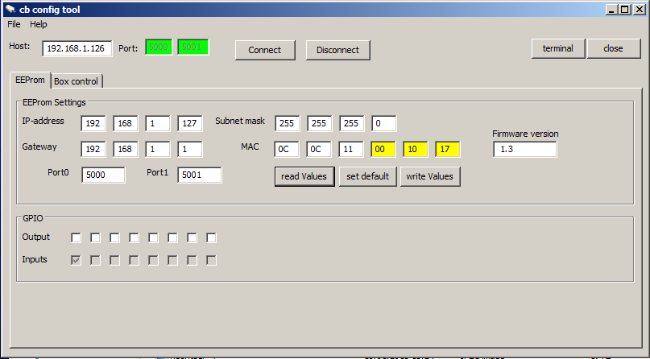

**Functionality**

1. Connect 🡪in case of a successful connection the Port-fields will be green
2. Reading of all values into the EEProm to check or set the internal IP-address, Subnet-mask, Gateway, Portnumbers and unique MAC-address (the last 3 numbers contains the unique number)
3. Set default-values for all fields. Attention: the last unique-number will be stored in the file cb\_config.ini to avoid double numbers. This is located in the same folder as cb\_config.exe.  
    Only necessary if the values are unknown!
4. Store all values into the FLASH-memory of the communicationboard.   
    Only necessary if the values are changed!
5. Show/hide of a terminal to view the communication   
    Only for expert!
6. Set / clear of the Relaisoutputs (Gate) and show of the inputs of the communicationboard. Possibility to test the door-opener on the gates.
7. Test of boxes in ROSENGRENS electronic SDL-column

For a test of the boxes of ROSENGRENS electronic SDL-column choose the 2.Tab “box-control”

This is an overview for all connected boxes of the complete BS500 controller. In case of a connected BS500, all “closed” boxes will be displayed with gray background, and the open or not connected boxes are in white.   
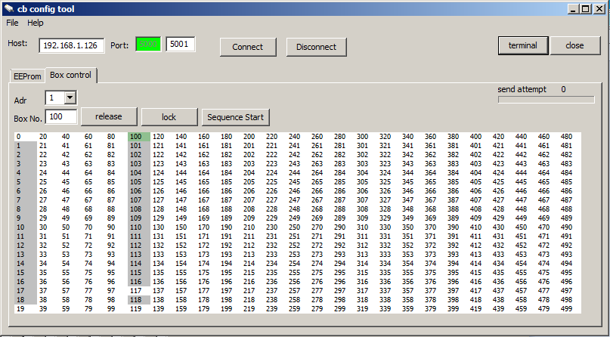

**Functionality**

1. Choose the address of the BS500, which is connected to the communicationboard
2. Enter the Boxnumber, which is to activate or make a simple click on the box into the matrix.
3. Matrix for all boxes: double click to activate the lock. White:open/not connected ; gray: closed/connected  
   green: active
4. Count of send attempt and warning in case of incorrect address of BS500
5. Release (activate) and lock (inactivate) the electronic-locks. This is the same functionality like a doubleclick on the box into the matrix.
6. Sequencial test: beginning from the selected box all boxes will be activated one after the other. For a automatically test of all connected boxes.

If the BS500 is not connected or the address is not correct, in the progressbar (4) the send attempt will increased and “BS500 no Answer” will be shown.

G:\Produktion\AV\SDL\RnD\Software\Testtool Commboard\doku\no_connection.JPG