**TEAM 5 - FOOD EXPIRATION ALERT SYSTEM**

1. **PROBLEM IDENTIFICATION REPORT**

* **IDENTIFIED PROBLEM/OPPORTUNITY:** Food waste is a major global challenge, with both households and grocery stores discarding large amounts of food due to expiration. Consumers often lose track of expiration dates or face difficulties managing their food inventory, resulting in unnecessary waste, higher costs, and environmental harm. Implementing a smart system that monitors food expiration and sends alerts can help tackle this issue by encouraging timely use or appropriate storage.
* **Significance in the Domain:** Approximately one-third of the world's food production is wasted, leading to significant losses in resources and contributing to both economic and environmental burdens. In households, forgotten or expired food increases costs, while grocery stores face financial losses from unsold, expired items. Reducing food waste is crucial for sustainability, cutting costs, and promoting a more efficient food supply chain. By solving this problem, consumers and retailers alike can benefit from enhanced food management and waste reduction.
* **STAKEHOLDER ANALYSIS:**
* **Grocery Stores:** Grocery Stores aim to reduce the number of expired products, lower operational costs, and maintain customer satisfaction through effective inventory management. Their goal is to balance profitability while providing quality service to their customers.
* **Households:** Households are focused on minimizing food waste, managing their expenses, and enjoying convenience in tracking the freshness of their food. They seek solutions that make it easier to plan meals and ensure the health and safety of the food they consume.
* **Food Banks:** Food Banks are primarily concerned with receiving safe and edible food donations to alleviate hunger. They focus on building partnerships with grocery stores and suppliers while ensuring proper storage and handling of the food they receive.
* **Environmental Groups:** Environmental Groups advocate for sustainability, striving to reduce food waste and promote environmentally friendly practices. They work to raise awareness about food waste issues and support policy changes that enhance waste management.
* **App Developers/Investors:** App Developers and Investors are interested in the viability of technological solutions for food management, user engagement, and the potential for profitability. They seek to develop effective applications that can be widely adopted and generate a good return on investment.
* **Engagement and Conflict Resolution:** Engaging these stakeholders effectively involves addressing their specific interests and concerns, resolving potential conflicts (like pricing issues between households and grocery stores), and implementing metrics to monitor the success of food waste reduction initiatives while adapting strategies based on stakeholder feedback.

**Challenging Component:** The connections among these stakeholders can be illustrated through a stakeholder diagram, highlighting their interactions and the benefits each group gains from the solution.

1. Households are connected to Grocery Stores as consumers while also collaborating with Environmental Groups to promote awareness and sustainability initiatives.
2. Grocery Stores partner with Food Banks for food donation efforts and with App Developers/Investors to enhance their inventory management through technology solutions.
3. Environmental Groups work with Households to raise awareness about food waste and also influence Grocery Store practices.
4. App Developers/Investors focus on developing effective solutions that support Grocery Stores and engage Food Banks by providing technology for improved food distribution.

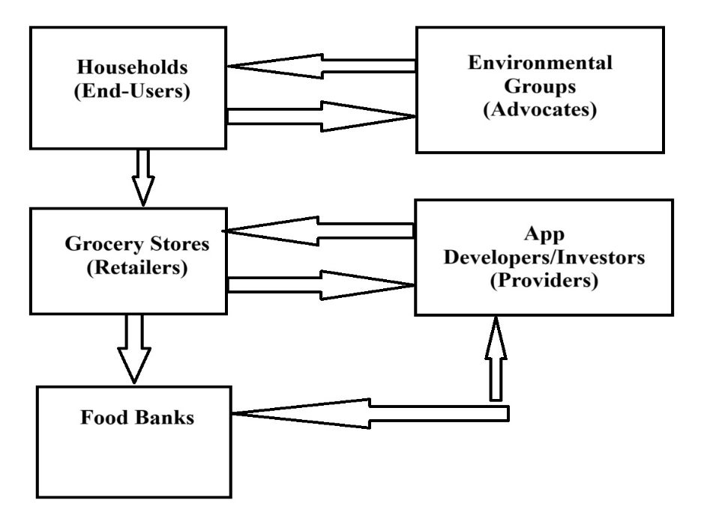

* **RELEVANCE TO SOFTWARE SOLUTION**
* **Addressing the Issue through Software Development:**  A Food Expiration Alert System can leverage smart technologies like barcode scanning, inventory management, and mobile notifications to keep track of food expiration dates in real time. This system would notify users when items are approaching their expiration dates and offer recipe suggestions or preservation tips to reduce waste. Additionally, grocery stores could implement an automated inventory tracking system to manage stock levels and identify products nearing expiration.
* **Initial Scope of the Software Solution:** The software could include:
* A mobile application enabling consumers to scan barcodes and record food items along with their expiration dates.
* Push notifications to alert users about upcoming expirations, along with recipe ideas.
* Inventory management for grocery stores, alerting managers about products nearing their expiration.
* A donation feature that allows the transfer of near-expiry items to food banks or shelters.
* Analytics to track food waste trends for both households and stores over time.

**Challenging Component:** A flowchart could be created to depict user interactions with the system, illustrating the process from adding items to receiving alerts and managing food consumption.

Here is the flowchart illustrating how users interact with the Food Expiration Alert System. The steps include scanning food items, logging expiration dates, setting notifications, receiving alerts, viewing recipe suggestions, and managing food use, culminating at the end of the process. This visual representation helps clarify the user journey within the system.

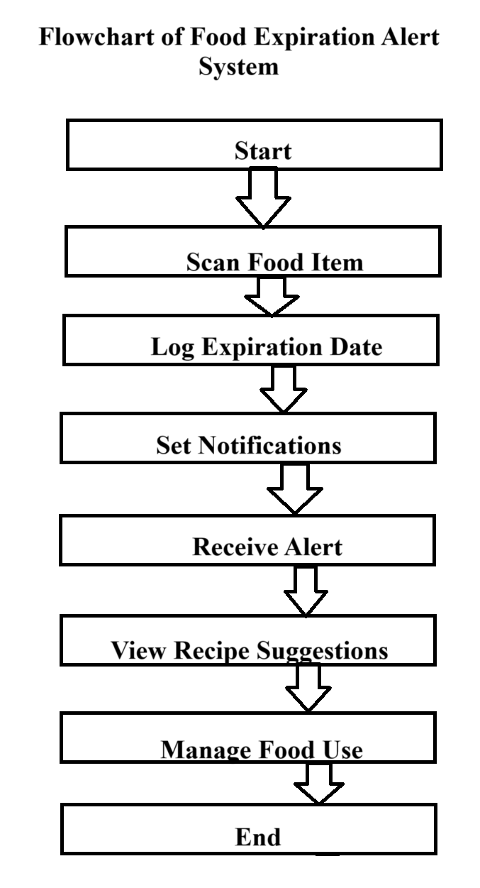

**MARKET ANALYSIS REPORT**

* **TARGET AUDIENCE IDENTIFICATION:**

1. **Households Typical Users:**

* Families: Parents managing multiple schedules, including meal planning and grocery shopping.
* Health-conscious Individuals: Single adults or couples-focused on maintaining a healthy diet and minimizing food waste.

**Context:**

* Industry: Consumer technology, health and wellness.
* Lifestyle: Busy lifestyles requiring efficient meal planning and grocery management. Examples include working parents who balance careers with family meals and health-conscious individuals who prioritize fresh, nutritious food.

1. **Grocery Stores Typical Users:**

* Store Managers: Responsible for inventory and operations, seeking to improve efficiency and customer satisfaction.
* Owners of Small to Medium-sized Retailers: Looking to reduce costs associated with expired products and optimize stock levels.

**Context:**

* Industry: Retail grocery, food service.
* Lifestyle: Business owners focused on sustainability, community engagement, and maximizing profits. These users often face challenges such as managing inventory turnover and enhancing customer experiences.
* **Demographic and Psychographic Characteristics of the Target Audience**

|  |  |  |
| --- | --- | --- |
| **CHARACTERISTICS** | **HOUSEHOLDS** | **GROCERY STORES** |
| **Demographic Characteristics** | **Age**: Primarily adults aged 25-45, a group likely to start families or establish independent living.  **Gender**: Predominantly female decision-makers in household purchases, though increasing male involvement in grocery shopping.  **Income**: Middle to upper-middle-class households with disposable income for healthy food options, typically earning between $60,000 - $100,000 annually.  **Location**: Urban and suburban areas where access to grocery stores and health-oriented products is more available. | **Age**: Store managers and owners typically range from 30 to 60 years old, with varying levels of experience in the grocery industry.  **Gender**: Mixed gender representation, with increasing numbers of women in management roles within the grocery sector.  **Income**: Varies widely; small to medium-sized grocery stores may have annual revenues from $500,000 to $5 million, with owners often reinvesting profits into business operations.  **Location**: Often located in community-centric urban and suburban areas where competition exists with larger chain stores. |
| **Psychographic Characteristics** | **Values**: A strong focus on health, sustainability, and the well-being of their families. Consumers favor organic, locally sourced, or minimally processed food options.  **Lifestyle**: Engaged in active, health-oriented lifestyles that involve meal preparation and accommodating dietary needs (such as vegetarian or gluten-free diets).  **Behavior**: Frequent grocery shoppers who are adept at using technology, often rely on apps for meal planning and recipes. They are driven by a desire to minimize food waste and save money. | **Values**: Strong focus on customer satisfaction, sustainability, and community engagement. Owners value innovations that enhance operational efficiency and minimize waste.  **Lifestyle**: Business-oriented, with an emphasis on maintaining a competitive edge through improved customer experiences and product offerings.  **Behavior**: Actively seeking solutions that streamline operations, reduce waste, and increase sales. These individuals are often involved in community outreach and prefer partnerships that align with their sustainability goals. |

**Competitor Analysis**

* **Identification and Analysis of Competitors Offering Similar Solutions:**

1. **Fridgely:**

* A mobile app designed to track food expiration dates and send reminders to users.
* Limitations: Lacks integration with grocery stores, which limits its functionality for users looking to manage inventory more comprehensively.

**2. NoWaste:**

* An app focused on helping households reduce food waste by tracking items in the fridge.
* Limitations: Offers only basic reminders and tracking features, without additional functionalities that could enhance user experience.

**3. Too Good To Go:**

* A food-waste reduction app that connects consumers with restaurants and grocery stores selling near-expiry food at discounted prices.
* Limitations: Primarily aimed at businesses, it does not provide comprehensive inventory tracking or household management features
* **Assessment of Competitors (SWOT):**

(strengths, weaknesses, opportunities, and threats) analysis is a framework used to evaluate a company's competitive position and to develop strategic planning. SWOT analysis assesses internal and external factors, as well as current and future potential.

|  |  |  |  |  |
| --- | --- | --- | --- | --- |
| **Competitor** | **Strengths** | **Weaknesses** | **Opportunities** | **Threats** |
| Fridgely | User-friendly interface with effective reminders | Limited to personal use, lacks grocery store integration | Potential to expand features for grocery stores | Competing with more comprehensive solutions |
| NoWaste | Simple and effective for household users | No features for retailers or food donation | Opportunity to add inventory and donation tracking | Other apps offer more advanced functionality |
| Too Good To Go | Strong focus on reducing food waste in retail | Not tailored for household management | Possibility to collaborate with households and small retailers | Growing competition in the sustainability space |

**Challenging Component:** A feature comparison matrix would be beneficial to illustrate how your new solution stands out against these competitors. The matrix could highlight strengths in areas such as:

1. **Grocery Store Integration:** Enable seamless inventory management and tracking for both households and retailers.
2. **Donation Tracking:** Provide features that facilitate food donations, ensuring that surplus items reach those in need.
3. **Recipe Suggestions:** Offer personalized recipe ideas based on tracked ingredients, helping users make the most of their food.

|  |  |  |  |  |
| --- | --- | --- | --- | --- |
| **Feature** | **Fridgely** | **NoWaste** | **Too Good To Go** | **Our Solution** |
| Grocery Store Integration | No | No | No | Yes |
| User-Friendly Interface | Yes | Yes | Yes | Yes |
| Inventory Tracking | No | No | No | Yes |
| Donation Tracking | No | No | No | Yes |
| Focus on Households & Retailers | No | No | No | Yes |
| Recipe Suggestions | No | No | No | Yes |

**Business Values**

1. **Unique Selling Points (USPs):**

* Comprehensive Solution: An integrated platform that combines food management for households and grocery stores, optimizing operations and improving user experience.
* Real-Time Alerts with Recipe Suggestions: Sends timely notifications regarding food items approaching expiration, along with inventive recipe ideas to encourage consumption before spoilage.
* Integration with Food Donation Networks: Connects users with local food donation organizations, allowing them to donate items that are close to their expiration date, thus reducing waste and aiding community needs.

1. **Value Proposition:** The Food Expiration Alert System offers considerable advantages to both consumers and retailers:

**For Households:**

* Reduces Food Waste: Assists families in minimizing food waste by providing alerts and effective strategies, promoting a more sustainable way of living.
* Saves Money: By efficiently managing food inventory, households can reduce their grocery expenses and avoid buying duplicates of items they already have.
* Convenience: Enables real-time tracking of food items, making meal planning easier and more efficient.

**For Grocery Stores:**

* Minimizes Losses: Lowers financial losses from expired stock, aiding retailers in more effective inventory management.
* Promotes Operational Efficiency: Optimizes inventory processes, allowing store managers to concentrate on customer service and sales.
* Strengthens Community Ties: Fosters donations of near-expiry food to local organizations, improving the store’s reputation and building goodwill within the community.
* This solution not only provides immediate benefits but also yields long-term advantages, such as cost savings, improved sustainability, and a positive social impact.

**Challenging Component:**

* To emphasize the tangible benefits of this value proposition, the solution can generate measurable long-term outcomes, such as:
* Reducing Household Food Waste by 20% Annually: Implementing the system can significantly lower the amount of food wasted by families, resulting in both environmental and economic gains.
* Cutting Expired Inventory Costs for Grocery Stores by 15%: Retailers can reduce losses from expired goods through efficient inventory management and proactive strategies to promote the sale of items nearing their expiration date.