TABLE OF CONTENTS

S.No. | Module No | Page No.
1 | Module 1 | 2 – 7
2 | Module 2 | 8 – 13

Module-1:
The SOLID principles were introduced by Robert C. Martin.
The following five concepts make up our SOLID principles:
- Single Responsibility
- Open/Closed
- Liskov Substitution
- Interface Segregation
- Dependency Inversion
SOLID Principles - Short Notes
S - Single Responsibility Principle (SRP)
Definition: A class should have only one responsibility and one reason to change.
Example:
- Book → Stores book data.
- BookPrinter → Prints book data.
Memory Trick: One Class = One Job

O - Open/Closed Principle (OCP)
Definition: A class should be open for extension but closed for modification.
Example:
- Guitar
- FlameGuitar extends Guitar
Add new functionality by extending existing code instead of modifying it.
Memory Trick: Extend, Don't Modify

L - Liskov Substitution Principle (LSP)
Definition: A subclass should be able to replace its parent class without breaking the program.
Example:
- MotorCar can replace Car.
- ElectricCar should not break Car behavior.
Memory Trick: Child Should Behave Like Parent

I - Interface Segregation Principle (ISP)
Definition: Clients should not be forced to implement methods they do not use.
Example:
Instead of:
- BearKeeper
Use:
- BearCleaner
- BearFeeder
- BearPetter
Memory Trick: Small Interfaces are Better

D - Dependency Inversion Principle (DIP)
Definition: Depend on abstractions (interfaces), not concrete implementations.
Example:
- Keyboard (Interface)
- StandardKeyboard implements Keyboard
Windows98Machine depends on Keyboard, not StandardKeyboard.
Memory Trick: Depend on Interface, Not Implementation

SOLID in One Line
S → One Class = One Responsibility
O → Extend, Don't Modify
L → Child Should Replace Parent Safely
I → Small Focused Interfaces
D → Depend on Abstractions

Design Pattern

A design pattern in programming is a reusable solution to a common problem
By applying design patterns, developers can improve code reusability, maintainability, and scalability, as well as enhance the overall design and architecture of software systems

Participated in Quiz:
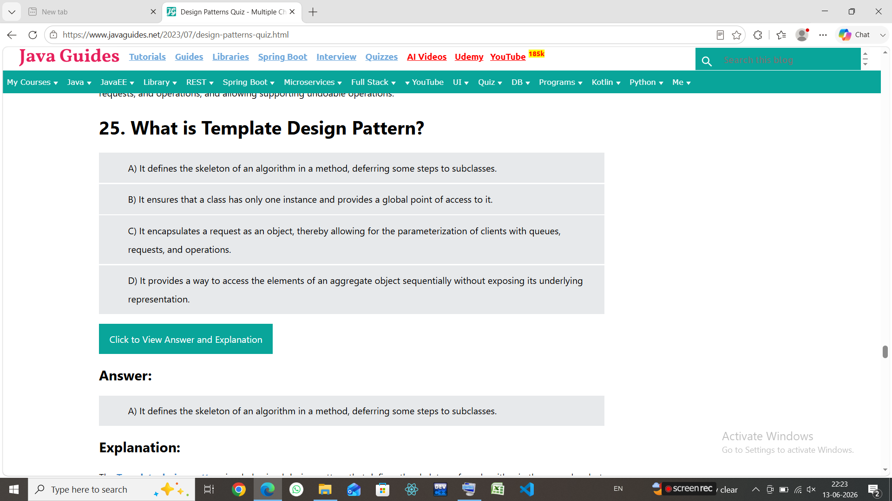

Hand`s On:
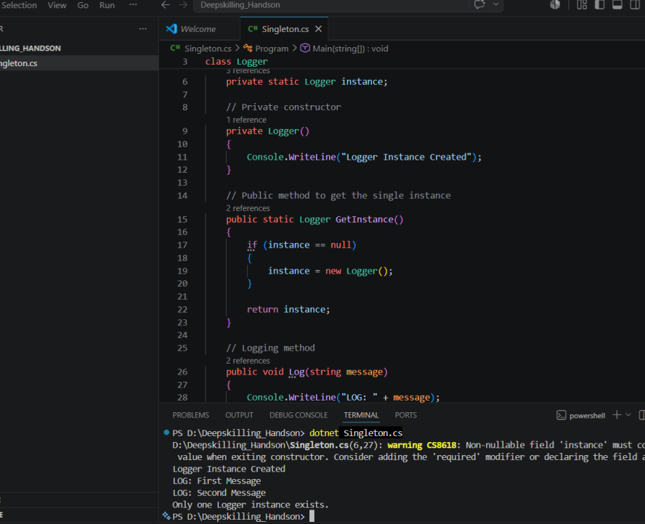
Test the Singleton Implementation:
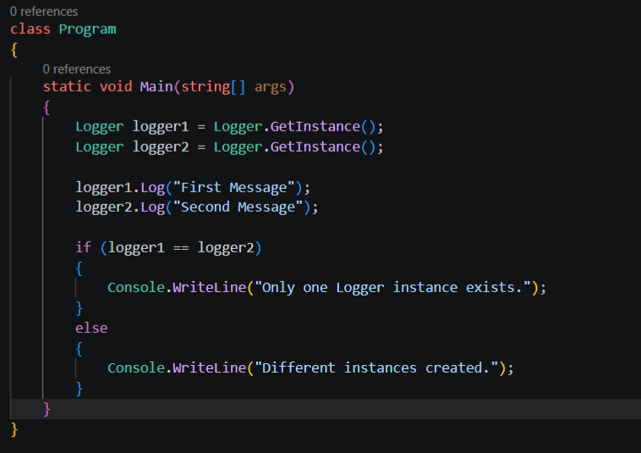

Hand`s On: ( Exercise 2: Implementing the Factory Method Pattern)
Scenario:
You are developing a document management system that needs to create different types of documents (e.g., Word, PDF, Excel). Use the Factory Method Pattern to achieve this.
Steps:
- Create a New Java Project:
  - Create a new Java project named FactoryMethodPatternExample.
- Define Document Classes:
  - Create interfaces or abstract classes for different document types such as WordDocument, PdfDocument, and ExcelDocument.
- Create Concrete Document Classes:
  - Implement concrete classes for each document type that implements or extends the above interfaces or abstract classes.
- Implement the Factory Method:
  - Create an abstract class DocumentFactory with a method createDocument().
  - Create concrete factory classes for each document type that extends DocumentFactory and implements the createDocument() method.
- Test the Factory Method Implementation:
  - Create a test class to demonstrate the creation of different document types using the factory method.

It is like ordering,a pdf or excel document from factory
My observation:
1)Interface , is like making white sheets
2)implementing---Storing the receipe to make that
3)FactoryMethod:---to provide menu
4)To ask the users/ clients

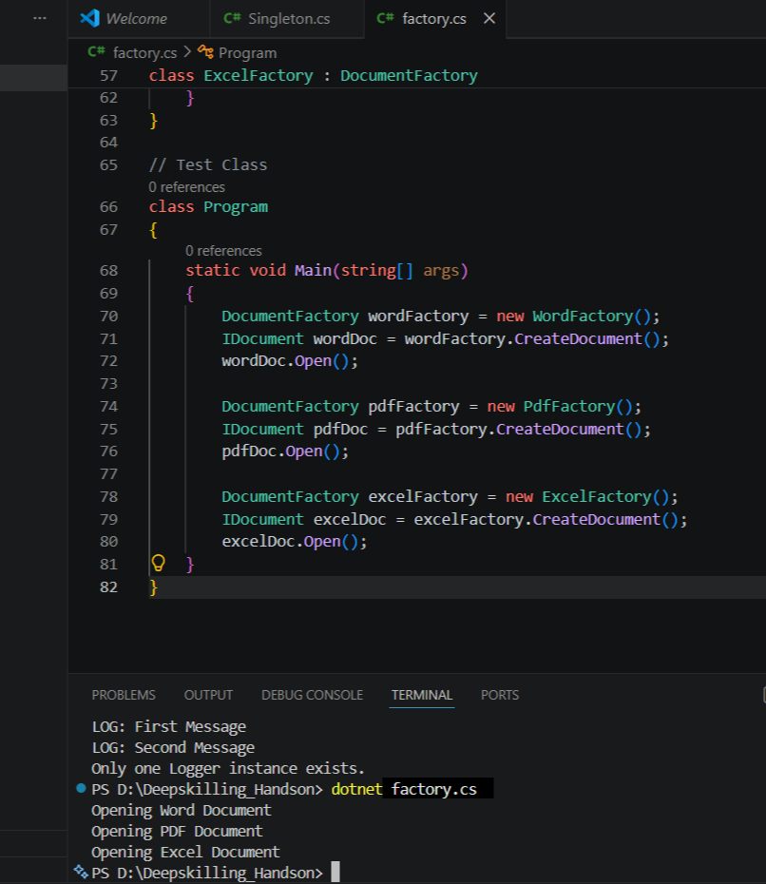

Module-2:

Data Structures & Algorithms:
Comparision between Linear Search VS Binary Search:----
Algorithm | Best | Average | Worst
Linear Search | O(1) | O(n) | O(n)
Binary Search | O(1) | O(log n) | O(log n)

Exercise 2: E-commerce Platform Search Function
Scenario:
You are working on the search functionality of an e-commerce platform. The search needs to be optimized for fast performance.

What is Big O Notation?
Big O notation measures how the running time of an algorithm grows as the input size increases.
Complexity | Name
O(1) | Constant
O(log n) | Logarithmic
O(n) | Linear
O(n²) | Quadratic

Search Operations
Linear Search
Best Case: O(1) (element found at first position)
Average Case: O(n)
Worst Case: O(n) (element at end or not found)
Binary Search
Best Case: O(1) (middle element)
Average Case: O(log n)
Worst Case: O(log n)

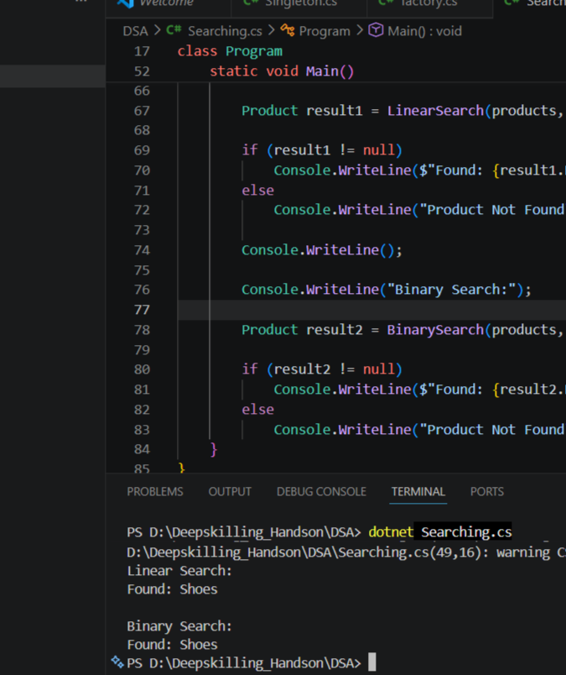
Exercise 7: Financial Forecasting
Scenario:
You are developing a financial forecasting tool that predicts future values based on past data.
Steps:
Understand Recursive Algorithms:
Explain the concept of recursion and how it can simplify certain problems.
Setup:
Create a method to calculate the future value using a recursive approach.
Implementation:
Implement a recursive algorithm to predict future values based on past growth rates.
Analysis:
Discuss the time complexity of your recursive algorithm.
Explain how to optimize the recursive solution to avoid excessive computation.

Implementation:

1. Recursion:
Recursion is a technique where a method calls itself until a base condition is reached.
Example:
factorial(n) = n * factorial(n-1)

2. Financial Forecasting Logic
Suppose:
- Current Value = 1000
- Growth Rate = 10%
- Years = 3
Then:
Year 1 = 1000 × 1.10 = 1100
Year 2 = 1100 × 1.10 = 1210
Year 3 = 1210 × 1.10 = 1331

3. Coding part:
using System;

class Program
{
static double Forecast(double currentValue, double growthRate, int years)
{
// Base Case
if (years == 0)
return currentValue;

// Recursive Case
return Forecast(currentValue, growthRate, years - 1)
* (1 + growthRate);
}

static void Main()
{
double presentValue = 10000;
double growthRate = 0.10; // 10%
int years = 5;

double futureValue =
Forecast(presentValue, growthRate, years);

Console.WriteLine("Present Value : " + presentValue);
Console.WriteLine("Growth Rate : " + (growthRate * 100) + "%");
Console.WriteLine("Years : " + years);
Console.WriteLine("Future Value : " + futureValue);
}
}

4. Analysis

Time Complexity
Each recursive call reduces years by 1.
T(n) = T(n-1) + O(1)
Therefore:
Time Complexity = O(n)
where n = number of years

Space Complexity
Recursive call stack:
O(n)

Optimization:
Instead of recursion, we can use:
double futureValue =
presentValue * Math.Pow(1 + growthRate, years);
Formula:
Future Value = Present Value × (1 + Growth Rate)^Years
This avoids many recursive calls and reduces overhead.

*Time Complexity*:-- O(1)

Quiz:--
Completion


