TABLE OF CONTENTS

S.No. | Module | Page No.
1 | Module 3 | 1 – 6

Module 3: Advanced SQL
Exercise-1:
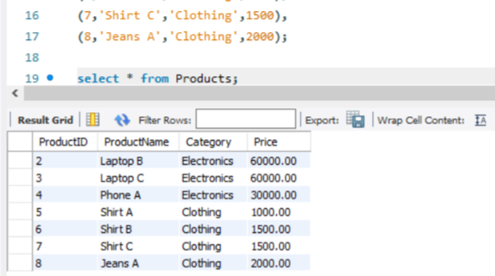
1. ROW_NUMBER()
Assigns a unique number to every row, even when prices are the same.
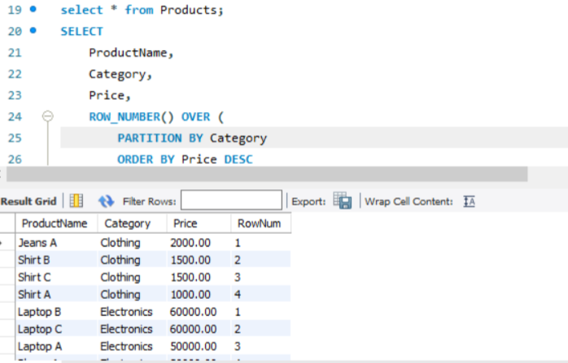

2. RANK()
Rows with the same value get the same rank, but ranks are skipped when duplicate values came.

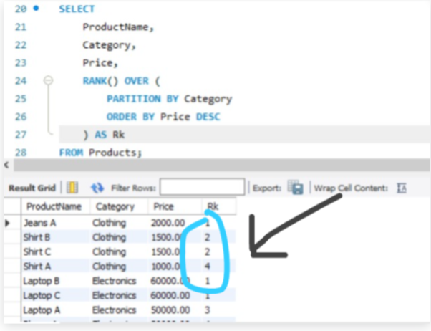

3. DENSE_RANK()
Rows with the same value get the same rank, but no ranks are skipped.
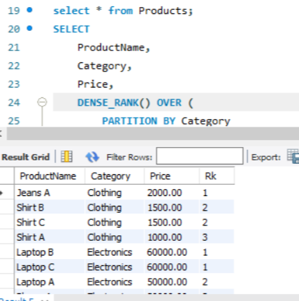

4) Top 3 Most Expensive Products in Each Category
By using all three functions we can achive the required condition
WITH RankedProducts AS
(
SELECT *,
ROW_NUMBER() OVER (
PARTITION BY Category
ORDER BY Price DESC
) AS rn
FROM Products
)
SELECT *
FROM RankedProducts
WHERE rn <= 3;
Output:
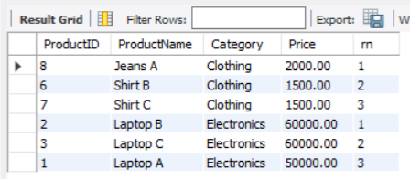

Exercise 1: Create a Stored Procedure

Stored Procedure :
A Stored Procedure is a collection of SQL statements stored in the database and executed whenever needed.
1. Stored Procedure to Retrieve Employees by Department
- Write the SQL query to select employee details based on the DepartmentID.

CREATE PROCEDURE sp_GetEmployeesByDepartment
@DepartmentID INT
AS
BEGIN
SELECT *
FROM Employees
WHERE DepartmentID = @DepartmentID;
END;
Execute:
EXEC sp_GetEmployeesByDepartment 3;

2. Stored Procedure to Insert a New Employee

CREATE PROCEDURE sp_InsertEmployee
@FirstName VARCHAR(50),
@LastName VARCHAR(50),
@DepartmentID INT,
@Salary DECIMAL(10,2),
@JoinDate DATE
AS
BEGIN
INSERT INTO Employees
(FirstName, LastName, DepartmentID, Salary, JoinDate)
VALUES
(@FirstName, @LastName, @DepartmentID, @Salary, @JoinDate);
END;
Execute:
EXEC sp_InsertEmployee
'Robert',
'Brown',
3,
6500.00,
'2022-05-10';

Exercise 5: Return Data from a Stored Procedure

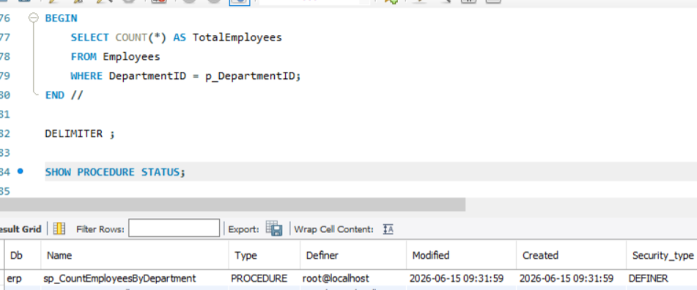
To print:
Due to unsupporting of system, unable to use – My SQL Server.So, doing in “MySQL Workbench”
SQL Server | MySQL
EXEC ProcedureName(...) | CALL ProcedureName(...)
CREATE PROCEDURE | CREATE PROCEDURE
EXEC sp_InsertEmployee ... | CALL sp_InsertEmployee(...)

CALL sp_CountEmployeesByDepartment(3);
