BEDAMAME
1. What exists right now?
Bedretto is currently using OpenBIS. This is an electronic lab notebook for capturing data in the field, storing it on ETH infrastructure, and sharing with collaborators. It has enumerations, classes and properties for various collections. The starting point of exploring this was difficult, because external collaborators cannot be added to the system directly – so I worked with exports. In there, some points were noticed quickly:
- People, and many other entities are represented as free text fields – very hard to query systematically
- All fields are custom – they are not reusing properties from external vocabularies or ontologies, even though OpenBIS offers that feature
- Definitions, labels and other information conveying semantics of the data model are incomplete or missing altogether.
- OpenBIS offers quite some possibilities for representing data types, cardinalities, and has forms based on those data models built in.
- It’s not easy to query OpenBIS, or to query across different experiments/campaigns or collections, finding the right data can be a manual task of exporting and manually joining spreadsheets to search through.
2. Improving the Data Model
Firstly, anytime we want to re-use a concept/entity across multiple contexts, it’s useful to model them as instances of classes, rather than free text strings. This circumvents spelling mistakes, conventions and other reasons for capturing the same item in different ways. People are a type of thing that should be consistently used across fields and collections. This also counts for Projects, Experiments/Campaigns.

Since OpenBIS allows it, we should make use of the ability to capture the ontology separately from the system, and refer to terms in the ontology:
Excel column | V3 API field | Example for "Borehole Meter (m)" on SENSOR_INSTAL
Ontology Id | predicateOntologyId | https://example.org/bedretto/terms
Ontology Version | predicateOntologyVersion | https://example.org/bedretto/terms/0.4.0
Ontology Annotation Id | predicateAccessionId | https://example.org/bedretto/terms#measuredDepth

If Bedretto had an ontology, these fields can be used to map them to the ontology. This mapping can be used both ways:
- In OpenBIS the ontology terms can be linked – so a researcher looking up a value can browse the ontology to understands its meaning and context.
- An export of OpenBIS data can be made to RDF, so an instance data set can be created in a knowledge graph, across experiments and collections. That graph can be queried and used by researchers to locate the data they need.
3. So – what now?
OpenBIS is a system with it’s own internal meta-model. It has limitations, but it is currently used heavily, is maintained and hosted by ETH IT, and should continue to form the source of truth. However, it could benefit from an external ontology for generating alternative views of the data or generating exports that can be shared with external researchers with RO-Crates.

Thus, the technical architecture becomes centered around 2 systems: OpenBIS, and RDF:
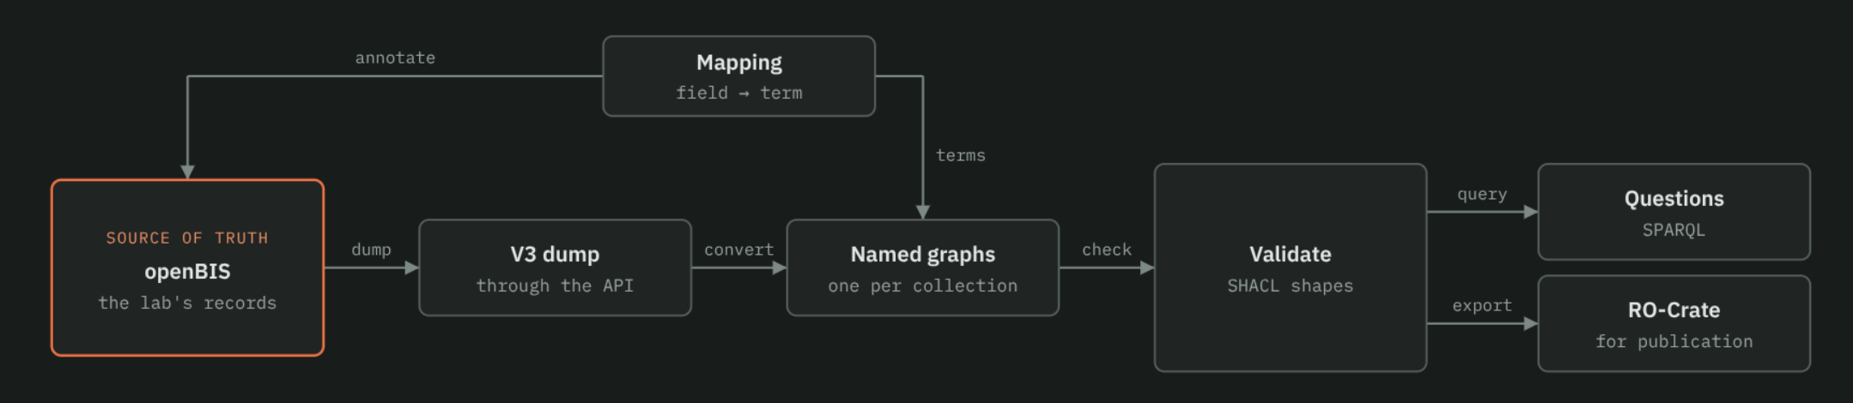
An architecture making use of the strenghts of OpenBIS (maintainability, connection to existing ways of working, user friendly, built-in history) combined with the strength of RDF (provide a taxonomic context/meaning layer for the data model and vocabularies, cross-context querying, advanced validation rules without custom scripting, exporting to RO-Crates) is envisioned.
Box | What it is
openBIS (source of truth) | The lab's openBIS, where people enter and edit boreholes, sensors, installations, cores and logging runs.
Mapping (field → term) | mapping/openbis-annotations.csv: for each openBIS type and field, its ontology term, unit and vocabulary. Used by the converter and by OpenBIS annotation fields.
V3 dump (through the API) | A JSON snapshot of openBIS read through its V3 API: every object of the Bedretto types, with its fields, links, who registered it and when.
Named graphs (one per collection) | The dump converted to RDF. Each openBIS collection becomes one named graph. Fields become ontology terms, vocabulary values become concepts, and numbers with units become quantity values. A provenance graph records when each collection last changed and who registered its objects.
Validate (SHACL shapes) | Checks the graphs against the shapes: required fields, data types, values from the right vocabulary. Values that contradict each other across objects (e.g. a sensor deeper than its borehole), are reported as warnings. Problems go back to the lab to fix in openBIS.
Questions (SPARQL) | Queries over the graphs, the ontology and the vocabulary together, for example "which hydromechanical sensors serve FEAR-2", which only works because of the vocabulary's hierarchy. (i.e. we use logic from the ontology, rather than state it inside the query)
RO-Crate (for publication) | A single file, ro-crate-metadata.json, that describes a dataset in a standard format, so that a repository or another lab can read what the dataset contains without knowing openBIS.

OpenBIS allows for custom python scripting to deal with more complicated validation rules (for example, survey-date needs to be before drilling date, as you would not survey a drilling site AFTER drilling it). However, in SHACL, these kinds of validation constraints are built-in. Combined with the cross-context strengths it offers (query or validate multiple experiments / contexts at once) this makes a RDF representation of the OpenBIS data valuable.

4. What does this look like?
The repository BEDAMAME contains 2 main things:
- The general architecture, with diagrams, examples and reasoning. It also contains questions and other points that are not sure about how to implement or interpret, to be handled by Bedretto lab.
- A basic, AI assisted implementation of the architecture. This consists of a collection of python scripts using a first export of OpenBIS, aswell as docker files, an ontology building on the first Bedretto project’s ontology, but expanded to account for more types of things found in OpenBIS, some documentation and some tests.
Both components of this repository can aid greatly in refining the needs of the solution, and providing a backbone for a proposal to actually implement this. The AI generated implementation is a useful tool to be used for quickly iterating on the needs and providing proof of concepts, but should not be used as the final implementation.

