DakotaCoin Exchange Docs

Table of Contents

Introduction 3

Basic Architecture 3

Setting up The Exchange 3

Setting up the Wallet 3

# Introduction

This document will give a brief description of how to setup, run and use the DakotaCoin exchange here at Mt. CCDC. Hopefully, after reading this document you should have a working understanding of how to keep things working.

## Basic Architecture

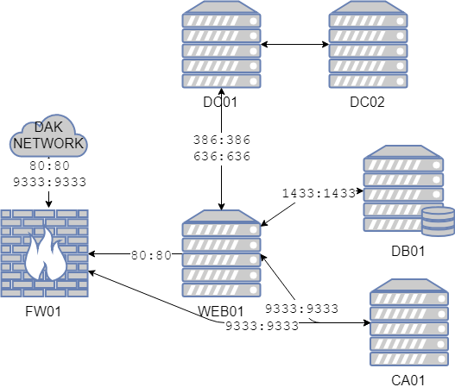

Figure Exchange Dependencies

*Figure 1* shows the overall dependency graph of services required to run the exchange. The core of the exchange is WEB01 that is where the web app for the exchange and the business logic that power it live. It is dependent on DB01 for tracking user information, transaction history, and certain configuration information. It depends of DC01 for user authentication using LDAPS. The choice to use LDAPS to handle user auth was made in an effort to the security posture of our exchange by removing any chance of mishandling user passwords and eliminate the possibility of SQL injection being used to gain unauthorized access. CA01 is where our wallet lives, as such it requires access to the internet so it can communicate with the rest of the DakotaCoin network to perform transactions.

# Setting up The Exchange

When setting up the exchange there are several steps that must be completed.

## Setting up the Wallet

Setting up the wallet is fairly simple, after acquiring the wallet executable (dakotacoind or dakotacoin-qt)