Course: Natural Language Processing Lab (TEE7100)
Department: Computer Science & Engineering
Institute: Symbiosis Institute of Technology, Pune
Academic Year: 2026–27
Student Name: Saurabh Shandilya
PRN: 23070122270
ScholarLens: Evidence-Grounded Research Gap Identification from Scientific Literature Using Transformer-Based Information Extraction, Semantic Clustering and Graph-Augmented Retrieval
Abstract
Finding an open research problem usually means reading hundreds of papers and then guessing, because authors rarely state gaps outright. They scatter phrases such as “future work” and “our method cannot” across sections, and every author words the same limitation differently. ScholarLens is an NLP pipeline that turns this scattered text into ranked, evidence-backed research gaps, and uses a language model only at the very end to explain what has already been retrieved. Papers are collected from arXiv, Semantic Scholar and the ACL Anthology, screened by a facet-and-cross-encoder relevance gate, parsed with GROBID, and split into typed statements (contribution, limitation, future work, dataset, model, metric) by spaCy cue rules with a SciBERT fallback. GLiNER2 extracts entities and relations into a Neo4j graph, SPECTER2 embeds the statements into Qdrant, and HDBSCAN groups paraphrased limitations into themes without a preset cluster count. DeBERTa-MNLI flags disagreements inside a theme, yearly mention counts give a trend slope, and a transparent weighted formula ranks the themes. No public benchmark exists for this task, so the system was built and checked on corpora collected for the topic of LLM security and prompt injection: a 50-document hand-labelled relevance pool, a 20-paper audit corpus that produced 27 clusters, and a small hand-labelled clustering set. Mean-centring the embeddings lifted within-theme cosine to 0.354 against −0.182 across themes, the relevance gate admitted all 12 on-topic documents while rejecting 15 of 17 near-topic ones, and the contradiction filters removed all four false conflicts found in the audit. The main limits are the small corpora and thresholds tuned on a single topic. Future work covers a larger multilingual corpus, a learned ranker and expert evaluation.
Keywords: research gap identification; scientific information extraction; SPECTER2 embeddings; HDBSCAN clustering; natural language inference; retrieval-augmented generation; knowledge graph; grounded generation

1. Introduction
A researcher starting in a new area is usually told to find something nobody has solved yet. In practice that means a Google Scholar search that returns several hundred papers. Take LLM security as an example: roughly 250 papers on attacks, 180 on prompt injection, 90 on agents and 150 on retrieval-augmented generation add up to about 600 documents, and at twenty minutes each that is around 200 hours of reading. After all of it the question of what is actually missing is still open. The people affected are master’s and PhD students choosing a topic, supervisors who have to judge whether a proposed problem is real, and review panels that need to see that a gap is backed by more than one author’s opinion.
The difficulty is not finding papers. Gaps are almost never written down as gaps. They appear as hedges and confessions spread through discussion sections, such as “performance decreases for multilingual datasets”, “existing datasets focus primarily on English” or “generalisation to regional languages remains limited”. A person reads these as the same complaint; a keyword search sees three unrelated sentences. Existing tools stop before this step. Search engines rank papers, citation-graph tools draw neighbourhoods, and chat-with-your-PDF assistants summarise one document at a time. Asking a general language model to name the gaps in a field is worse than it looks, because generated text is fluent whether or not it is supported: audits of commercial generative search engines found that only about half of the generated sentences were fully backed by the sources cited next to them (Liu et al., 2023), and hallucination in generated text is a well-documented failure mode (Ji et al., 2023).
This project started from that observation. Recent systems that generate research ideas with language models, from SciMON (Wang et al., 2024) to the knowledge-graph based work of Gu and Krenn (2024), produce plausible suggestions, but the suggestion is not tied to a checkable body of statements from the literature itself. What is missing is a pipeline that first reads the limitations and future-work statements authors really wrote, decides which of them mean the same thing, counts how many independent papers say it and whether that count is rising, and only then asks a language model to put the result into words. The core of that pipeline is a semantic-similarity problem, which makes it an NLP problem rather than a summarisation one.
The objectives were therefore to (i) build a reproducible text-processing pipeline from paper collection to ranked gaps, (ii) represent limitations of different phrasing in a common embedding space and group them without fixing the number of groups in advance, (iii) detect when papers disagree about the same setup, (iv) rank the groups with a formula whose every term can be recomputed by hand, and (v) restrict the language model to explaining evidence that was already retrieved, with every claim traceable to a stored passage.
The proposed system, ScholarLens, combines GROBID parsing, spaCy rules and SciBERT for sentence typing, GLiNER2 for joint entity and relation extraction, SPECTER2 sentence vectors in a Qdrant index, HDBSCAN for density-based clustering, DeBERTa-MNLI for contradiction checks and a LangGraph retrieval loop for interactive questions. All models are pre-trained and used for inference only. There is no public dataset for gap identification, so the data are corpora collected on demand from open sources for one topic, LLM security and prompt injection, plus small hand-labelled sets used to calibrate and test individual stages (Section 3.2).
The main contributions of the project are:
- An end-to-end ten-stage pipeline that goes from a topic string to ranked, evidence-linked research gaps, with the language model deliberately placed last.
- A statement-level representation of papers (typed facts, entities, relations) stored across PostgreSQL, Neo4j and Qdrant and linked by identifiers.
- A clustering recipe for sentence-level SPECTER2 vectors (mean-centring before HDBSCAN) with measured evidence for why it is needed.
- A layered contradiction detector (claim filter, lexical topic gate, two-direction NLI, corroboration across paper pairs) that removed every false positive found in the audit corpus.
- A transparent five-signal gap score with auditable per-cluster breakdowns, and a grounded explanation step that discards claims whose cited evidence was never retrieved.
- A bounded interactive GraphRAG mode (LangGraph) with sufficiency checks, query reformulation and a grounding check, exposed through a FastAPI backend and a React dashboard.
- An evaluation harness with time-shifted validation, survey cross-checking and expert scoring, plus the measurements reported in Section 5.

2. Literature Review
Scientific text representation and extraction. Most of the building blocks used here come from a short line of work on scientific language models. SciBERT (Beltagy et al., 2019) showed that pre-training BERT (Devlin et al., 2019) on scientific text helps downstream tasks, and SPECTER (Cohan et al., 2020) added citation-informed training for document vectors. SciRepEval (Singh et al., 2023) widened the evaluation to 24 tasks in four formats and produced SPECTER2, whose adapters target retrieval and proximity tasks. For information extraction, SciERC and DyGIE++ (Luan et al., 2018; Wadden et al., 2019) trained span-based joint entity and relation models on annotated abstracts, which ties the label set to the training data. GLiNER (Zaratiana et al., 2024) removed that tie by matching entity-type descriptions against spans, and GLiNER2 (Zaratiana et al., 2025) extends the idea to relations and schema-driven extraction on CPU. The trend is clear: models are moving from fixed label sets to prompt-by-description. The weak points are also consistent. SPECTER-family models are trained on titles and abstracts, so how they behave on single sentences is not covered by their evaluations, and the GLiNER2 numbers come from its authors only.
Grounded generation and its evaluation. Retrieval-augmented generation (Lewis et al., 2020; Gao et al., 2023b) is the usual answer to unsupported output. Self-RAG (Asai et al., 2024) trains the model to decide when to retrieve and to critique its own passages, and GraphRAG (Edge et al., 2024) builds an entity graph with community summaries so that questions about a whole corpus can be answered. Evaluation work is less encouraging than the methods. ALCE (Gao et al., 2023a) found that even strong systems left roughly half of their statements without full citation support on open-ended questions, the human audit by Liu et al. (2023) found 51.5% of sentences fully supported and 74.5% of citations supporting their sentence, and Liu et al. (2024) showed that accuracy drops when the relevant passage sits in the middle of a long context. RAGAs (Es et al., 2024) offers reference-free metrics for faithfulness and context relevance. These papers motivate keeping the evidence budget small and checking every claim against it, but they are all built around answering a question, not around aggregating limitations across hundreds of papers.
Claim verification and research-idea generation. SciFact-Open (Wadden et al., 2022) moved scientific claim verification to a collection of about half a million abstracts and reported a drop of at least fifteen F1 points compared with the closed setting, which is a useful reminder that retrieval noise hurts verification. On the idea-generation side, Krenn et al. (2022) predicted new links in a concept network built from AI papers, Gu and Krenn (2024) paired a much larger knowledge graph with GPT-4 and had over a hundred group leaders rate the suggestions, SciMON (Wang et al., 2024) retrieves inspirations and iteratively pushes drafts away from prior work, and Si et al. (2024) ran a blind study in which more than a hundred NLP researchers rated LLM ideas as more novel but somewhat less feasible than human ones. The AI Scientist (Lu et al., 2024) automates the whole loop from idea to paper. Across these, the starting point is either concept co-occurrence or the model’s own knowledge. None of them uses what authors explicitly say they could not do, and the ideas that come out carry no count of how many papers support them.
Clustering and the remaining gap. For grouping text, BERTopic (Grootendorst, 2022) combines transformer embeddings, UMAP, HDBSCAN (Campello et al., 2013; McInnes et al., 2017) and class-based TF-IDF, and Semantic Scholar (Kinney et al., 2023) supplies the metadata and open-access links that make a corpus like ours possible. Putting the four paragraphs together, current work covers representation, extraction, grounded answering and idea generation separately, but no system combines them to (a) extract the limitation and future-work statements authors actually wrote, (b) merge paraphrases into themes without a preset count, (c) test whether papers disagree, (d) add a trend and a solved-already signal, (e) rank the themes with a formula that can be audited, and (f) restrict the language model to explaining retrieved passages. That combination is the gap this project addresses.
The fourteen studies that matter most for the components or the goal of this project are summarised in Table 1.
Table 1. Summary of the reviewed studies.
Reference | Problem | Data | NLP technique / model | Key result | Limitation
Singh et al. (2023) | Scientific document representation | SciRepEval, 24 tasks, 4 formats | Transformer with task-format control codes and adapters (SPECTER2) | Over 2 points above the best single-embedding model | Document-level; single sentences not evaluated
Zaratiana et al. (2024) | Zero-shot NER for any entity type | Zero-shot NER benchmarks | Bidirectional encoder matching type prompts to spans (GLiNER) | Reported to beat ChatGPT and tuned LLMs zero-shot | Entities only, no relations
Zaratiana et al. (2025) | Unified extraction through a schema | Authors’ NER and classification sets | GLiNER2: NER, classification, structured output and relations in one encoder | Competitive with LLM extractors at CPU cost (authors’ report) | No independent benchmark found
Wadden et al. (2022) | Open-domain scientific claim verification | SciFact-Open, ~500k abstracts | Retrieval, rationale selection, label prediction | At least 15 F1 lost versus closed setting | Single claims; mostly biomedical
Edge et al. (2024) | Whole-corpus question answering | Corpora of about 1M tokens | LLM-built entity graph and community summaries (GraphRAG) | Higher comprehensiveness and diversity than vector RAG (LLM-judged) | Costly indexing; LLM as judge
Asai et al. (2024) | Factuality and citation of generated text | Open-domain QA, reasoning, fact checking | LM trained with retrieve and critique tokens (Self-RAG) | Beats ChatGPT and retrieval-augmented Llama 2 on several tasks | Needs fine-tuning; per-question focus
Gao et al. (2023a) | Citation quality of LLM answers | ASQA, QAMPARI, ELI5 | Prompted retrieval-augmented generation (ALCE benchmark) | Best systems lack full citation support about half the time | QA only
Liu et al. (2023) | Verifiability of generative search | Human audit of four commercial engines | Annotation of citation recall and precision | 51.5% sentences fully supported; 74.5% citations supportive | Audit, not a method
Liu et al. (2024) | Use of long context | Multi-document QA, key-value retrieval | Position experiments on several LLMs | Accuracy lowest when evidence is mid-context | No remedy proposed
Wang et al. (2024) | Idea generation from literature | Literature-derived problem–idea pairs | Retrieval of inspirations and iterative novelty checks (SciMON) | Better than plain prompting on novelty | GPT-4 ideas still shallow and incremental
Gu & Krenn (2024) | Personalised research ideas | Graph of ~58M papers | Knowledge graph plus GPT-4 (SciMuse) | 100+ group leaders rated ~4,400 ideas; graph features track interest | Built on concept links, not stated limitations
Si et al. (2024) | Can LLMs ideate like experts? | Blind review by 100+ NLP researchers | Human study of LLM-generated ideas | LLM ideas judged more novel, slightly less feasible | Narrow task; no evidence base
Krenn et al. (2022) | Predict future AI research links | Concept network from AI papers | Temporal graph features with link prediction | Useful ranking of likely concept pairs | Co-occurrence only
Grootendorst (2022) | Neural topic modelling | Standard topic corpora | Embeddings, UMAP, HDBSCAN, class-based TF-IDF (BERTopic) | Coherent topics without a preset count | Document-level; heavier pipeline

3. Proposed Methodology
The pipeline has ten stages. Stages 1 to 9 form the batch mode (Mode A) that discovers gaps without a user question; Stage 10 is the interactive mode (Mode B) that reuses the same stores. Everything below is implemented in the repository and is driven by values in one settings module, so a run can be repeated with the same configuration.

3.1 Overall System Architecture
Figure 1 shows the pipeline and the three stores it writes to. Each stage reads only what the previous ones stored, so a stage can be re-run without redoing the earlier ones.
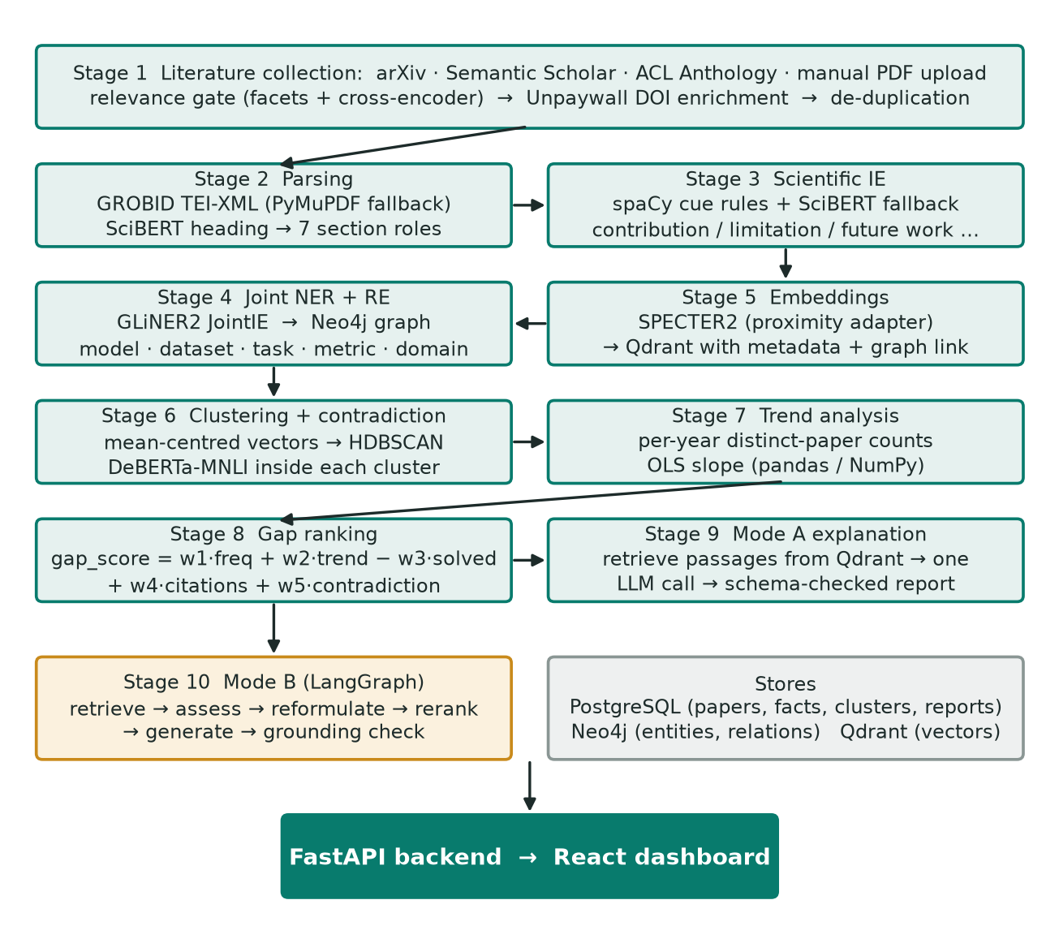
Figure 1. Overall architecture of ScholarLens (Stages 1–10, stores, API and dashboard).
1. Collection. A topic is split into facets with a versioned concept lexicon. arXiv, Semantic Scholar and the ACL Anthology each return candidates, a relevance gate admits or rejects each one and records why, at most ten papers per source are kept, Unpaywall adds a legal open-access PDF when a DOI exists, and de-duplication (DOI, arXiv ID, ACL ID, then normalised title and year) writes one record per paper.
2. Parsing. GROBID turns each PDF into TEI-XML with sections and paragraphs. PyMuPDF and pdfplumber take over when GROBID fails. Headings are mapped onto seven roles (Introduction, Methodology, Results, Discussion, Limitations, Future Work, Conclusion).
3. Statement extraction. Each sentence is typed as contribution, limitation, future work, dataset, model or metric by spaCy cue phrases, with a SciBERT similarity fallback for sentences without a cue. Section headings act as a prior.
4. Joint entity and relation extraction. GLiNER2 extracts model, dataset, task, metric and domain mentions and four typed relations in one pass; results are written to Neo4j.
5. Embedding and indexing. SPECTER2 vectors for every paragraph, limitation and future-work statement go to Qdrant with paper id, year, venue, section type and the matching Neo4j node id.
6. Clustering and contradiction detection. Limitation and future-work vectors are centred and clustered with HDBSCAN. Inside each cluster, DeBERTa-MNLI checks claim pairs that pass a set of filters.
7. Trend analysis. Distinct papers per cluster per year are counted and an ordinary least-squares slope is fitted.
8. Gap ranking. A weighted five-signal formula scores each cluster and stores the breakdown next to the score.
9. Grounded explanation. For each top-ranked cluster, passages are retrieved from Qdrant and sent in one structured request to the LLM. Claims citing evidence that was not retrieved are downgraded.
10. Interactive query. A LangGraph state machine retrieves, checks sufficiency, reformulates if needed, reranks, generates and verifies the answer before returning it with citations.

3.2 Dataset
Gap identification has no ready-made labelled dataset, because nobody has annotated “the research gaps of a field”. The project therefore treats the data as a corpus built per topic by the collection stage, plus four small hand-labelled sets that were used to calibrate and test individual stages. Table 2 summarises them. All text is English.
The topic used throughout is LLM security and prompt injection (Greshake et al., 2023), chosen because it is recent, fast-moving and heavily written about, which makes limitation statements plentiful.
Table 2. Data used in the project.
Set | Source and size | Labels | Used for
Topic corpus (live run) | arXiv + ACL Anthology; 50 papers stored in one collection run (Semantic Scholar was rate-limited in that run) | None (unlabelled) | End-to-end collection test
Audit corpus | 20 full-text LLM-security papers; produced 27 clusters in Stages 2–8 | None; manual audit of top gap | Stages 2–9 behaviour, ranking audit
Relevance pool | 50 candidate documents for “multilingual prompt injection” | 4 classes: ON 12, PARTIAL 4, NEIGHBOUR 17, OFF 17 | Calibrating and testing the Stage 1 gate
Clustering set | 12 limitation statements | 3 themes (multilingual, hallucination, compute cost) | Stage 6 integration test
Evaluation fixture | 3 gaps, 3 later papers, 2 surveys (3 open problems), 6 expert ratings | Relevant paper ids; 1–5 ratings | Demonstrating the Stage 13 harness

Sources and licensing. arXiv and Semantic Scholar supply metadata and, where open, PDFs; the ACL Anthology export used here is a cached bibliographic file of 127,839 records whose full texts are mostly open access. PDFs are used as pipeline input only. They are not redistributed, and the API returns only a has-full-text flag. Papers from IEEE, Springer and ACM enter only if a legal open-access copy exists or the owner uploads them.
Scale. Collection is capped at ten papers per automatic source per run, so one run yields at most thirty papers plus uploads. This keeps the work polite towards the source APIs and small enough to run on a CPU, but it also bounds every result in Section 5.
To show what the pipeline has to resolve, Table 3 gives five differently worded limitations that describe one underlying gap, and Table 4 shows the kind of typed output Stage 3 produces. Both are illustrative examples taken from the project’s design notes, not rows from a stored corpus.
Table 3. Five wordings of one underlying gap (illustrative).
Paper | Statement as written
A | Current methods fail in low-resource languages.
B | Performance decreases for multilingual datasets.
C | More work is required for cross-language reasoning.
D | Existing datasets focus primarily on English.
E | Generalisation to regional languages remains limited.

Table 4. Typed output of statement extraction (illustrative).
Input sentence | Fact type | Extracted statement
Our model achieves SOTA accuracy. | Contribution | SOTA accuracy
However, performance decreases significantly for multilingual datasets. | Limitation | Poor multilingual performance
Future work should explore few-shot multilingual learning. | Future work | Few-shot multilingual learning

3.3 Data Preprocessing
Figure 2 gives the flow from PDF to typed statements. The steps are described below.
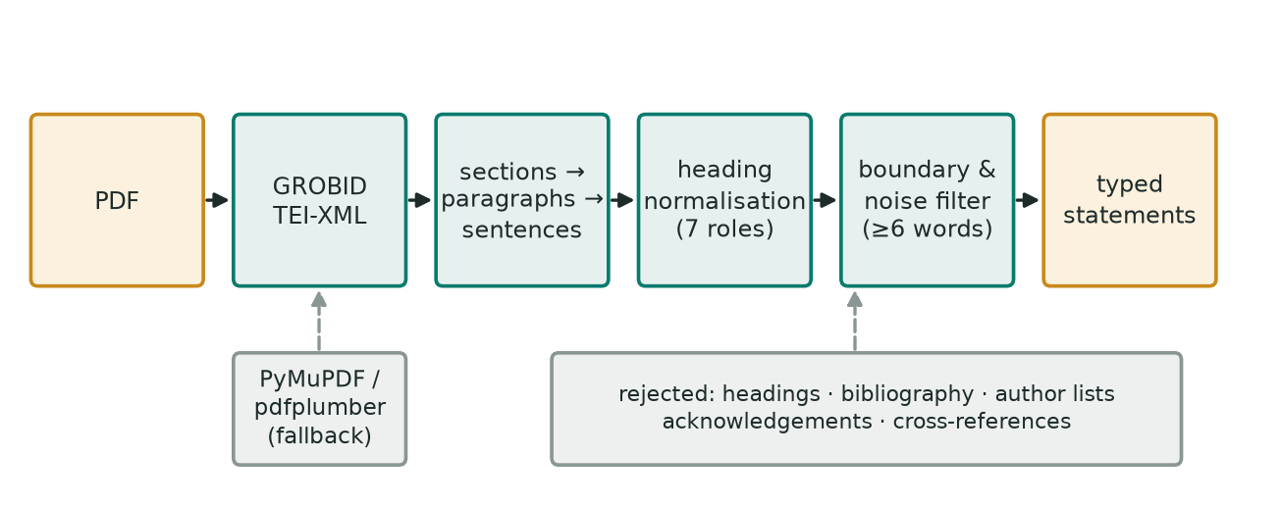
Figure 2. Preprocessing workflow from PDF to typed statements.
Parsing and sentence splitting. GROBID returns TEI-XML; the parser walks sections, paragraphs and sentences and keeps the heading text. A spaCy blank English pipeline with a rule-based sentencizer re-segments text where needed. If GROBID is unavailable or returns nothing, PyMuPDF and pdfplumber produce a flatter structure that goes through the same later stages.
Heading normalisation. A heading such as “3.2 Threats to Validity” is stripped of numbering and lower-cased, then matched against a keyword map. If no keyword fires, the heading is embedded with SciBERT (mean-pooled) and assigned to the closest of seven exemplar descriptions by cosine similarity. Exemplar vectors are cached so each heading costs one forward pass.
Cleaning before clustering. PDF extraction leaves a lot of non-research text that was being labelled as limitations: reference-list entries, author lists, funding lines, section cross-references and all-caps headings. A single filter at the clustering boundary now drops statements shorter than six words and statements matching those patterns. It was added after an audit showed that about 11 of 27 clusters were not themes at all and that four of them had reached the projected top ten.
Normalisation for lexical checks. Transformer inputs are left as written. Lower-casing, stop-word removal and stemming are used only in two places where lexical overlap is the right tool: cluster labels, and the topic gate in contradiction detection. The stop-word list there includes the hedging vocabulary every limitation sentence shares (“remains”, “limited”, “future”), otherwise every cluster would be labelled “future work limitations”.
Entity recognition. Named entities are not removed. Stage 4 extracts them, in chunks of at most 1,200 characters and at most twelve chunks per paper, to bound CPU time.
Relevance screening. Before a candidate paper enters the corpus, each facet of the topic must be evidenced in its title or abstract. Words that appear in another sense (“error injection” for “prompt injection”) are rejected, and the remaining candidates are scored by a cross-encoder on the topic against the title and abstract. Every decision is stored with a reason code.

3.4 Feature Engineering
The numerical representations used at each stage are shown in Figure 3 and described below.
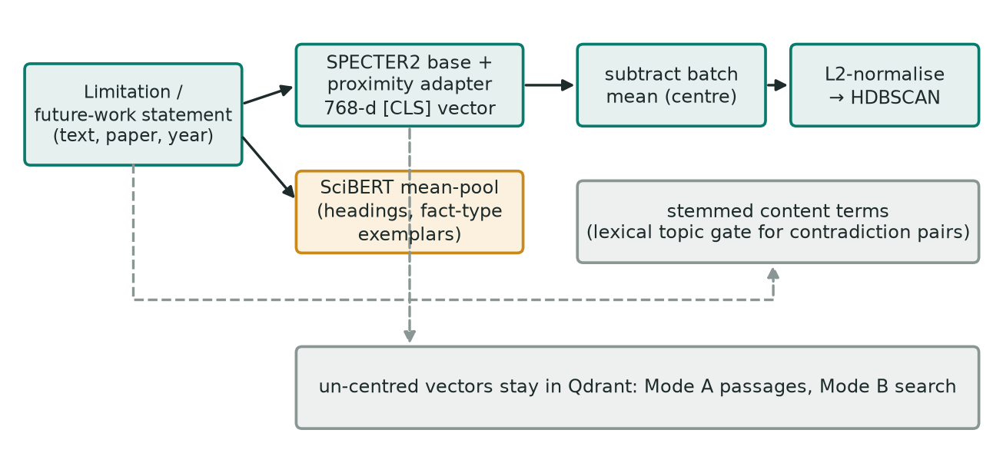
Figure 3. Feature construction for clustering, retrieval and lexical checks.
Sentence and paragraph vectors. Statements are encoded with SPECTER2 (Singh et al., 2023): the allenai/specter2_base encoder with the proximity adapter, which its model card prescribes for retrieval and clustering. Each vector is the 768-dimensional [CLS] representation, and inputs are capped at 512 word pieces. TF-IDF or bag-of-words would treat the five sentences in Table 3 as unrelated; a contextual encoder places them near each other (Reimers & Gurevych, 2019; Jurafsky & Martin, 2024).
Mean-centring. Raw transformer vectors occupy a narrow cone, so almost every pair looks similar. On the hand-labelled clustering set, raw within-theme cosine was 0.931 and across-theme 0.871, with the two ranges overlapping. Subtracting the batch mean before clustering separated them (Section 5.1). Only the copy used for clustering is centred; vectors in Qdrant are untouched so retrieval is unaffected.
SciBERT sentence vectors. Heading classification and the fallback fact classifier use mean-pooled SciBERT (Beltagy et al., 2019), since both need a general similarity to short descriptions rather than citation-aware document vectors.
Lexical features. Stemmed content terms of each statement support the topic gate and the cluster labels, and the label’s terms are reused to decide whether a paper’s contribution is on-theme for the solution-density signal.
Structured features for ranking. Distinct-paper counts per year, the slope of that series, the share of papers proposing a remedy, mean citation count and a contradiction measure feed the gap formula.

3.5 Model Development
Table 5 lists the model used at each stage with its main settings. Stage 10 is drawn in Figure 4.
Table 5. Models and key hyperparameters.
Stage | Model / method | Important settings
1 Gate | ms-marco-MiniLM-L-6-v2 cross-encoder (Bajaj et al., 2016; Nogueira & Cho, 2019) | Raw-logit floor −1.0; “strong” tier at 3.5; batch 16
2 Headings | Keyword map, then SciBERT scivocab-uncased exemplar similarity | 7 roles
3 Statements | spaCy PhraseMatcher cues; SciBERT fallback | Min cosine 0.55; margin 0.03 over runner-up and non-fact exemplar
4 NER + RE | GLiNER2.5 base (JointIE) | Entity threshold 0.15; relation threshold 0.5; 5 entity types, 4 relations
5 Embedding | SPECTER2 base + proximity adapter | Batch 16; 512 tokens; Qdrant cosine
6 Clustering | HDBSCAN (scikit-learn) | min_cluster_size 3; noise dropped; no cluster count
6 Contradiction | DeBERTa-base-MNLI (He et al., 2023; Williams et al., 2018) | P ≥ 0.7 in both directions; ≥ 2 paper pairs; ≤ 50 pairs per cluster
8 Ranking | Weighted formula (plain Python) | w = 1.0, 3.0, 25.0, 0.02, 5.0
9 Explanation | openai/gpt-oss-20b through Groq (OpenAI, 2025) | JSON schema; 4,000 completion tokens; top 5 gaps; 8 passages, ≤ 3 per paper
10 Mode B | LangGraph + MiniLM cross-encoder + same LLM | ≤ 3 retrieval rounds; ≥ 2 chunks from ≥ 2 papers; 1 regeneration

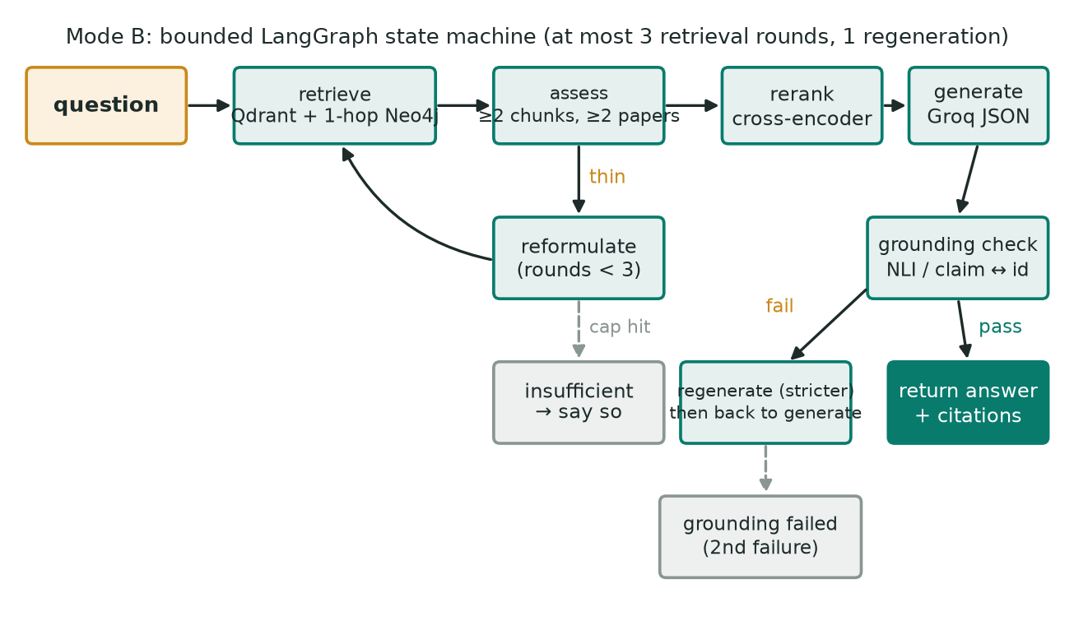
Figure 4. Mode B interactive workflow as a bounded LangGraph state machine.
Training and validation. No model was trained or fine-tuned. Every model is a published checkpoint used for inference. Validation therefore means checking each stage against something known: hand-labelled sets (Section 3.2), unit tests written before the code (1,297 backend tests passed at the last recorded run), and manual audits of stored output. This is a weaker form of validation than held-out test accuracy, and Section 7 says so.
Statement typing. A sentence is first matched against cue phrases per type (for example “we propose”, “performance degrades”, “future work”), with the section it sits in acting as a prior. Sentences with no cue go to the SciBERT fallback, which compares the sentence with one exemplar description per type plus a “neutral background” exemplar and abstains unless the best score clears 0.55 and beats the runner-up by 0.03.
Joint extraction. Entity types come with natural-language descriptions, which turned out to matter: without them “GSM8K” was typed as a metric rather than a dataset, which silently removed the evaluated_using edge. Relations are model–dataset (trained_on, evaluated_using), model–domain (fails_on) and model–metric (achieves). The 0.15 entity threshold sits under the lowest correct entity seen in a sample (“BERT” at 0.248) because a missed model entity removes every relation that has it as head.
Clustering and contradiction. HDBSCAN (Campello et al., 2013) is run on centred, L2-normalised vectors, so Euclidean distance orders neighbours exactly as cosine does. Points it cannot place are dropped instead of being merged into a catch-all cluster, since a cluster of leftovers would otherwise earn a trend and a gap score. Within a cluster, a pair is sent to NLI only if both sides are real claims of at least eight words (not headings, bullets, disclaimers or proposals), the two share at least three stemmed content terms with Jaccard overlap of at least 0.12, and both directions score at least 0.7 for contradiction. A cluster is flagged only if two distinct paper pairs disagree.
Trend and score. The trend slope is the least-squares slope of distinct papers per year, with silent interior years counted as zero and no extrapolation outside the observed range: slope = Σ(x − x̄)(y − ȳ) / Σ(x − x̄)². The gap score is gap_score = w1·mention_frequency + w2·trend_slope − w3·solution_density + w4·citation_impact + w5·contradiction. Mention frequency counts papers, not sentences. Solution density is the share of papers that are on-theme and propose a remedy. The weights put five different units on one scale: one point per mentioning paper, three per extra paper per year, 25 for a theme that is fully addressed, 0.02 per mean citation and 5 for a fully corroborated disagreement. A worked case from the audit: a cluster with about six mentioning papers and a solution density of 0.33 loses 8.33 points to the density term, which in a read-only simulation was enough to push the previously top-ranked cluster out of the top five.
Grounded explanation. For each top gap the system retrieves four times as many passages as it needs, then selects breadth-first (every paper’s best passage before any paper’s second) with at most three per paper, preferring the cluster’s own papers. The prompt asks for three separately cited claims: the problem exists, existing solutions fall short and a specific gap remains. Evidence for the first is not allowed to stand in for the other two. The code, not the prompt, enforces this: a claim with no citation is downgraded, and a claim citing an id that was not retrieved becomes unsupported before it is stored.
Interactive mode. The LangGraph state holds the question, retrieved chunks, round counter, sufficiency flag, draft answer and grounding flag. Retrieval combines Qdrant search with a one-hop Neo4j expansion. Evidence is sufficient only with at least two chunks from at least two papers above a minimum score, so a single prolific paper cannot pass for breadth. If not, the query is reformulated and retrieval repeats, up to three rounds. After reranking and generation, a grounding check verifies each claim against the retrieved text; failure triggers one stricter regeneration and then an explicit failure message.

3.6 Proposed Novelty
The contribution is an ordering and a set of safeguards rather than a new model. Gap candidates are built from stored author statements, clustered, tested for disagreement, scored by a formula whose terms can be recomputed by hand, and only then handed to an LLM that is limited to retrieved passages, so every sentence in a gap report can be traced to a stored paragraph (Figure 5).
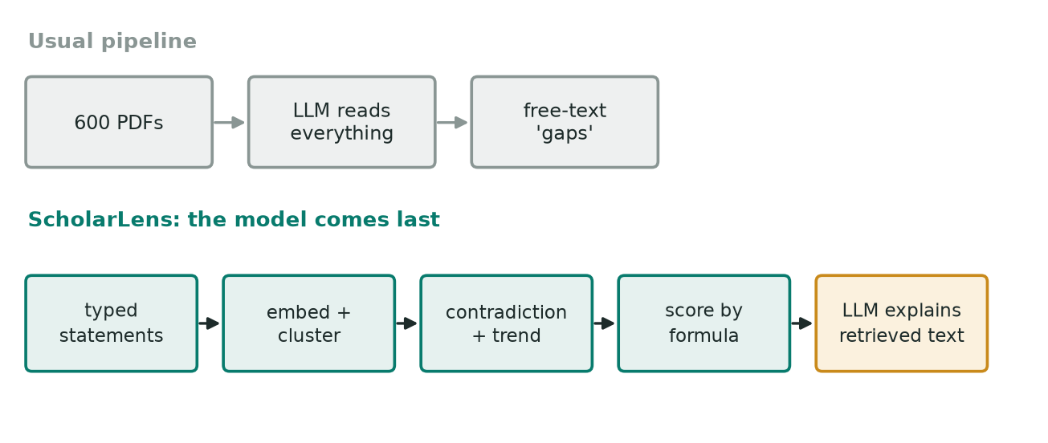
Figure 5. Conventional LLM-first pipeline versus the evidence-first ordering used here.

4. Experimental Setup
Development and all measurements reported here were done on a single personal laptop. The ML models run on CPU only (a CPU-only PyTorch wheel is installed), and the supporting services run as Docker containers. Table 6 lists the setup.
Table 6. Experimental environment.
Item | Configuration
Host | Windows 11 Home; VS Code; Docker Compose. [fill: CPU model, RAM]; no GPU
Language and runtime | Python 3.11 (python:3.11-slim image); Node.js for the dashboard
NLP / ML libraries | PyTorch (CPU) 2.9+; Hugging Face Transformers 4.57 (Wolf et al., 2020); sentence-transformers 5.x; adapters 1.3 (SPECTER2 adapter); spaCy 3.8 (Honnibal et al., 2020); GLiNER2 2.x; scikit-learn 1.7+ (Pedregosa et al., 2011); NumPy 2; pandas 2.2+
Parsing | GROBID 0.9.0 (Lopez, 2009) in Docker; PyMuPDF; pdfplumber
Stores | PostgreSQL 16 (papers, facts, clusters, reports); Neo4j 5 community (graph; Neo4j, 2025); Qdrant (vectors; Qdrant, 2025)
Orchestration and LLM | LangGraph 1.x (LangChain, 2025), no LangChain chains; Groq API (Groq, 2025), model openai/gpt-oss-20b
Backend and frontend | FastAPI with API-key authentication; React 19 + TypeScript, Plotly for trend charts, d3-force for the graph view
Testing | pytest (1,297 backend tests passing at last recorded run, 10 integration tests deselected by default), ruff lint, Vitest (19 frontend tests), 4 evaluation tests
Run time | About 15–40 minutes for the CPU-bound stages over 50 papers (no GPU), as recorded in the project log
Reproducibility | All thresholds and weights live in one settings module; the HF revisions of SPECTER2 and DeBERTa can be pinned; each run records the gate and lexicon version

5. Results and Discussion
Because there is no labelled benchmark, the results are measurements of individual design decisions, taken on the project’s own corpora, rather than a single accuracy figure. Each one below answers the same question: did this component do what the later stages assume it does? The corpora are small, so the numbers should be read as evidence for the design and not as general performance estimates.

5.1 Performance Evaluation and Comparative Analysis
Embedding geometry. Figure 6 and Table 7 show cosine similarity on the 12-statement hand-labelled set with the real SPECTER2 encoder. With raw vectors the two groups overlap (within-theme minimum 0.893, across-theme maximum 0.925), and the first run with real vectors pulled a compute-cost sentence into the multilingual cluster and lost the multilingual theme entirely. After centring, the ranges separate in the average and all three themes were recovered as exactly one cluster each.
Table 7. Cosine similarity on the hand-labelled clustering set.
Vectors | Within-theme cosine (mean / min) | Across-theme cosine (mean / max) | Themes recovered
Raw SPECTER2 | 0.931 / 0.893 | 0.871 / 0.925 | Multilingual theme lost
Mean-centred | 0.354 / 0.164 | −0.182 / 0.356 | 3 of 3, one cluster each

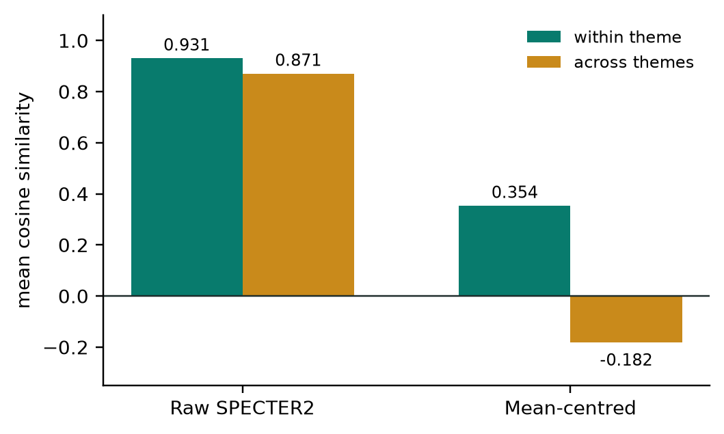
Figure 6. Effect of mean-centring on SPECTER2 similarity (12-statement set).
The centred ranges still touch (within-theme minimum 0.164, across-theme maximum 0.356), so the margin is a matter of averages, not a clean gap. With 12 points, one corpus and one encoder, this is a sanity check for the preprocessing choice and not a clustering benchmark.
Relevance gate. The gate was evaluated on the 50 hand-labelled candidates with the real cross-encoder (Figure 7, Table 8). All 12 on-topic documents were admitted, all 17 off-topic ones rejected and 15 of the 17 near-topic neighbours rejected. The two neighbours that passed both explicitly discuss prompt injection. The floor (−1.0) and the strong threshold (3.5) were set on this one topic, so they are settings that need re-checking for a new topic, not validated constants.
Table 8. Relevance gate outcome on the 50-document labelled pool.
Pool | Documents | Admitted | Rejected | Admitted rate
ON-topic | 12 | 12 | 0 | 100%
PARTIAL (some facets) | 4 | 2 | 2 | 50%
NEIGHBOUR (related field) | 17 | 2 | 15 | 12%
OFF-topic | 17 | 0 | 17 | 0%
Total | 50 | 16 | 34 | 32%

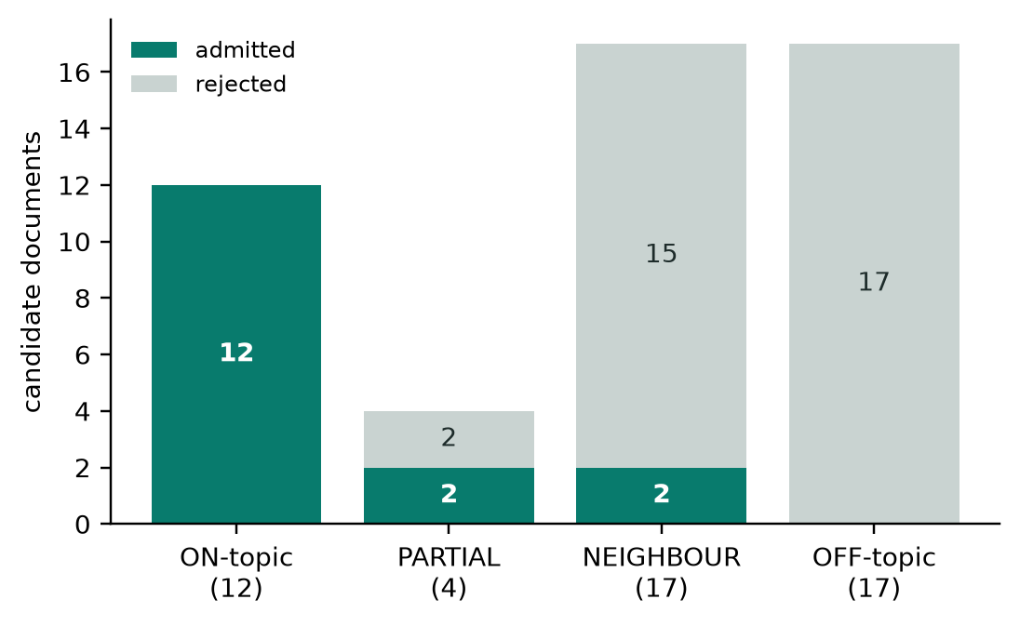
Figure 7. Admitted and rejected documents per pool category.
Contradiction detection. A manual check of the top-ranked gap in the 20-paper corpus found that its “conflicting evidence” flag was false. Four stored pairs all shared one right-hand sentence, an ethics disclaimer (“all attack templates are derived from the publicly available BIPIA benchmark … no attack tooling is released”), and DeBERTa-MNLI scored every one above 0.999. None was a disagreement. NLI on its own cannot tell a disagreement from two sentences that are about different things. The claim filter alone removes all four pairs because the disclaimer is not a claim, and the topic gate alone also removes them because the pairs share zero or one content terms (Table 9, Figure 8). A related earlier case: a hallucination limitation and a future-work proposal that agree with each other were flagged at 0.955.
Table 9. Contradiction filtering on the top-ranked cluster of the audit corpus.
Configuration | False pairs kept (cluster 1) | Note
DeBERTa-MNLI score only | 4 | All above P = 0.999
Claim filter alone | 0 | Disclaimer, bullet, related-work and proposal sentences rejected
Topic-overlap gate alone | 0 | False pairs shared 0–1 terms (Jaccard ≤ 0.042)
All gates + both directions + 2 paper pairs (final) | 0 | No cluster in the audit corpus is flagged; a real two-paper disagreement would also not be flagged by default

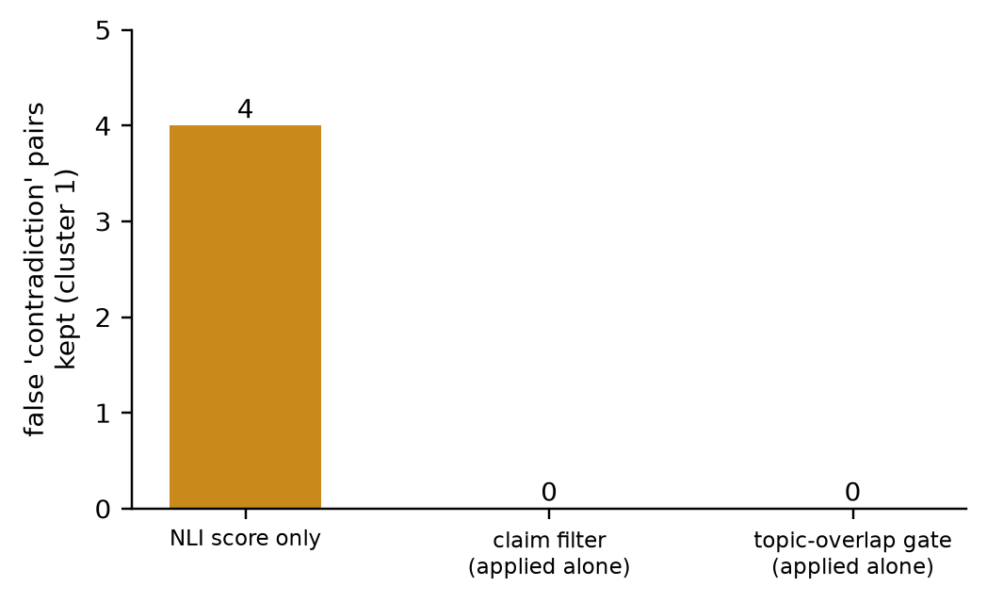
Figure 8. False contradiction pairs retained under each configuration.
The topic gate is lexical on purpose. The first idea was SPECTER2 cosine, so it was measured first: over the 239 cross-paper pairs inside stored clusters cosine ran from 0.836 to 0.975 (median 0.923), the four false positives sat at 0.89–0.93 in the middle, and the most similar pairs of all were boilerplate (“DISCUSSION AND LIMITATIONS” against “This study has several limitations”, 0.975). A document-level model gives single sentences from one field almost the same vector, so a cosine gate would have selected for boilerplate. Shared stemmed terms (at least three, Jaccard at least 0.12) admitted 3.8% of cross-paper pairs.
Solution density and ranking. The first rule required a contribution sentence containing every term of the cluster label, and no sentence in the corpus did, so the term was 0.00 for all 27 clusters and subtracting it did nothing. The final rule asks two things separately: is the paper on-theme (a member of the cluster, or sharing at least two label terms) and does it propose a remedy (a narrow cue list: defence, mitigation, detection, filter and similar). The density became non-zero for 17 of 27 clusters (Figure 9). Widening the cue list to words like “propose”, “framework” or “benchmark” marked a solver in 26 of 27 clusters, which makes the term constant again, so the list stays narrow. The clean-up of non-research statements mattered as much: four extraction-noise clusters (author lists, reference entries) had reached the projected top ten because nobody could be “solving” an author list.
Table 10. Solution-density variants on the 27 audit clusters.
Version | Clusters with density > 0 | Observation
Every-term rule | 0 / 27 | Term was decorative
On-theme + remedy cue (final) | 17 / 27 | Spread 0.25–1.00
Broad cue list (rejected) | 26 / 27 | Density ≈ 1.00 almost everywhere

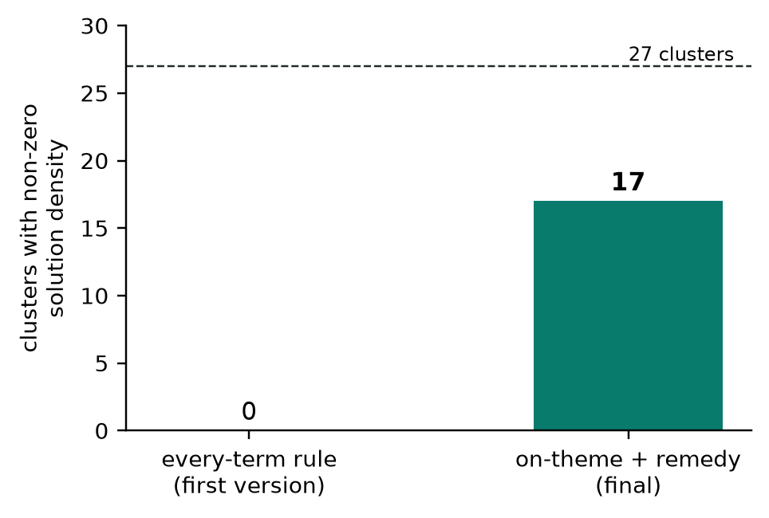
Figure 9. Clusters with a non-zero solution-density signal.
Evidence selection for explanations. In the first report for the top gap, eight retrieved passages included seven from one study and one from a paper outside the cluster, while five of the cluster’s six papers were never quoted; the figure “56% of tests” in that report was one study’s own experiment presented as the field’s position. With the per-paper cap of three and the breadth-first selection, a report quotes as many of the cluster’s papers as the evidence allows, and the report states passages and unique papers separately.
Generation reliability. In the first clean baseline of Stage 9, five ranked gaps were attempted, two reports were stored and three failed: two with a JSON validation error and one cut off at the token limit, while the pipeline still answered with a plain success. The model reasons before it answers and those hidden tokens count against the completion cap, so the cap was raised from 2,048 to 4,000 (a report is about 500–700 tokens, around 1.2K at worst), failures are now classified and reported, and a partial pass resumes only the missing reports. [fill: result of the next full Stage 9 run, if you have one]
Evaluation harness demonstration. The harness combines time-shifted validation, survey cross-checking and expert scoring into a validity index (Table 11). The run reported below used the small fixture shipped with the repository (three gaps, three later papers, two surveys, six ratings from two pseudonymous raters). It shows that the harness works and what its output looks like. It is not an accuracy claim about ScholarLens, and the ratings in the fixture should not be quoted as expert findings.
Table 11. Evaluation harness output on the shipped demonstration fixture.
Method | Measure | Value (fixture)
Time-shifted | Gaps addressed by later papers (2 of 3); precision / recall on labelled ids | 0.667; 1.00 / 1.00
Survey cross-check | Gaps matching a survey’s open problem (2 of 3), similarity threshold 0.15 | 0.667
Expert scoring | Mean novelty / validity / evidence / actionability (1–5) | 4.17 / 4.17 / 4.00 / 4.17
Expert scoring | Ratings with validity of 4 or 5 | 0.833
Composite | Mean of addressed rate, survey rate and validity ÷ 5 | 0.722

5.2 Output Screens and Result Demonstration
The application is a FastAPI backend with a React dashboard whose views cover paper collection, ranked gap reports with the five-signal breakdown, per-cluster trend charts and the interactive question box. To show what the system actually produces, Table 12 gives a real stored output from the audit corpus: the report for the top-ranked gap before the validity fixes described in Section 5.1.
Table 12. Stored report for the top-ranked gap of the audit corpus, before the fixes.
Field | Stored value (before fixes)
Gap statement | “Despite frequent prompt injection attacks, there is a lack of effective, adaptive defenses and inconsistent findings across studies, leaving LLMs vulnerable.”
gap_score / confidence | 11.01 / 70% (the confidence is the LLM’s own estimate, not a calibrated probability)
Flag shown | Conflicting evidence (false positive, see Table 9)
Cluster label | “prompt attacks injection” (frequency-derived terms)
Evidence | 8 passages, 7 from a single study (see Section 5.1)
What changed | False contradiction removed, solution density made informative, evidence capped at 3 passages per paper

6. Comparative Analysis
The comparison has two parts. Table 13 compares what each tool can do for the task of finding gaps. It is a capability comparison based on how these tools are documented and was not benchmarked. Table 14 compares design choices inside ScholarLens, using the measurements from Section 5.1, because those are the only like-for-like comparisons the project has data for.
Table 13. Capability comparison for the task of finding research gaps (not benchmarked).
Capability | Scholar search | Citation maps | PDF chat / LLM summary | ScholarLens
Finds relevant papers | Yes | Yes | Only uploaded ones | Yes, gated and logged
Extracts limitations and future work | No | No | Per document, on request | Yes, typed statements
Merges paraphrased limitations | No | No | No | Yes, HDBSCAN themes
Counts papers and trend | No | Citation counts only | No | Yes, per theme
Checks disagreement | No | No | No | Yes, filtered NLI
Ranks gaps with auditable score | No | No | No | Yes, five signals
Claims traceable to passages | n/a | n/a | Not guaranteed | Enforced in code

Table 14. Design alternatives inside ScholarLens and what each change measured.
Decision | Baseline choice | Final choice | Measured difference
Clustering input | Raw SPECTER2 vectors | Mean-centred vectors | Within vs across cosine 0.931 / 0.871 → 0.354 / −0.182; 3 of 3 themes recovered
Contradiction test | NLI score above 0.7 | Claim filter + topic gate + both directions + 2 paper pairs | 4 false pairs → 0
Topic gate | SPECTER2 cosine | Shared stemmed terms | Cosine put false pairs mid-distribution (0.89–0.93); lexical rule admits 3.8% of pairs
Solution density | Every label term in one sentence | On-theme and remedy cue | 0 / 27 → 17 / 27 clusters non-zero
Report evidence | Top 8 by score | Breadth-first, ≤ 3 per paper | 7 of 8 passages from one study → spread across papers
Relevance | Search results as returned | Facet check + cross-encoder gate | 12 / 12 on-topic kept; 32 of 34 off-topic and neighbour rejected

The strength of the approach is that each stage’s output can be inspected, which is how every defect in Table 14 was found. The cost is more moving parts than a single prompt, a CPU run measured in tens of minutes, and a dependence on the quality of PDF parsing. A plain LLM summary is faster for one paper; it cannot produce a count or a trend.

7. Limitations
- Data. The corpora are small (20 full-text papers in the audit, at most ten papers per source per run) and come from one topic, so cluster counts, trends and rankings are not statistically meaningful at this scale. There is no labelled benchmark for gap identification.
- Calibration on a single topic. The relevance floor and strong threshold were calibrated on one topic with 50 documents; the contradiction gates were designed around four false positives from one corpus. They may not transfer.
- Evaluation. Validation relies on hand-labelled sets, unit tests and manual audits, not on held-out accuracy. The evaluation harness has only been run on a three-gap fixture whose expert ratings are examples, so the project has no measured precision for the gaps it reports.
- Contradiction recall. At the default of two corroborating paper pairs, no cluster in the audit corpus is flagged. A real disagreement between exactly two papers is also missed. This trades recall for precision on purpose.
- Confidence. The confidence in a report is the LLM’s own estimate and is not calibrated.
- Extraction quality. Sentence typing uses cue phrases and similarity to short exemplars, and PDF parsing noise (reference lists, author lists) reached the clustering stage before the boundary filter was added. Only full-text papers yield statements; metadata-only records contribute little.
- Model and compute limits. SPECTER2 is a document-level model used on sentences; DeBERTa-base-MNLI was chosen over the large variant to save memory; everything runs on CPU, and the first full pass over 50 papers takes tens of minutes. Source APIs impose rate limits (arXiv returned HTTP 429 in some runs), which the collector handles by skipping the source.
- Live demonstration. Mode B was verified through unit and API tests with mocked services; the project log does not record a live end-to-end grounded answer, and the LLM stages depend on an external Groq quota.
- Scope. The pipeline is restricted to technical literature in computer science and does not claim to generalise to other fields.

8. Future Scope
- Larger and multilingual corpora. Run the pipeline over several hundred papers across more than one topic, and extend the encoder and extraction to non-English papers.
- A labelled evaluation set. Have two or more annotators mark gap statements and themes in a few dozen papers so that clustering and ranking can be scored with precision, recall and agreement instead of audits.
- Learned ranking. Replace or complement the hand-set weights with a ranker trained on gaps later confirmed by time-shifted validation.
- Better statement typing. Fine-tune SciBERT on labelled limitation and future-work sentences and compare against the cue-plus-exemplar approach, and add a part-of-speech or dependency-based claim detector to replace the narrow filters.
- Stronger contradiction detection. Try a larger NLI model and a claim-extraction step so that two-paper disagreements can be detected with fewer false alarms.
- Explainability and calibration. Show the contributing sentences next to each signal in the dashboard and replace the LLM’s self-reported confidence with a score derived from evidence breadth.
- Deployment. Add the full-stack container, a GPU path and incremental indexing so that a new paper updates clusters without a full rebuild.

9. Conclusion
This project set out to replace a guess with evidence. The usual way to look for a research gap is to read hundreds of papers and decide by feel, and the usual software answer is to ask a language model, which will always produce a fluent reply. ScholarLens takes a different order of work. It reads what authors wrote about their own limitations and future work, turns the sentences into vectors, groups the ones that mean the same thing, checks whether papers disagree, counts how many independent papers are involved and whether the count is rising, scores each theme with a formula anyone can recompute, and only then asks a model to explain the retrieved text.
Measured on the project’s own corpora, the design choices held up. Centring the SPECTER2 vectors separated within-theme from across-theme similarity (0.354 against −0.182) and recovered all three labelled themes. The relevance gate kept all 12 on-topic documents and rejected all 17 off-topic ones. The layered contradiction filter removed four false conflicts that a plain NLI model had scored above 0.999, and the redesigned solution-density signal went from carrying no information in any of 27 clusters to carrying some in 17. Several of these fixes came from looking at stored output and finding that it was wrong, which is itself an argument for a pipeline whose intermediate results can be read.
The objectives were met in the sense that the full pipeline, both modes, the API, the dashboard and the evaluation harness exist, are tested and run on a CPU-only machine. They were not met in the sense of a quantified accuracy for the gaps themselves. The corpora are small, thresholds were tuned on one topic, the harness has only been exercised on a fixture, and a live grounded answer from Mode B is not recorded. Those limits are stated plainly in Section 7 and they decide what comes next: a larger multilingual corpus, a labelled evaluation set and a learned ranker.
If those steps work out, the same design could help students choose a thesis topic, help supervisors check whether a proposed problem is already crowded, and give a review panel a count of independent papers and their years instead of a single opinion.

10. References
Asai, A., Wu, Z., Wang, Y., Sil, A., & Hajishirzi, H. (2024). Self-RAG: Learning to retrieve, generate, and critique through self-reflection. Proceedings of the Twelfth International Conference on Learning Representations (ICLR 2024). arXiv:2310.11511
Bajaj, P., Campos, D., Craswell, N., Deng, L., Gao, J., Liu, X., Majumder, R., McNamara, A., Mitra, B., Nguyen, T., Rosenberg, M., Song, X., Stoica, A., Tiwary, S., & Wang, T. (2016). MS MARCO: A human generated machine reading comprehension dataset. arXiv:1611.09268
Beltagy, I., Lo, K., & Cohan, A. (2019). SciBERT: A pretrained language model for scientific text. Proceedings of EMNLP-IJCNLP 2019, 3615–3620.
Campello, R. J. G. B., Moulavi, D., & Sander, J. (2013). Density-based clustering based on hierarchical density estimates. In Advances in Knowledge Discovery and Data Mining (PAKDD 2013) (pp. 160–172). Springer.
Cohan, A., Feldman, S., Beltagy, I., Downey, D., & Weld, D. S. (2020). SPECTER: Document-level representation learning using citation-informed transformers. Proceedings of ACL 2020, 2270–2282.
Devlin, J., Chang, M. W., Lee, K., & Toutanova, K. (2019). BERT: Pre-training of deep bidirectional transformers for language understanding. Proceedings of NAACL-HLT, 4171–4186.
Edge, D., Trinh, H., Cheng, N., Bradley, J., Chao, A., Mody, A., Truitt, S., Metropolitansky, D., Ness, R. O., & Larson, J. (2024). From local to global: A graph RAG approach to query-focused summarization. arXiv:2404.16130
Es, S., James, J., Espinosa Anke, L., & Schockaert, S. (2024). RAGAs: Automated evaluation of retrieval augmented generation. Proceedings of EACL 2024: System Demonstrations, 150–158.
Gao, T., Yen, H., Yu, J., & Chen, D. (2023a). Enabling large language models to generate text with citations. Proceedings of EMNLP 2023, 6465–6488.
Gao, Y., Xiong, Y., Gao, X., Jia, K., Pan, J., Bi, Y., Dai, Y., Sun, J., Wang, M., & Wang, H. (2023b). Retrieval-augmented generation for large language models: A survey. arXiv:2312.10997
Greshake, K., Abdelnabi, S., Mishra, S., Endres, C., Holz, T., & Fritz, M. (2023). Not what you’ve signed up for: Compromising real-world LLM-integrated applications with indirect prompt injection. Proceedings of the 16th ACM Workshop on Artificial Intelligence and Security (AISec ’23), 79–90.
Grootendorst, M. (2022). BERTopic: Neural topic modeling with a class-based TF-IDF procedure. arXiv:2203.05794
Groq. (2025). GroqCloud documentation. https://console.groq.com/docs
Gu, X., & Krenn, M. (2024). Generation and human-expert evaluation of interesting research ideas using knowledge graphs and large language models. arXiv:2405.17044
He, P., Gao, J., & Chen, W. (2023). DeBERTaV3: Improving DeBERTa using ELECTRA-style pre-training with gradient-disentangled embedding sharing. Proceedings of the Eleventh International Conference on Learning Representations (ICLR 2023).
Honnibal, M., Montani, I., Van Landeghem, S., & Boyd, A. (2020). spaCy: Industrial-strength natural language processing in Python [Computer software]. Zenodo. https://doi.org/10.5281/zenodo.1212303
Ji, Z., Lee, N., Frieske, R., Yu, T., Su, D., Xu, Y., Ishii, E., Bang, Y. J., Madotto, A., & Fung, P. (2023). Survey of hallucination in natural language generation. ACM Computing Surveys, 55(12), Article 248.
Jurafsky, D., & Martin, J. H. (2024). Speech and language processing (3rd ed., draft). https://web.stanford.edu/~jurafsky/slp3/
Kinney, R., Anastasiades, C., Authur, R., Beltagy, I., Bragg, J., Buraczynski, A., et al. (2023). The Semantic Scholar Open Data Platform. arXiv:2301.10140
Krenn, M., Buffoni, L., Coutinho, B., et al. (2022). Predicting the future of AI with AI: High-quality link prediction in an exponentially growing knowledge network. arXiv:2210.00881
LangChain. (2025). LangGraph documentation. https://langchain-ai.github.io/langgraph/
Lewis, P., Perez, E., Piktus, A., et al. (2020). Retrieval-augmented generation for knowledge-intensive NLP tasks. Advances in Neural Information Processing Systems, 33, 9459–9474.
Liu, N. F., Lin, K., Hewitt, J., Paranjape, A., Bevilacqua, M., Petroni, F., & Liang, P. (2024). Lost in the middle: How language models use long contexts. Transactions of the Association for Computational Linguistics, 12, 157–173.
Liu, N. F., Zhang, T., & Liang, P. (2023). Evaluating verifiability in generative search engines. Findings of the Association for Computational Linguistics: EMNLP 2023, 7001–7025.
Lopez, P. (2009). GROBID: Combining automatic bibliographic data recognition and term extraction for scholarship publications. In Research and Advanced Technology for Digital Libraries (ECDL 2009) (pp. 473–474). Springer.
Luan, Y., He, L., Ostendorf, M., & Hajishirzi, H. (2018). Multi-task identification of entities, relations, and coreference for scientific knowledge graph construction. Proceedings of EMNLP 2018, 3219–3232.
Lu, C., Lu, C., Lange, R. T., Foerster, J., Clune, J., & Ha, D. (2024). The AI Scientist: Towards fully automated open-ended scientific discovery. arXiv:2408.06292
McInnes, L., Healy, J., & Astels, S. (2017). hdbscan: Hierarchical density based clustering. Journal of Open Source Software, 2(11), 205.
Neo4j, Inc. (2025). Neo4j Cypher manual. https://neo4j.com/docs/cypher-manual/
Nogueira, R., & Cho, K. (2019). Passage re-ranking with BERT. arXiv:1901.04085
OpenAI. (2025). gpt-oss-120b & gpt-oss-20b model card. arXiv:2508.10925
Pedregosa, F., Varoquaux, G., Gramfort, A., et al. (2011). Scikit-learn: Machine learning in Python. Journal of Machine Learning Research, 12, 2825–2830.
Qdrant. (2025). Qdrant documentation. https://qdrant.tech/documentation/
Reimers, N., & Gurevych, I. (2019). Sentence-BERT: Sentence embeddings using Siamese BERT-networks. Proceedings of EMNLP-IJCNLP 2019, 3982–3992.
Si, C., Yang, D., & Hashimoto, T. (2024). Can LLMs generate novel research ideas? A large-scale human study with 100+ NLP researchers. arXiv:2409.04109
Singh, A., D’Arcy, M., Cohan, A., Downey, D., & Feldman, S. (2023). SciRepEval: A multi-format benchmark for scientific document representations. Proceedings of EMNLP 2023, 5548–5566.
Wadden, D., Lo, K., Kuehl, B., Cohan, A., Beltagy, I., Wang, L. L., & Hajishirzi, H. (2022). SciFact-Open: Towards open-domain scientific claim verification. Findings of the Association for Computational Linguistics: EMNLP 2022, 4719–4734.
Wadden, D., Wennberg, U., Luan, Y., & Hajishirzi, H. (2019). Entity, relation, and event extraction with contextualized span representations. Proceedings of EMNLP-IJCNLP 2019, 5784–5789.
Wang, Q., Downey, D., Ji, H., & Hope, T. (2024). SciMON: Scientific inspiration machines optimized for novelty. Proceedings of ACL 2024 (Volume 1: Long Papers), 279–299.
Williams, A., Nangia, N., & Bowman, S. R. (2018). A broad-coverage challenge corpus for sentence understanding through inference. Proceedings of NAACL-HLT 2018, 1112–1122.
Wolf, T., Debut, L., Sanh, V., et al. (2020). Transformers: State-of-the-art natural language processing. Proceedings of EMNLP 2020: System Demonstrations, 38–45.
Zaratiana, U., Pasternak, G., Boyd, O., Hurn-Maloney, G., & Lewis, A. (2025). GLiNER2: An efficient multi-task information extraction system with schema-driven interface. arXiv:2507.18546
Zaratiana, U., Tomeh, N., Holat, P., & Charnois, T. (2024). GLiNER: Generalist model for named entity recognition using bidirectional transformer. Proceedings of NAACL 2024, 5364–5376.

