图片服务宿主程序使用说明

程序目录
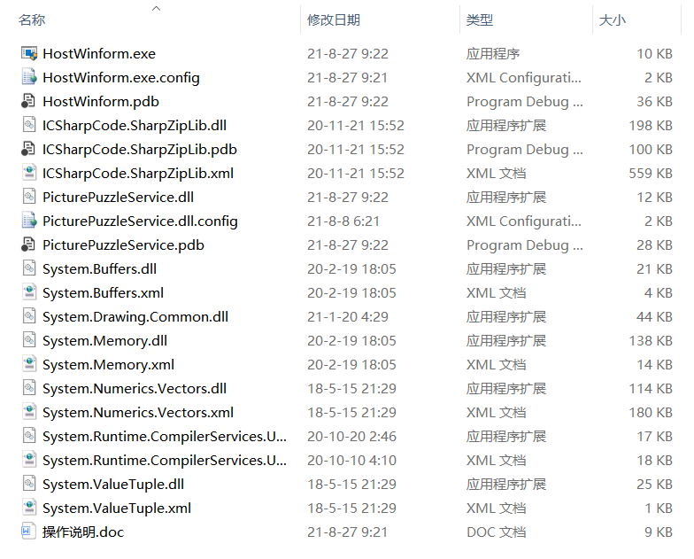
- 宿主程序：HostWinform.exe
- 配置文件：HostWinform.exe.config

操作方法
- 双击宿主程序启动
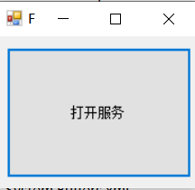
- 点击上图中的打开服务按钮即可

配置明
使用记事本打开HostWinform.exe.config配置文件，文件内容如下：
<?xml version="1.0" encoding="utf-8"?>
<configuration>
<configSections>
<sectionGroup name="userSettings" type="System.Configuration.UserSettingsGroup, System, Version=4.0.0.0, Culture=neutral, PublicKeyToken=b77a5c561934e089">
<section name="HostWinform.Properties.Settings" type="System.Configuration.ClientSettingsSection, System, Version=4.0.0.0, Culture=neutral, PublicKeyToken=b77a5c561934e089" allowExeDefinition="MachineToLocalUser" requirePermission="false" />
</sectionGroup>
</configSections>
<startup>
<supportedRuntime version="v4.0" sku=".NETFramework,Version=v4.7.1" />
</startup>
<runtime>
<assemblyBinding xmlns="urn:schemas-microsoft-com:asm.v1">
<dependentAssembly>
<assemblyIdentity name="System.Runtime.CompilerServices.Unsafe" publicKeyToken="b03f5f7f11d50a3a" culture="neutral" />
<bindingRedirect oldVersion="0.0.0.0-5.0.0.0" newVersion="5.0.0.0" />
</dependentAssembly>
</assemblyBinding>
</runtime>
<userSettings>
<HostWinform.Properties.Settings>
<setting name="ServicePath" serializeAs="String">
<value>http://localhost:8001/</value>
</setting>
<setting name="UploadPath" serializeAs="String">
<value>D:\PuzzleService\Upload\</value>
</setting>
<setting name="PuzzlePath" serializeAs="String">
<value>D:\PuzzleService\Puzzle\</value>
</setting>
<setting name="ZipPath" serializeAs="String">
<value>D:\PuzzleService\Zip\{0}.zip</value>
</setting>
</HostWinform.Properties.Settings>
</userSettings>
</configuration>

每个
<setting name="ServicePath" serializeAs="String">
<value>http://localhost:8001/</value>
</setting>
为一个配置点，name是配置名，<value>配置的值</value>

ServicePath 服务地址
UploadPath 上传图片的存放位置
PuzzlePath 拼图的存放位置
ZipPath 图片压缩后的存放位置

