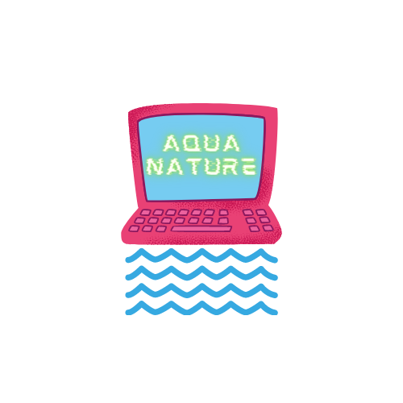

Aqua Nature

# Topic

The topic of our project, which consists of an application, a website and (an unfinished) database is to show people from all around the world about different animal species. It includes our protected Bulgarian national parks. We included them because we want to attract tourism from all around the world. Our team thinks that Bulgaria has some of the best nature from all around the world.

# Contents

We are developing a site and a program, which will have up-to-date information on water resources and animals, protected aquatic animals, protected water areas as well as technological solutions for their protection, monitoring and development. You can look through our [presentation] for a better introduction.

{Diagram}

# Authors

* *Stephan Danielov Stratev – Scrum Trainer* [*[email]*](mailto:sdstratev18@codingburgas.bg)
* *Alexander Zlatkov Yanev - Backend Developer* [*[email]*](mailto:azyanev18@codingburgas.bg)
* *Denis Nikolaev Kolev – Backend Developer* [*[email]*](mailto:dnkolev20@codingburgas.bg)
* *Yoan Georgiev Dimitrov – Backend Developer* [*[email]*](mailto:ygdimitrov19@codingburgas.bg)
* *Kliment Georgiev Tenev – Frontend Developer* [*[email]*](mailto:kgtenev20@codingburgas.bg)
* *Martin Milev Mechkov – Designer*

[*[email]*](mailto:mmmechkov19@codingburgas.bg)

# Summary

## Goals

Our goal was to create a website that could possibly make people more interested in different animal species. Our ***first goal*** was to create the concept. The ***second goal*** was to create a simple to use site, that has all the necessary information. Our ***third goal*** was to create the database and the program. Our ***last but not least goal*** is to present our project to the jury and hopefully we do well!

## Main stages in accomplishment of the project

The main stages of accomplishment were ***the planning, the*** ***realization*** and ***the presentation***. The planning went on for a couple of days. The presentation consists of a presentation and a script. We are going to present it on 29th of July 2021.

## Realization

Our Frontend developer and the designer started doing the site while our backend developers were doing the work on the program and the database. We mainly used ***Visual Studio*** for the program, ***Notepad++*** for the site, ***SQL Server Management Studio*** for the database. We couldn’t connect the program with the database due our lack of time. We used ***GitHub*** for cooperative work. And ***Microsoft Teams*** for messaging the team and sending different files to each other.

## Review of the program

# Conclusion

**In conclusion**, I think we could have done better. We didn’t organize our time well, because of the exams. Another thing was that it was the end of school, we had a lot of work to do for school. But we managed to do somethings that we think are well build and will work to influence people’s view on animal species and Bulgarian waters- rivers, sea and lakes.

# Table of contents

Structure of the documentation

**1. Topic 1**

**2. Contents 1**

**3. Authors 1**

**4. Summary 1**

**1. Goals 1**

**2. Main stages in accomplishment of the project 1**

**3. Realization 1**

**4. Review of the program 1**

**5. Conclusion 1**

**6. Table of contents 1**