SDS Patient Management Database:

My chosen project isa patient management database. The purpose of the project is to create a database to enter and store patient demographic and insurance information for future use in a healthcare setting. The following is a brief outline in what the program will do and how the user will interact with the UI.

**Please note: Due to timing constraints, the ability to look up patient by appointment date has been removed from the scope of this project. The program still meets all criteria required for the semester project. If there are any further questions, please feel free to contact me via elearn. Thank you.**

**Documentation Beta:**

* Click the icon to open SDS Patient Management Database. Upon start-up, you will be asked to log in with your user ID and password that should have been provided to you by your system administrator. (Note: If you are a new user, you will be prompted to contact your system administrator for your username and password.)

**For the scope of this project, you will be able to enter any username and password for operability. **

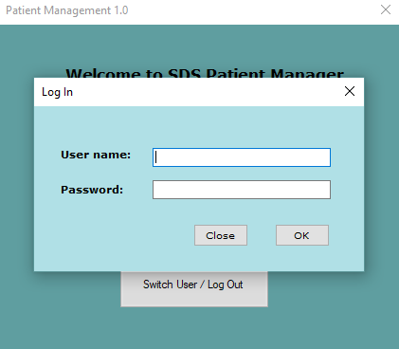

(If you do not successfully log in, the program will close as a safety feature.)

* Once logged in, you will see a home page with different options including “Search for Patient”, “Create New Patient”, “Switch User/Log Out”.

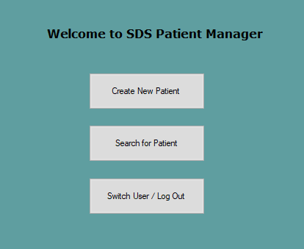

* If you choose to search for a patient, you will click the “Search for Patient” button on the home screen. This will take you to a form with options to find an existing patient by Name (Last, First), DOB, and SSN. If you search for a patient, it will return a list of possible patients that match your search parameters at the bottom of the search form. You may select the correct patient from the list by double-clicking on the right-hand side of the patient row.

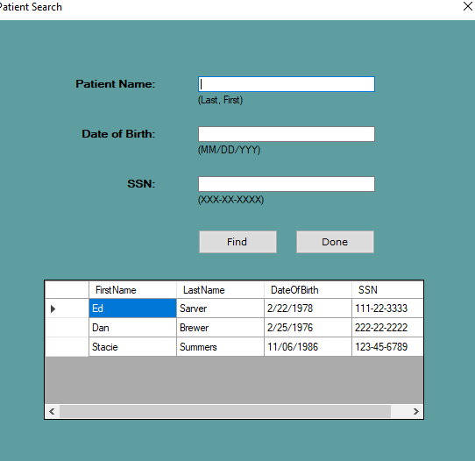

* This will take you to an editable form containing the patient’s demographic and insurance information. If the patient is not found, you will need to click the “Done” button to return to the home screen to click “Create a New Patient” to add the patient to the database.

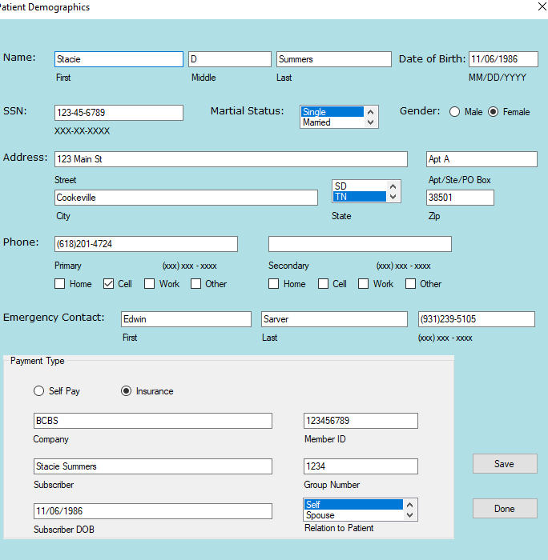

* Once you have verified all information and made any necessary changes, you can save the information by clicking the “Save” button at the bottom of the screen, which will update the database, close the patient demographic form, and return to the patient search form. If you do not wish to save the form, you may click the “Done” button instead. A window will warn you that any unsaved changes will be lost and give you the option to stay on the current form or continue with the form close.

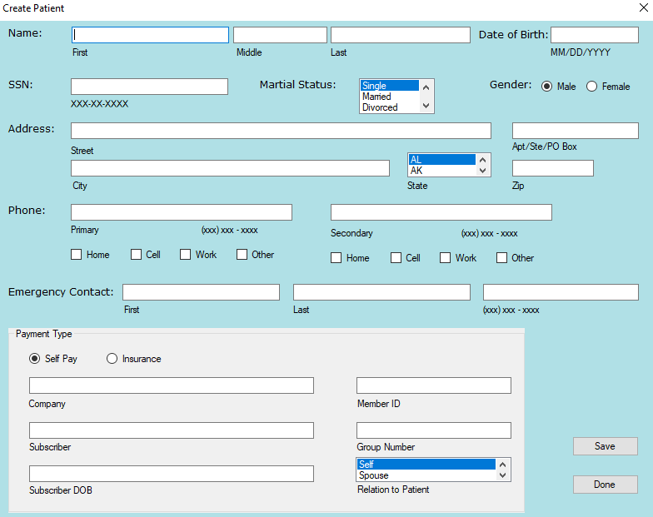

* If a new patient is created, it will send you to a screen similar to the Patient Demographics form, but the information will be blank. You will need to enter all required fields and click “Save” to save the information entered or edits made. If you wish to exit the form without creating a new patient or saving edits, simply click the “Done” button. This will prompt you to confirm your exit without saving. Select “Yes” to continue leaving form without saving any information or “No” to stay on the current form.

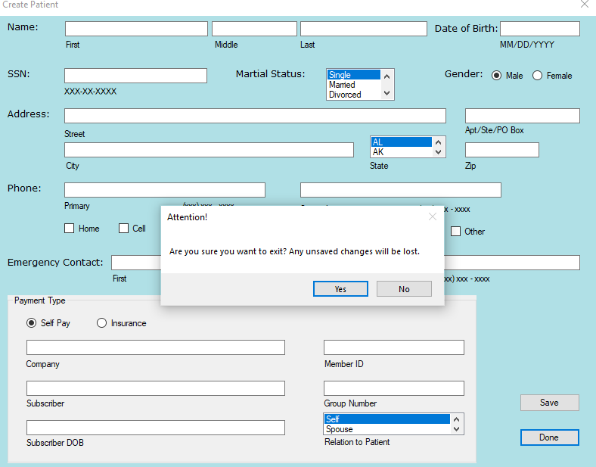

* Once you have finished creating the patient, it will return you to the home screen where you again can choose to look up a patient, create another new patient, or switch user/log out.
* If you choose to switch users or log out, you will be taken back to the log in screen. Currently, if you have an unsuccessful log in, the program will exit as a security measure. Otherwise, enter new user information and return to the log in screen.

