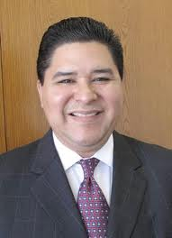

“I strongly support the RealSchoolPD project and look forward to its launch.”

Richard Carranza

Superintendent of Schools

San Francisco Unified School District

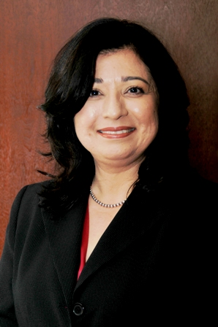

“As an administrator from a rural and geographically isolated district, the need for this training is paramount.”

Lura Damiano

Director of Special Programs

Fort Bragg Unified School District

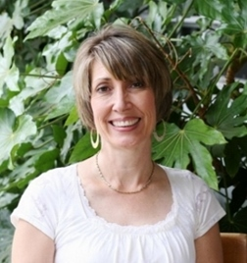

“I strongly support the RealSchoolPD endeavor as it will help schools access high quality robust interventions that support student achievement!”

Jarice Butterfield, Ph.D

Special Education Local Plan Area Director

Santa Barbara County

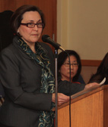

“The feedback from participants has been very positive…we have been receiving numerous requests for more trainings.”

Elizabeth Blanco, Ed.D

Assistant Superintendent

Special Education Services

San Francisco Public Schools