**What if China employ lean hog future in Thirteen 5-year plan? Evidence from CME lean hogs future**

In 2018, the pork price soared in China due to African swine fever. The first case was found in August 3, 2018. In the following months, millions of pigs were killed because of the disease and hundreds of millions CNY loss was incurred. As a necessity on the table of Chinese people, pork has always affected the CPI index. After transmission, it is directly related to the expectations of inflation and the direction of macro-control policies. After the crazy increase of the price, people were talking more to establish a pork-related future market to prevent the price inflation in the future.

China, as the country with the largest number of slaughter pigs in the world, has a market size of over one trillion CNY, accounting for about 57.46% of the world's total slaughter. The upstream and downstream industrial chain of pigs involves feed, breeding, veterinary medicine, slaughter, food and other fields. There are tens of thousands of directly connected enterprises and more than 100 million employees. After the listing of hog futures, it will play an important role in improving China's hog price formation mechanism and assisting the industry to stabilize business profits. First, hog futures can provide a fair forward price for the industry. Breeding enterprises can adjust the scale of breeding by referring to the forward price to avoid cyclical sharp price fluctuations caused by blindly increasing or decreasing the number of stocks. Second, hog futures will provide risk management tools for the hog industry.

The United States is the second largest country in the world for hog breeding and consumption. The development of hog large-scale breeding and hog futures was earlier than China for many years. The pig industry chain mainly includes three links: production, slaughter, processing and consumption. From 1960s, USA had already launched the frozen pork belly future contract and the hog futures. After years of development, the market in USA is mature and provides lots of lessons for China market. After analyze American Lean hog futures, we can learn more information about the futures and will avoid detour in our practices in futures market and related risk management.

In recent years agricultural commodity markets have experienced heightened price volatility which can have significant implications on production, marketing, and risk management practices (Wang, Fausti and Qasmi, 2012). In this environment, Isengildina, Irwin and Good (2004) indicate many individuals rely on agricultural forecasts in their decision making and that the value of accurate information can be substantial.

In this paper, we will first introduce the history of pig industry in USA, Secondly, we will test the ARIMA-GARCH seasonality model and volatility for lean hog future. The third part mainly focuses on the confirmation of relationship between lean hog, corn and wheat. The fourth part is about the B-S model developed for lean hog future and the model calibration. In the fifth part, we will pay attention to the difficulties China will meet in the future.

1. **Pig industry development in USA**

In America, hog’s industry has three specialized enterprises: Farrow- to-Finish, Farrow-to-Feeder, and Feeder-to-Finish operations. The first enterprise is to produce piglet, raise piglets to mature pigs and then slaughter mature pigs. The second company is feed pigs and sell them to farrow. The third corporate buys the feeder pigs and then slaughter pigs. The first type of company controls the upstream and downstream. The second and third enterprises are responsible for different stages of pig cultivations and slaughter. They cooperate and streamline the pig’s production.

The pig industry usually takes around 10 months to grow a pig to slaughter weight from birth, with 4 months for breeding and gestation and 6 months to raise the litter to market weight.The first stage is farrow-to-wean stage, it will take average 3 weeks before piglets are weaned. In this stage, the piglets will grow to about 10 pounds from birth. The second stage is wean-to-feeder stage. Pigs in the second stage are fed to reach an average weight of about 40 pounds. However, since the protein injects varies, the pigs grows rate also change accordingly and the time in second stage is affected. The third stage is feeder-to-finish. In this phase, pigs will be fed until they reach around 280 pounds for slaughting. The Farrow-to-finish company will control all three stages. The Farrow-to-Feeder corporate is responsible for stage 1 and stage 2. The Feeder-to-Finish enterprise only focus on stage 3.

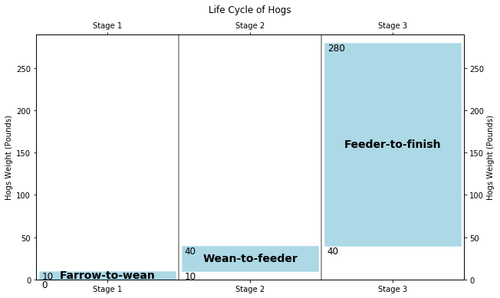

William D. and el mentioned that United States company in pig industry has structural change in increasing size and specialization of hog’s operation during 1992-2009. The quantity of Farrow-to-Finish companies decrease substantially during 1992-2004 and the specialized companies in Farrow-to-Feeder and Feeder-to-Finish increase. However, the increased quantity in Farrow-to-Feeder and Feeder-to-Finish companies is less than the quantity of decreased Farrow-to-Finish companies. The number of farms with hogs has declined as hog enterprises have grown larger. Large operations that specialize in a single phase of production have replaced farrow-to-finish operations that performed all phases of production. From 2004 to 2009 the shift toward operations specializing in a single phase of production slowed, and Farrow-to-Finish producers slightly increased their production share over this period. From 1992, the use of production contracts has increased. Operations producing under contract are larger than independent operations and are more likely to specialize in a single phase of production. Between 2004 and 2009, the share of hogs produced under contract grew slowly. From 1992 to 2004, the companies in pig industry increase their efficacy and productivity substantially because of large scale of production and technological innovation. However, individual and total factor productivity growth on feeder-to-finish farms, where most market hogs are produced, slowed considerably between 2004 and 2009.

Livestock production in China began to shift to a more commercialized mode in the 1990s (Fang et al., 2000). According to Ministry of Agriculture data, the share of hogs raised by small operations producing 50 or fewer hogs per year fell from over 90 percent during the 1980s to 32 percent in 2012. Somwaru, Zhang, and Tuan (2003) highlighted household-operated farms with 31-100 head as the most cost-efficient farm size, but most hogs are now raised on farms producing more than 100 head. Somwaru, Zhang, and Tuan identified large-scale farms as primarily state- and collective-owned, but large-scale company- and individually operated farms are now becoming common. The number of Chinese farms producing 5,000 or more hogs and pigs increased from 8,300 to 11,400 during 2009-12 (China Ministry of Agriculture, Livestock Industry Yearbooks 2014). In China thirteen five-year plan, China government guide the agricultural modernization transformation from resource-intensive to technology-intensive, and realize an intensive, efficient, safe and sustainable modern agricultural development model. In hog industry, the traditional Farrow-to-Finish companies narrow their working scopes to smaller segmentations and pay more attentions to technology. More and more professional Farrow-to-Feeder and Feeder-to-Finish companies are established. The plan calls for enlarging the scale of farms in order to raise productivity and to make China’s hog producers more internationally competitive (China Ministry of Agriculture, 2016). China’s hog industry is now in an era of rapid consolidation similar to that experienced by the United States during the 20th century (see Van Arsdall, 1978; Fredeen and Harmon, 1983). The plan calls for increasing mechanization and automation on swine farms, shifting pork production to grain abundant regions, and upgrading supporting industries that supply breeding stock, feed, and veterinary drugs. The plan set objectives that include raising the share of hogs produced by farms of 500 or more head from 42 percent in 2014 to 52 percent in 2020. Exit of small-scale farms with low productivity and high production costs is likely to continue. Expansion by larger farms with high productivity may be constrained by land scarcity, costs of complying with environmental regulations, and limited supplies of investment capital and skilled farm managers. China current hog industry is more similar with the USA hog industry from 1992 to 2004.

United States founded its hogs related derivatives in 1980s. During 1992 – 2004, the derivatives markets were developed well. China hog industry is going through the United States hog industry development during 1992 – 2004. The paper will focus on the performance of lean hogs futures from 1992 to 2004.

Contract Specs

Some important characteristics of the lean hog futures contract are as follows. (Source: Bloomberg)

|  |  |
| --- | --- |
| **Item** | **Contract Specs** |
| Ticker Symbol | LH |
| Exchange | Chicago Mercantile Exchange (CME) |
| Trading Hours | 10:05 AM to 2:00 PM EST |
| Contract Size | 40,000 pounds |
| Contract Months | Feb, Apr, May, Jun, Jul, Aug, Oct, and Dec. |
| Price Quote | price per pound |
| Tick Size | $0.00025 or 2.5 cents per pound = $10.00 (0.00025 x 40,000 lbs). |
| Last Trading Day | The tenth business day of the contract month |

The Lean hogs futures’ daily data are collected from Bloomberg from 1988 to 2019. The below image shows the futures’ daily movement, moving average volatility and daily return. The first image is about daily close price. The daily close price is not stationary and has no obvious trend. The second part is annualized volatility. The volatility has strong clustering effect according to the image. The lower part is about future return. The future return is calculated by log return and is seemingly stationary. The following article will test the future return for Seasonal ARIMA and GARCH model for more details.

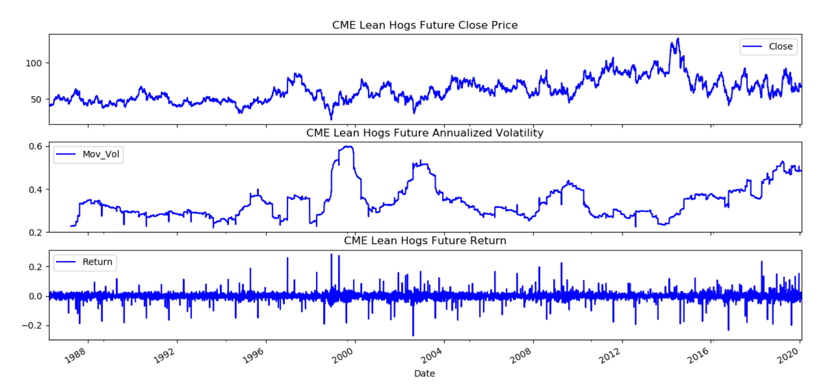

the daily log return is resampled to monthly data and multiple 100. The monthly data summary information is also shown as below. The skewness is between -0.5 and 0.5, the data are fairly symmetrical. The kurtosis is greater than zero, then the distribution has heavier tails. The distribution image shows that the distribution is fairly symmetrical and has heavy tail.

|  |  |
| --- | --- |
| **Summary** | **Details** |
| Count | 406 |
| Mean | 0.011480 |
| Std | 0.496453 |
| Min | -2.349821 |
| 25% | -0.271369 |
| 50% | 0.035296 |
| 75% | 0.307121 |
| Max | 1.566891 |
| Skewness | -0.203338 |
| Kurtosis | 1.430991 |

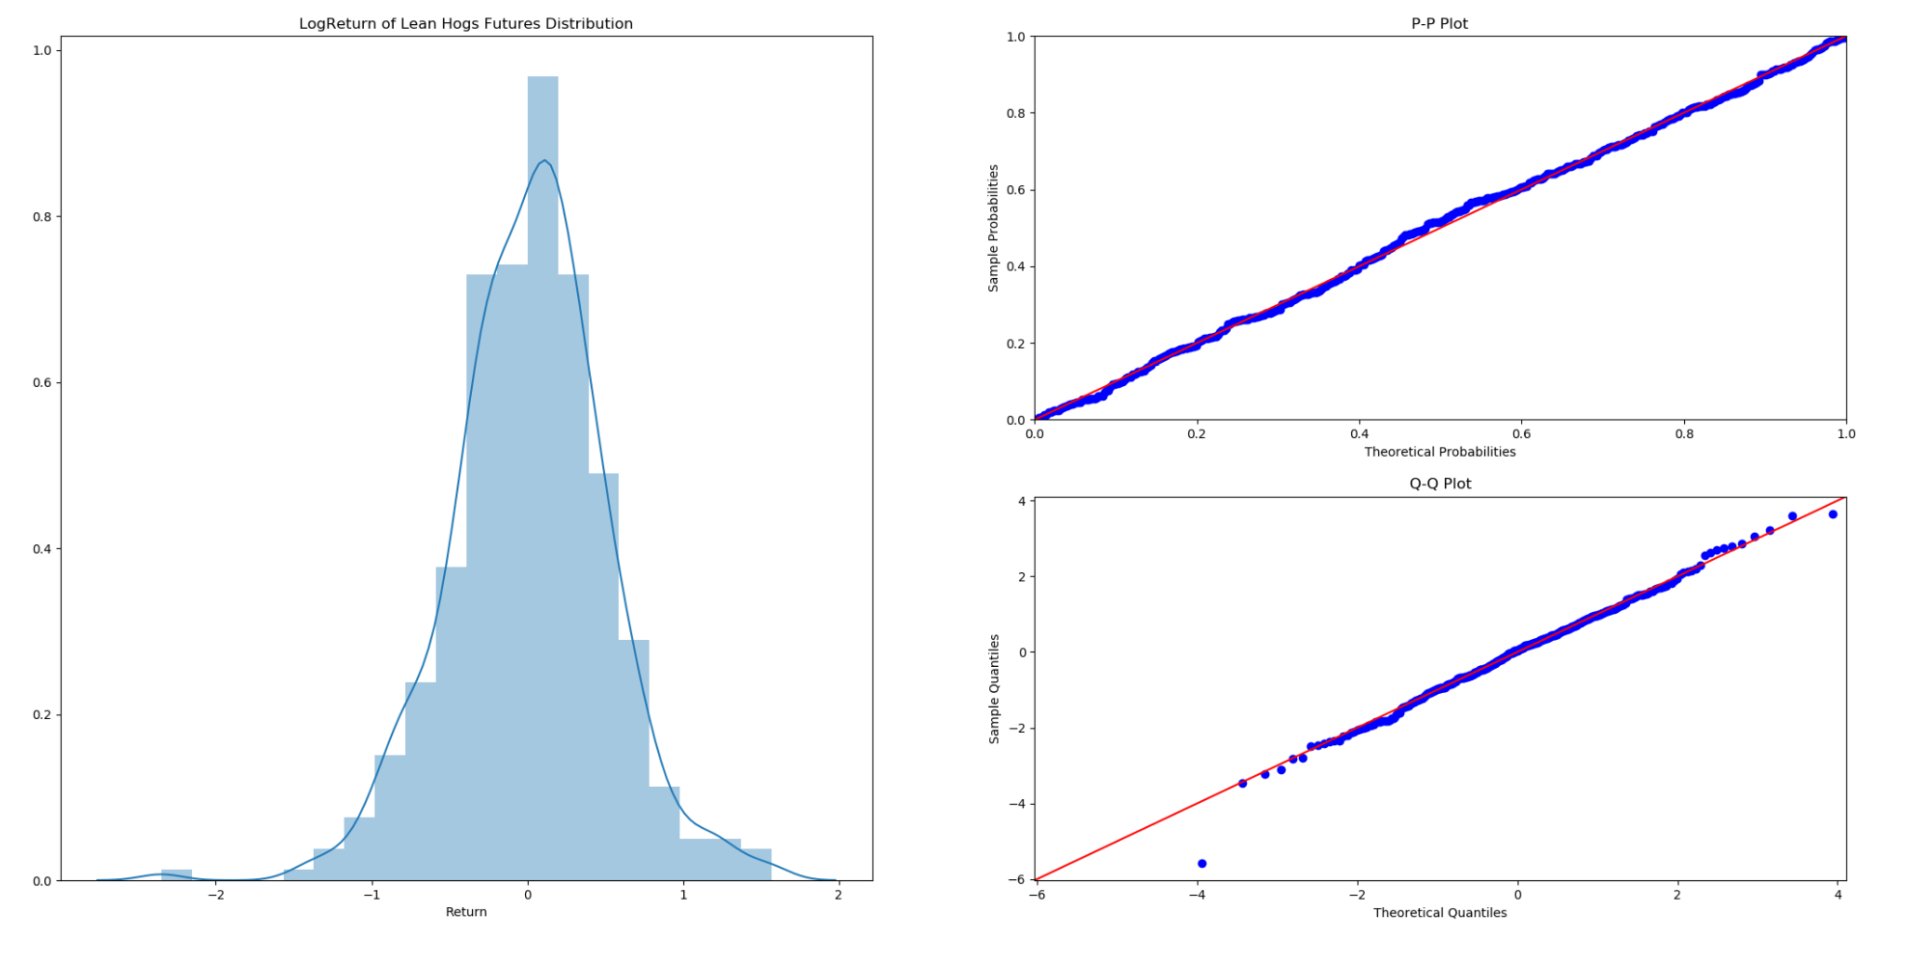

In order to confirm the lean hogs futures log return is stationary, several unit root tests are conducted as below. Before unit root tests, VR tests was performed to test whether the return series is a pure random walk versus having some predictability. P-value is smaller than 0.05 and the null hypothesis that the series is a pure random walk is rejected. The tests of unit roots and stationarity with ADF, KPSS, DFGLS, PP and ZA statistics are all shown that the time series is stationary.

|  |  |  |  |  |  |  |
| --- | --- | --- | --- | --- | --- | --- |
|  | **Variance-Ratio Test** | **Augmented Dickey-Fuller** | **KPSS** | **Dickey-Fuller GLS** | **Phillips-Perron** | **Zivot-Andrews** |
| **Test Statistic** | -4.532 | -5.584 | 0.030 | -2.145 | -24.684 | -5.838 |
| **p-value** | 0.000 | 0.000 | 0.977 | 0.032 | 0.000 | 0.001 |
| **Lags used** | 12 | 15 | 9 | 15 | 18 | 15 |
| **1%** |  | -3.45 | 0.74 | -2.62 | -3.45 | -5.28 |
| **5%** |  | -2.87 | 0.46 | -2.00 | -2.87 | -4.81 |
| **10%** |  | -2.57 | 0.35 | -1.68 | -2.57 | -4.57 |

1. Seasonality ARIMA test for lean hogs future

According to US meat consumption data, chicken and beef consumption account for a relatively large proportion, and pork consumption ranks third in meat consumption. Its consumption has maintained a steady and small increase in recent years. (美国猪肉消费周期性的统计数据证据)

2.1 Seasonal ARIMA Introduction

ARIMA is an acronym for AutoRegressive Integrated Moving. The full model can be written as

Where is the differenced series (it may have been differenced more than once). The “predictors” on the right hand side include both lagged values of and lagged errors. This is an **ARIMA(p, d, q) model**, where

|  |
| --- |
| p = order of the autoregressive part; |
| d = degree of first differencing involved; |
| q = order of the moving average part. |

A seasonal ARIMA model is formed by including additional seasonal terms in the ARIMA models. It is written as follows:

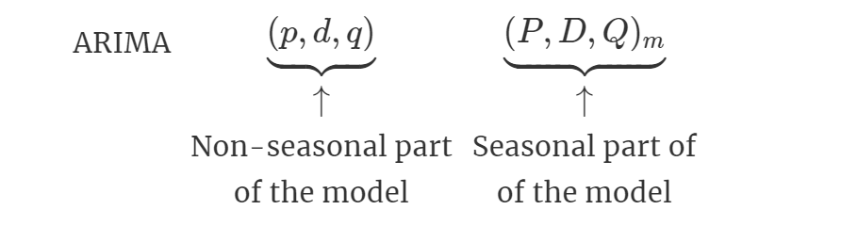

where . We use uppercase notation for the seasonal parts of the model, and lowercase notation for the non-seasonal parts of the model.

The seasonal part of the model consists of terms that are similar to the non-seasonal components of the model but involve backshifts of the seasonal period. For example, an model (without a constant) is for quarterly data ( ), and can be written as

The additional seasonal terms are simply multiplied by the non-seasonal terms.

**2.2 Seasonal ARIMA Test**

The test data is monthly log return of lean hogs future, which is stationary shown in the part 1. The below image is generated by sm.tsa.seasonal_decompose command. This image decomposes the lean hogs future return time-series into three distinct components: trend, seasonality, and noise. Analyzing the chart, the time-series has seasonality pattern is obviously observed. First quarter in each year has a peak of price for years. There is a random trend over the years.

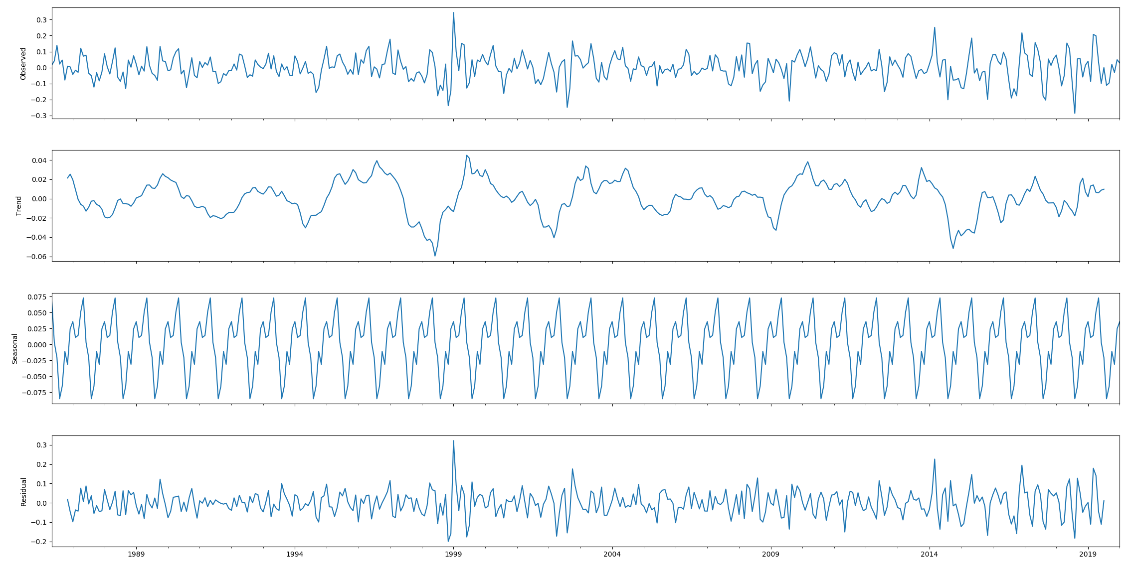

The left figure gives the ACF of log return of Lean Hogs Futures series. The significant spike at lag 1 in the ACF and PACF suggests a non-seasonal MA(1) component, and the significant spike at lag 12 in the ACF suggests a seasonal MA(1) component. Notice that in the regular part there is decay in the AR structure, whereas in lags 12, 24, 36, a slow decay is observed in the coefficients, indicating the presence of a 12 period seasonal component. The right figure shows an exponential decay occurs in the seasonal lags of the PACF. Therefore, model is selected.

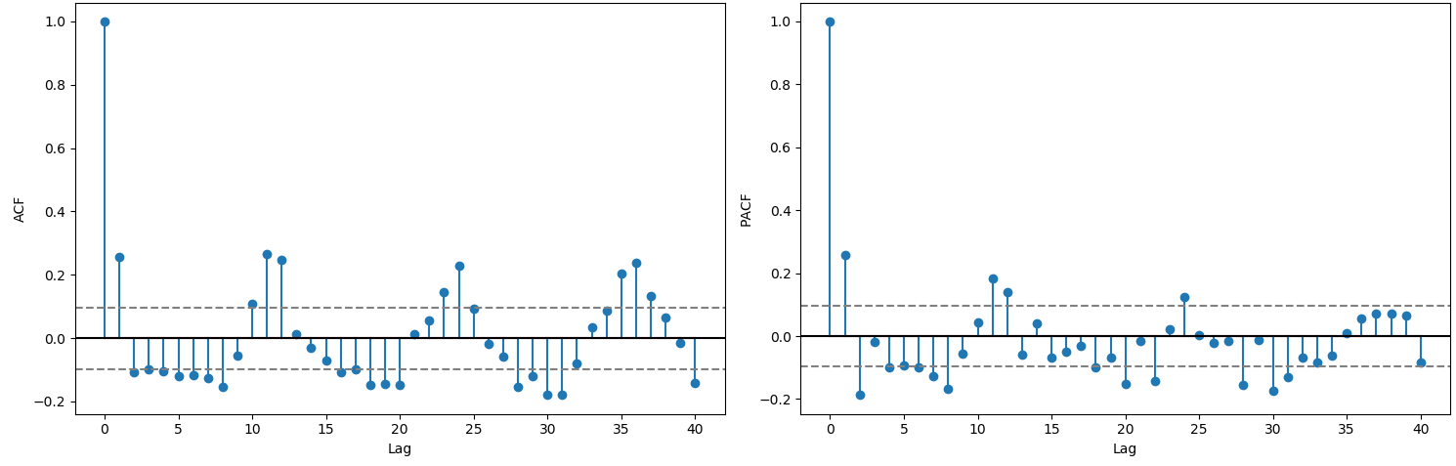

The fitted model coefficient and other information are displayed below.

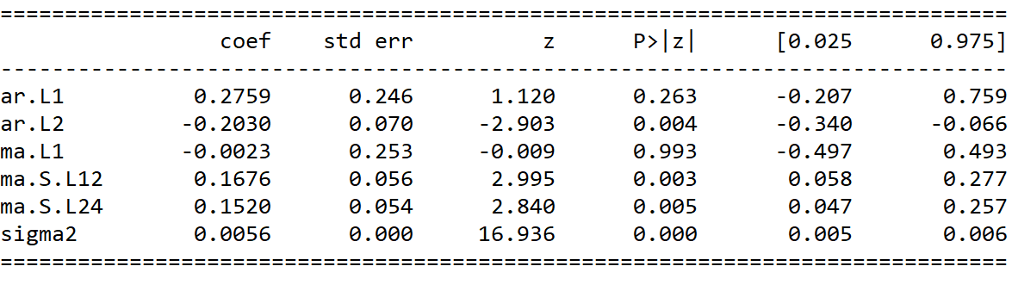

The residual of the model is stationary, but has volatility clustering effect in sub-figure 1. It means that lean hogs future may accommodate to GARCH model. The residual is conform to Normal distribution but has heavy tails based upon the sub-figure 2 and sub-figure 3. ACF of residual shows no obvious autocorrelation effect. In third part, the article will test the GARCH model.

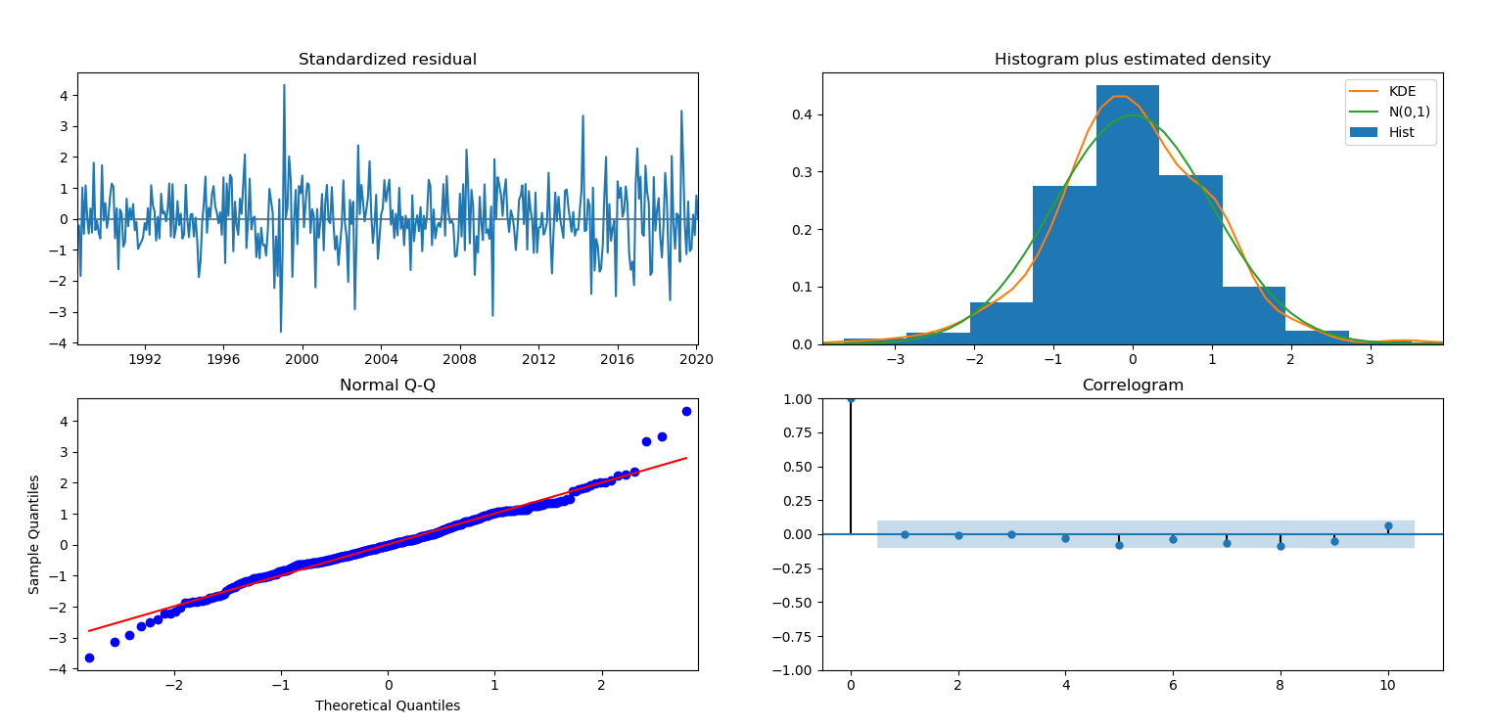

One step ahead forecast consists in comparing the true values with the forecast predictions. The below figure shows that the data trend is well predicated. In seasonal ARIMA model, the Mean Squared Error is 0.01, and the Root Mean Squared Error is 0.09.

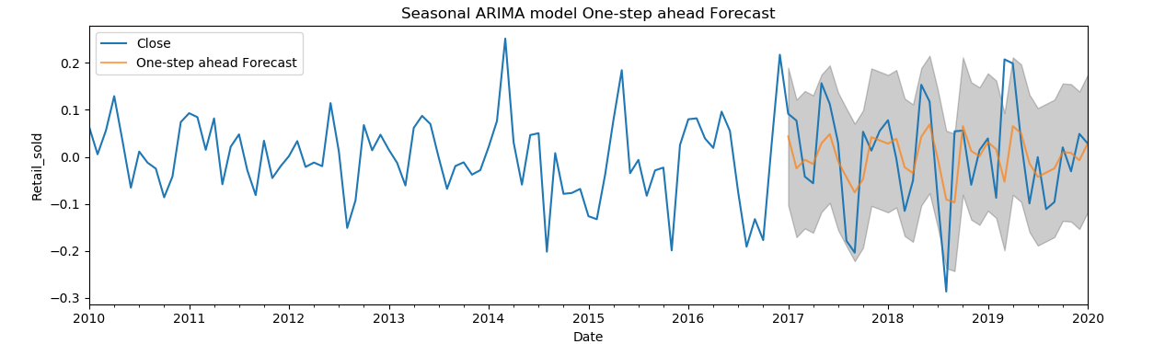

According to this part, lean hogs future shows strong seasonal effect. The price starts to go high at the beginning of year. After the first quarter, the price then goes down. Pork is one of major meat consumed in China. The seasonal effect will bring huge influence to China market. When China decides to begin lean hogs future, it is best for Chinese investors to be careful about the cyclical effect in lean hog future. The investors should hedge the future before the price goes high.

Seasonal ARIMA model predicts a right trend of future return and has a good performance in predication. As a precautionary method, investors should use advanced tools to predicate the fluctuation in case of market disorder.

Government should establish an ordering market and prevent the investors from disrupting the market. Government should employ an efficient method to curb the price when price has momentum to become abnormal.

1. **GARCH Volatility Tests for lean hogs future**

**GARCH Model**

Financial markets data often exhibit volatility clustering, where time series show periods of high volatility and periods of low volatility. ARMA models are used to model the conditional expectation of a process given the past, but in an ARMA model the conditional variance given the past is constant. GARCH model is a better time series models to model the nonconstant volatility. GARCH model is developed on ARCH model basis. ARCH is an acronym meaning AutoRegressive Conditional Heteroscedasticity. In ARCH models the conditional variance has a structure very similar to the structure of the conditional expectation in an AR model.

ARCH(p) model is simply an AR(p) model applied to the variance of a time series. let be Gaussian white noise with unit variance. Then is an ARCH(q) process if

,

where

is the conditional standard deviation of given the past values of this process. A deficiency of ARCH(q) models is that the conditional standard deviation process has high-frequency oscillations with high volatility coming in short bursts. GARCH models permit a wider range of behavior, in particular, more persistent volatility. The GARCH(p, q) model is

,

Where

Because past values of the process are fed back into the present value, the conditional standard deviation can exhibit more persistent periods of high or low volatility than seen in an ARCH process.

1. **VAR test for lean hogs futures and other futures**

In the last two parts, the paper focuses on the time series analysis of lean hogs future. In the following parts, the paper will concentrate on the correlation between different industries such as corn (pigs’ feeds) and cattle (pigs’ competitors). More experience will be unveiled by analyzing the influence from corn and cattle.

Pigs cultivation need feeds. In place of large volumes of coarse fodders and wastes, hog producers are using feeds that contain corn and soybean meal as the chief ingredients. The price of corn has a strong correlation with lean hog futures because hogs eat corn. China-U.S. comparisons show that hog producers in China face higher feed and labor costs than U.S. producers. (Fred Gale, 2017) The pigs’ price is affected by feed. High feed price contributes to high pigs’ price. After pig grows mature and meet the requirement of market, the future of the lean hogs will become more expensive. However, some analysts believe that corn and pigs have a negative correlation when price fluctuates. If the price of corn rises substantially, farmers tend to take their hogs to market at lower weights (younger) to avoid high feed costs. At these times, lean hog futures prices tend to drop due to increased supplies. (Chuck Kowalsk, 2020)

As an alternative to pork, beef price is another important reason for pork price fluctuation. In China, people will buy beef in place of pork when they feel the price of pork is out of their tolerance scope. This economic rule also applies for the meat consumption in United States. Beef and pork enjoy an obvious negative correlation.

This part will examine the relationships among pigs, corn and cattle. The data are from Bloomberg and they are lean hogs futures, live cattle futures and corn futures. The ticker of live cattle futures and corn futures in Bloomberg are Generic 1st ‘LC’ Future and Generic 1st ‘C’ future. Based upon the analysis of part 1, the data time scope of live cattle futures and corn futures is also from 1992 to 2004. The test method is Vector Autoregressive model.

**Vector Autoregressive Model**

A Vector autoregressive (VAR) model is useful when one is interested in predicting multiple time series variables using a single model. At its core, the VAR model is an extension of the univariate autoregressive model from ARIMA model. The vector autoregression (VAR) model extends the idea of univariate autoregression to time series regressions, where the lagged values of all series appear as regressors. Put differently, in a VAR model we regress a vector of time series variables on lagged vectors of these variables. As for AR(p) models, the lag order is denoted by so the VAR(p) model of two variables and ( ) is given by the equations

The s and s can be estimated using OLS on each equation. The assumptions for VARs are the time series assumptions presented in ARIMA model.

1. Worldwide influence of lean hogs futures

By now, this paper only analyzes the lean hogs futures of Chicago Mercantile Exchange and the relationship among lean hogs futures, corn and cattle. Except for the analysis, the international relationship is also an important research point. The increasing development of globalization is an important factor directly related to the development prospects of the world economy. So far, the exchanges that have carried out futures trading on the world futures market mainly include the Chicago Mercantile Exchange, European Energy Exchange, and Korea Exchange. Science and technology are changing with each passing day, multinational corporations are developing rapidly, the interdependence and influence of the economies of various countries are deepening, and the process of globalization is significantly accelerating. Economic and trade activities between countries and regions continue to increase. If Korea suffers from the short supply of pork. It can import pork from other country like United States, Germany and China. China too. The lean hogs futures in three markets will influence on another and eventually they will share the same fluctuation.

Korean lean hog futures start from 2008. Due to the short history, Bloomberg does not contain sufficient data for test. Regarding Europe Energy Exchange Lean hog futures, Bloomberg provides enough data. However European data does not cover the period concluded in part 1. In order to find out the relationship among countries, this part will unleash the period constrain on data. The test method is Ordinary least squares regression. Ordinary least squares (OLS) regression is a statistical method of analysis that estimates the relationship between one or more independent variables and a dependent variable; the method estimates the relationship by minimizing the sum of the squares in the difference between the observed and predicted values of the dependent variable configured as a straight line.

1. Conclusion

However, it is very difficult to start the lean hog future from scratch. The first obstacle is that the future contracts is very hard to standardize. Due to the large and scattered production of pigs in China and the limitation of the trading radius brought by the regional production of pigs, there is a large difference in pig breeds and quality. It is not easy to standardize the indicators of pig breeds, weight, and thickness thing. These differences bring difficulty to the setting of the delivery grade in the contract design. In the actual delivery process after the contract is launched, how many pig products can meet the delivery standards is also unknown. The second reason is the delivery difficulties. As a livestock and fresh agricultural product futures, hog futures are different from the traditional storage-resistant futures varieties. In the process of physical delivery, there are often more operational obstacles and risks. For example, the storage problem of live pigs during live transportation, and the more difficult risk of pig epidemic transmission. May wish to learn from other countries. In the 1960s, the US hog futures contract was listed, and the delivery method was physical delivery. By the end of the last century, the subject matter of the contract had changed from hogs to lean ketones, and the delivery method had become cash settlement. For 30 years, pigs were the target. In addition, the German Hannover Exchange (RMX) and the Korean Exchange (KRX) also have lean hog futures listed on the exchange, and the two have adopted cash delivery since the launch. The settlement price mainly depends on the spot price. index. In fact, these obstacles exist more or less in other countries, but they have not affected the United States, Germany and South Korea and other countries to eventually launch pig futures. Facts have shown that the listing of pig futures on the Chicago Mercantile Exchange in February 1966 further accelerated the scale operation and industrial integration of the pig industry. Thirty years later, in the mid-1990s, 70% of the pigs in the United States were able to meet futures delivery standards. Similar results have been seen in other varieties of futures markets in China.

Schulz, L. 2019, "Lean hog futures overly positive", Corn & Soybean Digest (Online Exclusive), .