|  |  |
| --- | --- |
| **Please add the following information to your cover page of the final report. Project Title** | **What if China employ lean hog future? Evidence from CME lean hog future** |
| **Name** | **SU Yulu** |
| **Student ID** | **A0182009L** |
|  | |
| - Data collection | 6 hours |
| - Literature review | 16 hours |
| - Programming and Statistics Testing | 38 hours |
| - Market Study | 18 hours |
| - Report Writing | 30 hours |
| **Total workload** | **108 hours** |
|  |  |
| **Original contribution** | - **Provide a thorough** **Introduction the hog industry in the United States and China,**  - **Prove the current stage of China hog industry in comparison with the United States industry,**  - **Study the different characteristics of CME lean hog futures,**  **- Determine the model’s efficiency on predication of CME lean hog futures,**  **- Give advice to China market based upon the United States market experience.** |

**What if China employ lean hog future? Evidence from CME lean hog future**

**Abstracts**

Lean hog future is created by CME in 1980s’ and it is a hedging instrument designed to assist pork industry to stabilize the pork price. China market suffered pork price increasing in 2018. The China government is researching to launch lean hog future to stabilize the pork industry. This article examines the development stage of China pork industry in comparison with the United States pork market. By analyzing historical data of CME lean hog future and other futures, this article helps researchers to understand the characteristics of lean hog futures and gives suggestions to China pork industry participants.

**Keywords**

Lean Hog Future, China, the United States, Corn Future, Live Cattle Future, South Korea, Seasonal AutoRegressive Integrated Moving Average (SARIMA), Generalized AutoRegressive Conditional Heteroskedasticity (GARCH), Vector AutoRegressive (VAR), predication

1. **Introduction**

In 2018, the pork price surged in China due to African swine fever. The first case was found in August 3, 2018. In the following months, millions of pigs were killed because of the disease and hundreds of millions CNY loss was incurred. As a necessity on the table of Chinese people, pork has always affected the CPI index. After transmission, it is directly related to the expectations of inflation and the direction of macro-control policies. After the crazy increase of the price, people were talking more to establish a pork-related future market to prevent the price inflation in the future.

China, as the country with the largest number of slaughter pigs in the world, has a market size of over one trillion CNY, accounting for about 57.46% of the world's total slaughter. The upstream and downstream industrial chain of pigs involves feed, breeding, veterinary medicine, slaughter, food and other fields. There are tens of thousands of directly connected enterprises and more than 100 million employees. After the listing of hog futures, it will play an important role in improving China's hog price formation mechanism and assisting the industry to stabilize business profits. First, hog futures can provide a fair forward price for the industry. Breeding enterprises can adjust the scale of breeding by referring to the forward price to avoid cyclical sharp price fluctuations caused by blindly increasing or decreasing the number of stocks. Second, hog futures will provide risk management tools for the hog industry.

The United States is the second largest country in the world for hog breeding and consumption. The development of hog large-scale breeding and hog futures was earlier than China for many years. The pig industry chain mainly includes three links: production, slaughter, processing and consumption. From 1960s, USA had already launched the frozen pork belly future contract and the hog futures. After years of development, the market in USA is mature and provides lots of lessons for China market. After analyzing American Lean hog futures, we can learn more information about the futures and will avoid detour in our practices in futures market and related risk management.

In recent years agricultural commodity markets have experienced increased price volatility which can have significant influence on production, marketing, and risk management practices (Wang, Fausti and Qasmi, 2012). In this environment, Isengildina, Irwin and Good (2004) indicate many individuals rely on agricultural forecasts in their decision making and that the value of accurate information can be substantial. It is important for investors to understand the characteristics of pork industry and lean hog future. Since China has no lean hog future yet, we will find the CME lean hog future is a unique dataset for lean hog future research.

In this paper, we will first introduce the development history of pig industry in USA and compare the China pork industry development with USA pork industry. In the second and third part, we will test the seasonal ARIMA model and volatility of lean hog future. These two features are tested by historical data of lean hog future. The fourth part focuses on the relationship between lean hog, corn and live cattle. The corn is the feeder of pigs and live cattle is substitution of pigs. They can affect pork price. The fifth part, we discussed the relationship between lean hog futures in different countries and figure out whether they have correlation. The fourth and fifth parts involve the interaction of different futures. In the final part, we will summarize the article and pay attention to the difficulties China will meet.

1. **Pig industry development in USA**

In America, hog’s industry has three specialized enterprises: Farrow-to-Finish, Farrow-to-Feeder, and Feeder-to-Finish operations. The first enterprise is to produce piglet, raise piglets to mature pigs and then slaughter mature pigs. The second company is feed pigs and sell them to farrow. The third corporate buys the feeder pigs and then slaughter pigs. The first type of company controls the upstream and downstream. The second and third enterprises are responsible for different stages of pig cultivations and slaughter. They cooperate and streamline the pig’s production.

The pig industry usually takes around 10 months to grow a pig to slaughter weight from birth, with 4 months for breeding and gestation and 6 months to raise the litter to market weight.The first stage is farrow-to-wean stage, it will take average 3 weeks before piglets are weaned. In this stage, the piglets will grow to about 10 pounds from birth. The second stage is wean-to-feeder stage. Pigs in the second stage are fed to reach an average weight of about 40 pounds. However, since the protein injects varies, the pigs grows rate also change accordingly and the time in second stage is affected. The third stage is feeder-to-finish. In this phase, pigs will be fed until they reach around 280 pounds for slaughting. The Farrow-to-finish company will control all three stages. The Farrow-to-Feeder corporate is responsible for stage 1 and stage 2. The Feeder-to-Finish enterprise only focus on stage 3.

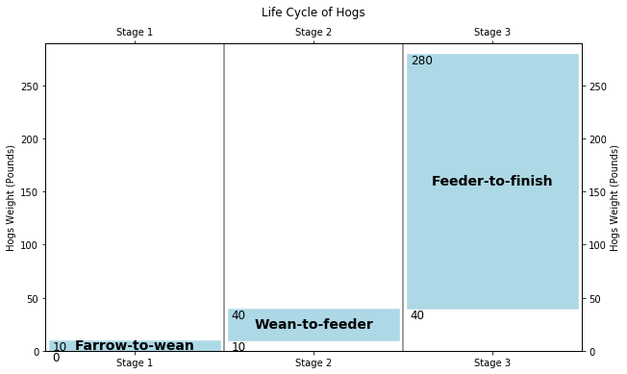

Figure 2-1. Life Cycle of Hogs

William D Mcbride and Nigel Key (2013) mentioned that The United States company in pig industry has structural change in increasing size and specialization of hog’s operation during 1992-2009. The quantity of Farrow-to-Finish companies decrease substantially during 1992-2004 and the specialized companies in Farrow-to-Feeder and Feeder-to-Finish increase. However, the increased quantity in Farrow-to-Feeder and Feeder-to-Finish companies is less than the quantity of decreased Farrow-to-Finish companies. The number of farms with hogs has declined as hog enterprises have grown larger. Large operations that specialize in a single phase of production have replaced farrow-to-finish operations that performed all phases of production. From 2004 to 2009 the shift toward operations specializing in a single phase of production slowed, and Farrow-to-Finish producers slightly increased their production share over this period. From 1992, the use of production contracts has increased. Operations producing under contract are larger than independent operations and are more likely to specialize in a single phase of production. Between 2004 and 2009, the share of hogs produced under contract grew slowly. From 1992 to 2004, the companies in pig industry increase their efficacy and productivity substantially because of large scale of production and technological innovation. However, individual and total factor productivity growth on feeder-to-finish farms, where most market hogs are produced, slowed considerably between 2004 and 2009.

Livestock production in China began to shift to a more commercialized mode in the 1990s (Fang et al., 2000). According to Ministry of Agriculture data, the share of hogs raised by small operations producing 50 or fewer hogs per year fell from over 90 percent during the 1980s to 32 percent in 2012. The number of Chinese farms producing 5,000 or more hogs and pigs increased from 8,300 to 11,400 during 2009-12 (China Ministry of Agriculture, Livestock Industry Yearbooks 2014). In China thirteen five-year plan, China government guide the agricultural modernization transformation from resource-intensive to technology-intensive, and realize an intensive, efficient, safe and sustainable modern agricultural development model. In hog industry, the traditional Farrow-to-Finish companies narrow their working scopes to smaller segmentations and pay more attentions to technology. More and more professional Farrow-to-Feeder and Feeder-to-Finish companies are established. The plan calls for increasing mechanization and automation on swine farms, shifting pork production to grain abundant regions, and upgrading supporting industries that supply breeding stock, feed, and veterinary drugs. The plan set objectives that include raising the share of hogs produced by farms of 500 or more head from 42 percent in 2014 to 52 percent in 2020. Exit of small-scale farms with low productivity and high production costs is likely to continue. Expansion by larger farms with high productivity may be constrained by land scarcity, costs of complying with environmental regulations, and limited supplies of investment capital and skilled farm managers. China’s hog industry is now in an era of rapid consolidation and is more similar with the USA hog industry from 1992 to 2004.

United States founded its hogs related derivatives in 1980s. During 1992 – 2004, the derivatives markets were developed well. China hog industry is going through the United States hog industry development during 1992 – 2004. The article will focus on the performance of lean hog futures from 1992 to 2004. Some important characteristics of the lean hog futures contract are in Table 1-1 (Source: Bloomberg).

Table 2-1. Contract Specs

|  |  |
| --- | --- |
| **Item** | **Contract Specs** |
| Ticker Symbol | LH |
| Exchange | Chicago Mercantile Exchange (CME) |
| Trading Hours | 10:05 AM to 2:00 PM EST |
| Contract Size | 40,000 pounds |
| Contract Months | Feb, Apr, May, Jun, Jul, Aug, Oct, and Dec. |
| Price Quote | price per pound |
| Tick Size | $0.00025 or 2.5 cents per pound = $10.00 (0.00025 x 40,000 lbs). |
| Last Trading Day | The tenth business day of the contract month |

The Lean hog futures’ daily data are collected from Bloomberg from 1992 to 2004. The Figure 1-2 shows the futures’ daily movement, moving average volatility and daily return. The first subplot in Figure 1-2 is about daily close price. The daily close price is not stationary and has no obvious trend. The second subplot is annualized volatility. The volatility has strong clustering effect according to the image. The third subplot is return of lean hog future. The future return is calculated by log return and is seemingly stationary. The following article will test the return of future in Seasonal ARIMA and GARCH model for more details.

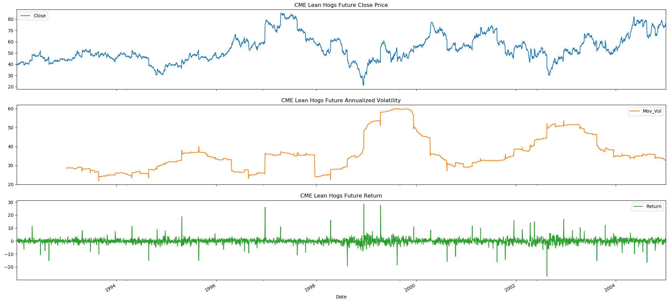

Figure 2-2. CME Lean Hog Future close price, annualized volatility and return

The daily log return is resampled to monthly data and multiple 100. The monthly data summary information is also shown as below. The skewness is between -0.5 and 0.5, the data are symmetrical. The kurtosis is greater than zero, then the distribution has heavier tails. The distribution image shows that the distribution is symmetrical and has heavy tail.

Table 2-2. Lean hog future statistics summary

|  |  |
| --- | --- |
| **Summary** | **Details** |
| Count | 155 |
| Mean | 0.401569 |
| Std | 8.187216 |
| Min | -24.911243 |
| 25% | -4.334213 |
| 50% | 0.432202 |
| 75% | 5.000366 |
| Max | 34.446780 |
| Skewness | 0.073770 |
| Kurtosis | 1.864762 |

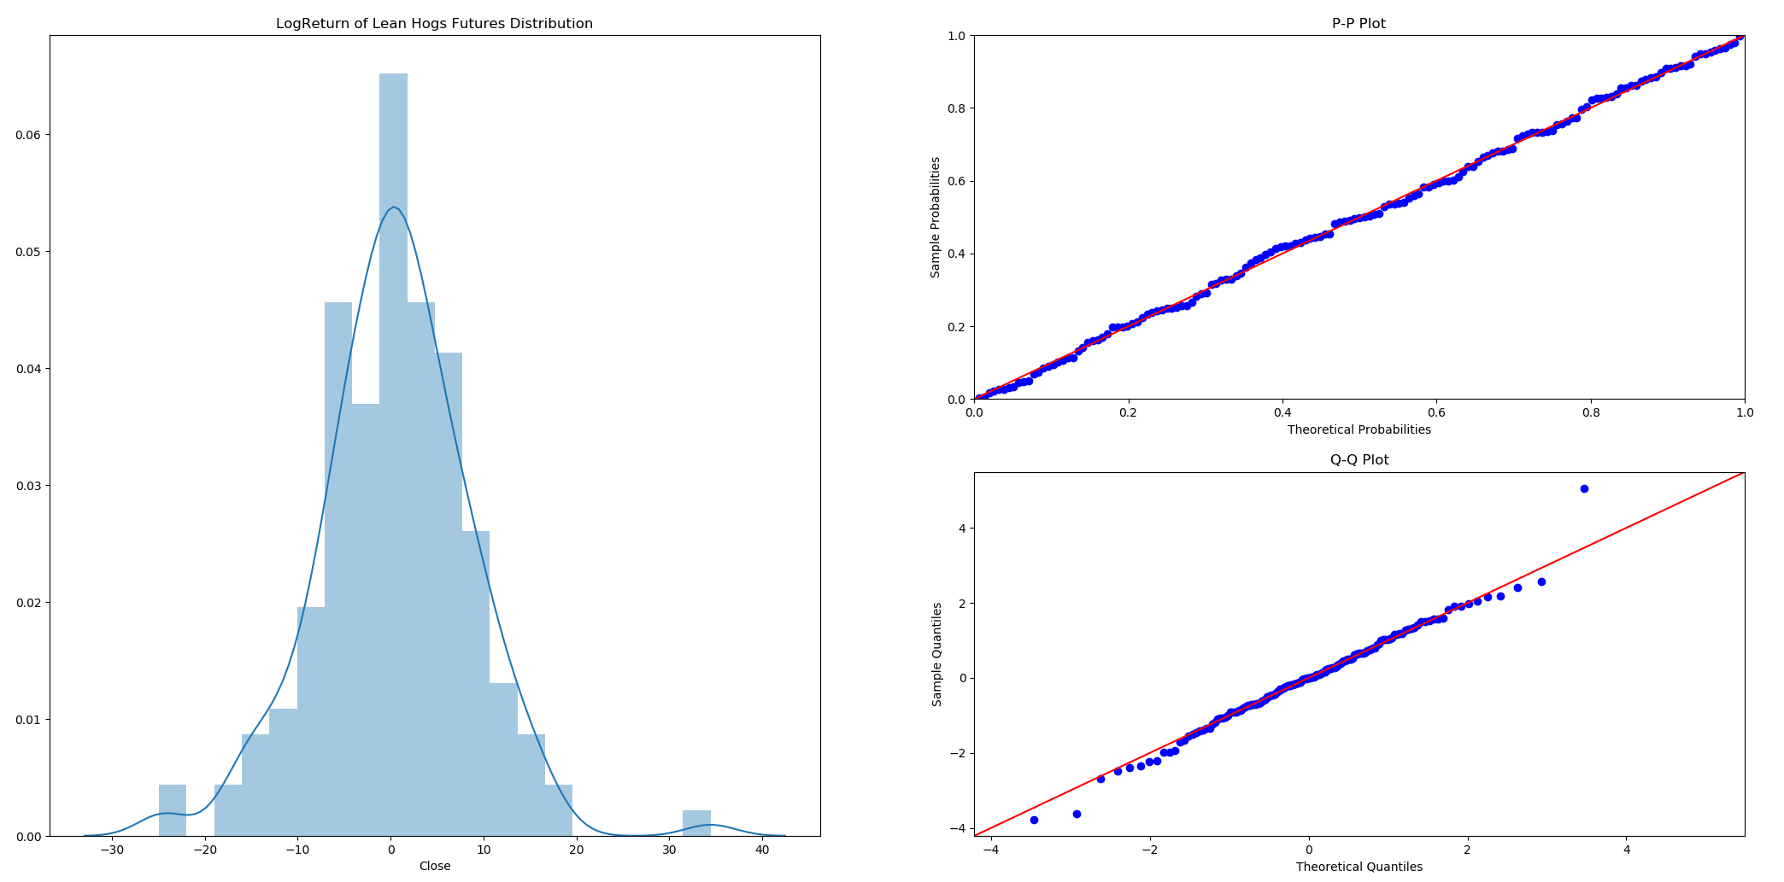

Figure 2-3. Log return of lean hog future histogram, P-P and Q-Q plot

In order to confirm the lean hogs futures log return is stationary, several unit root tests are conducted as below. Before unit root tests, VR tests was performed to test whether the return series is a pure random walk versus having some predictability. P-value is smaller than 0.05 and the null hypothesis that the series is a pure random walk is rejected. The tests of unit roots and stationarity with ADF, KPSS, DFGLS, Philips-Perron and ZA statistics shows that the time series is stationary.

Table 2-3. Unit root test of 100 times log return of lean hog future

|  |  |  |  |  |  |  |
| --- | --- | --- | --- | --- | --- | --- |
|  | **Variance-Ratio Test** | **Augmented Dickey-Fuller** | **KPSS** | **Dickey-Fuller GLS** | **Phillips-Perron** | **Zivot-Andrews** |
| **Test Statistic** | -2.210 | -3.150 | 0.043 | -2.665 | -9.049 | -3.937 |
| **p-value** | 0.027 | 0.023 | 0.916 | 0.008 | 0.000 | 0.390 |
| **Lags used** | 12 | 10 | 1 | 10 | 14 | 10 |
| **1%** |  | -3.48 | 0.74 | -2.70 | -3.47 | -5.28 |
| **5%** |  | -2.88 | 0.46 | -2.08 | -2.88 | -4.81 |
| **10%** |  | -2.58 | 0.35 | -1.77 | -2.58 | -4.57 |

1. **Seasonality ARIMA test for lean hog future**

In part 1, we understand that pigs have life cycle. It takes about 10 months for a pig to grow from birth to finish. The supply of pigs is subject to the life cycle of pigs. The price of pigs will also show the seasonal effect. In China, when the spring festive approaching, people will increase the consumption of meat including pork. The demand side also fluctuate according to season.

According to US meat consumption data, chicken and beef consumption account for a relatively large proportion, and pork consumption ranks third in meat consumption. Its consumption has maintained a steady and small increase in recent years. According to USDA Economic Research Service, hogs slaughter counts in commercial shows periodical changes in the below figure 2-1. In the part, we will test the seasonal effect of the lean hog future.

Figure 3-1. Commercial Hogs Slaughter Counts (1000 heads) [1]

3.1 Seasonal ARIMA Introduction

ARIMA is an acronym for AutoRegressive Integrated Moving Average. The full model can be written as

Where is the differenced series (it may have been differenced more than once). The “predictors” on the right hand side include both lagged values of and lagged errors. This is an **ARIMA(p, d, q) model**, where

|  |
| --- |
| p = order of the autoregressive part; |
| d = degree of first differencing involved; |
| q = order of the moving average part. |

A seasonal ARIMA model is formed by including additional seasonal terms in the ARIMA models. It is written as follows:

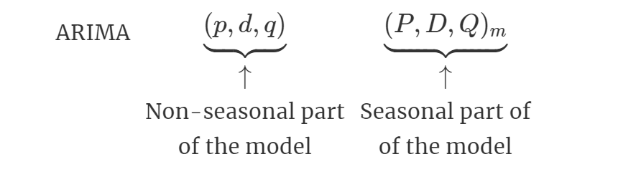

where . We use uppercase notation for the seasonal parts of the model, and lowercase notation for the non-seasonal parts of the model.

The seasonal part of the model consists of terms that are similar to the non-seasonal components of the model but involve backshifts of the seasonal period. For example, an model (without a constant) is for quarterly data ( ), and can be written as

The additional seasonal terms are simply multiplied by the non-seasonal terms.

3.2 Seasonal ARIMA Test

The test data is monthly log return of lean hog future, which is stationary shown in the part 1. The below figure 2-2 is generated by sm.tsa.seasonal_decompose function. This image decomposes the lean hog future return time-series into three distinct components: trend, seasonality, and noise. Analyzing the chart, the time-series has seasonality pattern is obviously observed. First quarter in each year has a peak of price for years. There is a random trend over the years.

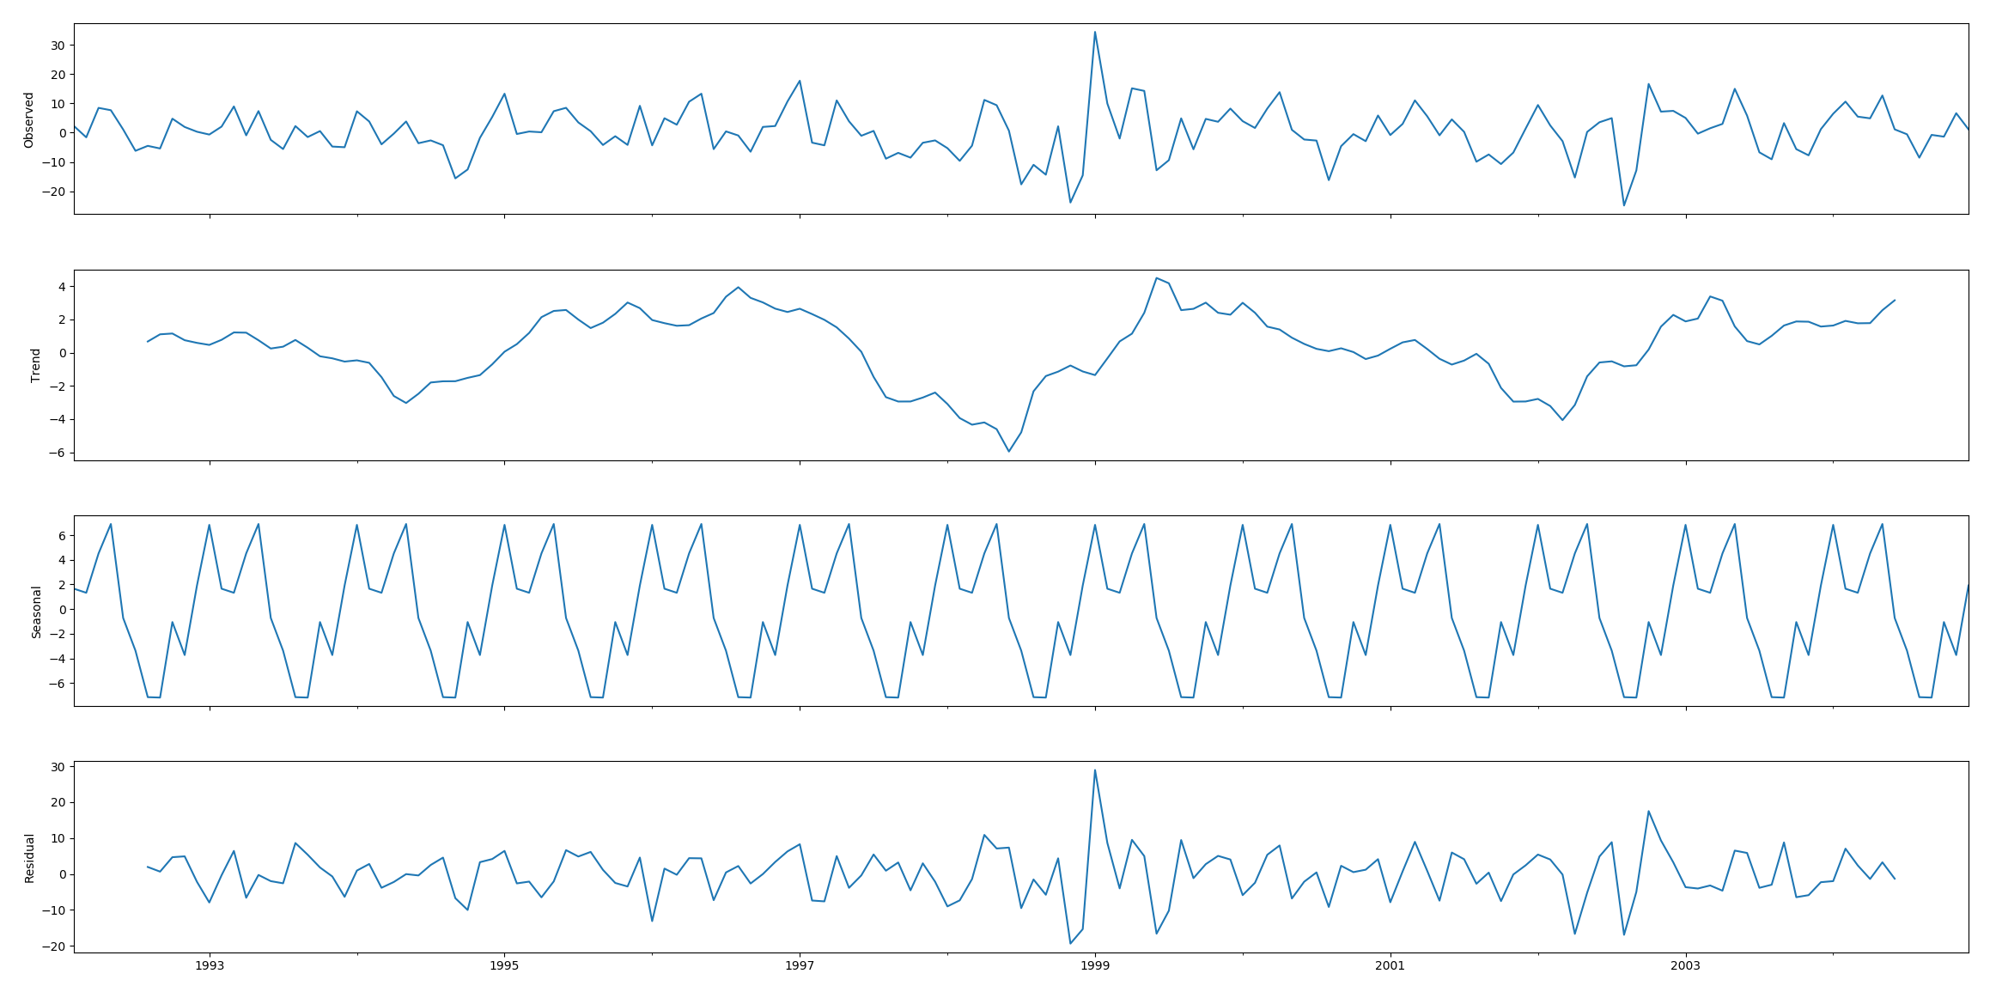

Figure 3-2. Lean hog future observed, trend, seasonal and residual

The left figure gives the ACF of log return of Lean Hogs Futures series. The significant spike at lag 1 in the ACF and PACF suggests a non-seasonal MA(1) component, and the significant spike at lag 12 in the ACF suggests a seasonal MA(1) component. Notice that in the regular part there is decay in the AR structure, whereas in lags 12, 24, 36, a slow decay is observed in the coefficients, indicating the presence of a 12-period seasonal component. The right figure shows an exponential decay occurs in the seasonal lags of the PACF. Therefore, model is selected.

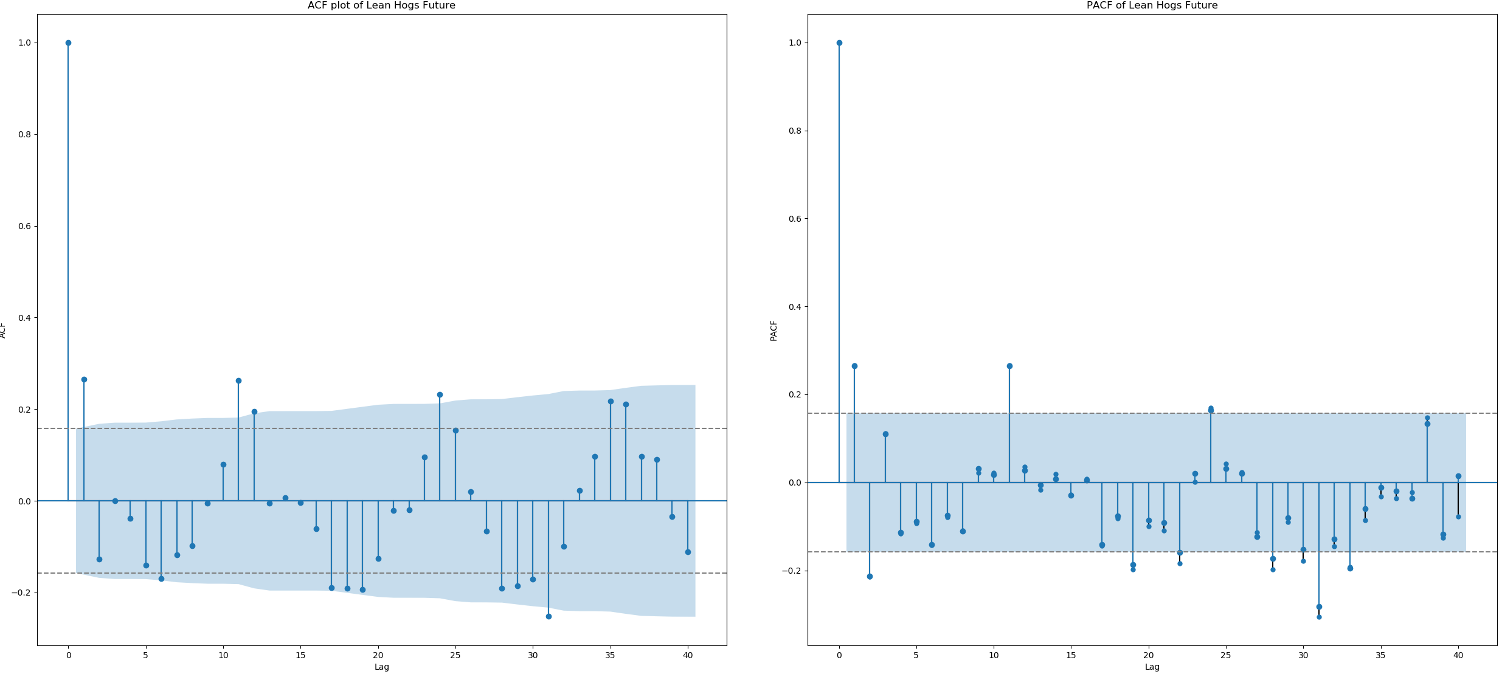

Figure 3-3. ACF and PACF of 100 times log return of Lean hog future

The fitted model coefficient and other information are displayed below.

Table 3-1. SARIMA Summary

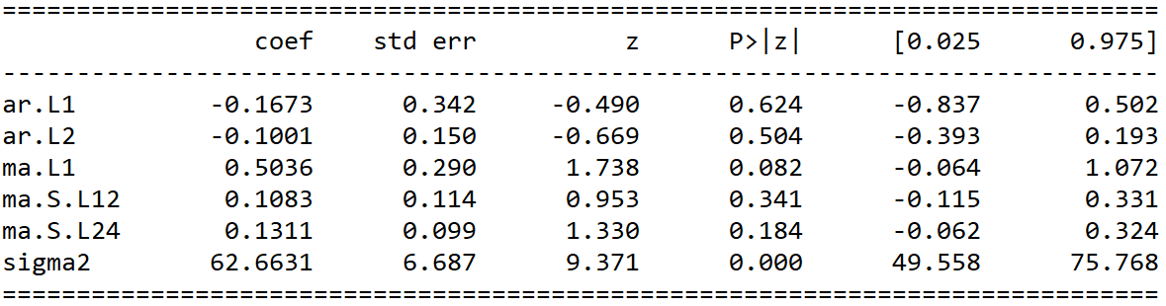

The residual of the model is stationary but has volatility clustering effect in sub-figure 1. It means that lean hogs future may accommodate to GARCH model. The residual is conforming to Normal distribution but has heavy tails based upon the sub-figure 2 and sub-figure 3. ACF of residual shows no obvious autocorrelation effect. In third part, the article will test the GARCH model.

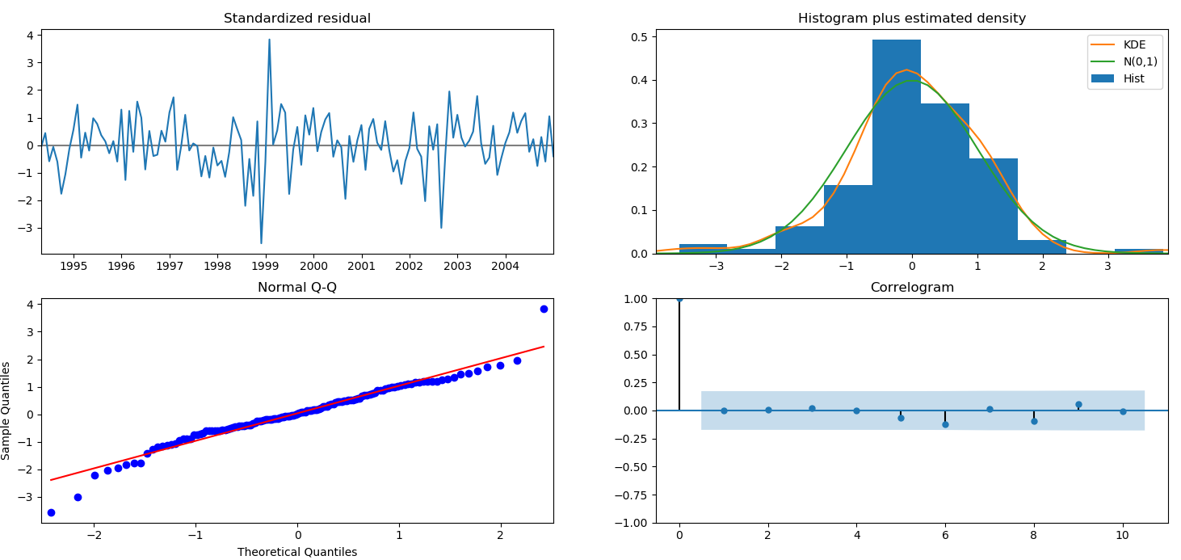

Figure 3-4. SARIMA Diagnosis

3.3 Predication and error

One step ahead forecast consists in comparing the true values with the forecast predictions. The training data set is from 1992 to 2003. The testing data set is from January 2004 to December 2004. The below figure shows that the data trend is well predicated. In seasonal ARIMA model, the mean squared error is 5.527.

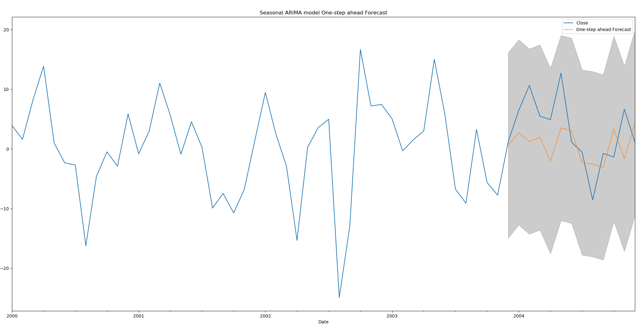

Figure 3-5. Seasonal ARIMA model one-step ahead forecast

3.4 Lessons

CME Lean hog future shows strong seasonal effect. If China market employs lean hog future, this part suggests that:

Pork is one of major meat consumed in China. The seasonal effect will bring huge influence on China market. The price starts to go high at the beginning of year. After the first quarter, the price then goes down It is best for Chinese investors to be careful about the seasonal effect in lean hog future. Investors can buy the futures when they are low and hedge the seasonal risk in advance.

Seasonal ARIMA model predicts a right trend of future return and has a good performance in predication. As a precautionary method, investors should use SARIMA and more advanced tools to predicate the fluctuation in case of market disorder. Accurate prediction models will help investors to predicate more correct results in the future. Investors should implement a well-organized plan to hedge the future risks and avoid predicated loss. Market managers should react properly to the peak season prediction. If the model shows that the futures price is a pinnacle, it may imply the supply and demand equilibrium is not balanced. Market managers should arrange enough supply of pork to meet the demand from market. Demanders can buy enough meat at a low price. If the model shows that the future price is a low area, it may indicate that the supply is more than demand. Market managers should decrease the market supply to sustain the pork price. The pork can be lucrative to the suppliers.

Market managers should establish market orders to prevent the arbitragers from disrupting the market. The arbitragers may deviate the market from normal level. When supply is less than demand, the price of future will increase. The arbitrage in the market will increase the price to abnormal level. Market managers should employ an efficient method to curb the price when price has momentum to become abnormal.

1. **GARCH Volatility Tests for lean hog future**

Financial markets data often exhibit volatility clustering, where time series show periods of high volatility and periods of low volatility. When financial market meets the shock, the market entries the high volatility period and the market will become less stable compared to previous market. Like that the object has inertia in Physics, in financial market the volatilities also have inertia. The volatilities will have lead-lag effects on future volatilities. In 2019, China hogs market encountered the diseases, the market tended to become more and more volatile. The price of hogs tended to become higher than before.

In previous chapter, the paper exams the ARIMA model. However, ARIMA model does not show the volatility of the time series. ARMA models are used to model the conditional expectation of a process given the past, but in an ARMA model the conditional variance given the past is constant. GARCH model is a better time series models to model the nonconstant volatility.

4.1 GARCH Model

GARCH model is developed on ARCH model basis. ARCH is an acronym meaning AutoRegressive Conditional Heteroscedasticity. In ARCH models the conditional variance has a structure very similar to the structure of the conditional expectation in an AR model.

ARCH(p) model is simply an AR(p) model applied to the variance of a time series. let be Gaussian white noise with unit variance. Then is an ARCH(q) process if

,

where

is the conditional standard deviation of given the past values of this process. A deficiency of ARCH(q) models is that the conditional standard deviation process has high-frequency oscillations with high volatility coming in short bursts. GARCH models permit a wider range of behavior, in particular, more persistent volatility. The GARCH(p, q) model is

,

Where

Because past values of the process are fed back into the present value, the conditional standard deviation can exhibit more persistent periods of high or low volatility than seen in an ARCH process.

* 1. GARCH Model Test

In 4.1 SARIMA model test, we got the residue and residue square in Figure 4-1. There are noticeable GARCH effects since the autocorrelations in the squared residuals are strong and the Box Ljung test has an extremely small p value 3.458e-05.

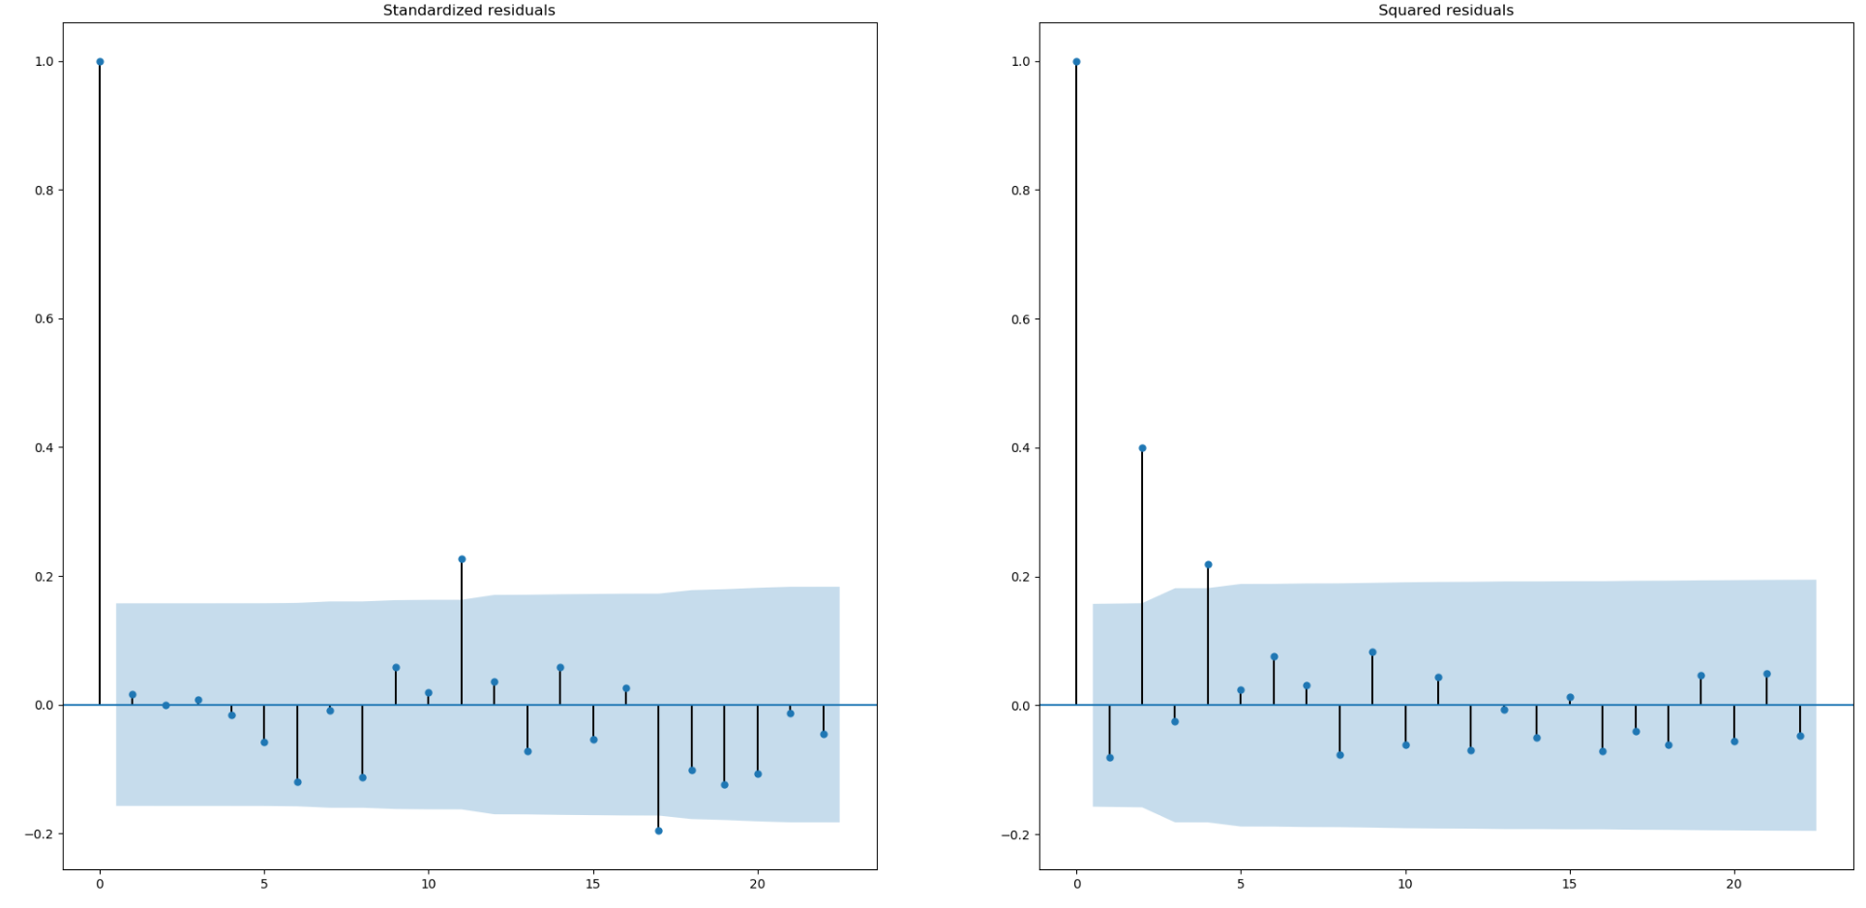

Figure 4-1. ACF of SARIMA residue and residue square

In Figure 4-2, CME lean hog futures’ prices in the past decades showing large fluctuations especially around the year 2014. with multiple cliff-like increases and decrease, the price remained at a relative low level. A clear evidence of significant serial auto-correlation in the original data can be seen from auto-correlation plot. The shape of the QQ and Probability plots indicate that the process is close to normality but with heavy tails.

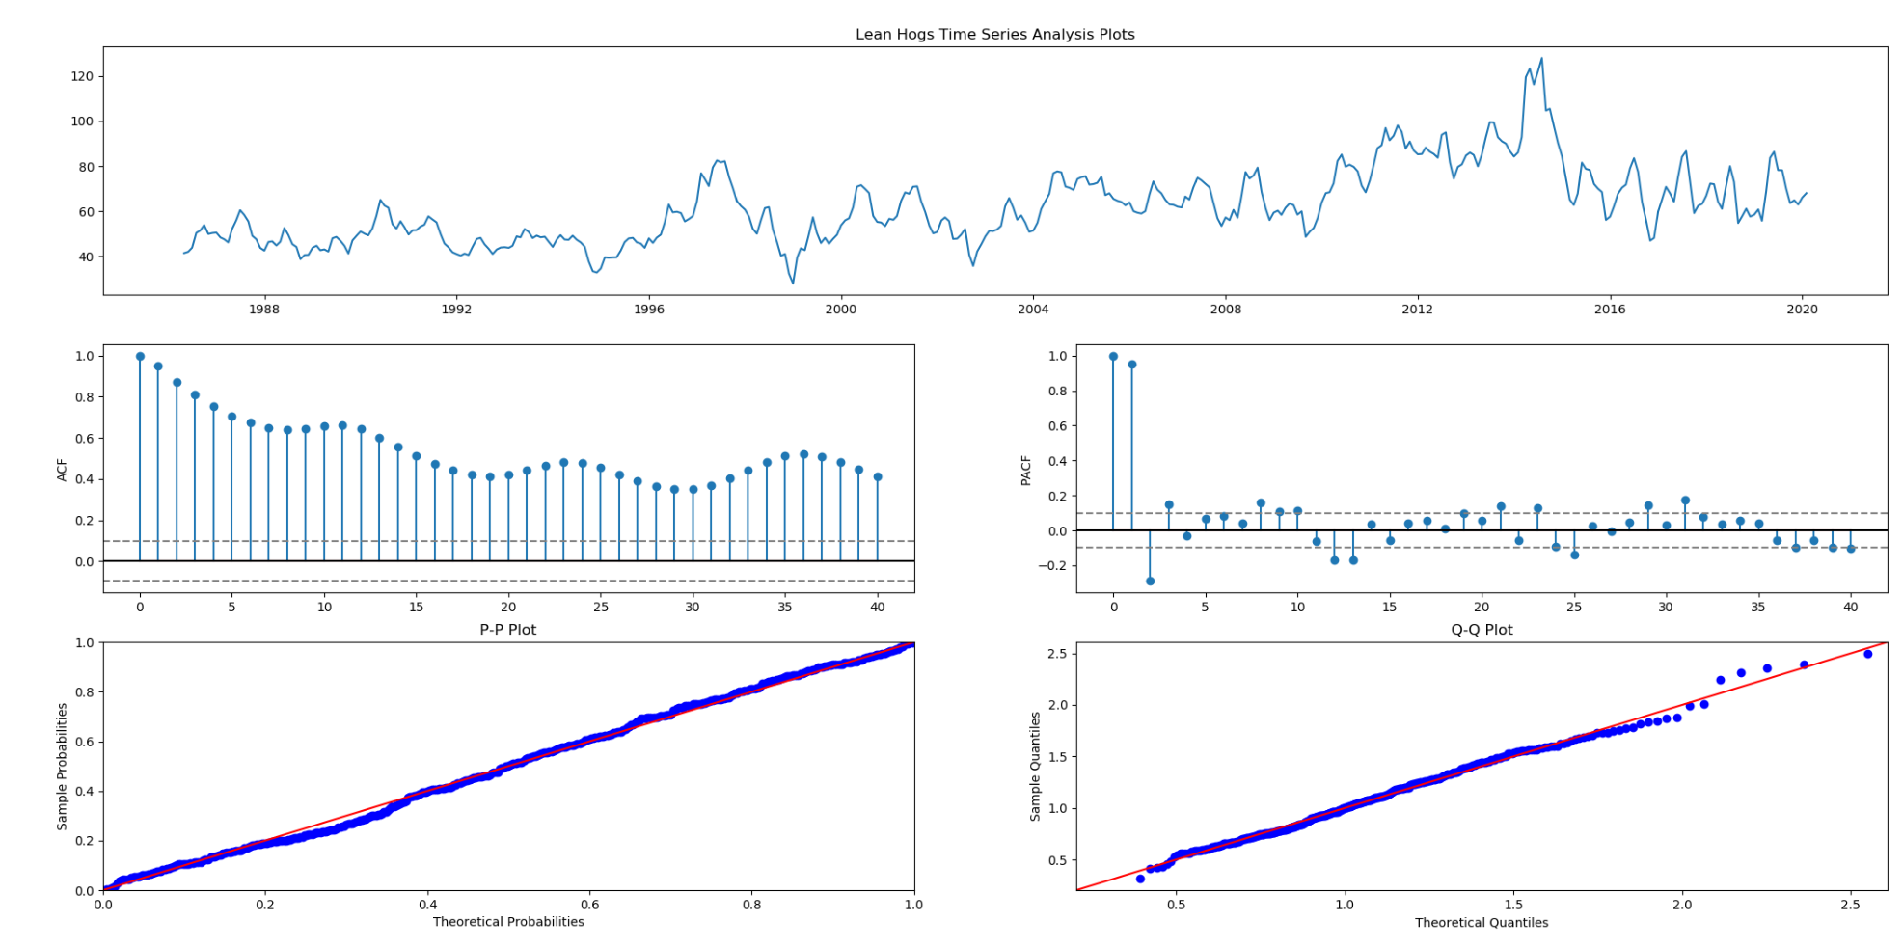

Figure 4-2. Lean hog future analysis

In Figure 4-3, the return series plot shows periods of high and low variability. A process of random and centered about zero can be seen in the plot. Both positive and negative returns with large amplitude fluctuation increase the difficulty of risk investment and management. The mean of monthly returns is substantially around the zero-level horizon with apparent volatility clustering, indicating the presence of heteroscedasticity. The ACF is small, serially uncorrelated, but highly dependent. The shape of the QQ and Probability plots show no significant changes. Lean Hogs Future log return’s skewness is -0.0344 and Lean Hogs Future log return’s kurtosis is 1.2687.

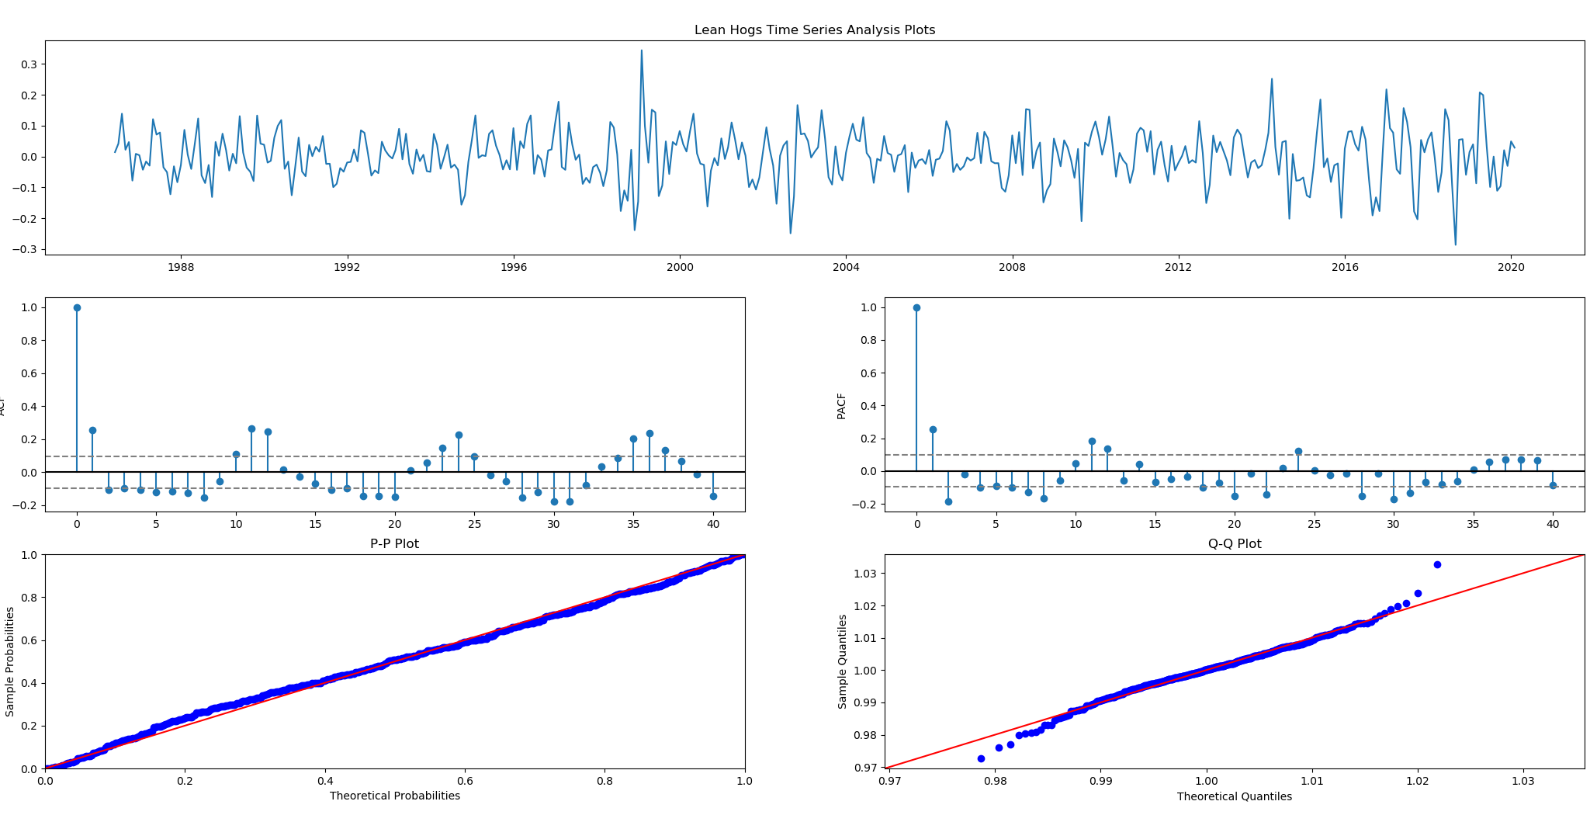

Figure 4-3. 100 times log return of lean hog future analysis

The tests shows that the GARCH(1,1,1) is best fitted model for lean hogs futures since its AIC is smallest. After fitting our model, the model generates the standard residue’s ACF plot for reference. Apparently, the ACF plot shows that the correlation effect is not offset by GARCH model. The model does not show a perfect fit.

Table 4-1. GARCH model summary

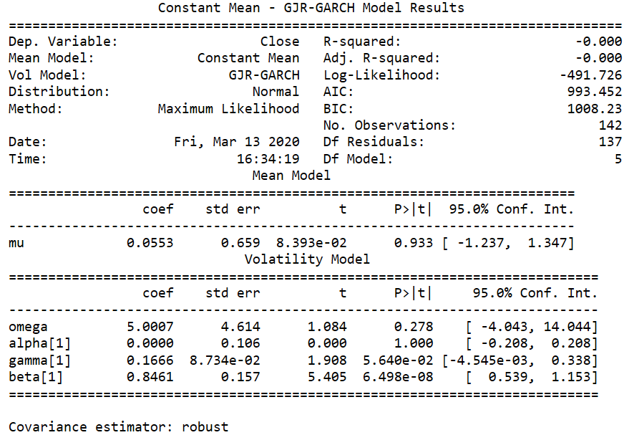

The squared standardized error shows that the model does not fit perfectly. some of the spikes are out of the shaded confidence zone. But they are lagged very far. So, we regard the fitting correctly.

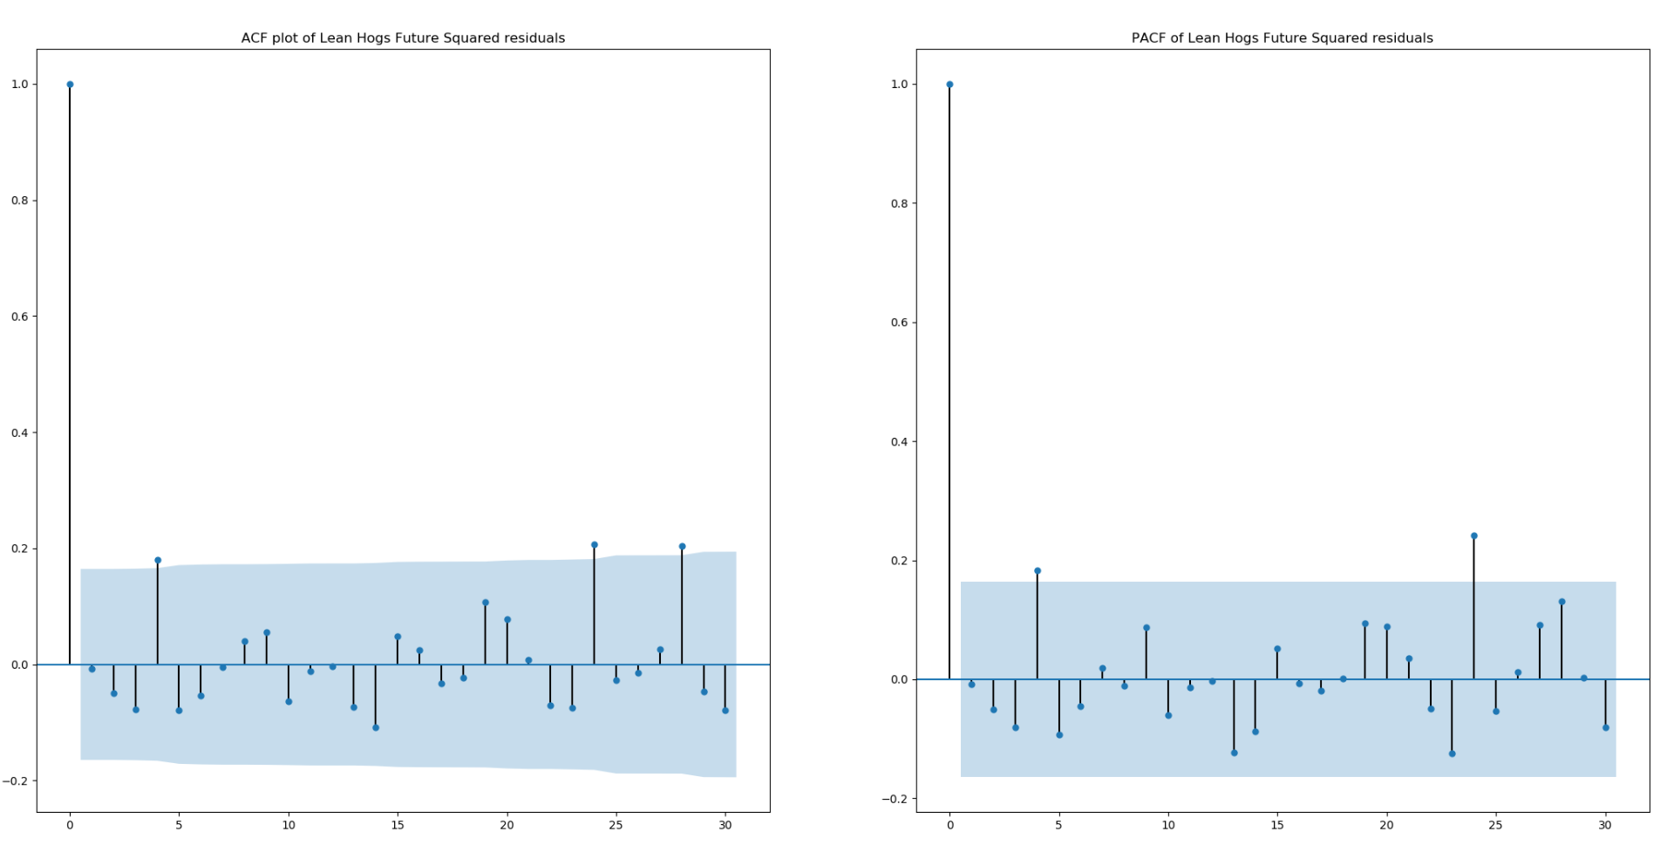

Figure 4-4. ACF and PACF of GARCH model squared standardized residual

4.3 The predication and error

After fitting the GARCH model, we use the GARCH model to predict the test data in 2004. As the figure shows below, the mean square error is 5.758610.

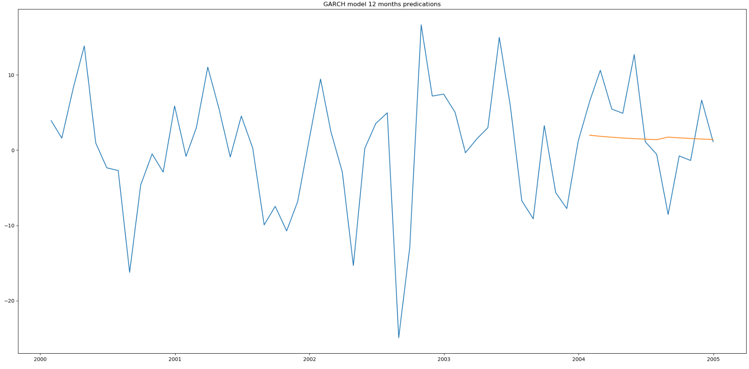Figure 4-5. GARCH model predication

* 1. Lessons

CME Lean hog future shows strong volatility clustering effect. If China market employs lean hog future, this part suggests that:

The lean hog futures in China will perform the same pattern as the lean hog futures in United states. Since the CME lean hog future shows strong volatility clustering effect, it gives the market and government more and more challenges. When market become less stable, the market managers should recommend the market become rational. Do not overreact to the market. Otherwise, the market will become more and more unstable than before. In addition to being calm, the market managers should prohibit the arbitragers from entering the market. The arbitragers only take their profits and losses into considerations. They will manipulate the market so that they will benefit from the unstable market. Their existence in the market will disturb the market and drive the real investors out of market. Eventually, the market becomes abnormal and arbitragers earn huge profits when they decide to leave this market. Thirdly, the market managers should issue more beneficial policies to push the market become healthy In China, the market managers usually gave more tax cuts to the farmers and industries when they are determined to help the market.

For investors, when they meet the fierce market, they should stay calm and be rational. In 2018, the flash crash in United States market was triggered by the stop loss algorithm. Fear can crash the market. The investors should regard the lean hog futures as the risk hedge tool to their real market. If they stay clam during the high volatility period, the market will regain the confidence and recover as a stable one. Secondly, investors should diversify their investment. Diversification will help investors diminish various risks stemmed from single asset. After mitigating the risks, the portfolio will become resistant during high volatility period. Thirdly, the circuit breaker mechanism will help market stay calm. When the market price drops a lot, the circuit breaker will be triggered, and the market will be halted for a while. After the investors calm down, the market will be restarted and continue to trade.

1. **VAR test for lean hogs futures and other futures**

In the last two parts, the paper focuses on the time series analysis of lean hogs future. In the following parts, the paper will concentrate on the correlation between different industries such as corn (pigs’ feeds) and cattle (pigs’ competitors). More experience will be unveiled by analyzing the influence from corn and cattle.

Pigs cultivation need feeds. In place of large volumes of coarse fodders and wastes, hog producers are using feeds that contain corn and soybean meal as the chief ingredients. The price of corn has a strong correlation with lean hog futures because hogs eat corn. China-U.S. comparisons show that hog producers in China face higher feed and labor costs than U.S. producers. (Fred Gale, 2017) The pigs’ price is affected by feed. High feed price contributes to high pigs’ price. After pig grows mature and meet the requirement of market, the future of the lean hogs will become more expensive. However, some analysts believe that corn and pigs have a negative correlation when price fluctuates. If the price of corn rises substantially, farmers tend to take their hogs to market at lower weights (younger) to avoid high feed costs. At these times, lean hog futures prices tend to drop due to increased supplies. (Chuck Kowalsk, 2020)

As an alternative to pork, beef price is another important reason for pork price fluctuation. In China, people will buy beef in place of pork when they feel the price of pork is out of their tolerance scope. This economic rule also applies for the meat consumption in United States. Beef and pork enjoy an obvious negative correlation.

This part will examine the relationships among pigs, corn and cattle. The data are from Bloomberg and they are lean hogs futures, live cattle futures and corn futures. The ticker of live cattle futures and corn futures in Bloomberg are Generic 1st ‘LC’ Future and Generic 1st ‘C’ future. Based upon the analysis of part 1, the data time scope of live cattle futures and corn futures is also from 1992 to 2004. The test method is Vector Autoregressive model.

5.1 Vector Autoregressive Model introduction

A Vector autoregressive (VAR) model is useful when one is interested in predicting multiple time series variables using a single model. At its core, the VAR model is an extension of the univariate autoregressive model from ARIMA model. The vector autoregression (VAR) model extends the idea of univariate autoregression to time series regressions, where the lagged values of all series appear as regressors. Put differently, in a VAR model we regress a vector of time series variables on lagged vectors of these variables. As for AR(p) models, the lag order is denoted by so the VAR(p) model of two variables and ( ) is given by the equations

The s and s can be estimated using OLS on each equation. The assumptions for VARs are the time series assumptions presented in ARIMA model.

5.2 VAR model test

The first subplot is the price of lean hogs futures. The second is the price of corn futures. The third one is the price of live cattle futures. The Augmented Dickey-Fuller Results of three futures shows that the three futures are stationary.

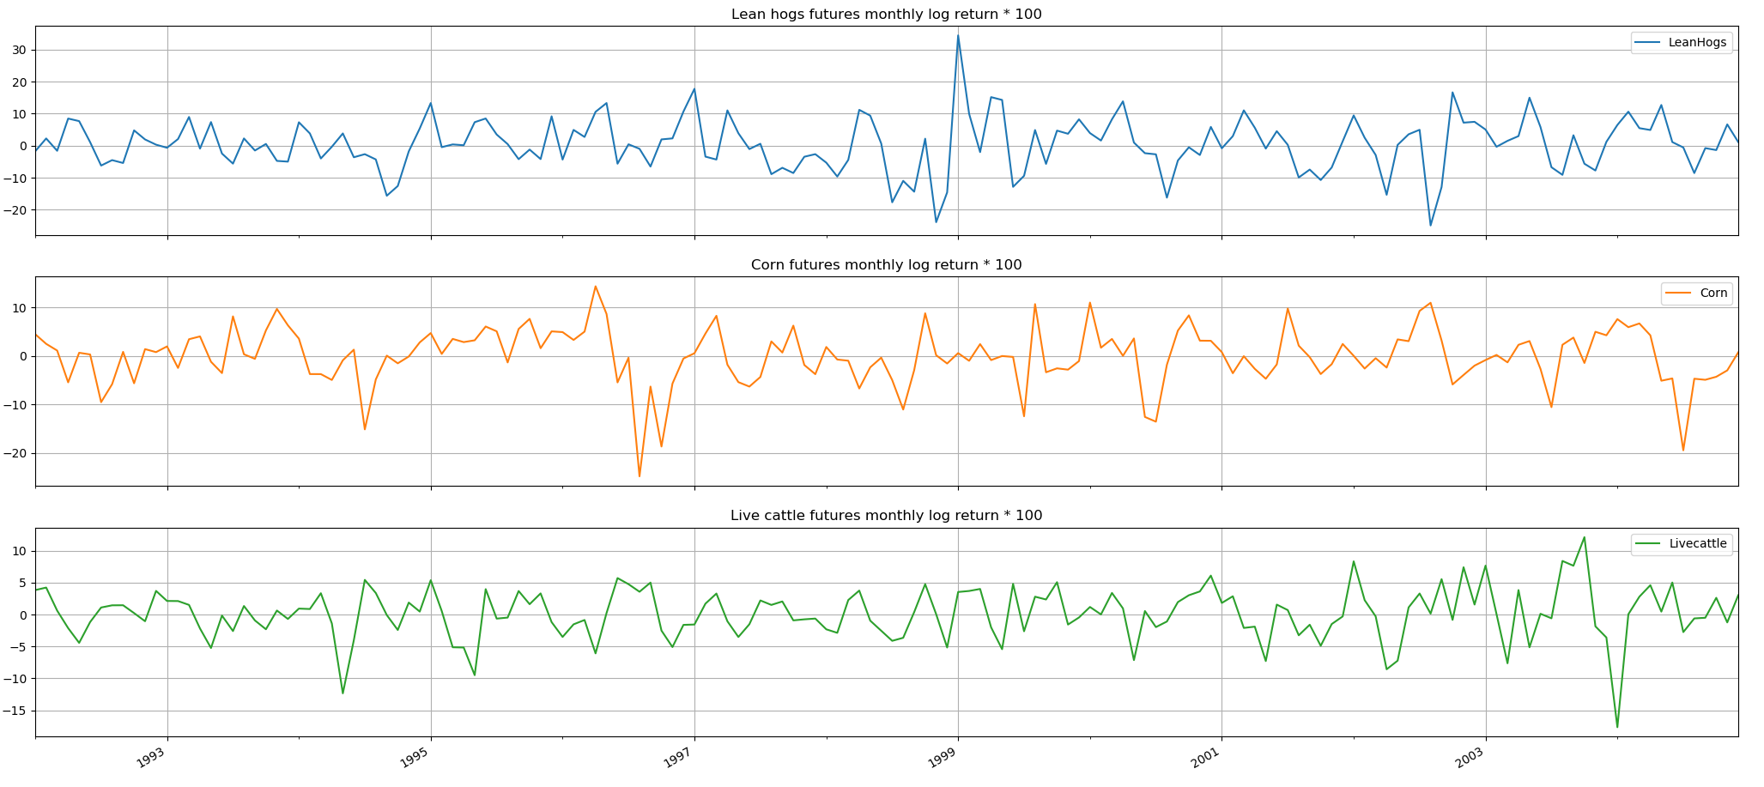

Figure 5-1. Lean hog future, corn future and live cattle future

The VAR(1) model is selected because AIC criteria reach their minimum. The lean hog futures are negatively related to live cattle futures and positively related to corn futures.

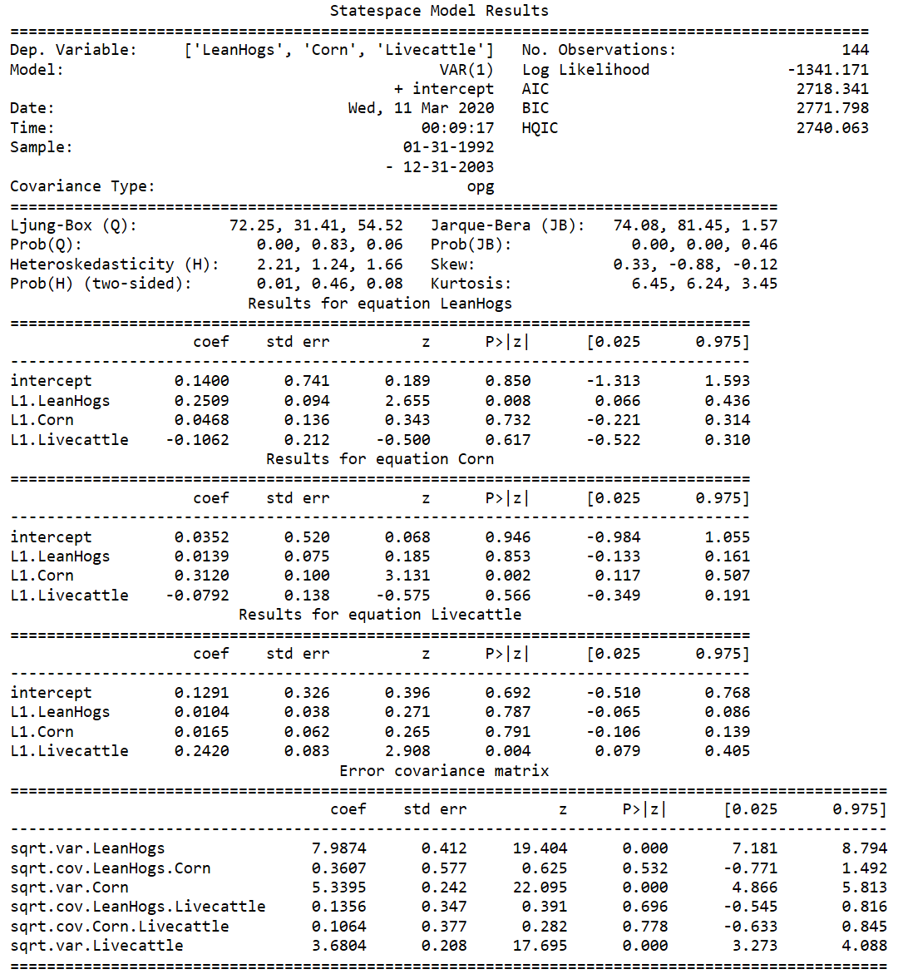

The VARMAX class in Statsmodels allows estimation of VAR, VMA, and VARMA models (through the order argument) The VARMAX procedure is a well-established and powerful tool for analyzing multivariate time series. After model fitting, a common overall diagnostic is employed in below figure. The plot of the residuals obeys the model’s assumptions. The residuals conform the normal distribution, free of serial correlation. The model fit correctly.

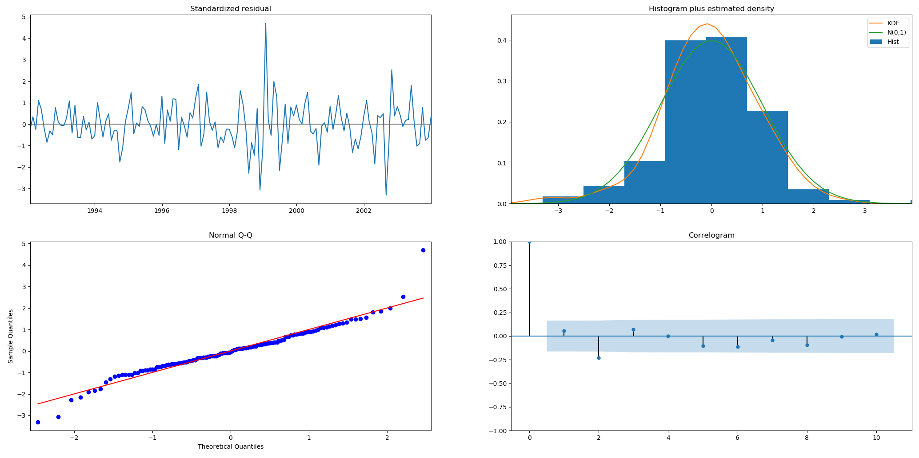

Figure 5-2 VAR model Diagnosis

5.3 Predications and error

The Root Mean Squared Error between predications and actuals 6.571636.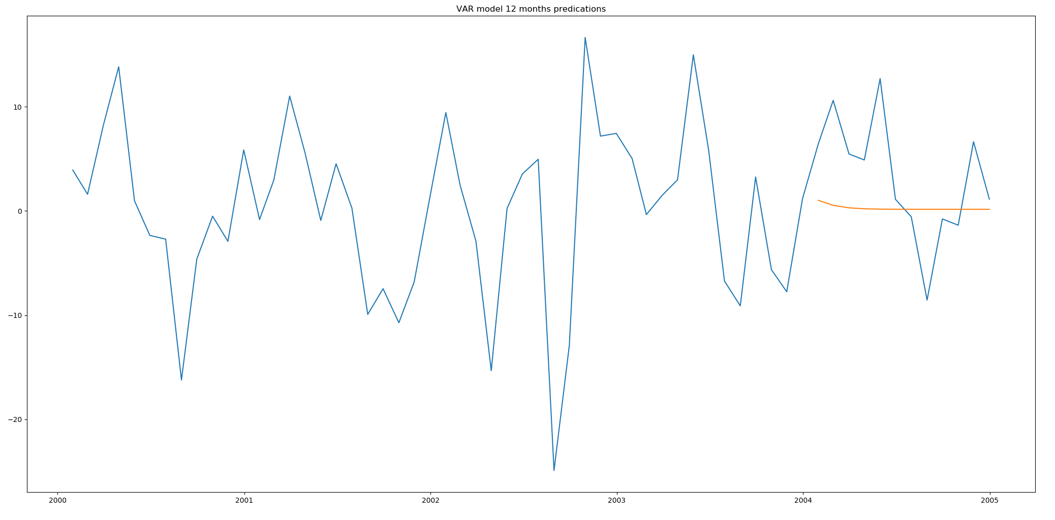

Figure 5-3. VAR model predications

5.4 Lesson:

CME Lean hog future has correlation with corn and live cattle futures. If China market employs lean hog future, this part suggests that:

The hog price is related to corn and beef. As the feeder, the increasing corn price will cause the increase of hogs. On the contrary, the beef price increase, the lean hog price will be negatively affected. Market managers should maintain a stable supply of feeder, such as corn and wheat. Stable supply of feeder will help maintain a stabilized price of pork. The supply of substitution of pork should also be well maintained. The unstable substitution price will contribute to fluctuations of pork.

Investors should be careful about the supply and price of feeder and substitution. Investors may buy the feeders and substitutions futures or options to hedge the risks in pork.

1. Worldwide influence of lean hogs futures

By now, this paper only analyzes the lean hogs futures of Chicago Mercantile Exchange and the relationship among lean hogs futures, corn and cattle. Except for the analysis, the international relationship is also an important research point. The increasing development of globalization is an important factor directly related to the development prospects of the world economy. So far, the exchanges that have carried out futures trading on the world futures market mainly include the Chicago Mercantile Exchange, European Energy Exchange, and Korea Exchange. Science and technology are changing with each passing day, multinational corporations are developing rapidly, the interdependence and influence of the economies of various countries are deepening, and the process of globalization is significantly accelerating. Economic and trade activities between countries and regions continue to increase. If Korea suffers from the short supply of pork. It can import pork from other country like United States, Germany and China. China too. The lean hogs futures in three markets will influence on another and eventually they will share the same fluctuation.

Korean lean hog futures start from 2008. Due to the short history, Bloomberg does not contain sufficient data for test. Regarding Europe Energy Exchange Lean hog futures, Bloomberg provides scarce data. However South Korean data does not cover the period concluded in part 1. In order to find out the relationship among countries, this part will unleash the period constrain on data. The test method is Ordinary least squares regression. The test period is from 2016 to 2020.

Ordinary least squares (OLS) regression is a statistical method of analysis that estimates the relationship between one or more independent variables and a dependent variable; the method estimates the relationship by minimizing the sum of the squares in the difference between the observed and predicted values of the dependent variable configured as a straight line.

6.1 OLS test

This is the CME lean hogs futures daily price and South Korea lean hogs futures daily price.

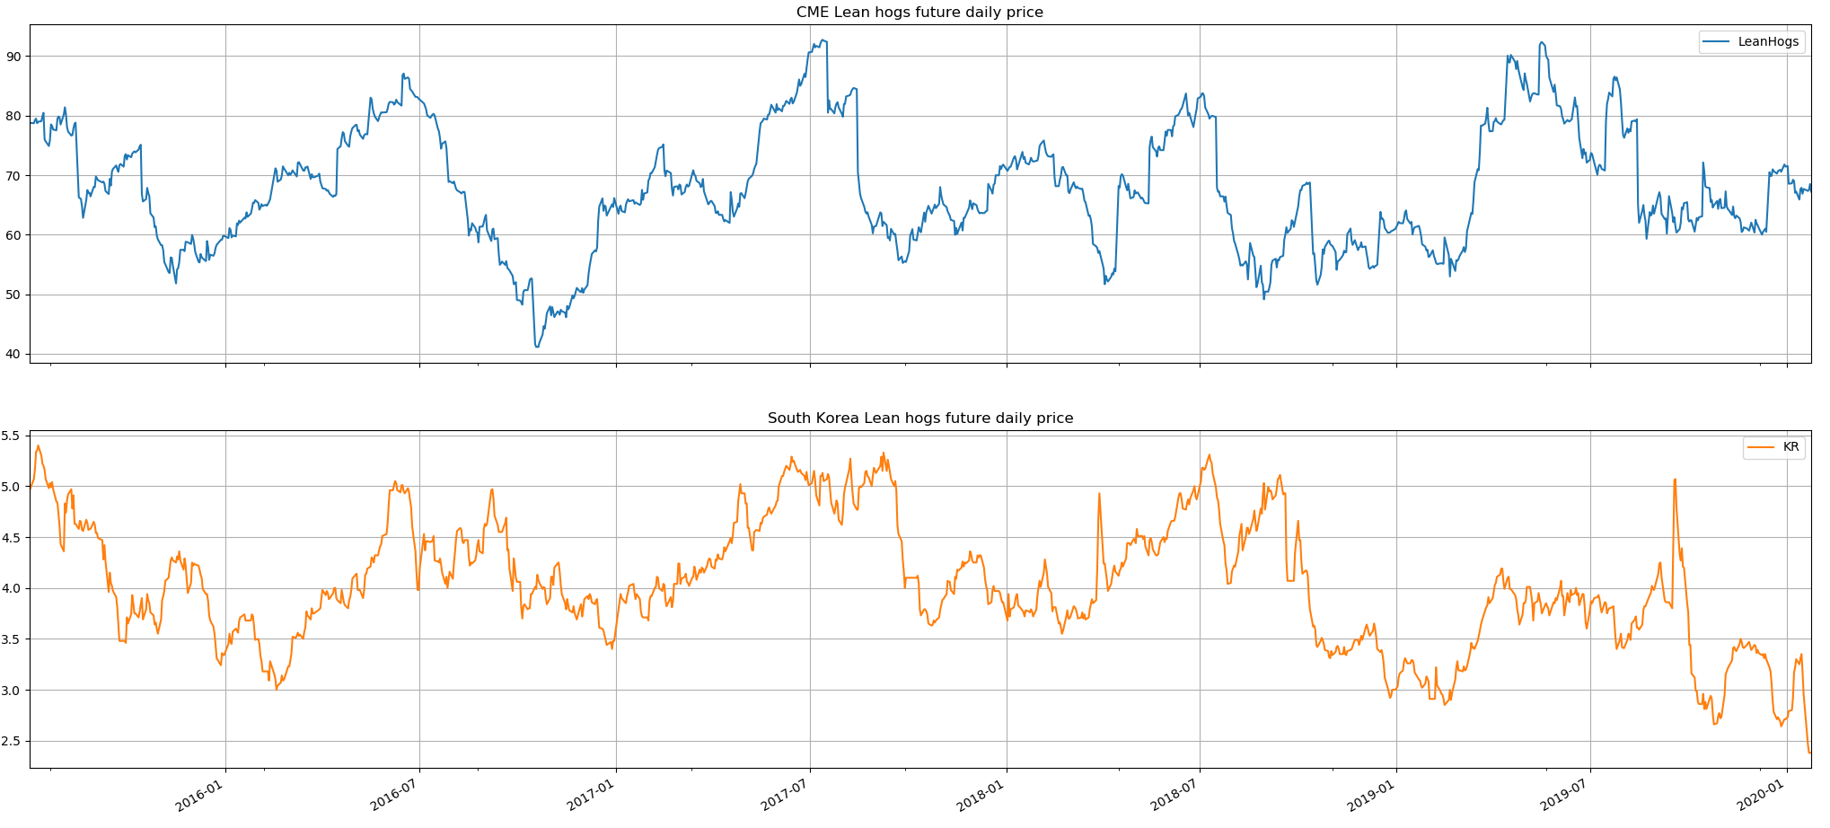

Figure 6-1. CME lean hog future and South Korea lean hog future

This is the 100 times CME lean hogs futures monthly log return and 100 times South Korea lean hogs futures monthly log return.

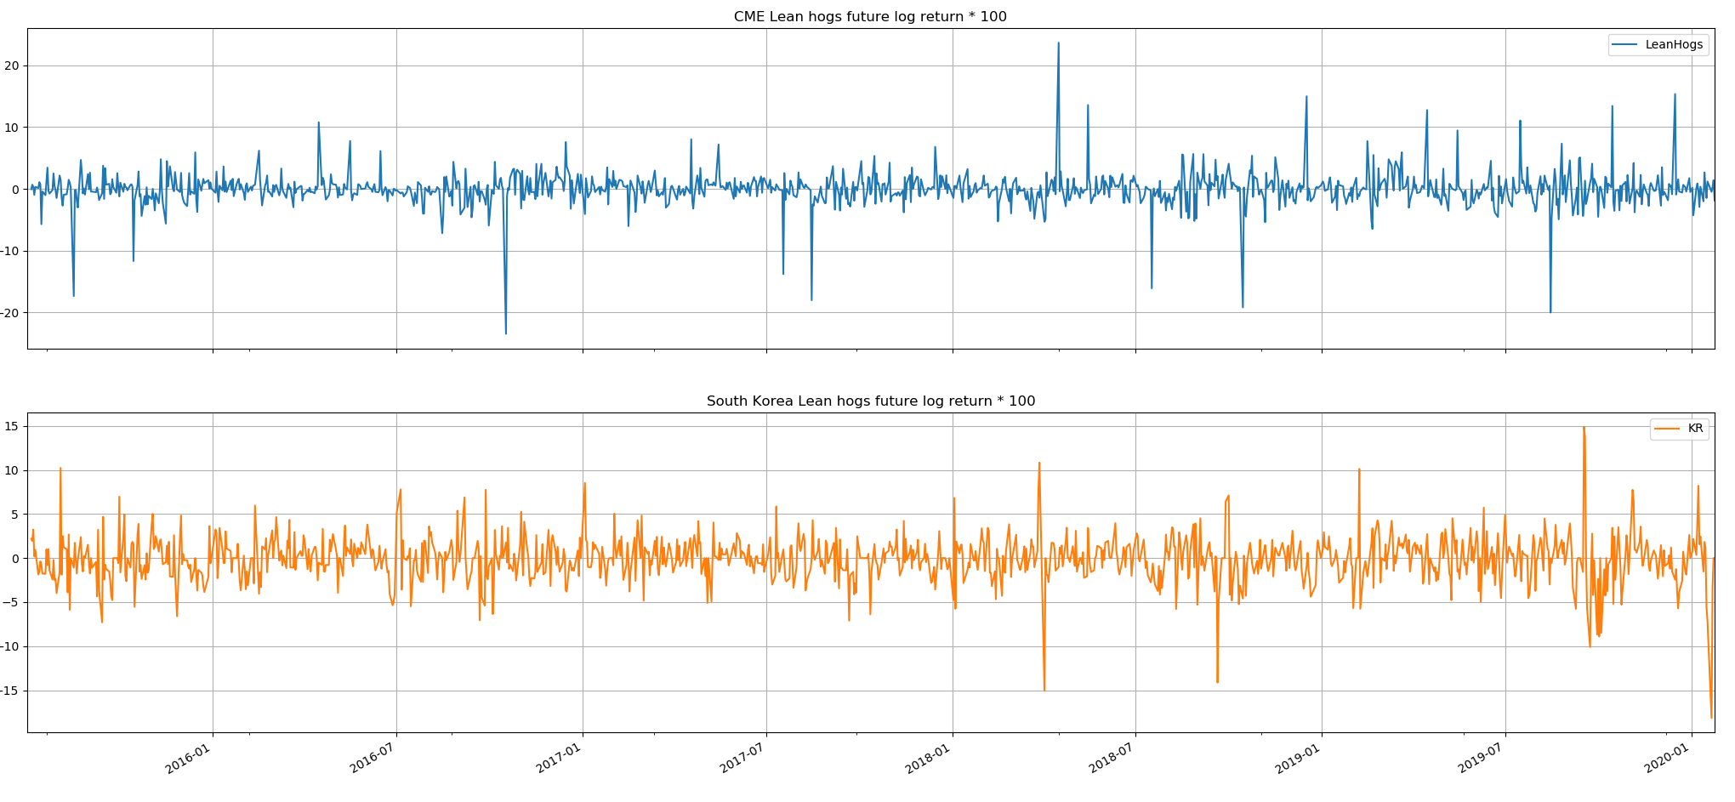

Figure 6-2. 100 times log return of CME lean hog future and South Korea lean hog future

The OLS regression results show that the coefficient of variable is 0.0518 (Positive). CME lean hogs future is positively correlated with South Korea lean hogs future.

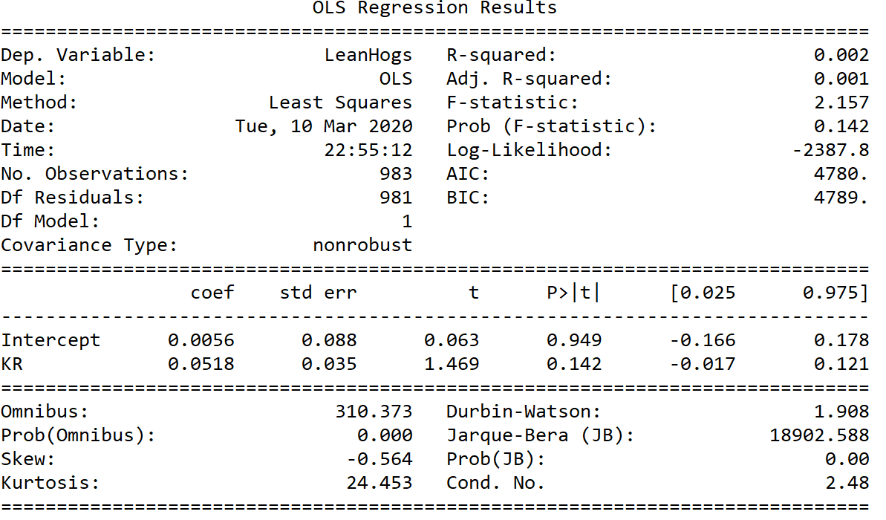

The simulate plot is below shows that the correlation between CME lean hogs future and South Korea lean hogs futures is not strong.

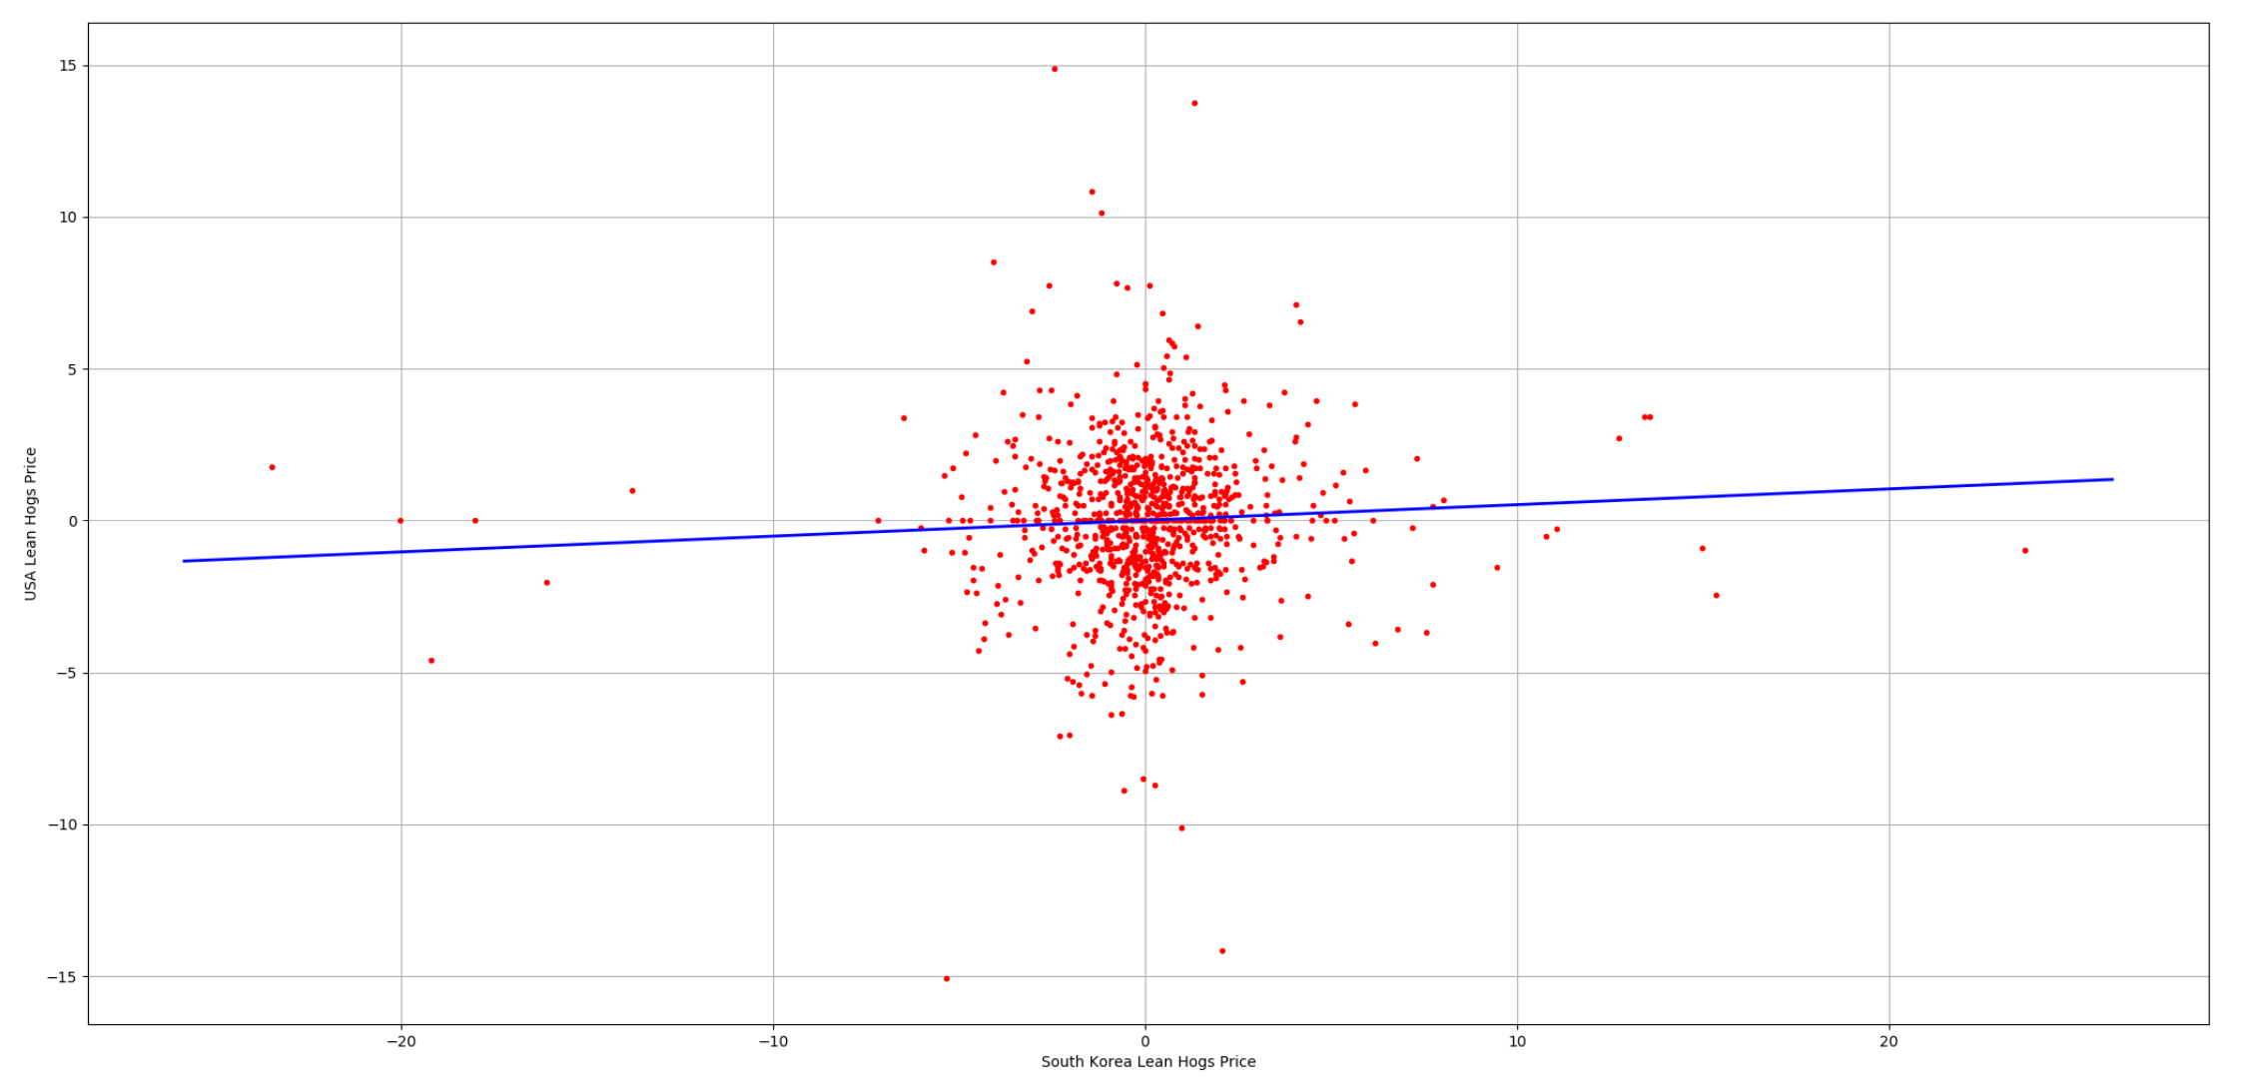

Figure 6-3. OLS result of CME lean hog future and South Korea lean hog future

6.2 OLS predications and error

We use the fitted OLS model and 30 days data of South Korea Lean hogs future to predicate the 30 days results for CME lean hogs future. The Mean Squared Error between actual data and predicated data is 9.65 and the Root Mean Squared Error is 3.11.

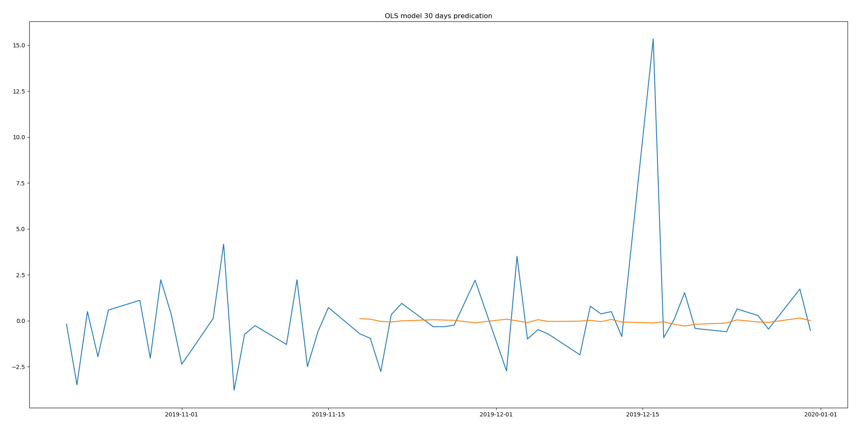

Figure 6-4. OLS model predications

6.3 Lesson:

CME Lean hog future has correlation with global lean hog futures. If China market employs lean hog future, this part suggests that:

Investors should be aware of the fluctuations from foreign countries. When supply in foreign countries goes low, the supply in China will be affected as well. At this time, if the demand increases, the price of hogs will surge. Therefore, when they meet this circumstance, they should have an eye on the global market and prepare in advance to stop the market disruption.

The market managers should schedule a reasonable export and import policy to make sure that China market has enough supply. When the domestic supply exceeds the domestic demand, the market managers should encourage the pork export and stabilize the supply price to protect the proactive of suppliers. However, if the domestic demand supersedes the domestic supply, the market managers should increase import from foreign market to decrease the pork price to protect consumers.

The market mangers should maintain the pork reserve. If the global supply shortage of pork occurs, the country will have no source for pork import. In such case, the pork reserve will decelerate the deterioration from global pork market and accelerate the recovery of domestic market. For example, when citizens notice the supply shortage in the global market, they will worry about the local market as well. In this scenario, the panic buying will happen in the market. If the market managers announce that they contain sufficient reserve and domestic supply, the domestic market will turn to be rational. This scenario happens in Singapore when the market has not enough surgical masks supply.

1. Conclusion

In this article, we employ four different models to predict the lean hog future price. Based upon the mean square error, the SARIMA model shows that it fits the actual data better. However, these four models have their own shortcomings. SARIMA model does not consider the Volatility clustering effect. The GARCH model does not have ARIMA part and does not fit the data well. The VAR model does not consider the GARCH effect as well. The OLS does not explain too many data in the test.

Table 7-1. Comparison of four models

|  |  |  |  |  |
| --- | --- | --- | --- | --- |
| Model | SARIMA | GARCH | VAR | OLS |
| Factors | CME hogs | CME hogs | CME Hogs, corn and cattle | CME hogs and South Korea hogs |
| MSE | 5.53 | 5.76 | 6.57 | 9.65 |
| shortcomings | Do not consider GARCH effect | Do not have ARIMA,  Not fit well | Do not consider GARCH effect | Linear model |

This article demonstrates some characteristics of CME lean hog future. The CME lean hog future has seasonal autoregressive effect. The lean hog future price has regular periodic fluctuations. The price contains the volatility clustering effects. The price will tend to be more volatile when the price become volatile. However, we did not add ARIMA model into GARCH model. The GARCH model does not fit perfectly. Thirdly, the CME lean hog future has correlation with corn and live cattle futures. The corn price positively changes with lean hog future. But live cattle future negatively fluctuates with lean hog future. Fourth, CME lean hog future is affected by South Korean market. But in this analysis, we do not have lean hog future data of other countries so that we did not test the correlation with futures in other countries. When China decides to employ lean hog future, these characteristics may still be existing for reference. Our research is designed upon current China pork industry. The market is similar to United States Pork industry from 1992 to 2004.

However, it is very difficult to start the lean hog future from scratch. The first obstacle is that the future contracts is very hard to standardize. Due to the large and scattered production of pigs in China and the limitation of the trading radius brought by the regional production of pigs, there is a large difference in pig breeds and quality. It is not easy to standardize the indicators of pig breeds, weight, and thickness thing. These differences bring difficulty to the setting of the delivery grade in the contract design. In the actual delivery process after the contract is launched, the quantities of pig products can meet the delivery standards is also unknown. The second reason is the delivery difficulties. As a livestock and fresh agricultural product futures, hog futures are different from the traditional storage-resistant futures varieties. In the process of physical delivery, there are often more operational obstacles and risks. For example, the storage problem of live pigs during live transportation, and the more difficult risk of pig epidemic transmission. May wish to learn from other countries. In the 1960s, the US hog futures contract was listed, and the delivery method was physical delivery. By the end of the last century, the subject matter of the contract had changed from hogs to lean ketones, and the delivery method had become cash settlement. For 30 years, pigs were the target. In addition, the German Hannover Exchange (RMX) and the Korean Exchange (KRX) also have lean hog futures listed on the exchange, and the two have adopted cash delivery since the launch. The settlement price mainly depends on the spot price and index. In fact, these obstacles exist more or less in other countries, but they have not affected the United States, Germany and South Korea to eventually launch pig futures. Facts have shown that the listing of pig futures on the Chicago Mercantile Exchange in February 1966 further accelerated the scale operation and industrial integration of the pig industry. Thirty years later, in the mid-1990s, 70% of the pigs in the United States were able to meet futures delivery standards. Similar results have been seen in other varieties of futures markets in China.

1. Reference

China Ministry of Agriculture. 2016. Quan Guo Sheng Zhu Fazhan Guihua (2016-2020) [National Hog Production Development Plan 2016-2020]. Nong Mu Fa (2015) no. 6.

Fang, C., F. Fuller, M. Lopez, and F. Tuan. 2000. “Livestock Production Slowly Evolving From Sideline to Principal Occupation,” in H.-H. Hsu and M. Lopez, China: Situation and Outlook Series, International Agriculture and Trade Reports, WRS-99-4. <https://www.ers.usda.gov/>webdocs/publications/wrs994/54066_wrs99-4.pdf (accessed December 2016).

Isengildina, O., Irwin, S. H. and Good, D. L. (2004). Evaluation of USDA interval forecasts of corn and soybean prices. American Journal of Agricultural Economics 86(4): 990–1004.

Wang, Z., Fausti, S. W. and Qasmi, B. A. (2012). Variance risk premiums and predictive power of alternative forward variances in the corn market. Journal of Futures Markets 32(6): 587–608.

William D Mcbride and Nigel Key (2013). U.S. Hog Production From 1992 to 2009: Technology, Restructuring, and Productivity Growth. Economic Research Report No. (ERR-158) 48 pp.

Schulz, L. 2019, "Lean hog futures overly positive", Corn & Soybean Digest (Online Exclusive) .

1. Source: Livestock and poultry slaughter (1000 heads), USDA Economic Research Service