**How to revise the Cookie.json**

1. Press F12 to DevTools and select Network tab.

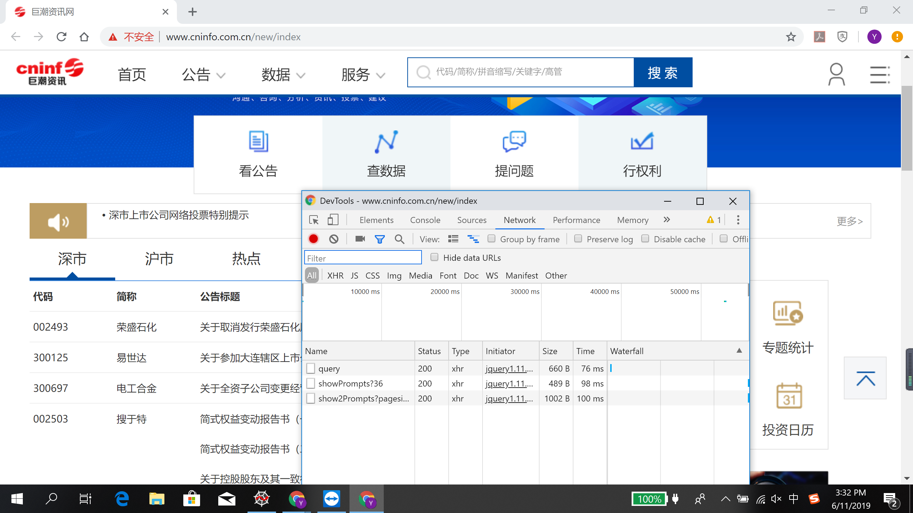

2. Search Keyword and select different pages more than twice

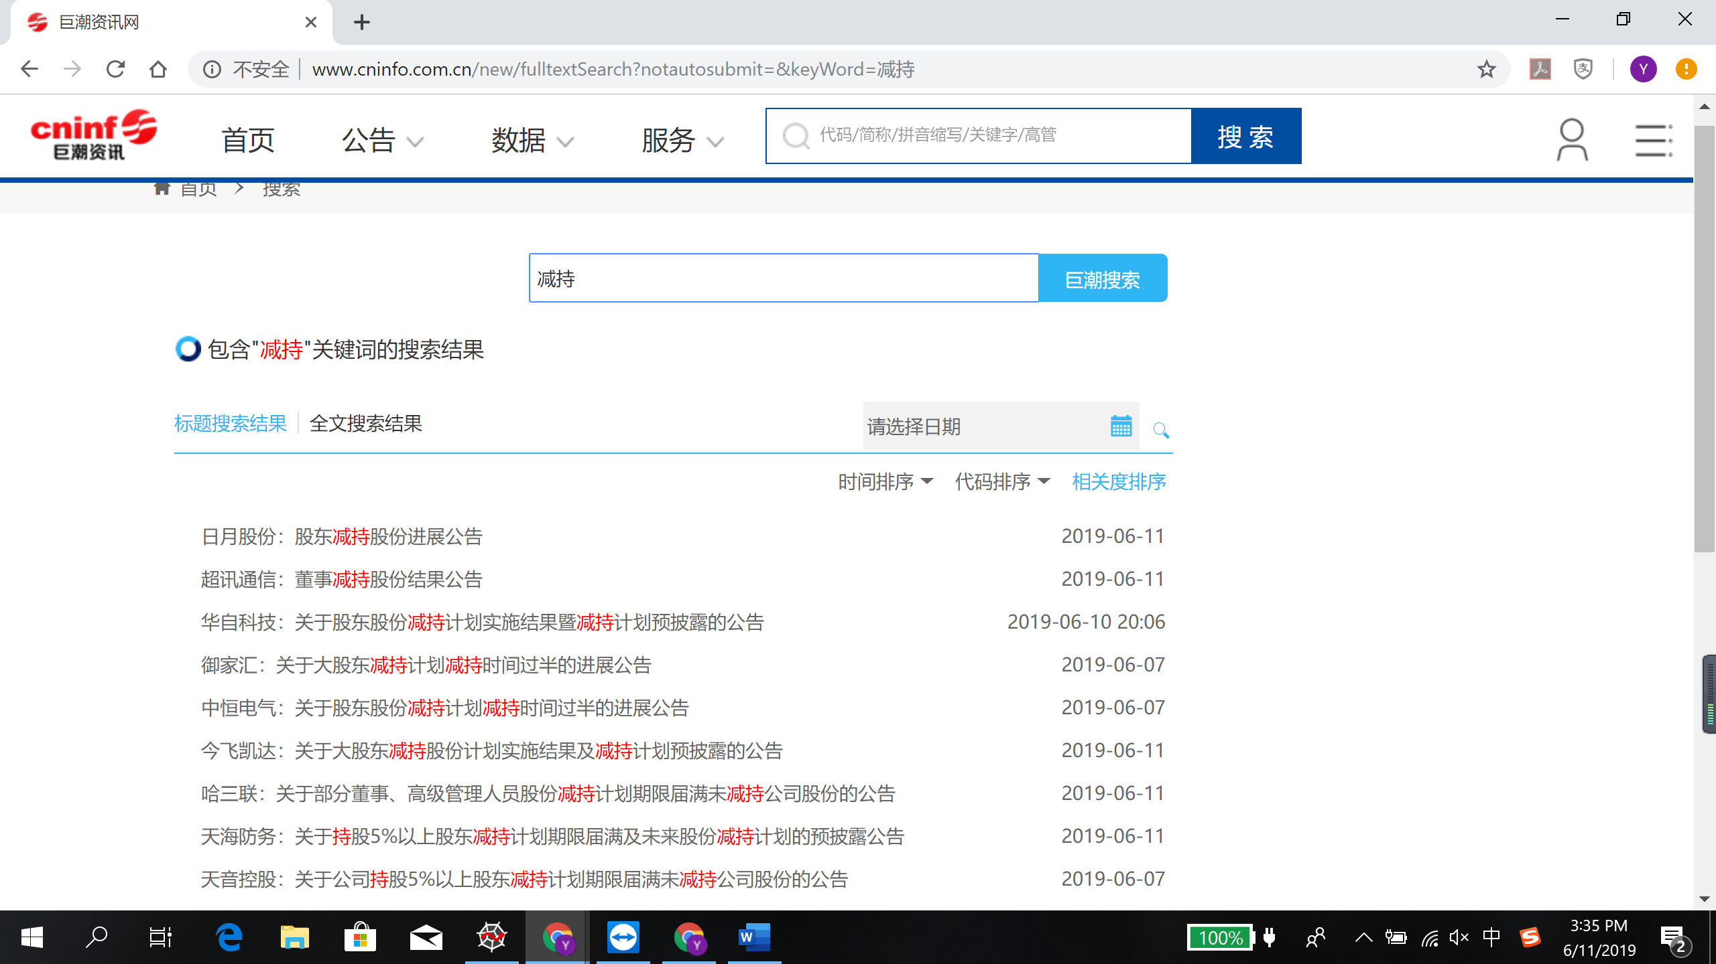

3. Get the latest cookie in DevTools

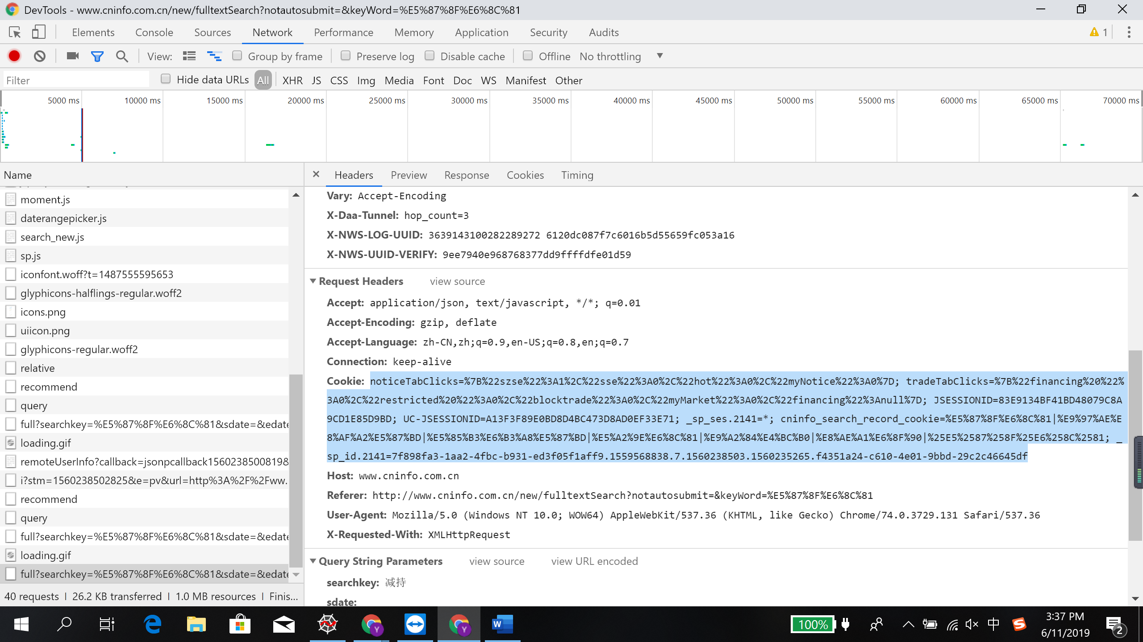

4. Input into cookie.json

