10.1
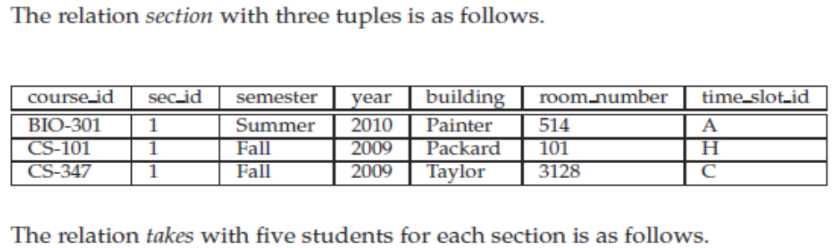
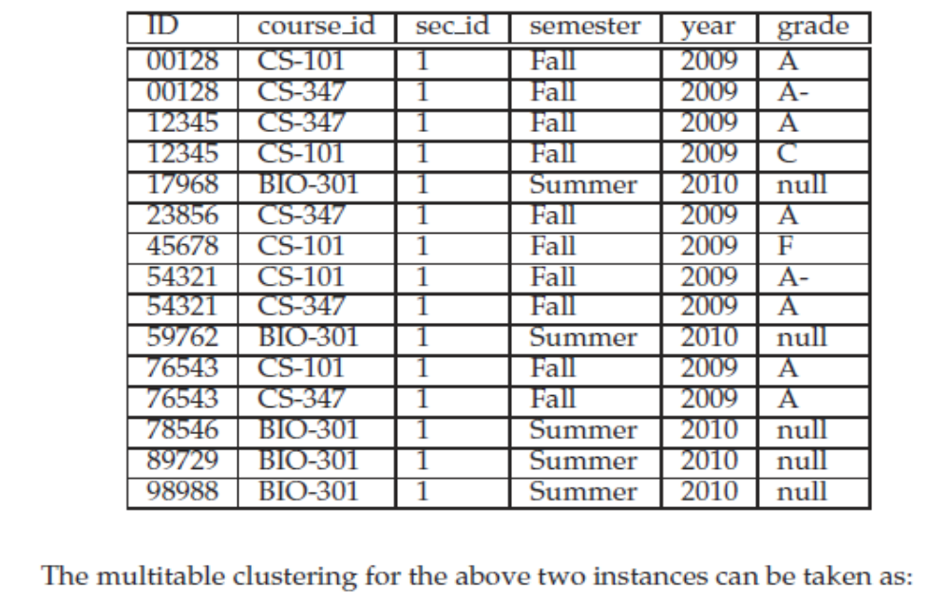
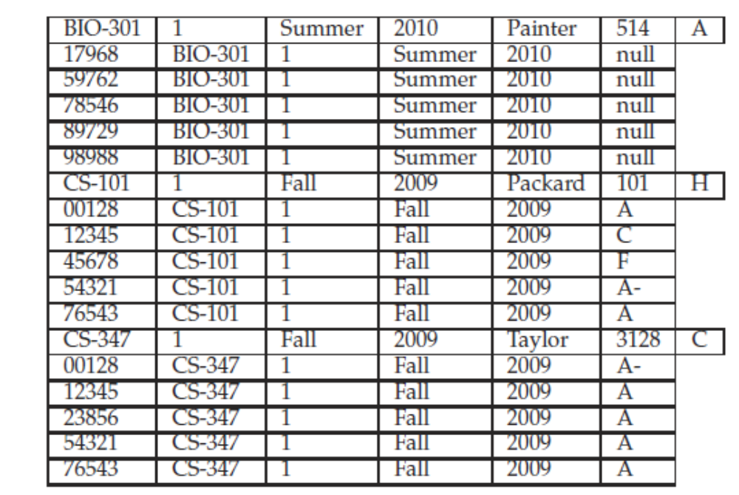
10.2
Hash table is the common option for large database buffers. The hash function helps in locating the appropriate bucket, on which linear search is performed.
10.3
a. MRU is preferable to LRU where R₁⋈R₂ is computed by using a nested-loop processing strategy where each tuple in R₁ must be compared to each block in R₂. After the first tuple of R₁ is processed, the next needed block is the first one in R₂. However, since it is the least recently used, the LRU buffer management strategy would replace that block if a new block was needed by the system.
b. LRU is preferable to MRU where R1⋈R2 is computed by sorting the relations by join values and then comparing the values by proceeding through the relations. Due to duplicate join values, it may be necessary to “back-up” in one of the relations. This “backing-up” could cross a block boundary into the most recently used block, which would have been replaced by a system using MRU buffer management, if a new block was needed.
Under MRU, some unused blocks may remain in memory forever. In practice, MRU can be used only in special situations like that of the nested-loop strategy discussed in Exercise 10.3a.

10.4
Reasons for not keeping indices on every attribute include:
• Every index requires additional CPU time and disk I/O overhead during inserts and deletions.
• Indices on non-primary keys might have to be changed on updates, although an index on the primary key might not (this is because updates typically do not modify the primary key attributes).
• Each extra index requires additional storage space.
• For queries which involve conditions on several search keys, efficiency might not be bad even if only some of the keys have indices on them. Therefore database performance is improved less by adding indices when many indices already exist.
10.5
In general, it is not possible to have two primary indices on the same relation for different keys because the tuples in a relation would have to be stored in different order to have same values stored together. We could accomplish this by storing the relation twice and duplicating all values, but for a centralized system, this is not efficient.
10.11
a. Advantages of storing a relation as a file include using the file system provided by the OS, thus simplifying the DBMS, but incurs the disadvantage of restricting the ability of the DBMS to increase performance by using more sophisticated storage structures.
b. By using one file for the entire database, these complex structures can be implemented through the DBMS, but this increases the size and complexity of the DBMS.
10.12
The Index-metadata relation can be normalized as follows:
Index_metadata(index_name, relation_name, index_type, attrib_set)
Attribset_metadata(relation_name, attrib_set, attribute_name)
The normalized version will require extra disk accesses to read Attribset-metadata everytime an index has to be accessed. Thus, it will lead to worse performance.
10.14
It is preferable to use a dense index instead of a sparse index when the file is not sorted on the indexed field (such as when the index is a secondary index) or when the index file is small compared to the size of memory.
10.15
The clustering index is on the field which specifies the sequential order of the file. There can be only one clustering index, while there can be many secondary indices.

