1. (10 points) Mark each statement True or False.
(1) ( ) Rank A = dim(Nul A).
(2) ( ) The set of all linear combinations of 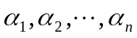is a vector space.
(3)( ) Two eigenvectors corresponding to the distinct eigenvalues are always
linearly independent.
(4) ( ) If the matrix A contains a row of zeros, then 0 is an eigenvalue of A.
(5) ( ) A matrix A is orthogonally diagonalizable if and only if A is symmetric.
2. (20 points) Let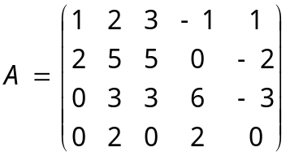.
(1) Find a basis for ColA, NulA and RowA.
(2) Find dimensions of ColA and NulA and find RankA.

3. (14 points) Let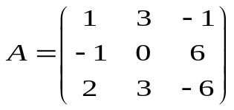and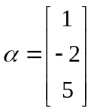. Determine if is in ColA. Is in NulA?
4. (10 points) Suppose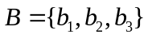is a basis for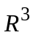, where
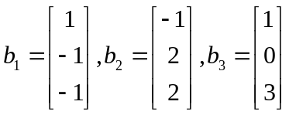. Find the coordinates of 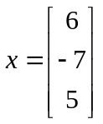relative to the basis B.

5. ( 9 points) It’s known that -2 is an eigenvalue of matrix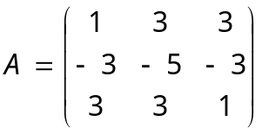. Diagonalize A if possible.
6. (18 points) Let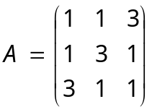.
(1) Verify that 5 is an eigenvalue of A. (2) Verify that 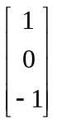is an eigenvector of A.
(3) Orthogonally diagonalize A.
7. (14 points) Let quadratic form.
(1) Write the matrix A of the quadratic form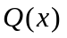.
(2) Make a change of variable x=Py, that transforms the quadratic form into a quadratic form with no cross-product term. Give P and the new quadratic form.
(3) Determine whether the quadratic form 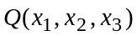is positive definite.
8. (5 points) If v₁, v₂ are eigenvectors that corresponding to distinct eigenvalues λ₁, λ₂ of a matrix A, show that {v₁ , v₂ } are linearly independent .

