

**Project Summary: Maven Market Data Analysis**

The Maven Market Data Analysis project aims to provide comprehensive insights into various aspects of customer behavior, sales performance, store operations, and returns analysis through interactive Power BI dashboards. The project encompasses four distinct dashboards: Customers, Sales, Returns, and Store. These dashboards are interlinked to facilitate seamless navigation and exploration of data.

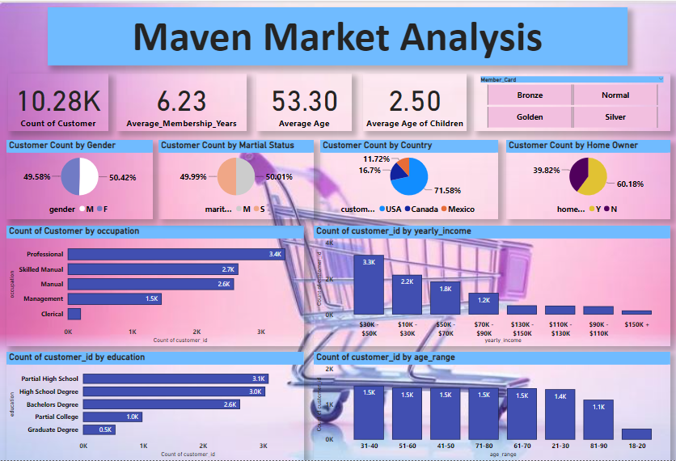

**Customer Dashboard:** This dashboard presents a detailed summary of customer demographics and characteristics. Users can analyze customer count by gender, marital status, country, occupation, yearly income, education, and age range. It provides a holistic view of the customer base, enabling targeted marketing strategies and customer segmentation.

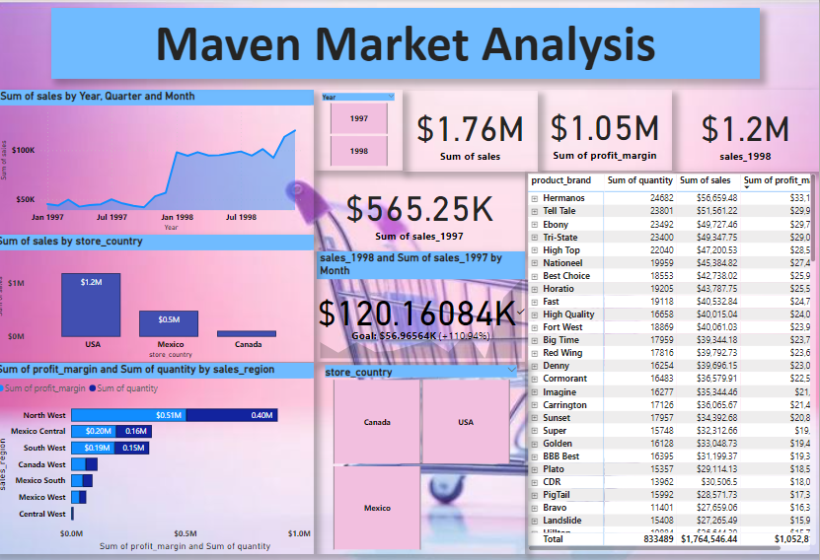

1. **Sales Dashboard:** The Sales Dashboard offers insights into sales performance across different time frames - yearly sales for 1997 and 1998, quarterly, and monthly trends. Users can explore the sum of sales by store country, profit margin, and quantity by sales region. Slicers are available to filter and drill down into specific data subsets, enhancing the granularity of analysis.

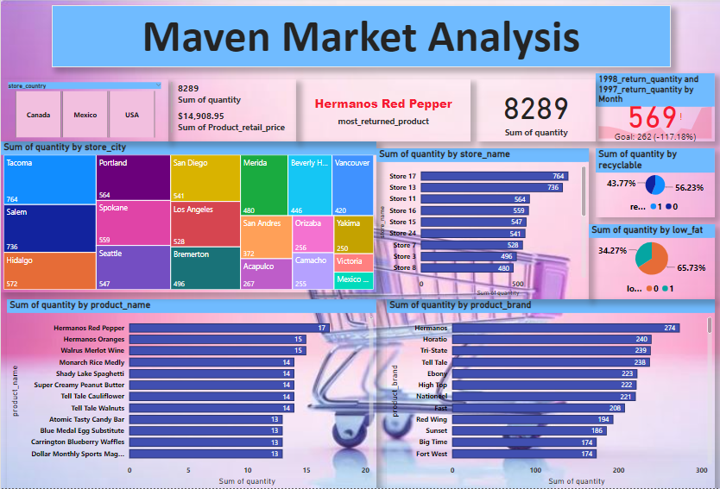

**Returns Dashboard:** This dashboard provides a detailed overview of product returns, categorized by country, product name, brand, store name, and store city. Users can identify patterns and trends in return behavior, facilitating optimization of inventory management and product quality control measures.

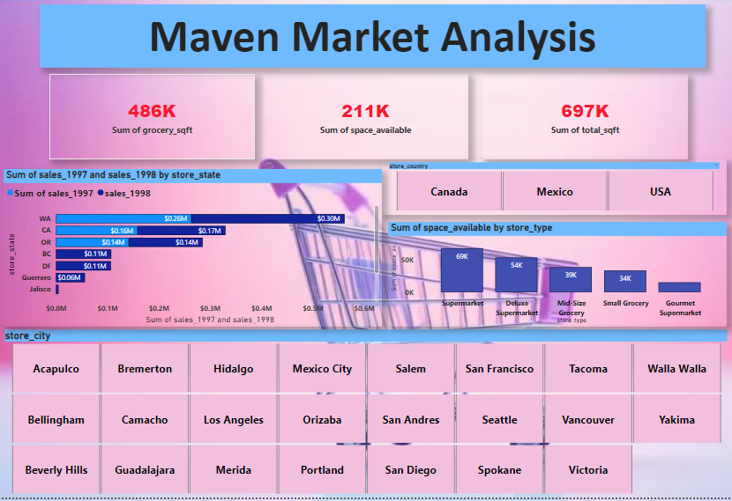

**Store Dashboard:** The Store Dashboard offers insights into store performance, showcasing the sum of sales for 1997 and 1998 by store state, as well as the sum of available store space by store type. It enables stakeholders to evaluate the profitability and efficiency of different store locations and formats.



1. **Profile Dashboard:** The Profile Dashboard serves as a centralized hub, linking to various professional profiles such as LinkedIn, GitHub, Twitter, and Kaggle. Users can navigate to these platforms by clicking on the respective icons, facilitating networking and collaboration opportunities.

Overall, the Maven Market Data Analysis project empowers stakeholders with actionable insights derived from comprehensive data analysis, enabling informed decision-making and strategic planning for business growth and optimization.