**Summary**

1. **Total Sales by Country**

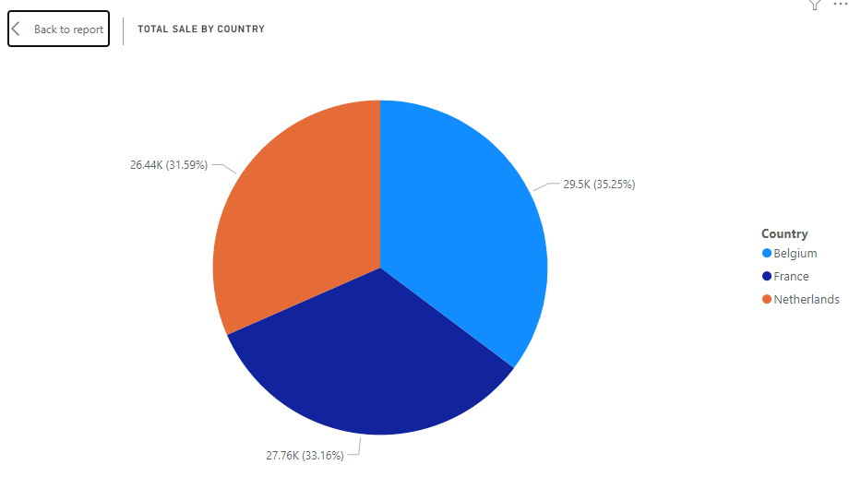

In analysis of total sales by country, Belgium accounted for the highest proportion of sales, contributing 35.25% (29.6K) of the total sales. This was closely followed by France, which made up 33.16% (26.76K) of the sales. The Netherlands, while still a significant contributor, had a slightly lower share at 31.59% (26.44K).

1. **Volume of Product Sold Weekly**

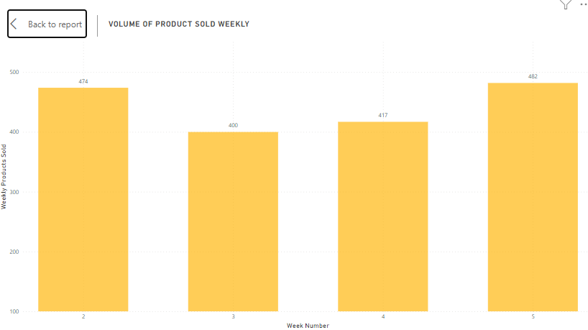

Week 1: First week saw a total of 474 products sold. This serves as baseline for the following weeks.

Week 2: In the second week, there was a slight decrease in the volume of products sold, with a total of 400 products sold. This represents a week-over-week (WoW) decrease of 15.6%.

Week 3: The third week saw a slight increase in sales volume, with a total of 417 products sold. This represents a WoW increase of 4.25%.

Week 4: The fourth week saw the highest volume of products sold, with a total of 482 products. This represents a WoW increase of 15.6%.

1. **Total Weekly Sales with Week-Over-Week Comparison**

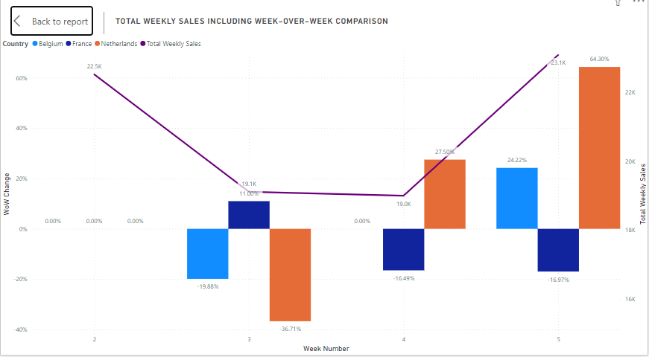

Week 1: The first week served as baseline with total weekly sales for Belgium at 8200, France at 7292, and the Netherlands at 7022. As this was the first week, the week-over-week (WoW) change was 0%.

Week 2: In the second week, there is a decrease in sales for Belgium and the Netherlands by 19.88% and 36.71% respectively, bringing their total sales to 6570 and 4444. However, France saw an increase in sales by 11%, totaling 8094.

Week 3: The third week saw a stabilization in sales for Belgium with no WoW change, maintaining their total sales at 6570. France experienced a decrease in sales by 16.49%, bringing their total to 6759. The Netherlands, on the other hand, saw a significant increase in sales by 27.50%, totaling 5666.

Week 4: The fourth week brought about the most significant changes. Belgium and the Netherlands saw a substantial increase in sales by 24.22% and 64.30% respectively, bringing their total sales to 8161 and 9303. France, however, experienced a decrease in sales by 16.97%, with total sales dropping to 5612.