Johnson Video Store Records Automation

Steven Duchene

MIS407 – Reginald Haseltine

Colorado State University – Global Campus

April 5 2020

Johnson Video Store Records Automation

As was discussed in our original meeting, Johnson Video Store has been utilizing a paper invoice and inventory system for several years. In order to develop a relational database to automate the store’s record keeping system, a thorough analysis was completed of the organization’s operational practices and current method of recordkeeping. The store maintains several copies of each movie that is rented; in the form of both videos and DVDs options.

The previously submitted report detailed the database initial study and database design steps of the database development lifecycle. The following sections detail the steps and results of the implementation/loading, testing/evaluation, operation, and maintenance of the Johnson Video Store Database. Overall, the methodology utilized to develop the database was the Waterfall Model of database development.

**Entity Relationship Diagram**

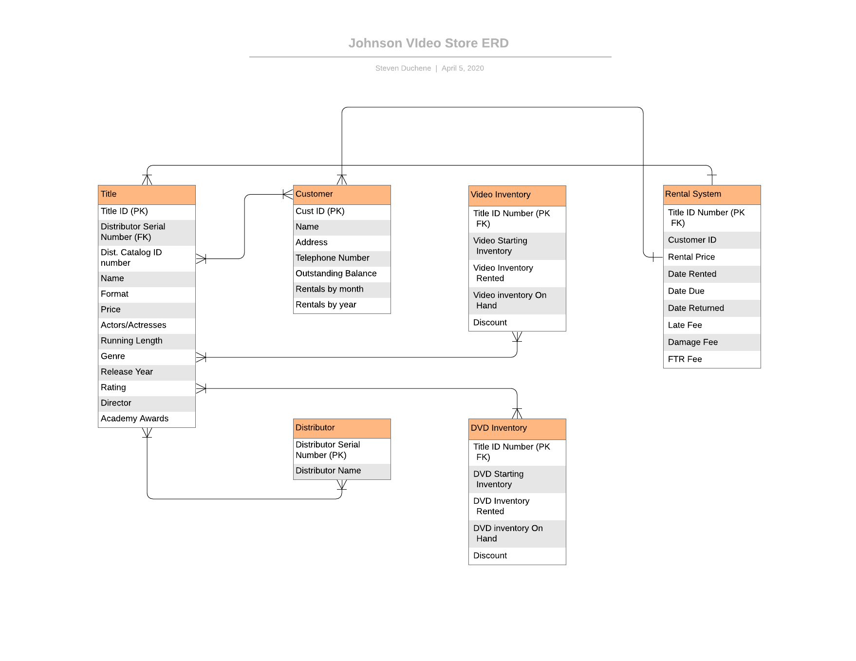

**Database Table Creation Scripts**

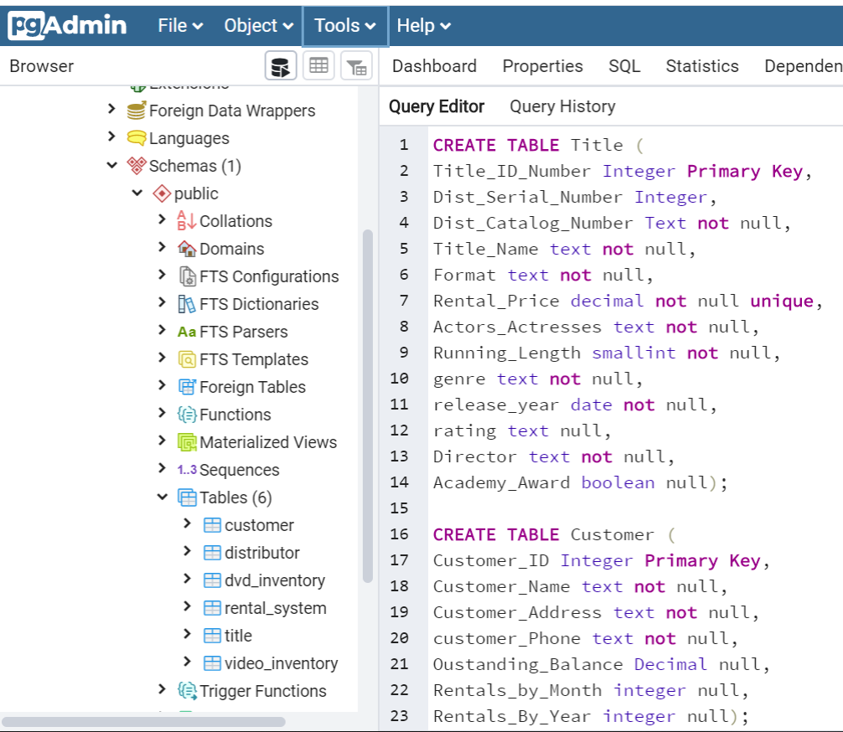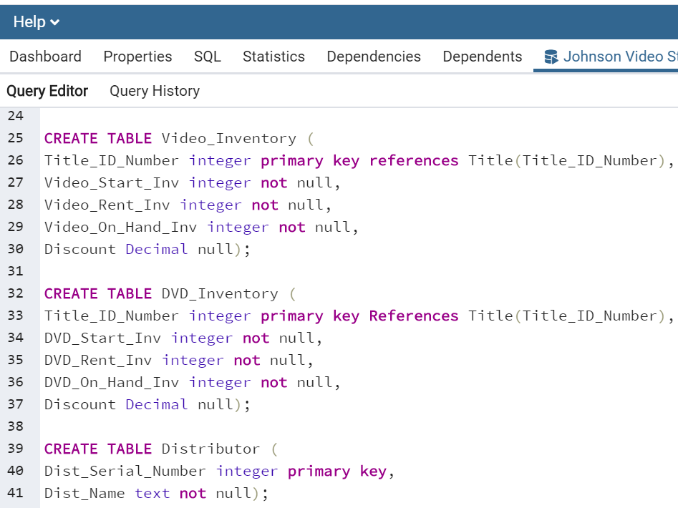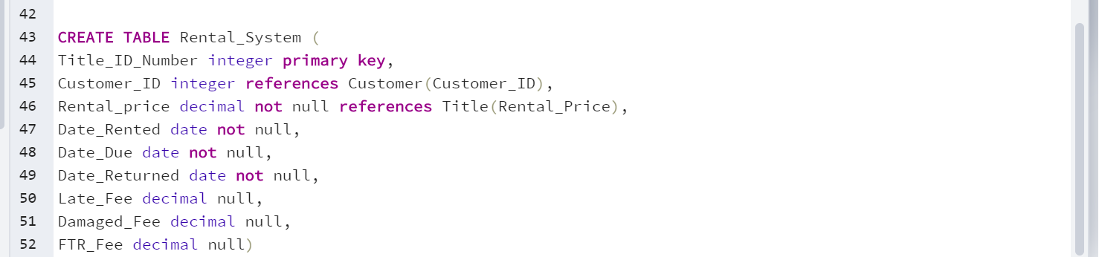

**Insertion of Data Statements (**I was unable to go back far enough in query history to see the last two statements, so I had to rework them)

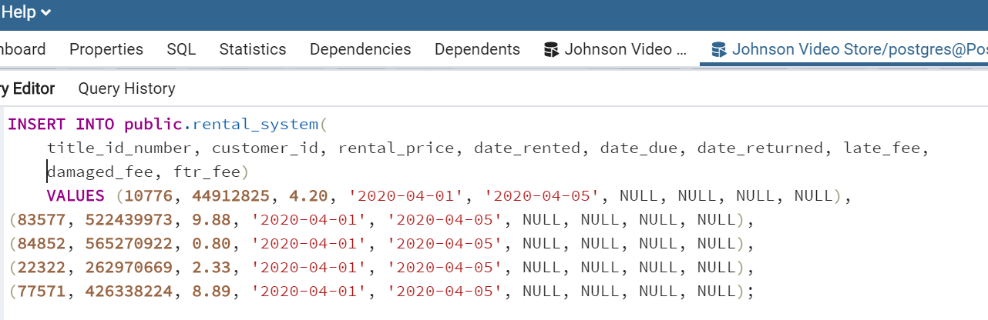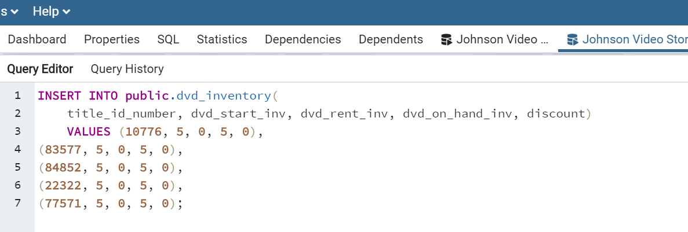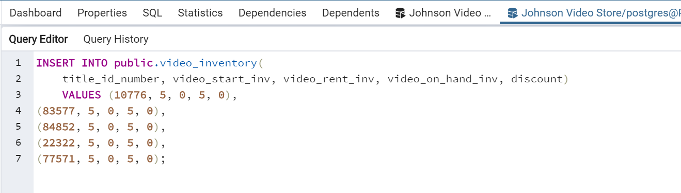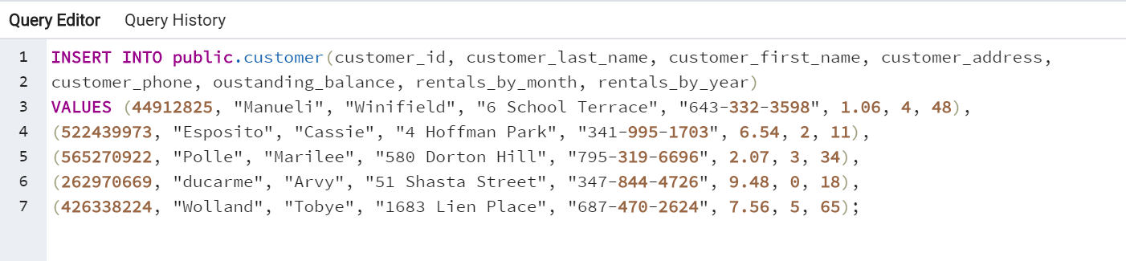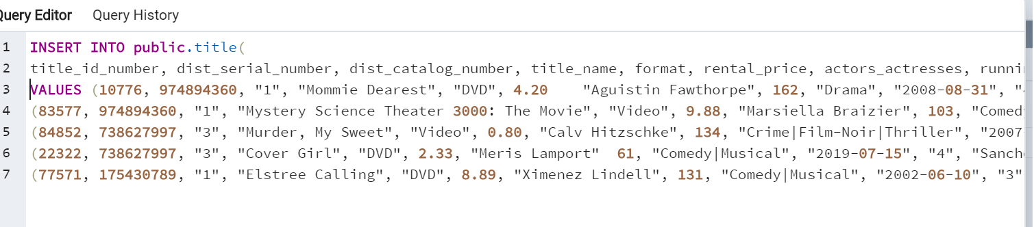

**Select Statement to Show the Contents of All Tables**

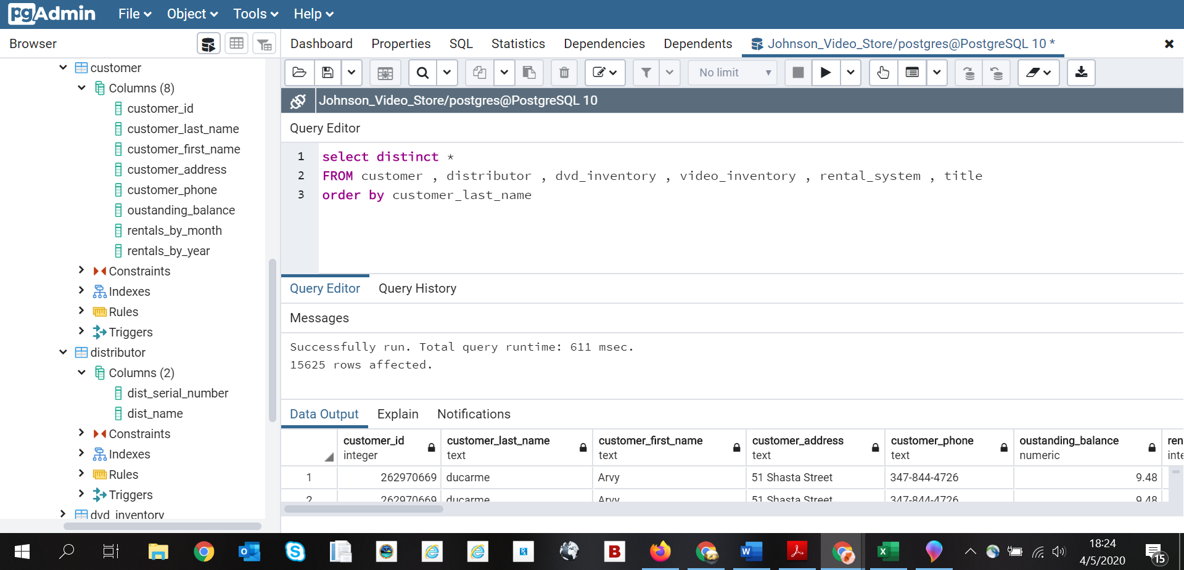

**Select Statement to Show Customer Information Sorted by Customer ID Number**

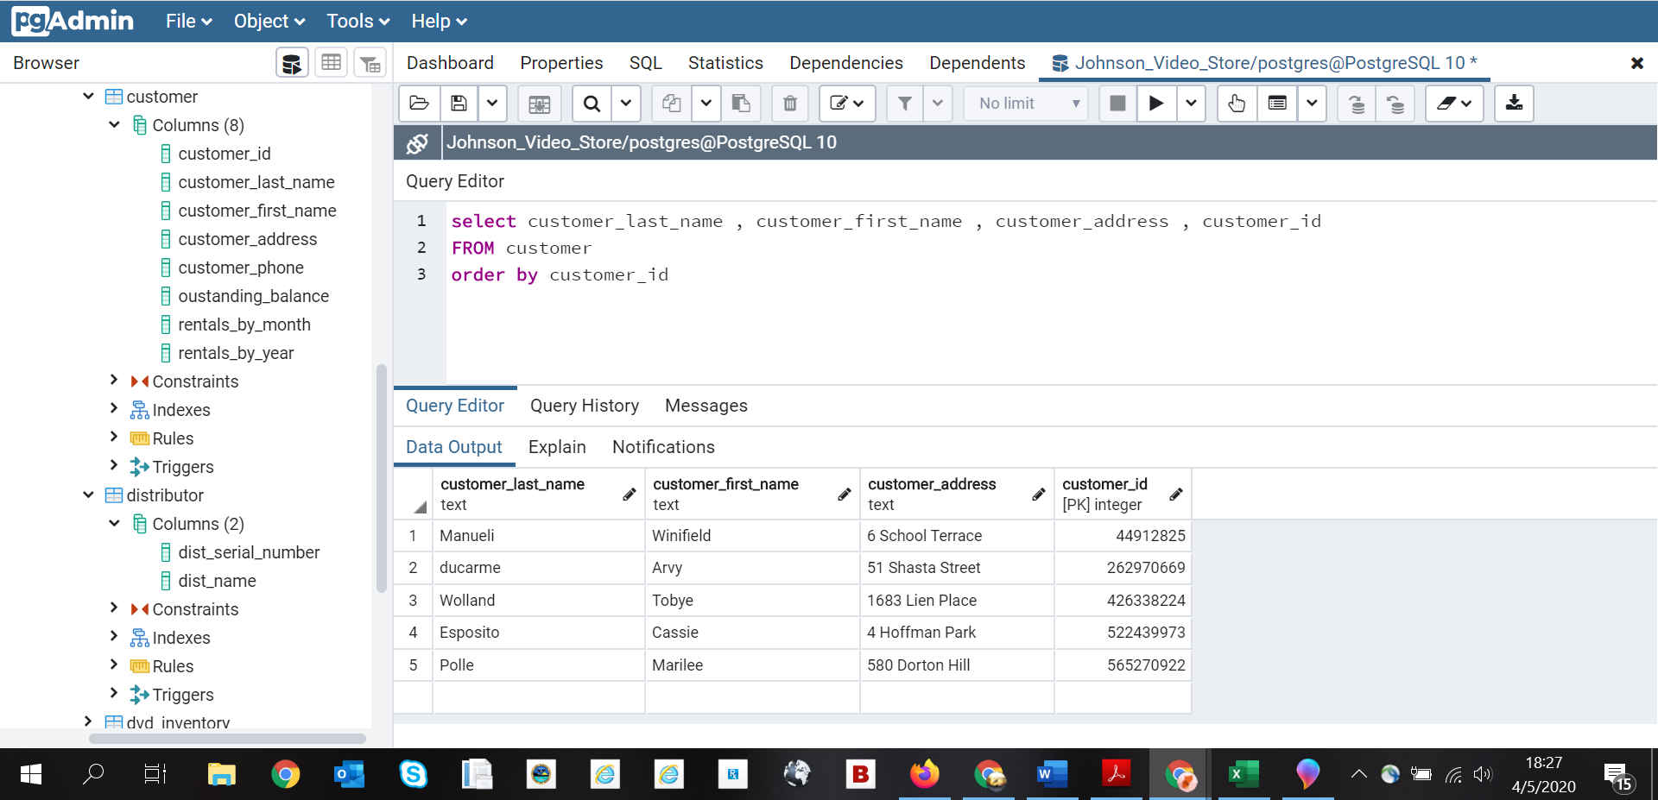

**Sort by Date Rented**

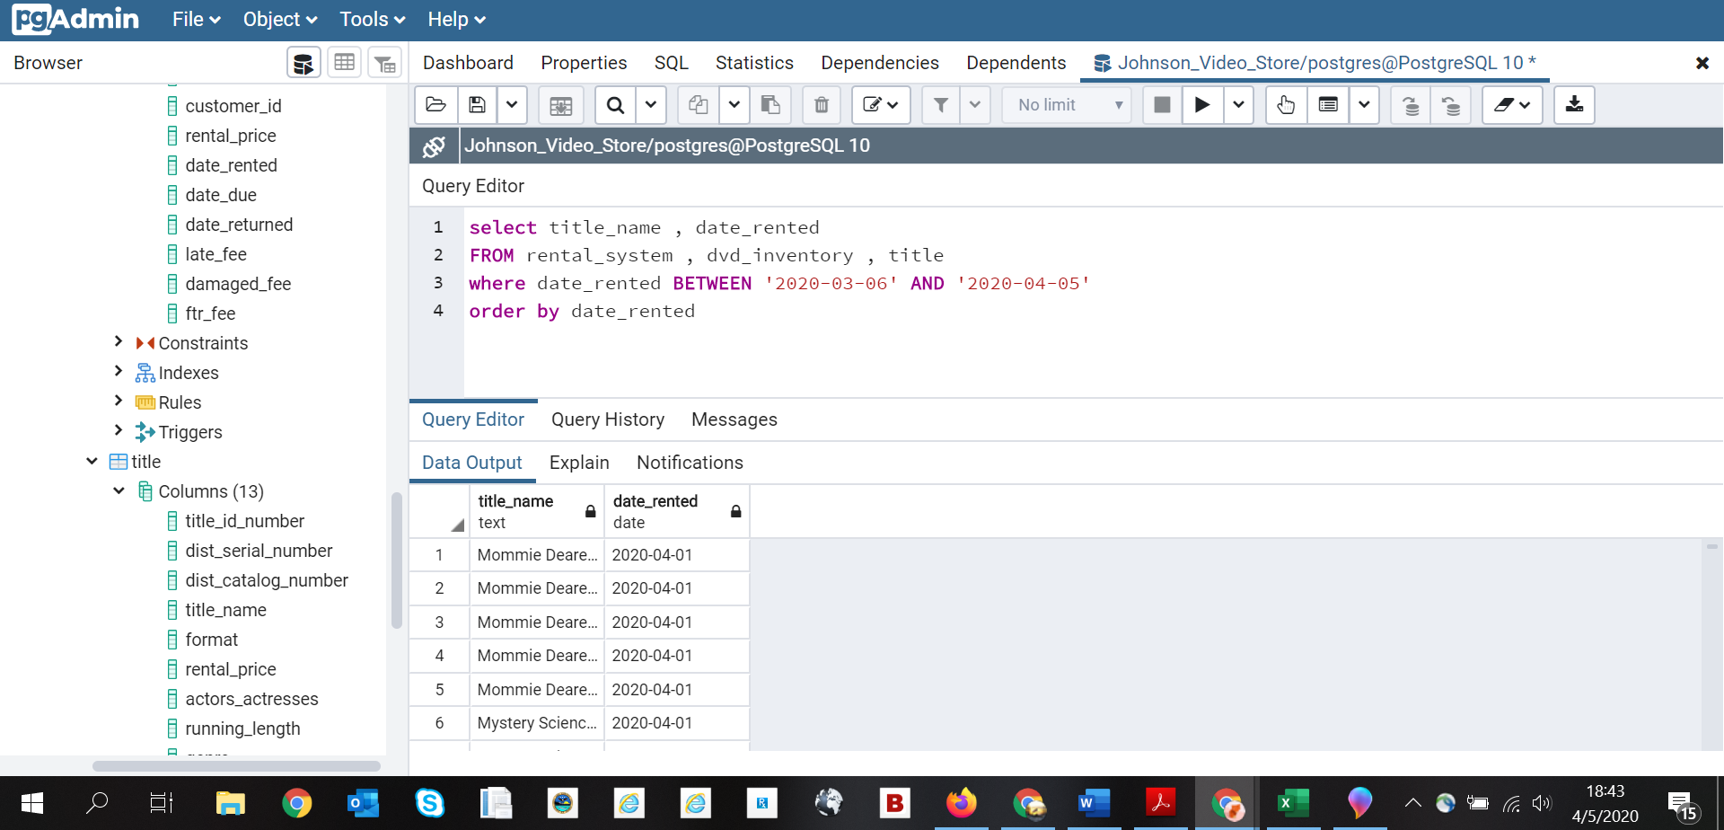

**Update Customer Last Name**

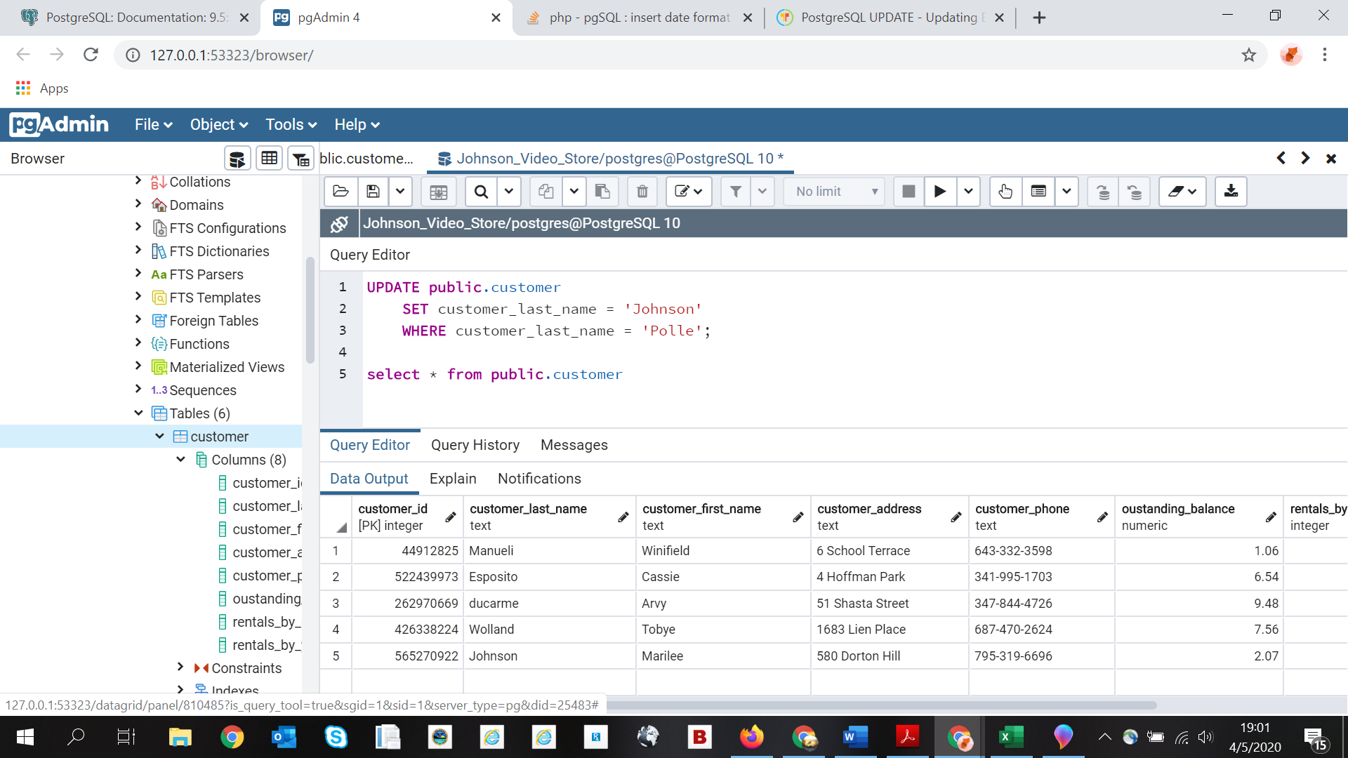

**Delete Customer from Database**

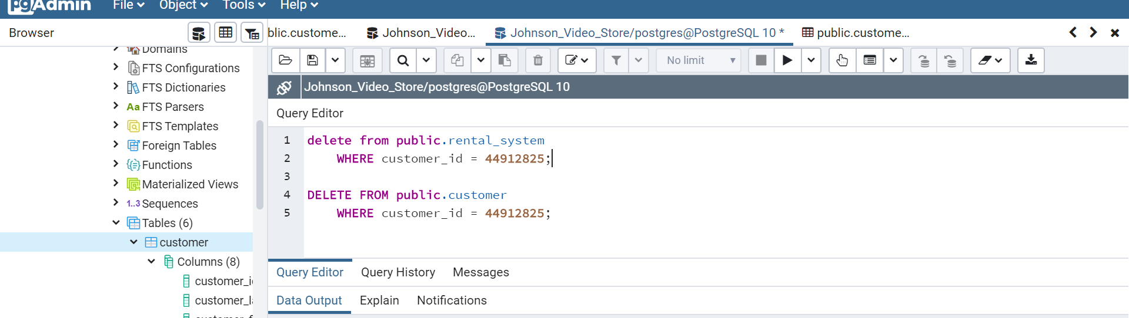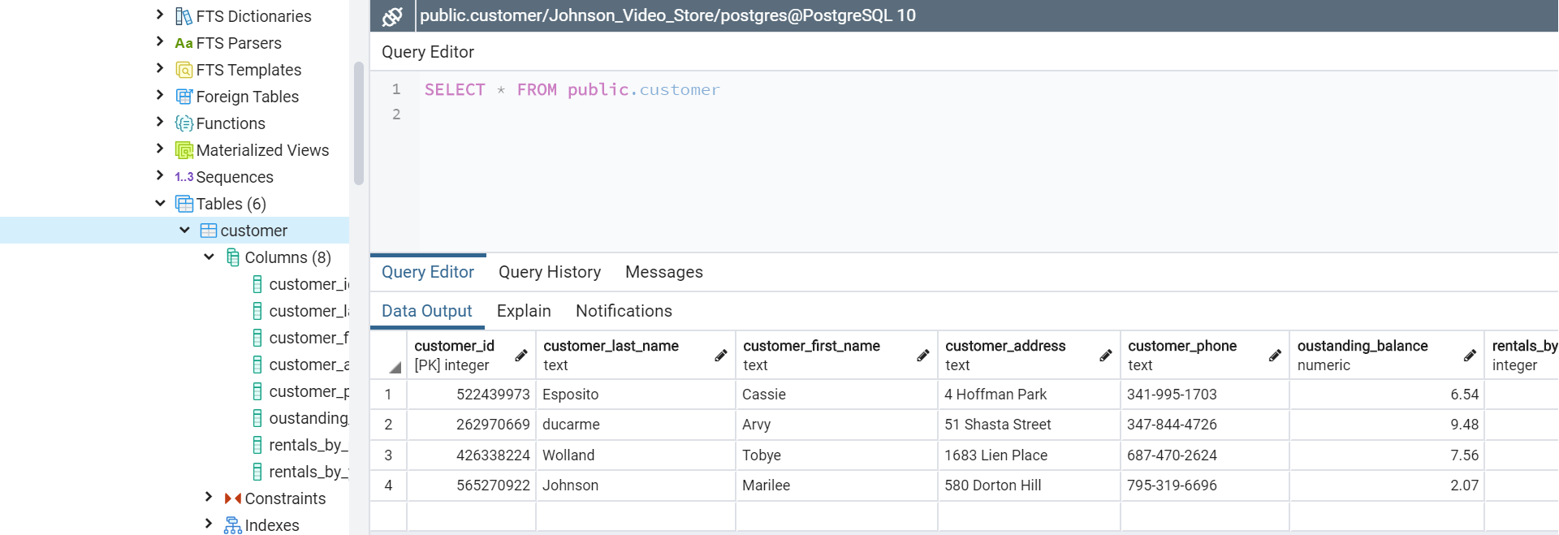

**Conclusion**

In concluding this assignment, there were several things that I learned regarding the use of the PostgreSQL platform as well as about myself. In the current environment we are experiencing, I came down with a still unknown illness; making it that much harder to complete the assignment. Nonetheless, I prevailed. PostgreSQL continues to be an easy platform to work with and is very user friendly. Most, if not all, of my troubles came from having an inadequate understanding of and experience with the SQL language.

Another area where I found a major mistake in my development of the database was regarding the title, DVD, and video tables. I realized towards the end of the assignment that I had failed to include the format when selecting only for DVDs. Looking back, it is likely that my results included both videos and DVDs. If I were to fix that mistake, I would have also included format in my statement as well as selected only for DVD formats. I thoroughly enjoyed this class and it has likely been one of my favorite courses this far. I look forward to utilizing it in the future.

**References**

Mockaroo. (n.d.). Random Data Generator and API Mocking Tool: JSON / CSV / SQL / Excel. Retrieved from https://www.mockaroo.com/