CS60 Project 1 Fall 2018

Due Midnight, Sunday Sept 9

Total 25 Pts

Download this file from the CS60 Project1 Link, rename the file to have the form:- YourStudentId#_CS60_Lastname_Firstname.docx, edit the footer and other parts to answer the **ten** questions below. After completing the project, load the file using the Project 1 Upload option in Canvas. *Figures from below are also available as data files if you prefer to use MS Access.*

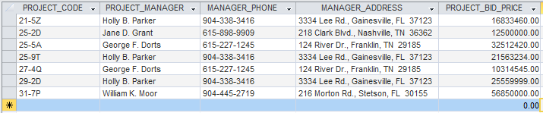

1. How many records (rows of raw data) does the above table store, and how many fields (columns or attributes) are in each record? (2 Pts)

There are 7 records in the table. There are 5 fields in each record in the table.

2. What problem would you encounter if you wanted to list the records in order of the manager’s last name, or if you sometimes wanted to omit the first name or middle name in a display or printout? This design fault is referred to as a **composite attribute**. Show the table structure of an altered table that will correct this problem? Show all columns and rows of raw data in this revised table. (2 Pts)

With the manager’s name represented as a composite attribute, it would be difficult, if not impossible, to produce an alphabetical listing of managers based on their last names or to omit the first name or middle name in a display. A table structure that corrects this problem is shown below:

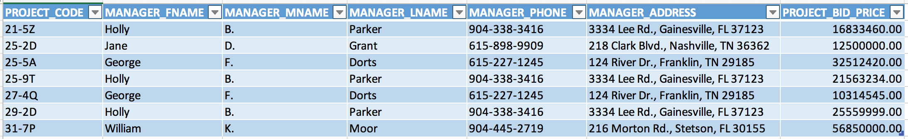

3. What problem would you encounter if you wanted to list the records in order of the street address, city, state, or zip, or area code? Building upon the improvements that you’ve already made, show the table structure of an altered table that also corrects this problem? Show all columns and rows in this revised table, including the new ones from Step 2.

(3 Pts)

With the manager’s address represented as a composite attribute, it would be difficult, if not impossible, to list the records in order of the street address, city, state, or zip code. To correct the problem they should be separate attributes as shown in the table below:

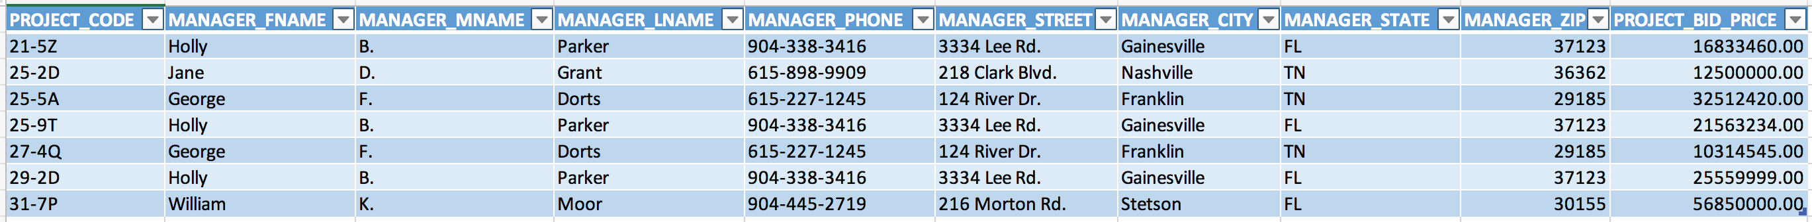

If you also wanted to list the records in order of the area code of the phone number, it would be difficult to do so with the manager’s phone number represented as a composite attribute. As demonstrated in the textbook, the area code and phone number can be split into two separate attributes as shown in the table below:

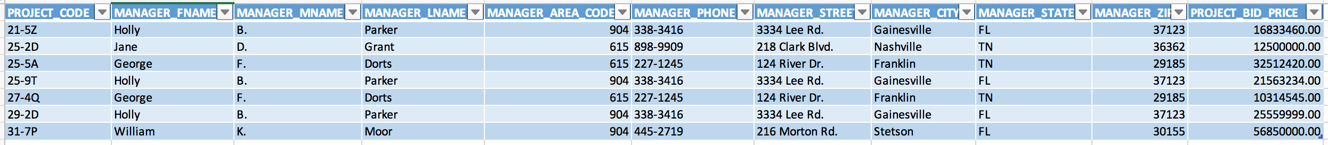

4. What data redundancies do you detect; i.e., what unnecessary repetitions are occurring? How could these redundancies lead to update anomalies, delete anomalies, or insert anomalies? (2 Pts)

Data redundancies occur in the MANAGER_FNAME, MANAGER_MNAME, MANAGER_LNAME, MANAGER_AREA_CODE, MANAGER_PHONE, MANAGER_STREET, MANAGER_CITY, MANAGER_STATE, and MANAGER_ZIP fields. This increases the likelihood of data anomalies, or inconsistencies, because field value changes must be made in multiple different places.

* An update anomaly could occur if the manager Holly B. Parker changed her name, because the name must be updated on each project record that it occurs on.
* A delete anomaly could occur if you delete the manager Jane D. Grant, because you will also unintentionally delete the project data for project 25-2D.
* An insert anomaly could occur if you needed to add a new manager, because you would also add a dummy project data entry to reflect the new manager’s addition. Again, this would increase the potential for creating data inconsistencies.

5. Using two relational tables, PROJECT and MANAGER, eliminate the redundancies you identified in Problem 4. Create a ManagerID column in both tables so you can link the two tables with the ManagerID being the primary key in MANAGER and a foreign key in PROJECT. Identify the primary key in each table. With words, show how the two tables join together by a foreign key that references a primary key. A format that would be useful is

Tablename.Columnname references Tablename.Columnname.

*Foreign Key Primary Key*

In this problem, show the column names across the top of each table and the rows of raw data below the column names. The columns must correct all faults (composite attributes and redundancies) that you saw above. (5 Pts)

PROJECT Table:

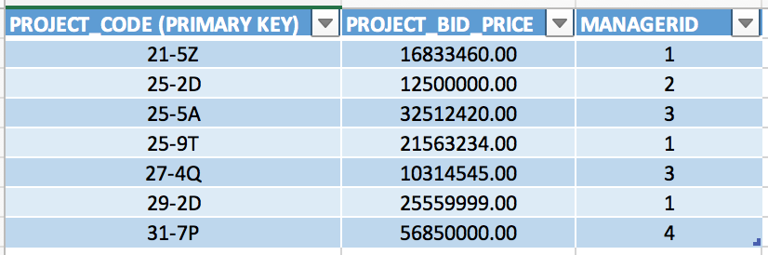

MANAGER Table:



PROJECT.MANAGERID references MANAGER. MANAGERID.

*Foreign Key Primary Key*

6. Create the **relational schema** to show the two tables and their columns, primary keys, foreign key, a line that shows how the two tables join, and the symbols 1 and ∞ (for *many*). As shown in the template on the following page that you can edit, a relational schema has a rectangle for each table and includes the table name, but lists the column names one-by-one after the tablename in the rectangle. A relational schema uses the infinity symbol (∞) for *Many.* The columns must correct the faults you saw above. (5 Pts)

Template for a relational schema that you can edit; label tablenames, column names, add or remove columns, connect the foreign key to the primary key with line(s), and position the connectivities (the 1 and ∞) correctly.

MANAGER

PROJECT

∞

|  |
| --- |
| **MANAGERID (PK is bolded)** |
| MANAGER_FNAME |
| MANAGER_MNAME |
| MANAGER_LNAME |
| MANAGER_AREA_CODE |
| MANAGER_PHONE |
| MANAGER_STREET |
| MANAGER_CITY |
| MANAGER_STATE |
| MANAGER_ZIP |

1

|  |
| --- |
| **PROJECT_CODE (PK is bolded)** |
| PROJECT_BID_PRICE |
| MANAGERID |

A new table for questions 7 and 8:

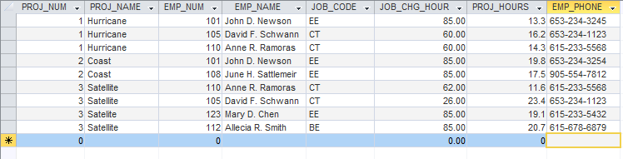

7. Based on the table above, identify pairs of columns that for the same value in one column, the 2nd column also has the same value. Such columns are **dependent** upon each other, or one column **determines** the other. You could write this functional relationship as

Column2 = function(Column1)

Unlike mathematical functions such as y = x2 and functions that are plotted or graphed as y = f(x), this function is a tabular function with data stored in a table. (3 Pts)

EMP_NAME = function(EMP_NUM)

EMP_PHONE = function(EMP_NUM)

PROJ_NAME = function(PROJ_NUM)

8. These dependencies lead to what redundancies in the table (what data is being stored redundantly)? Do you see any relationship between the pairs of columns that you identified in Question 7 and the occurrence of redundancies?

(3 Pts)

The fields EMP_NAME, EMP_PHONE, and PROJ_NAME are being stored redundantly. The following answers assume the given table is named PROJECT.

* Yes, both EMP_NAME and EMP_PHONE are dependents of the determinant EMP_NUM which results in the redundancies. The redundancy problem could be corrected by storing EMP_NAME and EMP_PHONE in a separate EMPLOYEE table with a primary key of EMP_NUM, and only including the foreign key EMP_NUM in the PROJECT table.
* Yes, PROJ_NAME is a dependent of the determinant PROJ_NUM which results in the redundancies. The problem could be corrected by renaming the given table to PROJECT_ASSIGNMENT and giving it a foreign key of PROJ_NUM. In a separate PROJECT table with a primary key of PROJ_NUM, you could store PROJ_NAME.

9. Create an ERD for each of the following descriptions. (Note the word *many* merely means *more than one* in the database modeling environment.) If you have access to Visio, you can use that for your drawings – if you don’t, you can draw it using Word.

1. Each of the ABC Corp’s divisions is composed of many departments. Each department has many employees assigned to it, but each employee works for only one department. Each department is managed by one employee and each of the managers can manage only one department at a time. (4 Points)

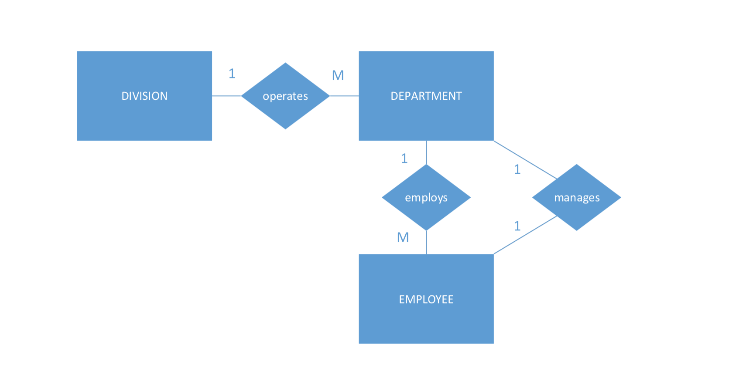

1. During some period of time, a customer can download many ebooks from BooksOnline. Each of the books can be downloaded by many customers during this period of time. (2 Pts)

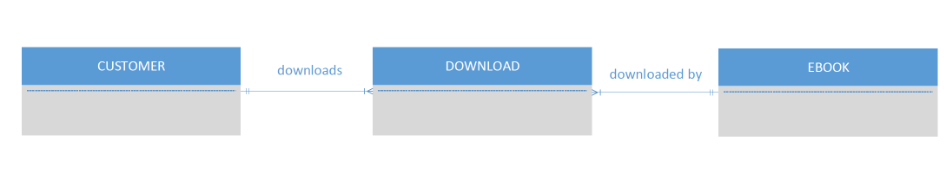This is a many-to-many (M:N) relationship, so we use a composite entity (also called a bridge entity or associative entity). Because the DOWNLOAD table links two tables, CUSTOMER and EBOOK, it is also called a linking table.

1. An airliner can be assigned to fly many flights, but each flight is flown by only one airliner. (2 Pts)

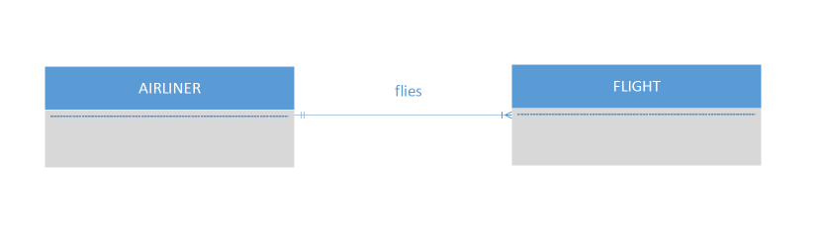

d. QuickTime Corp operates many factories. Each factory is located in a region and each region can be home to many

QuickTime factories. Each factory has many employees but each employee is employed by only one factory.

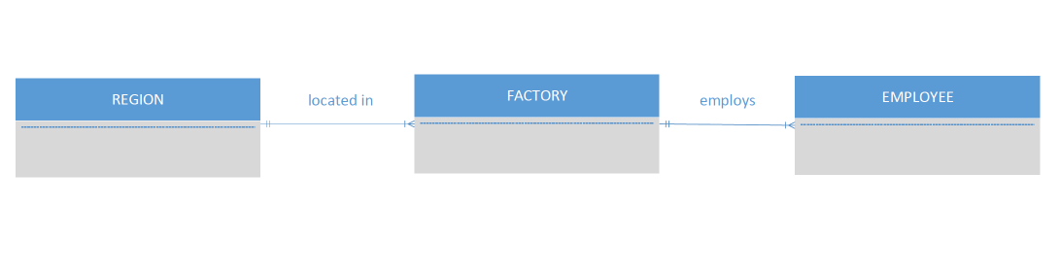 (4 Pts)

e. An employee may have earned many degrees and each degree may have been earned by many employees. (3 Pts)

This is a many-to-many (M:N) relationship, so we use a composite entity (also called a bridge entity or associative entity). Because the GRADUATE table links two tables, EMPLOYEE and DEGREE, it is also called a linking table.

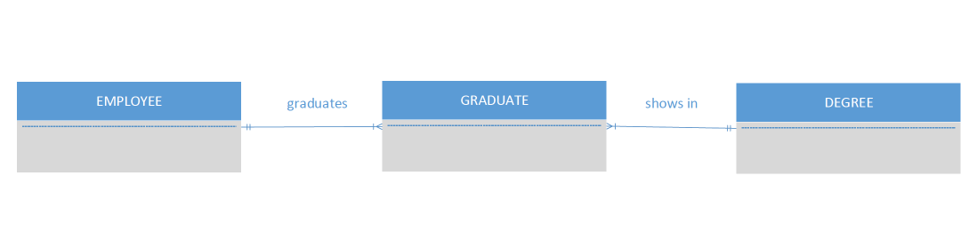

10. Use this Figure as a guide to answer parts (a) to (c).

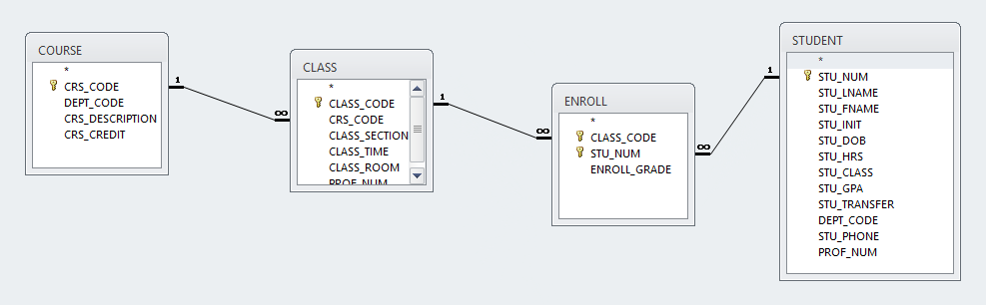

1. identify each relation type and write all business rules. (3 Pts)

* Each COURSE may generate many CLASSes, but each CLASS references a single COURSE. **(1:M)**
* Each STUDENT can enroll in many CLASSes, and each CLASS can be taken by many STUDENTs. **(M:N)** This is represented by the composite entity ENROLL and the following two relationships:
  + Each CLASS can appear in many rows of the ENROLL linking table, but each row of the ENROLL table corresponds to only one CLASS. **(1:M)**
  + Each STUDENT can appear in many rows of the ENROLL linking table, but each row of the ENROLL table corresponds to only one STUDENT. **(1:M)**

1. create the basic Crow’s Foot ERD for Tiny College. (3 Pts)

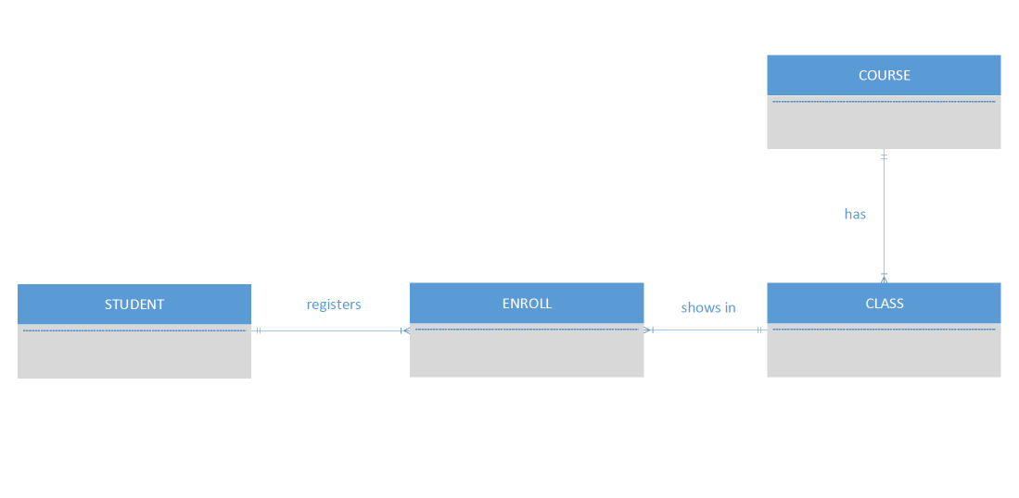

c. create the UML class diagram that reflects the entities and relationships you identified in the relational diagram.

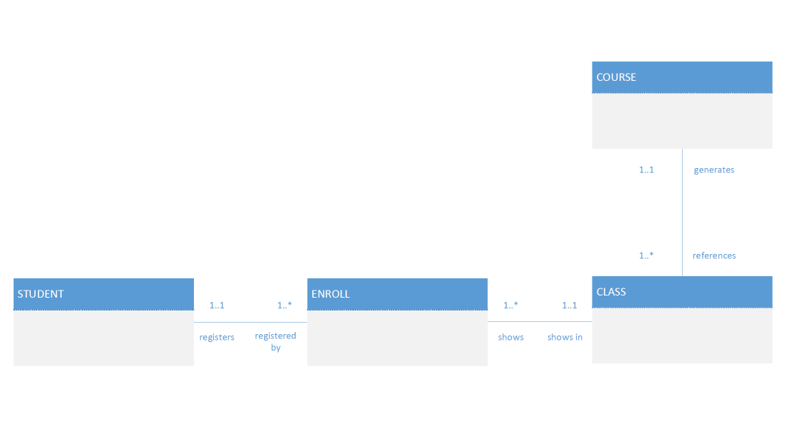 (4 Pts)