**Problem Set 4**

Submission:- Create a zipped folder with all your assignment files - rename the folder to have the form:-**YourStudentId#_CS60_Lastname_Firstname_PS4.zip.**  After completing the project, load the zipped folder using the Problem Set 4 Upload option.

If you need to make changes to an already uploaded assignment, change your filename to:-**YourStudentId#_CS60_VX_Lastname_Firstname_PS4.zip**, where X indicates the version number.

**Due Date**:- Nov 19 at 11:59pm

**Problem 1**:-

Using the STUDENT table structure shown in the below do the following:-

1. Write the relational schema and draw its dependency diagram. Identify all dependencies, including all transitive dependencies.

Note the following:

* The STUDENT table is automatically in 2NF because it is impossible to have partial dependencies when the PK (STU_NUM) consists of a single attribute.
* ADVISOR_OFFICE is a determinant of ADVISOR_BUILDING because it has a prefix indicating which building the office is in.

STUDENT(**STU_NUM**, STU_LNAME, STU_MAJOR, DEPT_CODE, DEPT_NAME, DEPT_PHONE, COLLEGE_NAME, ADVISOR_LNAME, ADVISOR_OFFICE, ADVISOR_BLDG, ADVISOR_PHONE, STU_GPA, STU_HOURS, STU_CLASS)

PARTIAL DEPENDENCIES:

* None

TRANSITIVE DEPENDENCIES:

* (DEPT_CODE 🡪 DEPT_NAME, DEPT_PHONE, COLLEGE_NAME)
* (STU_MAJOR 🡪 DEPT_CODE, DEPT_NAME, DEPT_PHONE, COLLEGE_NAME)
* (DEPT_PHONE 🡪 DEPT_CODE)
* (ADVISOR_OFFICE 🡪 ADVISOR_BUILDING)
* (STU_HOURS 🡪 STU_CLASS)

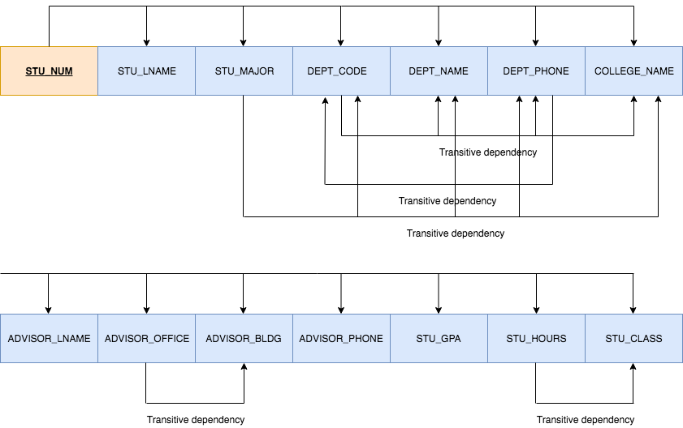

1. Write the relational schema and draw the dependency diagram to meet the 3NF requirements to the greatest practical extent possible. If you believe that practical considerations dictate using a 2NF structure, explain why your decision to retain 2NF is appropriate. If necessary, add or modify attributes to create appropriate determinants and to adhere to the naming conventions.

Note the following:

* It is safe to ignore the transitive dependency (ADVISOR_OFFICE 🡪 ADVISOR_BUILDING) because it can be argued that having to partition the prefix to get a dependency means that it is not a determinant in a strict sense, and it does not cause any practical problems.
* We choose to also ignore the transitive dependency (STU_HOURS 🡪 STU_CLASS) because any value of STU_HOURS within a range corresponds to a particular STU_CLASS so it would not make sense to create a new table with STU_HOURS as the primary key.
* We choose to also ignore the transitive dependency (DEPT_PHONE 🡪 DEPT_CODE) because it does not cause any practical problems.
* Therefore, these practical considerations justify retaining a 2NF structure.

STUDENT(**STU_NUM**, STU_LNAME, STU_MAJOR, ADVISOR_CODE, STU_GPA, STU_HOURS, STU_CLASS)

MAJOR(**MAJOR_CODE**, DEPT_CODE, MAJOR_NAME)

DEPT(**DEPT_CODE**, DEPT_NAME, DEPT_PHONE, COLLEGE_NAME)

ADVISOR(**ADVISOR_CODE**, ADVISOR_LNAME, ADVISOR_OFFICE, ADVISOR_BLDG, ADVISOR_PHONE)

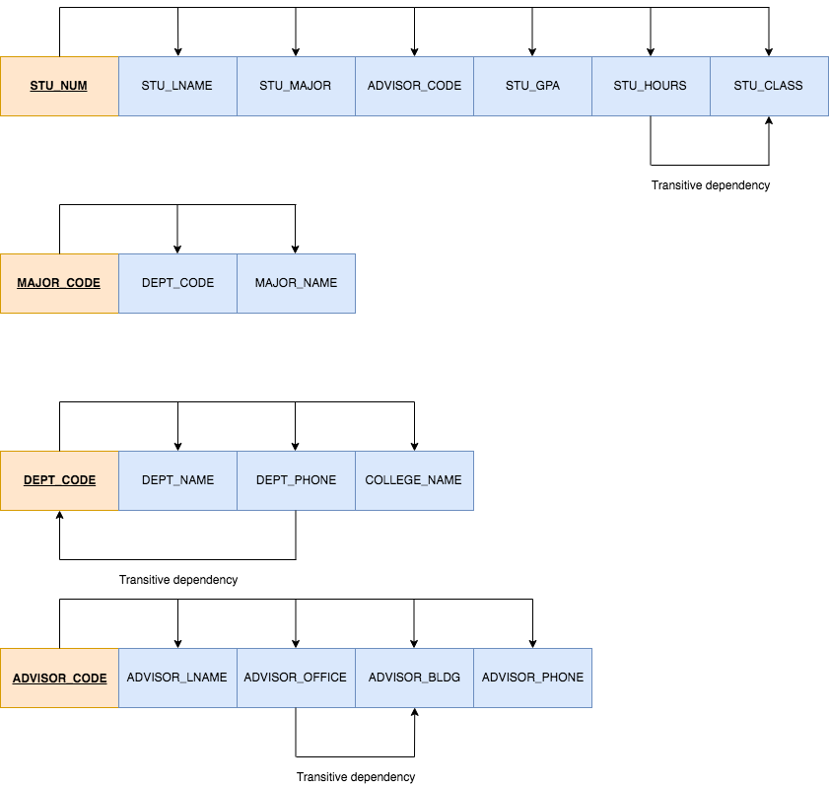

1. Write the relational schema and draw the dependency diagram to meet the 3NF requirements to the greatest practical extent possible. If you believe that practical considerations dictate using a 2NF structure, explain why your decision to retain 2NF is appropriate. If necessary, add or modify attributes to create appropriate determinants and to adhere to the naming conventions.

Note: see part (b).

1. 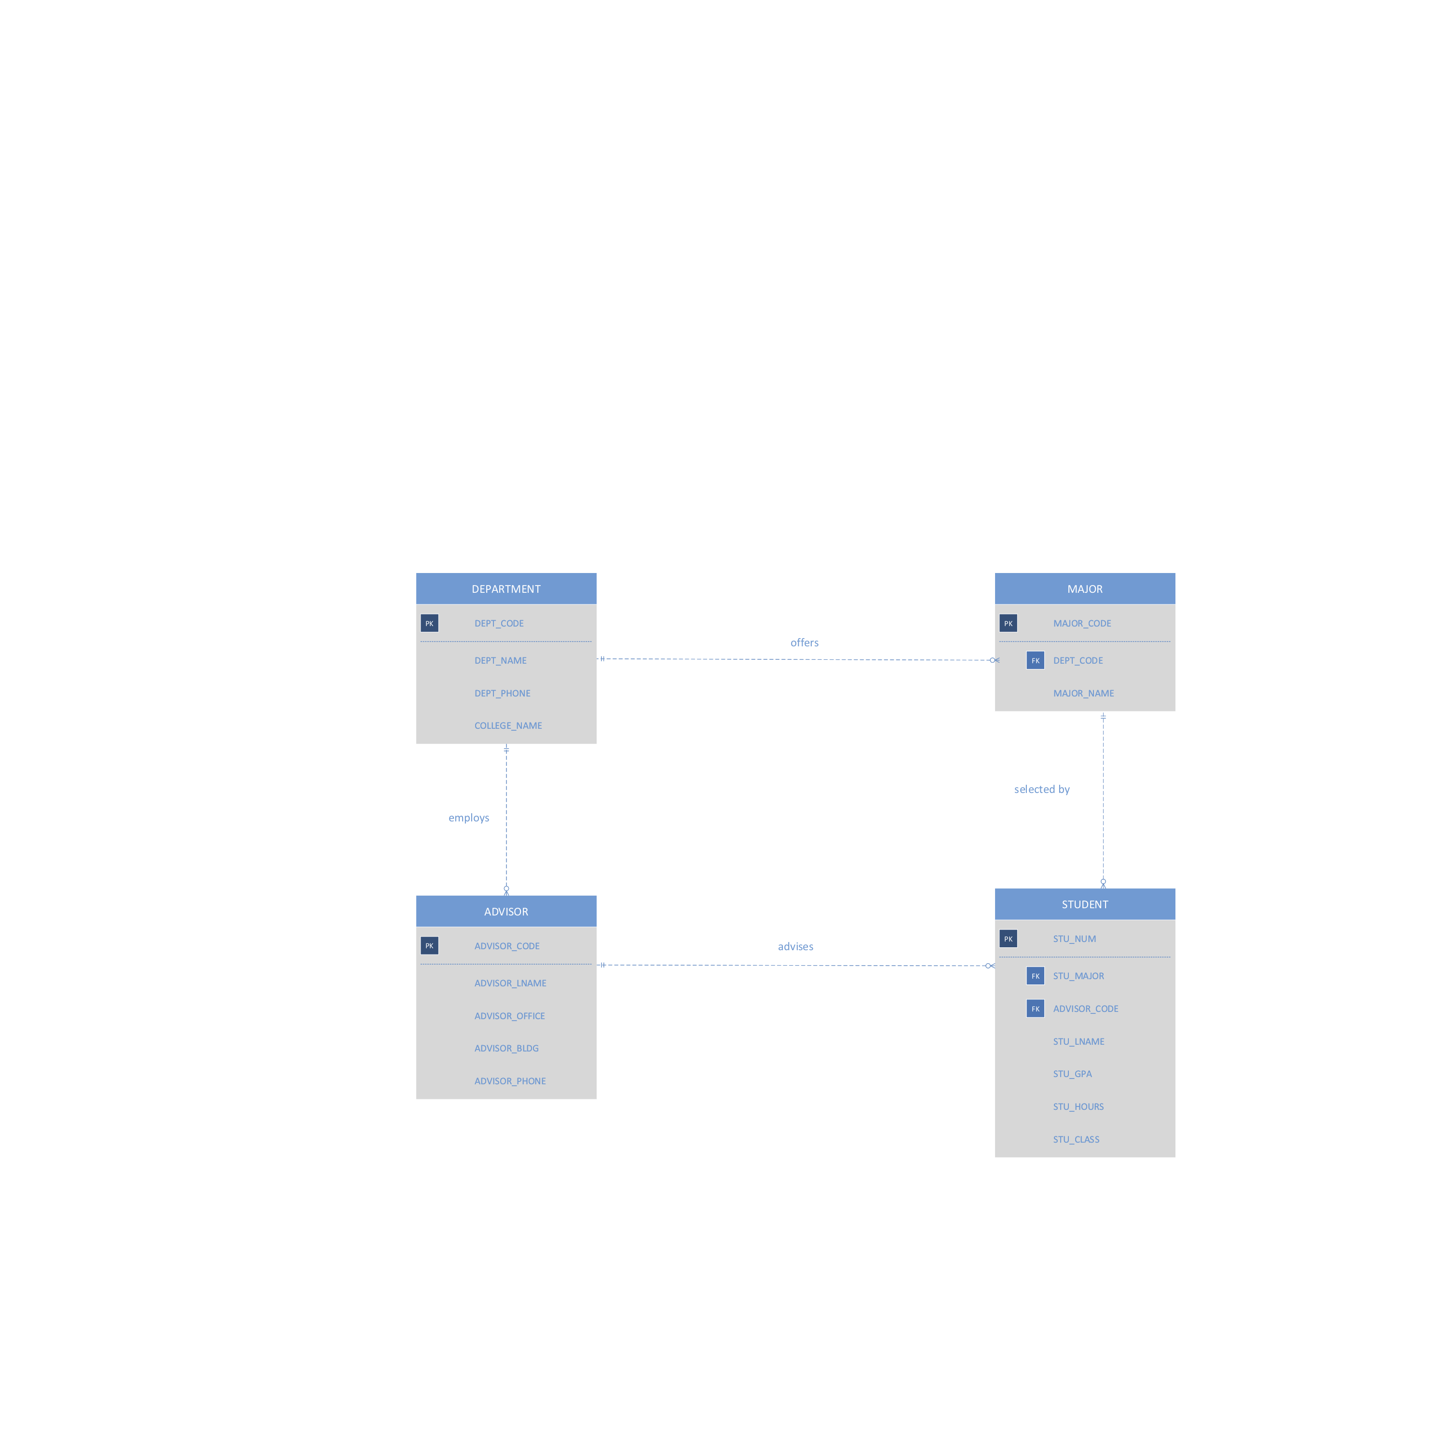Draw the Crow’s Foot ERD.

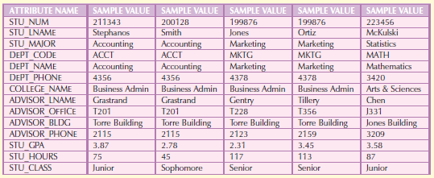

**Problem 2**:-

The table structure shown below contains many unsatisfactory components and characteristics. For example, there are several multivalued attributes, naming conventions are violated, and some attributes are not atomic.

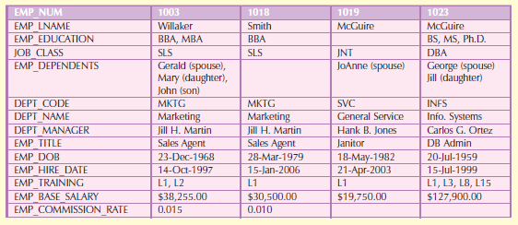

1. Given the structure shown in Table P6.6, write the relational schema and draw its dependency diagram. Label all transitive and/or partial dependencies.

EMPLOYEE(**EMP_NUM**, EMP_LNAME, EMP_EDUCATION, JOB_CLASS, EMP_DEPENDENTS, DEPT_CODE, DEPT_NAME, DEPT_MANAGER, EMP_TITLE, EMP_DOB, EMP_HIRE_DATE, EMP_TRAINING, EMP_BASE_SALARY, EMP_COMMISSION_RATE)

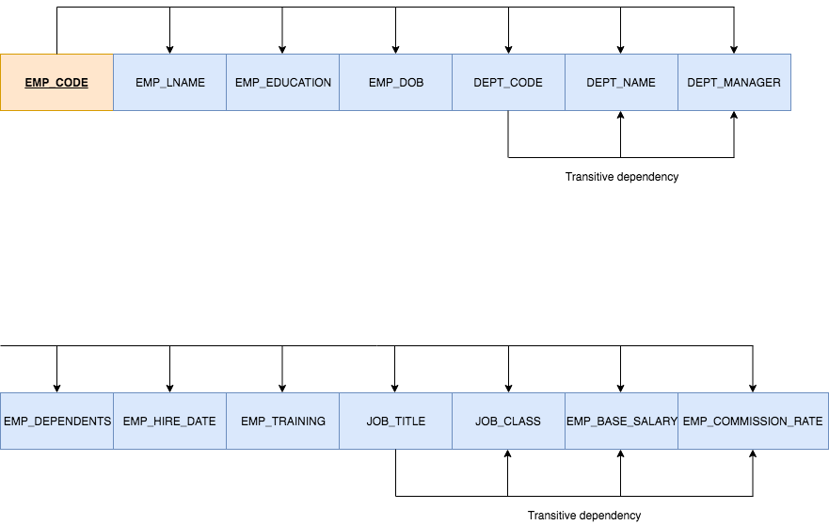

1. Draw the dependency diagrams that are in 3NF. (Hint: You might have to create a few new attributes. Also make sure that the new dependency diagrams contain attributes that meet proper design criteria; that is, make sure that there are no multivalued attributes, that the naming conventions are met, and so on.)

Note the following:

* Given the sample data, the multivalued attributes in the original table structure are EMP_EDUCATION, EMP_DEPENDENTS, and EMP_TRAINING. We will break these multivalued attributes as well as the transitive dependencies off into new tables in order to produce dependency diagrams that are in 3NF.

EMPLOYEE(**EMP_CODE**, EMP_LNAME, DEPT_CODE, JOB_TITLE, EMP_DOB, EMP_HIRE_DATE)

DEPARTMENT(**DEPT_CODE**, DEPT_NAME, DEPT_MANAGER)

JOB(**JOB_TITLE**, JOB_CLASS, JOB_BASE_SALARY, JOB_COMMISSION_RATE)

DEPENDENT(**EMP_CODE**, **DEP_CODE**, DEP_TYPE)

EDUCATION(**EDUC_CODE**, EDUC_DESCRIPTION)

QUALIFICATION(**EMP_CODE**, **EDUC_CODE**, QUAL_DATE)

TRAINING(**TRAIN_CODE**, TRAIN_DESCRIPTION)

EMP_TRAINING(**EMP_CODE**, **TRAIN_CODE**, EMP_TRAIN_DATE)

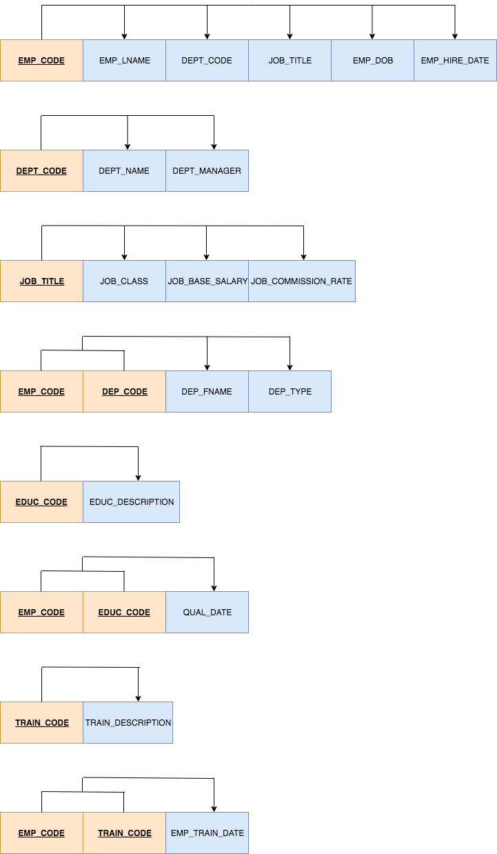

1. Draw the relational diagram.

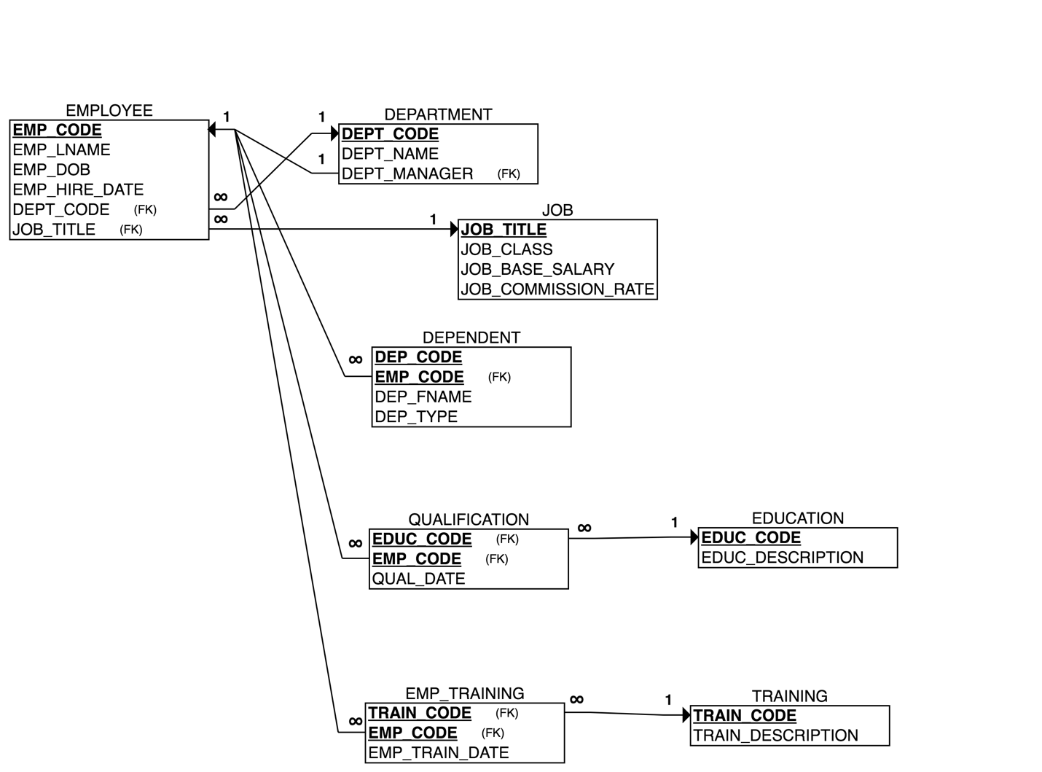

1. Draw the Crow’s Foot ERD.

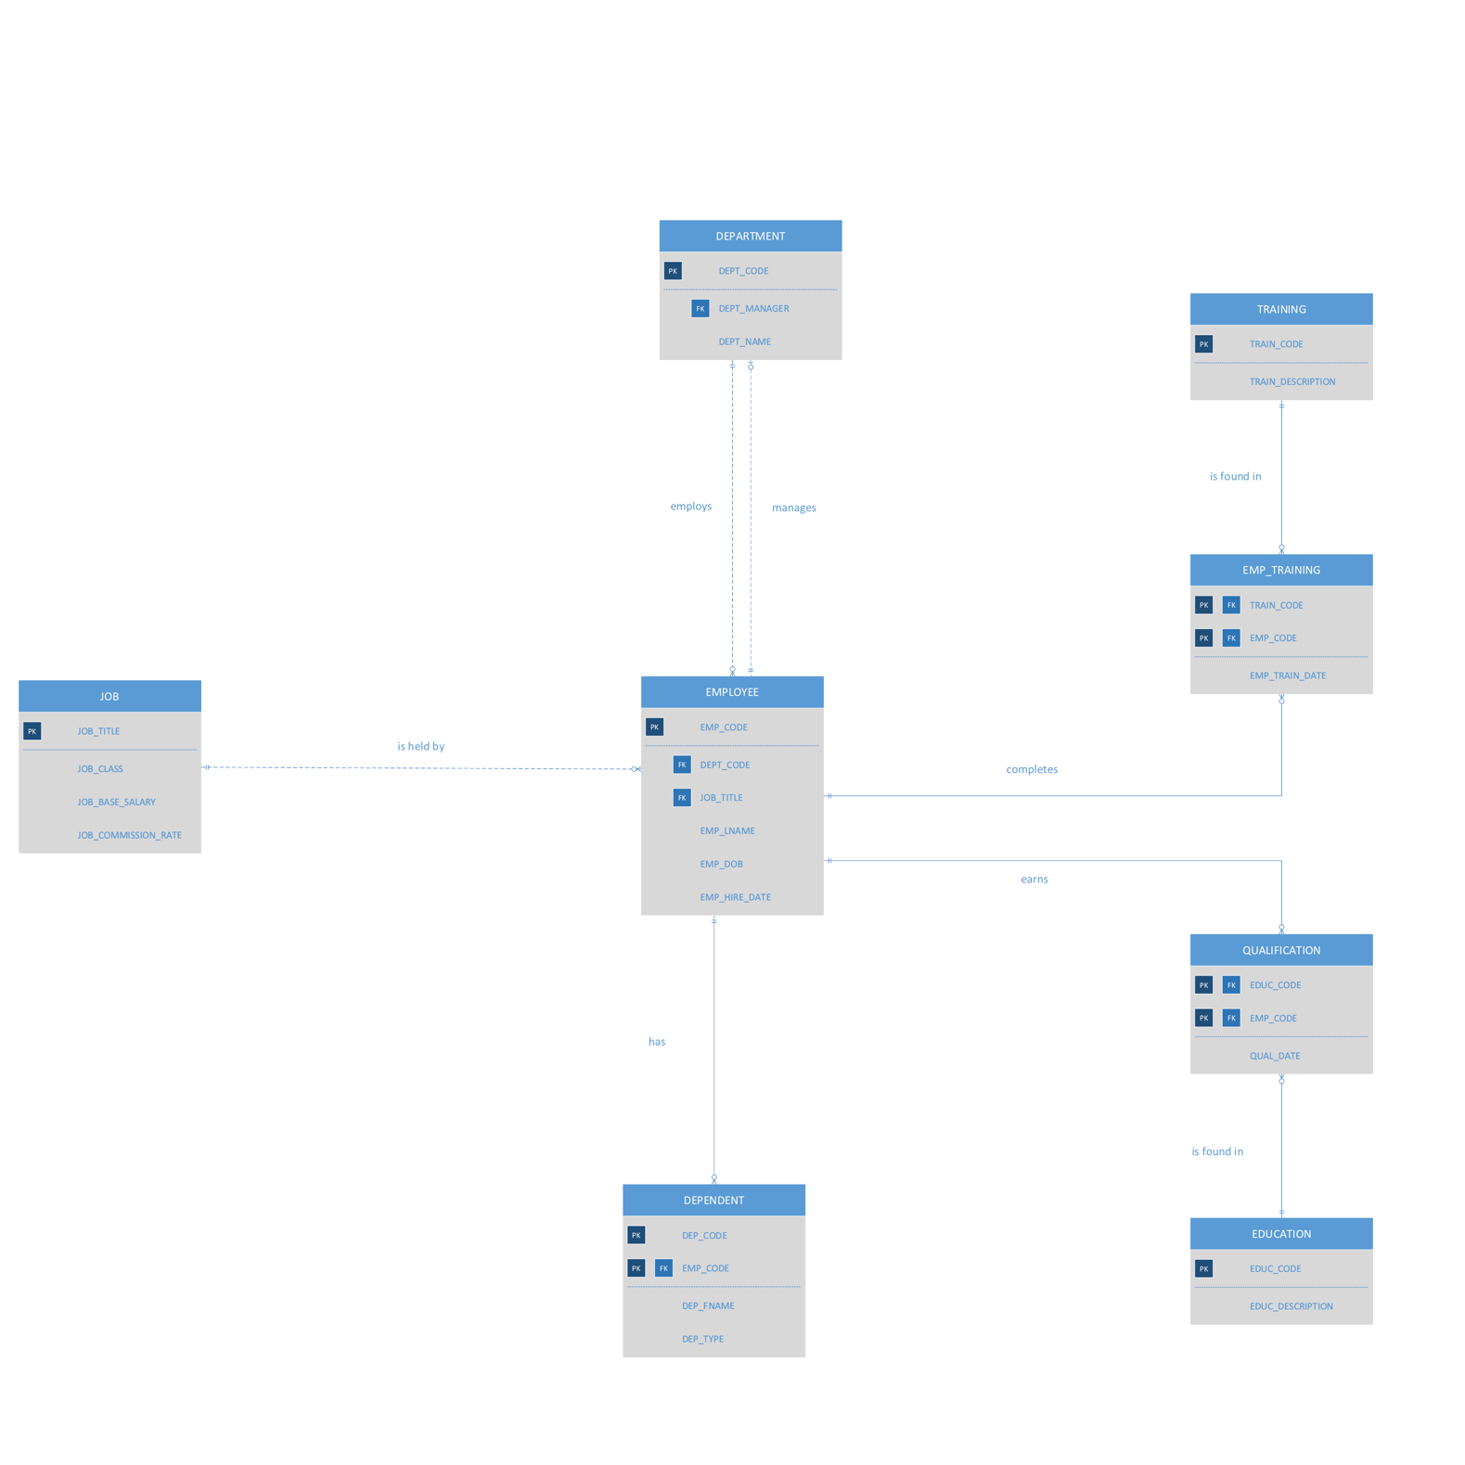

**Problem 3**:-

Suppose you have been given the table structure and data shown in Table P6.9, which was imported from an Excel spreadsheet. The data reflect that a professor can have multiple advisees, can serve on multiple committees, and can edit more than one journal.

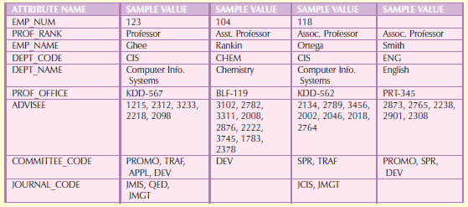

Given the information in the table above:-

Draw the dependency diagram.

1. Identify the multivalued dependencies.

The multivalued dependencies are ADVISEE, COMMITTEE_CODE, and JOURNAL_CODE.

Note the following:

* The value of a unique multivalued attribute cannot be determined given a value of EMP_NUM. This is indicated by a dashed line in the dependency diagram.

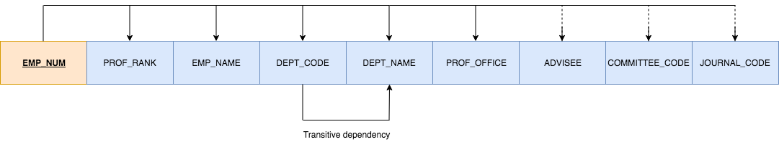

1. Create the dependency diagrams to yield a set of table structures in 3NF.

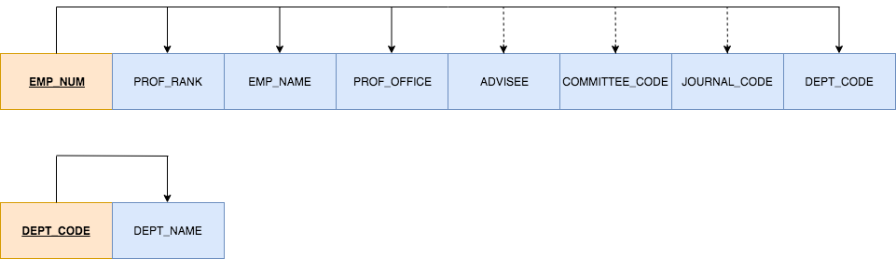

1. Eliminate the multivalued dependencies by converting the affected table structures to 4NF.

Note the following:

* Although these dependency diagrams are in 4NF, they are not implementable solutions because the relationships between EMP_NUM/COMMITTEE_CODE and EMP_NUM/JOURNAL_CODE are both M:N.
* Assuming that each ADVISEE has only one professor as their advisor (but each professor can have many ADVISEES), the relationship between ADVISEE and professor is not M:N.

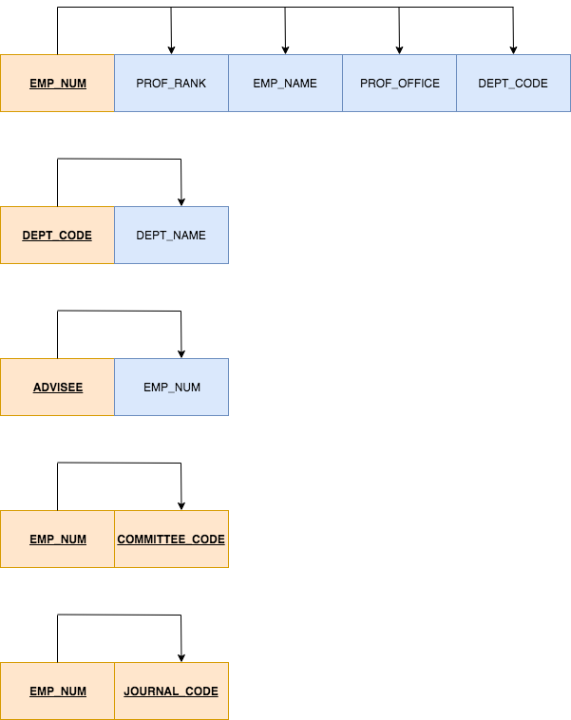

1. Draw the Crow’s Foot ERD to reflect the dependency diagrams you drew in Part (c). (Note: You might have to create additional attributes to define the proper PKs and FKs. Make sure that all of your attributes conform to the naming conventions.)

Note the following:

* 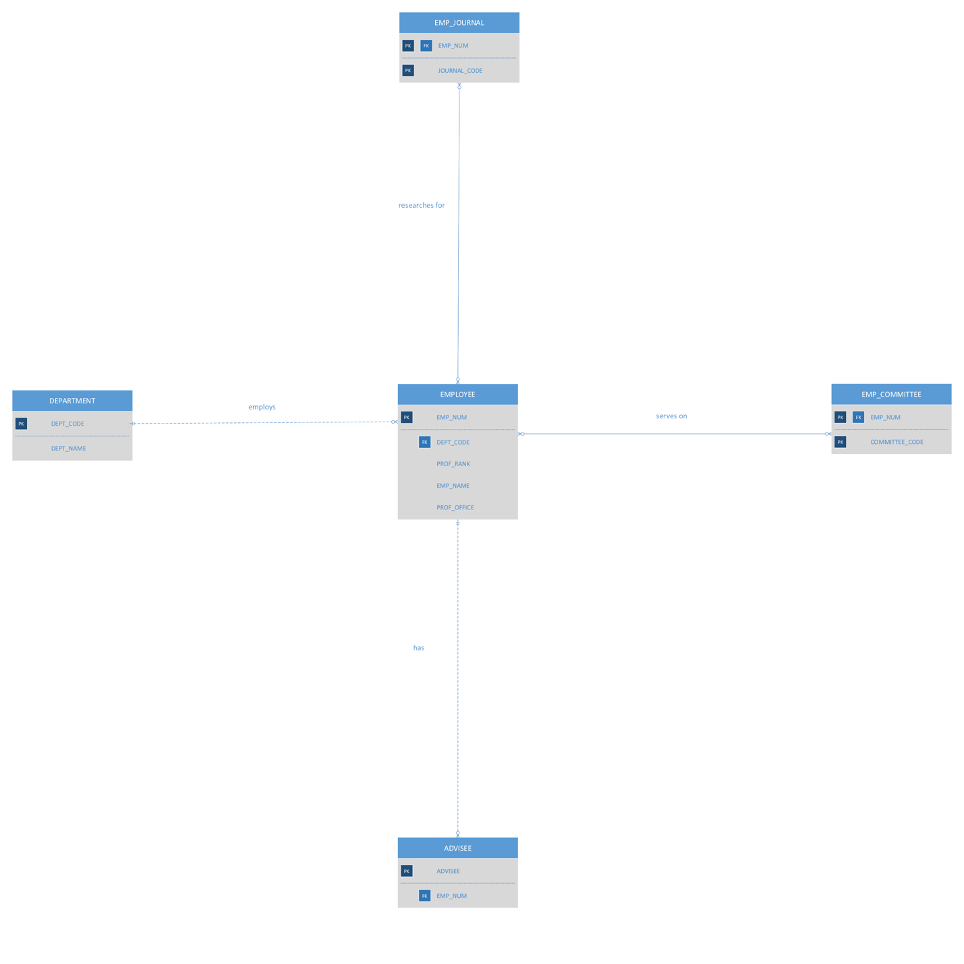As in the dependency diagrams, this ERD contains two M:N relationships. In order to implement this design, we would need to create composite entities to break down each M:N relationship into two 1:M relationships.