Pariya Samandi

UID: 205-092-357

Stewart Dulaney

UID: 904-064-791

Where is the missing person?

1. Introduction

Scotland Police has revealed an aerial drone system to assist in finding people who are missing or in need of help. Although it may not look special from the outside, the drone has been specifically trained to aid police with search and rescue operations by using deep learning.

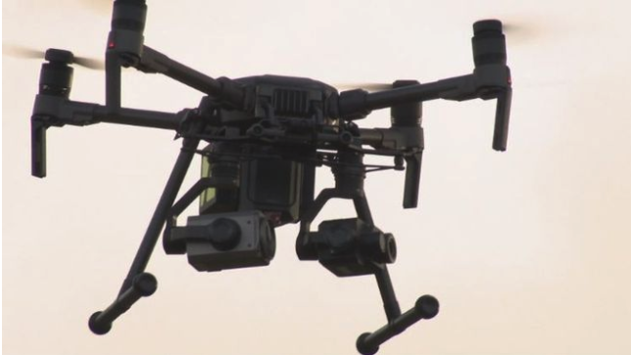

Drone deployed by Police Scotland (Macdonald)

This remotely-piloted aircraft system (RPAS) can detect objects invisible to the human eye. It uses advanced technologies such as highly-powered optical cameras, neural networks, thermal imaging sensors, and an Internet of Things devices to enhance the ability of an officer to save lives in real time. The system has the capability of identifying a missing person up to 150 meters away. The low cost drone uses an AI recognition system that can be operated by two people: one for flying the drone from a remote control panel and a second for using the recognition software from a mobile phone (Macdonald).

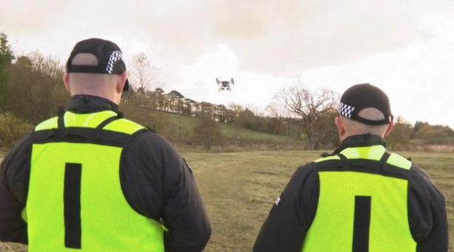

Two Police Scotland officers operate the drone (Macdonald)

This news is exciting for Police Scotland for two reasons. First, the drones will provide a new and improved air support capability to the north of Scotland (Whyte). This is significant for Scotland because thousands of people go missing in the northern part of the country, where the notoriously bad weather and terrain has hindered police search and rescue by helicopter and land. Second, the drone project represents a unique collaboration with industry partners and academia to improve drone technology used in police work. In addition to operational deployment, they are doing research and development on drones with partners such as Glasgow University, University of West of Scotland, CENSIS (one of Scotland’s non-profit innovation centers), and Thales (a French aerospace company) (Whyte). This exploration of the evolving technology of drones and sensor equipment as it relates to emergency service applications is significant. Technology developed by Police Scotland will benefit future emergency services throughout the UK as well as the industry as a whole. Although the drones put into service by Police Scotland are easy-to-use, affordable, and suggestive of exciting new applications for drones in law enforcement, the program falls short in preserving privacy by failing to protect potentially sensitive captured data.

2. Usability

Although many drones used by law enforcement are technology-centered with less emphasis on user-centered usability, the drone system used by Police Scotland adequately incorporates both of these important aspects. The systems have been developed with consideration of end-user (human) needs in their designs. Because the technology has been developed in house, the drone system design has considered the experiences of real police officer users, who do not have a technical background in drone hardware design and software development.

In particular, the design of Police Scotland’s drone system adheres to Nielsen’s usability heuristics, which are the most commonly used principles for evaluating the usability of a user interface (Nielsen 1-8). The table below summarizes Nielsen’s usability Heuristic Evaluation (HE) (Nielsen 1-8).

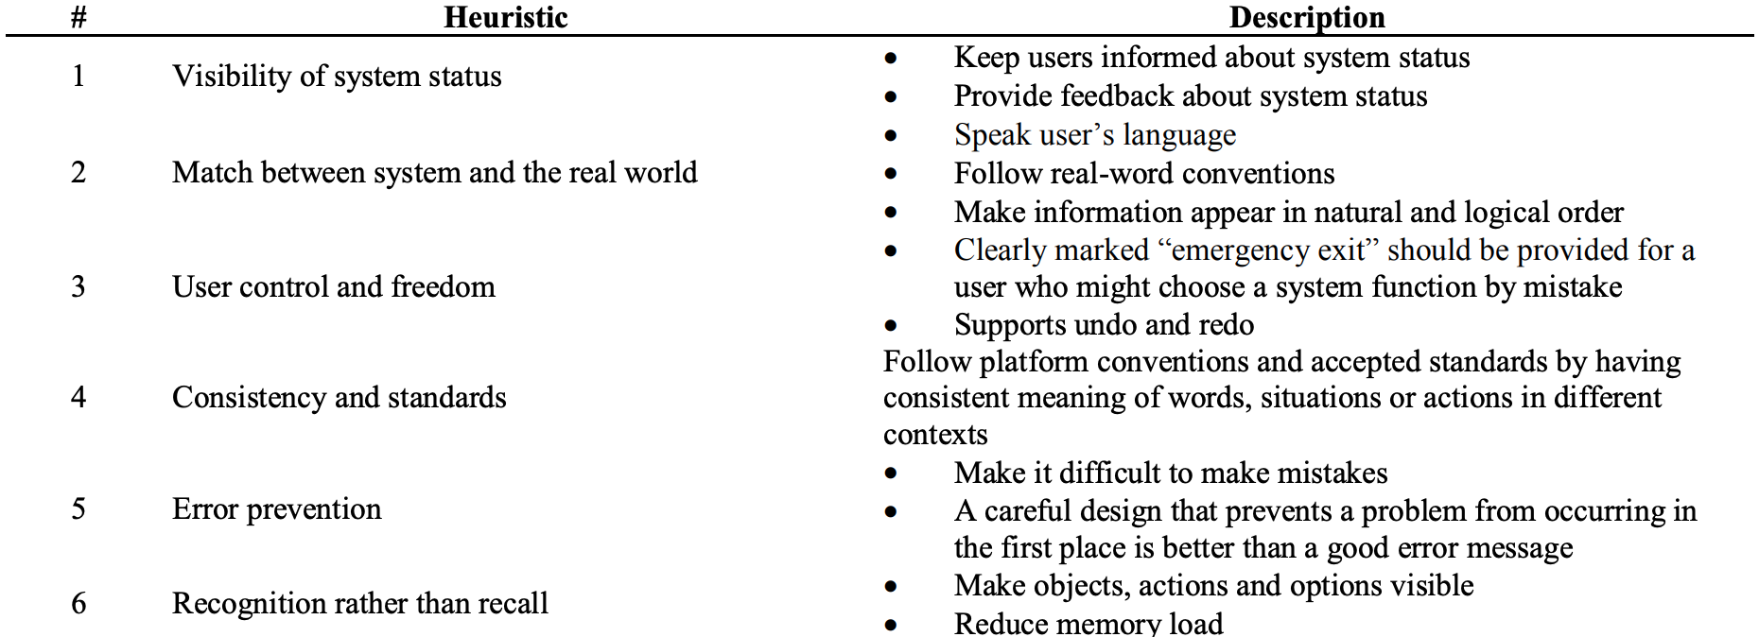

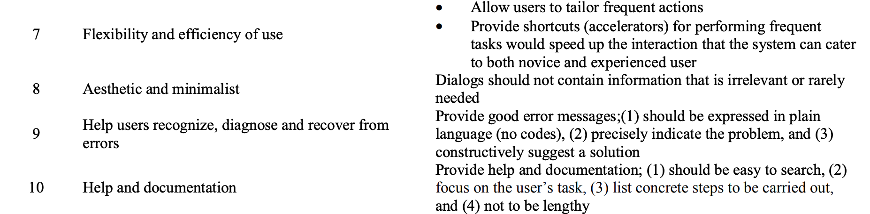

Nielsen’s Heuristics for Expert Evaluation (Nielsen 1-8)

A major breakthrough is that the recognition software can be operated from a mobile platform, which reduces the cognitive burden caused by a deluge of data when a more complex drone specific software platform is used (Macdonald). This aligns with the heuristic of recognition rather than recall because the officer is using familiar buttons, switches, graphics, and other interactive elements instead of having to remember how to use a completely separate platform. In other words, the recognition software used with the drone by Police Scotland has a simple user interface that enables non-technical police officers to easily use it without complications. Another advantage is that the recognition software interface doesn’t reveal the details of the prediction made by the neural network to the user (Whyte). This adheres to the principle of being aesthetic and minimalist because information that is not relevant or rarely needed is not displayed. It also follows the heuristic of error prevention because it makes it more difficult to make mistakes by displaying a concrete decision to the officer instead of raw sensor or prediction data. Lastly, per Nielsen’s HE, any new system similar to the drone system interfaces and the prototypes of these novel technologies should have a fully functioning safety inspection before its use in real time scenarios (Nielsen 1-8). The evaluation of the interface for operation of the drone has been well documented in Police Scotland’s collaboration with its partners in industry and academia in the research and development of the software (Whyte).

Furthermore, it can be seen that the design of Police Scotland’s drone system follows Nielsen’s heuristics by evaluating at a higher level how the system enables non-technical users to find missing or vulnerable people who cannot be found or seen with previous search methods. For example, the interface of the system is efficient enough to be ideally used (Irizarry et al). This is because the neural network system deployed with the drone has a low enough prediction error rate in detecting the missing persons to be useful in enhancing search and rescue. Moreover, the drone signals a blue light to alert people of its presence (visibility of system status), allows remote navigation through display of the drone’s line of sight on a mobile phone (match between system and the real world), can be controlled by non-technical users like police officers (recognition rather than recall), aligns with Police Scotland protocols and the larger UK’s regulations (consistency and standards), has been tested many times before being used in real applications (fully functioning safety inspections), is efficient enough to be used without needing a technical person (aesthetic and minimalist), indicates prediction errors instead of showing false positives (help users recognize and diagnose errors), and provides sufficient police training documentation for easier use of the drone systems (help and documentation).

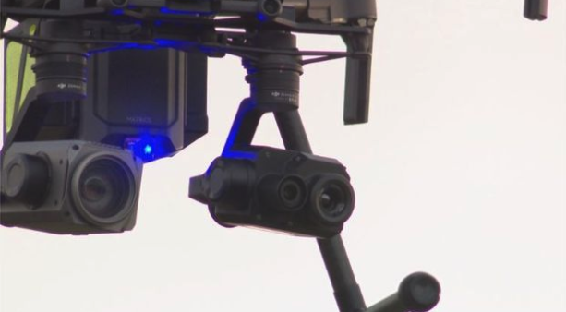

The drone has a flashing blue light to alert people to its presence (Macdonald)

3. Applications

Police Scotland’s drone program is representative of a larger expansion of drone use by law enforcement in recent years due to the extensive practical applications of drones in performing police work. For example, in addition to searching for missing persons, Police Scotland also intends to use the drones for collecting evidence in the form of crime scene imagery, deployment in situations unsafe for an officer such as a bomb threat, and supporting police operations such as demonstrations, sporting events, and festivals (Whyte).

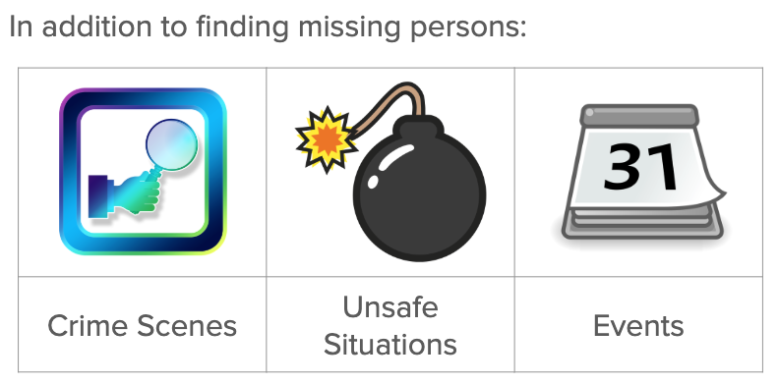

Applications - Police Scotland (Whyte)

Although searching large open areas is something that can be done with a helicopter, these drones support additional tasks in which their smaller size and lower cost to deploy are advantageous. In addition, drones can be used to safeguard persons of interest, detect crime and criminals, evaluate a situation during a severe disaster, detect hotspots to target in a burning house using thermal imaging, and even determine emergency response by police after a car accident (Custers 100-111).

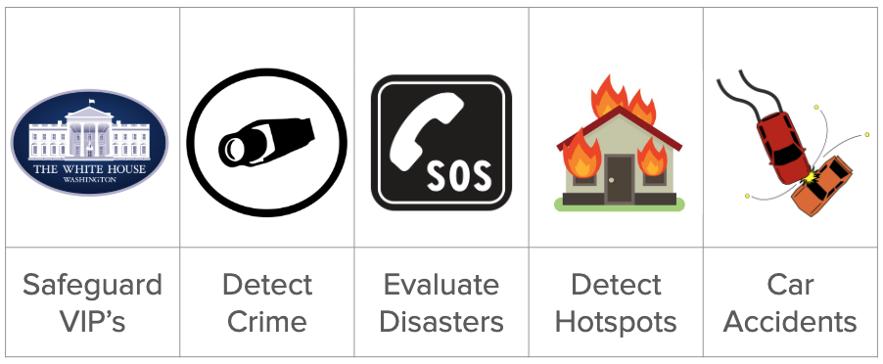

Applications - Broader Law Enforcement (Custers 100-111)

In the same way Police Scotland’s drone gives officers the ability to find people who are not visible to the naked eye, a drone with a high-powered camera can be leveraged to augment the ability of an officer to gather information in a plethora of police tasks in real time. There is an abundance of ways that drones can help police do their jobs, and even more become possible if the drone is outfitted with additional sensors or tools such as air quality sensors, pepper spray, or cell phone trackers.

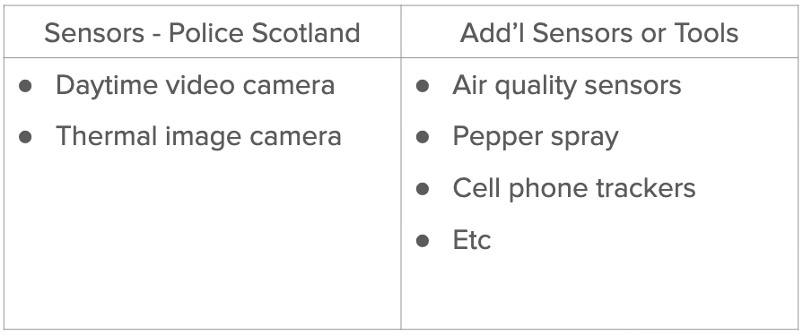

Applications - Many More (Whyte)

4. Privacy

While police using drones equipped with cameras inevitably evokes concerns about privacy and surveillance, Police Scotland has completed all administrative steps required by law for data protection. However, the technologies used are far behind the industry standard. Nonetheless, Inspector Nicholas Whyte of the Police Scotland Air Support Unit (ASU) has completed a Data Protection Impact Assessment which is required in Europe under the GDPR any time you begin a project that is likely to involve a high risk to peoples’ personal information (Wolford).



Privacy - The Good (Wolford)

While the assessment is not published and only became available due to a public information request, it is comforting to see that the questions seem to have been answered with integrity. There is an acknowledgement that the project has a high risk to personal data, specifically that the inability to predict what the drone’s camera will record means there is an inevitable risk for unintentionally collecting sensitive personal data. However, under the “Security of processing” section, it’s noted that the data will not be encrypted and there is no logging of who accesses the personal data post collection (Whyte).



Privacy - The Bad (Whyte)

It’s worth noting that image and video data is only retained by Police Scotland in criminal investigation or evidence gathering cases, not searching for missing persons. Also, Police Scotland thoroughly documents the flow of personal information in the data protection impact assessment.



Privacy - Flow of Personal Data (Whyte)

Still, considering the minimum of 128-bit AES encryption of personal data that is now expected for consumer services like Apple iCloud, it is surprising that Police Scotland did not have in their requirements for their drone at least encryption of data in storage if not in transit as well (“iCloud Security Overview”). Equally important, the fact that imagery is manually scanned for potentially very sensitive data demands that there be logs of all accesses to audit. In summary, Police Scotland is on the right track in following GDPR requirements for data protection, but the fact that the technical issues we’ve raised were not a roadblock suggests that they should be evaluated as potential hard requirements in a future data protection policy.

5. Conclusion

In brief, Police Scotland recently deployed drones to help with search and rescue of missing persons. The system utilizes a high-powered optical camera, a thermal imaging camera, and recognition software based on deep learning that is operated from a mobile phone. This is exciting for Police Scotland because it will save lives and create opportunities for research and development with its partners. While Police Scotland has done well following GDPR processes for the project, there are improvements that could be made to the technical aspects of the system’s data security. Despite this, the collaboration between Police Scotland and its partners in industry and academia to advance drone technology for emergency services and law enforcement is promising both for the United Kingdom and the wider industry as a whole.

Works Cited

Custers, Bart. *The Future of Drone Use: Opportunities and Threats from Ethical and Legal Perspectives*. T.M.C. Asser Press, 2016. doi: [10.1007/978-94-6265-132-6](https://doi.org/10.1007/978-94-6265-132-6)

“iCloud Security Overview.” *Apple Support*, 18 Nov. 2019, [support.apple.com/en-us/HT202303](https://support.apple.com/en-us/HT202303).

Irizarry, Javier, et al. “[Usability Assessment of Drone Technology as Safety Inspection Tools](https://www.itcon.org/papers/2012_12.content.09869.pdf).” *Journal of Information Technology in Construction (ITcon)*, 6 Sept. 2012, [www.itcon.org/paper/2012/12](https://www.itcon.org/paper/2012/12).

Macdonald, Ken. “Police to Use AI Recognition Drones to Help Find the Missing.” *BBC News*, BBC, 4 Nov. 2019, [www.bbc.com/news/uk-scotland-50262650](https://www.bbc.com/news/uk-scotland-50262650).

Nielsen, Jakob. *Usability Inspection Methods*. IFIP, Internat. Federation for Information Processing, 1995. doi: [10.1145/259963.260531](https://doi.org/10.1145/259963.260531)

Whyte, Nicholas. “Data Protection Impact Assessment – Remotely Piloted Aircraft Systems.” *The Scottish Parliament*, 28 June 2019, [www.parliament.scot/S5_JusticeSubCommitteeOnPolicing/Binder1.pdf](https://www.parliament.scot/S5_JusticeSubCommitteeOnPolicing/Binder1.pdf).

Wolford, Ben. “Data Protection Impact Assessment (DPIA).” *GDPR.eu*, 8 Mar. 2019, [gdpr.eu/data-protection-impact-assessment-template/](https://gdpr.eu/data-protection-impact-assessment-template/).