**COUP LIE DETECTOR**

**USER MANUAL**

**Developed by:**

Sarah Dunn

Joe Guardiola

Emmily lusz

Benjamin Tompkins

Dorah Mangeni

**TABLE OF CONTENTS**

Page No.

1. GENERAL INFORMATION
   1. Overview of
   2. Overview of the Coup Lie Detector
   3. Contact
2. SYSTEM SUMMARY
3. GETTING STARTED
   1. Create an account
   2. Setting up a new game
      1. Add players
      2. Add Actions for review
         1. Add Action
         2. Add challenge
         3. Add counter-action.
4. REVIEW STATISTICS.

**General Information**

**Overview of the Game**

The aim of this game is to be the last player with influence which is represented by a face-down card within your play area. The 15-card deck consists of three copies of five different characters, each with a unique identity and a set of powers.

**Duke:** Takes three coins from the treasury. Blocks someone from taking foreign aid

**Assassin:** Pays seven coins and can eliminate someone from the game.

**Contessa:** Block an assassination attempt.

**Captain:** Steals two coins from another player. Blocks a player from stealing from another.

**Ambassador:** Draws two character cards from the deck and choose which card (if any) to exchange and return two cards at the deck.

In their turn, a player can take any of the actions listed above regardless of what their characters are or he/she can take one of the following actions:

**Income:** Take two coins from the treasury

**Foreign aid:**   Take two coins from the treasury

**Coup:**           Pay seven coins and eliminate one player from the game.

Each player is dealt two face-down cards from the deck and two coins. The face-down characters represent the members of government under your control and your aim is to accumulate more money to assassinate or stage coups against other players. The game begins by any player taking any action regardless of what their identities are. Each player’s character action automatically succeeds unless challenged by another player. If the player is unable to reveal the appropriate character, the player loses one card; places one card face-up. Face-up characters cannot be used in the game and if the player’s cards are both face-up, the player is eliminated.

However, if the player reveals the appropriate character, the opponent loses one card. The revealed character card is shuffled into the deck and the player draws a new card. The last player with influence wins the game; with either one or both character cards face-down.

**Overview of Coup Lie Detector**

This is a web-based program that shows the degree of the player’s lying capabilities throughout the game. Players primarily use three strategies to win the game.You can choose to play it safe, tell the truth most of the time but lie unpredictably to draw your opponents into challenging your truthful plays or read your opponents to determine when to call them out on their bluffs. Therefore, the program tells its users the percentage that all players lying throughout the game.

**Contact**

For additional information about the program, the team can be contacted through Project Liaison [insert name] (name@gmail.com).

**System Summary**

Can someone add something here? If not, I will figure it out.

**Getting started with the Coup Lie Detector**

1. Create an account

Head over to [www.coupliedetector.com](http://www.coupliedetector.com). The first thing you will see when you visit the website is the login form. Returning users should enter the username and password and click “login” button. They will then be redirected to the home page where they can review statistics for previous games or start a new game.

Login

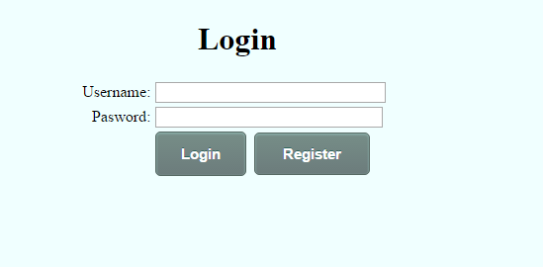

If you are a new user, you need to register before accessing CoupLieDetector. Click register and you will be redirected to a registration page. The registration form only asks for a username and a password that will be used to access your account. An overview of the form and its fields can be seen in the following picture. All fields have to be completed for successful registration.

Registration

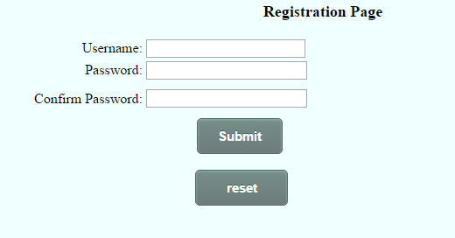

If you click submit and all information is correct, your account will be created and you'll be forwarded to detector's main page. Else you will be notified of any registration errors. After successful submission, you will be redirected to the Home page where you can start a new game. If you click reset, any data you might have filled in the form will be deleted, and you can start filling them from scratch.

Home

After successful login and registration, the user is directed to the home page, where they can review statistics for a previous game or start a new game.

Home Page

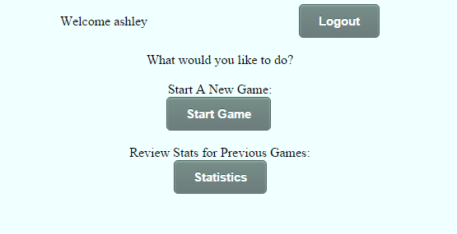

Click “start game” button if you would like to create a new game. You will then be redirected to a page for setting up your game.

**Setting up a new game**

**Add players**

Once you click ‘start game’ button on the home page, you will be redirected to the following page:

Game Setup Page

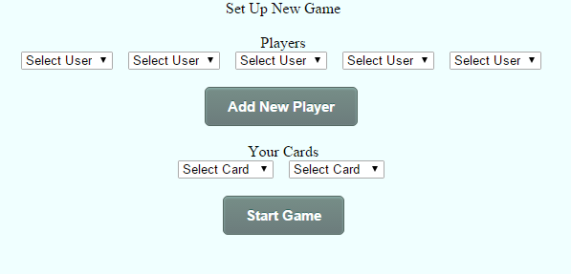

You can select a maximum of five players. Click the drop down list and select the users you would like to play against. If you would like to register a new player, click ‘add new player” button and you will be redirected to the registration page. For additional information on registration, go to registration.

Once you have selected your players, select the cards you would like to have and click the ‘start game’ button and the game play page will open up.You are now ready to add actions for the different users that can be reviewed

**Adding Actions.**

You can add actions on the gameplay page. This means you have already set up your opponents and you have chosen your two unique identities. The following is a snapshot of what you will view:

Game play page

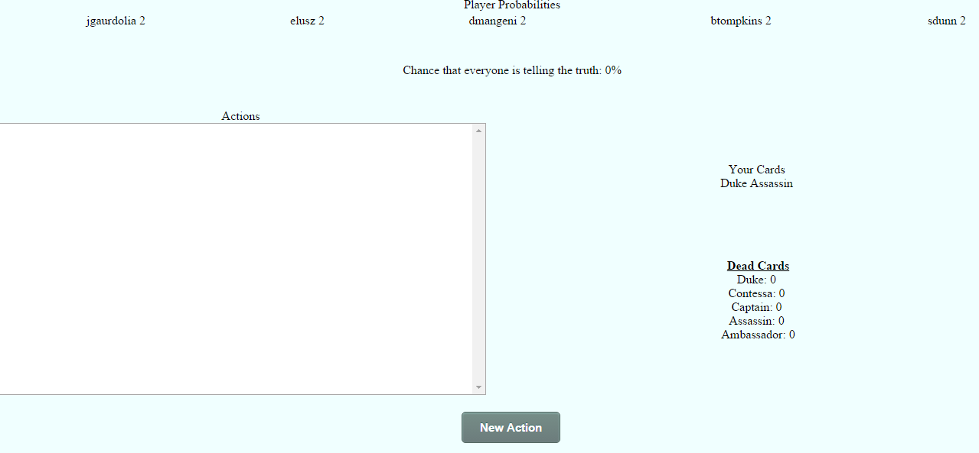

The header lists the names of your players horizontally and their face-down character cards.

At the top center, you will see the probability that everyone is telling the truth and hence derive the chance that everyone might be lying in a particular game scenario.

The textbox labelled actions shows the actions you have chosen to review in a single game play scenario.

The Dead cards list on the right shows the face-up character cards that have been lost by the players and cannot be used during the game.

You will also see your two identities listed under ‘Your cards’.

1. **Adding an action**

At the game play page, click “new action’ to add an action for a particular player. This will open up a new window for adding the action as follows:

Action page

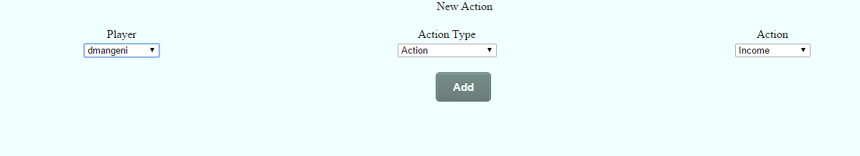

Click the dropdown list and select the player whose action you would like to add. The second dropdown lists three types of actions; action, challenge and counteraction. For more information on what actions and types of actions players can take, visit the ‘overview of the game section’. Next, select the action that will be taken by the player and click add. You will be redirected back to the game play page where you can see the action that you just added for the player. You can add actions as many times as you would like. You will realize that the more you add actions, the player’s identities will be revealed as follows:

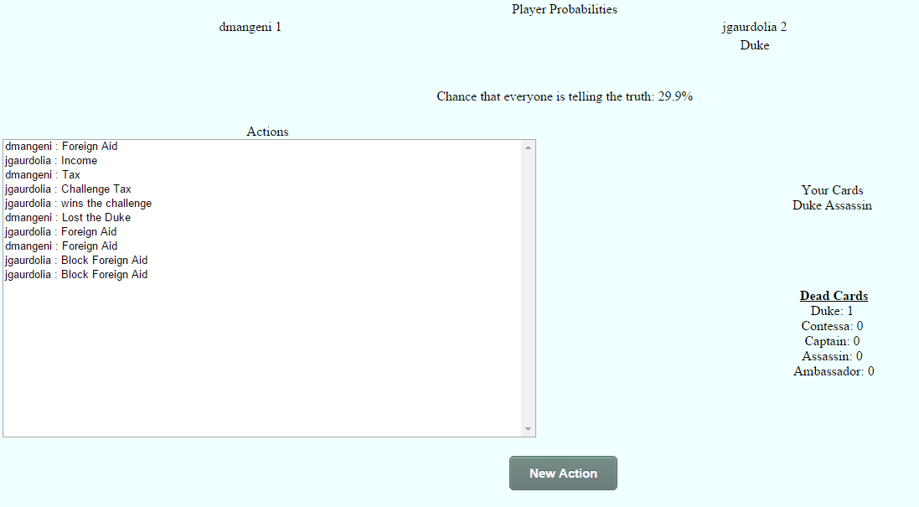

Notice the identity provided below the player: jguardiola.

1. **Adding a challenge**

Any player can challenge their opponent’s claims at any time. If you would like to add a challenge for your game session, click ‘new action’ button on the gameplay page. You will get another window for the action page. There are six challenges that a player can stage.

* Challenge tax
* Challenge block foreign aid
* Challenge block stealing
* Challenge stealing
* Challenge assassinate
* Challenge tax
* Challenge exchange
* Challenge block an assassination

The following are the steps for adding any of the challenges listed above.

1. Select the player that was challenged. Select the ‘action’ as the type of action i.e. action, challenge or counter-action. Then select the action that was taken i.e. steal, take foreign aid. Click add.

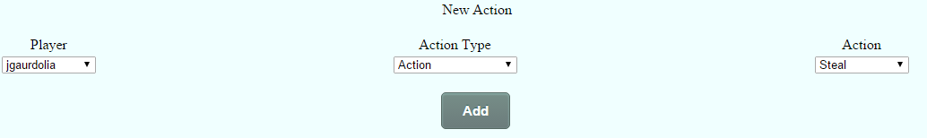

1. A text box will pop-up. Click yes.

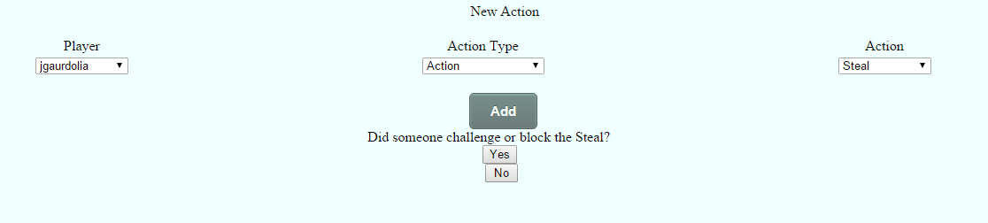

1. Select the name of the challenger. Select ‘challenge’ as the action type then select the challenge i.e. challenge stealing. Click add upon completion and a question text box will pop-up.

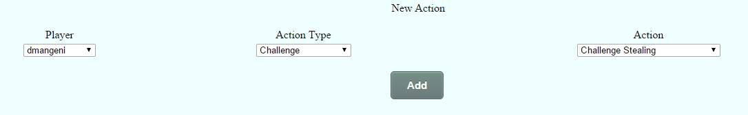

1. Click yes on the text box pop-up, if the challenger won and no, if the challenger lost.

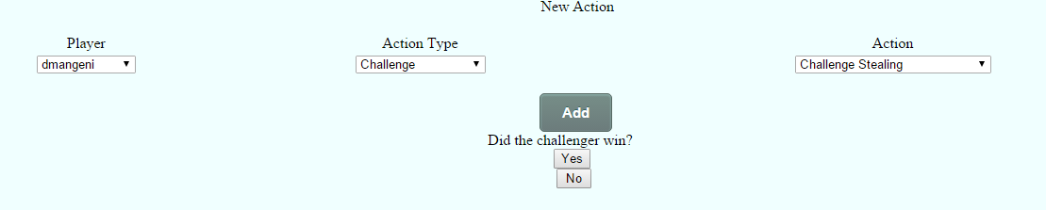

1. Choose the card that the challenger or the opponent lost and click submit.

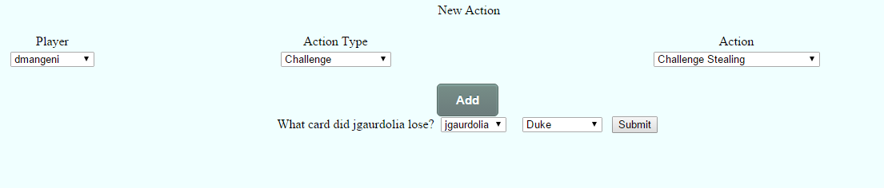

1. You will be redirected to the game play page. You will see a new higher score for the probability and new entry for the card lost as follows: [insert username] lost [insert card type].
2. **Adding a counteraction**

Remember a counteraction is an action taken by a player in response to an action taken by another player on their turn For example. If Joe tried to steal, dmangeni could block the stealing. This means that both players would be claiming certain identities with the capabilities corresponding to the actions they attempted to take. In this case, Joe would be claiming to be either the captain while dmangeni would be claiming to be the captain or the ambassador. This is different for a challenge. Any player can challenge an opponent on the opponent’s turn. There are also only three counter-actions a player can take:

* Block stealing
* Block assassination
* Block foreign aid

The following are steps for adding a counteraction:

1. Select the player. Select “action” as the type of action. Then select the action that was taken i.e. steal, take foreign aid. Click add.

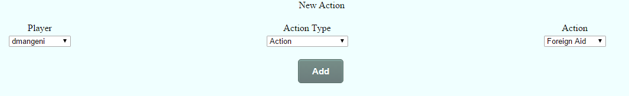

1. Click yes on the next pop-up. You will be redirected to the next page in step 3.

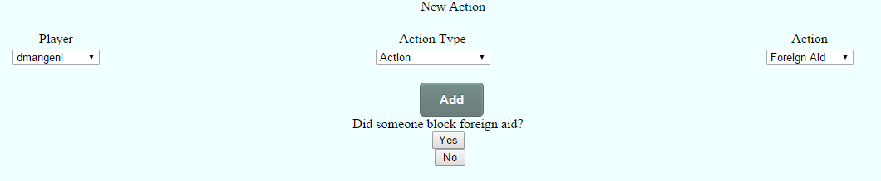

1. Select the name of the player that made the counter-action. Select ‘counter-action’ as the action type then select the counter-action i.e. block stealing. Click ‘add’ button upon completion and a question text box will pop-up. Click ‘yes’ if you would like another player who challenged the counter-action, otherwise click ‘No’

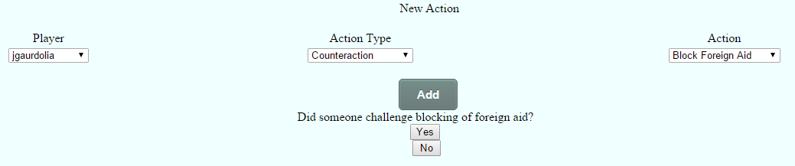

1. If yes. You will be redirected back to the game play page. You will see an added entry for the action textbox as follows: [insert username]: Block [name of counteraction].
   1. **Review statistics**

After successful login or registration click “Review stats for previous game’ button. You will redirected to the following page where you can view the game history statistics.