  STEFAN DUPREY, Ph.D.  CONTACT  8 route du pavé des Gardes  92370 Chaville  France  +33 6 24799558  stefan.duprey@gmail.com  Male, french, born 19/01/1979  Personal web site  EXPERTISE  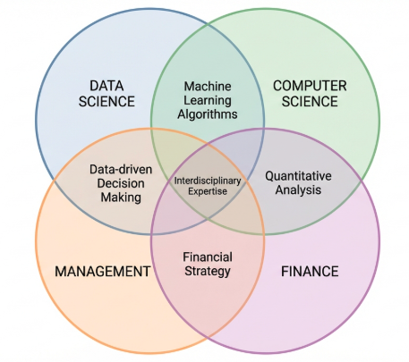  IT SKILLS  Python  SQL  Cloud  LANGUAGES  English  French  German |  | LEAD DATA SCIENTIST  PROFESSIONAL SUMMARY  20 years in data science and mathematical modeling to provide business value out of data through machine learning and data science  Solid business expertise in market finance, asset management and insurance business. Managing projects scoping and execution, reporting  WORK EXPERIENCE  SwissBorg, Lausanne 2025 - present  Lead Data Scientist. AI-driven on-chain financial framework around crypto AM.  Coinshares, Paris 2018 - 2021  Lead Data Scientist in crypto asset management  EY, Paris 2016 - 2018  Lead Data Scientist-Senior consultant in quantitative finance, risk modeling & data science.  Ravenpack, Spain 2014 - 2016  Researcher in statistical and ML models, NLP for finance, and macro forecasting.  The MathWorks, Paris 2010 - 2014  Consulting lead in software for portfolio optimization, risk modeling & derivatives.  Freelance consultant , Paris 2008 - present  Missions in big data, machine learning, NLP & trading systems for french banks and e-commerce platforms  EADS, Paris 2006-2008  Researcher in applied maths, HPC, high-level scientific publications  EDUCATION  PhD Applied Maths 2003-2006 University Henri Poincaré and EADS (aerospatial)  Master in Market Finance 2009  CNAM  Civil Engineer 2000 -2003  Mines de Nancy - French top 10 engineering school  SELECTED WORKS  Linked In profile  Papers and talks  Github repository  Kaggle profile

