**USER GUIDE**

**Live Demo:**

The interactive live demo is available on Tableau Public server hosted at link: <https://public.tableau.com/app/profile/solomon.jayakar.durgam/viz/DataVisProj_Assignment3/DashboardExpFinalBeta-PhaseRelease>

**Tutorial:**

A popular tool to create data visualizations in Tableau. It has a user-friendly interface and needs no coding to create a visualization and is most often used to create dashboards for reporting purposes. It has two variants, a public version and a business version.

**Downloading/Setting up Tableau:**

1. Click on the “*Download Tableau Public*” button as shown in the image below to install the public version of Tableau:

**Fig . 1.** Tableau Public official website for downloading Tableau Public software.

1. Fill in the details and click on “*Download the App*” to start downloading the tableau.exe file. As shown in Fig. 2.

**Fig . 2.** Account creation form for downloading Tableau Public software.

1. File will start downloading automatically. If it doesn’t start automatically, we might need to select the type of executable file manually based on the system we are using, for example, “*Windows*” or “*Mac*” as shown in the image below:

**Fig . 3.** Tableau Public software download operating system selection.

1. Once the file is downloaded, you can run it to install Tableau on your system.

**Fig . 4.** Tableau Public software installation progress.

1. Once the app is installed, you can open it to view the first screen as shown below in the image:

**Fig . 5.** Tableau Public software opening screen.

**Working with Tableau:**

1. To load the data, we need to select one of the options which is provided under “*Connect -> To a File*” based on the data we are trying to load into Tableau. Once you select an option, a Windows Explorer window pops up, using which you can navigate to the data and click on “*Open*”.
   1. Microsoft Excel (To load excel data with (.xls, .xlxs, .xlsm) formats).
   2. Text File (To load data from text file, CSV with file formats (.txt, .csv, .tab,.ts))
   3. JSON File (To load data in JSON format with file formats (.json))
   4. Microsoft Access
   5. PDF file
   6. Spatial file
   7. Statistical file

**Fig . 6.** Tableau Public software opening screen with data selection menu.

In our case we select the option a. Microsoft Excel and load the datasets named Plastic Waste Final.xlsx and Transposed Task 3 Final.xlsx. We can directly open the tableau code by opening the tableau workbooks that are included in the folder named code as part of the Group7_FinalRelease.zip folder.

**Interaction with the system**

Hovering over each of the countries in the geospatial map would give the quantity and the name of the country in the form of Tool tip.

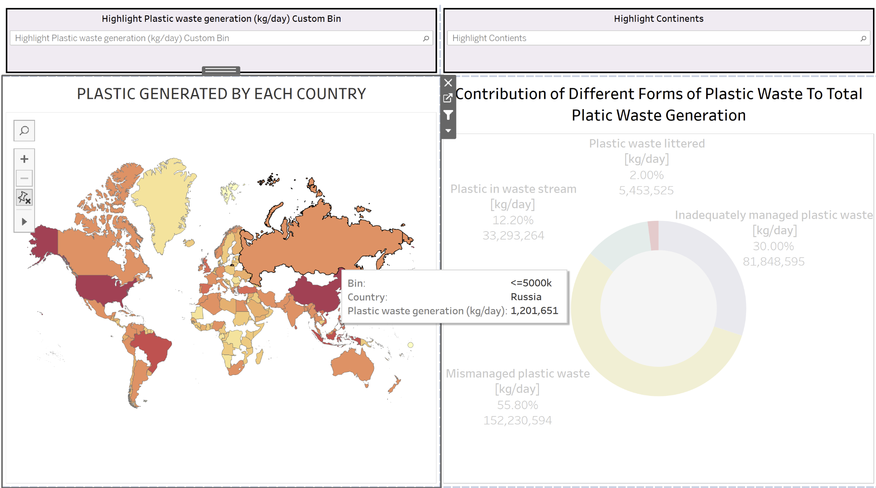 **Fig . 6.** Hovering over Maps to get Tooltips with information specific to that country.

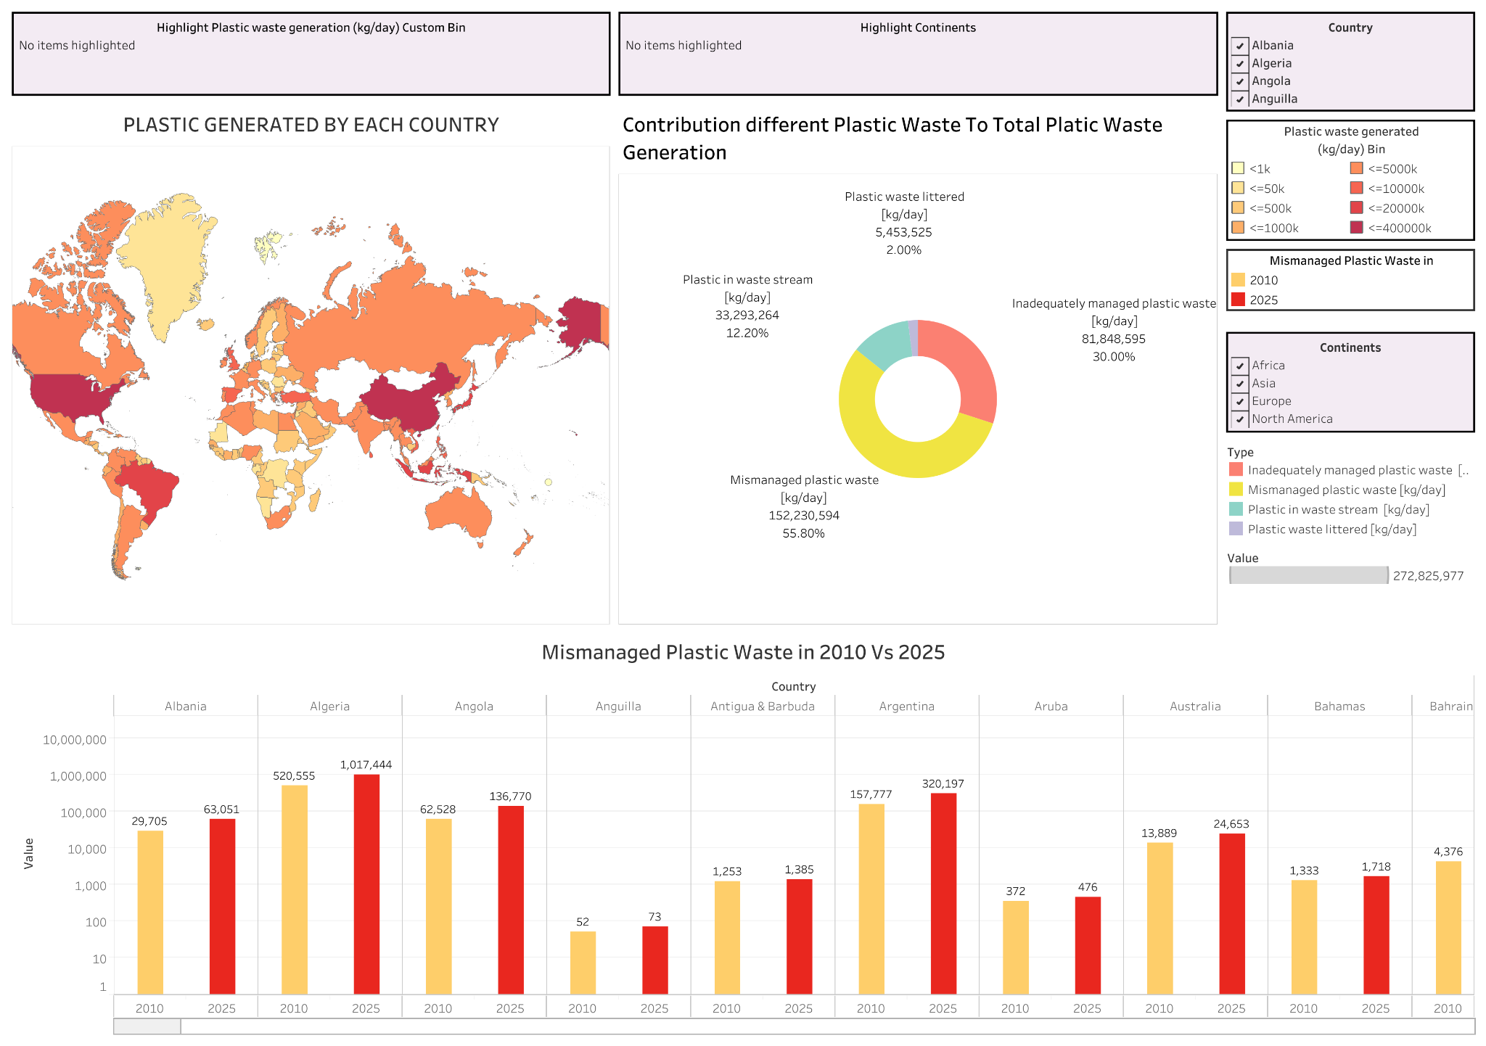

**Fig . 7.** Dashboard before selection of countries.

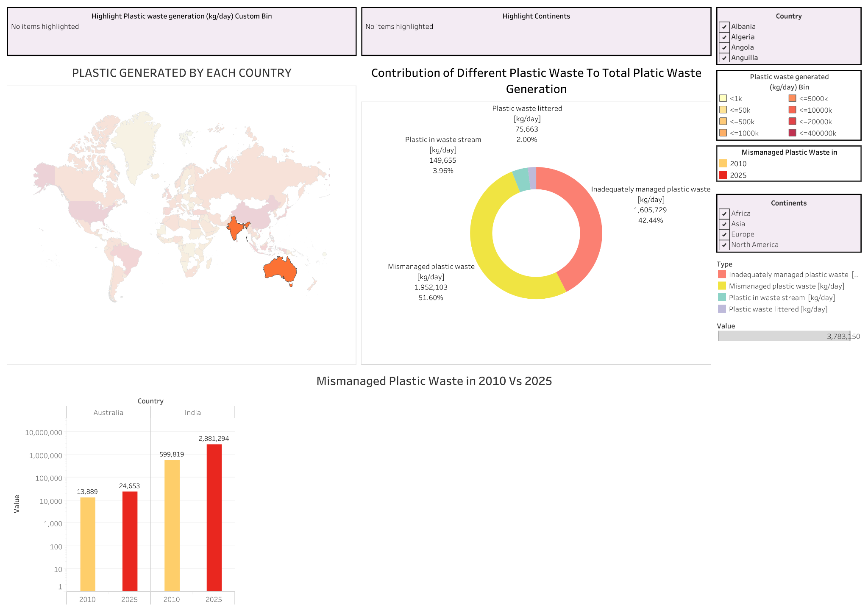

**Fig . 8.** Dashboard after selection of countries.

The functionality of item filtering is implemented which would remove the items that are not of interest to the user, this can help the users to compare specific countries of their choice by selecting and clicking on the countries using the mouse when the control key is pressed on the keyboard that allows multi selection. When the users select multiple countries on the Map plot as shown in Fig. 8. the donut chart now shows only the aggregated contribution of different forms of plastic waste to total plastic waste generated by the countries selected and the bar plot shows only the information for these countries and the rest of the data is eliminated from the view. If the user clicks on the empty space on the Map plot this would deselect the selected countries and the view goes back to the original view as shown in Fig .7.

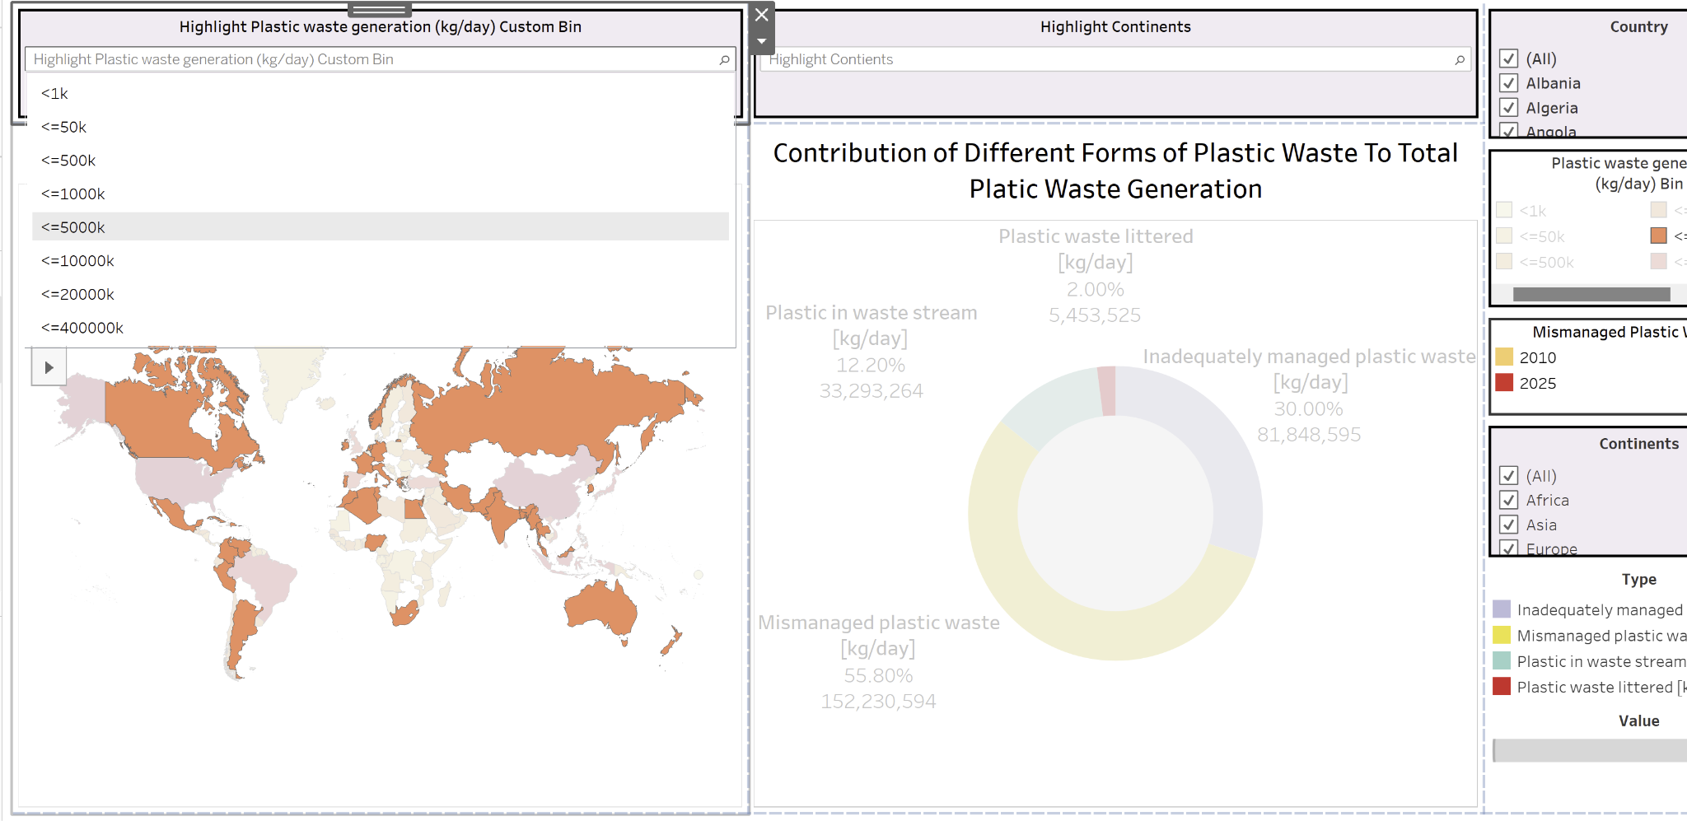

**Fig . 9.** Dashboard after selection of countries.

As shown in Fig. 9. We can select the bin range from the “Highlight Plastic Waste generation (kg/day) Custom Bin” dropdown menu, this will highlight the countries that belong to this specific bin and gray out the other countries. This would make the data pop out to the user.

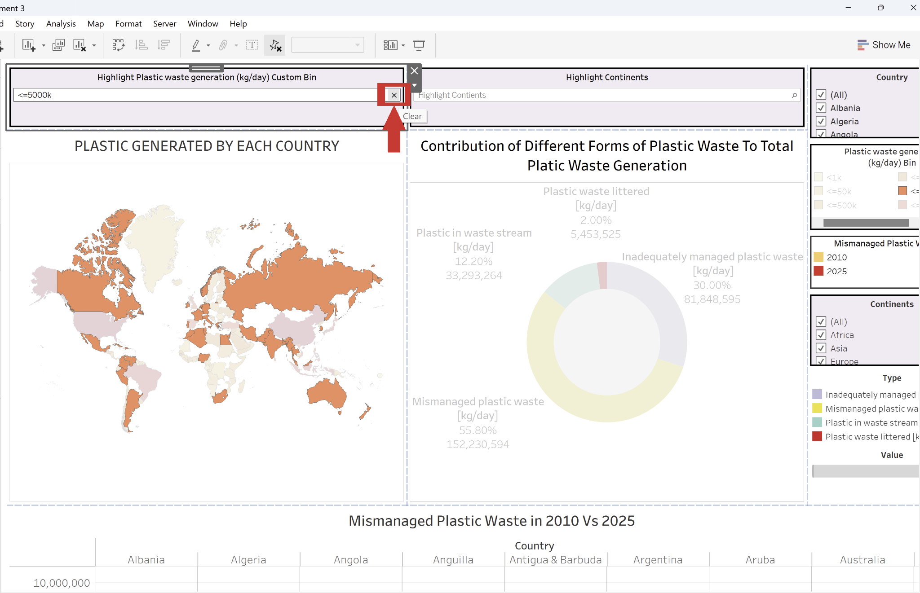

**Fig . 10.** Clearing the Highlight selection of bins.

To clear the highlight and go back to original state, we need to click on “x” mark in the “Highlight Plastic Waste generation (kg/day) Custom Bin” dropdown menu as shown the Fig . 10.

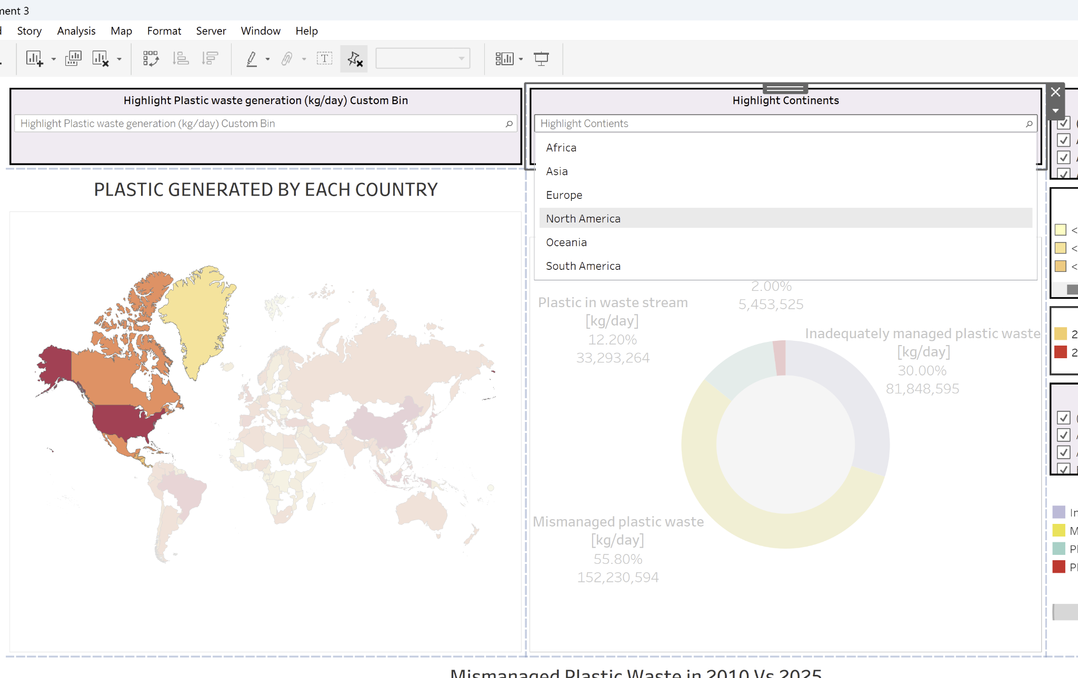

**Fig . 11.** Dashboard after selection of countries.

The Highlight Continents dropdown can be selected to see the countries that belong to a specific continent and based on the color we can know how each of the countries belonging to that continent are producing the plastic waste.

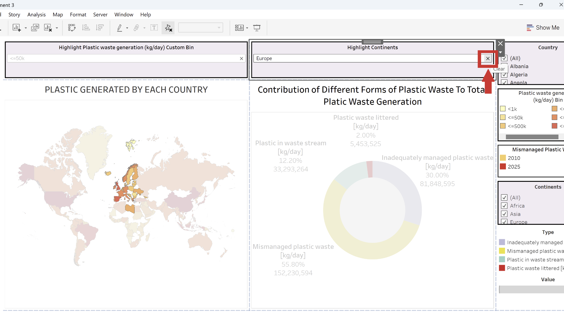

**Fig . 12.** Clearing the Highlight selection of Continents.

To clear the content’s highlight and go back to the original view, we need to click on “x” mark in the “Highlight Continents dropdown” dropdown menu as shown the Fig . 12.