**Dataset:** Housing Code Violations joined with mc311 Service Requests

**Screenshot of Visualization 1:**

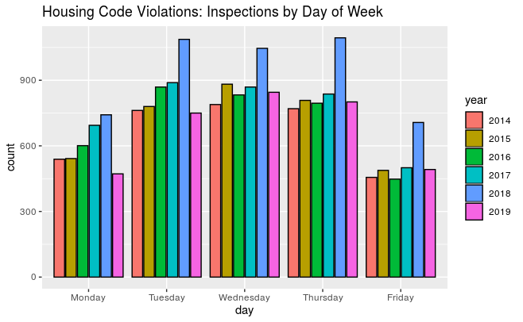

1. Why would this view be of interest to the public?

If you are a tennant with a complaint, you may want the inspection to happen mid week.

If you are a property owner, you may wish to schedule your inspection on Monday or Friday when the inspector may be less thorough.

1. Is there an opportunity to improve the view, such as through better visualizations or by providing further breakdowns or incorporating graphics not available in socrata?

This visualization was produced by ggplot histogram.

Rather than just a count of the inspections, I would be interested in weighting them by severities and counts of the violations found.

1. Are there ways that this visualization could be misinterpreted? What definitions or clarifications could be added to make sure that this was correctly interpreted?

Inspectors may routinely schedule desk work on Mondays and Fridays. These data in particular are linked to service requests placed by tennants with complaints or responses by property owners. It mostly does not appear to include regularly scheduled follow up, annual, or triennial inspections.

**Screenshot of Visualization 2:**

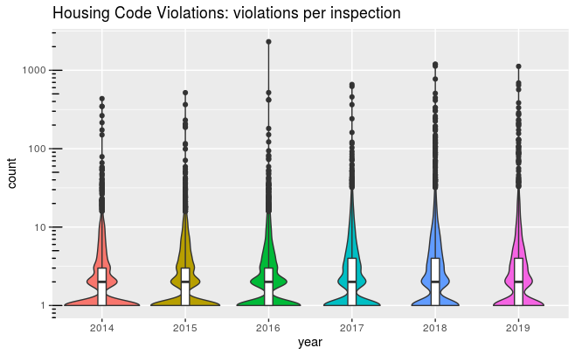

1. Why would this view be of interest to the public?

The increased density of outliers in the upper quartiles possibly indicates that inspectors are more aggressively pursuing more flagrant violations.

1. Is there an opportunity to improve the view, such as through better visualizations or by providing further breakdowns or incorporating graphics not available in socrata?

This visualization is a violin plot produced by ggplot.

The log scale represents the full range of the data.

The fill color redundantly represents the year. It could be better used to represent a summary statistic such as the inspector workload or, particularly with the outliers, a measure of the severity of the violations.

1. Are there ways that this visualization could be misinterpreted? What definitions or clarifications could be added to make sure that this was correctly interpreted?

One could potentially incorrectly infer that most inspections are routine, involving little effort by the inspectors. Unfortunately, the dataset does not have any convenient way of measuring effort.

Again, it should be emphasized that this is limited to inspections made in response to service requests.

**Screenshot of Visualization 3:**

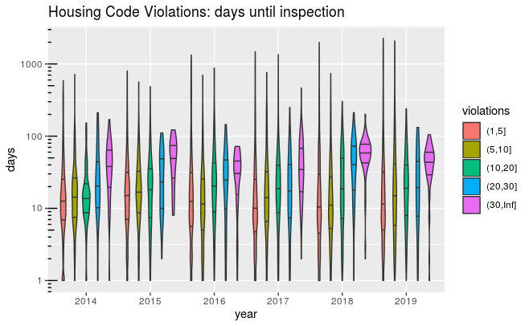

1. Why would this view be of interest to the public?

The plot may indicate that in 2019 the inspectors pursued a greater number of rental properties with multiple violations with less delay.

1. Is there an opportunity to improve the view, such as through better visualizations or by providing further breakdowns or incorporating graphics not available in socrata?

This is another violin plot produced by ggplot.

As above, weighting the number of violations by severity may give a more realistic picture of workload and effort.

Using plotly would allow additional relevant data to be presented.

1. Are there ways that this visualization could be misinterpreted? What definitions or clarifications could be added to make sure that this was correctly interpreted?

It is not clear whether the inspection date in the dataset represents the first or final inspection. Delay to the first inspection is a bad thing. A longer time to the final inspection may indicate the extent of violations or the effort needed to ensure their correction. I have asked the dataset owner for clarifications.

The number of days to inspection should represent elapsed business days. There are reported problems in the bizdays package I use to calculate this. I need to verify that it works correctly.