The 7th International Conference on
Computer Science & Education (ICCSE 2012)
July 14-17, 2012. Melbourne, Australia
ThP6.11
Research on The Improvement of MongoDB Auto-
Sharding in Cloud Environment
Yimeng Liu, Yizhi Wang,Yi Jin
School of Computer and Information Technology
Beijing Jiaotong University
Beijing , China
Abstract—With the rapid development of the Internet Web
2.0 technology,the demands of large-scale distributed service and
storage in cloud computing have brought great challenges to
traditional relational database.NoSQL database which breaks the
shackles of RDBMS is becoming the focus of attention.In this
paper, the principles and implementation mechanisms of Auto-
Sharding in MongoDB database are firstly presented, then an
improved algorithm based on the frequency of data operation is
proposed in order to solve the problem of uneven distribution of
data in auto-sharding.The improved balancing strategy can
effectively balance the data among shards,and improve the
cluster’s concurrent reading and writing performance.
key words—NoSQL, MongoDB, Auto-Sharding, balance
strategy
I.
INTRODUCTION
different challenges in dealing with data that the RDBMS
solutions could not cope with. These companies realized that
performance and real time nature was more important than
consistency, which traditional relational databases were
spending a high amount of processing time to achieve. As such,
NoSQL databases are often highly optimized for retrieve and
append operations and often offer little functionality beyond
record storage. The reduced run time flexibility compared to
RDBMS systems is compensated by significant gains in
scalability and performance. Often, NoSQL databases are
categorized according to the way they store the data and fall
under categories such as key-value stores(e.g. Dynamo[2]),
BigTableimplementations[3]anddocumentstore
databases(e.g. MongoDB[4]). However, due to the immature
technology of cloud data mangement, there are still many
issues need to be addressed in actual production environment.
This paper discusses the design principles and
implementation mechanism of MongoDB database, and
focuses on the principle of Auto-Sharding. The goal of Auto-
Sharding is to split data up across machines and rebalance
automatically making it possible to store more data and handle
more load without requiring large or powerful machines. But
the balancer algorithm isn't so intelligent that data isn’t evenly
distributed among servers. In order to solve this problem, an
improved FODO (i.e. frequency of data operation)algorithm is
proposed. The FODO algorithm is based on the frequency of
data operation and taking the load of server into consideration.
The data balancing strategy based on FODO algorithm can
effectively balance the data among servers, and improve the
cluster’s concurrent reading and writing performance.
II.
AUTO-SHARDING IN MONGODB
In recent years,with the rapid growth of the amount of data
and the development of Internet web 2.0 technology, how to
efficiently store, process and extract large amounts of data
becomes an urgent problem, Cloud computing emerged in this
context. Cloud computing is the delivery of computing as a
service rather than a product, whereby shared resources,
software, and information are provided to computers and other
devices as a metered service over a network (typically the
Internet)[1]. Many universities, vendors and government
organisations are investing in research around the topic of
cloud computing, for example: Amazon launched Simple
Storage Service (S3) and Elastic Compute Cloud(EC2), Google
proposed GFS, BigTable and MapReduce, which have all been
successfully used in production environment. Distributed File
System can organize the huge amounts of data in cloud
computing, and also be able to efficiently read the cloud data,
but we still need specialized data management tools for better
management of structured data.
Cloud Data Management is a new data management
concept with the development of cloud computing, it must be
able to efficiently manage of large data sets in the cloud, and
quickly locate specific data in massive data sets, which makes
the Cloud Data Management with the following common
characteristics: (1) high concurrent read and write performance,
(2) efficiently store and access huge amounts of data, and (3)
high scalability and high availability requirements of the
database. In the face of these demands, the traditional relational
data management system(RDBMS) has encountered an
insurmountable obstacle. Therefore, NoSQL database systems
rose alongside major internet companies, such as Google,
Amazon, Twitter, and Facebook which had significantly
978-1-4673-0242-5/12/$31.00 ©2012 IEEE
851
A. Brief introduction of MongoDB
MongoDB (from "humongous") is an open source
document-oriented NoSQL database system written in the C++
programming language. It manages collections of BSON
documents. Development of MongoDB began in October 2007
by 10gen. MongoDB features[5]: Document-oriented storage,
JSON-style documents with dynamic schemas offer simplicity
and power; full index support; replication and high availability;
Auto-Sharding, scale horizontally without compromising
functionality; Map/Reduce, flexible aggregation and data
processing; GridFS, store files of any size without complicating
your stack.
At the heart of MongoDB is the concept of a document
which is the basic unit of data for MongoDB, roughly
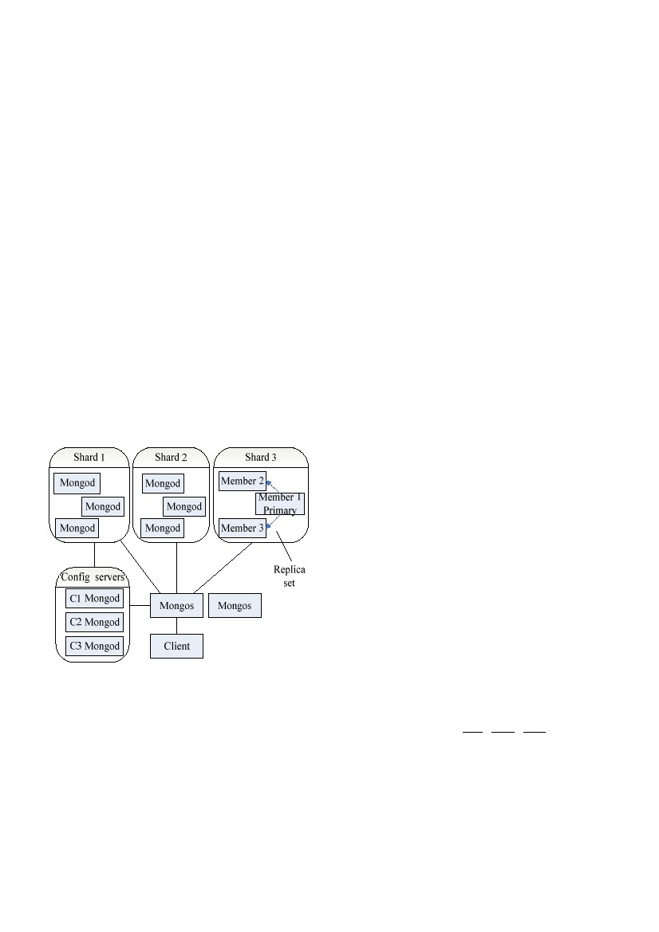
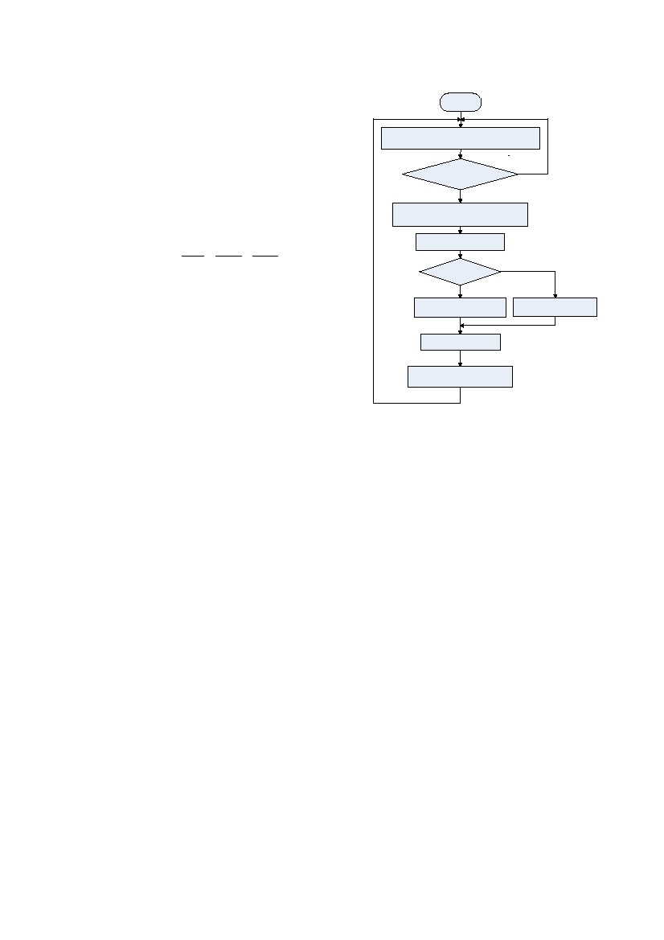
ThP6.11
equivalent to a row in a RDBMS. Similary, a collection can be
thought of as the schema-free equivalent of a table. A single
instance of MongoDB can host multiple independent databases,
each of which can have its own collections and permissions.
B. Auto-Sharding architecture
Sharding refers to the process of splitting data up and
storing different portions of the data on different machines. By
splitting data up across machines, it becomes possible to store
more data and handle more load without requiring large or
powerful machines[6]. MongoDB supports Auto-Sharding,
which eliminates some of the manual sharding, the cluster can
split up data and rebalance automatically. MongoDB sharding
provides: (1) automatic balancing for changes in load and data
distribution, (2) easy addition of new machines without down
time, (3) no single points of failure, and (4)Automatic failover.
The basic concept behind MongoDB's sharding is to break
up collections into smaller chunks. These chunks can be
distributed across shards so that each shard is responsible for a
subset of the total data set. To partition a collection, MongoDB
specify a shard key pattern which names one or more fileds to
define the key upon which we distribute data. Because of shard
key, chunks can be described as a triple of collection, minkey
and maxkey. Chunks grow to a maximum size, uaually
200MB, once a chunk has reached that approximate size, the
chunk splits into two new chunks. The architecture of Auto-
Sharding is displayed in Fig. 1.
from client, the mongos routes the request to the appropriate
server and merges any results to be sent back to the client.
C. The balancing strategy of Auto-Sharding
MongoDB uses balancer to keep chunks evenly across all
servers of the cluster. The unit of transfer is a chunk, and
balancer waits for a threshold of uneven chunks counts to
occur. In the field, having a difference of 8 chunks between the
least and most loaded shards showed to be a good heuristic.
Once the threshold is reached, balancer will redistribute
chunks, until that difference in chunks beween any two shards
is down to 2 chunks.
In order to reduce the amount of data transferred, each
shard contains multiple ranges. When a new shard added into
the cluster or some of the shards contain too much data to reach
the threshold, the balancer will skim chunks off of the top of
the most-populous shard and move these chunks to the least-
populous shard, allowing the data evenly distributed in the
cluster by moving the bare minimum.
The goal of the balancer is not only to keep the data evenly
distributed but also to minimize the amount of data transferred.
The balancer's algorithm isn't terribly intelligent. It moves
chunks based on the overall size of the shard[7]. The migration
chunks are just the ones located on the top of each shard, but
the operation of data is not taking into consideration. The data
transferred between shards may not often be used, it will makes
the system load can not achieve an effective balance. It is
necessary to improve the balancing strategy of Auto-Sharding
in MongoDB.
III.
ALGORITHM BASED ON THE FREQUENCY OF DATA
OPERATION
A. Basic idea of FODO algorithm
In order to solve the problem of data’s uneven distribution
in auto-sharding, an improved algorithm (FODO algorithm)
based on the frequency of data operation is proposed.
In MongoDB, the unit of transfer is a chunk. There are n
chunks in a shard, the ith chunk is represented as Ci and its
frequency of data operation value is F_DOi. In MongoDB
database, the main operations of data are insert, find, update
and delete. As the data in the cluster rarely be frequently
deleted, the manipulations which affect system performance
mainly concentrated in the first three operations. We use Ii, Fi
and Ui to represent the number of these three kinds of
operations to a chunk. So the value of F_DOi in normalized
form is (1)
F _ DO i =
Ii
n
i
i =1
Figure 1. Architecture of Auto-Sharding .
A MongoDB shard cluster consists of two or more shards,
one or more config servers, and any number of routing
processes. Each of the components is described below.
1) Shard: Each shard consists of one or more servers and
stores data using mongod processes. In production situation,
each shard will consists of a replica set to ensure availability
and automated failover.
2) Config server: It stores the cluster's metadata which
includes basic information on each shard server and the chunks
contained therein.
3) Mongos(Routing Processes): It can be thought of as a
routing and coordination process. When receiving requests
852
ƒ I ƒ F ƒU
i
i =1
i =1
+
Fi
n
+
Ui
n
i
(1)
However, the insert, find and update operations have
different impacts on the cluster load and should not be treated
equally. In Auto-Sharding environment, it's not necessary to
make a physical connection when query record from database
because cashes have already kept the fresh data. Moreover,
each shard will consists of a replica set in production situation.
The secondary nodes in a replica set can read the data written
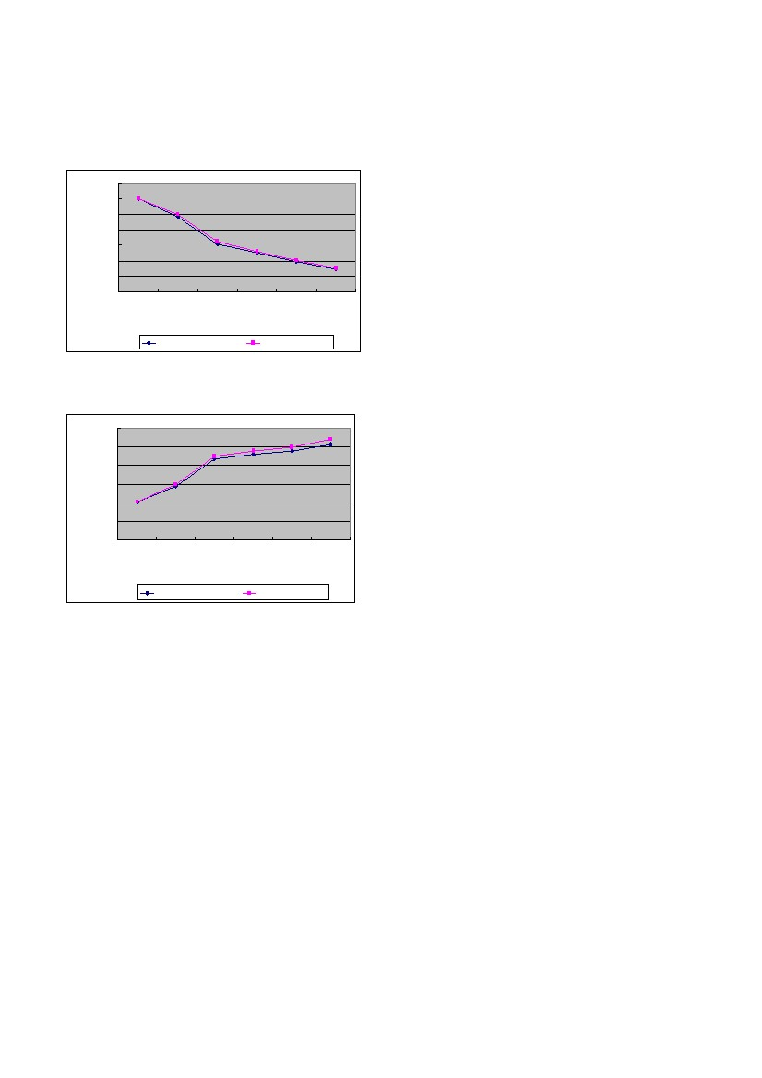
ThP6.11
from the primary node, so it can lighten the querying load on
the primary node to a certain extent. Contrarily, the insert and
update operations result directly to database every time when
they commit a transaction, which occupy a bigger part of the
whole cluster workload. In particular, insert data will cause the
number of data in each shard is different. Once the threshold is
reached, balancer will balance data automatically, which will
greatly consume system resources. So FODO algorithm adds a
parameter inc (always >1) before inserting part in the equation,
called insert coefficient, to put more weight on insert operation.
Here is the final FODO value definition in (2)
Begin
Calculate the difference of chunk s number
Reach the migration
threshold value
Yes
Determine the from-shard and to-shard
Calculate the F_DO value
No
F _ DOi = inc ⋅
Ii
n
i
i =1
ƒ I ƒ F ƒU
i
i =1
i =1
n
+
Fi
n
+
Ui
n
i
(2)
f(F_DO)>t(F_DO)
Yes
Choose the max(F_DOi)
Choose the min(F_DOi)
No
The F_DO value of each shard is the sum of its containing
chunk's F_DOi value, that is (3)
s(F_DO) = ƒ ci(F_DOi)
i =1
(3)
Migrate the chunk
We need to modify data structures recording the chunk's
information, adding I, F, U and F_DOi four variables to store
insert, find, update and F_DOi values. Each operation to the
data must be recorded in the four variable of the corresponding
chunk.
B. Balancing strategy of FODO algorithm
F_DOi value indicates the frequency of data operations in
each chunk. If a chunk’s F_DOi value is high, it means data in
this chunk is frequently used. The threshold of data
redistribution is still the difference in the number of chunks in
each shard, but the migration chunks are selected based on its
F_DOi value. There are trade-offs between overall size of shard
and operating frequency of data in this balancing strategy. The
process of data balance has three steps.
1) The threshold of data migration: Calculate the number
of chunks in each shard. If the difference is greater than 8, then
begin to balance the data until the difference is less than 2.
Chunks will be migrated from the most-populous shard called
from-shard to the least-populous shard called to-shard.
2) Choose the migration chunks: Calculate the difference
of F_DO value between from-shard and to-shard. If
f(F_DO)>t(F_DO), then choose the chunk with the maximum
F_DOi value in from-shard. Otherwise, choose the chunk with
the minimum F_DOi value in from-shard.
3) Migrate chunks: Migrate the selected chunk in step 2)
to the to-shard, and recalculate the F_DOi value of each chunks
both in from-shard and to-shard.Repeat step 1).
The flowchart of data balance process is displayed in Fig. 2.
Moreover, we should determine the value of inc. The role
of inc is to put more weight on insert operation, so
the value should be greater than 1. The specific value of inc
relies on server-related parameters and system load, we can
setthe initial value and then adjust it according to the actual
needs of business.
Recalculate the F_DO value
Figure 2. The flowchart of data balance process
IV.
EVALUATION OF PERFORMANCE
The test environment based on the MongoDB Auto-
Sharding cluster, it contains 10 virtual machines, each of which
has the same hardware configuration: 8GB of memory and
CPU speed is 2.4G HZ. Each virtual machine has a Linux
RedHat operating system, and be connected by the 100Mbps
LAN. The MongoDB version is 1.8.2, and the Auto-Sharding
cluster has three shards, each of which consists of a replica set.
Each replica set contains three nodes: one primary node and
two secondary nodes. We should run the rs.slaveOk()
command on the secondary nodes in order to query data from
them.
We realize the FODO algorithm in MongoDB, and
compare the two algorithm by testing the concurrent read and
write performance of the cluster. The data set used in test is a
simple line data, including four fields of int, long, string and
double. In addition, the value of inc parameter in FODO
algorithm is 1.5.
In order to see the effect of the FODO algorithm, we only
add two shards, insert 1000000 records and use randomly
generated id to do find and update operations. Then we add the
third shard to the cluster. The purpose of this action is to ensure
the cluster has data at the beginning of the test and the value of
F_DO is not zero.
Firstly, we test the concurrent writing performance of the
cluster. We insert 10000000 records into the cluster and remain
the overall amount of records be same under different number
of concurrent. The concurrent writing performance of this two
algorithm is shown in the Fig. 3.
853
ThP6.11
Remain the concurrent number and records be unchanged,
and test the concurrent reading performance of the cluster. The
concurrent reading performance of this two algorithms is
shown in the Fig. 4.
V.
CONCLUSION
This paper analysises the principle of the MongoDB Auto-
Sharding. For the problem of uneven distribution of data
among shards, we introduce an improved balancing algorithm-
algorithm based on the frequency of data operation(FODM).
A data balancing strategy based on FODO algorithm is
proposed and its effectiveness is verified by experiments. The
concurrent writing and reading performance of the Auto-
Sharding cluster is significantly improved. And more aspects of
the FODO algorithm could be explored, such as determination
of inc value.
REFERENCES
[1] Peter Mell, Tim Grance. "The NIST Definition of Cloud Computing".
National Institute of Science and Technology. Retrieved 24 July 2011.
[2] Giuseppe DeCandia, Deniz Hastorun, Madan Jampani, et al.
Dynamo:Amaon’s Highly Available Key-value Store. SOSP’07.
Stevenson, washington, USA:2007.
[3] Fay Chang, Jeffery Dean, Sanjay Ghemawat, et al. Bigtable: A
Distributed Storage System for Structured Data. 7th Symposium on
Operating System Design and Implementation. Seattle, WA, USA: 2006.
[4] 10gen. MongoDB. http://www.mongodb.org, 2011-07-15.
[5] MongoDB. features.http://www.mongodb.org/.
[6] Kristina Chodorow, Michael Dirolf. “MongoDB: The Definitive Guide”.
O Reilly Media,September 2010. p135
[7] Kristina Chodorow. “scaling MongoDB”. O Reilly Media,January
2011. p13.
Figure 3. Concurrent writing performance
Figure 4. Concurrent writing performance
854

