Architecture of Netflix
A Distributed Systems Case Study

1. Introduction
Netflix is a subscription service that streams films and TV series on demand to many kinds of devices. I chose it as a case study because it mixes small, frequent requests (browsing, account actions) with very large, sustained video transfers, and because Netflix engineers have publicly explained how they design for failure. A 2016 Netflix presentation stated that Netflix streaming made up over one-third of North American peak internet traffic. The figure is dated, but it shows why a single server or data centre could never serve all users.
This report covers only the main architectural ideas. Sentences marked Interpretation are my own reasoning. Many public sources are several years old, so some details may have changed.

2. High-Level Netflix Architecture
Netflix's material splits the system in two. Everything before a video starts (sign-in, browsing, recommendations, deciding what to play) is handled by services on Amazon Web Services (AWS), called the control plane. Once playback starts, the video itself is served by Open Connect, Netflix's own content delivery network, called the data plane. Figure 1 shows the layers.
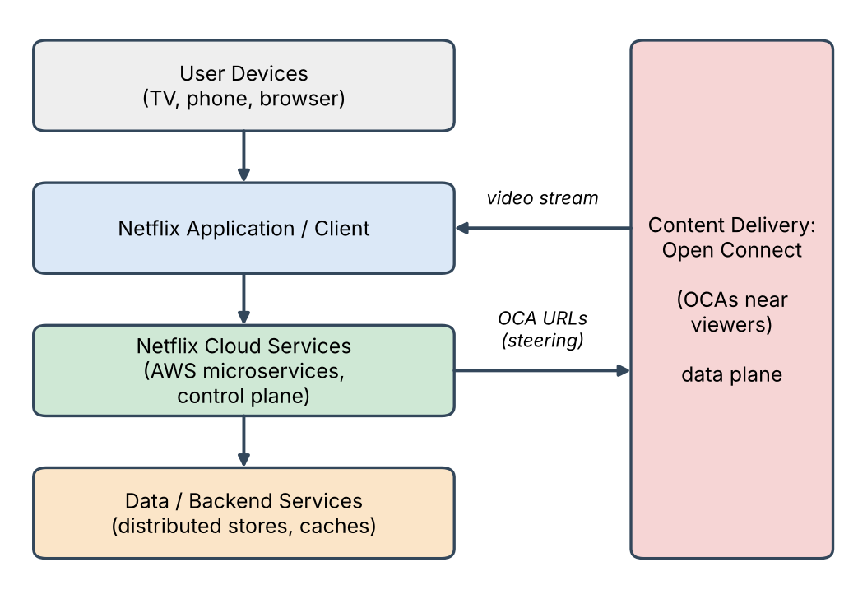
Figure 1: Conceptual layers of the Netflix platform
- User devices and client: the Netflix app lets the member browse and press play, then fetches video directly from an Open Connect server.
- Cloud services: microservices on AWS check authorisation and licensing and decide which video files and which Open Connect servers to use.
- Data and backend services: member and catalogue data is stored and cached in distributed stores replicated across zones and regions.
- Content delivery: purpose-built servers close to viewers store and stream the video. They do not store client data such as viewing history.

3. Microservices Architecture
Netflix runs its application as many small, independently deployed services instead of one large program. In a 2015 talk a Netflix engineer listed 500+ microservices on tens of thousands of virtual machines in three AWS regions. Netflix talks also describe a failure-driven design: failure is inevitable, so the aim is to never fail the same way twice. Netflix does not give one single reason for using microservices, so the benefits below are partly my interpretation.
- Separation of responsibilities: each service has one job, so a team can understand and change it without knowing the whole system.
- Independent development and deployment: Interpretation: teams can release their own service without redeploying everything.
- Independent scaling and failure containment: a busy service can get more instances on its own, and one failing service need not bring down the rest (Sections 7 and 8).
A documented example is the playback path: separate "playback application services" check authorisation and work out the required assets, while a separate "steering service" selects the Open Connect servers.

4. Service Communication
Because service instances come and go, services cannot depend on fixed addresses. Netflix open-sourced several components for this; three matter here:
- Service discovery: Eureka is Netflix's discovery component, and Netflix material notes it is multi-region aware. Interpretation: instances register themselves and callers look up healthy peers instead of using hard-coded addresses.
- Gateway and routing: Zuul routes traffic. Netflix describes Zuul-to-Zuul routing that sends traffic to a member's home region or fails it over to another region.
- Protected calls: calls between services go through Hystrix, a library that isolates points of access between services and adds latency and fault tolerance logic.

5. Data and Storage
Member and catalogue data must be available worldwide and survive failures, so Netflix uses distributed stores rather than one central database. Two documented examples:
- Apache Cassandra: per Netflix engineers (2013), every node is a peer in a ring and replication is handled internally. Clusters ran across multiple availability zones in each AWS region, with data sharded and replicated across zones and also replicated between regions.
- EVCache: a caching layer. An update in one region invalidates the matching entry in another region using SQS messages.
The key concepts are partitioning (data spread over many nodes), replication (copies in different zones and regions) and caching (frequently used data kept in fast memory). A 2013 Netflix failure-mode table also lists restoring from S3 backups for a data-store failure.

6. Content Delivery – Open Connect
Video is large and streamed continuously, so serving it from a few central locations would overload those locations and the networks to every viewer. Netflix began Open Connect in 2011 because its streaming was growing quickly and had become a significant share of ISP traffic. Open Connect is Netflix's CDN, which brings content close to where it is watched. Its building blocks are Open Connect Appliances (OCAs): servers built from commodity PC components whose only job is to deliver video to clients efficiently. They are placed in two ways:
- Embedded OCAs sit inside qualifying ISPs' networks, free of charge, with the same capabilities as other OCAs.
- OCAs at internet exchange points (IXPs) and Netflix sites, linked to ISPs by peering. Netflix states it has 60+ global data centres with OCAs.
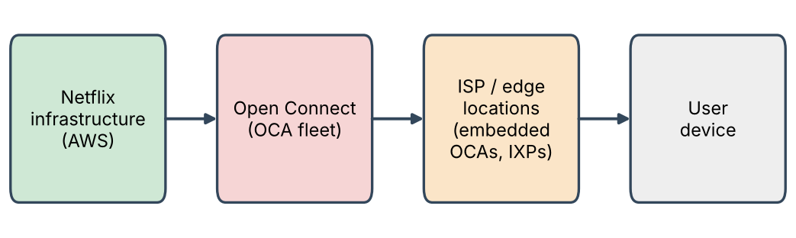
Figure 2: Content path from Netflix infrastructure to the user
Netflix documents a playback request as follows:
1. The user requests a title in the Netflix app.
2. Playback services in AWS check authorisation and licensing and work out which assets are needed, considering the client and network conditions.
3. A steering service uses data from a cache control service, which OCAs update with their health, routes and content, to pick the best OCAs and create URLs for them.
4. The URLs go to the client, which streams directly from the OCA.
An OCA only serves client addresses advertised to it via BGP. If embedded OCAs at an ISP are down, traffic is re-routed to Netflix IXP appliances.
Because OCAs cache the video near viewers, each embedded deployment offloads a substantial amount of Netflix traffic from peering or transport links. Interpretation: video bytes then travel a short distance and never touch AWS, so the cloud only handles small control requests. I could not find enough detail on how OCAs are filled with content, so I leave that out.

7. Scalability
Concept | How it appears in Netflix | Why it is needed
Distributed services / horizontal scaling | Many service instances on cloud VMs across regions. | Add instances instead of buying one bigger machine.
Independent service scaling | Responsibilities split into separate services (Section 3). | Only busy parts need extra capacity.
Load distribution | Routing across instances and regions, e.g. Zuul; steering among OCAs. | No single server or site is overloaded.
Caching and content delivery | OCAs cache video near viewers; EVCache caches data. | Less load on central systems and network paths.
Data partitioning | Cassandra data is sharded and replicated. | Data is larger than one server can hold.

The design matches the workload: light, frequent requests go to scalable cloud services, while heavy video traffic is pushed out to Open Connect. I give no capacity numbers because the sources I used have no current verified figures.

8. Availability and Fault Tolerance
Netflix engineers design on the assumption that failures will happen. The main ideas are:
- Redundancy across zones and regions: a 2013 Netflix presentation shows services and data over three balanced availability zones and isolated regions, planning to keep running on two of three zones if one fails.
- Active-active regions: Netflix redesigned its service so users can be served from several AWS regions and, if one fails, another can quickly take its place.
- Failure isolation and graceful degradation: Hystrix uses bulkhead and circuit-breaker patterns to stop cascading failures and provide fallbacks. The 2013 table lists an automatic degraded response for application failure. Interpretation: users may see a simpler result instead of an error.
- Redundant delivery: embedded OCAs are typically deployed in an n+1 configuration and tolerate certain hardware failures; traffic can fall back to other Netflix appliances (Section 6).

9. Observability and Reliability
Operating hundreds of services needs visibility into their health. Hystrix offers real-time monitoring, and Netflix material describes Hystrix streams aggregated by Turbine and shown on a dashboard. OCAs report health and routing information to Open Connect control services, and the control plane gathers playback telemetry. I could not find enough reliable detail on Netflix's logging, so I omit it.
Netflix also tests reliability on purpose. Chaos Monkey randomly terminates production virtual machine instances so engineers design services that survive instance failures, and Chaos Kong exercises simulate the loss of a whole AWS region. Netflix calls this chaos engineering: experimenting on a distributed system to build confidence that it can withstand turbulent production conditions.

10. Overall Architecture Summary
Architectural Component | Purpose in Netflix
Client/Application | Lets members browse and play; fetches video directly from an OCA.
Microservices | Small independent services with separate responsibilities.
Service Communication | Eureka discovery, Zuul routing and Hystrix-protected calls.
Data/Storage | Partitioned, replicated stores such as Cassandra.
Content Delivery/Open Connect | OCAs near viewers stream the video bytes.
Caching | OCAs cache video; EVCache caches data.
Scalability Mechanisms | Horizontal scaling, service split, load distribution, caching, partitioning (Section 7).
Availability/Fault Tolerance | Zone/region redundancy, active-active regions, isolation, fallbacks.
Observability | Real-time monitoring, health telemetry, chaos experiments.

