Distributed Paradigms and Algorithms in Netflix’s Architecture
1. Netflix as a Distributed Application
Netflix is a very large streaming service that runs on many computers working together. It has two main parts. The first handles requests such as login, browsing, recommendations and pressing “play”; it runs on many small services in the cloud (Amazon AWS). The second delivers the video itself through Open Connect, Netflix’s own network of video servers placed close to viewers. The Netflix app talks to the first part through a gateway called Zuul.
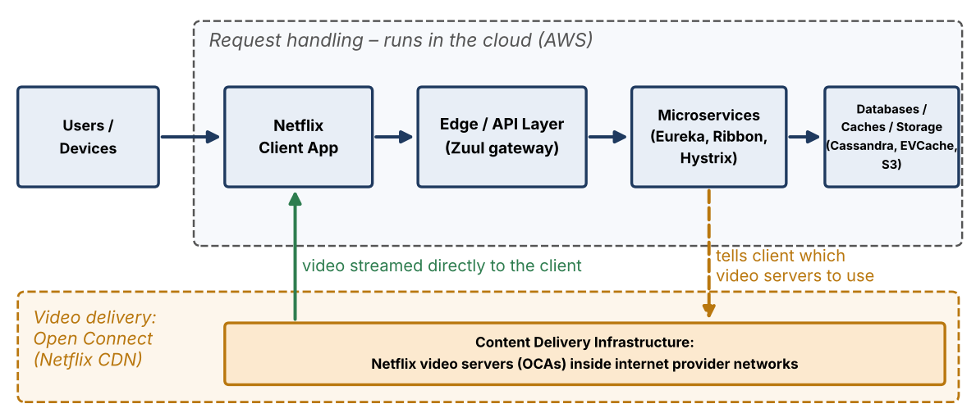
Figure 1. Simplified view of Netflix’s distributed architecture.
Why Netflix needs distributed computing
Need | What it means for the design
Very large user base | The work is shared across many computers.
Users all over the world | Services run in several regions, and video servers sit inside local internet providers.
Very many requests | No single computer can handle all requests and usage data.
Continuous video streaming | Video uses a lot of bandwidth, so it is sent from nearby servers.
Always available | Copies of the system run in different locations.
Parts will fail | Computers fail sometimes, so the system must keep working anyway.
Services grow differently | Each service can be made bigger or smaller on its own.
2. Distributed Paradigms Used by Netflix
A paradigm is a basic way of organising a distributed system. Netflix uses five.
2.1 Client–Server
The Netflix app (client) sends requests such as login, search and play to Netflix’s computers (servers) through the Zuul gateway. For video, the app then downloads it directly from a nearby Open Connect server.
2.2 Microservices
Netflix is built from many small services, each doing one job. Each can be updated and scaled separately. A service called Eureka keeps a list of where every service is running, and a tool called Ribbon helps services call each other. A problem in one service can be kept from spreading.
2.3 Distributed Data
Netflix does not keep all data in one database. Cassandra stores data copied across regions, EVCache is a fast memory store for popular data, and Amazon S3 stores the video files.
2.4 Content Delivery (Edge Distribution)
Netflix places its own video servers (called OCAs) inside internet providers’ networks. Videos are copied to them in advance, at night when traffic is low, so viewers get video from a nearby server.
2.5 Event-Based Messaging
Services send small event messages (for example, “a user pressed play”) into a system called Keystone, built on Apache Kafka. These messages are passed on in the background to tools that analyse and store them. Messages are also used to clear outdated cached data between regions.
3. Scalability Mechanisms
Scalability means handling more users by adding more resources.
Mechanism | What it is | How Netflix uses it | Why it helps
3.1 Horizontal scaling | Adding more computers instead of one bigger one | Services run on many cloud instances that are added or removed as needed. One Cassandra test reached 1.1 million writes per second on 288 machines. | Capacity grows by adding machines.
3.2 Service-level scaling | Growing each service by its own need | Each service is its own group of machines, listed in Eureka. | Only busy services get more resources.
3.3 Load balancing | Sharing requests among machines | Ribbon picks a machine from Eureka’s list, using simple rules such as taking turns or preferring faster ones. Zuul uses Ribbon too. | No single machine becomes a bottleneck.
3.4 Content distribution | Serving from many nearby servers | Open Connect servers deliver the video, and Netflix tells each app which server to use. | Heavy video traffic stays off the main services.
3.5 Caching | Keeping popular data in fast memory | EVCache answers repeated requests from memory instead of the database. Most requests (over 99%) are typically found there. | Fewer slow database calls.
4. Availability and Fault Tolerance
Availability means the service stays up. Fault tolerance means it keeps working when parts fail.
4.1 Redundancy
Netflix keeps extra copies of services and data in several data centres and regions. If one region has a problem, another can serve users. EVCache copies data across data centres, and apps remember the Eureka list so they still work if Eureka is down.
4.2 Failure Isolation
Services are separate, and a tool called Hystrix guards every call between them, so one failing service does not bring down the others. Regions are also kept separate.
4.3 Circuit Breaker Pattern (Hystrix)
Like an electrical circuit breaker, Hystrix watches calls to a service. If too many fail, it stops sending calls and returns a backup response straight away. After a short wait it tests whether the service has recovered. This stops one slow service from making others slow and failing too. Hystrix is no longer actively developed, but the pattern is still widely used.
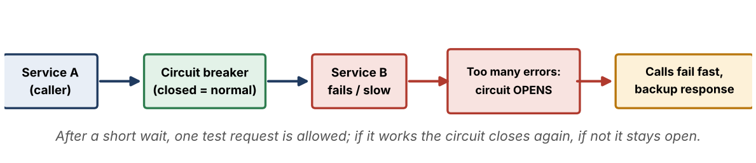
Figure 2. How a circuit breaker works between Service A and Service B.
4.4 Timeout and Retry
Each call has a time limit, so a slow service cannot make others wait forever; after the limit, the backup response is used. Ribbon can retry on another machine and skips machines that are not responding.
4.5 Bulkhead (Isolation)
Like the sealed sections of a ship, each service call gets its own small set of workers. If that set is full, new calls are refused at once, so one slow service cannot use up all the workers.
4.6 Chaos Engineering
This is a testing technique, not an algorithm. Netflix’s Chaos Monkey randomly shuts down real servers to prove the system survives failures. Related tools add delays or simulate losing a whole data centre.
5. Distributed Algorithms and Coordination Mechanisms
An algorithm is a step-by-step method. A mechanism or protocol is an agreed way for computers to work together. Only items found in Netflix sources are listed.
5.1 Consistent Hashing — Algorithm
This method decides which machine stores which data, so that when a machine is added or removed, only a small part of the data moves. EVCache uses it (the Ketama method), and Cassandra spreads data in a similar way.
5.2 Service Discovery and Load Distribution — Mechanism and algorithms
Eureka works like a phone book of services. Each service reports “I am alive” every 30 seconds, and is removed if silent for about 90 seconds. It keeps working even if some information is slightly out of date. This is a mechanism, not a formal algorithm. Ribbon’s simple rules for choosing a machine (take turns, prefer faster ones, prefer nearby ones) are load-balancing algorithms.
5.3 Distributed Coordination — Protocol
The sources do not describe a Netflix-specific agreement algorithm, so none is claimed. Cassandra keeps copies in step by waiting for a majority of copies to confirm a write, and by updating other regions in the background. Netflix uses this method but did not invent it.
5.4 Content Placement and Steering — Policy
Netflix’s central system tells each video server what to store and where to copy it from, preferring nearby servers first and the main storage last. It also picks the best video servers for each viewer, based on which have the video, are healthy and are close. Netflix has not published this as a named algorithm, so it is described as a policy.
Summary of types. Algorithms: consistent hashing, Ribbon’s selection rules. Mechanisms/protocols: Eureka, majority-based copying, video server filling and selection. Design patterns: circuit breaker, bulkhead, timeout and retry. Paradigms: client–server, microservices. Testing technique: Chaos Engineering.
6. Relationship of Paradigms and Algorithms to Netflix
Concept | Type | Role in Netflix
Client–Server | Distributed paradigm | The app talks to Netflix’s servers through Zuul.
Microservices | Architectural paradigm | Many small services, each scaled on its own.
Distributed Data | Paradigm / design | Data is spread over Cassandra, EVCache and S3.
Content Distribution | Paradigm / mechanism | Open Connect puts video close to viewers.
Horizontal Scaling | Scalability mechanism | Adding more machines handles more load.
Load Balancing | Distribution mechanism | Ribbon and Zuul share requests among machines.
Caching | Distributed mechanism | EVCache and Open Connect avoid repeated work.
Circuit Breaker | Fault-tolerance pattern | Hystrix stops failures from spreading.
Chaos Engineering | Testing technique | Chaos Monkey checks the system survives failures.
Consistent Hashing | Algorithm (verified) | EVCache and Cassandra spread data with little movement.
Service Discovery | Distributed mechanism | Eureka helps services find running machines.
7. Overall Architecture Relationship
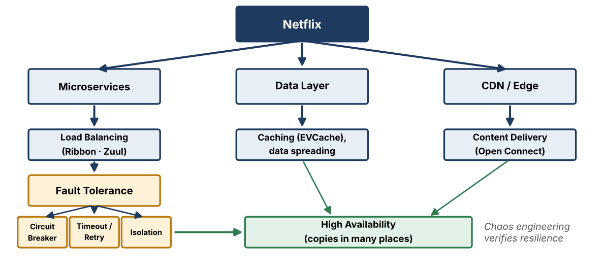
Figure 3. How the paradigms, mechanisms and fault-tolerance techniques fit together.
Conclusion
Netflix combines distributed paradigms, ways of handling growth, protection against failures, nearby video delivery and coordination methods to provide a reliable streaming service worldwide.

