Chat with AI in PowerShell using AIShell
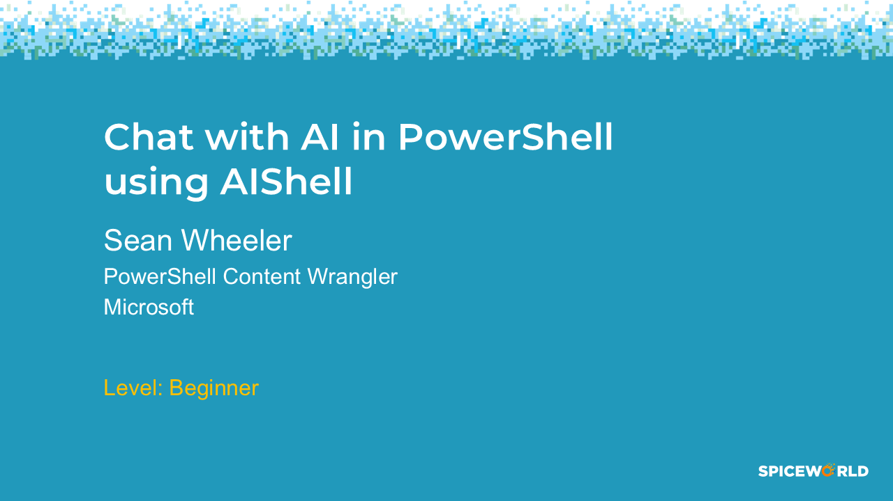

Come learn about AIShell, the newest AI user experience brought to you by the PowerShell team. AIShell integrates with you PowerShell session and provide easy access to many different AI agents. Chat with AI from the PowerShell command line or in AIShell and post the resulting solutions back into your command line. Use AIShell to write PowerShell and Azure CLI code and explain how it work. Connect AIShell to your own language models trained with your own data. Integrate with MCPs to let AI perform actions for you.
This is a beginner session that shows you how to get started with AIShell.
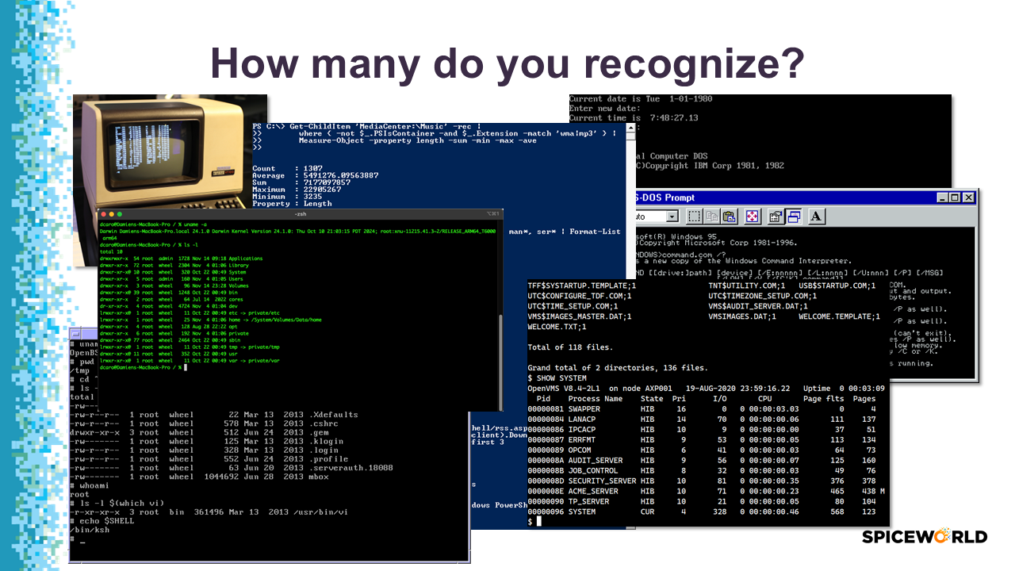

Lots of command line interfaces
The command line interface was the standard for over 30 years, until the graphical user interface (GUI) debuted with Windows and Macintosh. Today, command line interfaces (shells) are much more powerful. They allow you to automate tasks that must be done manually in the GUI. But with that power come complexity.

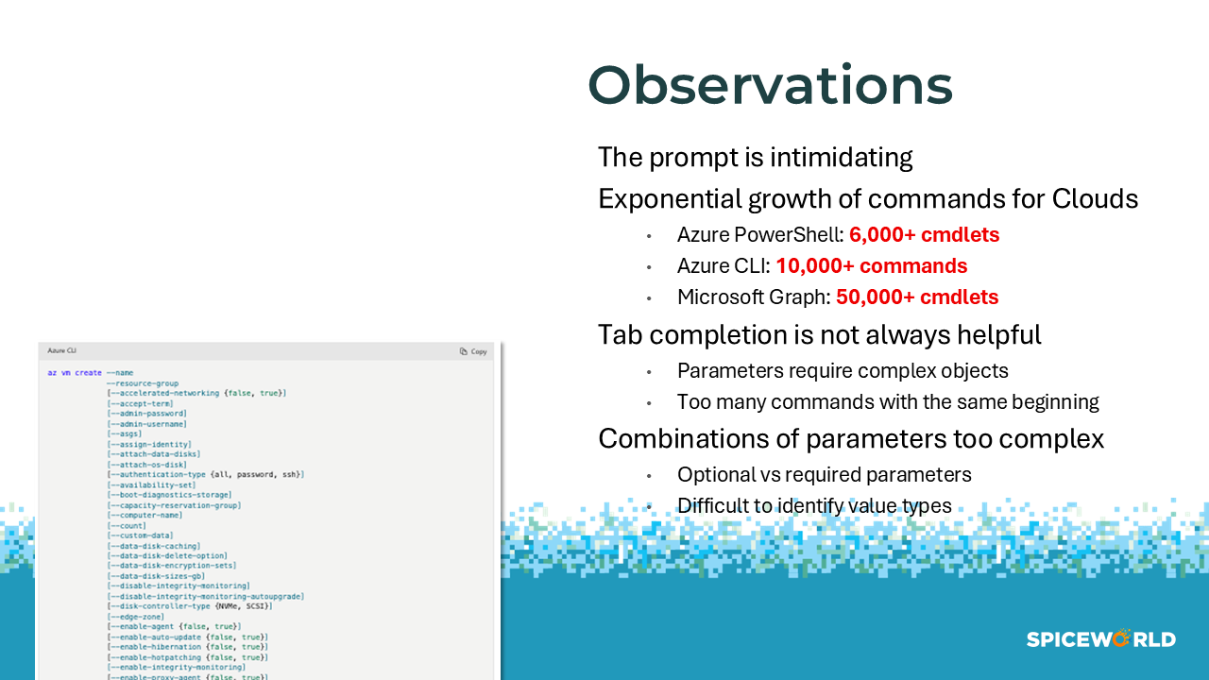

Command-line tools are hard to use
Today, the prompt can be intimidating. There are so many more commands available, with so many parameters. It’s hard to know which commands to use, with which parameters, in what sequence.
Linux commands are notoriously terse. And there is no consistency with how parameters are handled across commands:
- Do I use /, -, --?
- What input types are expected?

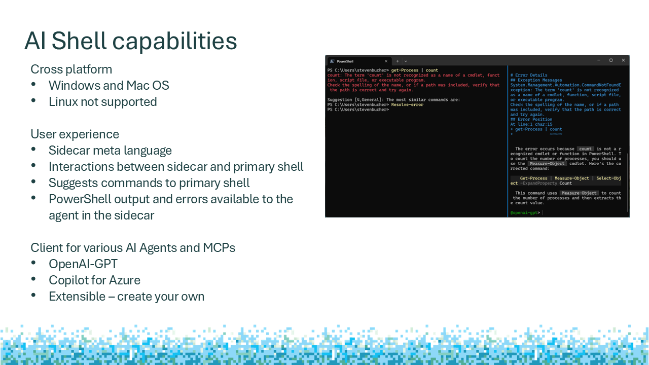

AI Shell features
AI Shell is an interactive shell that provides a chat interface with language models. The shell provides agents that connect to different AI models and other assistance providers. Users can interact with the agents in a conversational manner.
The AI Shell project includes:
- A command-line shell interface (aish)
- A framework for creating AI agents and other assistance providers
- Integration with Windows Terminal and iTerm2 on macOS
- A PowerShell module for integration with PowerShell. For more information, see the AI Shell module.
- Support for MCP servers and tools
- Support for Foundry Local deployments
Each AI assistant is known as an agent. The initial release of AI Shell includes two agents:
- Azure OpenAI agent that connects to an instance of gpt-4o. Use this agent for general AI tasks.
- Copilot in Azure agent that can assist with Microsoft Azure knowledge. Use the Azure agent for assistance with Azure CLI and Azure PowerShell commands.

See What is AI Shell?
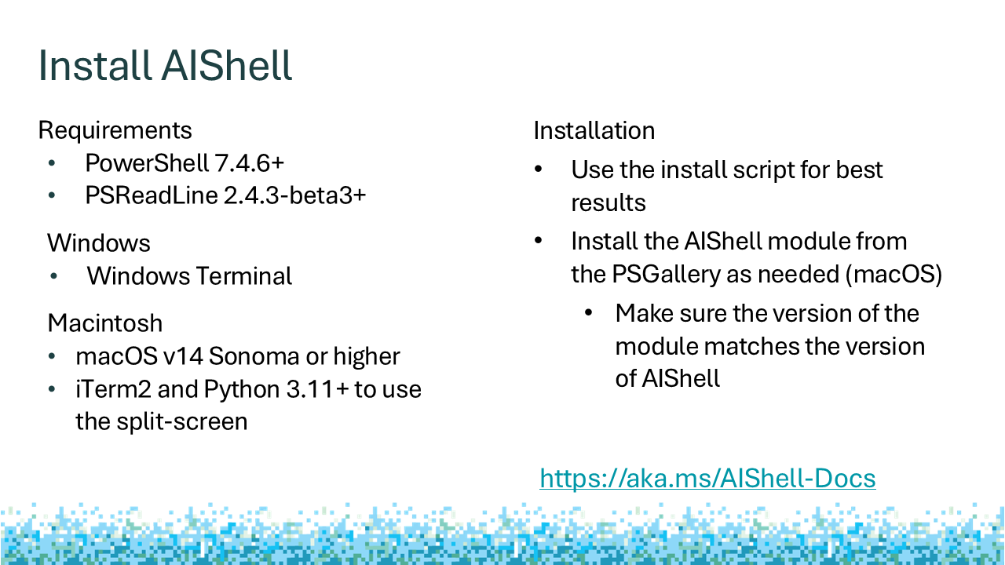

Install AI Shell
System requirements
All platforms
- PowerShell 7.4.6 or higher
- PSReadLine v2.4.2-beta2 or higher
Windows 11 or higher
- Windows Terminal
macOS v14 Sonoma or higher
- Default macOS Terminal app for the standalone experience
- iTerm2 required to use the sidecar experience
  - Python 3.11 or higher required to support iTerm2
  - Must enable Python APIs in the iTerm2 settings

Install AI Shell
Invoke-Expression "& { $(Invoke-RestMethod 'https://aka.ms/install-aishell.ps1') }"
On Windows, this script:
- Installs aish.exe to $env:LOCALAPPDATA\Programs\AIShell and adds it to your PATH
- Installs the AIShell module to your module path location
On macOS, this script:
- Installs the aish executable to /usr/local/AIShell and creates a symbolic link to /usr/local/bin/aish.

See Install AI Shell
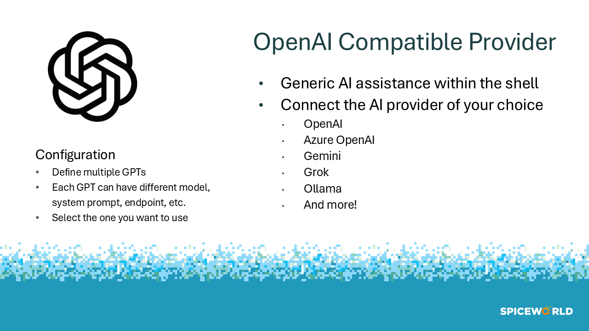

OpenAI Agent
The OpenAI agent can connect to a public OpenAI service, a private deployment of the Azure OpenAI service, or any other OpenAI-compatible service. We recommend using a deployment of Azure OpenAI deployment for enhanced security and privacy. Some of these models are open-source tools for running SLMs and LLMs locally. The OpenAI agent supports the following 3rd-party models:
- Ollama
- LM Studio
- Deepseek
- LocalAI
- Google Gemini
- Grok
- Foundry Local

See OpenAI agent

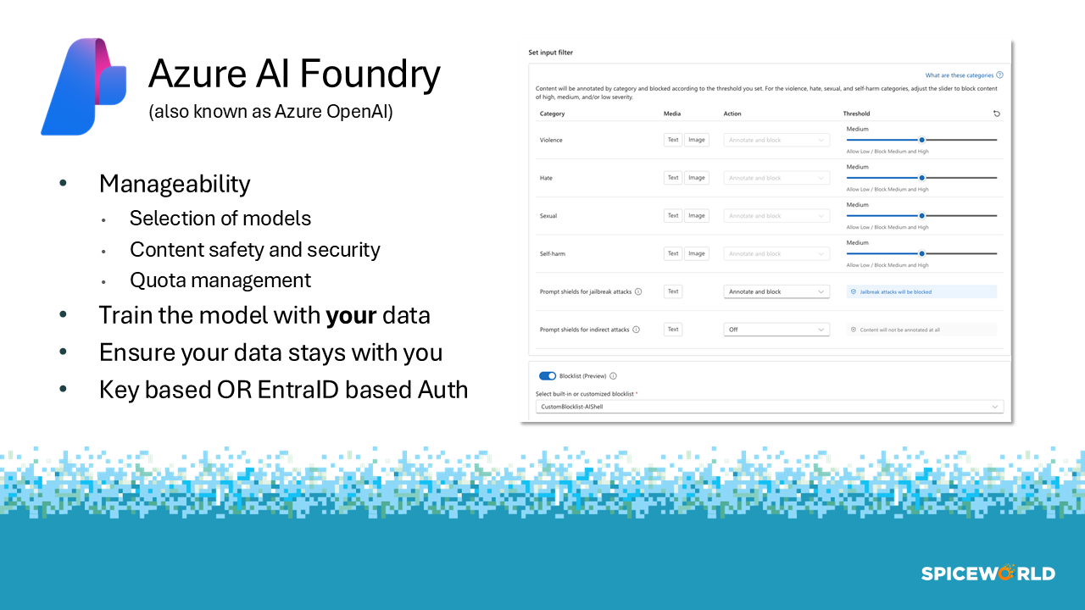

Azure AI Foundary
Azure AI Foundry is a unified Azure platform-as-a-service offering for enterprise AI operations, model builders, and application development. This foundation combines production-grade infrastructure with friendly interfaces, enabling developers to focus on building applications rather than managing infrastructure.
Azure AI Foundry unifies agents, models, and tools under a single management grouping with built-in enterprise-readiness capabilities including tracing, monitoring, evaluations, and customizable enterprise setup configurations.
See What is Azure AI Foundry?
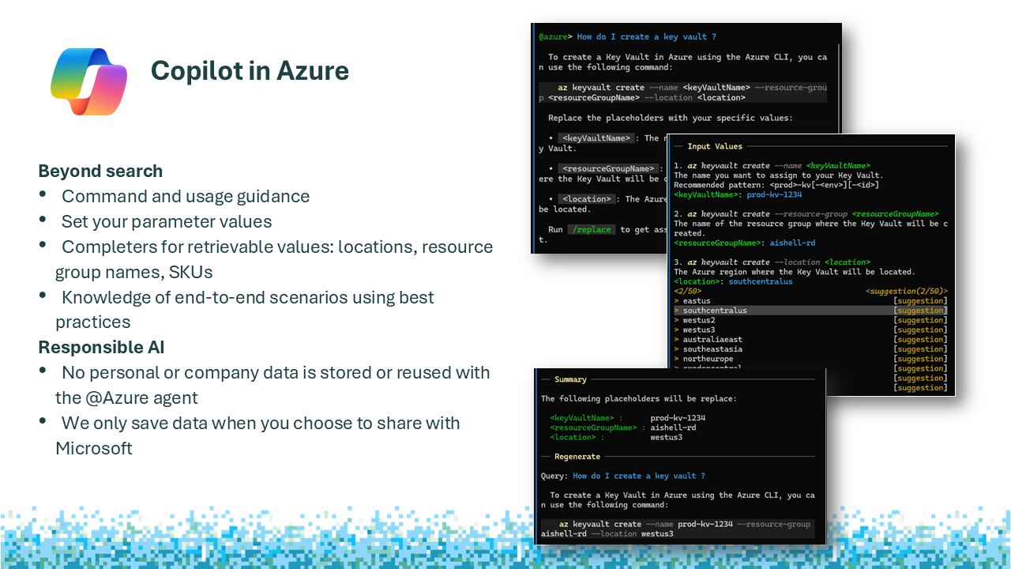

Copilot in Azure
Microsoft Copilot in Azure is an AI-powered tool to help you do more with Azure. With Microsoft Copilot in Azure, you can gain new insights, discover more benefits of the cloud, and orchestrate across both cloud and edge. Copilot leverages Large Language Models (LLMs), the Azure control plane, and insights about your Azure environment to help you work more efficiently.
Microsoft Copilot in Azure can help you navigate the hundreds of services and thousands of resource types that Azure offers. It unifies knowledge and data across hundreds of services to increase productivity, reduce costs, and provide deep insights. Copilot in Azure helps you learn about Azure by answering questions, and it can provide information tailored to your own Azure resources and environment. By letting you express your goals in natural language, Copilot in Azure simplifies your Azure management experience.
See Microsoft Copilot in Azure Overview
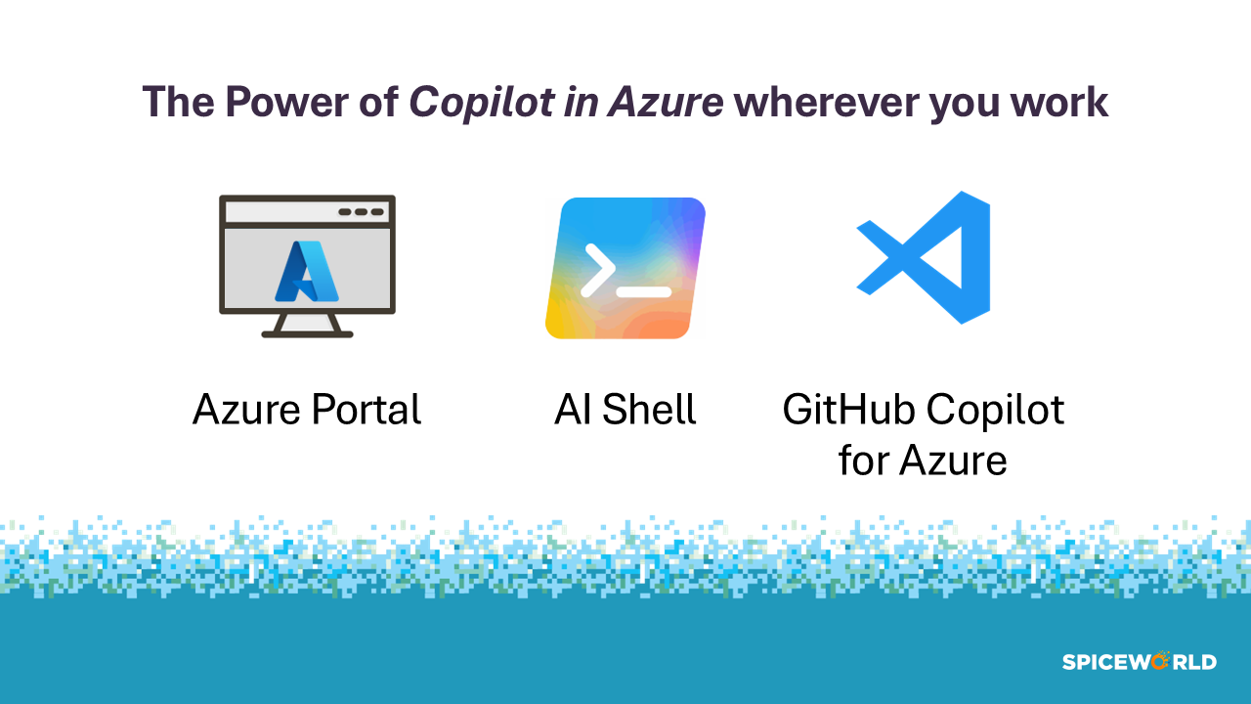

Copilot in Azure everywhere you are
Microsoft Copilot in Azure is available from everywhere you want to work with Azure from.
- Azure Portal
- AI Shell
- GitHub Copilot for Azure in Visual Studio Code
You get the same Copilot for Azure capabilities in in location.
See Microsoft Copilot in Azure capabilities
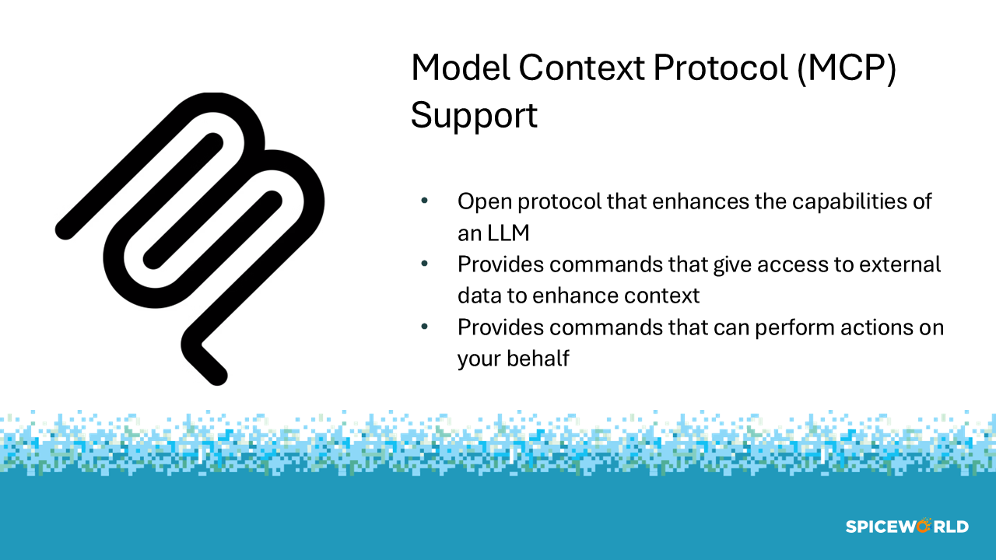

MCPs for automation
Model Context Protocol (MCP) is an open protocol that standardizes how applications provide context to large language models (LLMs). Starting in AI Shell 1.0.0-preview.6, AI Shell can act as an MCP Host and client to MCP servers. The key participants in the MCP architecture are:
- MCP Host - AI Shell coordinates and manages one or multiple MCP clients
- MCP Client - The client component of AI Shell maintains a connection to an MCP server and obtains context from an MCP server for the MCP host to use
- MCP Server - A program, running locally or hosted remotely, that provides context to MCP clients
MCP tools enable AI agents to access external tools and services to enhance their capabilities and provide more accurate responses. MCPs can integrate with various APIs, databases, and other resources, allowing agents to retrieve real-time information and perform complex tasks.
See MCP support
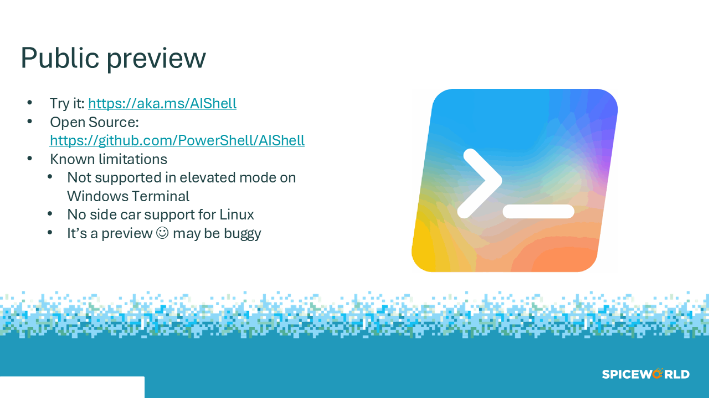

Try it out
Try it out: https://aka.ms/AIShell

Open Source: https://github.com/PowerShell/AIShell

Known limitations
- Not supported in elevated mode on Windows Terminal
- No side car support for Linux (and not tested)
- It’s a preview so it may be buggy

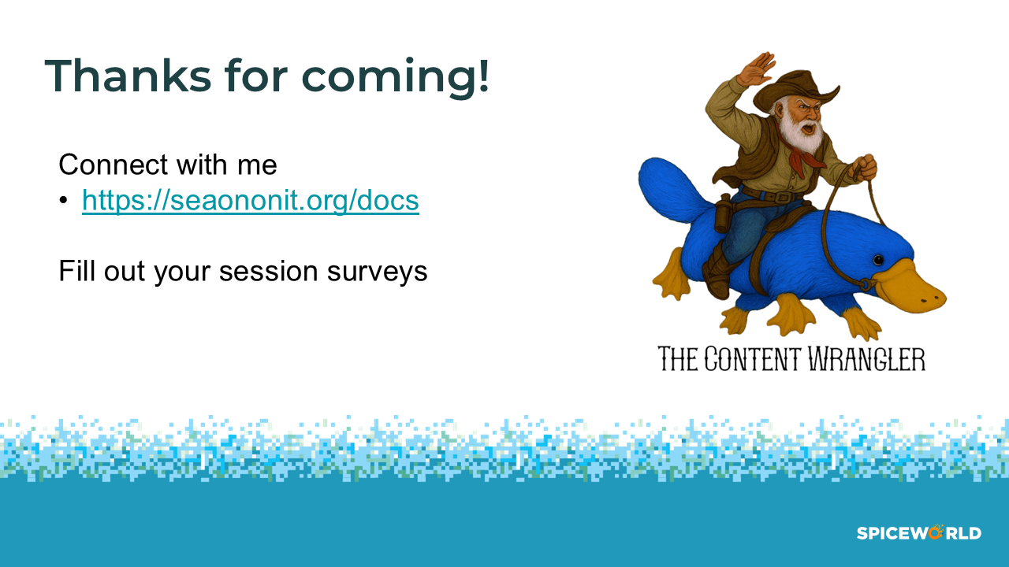

Presented by Sean Wheeler
Check out my website for links to my social media and other topics I have presented.
Presentations: https://seanonit.org/docs
GitHub: https://github.com/sdwheeler
Bluesky: @sdwheeler.bsky.social
LinkedIn: in/scriptingsean

