**IDS 410 – Business Database Technology**

**Fall 2022**

**AWS Lab 1**

**Submitted by:**

**Shubham Dwivedi** [**|sdwive4@uic.edu**](mailto:|sdwive4@uic.edu) **| 660328503**

* **Lab Start: In creation**

* **IAM dashboard**

* **AWS Groups**

* **Awsusers group permission in JSON format**

* **Adding awsusers to the awsusers group**

* **Account ID**

* **Log in Again with Account ID and IAM user name**

* **Create S3 bucket**

* **Upload an Object in the Bucket**

* **Query the file uploaded in S3**

* **Run different query**

* **Result**

* **Edit Server Side Encryption**

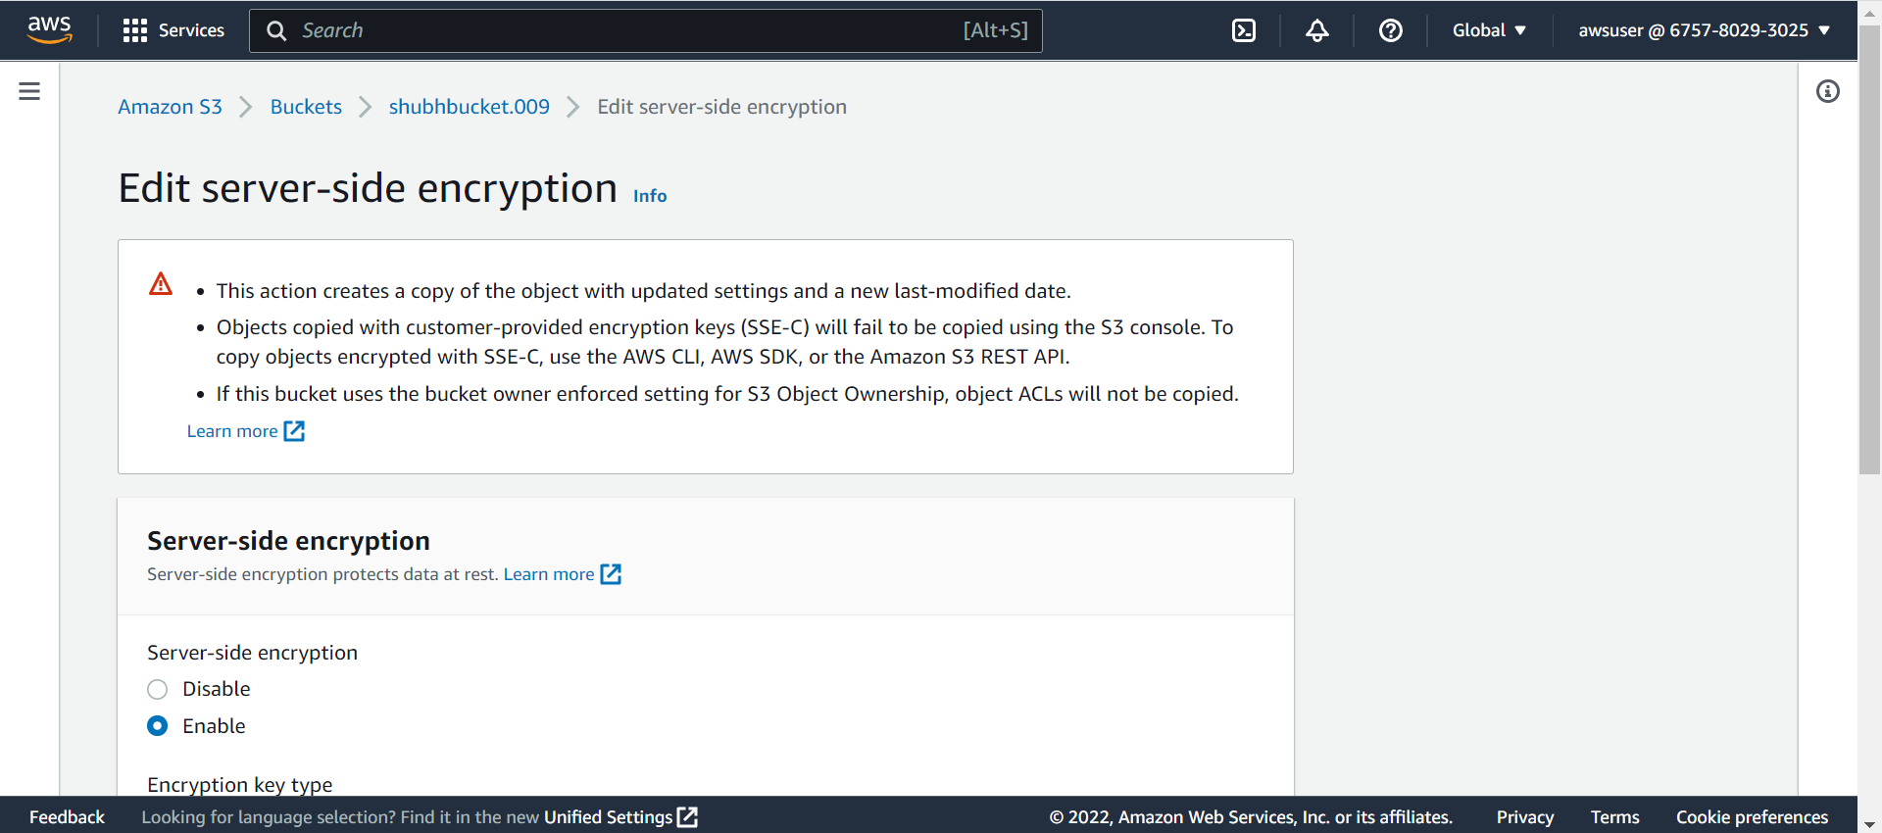

**Edit Storage Class : Choose Intelligent-Tiering**

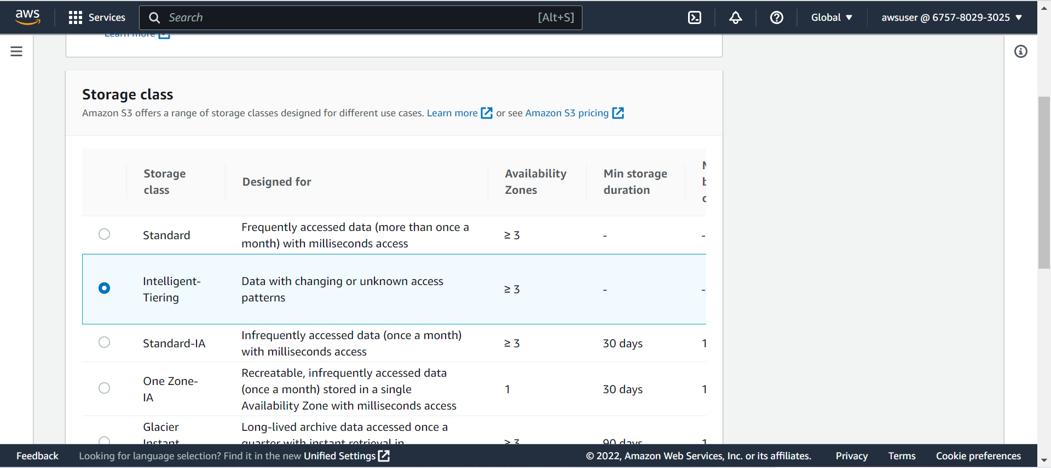

* **Uploading a compressed file**

* **Query the uploaded compressed file**

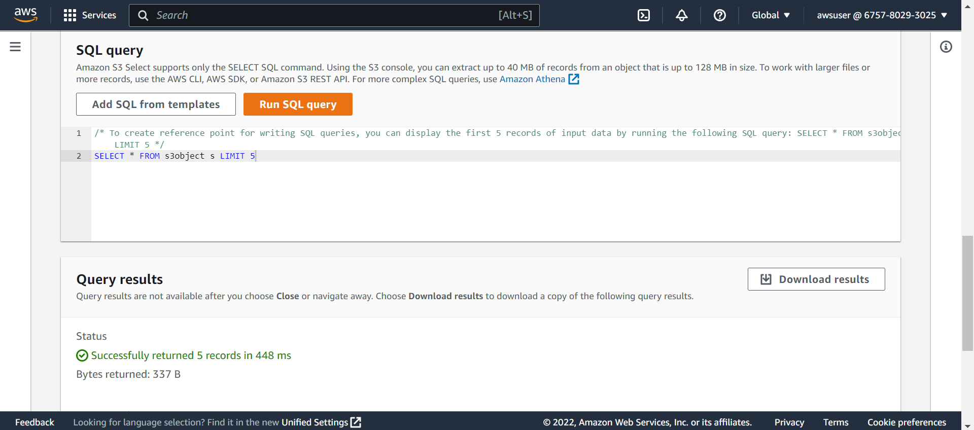

* **Query for Count**

* **Query Result**

* **End Lab**

* **Lab 1 Completion**

