**IDS 410 – Business Database Technology**

**Fall 2022**

**AWS Lab 4**

**Submitted by:**

**Shubham Dwivedi** [**|sdwive4@uic.edu**](mailto:|sdwive4@uic.edu) **| 660328503**

**Task 1: Review the security group for accessing the Amazon Redshift console**

**Choose Roles in IAM.**

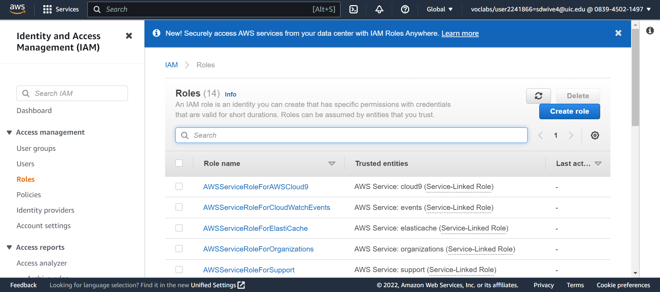

**Task 2: Create and configure an Amazon Redshift cluster**

**Create Cluster from Amazon Redshift services with the below configurations.**

**Task 2.1: Create a security group for your cluster**

**Choose Security groups from the EC2 service with the following configurations.**

**Task 2.2: Configure your Amazon Redshift cluster**

**Select the created cluster from the Redshift Service and Edit the Network and Security Settings section under the properties tab.**

**Select the Redshift Security Group from the dropdown list and remove the default group.**

**Task 3: Load data into your Amazon Redshift cluster**

**Task 3.1: Create the tables in the dev database and connect to the database**

**Use the following configurations to connect to the database.**

**Create users table from the query editor.**

**Create data and sales table**

**Task 3.2: Load data from Amazon S3**

**Run the following queries.**

**Task 4: Query the data**

**To see the overall structure of the sales table:**

**To retrieve the number of items sold for a particular date**

**To find the top 10 buyers by quantity.**

* **Challenge Questions**

1. **Challenge Question 1:**

SELECT eventid,pricepaid,ntile(1000) OVER(ORDER BY pricepaid DESC)AS percentile

FROM (SELECT eventid AS eventid,SUM(pricepaid)AS pricepaid FROM sales

GROUP BY eventid)

1. **Challenge Question 2:**

**Sorting by Total Quantity Sold.**

**Query: SELECT eventid, sum(sales.qtysold) as Total_Sales FROM sales GROUP BY eventid order by sum(sales.qtysold) desc;**

**Sorting According to EventId**

**Query: SELECT eventid, sum(sales.qtysold) as Total_Sales FROM sales GROUP BY eventid order by eventid desc;**

