**IDS 410 – Business Database Technology**

**Fall 2022**

**AWS Lab 5**

**Submitted by:**

**Shubham Dwivedi** [**|sdwive4@uic.edu**](mailto:|sdwive4@uic.edu) **| 660328503**

**Task 1: Obtain the AWS Identity and Access Management (IAM) role**

**Select sagemarkerlab from IAM Roles**

**Copy the ARN**

**Task 2: Create a Jupyter notebook with Amazon SageMaker**

**Select Notebook instance from the Amazon SageMaker service**

**Create Notebook instance with the below configurations**

**Task 3: Open your Jupyter notebook instance**

**Select the created notebook and choose the Open Jupyter option.**

**Choose New, and from the list of environments, select conda_python3.**

**Jupyter Notebook running in Python version 3 opens up.**

**Task 4: Create visualizations with Bokeh**

**Task 4.1: Create a line graph**

**Save the file**

**Open the lines.html file containing the graph by clinking on the Jupyter icon and selecting the file**

**Task 4.2: Create a bar chart: Use the below code in the** [Create line graph.ipynb](https://mynotebook-as4h.notebook.us-east-1.sagemaker.aws/notebooks/Create%20line%20graph.ipynb) **file.**

**Task 4.3: Create a grouped bar chart: Paste the following code the next line of the python editor**

**Task 5: Create a visualization from a dataset**

**Open a new Terminal window from Jupyter**

**Download the file using given command in the CLI**

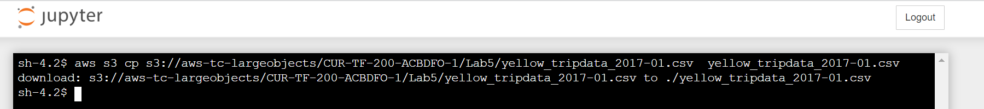

**Task 5.2: Create the notebook: Select conda_python3 from the new dropdown list**

**Select Markdown from the content dropdown list**

**Run the below code in the 1st line of the editor**

**Enter the following code in the next line of the editor**

**Save the file**

**Challenge Question**

**Open Terminal and get the file from AWS S3**



**Create new Notebook by clinking conda_python3**

**Use the following code to analyze**

**By using the graph made from the data in the given excel sheet we can say that there is a surge in the delay time usually around 1500 hours.**