(Landing Page if not logged in) index.php

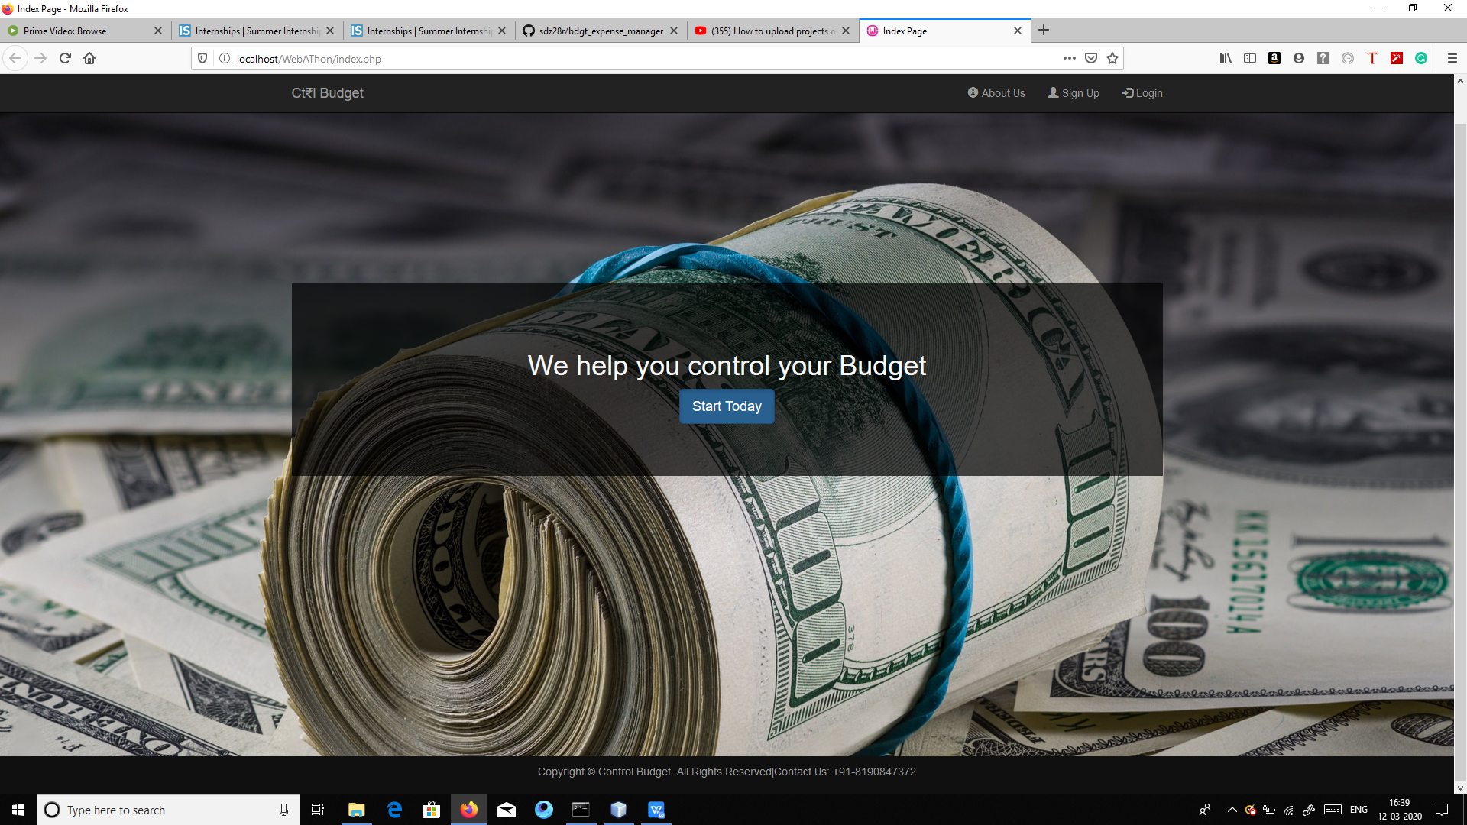

Signup.php Page

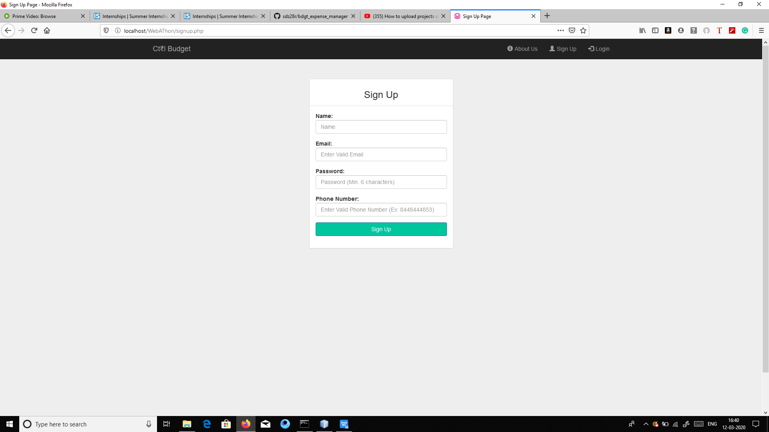

Login Page

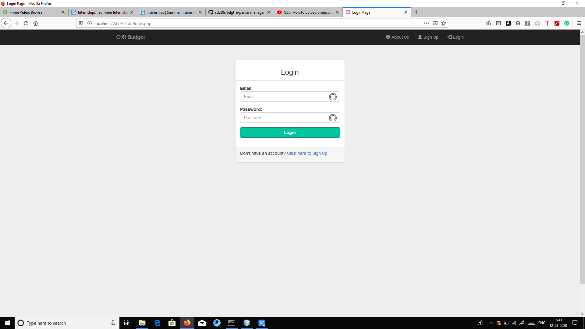

About Us Page

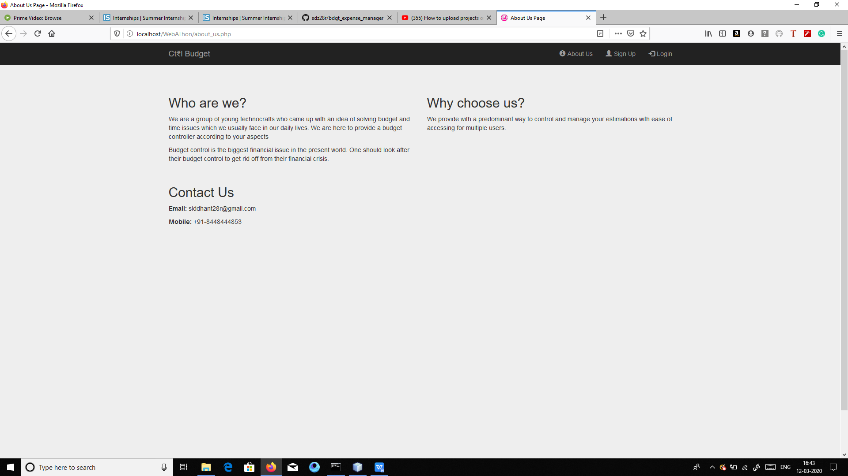

(Landing Page if logged in) Home Page for Logged in user

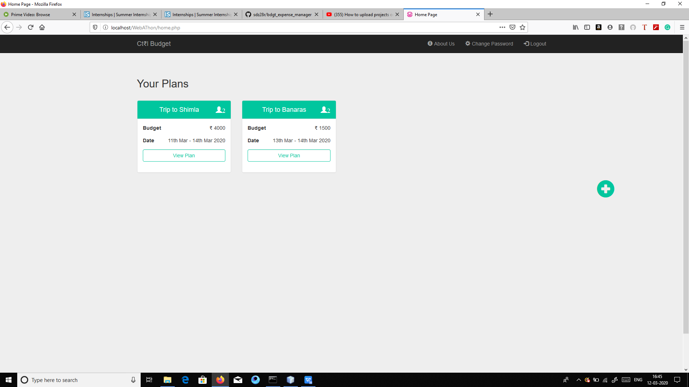

Click on + symbol to add a new plan (create_new_plan Page)

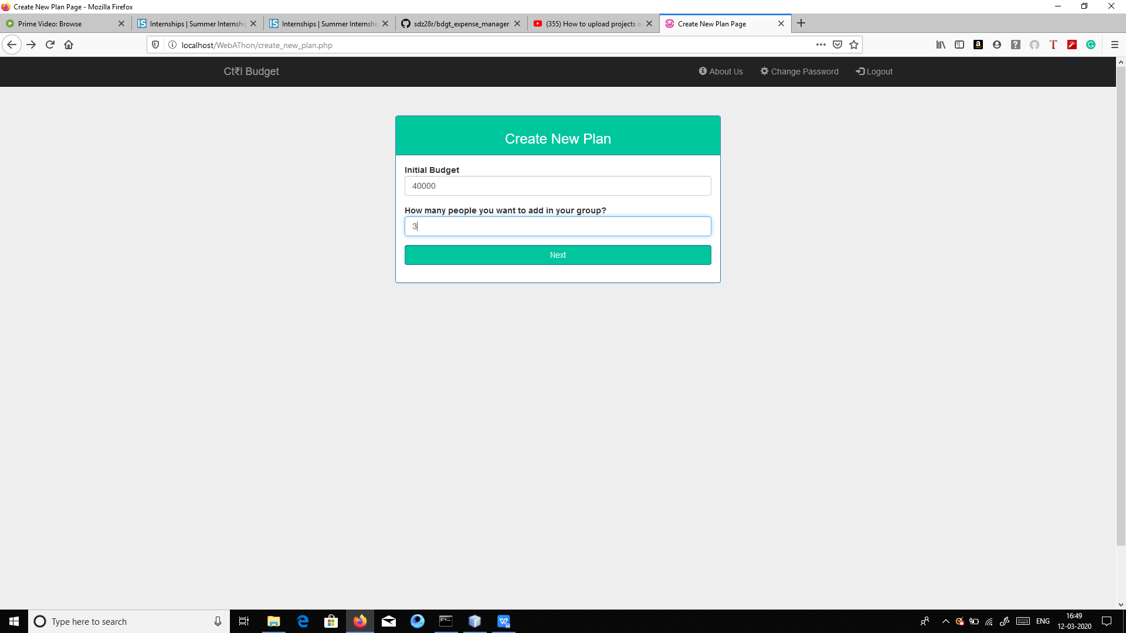

Click next and give plan details(plan_details page)

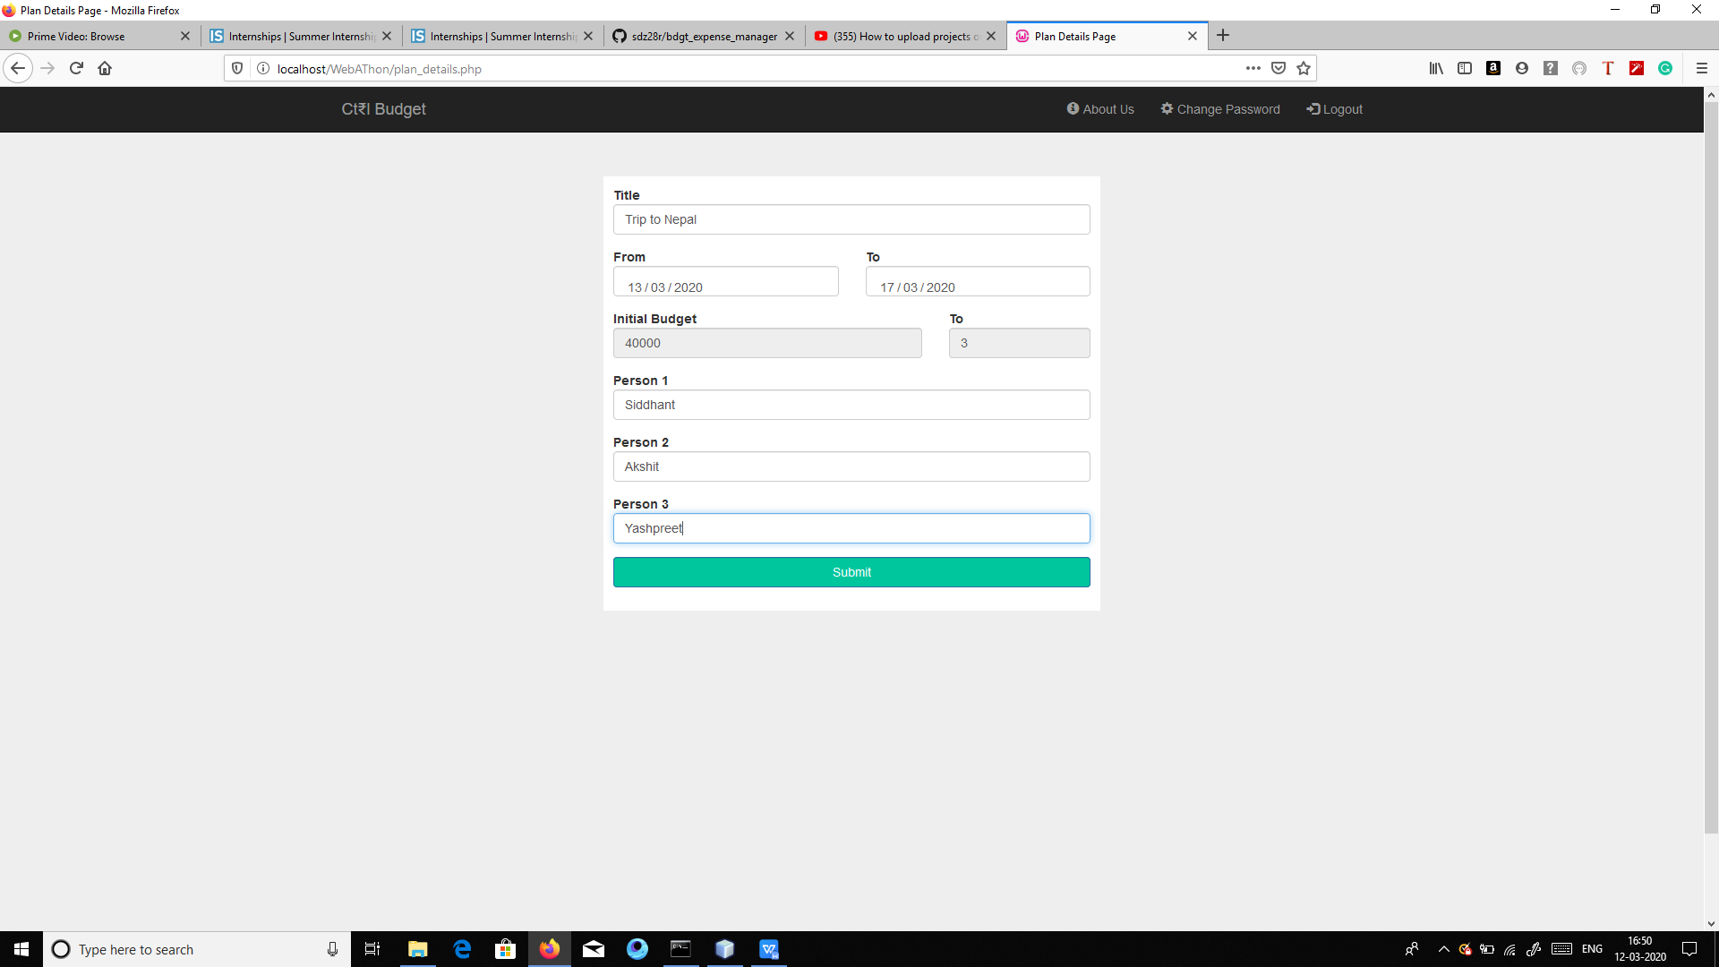

New plan will be created on home.php page

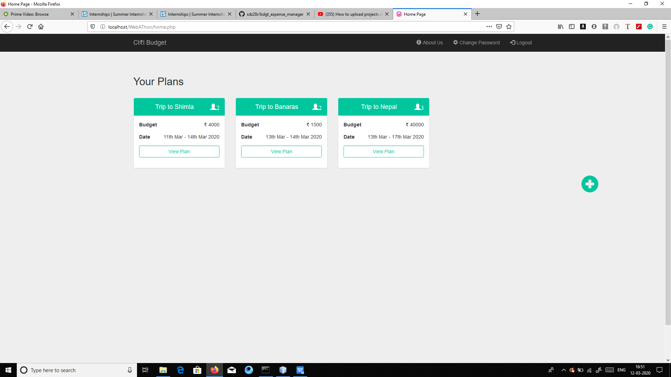

Click on view plan to see the plan details and expenses (ViewPan.php page)

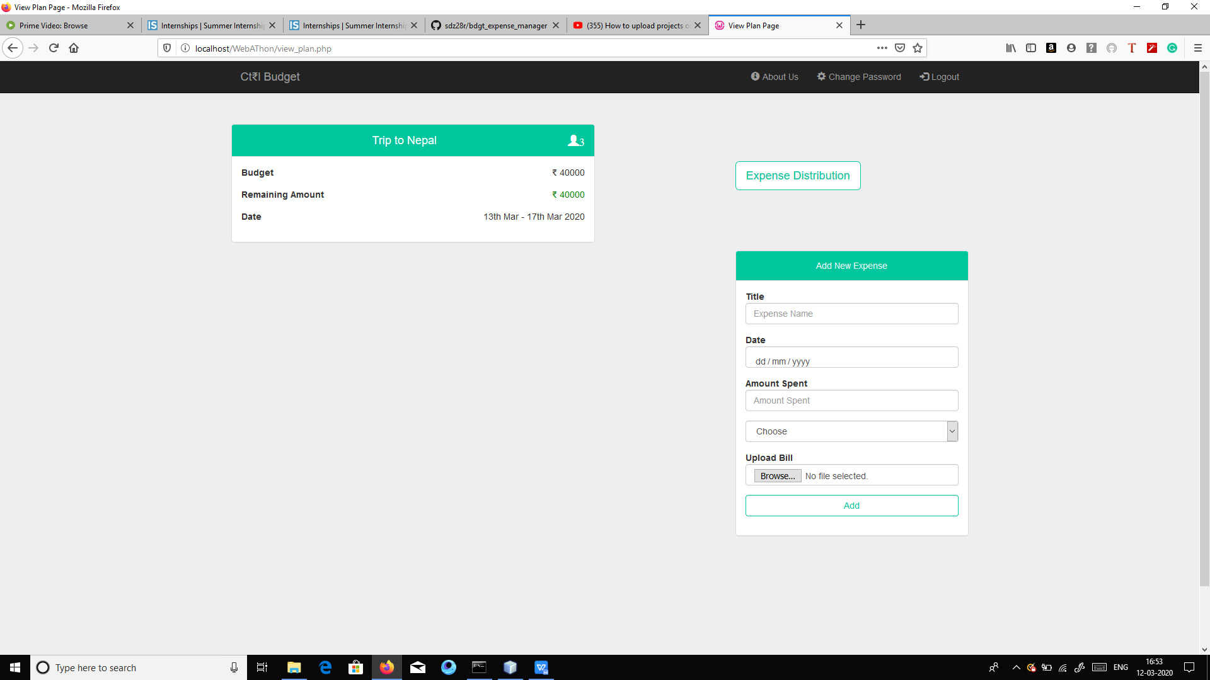

To add new expense fill the “Add New Expense” form

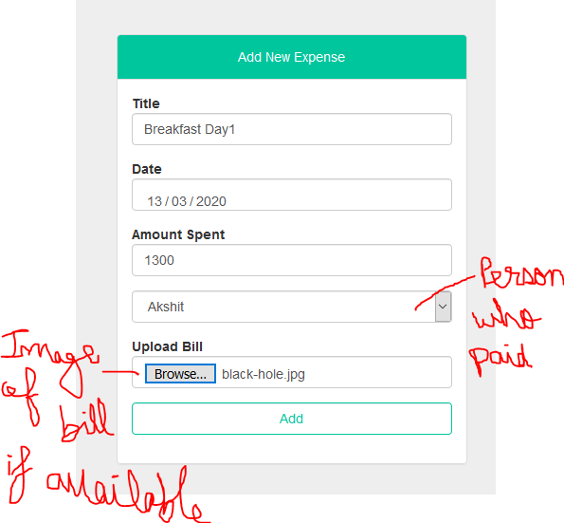

The view plan will show the added expense

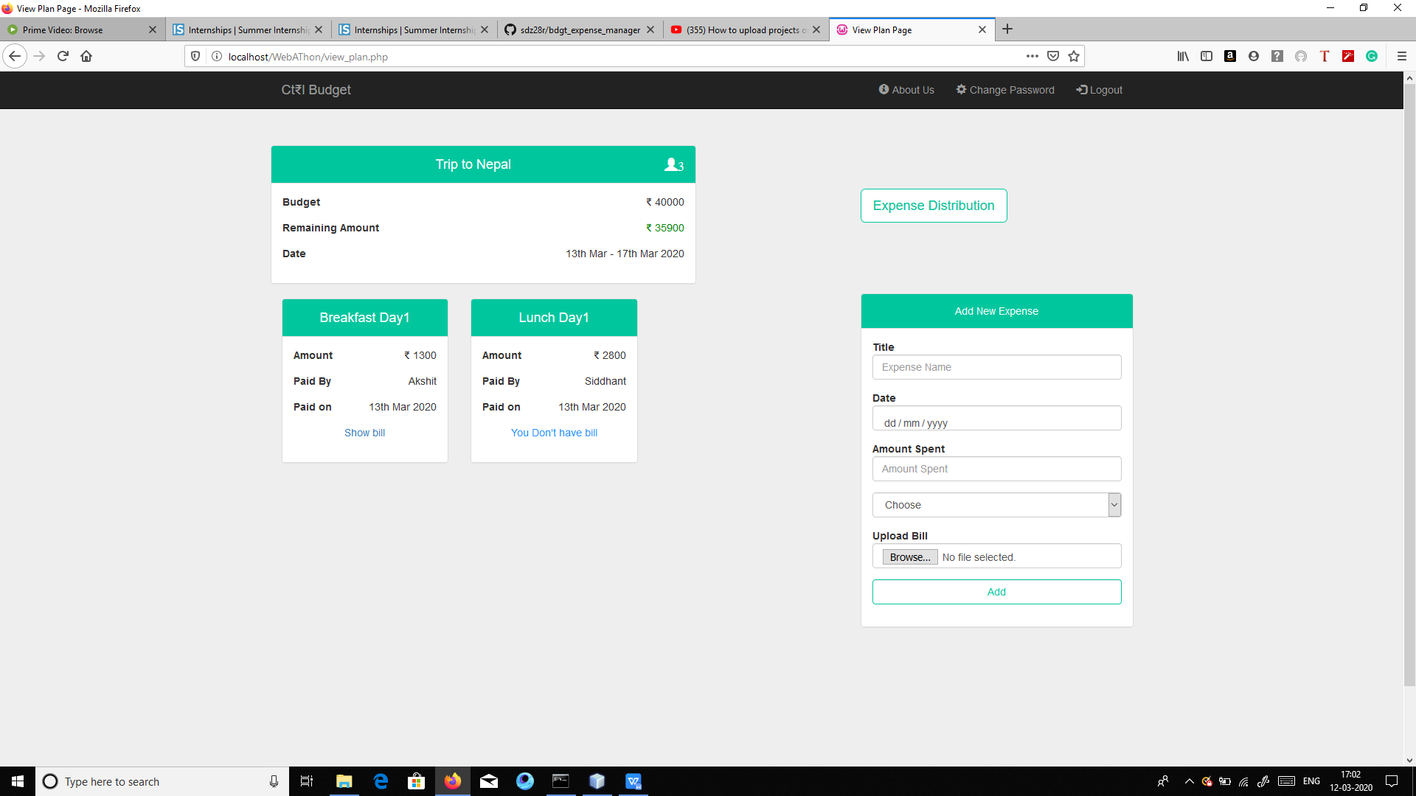

Click the Expense distribution button to see the Expense Distribution (expense_distribution.php page)

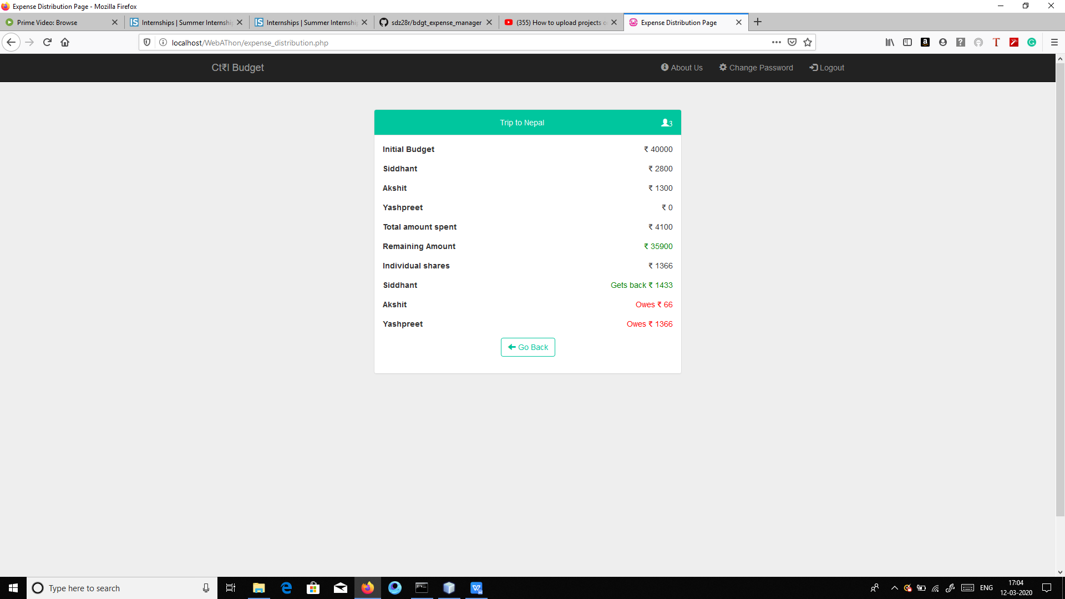

Logged in user can change the password by clicking the change password button in the menu (change_password.php page)

