**Find the details of people who are currently on the International Space Station and mark the current position of the ISS overhead Earth’s map.**

1. **Find the details of people who are currently on the International Space Station and mark the current position of the ISS overhead Earth’s map.**
2. **Api for name of astronauts on ISS - http://api.opennotify.org/astros.json (use requests library to fetch api content and the data that comes is in json format don’t forget to convert it to dictionary)**
3. **Use http://api.open-notify.org/iss-now.json to find position of ISS real time**
4. **Read this documentation to find plotting on world map in python using latitude and longitude fetched from API** [**https://matplotlib.org/basemap/users/examples.html**](https://matplotlib.org/basemap/users/examples.html)

**(SIDDHANT, 17BIT0244)**

**ABSTRACT**

This project, titled, ISS is a simple yet efficient location locator for ISS overhead Earth’s map. It manages the position of the station and meanwhile allows base station the access of the details of the people working there .The database has a very low risk of getting corrupted and is also secure against malicious activities. Hence, this project offers a great deal of ease and comfort to the base station in retrieving the exact location.

**FUNCTIONAL_REQUIREMENTS**

1. The location of the space station.

2) The details of people working there

3) Data retrieval on map.

4) Mark the current position of the ISS overhead Earth’s map.

**Implementation**

1. The package named request has been imported and in order to use node-js express framework has been installed.

2. In order to not specify the file type at every alteration, view engine is set to ejs, thereby any extension is provided or not , it`s going to render it in ejs format itself.

3. By the time data has been fetched, it is checked against for errors and whether the status code is not ‘200’ i.e., either the data has not been sent or acknowledged properly

4. In that case general error message will be displayed: “CANNOT GET /”

5. Otherwise the same data will be stored in the variable “pdata” and “ddata”. Using these variables we will print and embed leaflet with link as done for bootstrap and henceforth visualized the map using leaflet.

6. Further additional features like zoom - in and out---“<https://leafletjs.com/download.html>” and further added SLA to use this site as proprietary medium.

7. L.marker-- leaflet command, will help to mark the pointer at the given co-ordinates.

**Result**

localhost:3000/details --- to get details of the members on ISS(real time)

localhost:3000/location --- to see the location of ISS(real time) on Earth’s map

**Plot map fig:**

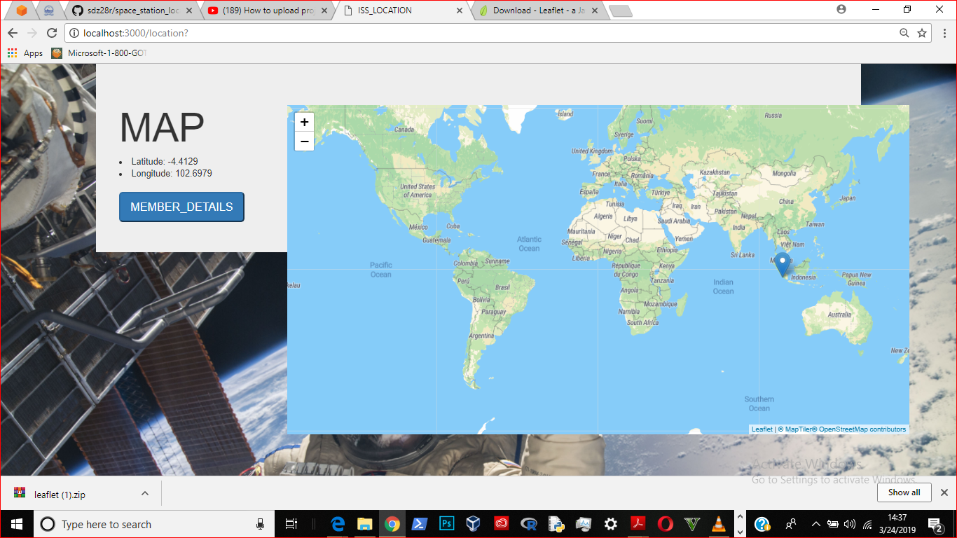

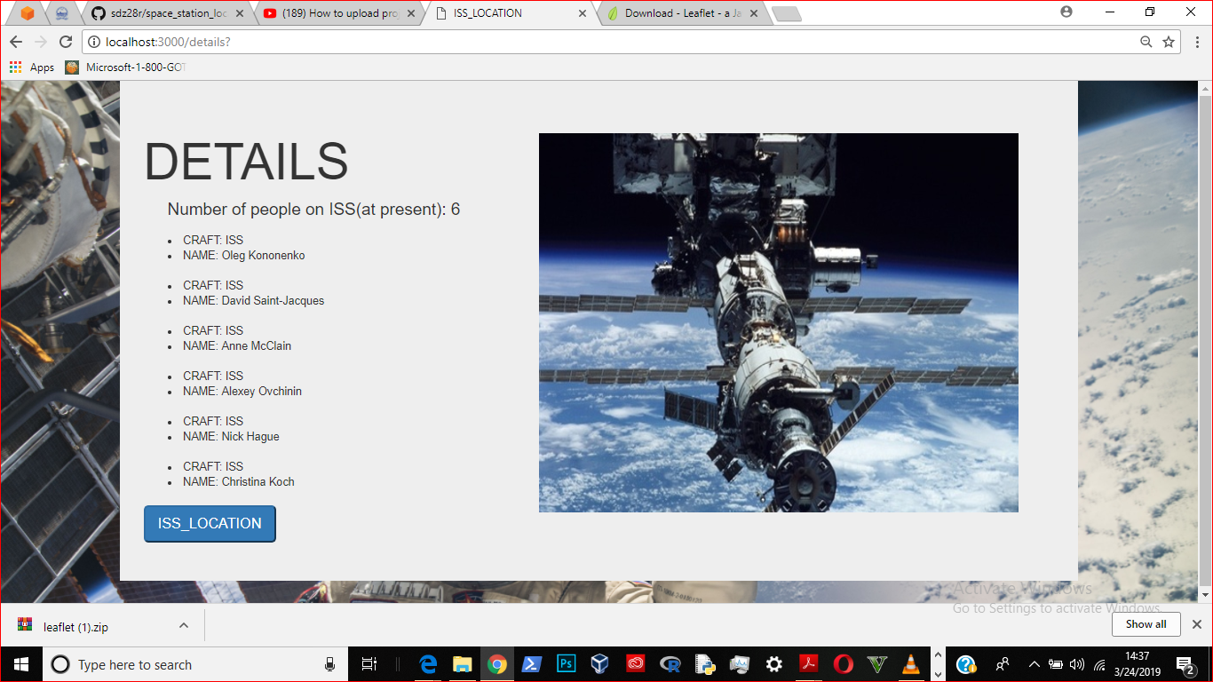

**Codes used:**

1. app.js

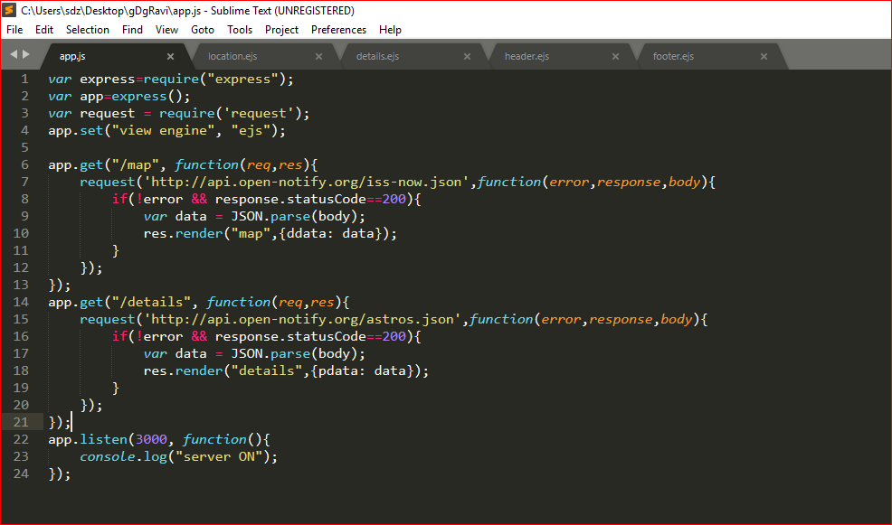

2. location.ejs

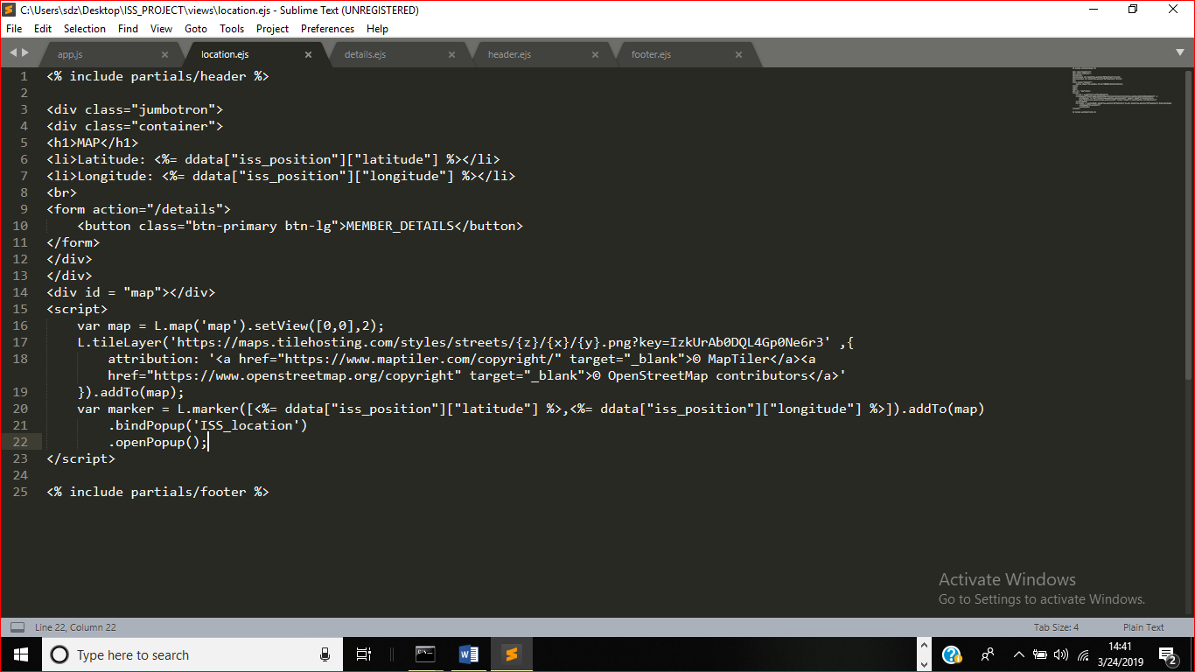

3. details.ejs

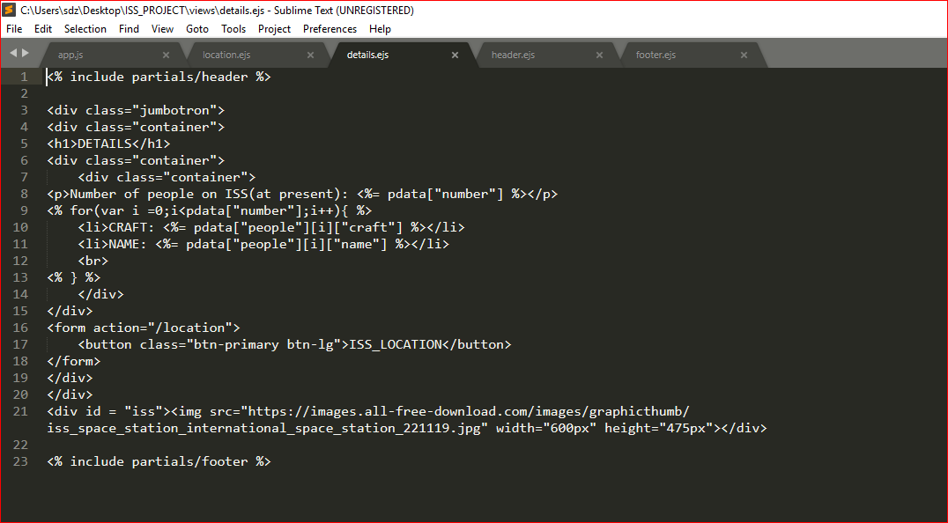

4. header.ejs

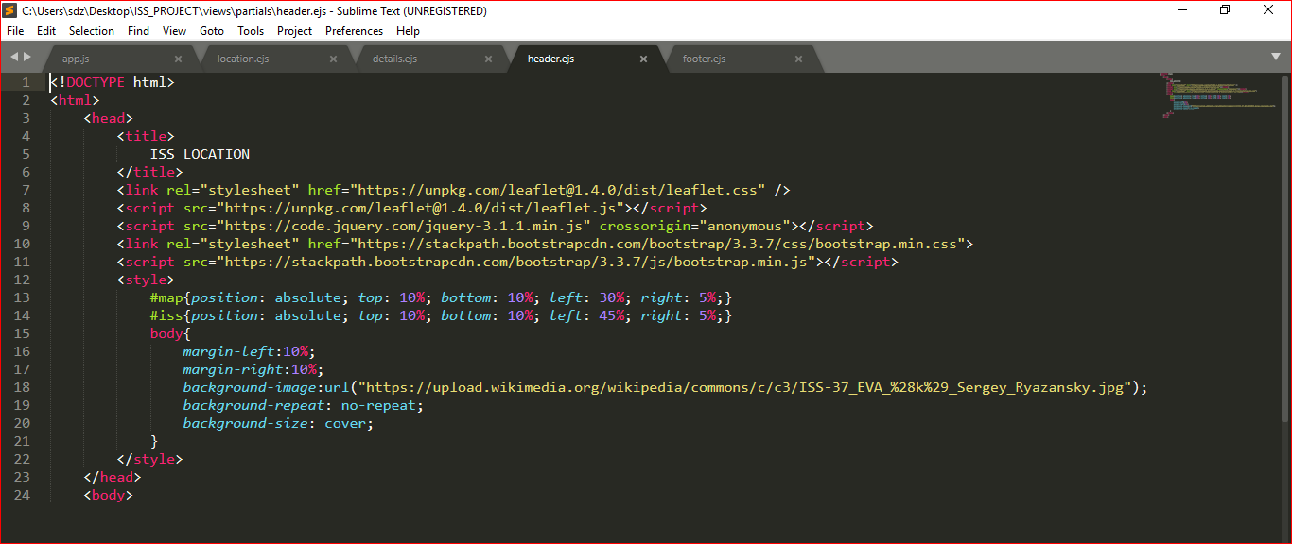

5. footer.ejs

