NAGIOS INSTALLATION

DevOps Training

**NAGIOS INSTALLATION ON UBUNTU**

Nagios installation has been divided into three parts.

1. Installing Nagios on Master
2. Installing NRPE on slave
3. Installing Check_NRPE Plugin on Master

Commands with green font represents master, white font terminal represents slave.

**Installing Nagios on Master**

**Step 1:**Update package index.

$ sudo apt-get update

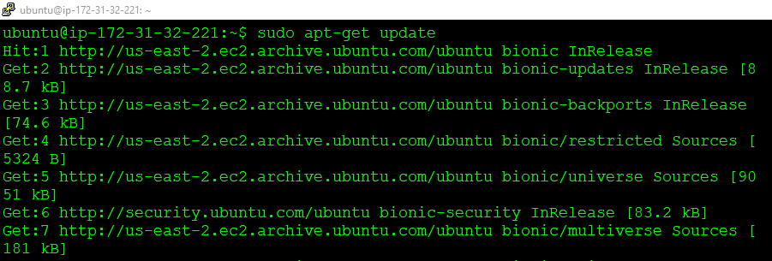

**Step 2:**Run the following two commands after that.

$ sudo apt-get install wget build-essential unzip openssllibssl-dev

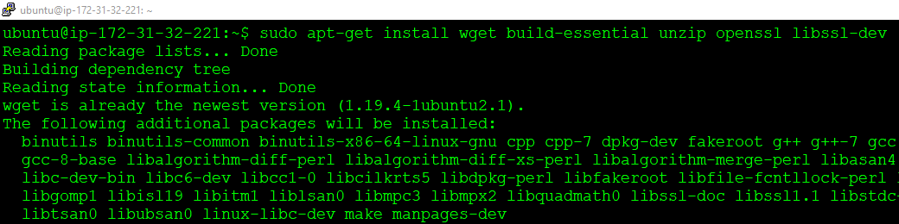

$ sudo apt-get install apache2 php libapache2-mod-php php-gdlibgd-dev

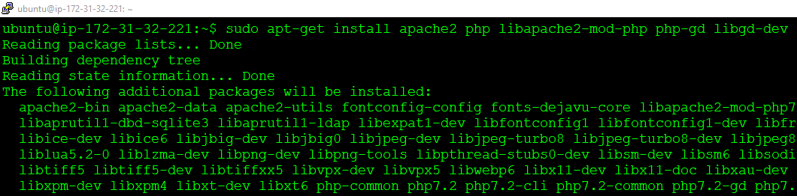

**Step 3:**Now,add user with the commands given below.

$ sudo adduser nagios

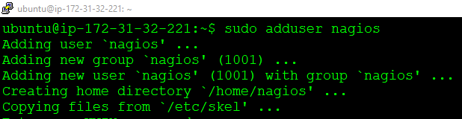

You can add passwords and Enter the user information as shown below.

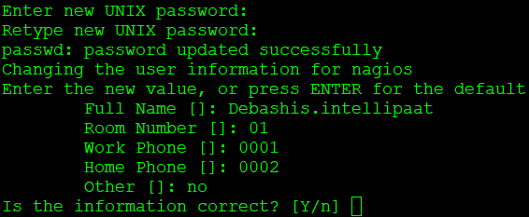

**Step 4:**Run the following commands to complete the user adding process.

$ sudo groupaddnagcmd

$ sudo usermod -a -G nagcmd nagios

$ sudo usermod -a -G nagcmd www-data

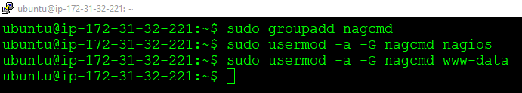

**Step 5:**Now that we are set with the prerequisites, install Nagios Core as shown below.

$ wget https://assets.nagios.com/downloads/nagioscore/releases/nagios-4.4.2.tar.gz

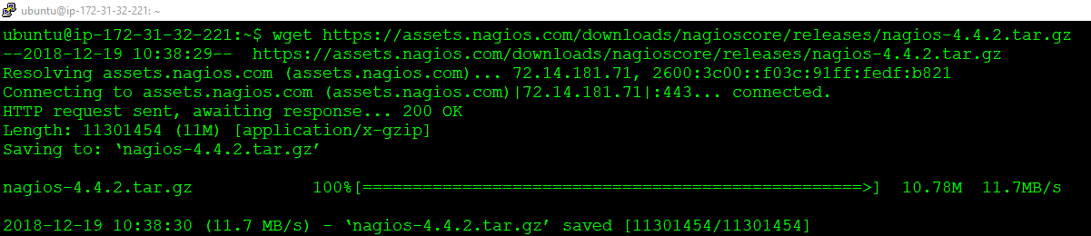

**Step 6:**Untar the file with the command shown below.

$ tar xzf nagios-4.4.2.tar.gz

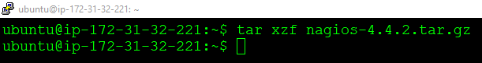

**Step 7:**Enter the Nagios-4.4.2 directory.

$ cd nagios-4.4.2

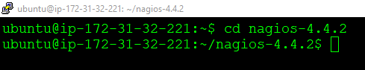

**Step 8:**Now with the given command make the required configurations.

$ sudo ./configure --with-command-group=nagcmd

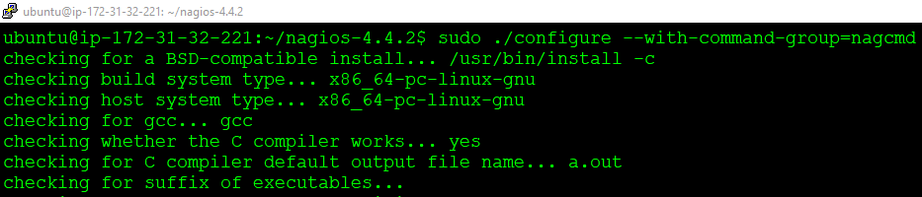

If the execution ends with the below given setup then we are good to go.

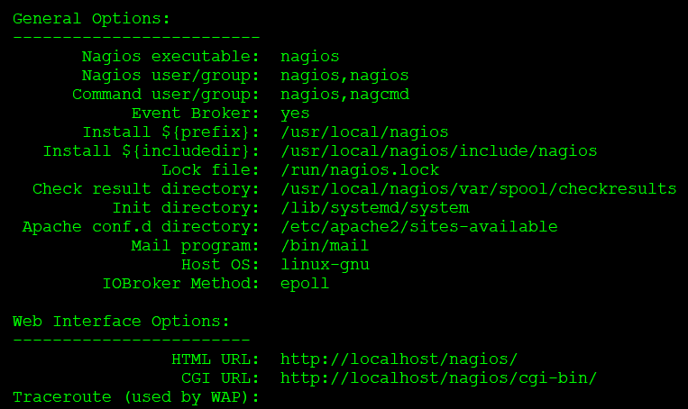

Now we will make all the configuration work.

$ sudo make all

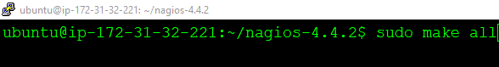

If everything is perfect, we should see an output as shown below.

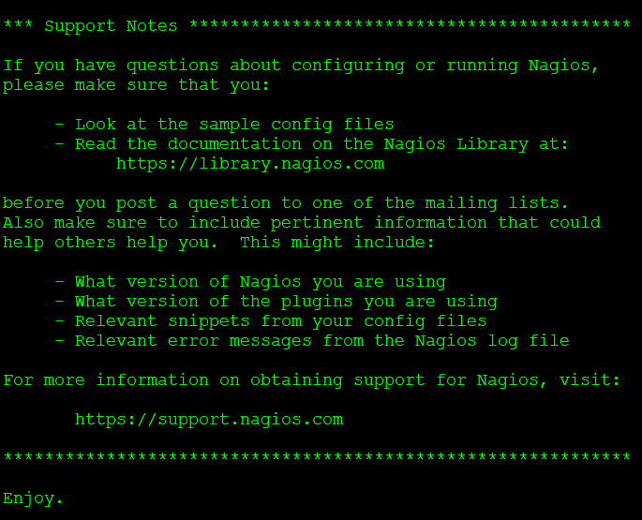

**Step 9:** Run the following command.

$ sudo make install

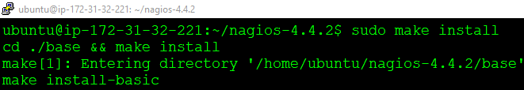

After that you will see the output as shown below:

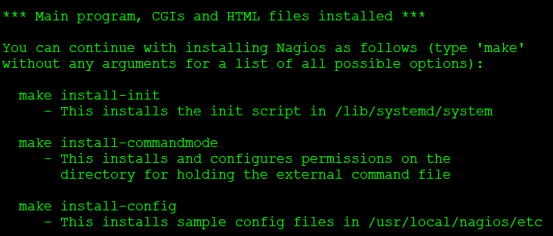

**Step 10:** Install init and run the following command.

$ sudo make install-init

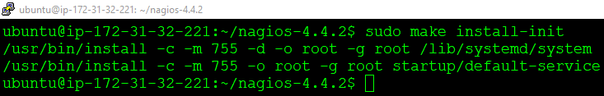

**Step 11:** Install config and run the following command.

$ sudo make install-config

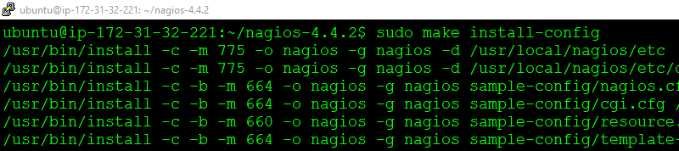

**Step 12:** Install commandmode as shown below:

$ sudo make install-commandmode

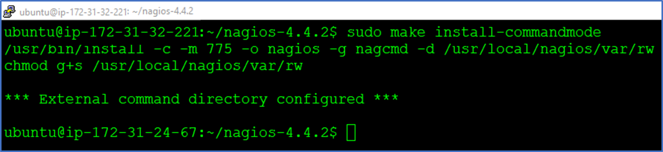

**Step 13:** Before moving ahead run the following commands to copy eventhandlers scripts under the ***libexec*** directory.

$ sudo cp -R contrib/eventhandlers/ /usr/local/nagios/libexec/

$ sudo chown -R nagios:nagios /usr/local/nagios/libexec/eventhandlers



**Step 14:** Create Apache configuration

$ sudo nano /etc/apache2/conf-available/nagios.conf



Add the below given content to the configuration file.

ScriptAlias /nagios/cgi-bin "/usr/local/nagios/sbin"

<Directory "/usr/local/nagios/sbin">

Options ExecCGI

AllowOverride None

Order allow,deny

Allow from all

AuthName "Restricted Area"

AuthType Basic

AuthUserFile /usr/local/nagios/etc/htpasswd.users

Require valid-user

</Directory>

Alias /nagios "/usr/local/nagios/share"

<Directory "/usr/local/nagios/share">

Options None

AllowOverride None

Order allow,deny

Allow from all

AuthName "Restricted Area"

AuthType Basic

AuthUserFile /usr/local/nagios/etc/htpasswd.users

Require valid-user

</Directory>

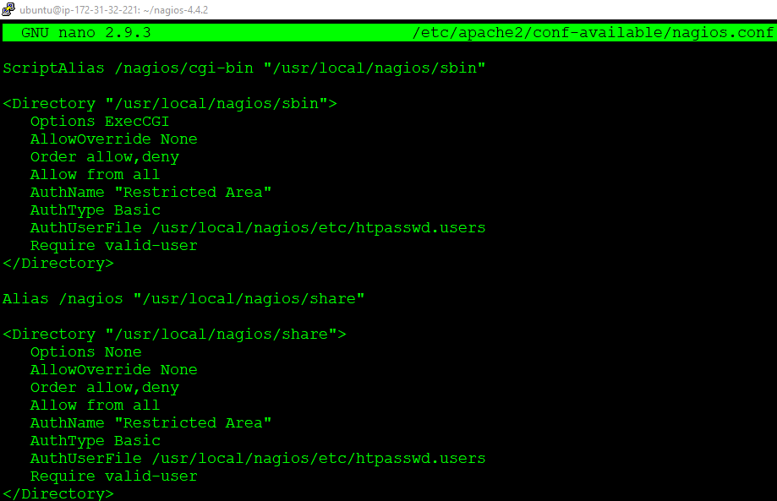

**Step 15:** Add a password as shown below, to complete apache configuration

$ sudo htpasswd -c /usr/local/nagios/etc/htpasswd.usersnagiosadmin



**Step 16:** Enable Apache configuration

$ sudo a2enconf nagios

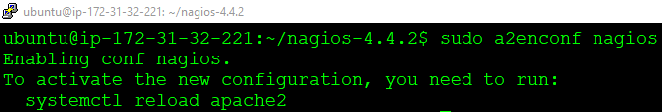

**Step 17:** Enable Apache configuration

$ sudo a2enmod cgi rewrite

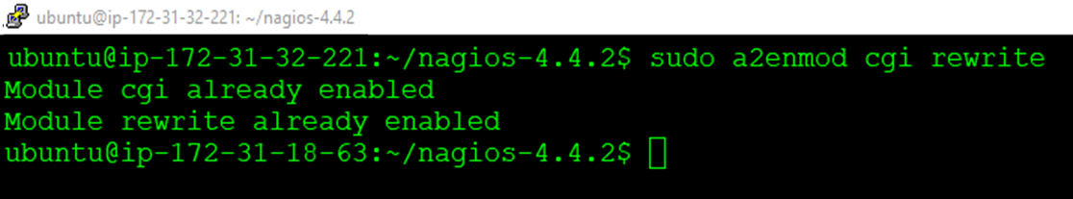

**Step 18:** Restart apache service.

$ sudo service apache2 restart

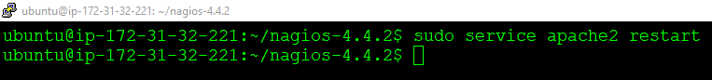

**Step 19:** Now go to the main directory.

$ cd

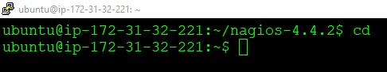

**Step 20:** To install the required Nagios plugin, download the plugins.

$ wget http://www.nagios-plugins.org/download/nagios-plugins-2.2.1.tar.gz

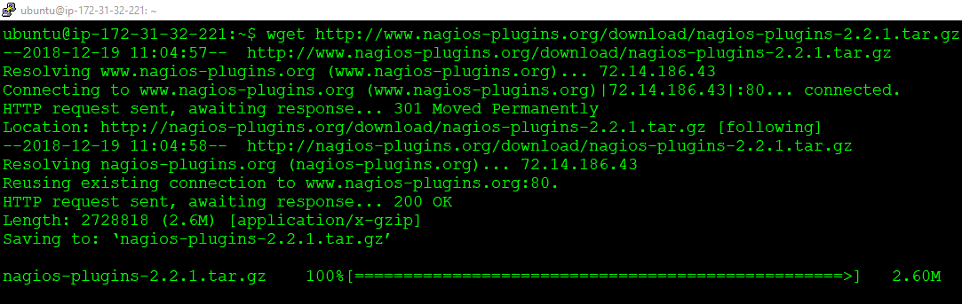

**Step 21:** Untar the file.

$ tar xzf nagios-plugins-2.2.1.tar.gz

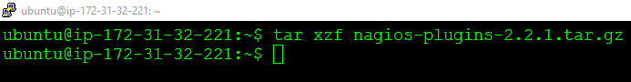

**Step 22:** Go inside Nagios-2.2.1 directory.

$ cd nagios-plugins-2.2.1

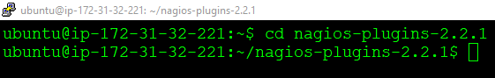

**Step 23:** Compile the plugins and then complete the plugin installation process running the three commands given below:

$ sudo ./configure --with-nagios-user=nagios --with-nagios-group=nagios --with-openssl

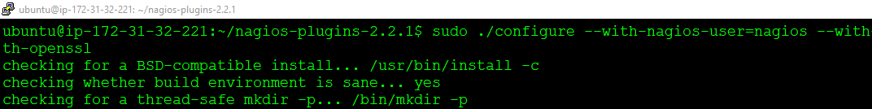

$ sudo make

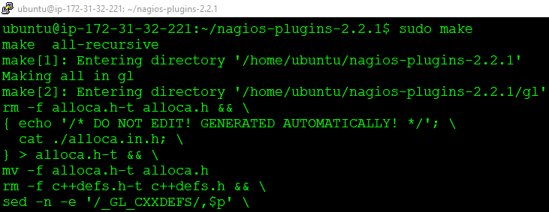

$ sudo make install

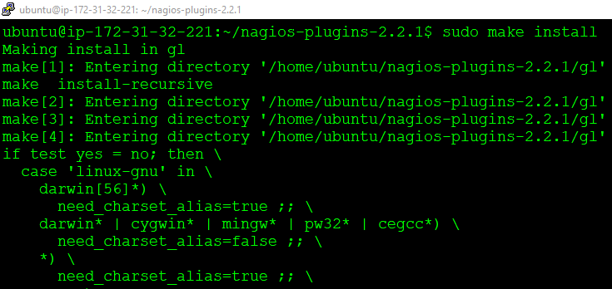

Before we can start using Nagios, we going to need to make a small change in the base configurations.

**Step 24:** Go to the main directory.

$ cd

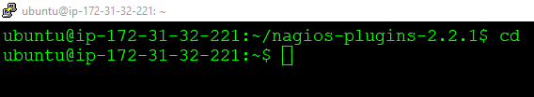

**Step 25:** Get inside***/usr/local/nagios/etc/nagios.cfg***

$ sudo nano /usr/local/nagios/etc/nagios.cfg

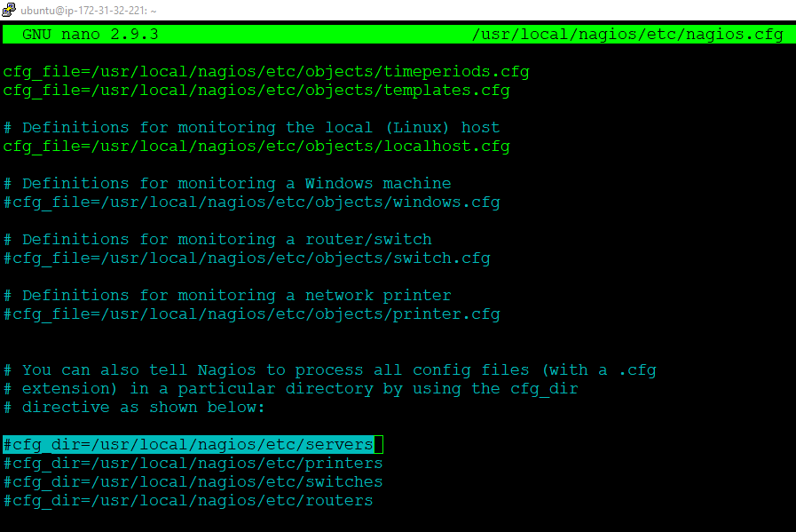

Uncomment that line:

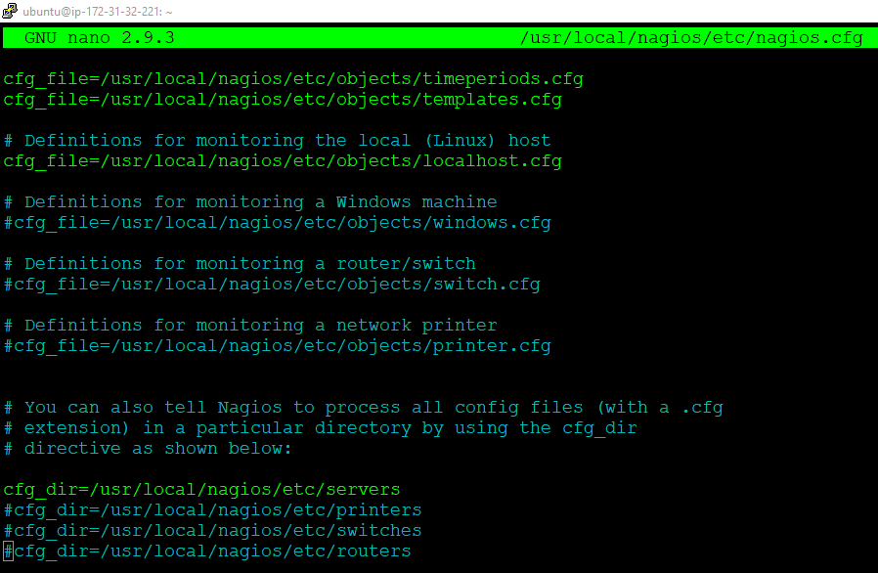

**Step 26:** Make the following directory.

$ sudo mkdir /usr/local/nagios/etc/servers

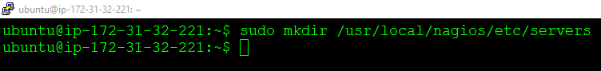

**Step 27:** Verify the configuration before starting Nagios.

$ sudo /usr/local/nagios/bin/nagios -v /usr/local/nagios/etc/nagios.cfg

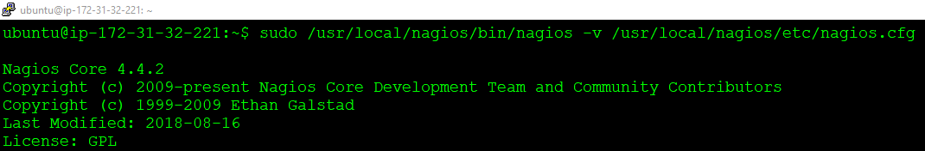

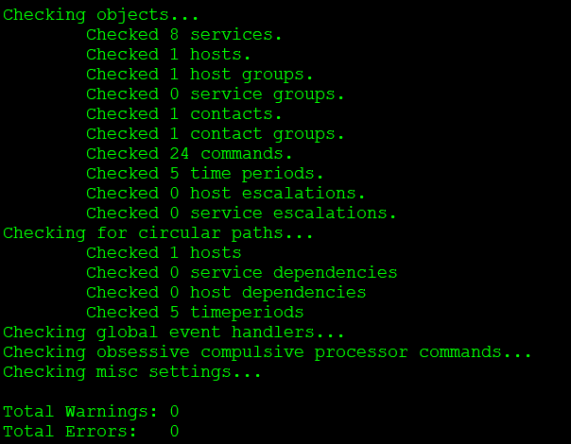

Everything looks fine!

**Step28:** Start Nagios.

$ sudo servicenagios start

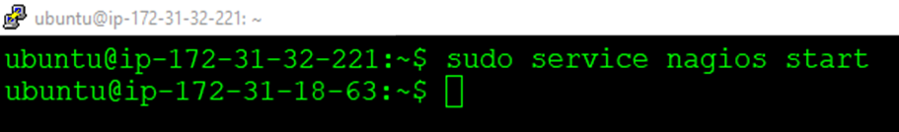

$ sudo systemctl enable nagios

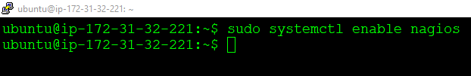

If no error occurs move to the next step on the browser

http://MasterIP/nagios/

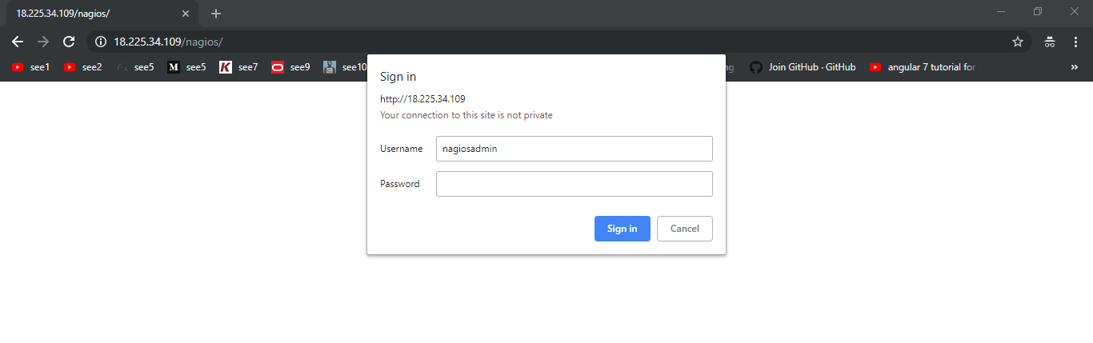

After entering the user id password, you will land on a page as shown below:

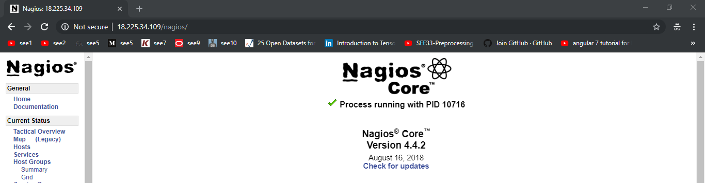

Click on host.

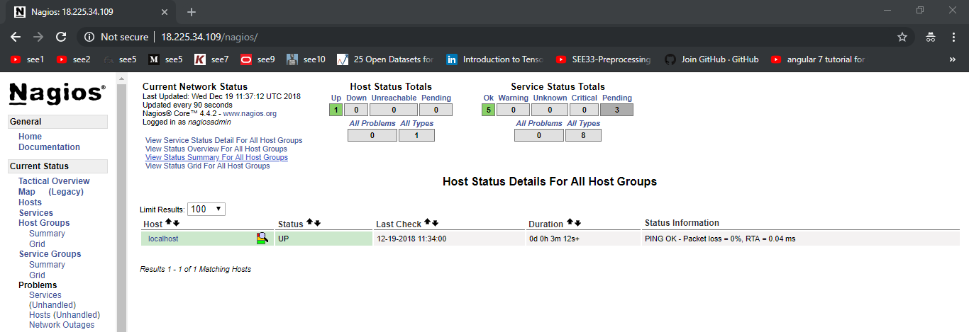

We are all set with the Nagios installation on Master.